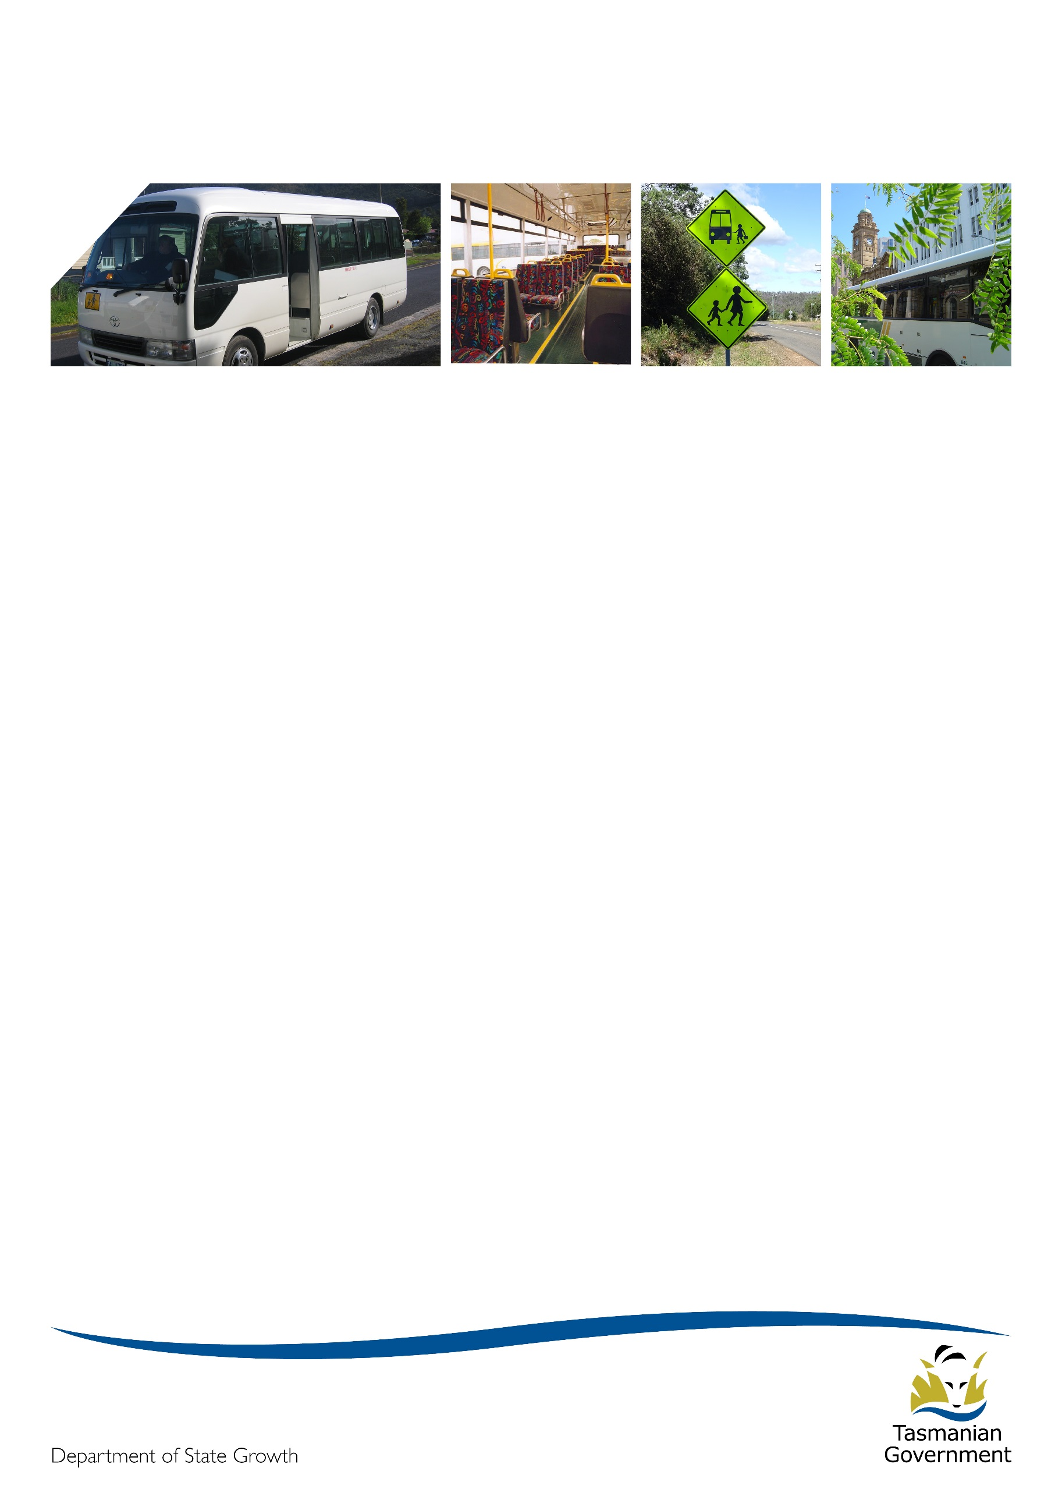
Transporter

January 2017

Happy New Year
Welcome to 2017! We hope you and your loved ones enjoyed a very relaxing holiday period. With 2016 now in the rear view mirror, we would like to thank you for your assistance during a tremendously busy, challenging and productive year. Preparations are well underway for a fast approaching new school year, and many significant projects are already deep in development, with many more on the near horizon.
2017 is shaping up to be another impactful period which will see the first of the New Service Contracts reaching the end of their 5 + 5 year term. As you are all aware, the Project 2018 team have been working hard on how the bus contract landscape will look going forward, and the end of this year will see their endeavours come to fruition.
We look forward to working closely with you all again throughout 2017.

Project 2018 update
Rural school bus regional forums
Between 14 and 24 November 2016, six Regional Forums were held in locations around Tasmania to discuss progress on rural school bus services.
Approximately 95 rural school bus operators attended these meetings and we’ve also held around 50 individual meetings with operators to discuss their routes and route advice in more detail. We would like to thank all those that took the time to attend the meetings, especially those who took up the opportunity to have individual meetings.
There were a range of questions raised at each of the forums – many of which cover topics of interest to other operators. In the interest of sharing information, attached to this edition of Transporter are the key questions and answers raised during the Forums.
If it’s felt there were questions asked at the forums that we missed and which should be in included, please contact Andrew Mullen on 6166 4470 or andrew.mullen@stategrowth.tas.gov.au
Release of guidelines for matching incumbent operators to new services
Guidelines have now been agreed with the Tasmanian Bus Association for matching incumbent operators against new routes in order to meet the Tasmanian Government’s commitment to offer 5 + 5 year contracts to incumbent operators (providing key performance conditions are met, and there is an ongoing need for a particular service in a particular area).

In many cases it will be clear who the incumbent operator for a new service is, however, for some areas, especially where network re-deigns have occurred, the matching of routes to incumbent operator/s may be less clear. These guidelines are what the Project 2018 team will use to match, or best match, operators to these new services.
The guidelines can be viewed at http://www.transport.tas.gov.au/passenger/project_2018 under the Operator FAQ section of the page.
General Access network update
Over the last few months the Department has been developing an option for a new state wide General Access Network as a basis public consultation during 2017.
This process has involved a lot of cooperation, time and data provision from General Access operators to help inform the process and the Department would like to acknowledge and thank those operators for their commitment and professionalism through the last few months.
We currently expect to release this network for wider public comment early in 2017, with the longer term objective of providing a recommendation on the design of the general access network by the end of the year. This will then allow us to focus on the recontracting of those services, and the significant change management tasks, throughout 2018.
Fare paying services update
The review of urban, urban fringe, rural fare paying and town services is one of the Project 2018 team’s highest priorities for the first quarter of this calendar year.
Thanks to the great response rate to the surveys sent out to operators late last year, we now have a mountain of data to work our way through with the goal of providing initial advice on changes to service to operators by March this year.
As part of this process, once we have released initial advice to operators in March, we will hold another round of regional forums to meet with operators to further discuss any changes identified to the four urban networks. (Hobart, Launceston, Burnie and Devonport).

Managing passenger behaviour
With a new school year about to begin, it seems appropriate timing for a reminder about the importance of managing passenger behaviour on buses. In accordance with the contract, all operators should have a code of conduct that students travelling on the bus must adhere to. This code of conduct should outline expected behaviours, repercussions/suspensions where behaviours do not conform and what timeframes are appropriate, and the process of notifying parents/schools.
It is highly recommended that you work closely with schools to help identify students who are disruptive and develop strategies in dealing with difficult students on and off the bus. The risks of not managing disruptive behaviour, or the implications of letting the behaviour continue, pose a threat to the safety and comfort of other students and may prevent other students from using the service.
Passenger Transport has developed a code of conduct that you may wish to adopt or adapt, which is available at www.transport.tas.gov.au/passenger/student_travel/behaviour_management.

Driver behaviour
Recently, we were contacted by a school and asked to raise the issue of driver behaviour with all bus operators. While conducting a survey of driver behaviour in and around school grounds, there were several incidences noted of unsafe driver behaviour whilst operating a school bus. Some of the behaviours observed were:
- Drivers using mobile phones whilst operating the bus
- Buses cutting corners and driving over footpaths/driveways
- Drivers pulling out of bus stops without appropriate caution, or indication
- Buses performing u-turns from bus stop areas
These behaviours not only pose a significant threat to the safety of the students on the bus, but also to other vehicles on the road and pedestrians, and may result in traffic infringement notices should the police be involved.
Road safety is the responsibility of all road users and is not be taken lightly. This is especially pertinent to school bus drivers who must display exceptional vigilance in their duty to safely transport children to and from school on a daily basis.

Deviations from contracted route
Further to the correspondence that was issued in December 2016, the Department would like to remind operators of the obligation to deliver services as detailed in the contract. If a situation arises where you may need to make changes to your route, whether permanent or temporary, you are required to consult with Passenger Transport before any changes are implemented.
The process of consultation should be followed as per the steps listed below:
- contact Passenger Transport Contracts
- provide details of the intended change (ie route deviation, vehicle change)
- advise if this change is to be permanent or temporary
- seek approval to proceed with the variation
We are currently developing an online reporting system which will simplify and formalise this process. In the interim we will be providing a contract variation request form on the Transport website, which will be available for download in the near future.

Reminder on student fare increase and 10-ride tickets
As previously advised, effective 1 January 2017 student fares have increased from $1.60 to $1.70.
10-ride tickets purchased in 2016 should still be accepted to access the discounted student fare in 2017 as long as the passenger is a full-time student under the age of 18, or turning 18 this year. When claiming for payment, your top-up will be based on the new student fare rates of $1.70 (full student fare) and $1.36 (discounted student fare).
Any student who does not present a Greencard/Smart Card, 10-ride ticket, or a valid student bus pass for free travel will be required to pay the full student fare of $1.70.
More information regarding student fares and ticketing is available at www.transport.tas.gov.au/student.

Fuel card use
The Department will be closely monitoring the use of fuel cards issued through the Bulk Purchase Fuel Scheme to ensure they are being used appropriately, in accordance with government policy. As outlined in the October 2016 newsletter, please be reminded again that the Bulk Fuel Purchase Scheme provides access to the government fuel discount under the provision that fuel purchased must be for a student-only school bus service.
A fuel card may be authorised for each bus used to service a student-only contract, along with one additional fuel card per contract for a support vehicle used specifically in the provision of the service.
In 2017 we will also be conducting an audit on all active fuel cards to ensure proper usage.

Liaison officer
In accordance with the contract, we are only able to discuss contract issues/variations with the nominated Liaison Officer recorded on the contract. A Liaison Officer was nominated when you first signed your New Service Contract.
If you are unsure of who you have nominated as your contracted Liaison Officer, or you wish to make a change, please email us at ptscontracts@stategrowth.tas.gov.au and we will send you the appropriate document to complete.

Black box process
A reminder that all Black Box concerns/queries need to be directed through the Department in the first instance. In-Vehicle Unit installations and/or removals must be co-ordinated by the Department and performed by a Black Box approved installer. No attempt should be made to repair, install or remove a Black Box under any circumstance.

Email payment remittances
Where possible we are endeavouring to reduce our paper usage within the Department. One major step toward this goal, is the issuing of contract variations via email. This has proved beneficial, not only in resource management, but as a more time efficient method of correspondence.
In line with this practice, effective March 2017 we will be issuing payment remittance advices via email. To ensure you receive your remittance advice, can you please provide a current email address for your contracted Liaison Officer to ptscontracts@stategrowth.tas.gov.au.

Staff update
Following a very productive 12 months in the role, Babette Moate has now formally secured the position of Manager of Passenger Transport and Delegate of the Secretary, on a permanent basis. Effective 18 January 2017, Stephanie Katz will be joining the Contracts team for a period of 6 months.
Bus cost model index (BCMI) and capital rates
The BCMI has been calculated for January 2017 and is 118.6
The capital payment rates have not yet been finalised for this quarter. The rates applicable to all fare-paying monthly contract payments can be found on the Statement of Payment.
Contract Type | October 2016 | January 2017
Urban Fringe Student Only | $1.72 | TO BE ADVISED
Rural Fare Paying | $1.72
Long Distance Student Only | $1.72
Long Distance General Access | $2.86
Urban Fringe General Access | $2.86
Urban | $1.01
Town | $1.01

Contacting State Growth
We are noticing that a lot of queries within the Department are being forwarded to the Project 2018 team. Just as a reminder, for all matters relating to your current contract (ie the services you currently provide) such as routes, timetables, payments, reporting etc you should contact Passenger Transport via email ptscontracts@stategrowth.tas.gov.au or phone 6166 3343.

Attachment
Project 2018: Issues raised at the rural school bus regional forums
Q. There are places where there is a Town service (which covers much of the Town) which is fare-paying, but there are some areas in those same Towns where Rural School Bus Services (RSB) pick up students with no fare applying. Will this be resolved in future arrangements?
A. To date the Department has only reviewed RSB services. Town services are being reviewed shortly. The Project 2018 review of services will take these inconsistencies into account, and attempt to resolve these in the new network of services/contract arrangements.

Q. Is there any ability for State Growth (the Department) to encourage the council to improve bus stop facilities?
A. The Department works well with councils, particularly where safety concerns are raised. Individual issues (particularly around safety) should be pursued/discussed with the Department.

Q. Concerns raised over the length of time taken for (potential) new drivers to obtain Ancillary Certificate and Working With Children registration, and if anything can be done about this?
A. Agreed to pass this on to the Department of State Growth’s Registration and Licensing area and to the Department of Justice. However, recognising that these processes do take time, operators needed to be aware of this, and ensure that contingencies in place for driver coverage on all contracted services.
(Context: Brief discussions held on the possible requirement for all operators to have email/internet access to assist with timely and efficient communication between parties.)

Q. Would costs for computer/internet /email be covered in any new funding model. Particularly in remote areas where internet access is not so good?
A. While discussions around any (new) funding model have only just commenced, consideration of all reasonable costs incurred in operating bus services will be considered.

Q. Given the benefits of cameras in buses, is this something that the department will require in the future – and if so will this be funded?
A. Acknowledged the issue, and would take away for further consideration, and consultation with stakeholders (bus operators and school community primarily).

Q. Will the Department require seat belts on school buses, and fund capital to enable this to happen?
A. The details around bus requirements under the new contracts are yet to be determined. While evidence and research supports benefits for seat belts on small buses, as required under contracts at present, the benefits on larger buses is not as evident. Requiring seat belts on buses will remove (compromise) the ability for 3 for 2 seating, and possibly standees. This takes away flexibility. All of this will be taken into account when deciding what is/isn’t required under the new model.

Q. What will happen with the current tracking devices (Black Boxes) under the new contracts, and what else is the Department contemplating in regard to tracking/ticketing/claiming?
A. The Black Boxes will continue to be used under the current contracts to monitor route and timetable compliance. No decisions have been made on the use of these under the new contracts.
Q. When will we know more about RSB services which feed into the Urban Fringe Network?
A. The review of the Urban Fringe Network will take place over the next 2 months with initial advices likely to be sent out in late February. As part of this review, those RSB services which are used as a feeder to the Urban Fringe Network will be reviewed, and initial advices provided to RSB operators.

Q. Is it going to be easier in the future to change buses across contracts?
A. That is what we are aiming for. While there is still likely to be minimum requirements for buses being used, if we move to having one bus contract per operator, with a listed fleet of buses, this should enable bus operators to move their buses around to suit arrangements.

Q. As an idea, can the Department pay out contracts to help align the start dates?
A. That is not an option at present. Other options are being explored at present to have new contracts align.

Q. Is there a possibility of relaxing some of the guidelines, so that bus routes/timetables can be more flexible?
A. We are looking at alternatives to the requirement for 8 at the first stop, and on each spur, but have not looked at reviewing others. However, if there are sound reasons for doing so, we can review other aspects of the guidelines.

Q. Will there be a probity adviser associated with the re-contracting process?
A. Yes, a probity adviser has already been appointed, and has reviewed the work to date. His name is Harvey Gibson from Wise, Lord and Ferguson.

Q. Where Schools have both Urban Fringe Student Only (UFSO) and RSB providing services, what will the timing of the school community consultation be?
A. There are relatively few in this category, but where this occurs the consultation will take place after both sets of reviews are complete.

Q. Given recent talks about lowering the enrolment age for students, will bus operators be required to carry unaccompanied 3 year olds?
A. Any lowering of enrolment ages will be some years off by 2021 at the earliest. There is an agreement with Department of Education that prior to any changes occurring, that discussions are held on the rules associated with bus travel. New contracts may stipulate minimum ages/circumstances for student travel.

Q. There is likely to be an election in 2018 – will this have an effect on the Project?
A. The project is being conducted in line with current government policy/direction.

Q. Can you provide further information on the matching and tendering process?
A. A fuller explanation was provided – for details refer to the website.

Q. What will the novation arrangements be in the new contracts?
A. While this is yet to be determined, hopefully the novation process will be simplified for all parties. The existing checks are likely to remain (Accreditation and other requirements in place, performance background, GST registration etc). But hopefully the process may be a simpler/quicker process for all.

