Transporter

October 2017

Spring is in the air!
We have now entered the final school term of the year and summer holidays are just around the corner – hope you have your Christmas lists prepared!
This edition of the Transporter is a long one because we have many messages for you. Please read to the end for an update from Project 2018.

Heavy vehicle registration labels – a message from Registration and Licensing Services
From 1 September 2017, registration labels will no longer need to be displayed on heavy vehicles with a Gross Vehicle Mass (GVM) over 4.5 tonne in Tasmania.
This is part of a nation-wide commitment to abolish registration labels from heavy vehicles across Australia by July 2018.
Operators will continue to be sent registration renewal notices 4-6 weeks prior to the expiry date with a reminder sent out some 21 days after expiry if required.

Changes to heavy vehicle compliance and enforcement in 2018
How is heavy vehicle compliance and enforcement delivered now?
At present heavy vehicle compliance and enforcement services are provided by Transport Inspectors from the Tasmanian Department of State Growth based in Burnie, Launceston and Hobart.
State Growth delivers these services on behalf of the National Heavy Vehicle Regulator (NHVR), Australia’s independent regulator for all vehicles over 4.5 tonnes gross vehicle mass.
What will change?
From the second half of 2018 heavy vehicle compliance and enforcement will no longer be provided by State Growth but directly by the NHVR. NHVR safety and compliance officers will have authority to issue infringements for state-based offences as well as those under the National Heavy Vehicle Law. Once the transition takes place NHVR officers will be easily recognisable by their uniforms.

When will this happen?
Transition to the NHVR is expected to be completed as early as July 2018 and no later than December 2018.
What services will transition to the NHVR?
- On-road compliance for heavy vehicles, including mass, dimension, vehicle standards, load restraints, route compliance and driver fatigue.
- Investigations and prosecutions.
What services won't transition to the NHVR?
- Heavy and light vehicle crash inspections for the Coroner.
- Escorting Over-Size and Over-Mass vehicles.
- Written-off Vehicle Register (WOVR): light vehicle identity inspections.
- Passenger transport (taxi and bus) compliance activities.
State Growth is assessing how each of these remaining services will be delivered after the core heavy vehicle compliance and enforcement tasks move to the NHVR. More information will be provided closer to the time of transition.
Why is this happening?
All Australian states and territories (except Western Australia and the Northern Territory) have adopted one rule book for heavy vehicles – the Heavy Vehicle National Law. The long-term goal is also to have one body, the NHVR, deliver consistent heavy vehicle compliance and enforcement across state boundaries.
Tasmania will be the second Australian state, after South Australia, to deliver this part of the national heavy vehicle reforms. As the national regulator, the NHVR will provide nationally-consistent training, enforcement methods and resources, and undertake more complex investigations, including Chain of Responsibility.
Is there anything I need to do now?
No. All heavy vehicle drivers, operators and others parties in the Chain of Responsibility are already covered under the Heavy Vehicle National Law which continues to apply in Tasmania both currently and post-transition.
When will more information be available?
More information will be provided as planning by the NHVR and State Growth progresses. In the meantime you can find more information about compliance and enforcement at the NHVR at: www.nhvr.gov.au/safety-accreditation-compliance/on-road-compliance-and-enforcement

Student fare increase 2018
New student fares will apply for 2018. Effective 1 January 2018, the maximum student fare will increase to $1.80 and the maximum multi-trip/smartcard/greencard discounted ticket will be $1.44.

Student bus passes expiring in 2017
We have now commenced our yearly campaign to remind students that if their Bus Pass for Free Travel expires in 2017 they will need to reapply to remain eligible for free travel to/from school.
Like previous years, posters will soon be issued to all fare-paying operators to be displayed in buses prior to the end of the school year as a reminder to students on where and how to apply.
The poster will encourage students to use the online system to submit their application, as this will be the fastest way to receive approval for free travel.
Students who apply for a free travel bus pass between 15 November 2017 and 5 January 2018 will receive their bus pass before the start of the 2018 school year. Applications received after 5 January 2018 may take up to 4 weeks to process.
Students who currently have an expiring free student bus pass and will be travelling on Metro or Tassielink in 2018, should not throw away their current card. If eligible for free travel in 2018, this entitlement will be applied to their existing card – they will not receive a new card.

Project 2018 update
There’s lots going on behind the scenes with Project 2018 and below is a brief update from the Project Director.
School bus services update
After concluding the first round of consultations with rural school principals in August, the team moved its focus onto progressing the offer of Short Term Interim Contracts and working with those operators who expressed interest in looking at the Early Rationalisation of Services Incentive Scheme (Early Exit Scheme).
These will continue to be our main focus over the next two months, and updates on each of these activities are below.
Offer of Short Term Interim Contracts
318 short term contract offers were sent out to 122 operators in August and around 90 percent of these have now been returned, processed and sent back to operators.
Reminder letters were sent late last month to the remaining operators. If you have not received any advice from us, and were expecting to, or you do not intend to sign the short term contract, please contact Deb Males on 6166 3496 as soon as possible.
Early Exit Scheme
Following the Minister’s announcement of the Early Exit Scheme in June around 35 services were identified for potential early exit.
The team has been working with these operators, and affected schools, since the announcement and about 30 of these possible exits are being progressed.
A lot of focus is needed on these services over the next two months to ensure that any changes are communicated to schools and affected parents as early as possible. Because of this, we are no longer accepting expressions of interest in this program.
Release of matching decisions
The first step in making contract offers to incumbent operators is to identify the new route and service that will be procured and then make a ‘matching’ decision of an operator, or operators, to the route.
Given that we have fallen behind in our commitment to start releasing these matching decisions in August due to our focus on the Early Exit Scheme, we recently reviewed our priorities. This led to us, in September, starting to release matching decisions for clusters of routes on a town by town basis.
So far we have released the matching decisions for St Helens, Dunalley and Nubeena and we expect to continue working our way around the State.
Not all matching decisions will be on a town by town basis, with some services (eg. where early exits are being implemented or where operators have vehicles going out of capital) being brought forward on a case by case basis.
Details of the Operator Matching Process can be found at this URL:
http://www.transport.tas.gov.au/project2018/public_transport_bus_services_procurement
The actual register of decisions is available at:
http://www.transport.tas.gov.au/project2018/public_transport_bus_services_procurement/register_of_decisions
From this address you will be able to view maps of the proposed new route and the current contract, or contracts, that will be matched against it such as the one below. This is an example of two routes that will be merged into one:
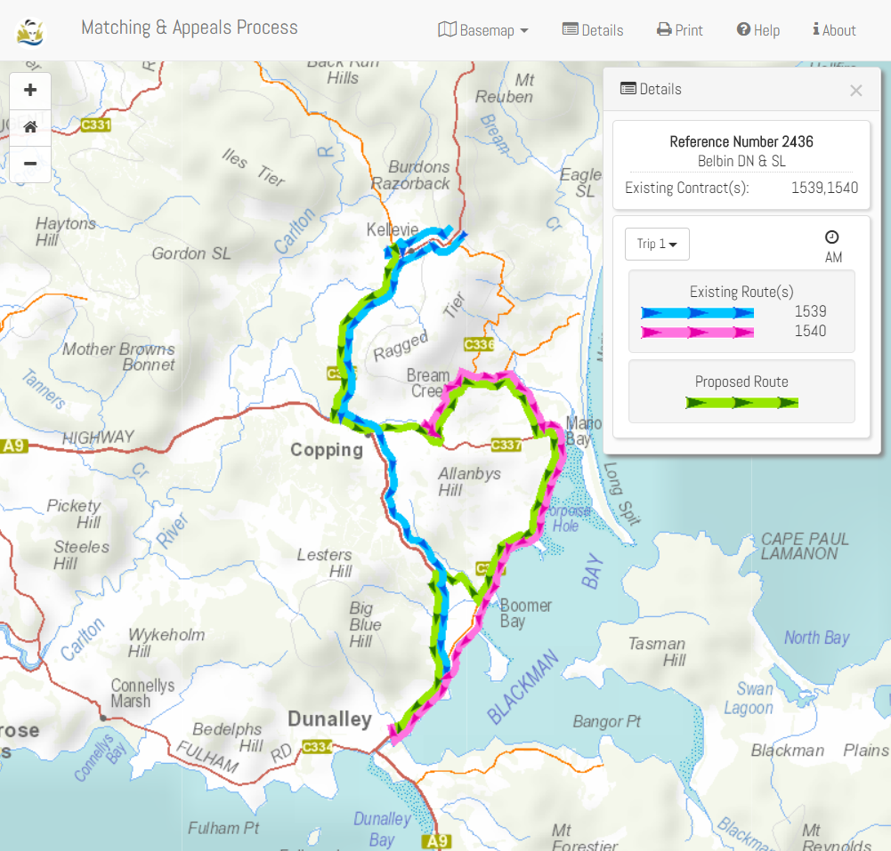
Decisions are released each Tuesday morning and can be appealed for 30 days from that date. Full details of the process are on the website, or you can contact Andrew Mullen on 6166 4470 with any questions.
General Access Services
The draft report for the Devonport and Burnie networks, mentioned in the last Transporter, has now been received and discussions have already commenced with the General Access operators in the North West about the proposed network of services and possible timetables in that region.
User surveys were also undertaken, earlier this year, on a number of services that are under review. The results of these surveys, as well as submissions made through our online feedback form, have now been shared with the local General Access operators and councils to inform decisions on these services.
This is all working towards providing updated advice to the Minister for Infrastructure on what the expected network will look like later this year.
Another piece of work that is also underway is looking at the implications of the proposed network on the need for new bus stops and related infrastructure so that these changes can be factored into any decisions on the future network.
The General Access network won’t roll out until at least 2019, with a likely staged roll out of changes to the network out to 2022.
Update on Contracts and Funding Model
Contract and funding negotiations continue. There is still little that can be reported until both parties agree, at least in principle, on the agreements.
I would, however, like to thank the operators who have let us come onto their work sites and walked us through all the different elements of running their businesses. This has given us a better understanding of the day to day issues, and challenges, of running a bus operation.
Do you sell advertising on your buses?
The Project 2018 team is keen to talk to anyone who sells advertising space on their buses as it is an issue that has come up in the contract negotiations. We have a very limited understanding of how widespread the sale of advertising space is on buses and how it generally works.
If you are willing to have a chat about your experience in this area, please give John Dawson a call on 0429 194 125.
Bus cost model index (BCMI)
The BCMI has been calculated for October 2017 and is 121.1
Capital rates
The Capital Payment rates have been calculated for the quarter commencing October 2017. Please consider these rates before requesting bus changes on your contract.
For all fare-paying operators, the rates applicable to your monthly contract payment can be found on your Statement of Payment.
Contract Type | July 2017 | October 2017
Urban Fringe Student Only | $1.23 | $1.23
Rural Fare Paying | $1.23 | $1.23
Long Distance Student Only | $1.23 | $1.23
Long Distance General Access | $2.90 | $2.90
Urban Fringe General Access | $2.90 | $2.90
Urban | $0.77 | $0.77
Town | $0.77 | $0.77

Contacting the Passenger Transport Branch
For all enquiries or notifications relating to your current contract (i.e. a service you currently provide) contact Passenger Transport Branch via email ptscontracts@stategrowth.tas.gov.au or phone 6166 3343.

