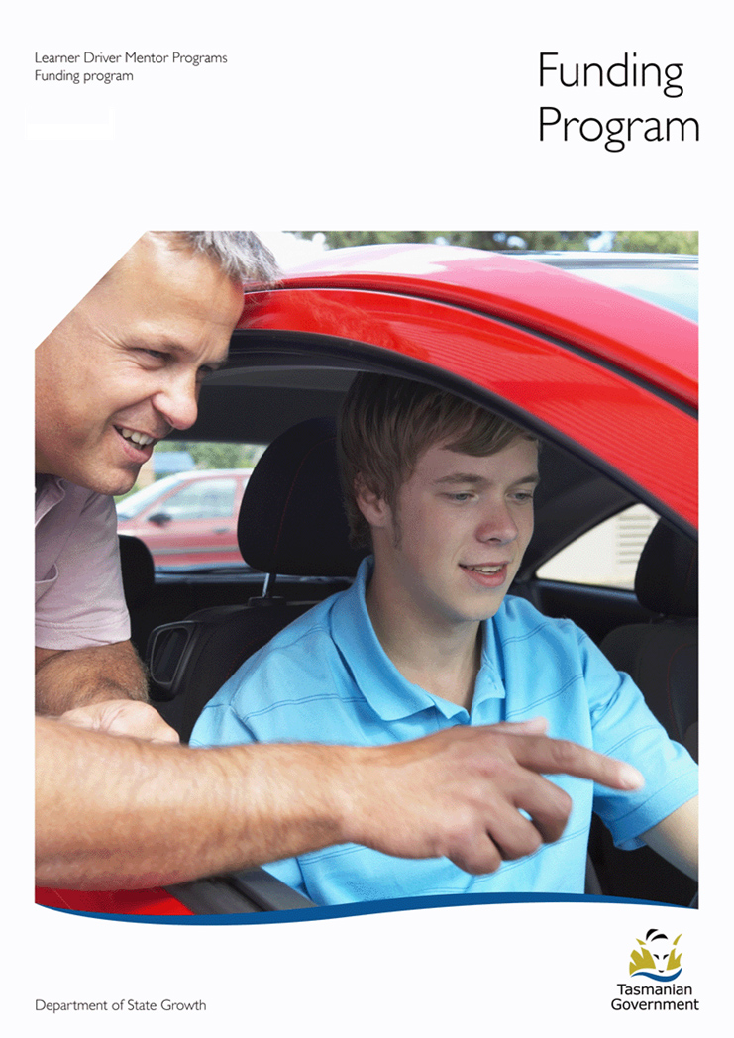

Contents
Funding Program 3
Roles and responsibilities 3
Eligibility 4
Applying for funding 5
Auspicing Fees 6
Funding requirements 6
Program evaluation 7
Assessing applications 7
Assessing existing LDMPs 8
Assessing new LDMPs 10

Funding Program
Learner Driver Mentor Program (LDMP) Funding 2017-2018 is currently available to assist LDMPs and Driver Mentoring Tasmania (DMT). Funding is made available from the Road Safety Levy to support LDMPs to assist disadvantaged learner drivers gain essential on-road driving experience towards obtaining a driver licence.
It is critical that disadvantaged learner drivers are supported to enter the licensing system as this decreases the risk of unlicensed driving and encourages mobility within the community and increased job prospects.
The core function of LDMPs is to assist disadvantaged learner drivers who do not have access to a suitable car and/or supervisory driver to obtain their licence. For the purpose of participating in a LDMP, a learner driver meets the disadvantaged criteria if they:
- Do not have access to a suitable supervisory driver and/or car; and
- Are on a low income and are not able to afford professional driving lessons to gain the minimum hours required to obtain a driver licence.
Although the following factors alone do not automatically guarantee a potential participant a place in a LDMP, they do assist in determining an individual’s circumstances and level of disadvantage.
- Holder of a Healthcare or Pensioner Concession card;
- Socially isolated or living in a remote area (no public transport);
- From low socioeconomic area and high unemployment;
- Experiencing language and literacy problems;
- Migrants or refugees; and/or
- Have little or no family support.

Roles and responsibilities
There is an increased expectation of performance from the Government and the community associated with this substantial funding commitment. The Department of State Growth (State Growth) and DMT are working in close partnership to support LDMPs to continue to deliver benefits to individuals and to the community.
State Growth is responsible for administering the funding program to LDMPs and is also responsible for:
- Providing advice to the Minister on the performance of LDMPs.
- Reporting to the Road Safety Advisory Council (RSAC) on LDMP funding expenditure and performance.
- Setting performance targets and reporting requirements for Government funded LDMPs.
- Managing the engagement of a consultant to undertake an evaluation of LDMPs (mid/late 2016).
- Assisting LDMPs with applying for Government funding.
- Supporting Government funded LDMPs to meet performance targets and reporting requirements.
- Monitoring and assessing six monthly evaluation reports, recognising achievements and identifying issues to assist in improving performance.
- Working in conjunction with DMT to identify areas where extra support for individual LDMPs is required.
- Facilitating Workshops for LDMPs (as required).
- Setting strategic priorities for LDMPs.
DMT, the peak body representing LDMPs in Tasmania, is responsible for:
- Representing and lobbying Government on behalf of member LDMPs.
- Working with Government to identify, prioritise and implement business improvements to support LDMPs.
- Providing high level support and advice to individual LDMPs, including providing tools and advice for managing and administering programs and recruiting and retaining mentors and learners.
- Collecting data and reporting on LDMPs performance to State Growth on a quarterly basis.

Eligibility
To be eligible to receive funding under this program, a LDMP must meet the following criteria:
- Not-for-profit
- Incorporated, or affiliated with an incorporated organisation (i.e. an auspicing body)
- Based in Tasmania
- Set up to address an identified need or opportunity aimed at improving outcomes for disadvantaged learner drivers
Organisations may be:
- Affiliated with Local Government or non-Government organisations
- Tasmanian Senior Secondary Colleges
State Growth will not consider applications for funding from:
- State and Australian Government agencies or affiliated organisations
- Individuals
- LDMPs that:
  - Require payment (cash or in-kind) from participants
  - Allow volunteer mentors to receive reward for providing mentor driving services

Applying for funding
There are no set limits for the amount of funding a program can apply for. Programs can apply for funding to establish, consolidate or expand their LDMP, providing a strong business case can be demonstrated that is in line with the funding request. The funding application will assist programs to outline plans for their program over the funding period.
An application template and updated funding round information can be found at: transport.tas.gov.au/roadsafety/people/mentor
Signed and fully completed applications are to be submitted to State Growth, as instructed, by the due date.
The following are examples of some items that funding can be applied for, including:
- Coordinator wages (a request to increase hours must be supported by a strong business need).
- Day-to-day running costs of car/s (petrol, rego, insurance, etc).
- Vehicle (provided minimum hours are being met).
- Campaigns aimed at recruiting new mentors and/or learners (i.e. print, social media, etc).
- Costs of ‘Working for Children’ registration requirements for mentors and Program Coordinators who are employed exclusively in the program and not in other roles for the auspicing body.
- Training for mentors.
- Administration costs (Note: It is expected that auspicing bodies provide reasonable in-kind support, particularly for administration costs).

Auspicing Fees
As a general rule auspicing fees will not be funded under this program. Funding is to be used for the direct costs of operating a LDMP to assist disadvantaged learner drivers obtain their licence and as such it is expected that auspicing bodies provide reasonable in-kind support to achieve this aim.
State Growth considers it is reasonable to have this expectation of auspicing bodies, as in most cases, the aim for operating a LDMP aligns with the core business of the auspicing body. Auspicing bodies generally already have the existing infrastructure in place within their organisations to support the running of a program.
The funding program seeks to ensure LDMPs receive as much funding as is available to assist as many learners as possible and that funding is not reduced by auspicing fees which do not directly benefit the program or learners i.e. centralised finance, human resource, IT, legal, insurance, marketing, communications and governance expenses directly aligned to the auspicing body and not the LDMP.
These fees may also be known as organisational overheads, administration and/or management fees.

Funding requirements
It is a condition of Government funding that auspicing bodies and Program Coordinators actively work towards meeting reporting and performance requirements, including:
- Achieving minimum on-road hours (1x car =15-20hrs p/wk) (2 x cars = 30-40hrs p/w).
- Attend workshops (as required).
- Provide completed Program Evaluations as required
- Provide monthly data reports to DMT or State Growth
- Spend the amount of hours per week funded by the Government grant to manage programs.
Programs that receive grant funding will receive a deed outlining the conditions of funding. This document must be signed (usually by an authorised person from the auspicing body) and returned to State Growth for oversighting of the legal obligations entered into by the LDMP. Failure to meet funding conditions will be reviewed by State Growth and in extreme circumstances, may result in funding being withdrawn.
It is understood that on occasions there are circumstances in which meeting these requirements may not be possible (i.e. car not available due to repairs or sickness among participants and volunteers). In this instance, it is expected that a satisfactory explanation is provided in the program evaluation for State Growth to consider. There is also an expectation that any issues are brought to the attention of DMT as soon as they arise. Providing regular reporting and regular contact with DMT will assist in identifying any such issues.

Program evaluation
Completion of six monthly reporting is an essential requirement for all government funded LDMPs.
Completing a program evaluation helps State Growth to see that funding is being spent appropriately. It also assists both State Growth and individual programs to identify areas where programs are achieving and where more work is needed.
A program evaluation is to be provided to State Growth every six months, from the date funding is granted, until all funding is expended.
The program evaluation template can be found at: transport.tas.gov.au/roadsafety/people/mentor

Assessing applications
A Funding Assessment Panel (the Panel) assesses applications for LDMP funding. The Panel is made up of representatives from State Growth, DMT and an independent body (usually from the Local Government Association of Tasmanian, LGAT).
The Panel looks for clear, well thought-out, transparent and detailed applications. The Program Plan (included in the funding program’s Application form) provides LDMPs with the greatest opportunity to demonstrate this.
In assessing applications the Panel:
- looks favourably upon reasonable in-kind support from auspicing bodies;
- looks to grant funds for day-to-day running costs only, unless a strong business case can be demonstrated;
- may exercise discretion in granting the total amount of funding requested; and
- may choose to impose specific conditions upon individual program (i.e. probation periods, increased reporting and/or a reduced funding period).
Usually imposing conditions is only considered necessary if a program is rated as low performing or other major issues are identified which may affect its operation. The Panel may offer a program additional support either from DMT or through additional funding for the Program Coordinator to increase performance and meet additional funding requirements. Conditions of funding will be offered to successful programs for acceptance prior to receiving grant funding.

Assessing existing LDMPs
Funding under this program is extremely competitive and as such the Panel looks to see how well an existing program is meeting all the funding and performance requirements.

The Panel uses a 1-5 scoring system (below) to rate how well an existing LDMP is performing in all areas directly related to the day-to-day running of a program. An overall score is given.
Score | Description | Full Description
5 | Superior | High achievement in this area. Demonstrated strengths, negligible errors, weaknesses or omissions.
4 | Good | Sound achievement in this area. Some errors, risks, weaknesses or omissions, which can be corrected/ overcome with minimum effort.
3 | Adequate | Reasonable achievement in this area. Some errors, risks, weaknesses or omissions, which are possible to correct/overcome and make acceptable.
2 | Poor to deficient | Minimal achievement in this area. Existence of numerous errors, risks, weaknesses or omissions, which are difficult to correct/overcome and make acceptable.
1 | Unacceptable | No achievement in this area. Totally deficient.
Programs are then ranked as either:
- High performing (4– good or 5– superior)
- Medium performing (3– adequate)
- Low performing (1– unacceptable or 2– poor to deficient)
Examples of what the Panel considers to be either a high or low performing program are provided at the end of this document.
The Panel is guided by this ranking methodology when assessing the budget requests of individual programs and determining the overall amount of funding granted.
Key areas relating to the day-to-day running of a LDMP that are considered by the Panel include:
- Target Group (how well the program is reaching its target disadvantaged group, benefits to community, intake procedures)
- Learners (number of learner drivers in program, hours on road, strategies for engaging learners)
- Mentors (number of active mentors in program, recruitment process, ongoing support, retention, recognition, induction)
- Vehicles (vehicle management and safety)
- Program Management (management structure, governance, record keeping)
- Program Performance (on road hours)
- Evaluation (measuring program success and sustainability)
Programs are encouraged to use the LDMP Toolkit as a resource to assist with managing these aspects of running a LDMP.
The Toolkit can be found at: transport.tas.gov.au/roadsafety/people/mentor

Assessing new LDMPs
Currently there is good geographical coverage of LDMPs across Tasmania and as such the strategic focus for LDMPs is improving the performance of individual programs and where appropriate, consolidating.
Future expansion of LDMPs across Tasmania can occur, where required. However, any new application must demonstrate a clear and high geographical and target group need and a strong business case.
Existing well performing programs are best placed to expand into high demand areas and as such applications for new programs are carefully considered by the Panel. This approach ensures the most efficient and effective use of LDMP funding and resources.
If an application for a new program is received, no score is awarded by the Panel as the performance of the program is unable to be rated as per the program ranking methodology. Applications for funding for new programs are assessed as detailed below.
The Panel first determines whether there is a need for a new program. The Panel looks at the proposed location of the new program to determine whether another LDMP services the area and/or proposed target group. If an existing LDMP is identified in close proximity to the area that the new program is proposed to operate in, the Panel will explore opportunities for the need to be addressed by:
- expanding the boundaries of the existing LDMP’s operation; or
- facilitating a partnership between the existing program and the proposed new program.
For a new program to be granted there must be:
- A clear geographical need where no existing LDMP is adequately servicing the area and target group; and
- An existing LDMP would not be able to adequately service the target group by further expansion and resourcing if appropriate (additional vehicle, additional program co-ordinator hours etc).
If a strong need is established and expansion via an existing LDMP is not viable, the Panel will assess the merit of the program based on the same key areas of running a program used to assess existing programs (target group, learners, mentors, vehicles, program management and evaluation).

EXAMPLE OF HIGH AND LOW PERFORMING LDMP PROGRAMS
 | HIGH PERFORMING LDMP (SCORE 5) | LOW PERFORMING LDMP (SCORE 1)
TARGET GROUP | Has established strong links with various stakeholder groups i.e. local Council, Police, LINC, employment agency and delivers clear benefits to community. Has solid learner intake guidelines in place and strictly adheres to disadvantage criteria. | Has no or limited engagement with local stakeholder groups. Has poor learner intake guidelines and does not strictly adhere to disadvantage criteria.
LEARNERS | Program has a high number of actively engaged learners who are receiving at least 1hr on-road driving per week. | Low number of learners receiving low on-road experience (30mins or less per week).
MENTORS | High number of fully engaged mentors who are well trained and providing weekly on-road supervision of 1hr + per week, good mentor retention practices in place. | 0-2 Mentors actively involved in program, achieving 30mins or less on-road supervision per week, minimal training provided.
VEHICLES | Vehicle/s fully insured and registration and scheduled maintenance is up-to-date, modern vehicle (less than 10 years old). Vehicle transmission (auto\manual) suitable for program/client’s needs. | Vehicle/s insurance arrangements are unsatisfactory and registration and scheduled maintenance are behind, vehicle not appropriate to program’s needs (manual not preferred), vehicle older than 10 years.
PROGRAM MANAGEMENT | Coordinator works sufficient hours to ensure performance measures are met, data collected is accurate and consistent, program fully supported by auspicing body. | Coordinator does not dedicate allocated hours to program, data collection is poor, lack of support from auspicing body.
Program Performance | At least one car should maintain a minimum of 15-20 hours on road per week and two cars should maintain a minimum of 30-40hrs minimum per week. | Not consistently achieving minimum on road hours without reasonable explanation
EVALUATION | Has sources of funding, other than from the Government, to access | Relies exclusively on Government funding

