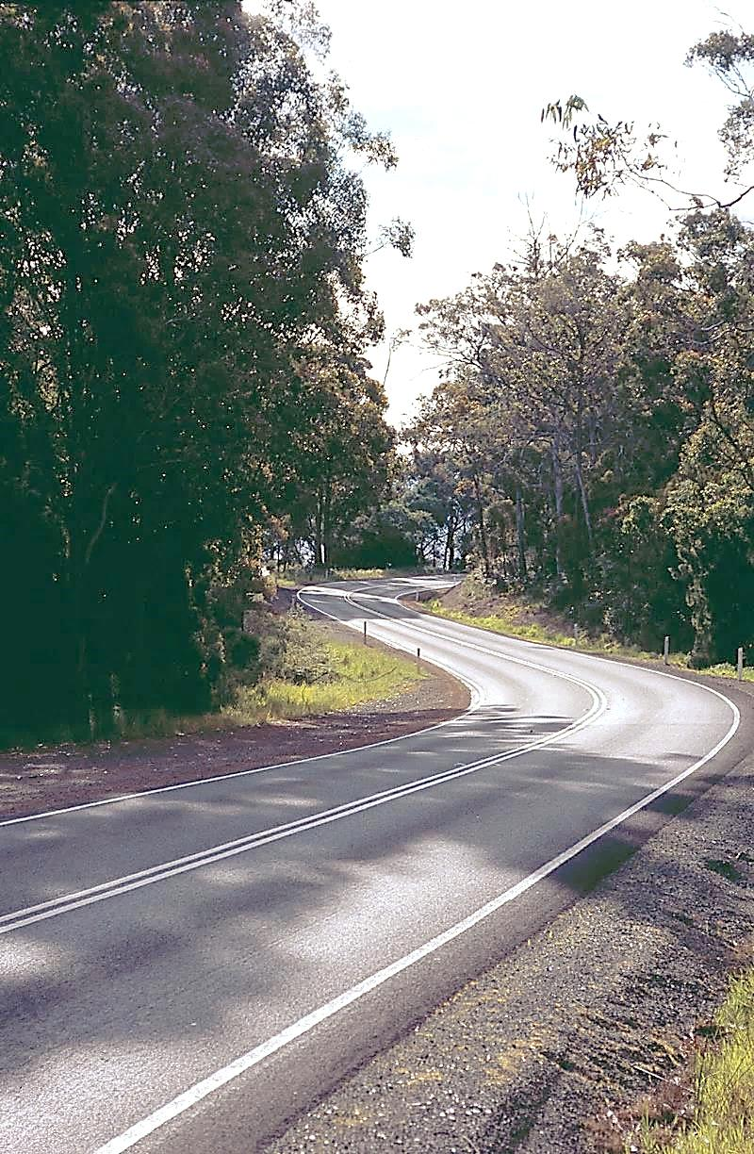

**TRANSPRTER**



Department of State Growth



**JANUARY 2015**



**HAPPY NEW YEAR!!**

Welcome to 2015! We hope you all had a very happy and rejuvenating holiday break and are fresh and ready for the year ahead.

**INCREASE TO STUDENT FARE**

From 5 January 2015 the cost of a standard child student bus fare increased from $1.30 to $1.40 for a single trip. The cost of a discounted student bus fare, available on the presentation of a student Greencard, increased from $1.00 to $1.10 for a single trip. Free student travel arrangements remain unchanged.

*Just a reminder that students are only entitled to the discounted fare or free travel upon the presentation of a valid student Greencard. Students that do not hold a valid Greencard can be required to pay the full standard student fare of $1.40. It is the responsibility of the contractor to ensure that all passengers are charged the appropriate fare where applicable.*

Top-up payments will be adjusted to reflect the new fare structure of $1.10, and in due course the $1.40, and paid in accordance with student fare policy and claim rates as outlined in the New Service Contract.

**STUDENT GREENCARDS**

Please note that student Greencards remain the property of the student and under no circumstances should they be retained by the contractor/driver. The student is required to tap the card each time they board a bus which is fitted with a reader. The student also needs to retain the card so they can use it to access discounted fares on any other contracted service.

**TASSIELINK NEW TICKETING SYSTEM**

Tassielink will be changing over to the INIT ticketing system, the same system used by Metro for the last few years. The INIT system allows Tassielink (and Metro) to use the full functionality of the Greencard, including the electronic purse and electronic coding of free student travel.

Other operators should note that the Greencards issued to students on Tassielink are no different to any other Greencard, and can therefore still be used for discount travel on other services.

**BUS ROUTES/TIMETABLES**

Please note the Department is now conducting regular reviews to ensure that all services are operating to the approved route and timetable.

The performance standards in the New Service Contract state that delivered journeys must follow the approved route at all times for the relevant service. Please take the time to review your contract and ensure that the maps and timetables for each service are current, as any service found to be operating contrary to the conditions of the contract will be determined to be non-compliant with the performance standards. This may result in a reduction in performance payments.

**CAPITAL RATES**

The Capital Payment rates have been calculated for the quarter commencing

January 2015. Please consider these rates before making changes to your contract.

For all fare-paying operators the rates applicable to your monthly contract payment can be found on your Statement of Payment.

|  |  |  |
| --- | --- | --- |
|  | OCT 2014 | JAN 2015 |
| Urban Fringe Student Only | **$1.49** | **$1.66** |
| Rural Fare Paying | **$1.49** | **$1.66** |
| Long Distance Student Only | **$1.49** | **$1.66** |
| Long Distance General Access | **$3.09** | **$3.17** |
| Urban Fringe General Access | **$3.09** | **$3.17** |
| Urban | **$0.95** | **$1.02** |
| Town | **$0.95** | **$1.02** |

**BUS COST MODEL INDEX (BCMI)**

The BCMI has been calculated for January 2015 and is 118.0

**CONTACT US**

Should you have a query for any member of the Contracts team, please don’t hesitate to contact us:

Martin Grace 6166 3332 [martin.grace@stategrowth.tas.gov.au](mailto:martin.grace@stategrowth.tas.gov.au)

Andrew Mullen 6166 3343 [andrew.mullen@stategrowth.tas.gov.au](mailto:andrew.mullen@stategrowth.tas.gov.au)

Kim Harris 6166 3340 [kim.harris@stategrowth.tas.gov.au](mailto:kim.harris@stategrowth.tas.gov.au)

Lauren Stewart 6166 3336 [lauren.stewart@stategrowth.tas.gov.au](mailto:lauren.stewart@stategrowth.tas.gov.au)

Andy Hall 6166 3342 [andrew.hall@stategrowth.tas.gov.au](mailto:andrew.hall@stategrowth.tas.gov.au)

Lisa Cairns 6166 3333 [lisa.cairns@stategrowth.tas.gov.au](mailto:lisa.cairns@stategrowth.tas.gov.au)

Geoff Reason 6166 3341 [geoffrey.reason@stategrowth.tas.gov.au](mailto:geoffrey.reason@stategrowth.tas.gov.au)