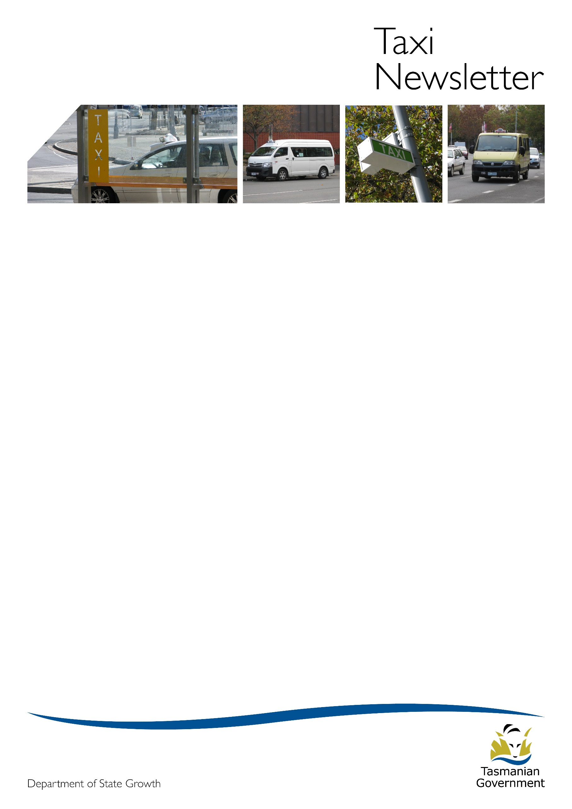Welcome to the October 2017 edition of the Taxi Newsletter.

New exemption for ride-sourcing drivers

The Transport Commission has approved a new exemption for ride-sourcing drivers, replacing the exemption which was due to expire on 31 December 2017.  The new notice is identical to the previous version, with the exception of minor amendments to the definition of ride-sourcing vehicle to reflect what is already occurring (i.e. that the vehicle must only be a light vehicle and must also be registered in Tasmania).  Practically, this new exemption has the effect of extending the current arrangements for ride-sourcing services for up to two years.  This timeframe will provide the taxi and hire vehicle industries with regulatory certainty while the Department continues to undertake the Review.  When legislation is enacted that provides for the formal legislative recognition of ride-sourcing services in Tasmania, the exemption will no longer be necessary.

Uber Advertising

The Department has recently received some complaints from taxi drivers about individuals in the Hobart CBD and elsewhere handing out advertising material for ride-source platform provider Uber.  The Department understands that these individuals are not themselves engaged in providing ride-sourcing services but have been employed to pass out pamphlets. The Department would like to re-emphasise that it is indeed unlawful for Uber drivers to use taxi ranks, accept jobs from passengers ‘hailing’ in the street, and to solicit for passenger trade on a public street (for example, by parking their vehicles and calling out to people). However, the distribution of pamphlets or other advertising material to the public does not constitute ‘touting’ or solicitation for the purposes of the relevant passenger transport legislation.

Taxi and Hire Vehicle Industries Regulatory Review – Market Research

As part of the ongoing consultation process informing the Taxi and Hire Vehicle Industries Regulatory Review, the Department has engaged a consultant to undertake research to better understand the views, expectations and choices of Tasmanians who use taxi and hire vehicle services. The market research will involve a series of focus group sessions and a state-wide telephone and online survey.  The aim of connecting directly with consumers via market research is to ensure that the Department has a balanced understanding of the issues on both the demand and supply sides of the industry when formulating potential regulatory reform options.

# Cruise ship season 2017/18

The Hobart cruise ship season will be between 10 October 2017 and 21 June 2018 with 60 cruise ships scheduled to dock at the Port of Hobart. The Transport Commission has approved and issued an authorisation for six parking spots in Hunter Street (adjacent to Victoria Dock) to be used by specifically authorised restricted hire vehicle (RHV) and luxury hire car (LHC) operators who have been issued with a permit from Destination Southern Tasmania to offer and accept walk-up bookings from cruise ship passengers on relevant days. No other operators are permitted to use this area. See Attachment 1 for a map of the approved parking spots. Standing for hire in any other place is not permitted unless the vehicle is a taxi and is standing on a taxi rank.

# National Police Certificate (NPC) for accreditation

**Why do I need to provide a current NPC?**

An accredited operator or nominated responsible person must be a *fit and proper* person. Any convictions for offences or crimes (in particular offences which are considered serious offences under the *Passenger Transport Services Act 2011* [the Act]) are considered when making a determination about whether a person is a *fit and proper* person. An NPC provides a record of all disclosable prior convictions and findings of guilt and is used, along with other information to make a determination about whether or not a person is a *fit and proper* person to hold accreditation or be nominated as a responsible person for the accreditation.

**What type of NPC is required for accreditation?**

The **only type of NPC** that is acceptable for accreditation is an NPC obtained through Tasmania Police *that is issued for the purpose of a Schedule 1 record*. There are different types of NPCs available. It is important that you supply the correct type of NPC or it may not be accepted and you will need to get the correct one.

**How do I get an NPC?**

You can get an application form for an NPC from a Service Tasmania shop, police station or download it from the Tasmania Police website at <http://www.police.tas.gov.au/services-online/police-history-record-checks/> The form is called a ‘Consent to Check and Release a National Police Certificate’. For accreditation, the purpose of the record check is *Option 1 – Employment/Privilege under Schedule 1 - Driver / Public Passenger Licence*.

**Does it cost to get an NPC?**

You will need to pay a fee for the NPC.

**Do I need an NPC because I am maintaining an existing accreditation?**

A standard condition of accreditation requires the holder of the accreditation or nominated responsible person to supply a current NPC to the Commission every three years. The date by which the NPC must be provided is printed on the accreditation certificate. If it is not supplied then a condition of the accreditation will be contravened and the accredited operator (or responsible person) is committing an offence.

**Where do I send the NPC?**

Have a copy of the NPC certified and send **the certified copy** of the certificate to the Commission by:

* posting to: Regulations and Concessions Unit, GPO Box 536, Hobart TAS 7001; or
* scanning and emailing to: operator.accreditation@stategrowth.tas.gov.au

**What certificates won’t be accepted?**

Only current NPCs will be accepted. NPCs older than 90 days, or National Police Checks or certificates obtained from an internet-based facility or website (other than downloaded from the Tasmania Police website above) are not satisfactory.

# Pre-departure inspections

The purpose of accreditation is to ensure passenger transport services are safe. As a taxi operator you are legally required to have systems in place for your service so that your vehicles, drivers and passengers are safe.

There are a range of tasks that a taxi operator must do so that their taxi service is safe which includes inspecting each of your taxis every day before they are used to provide a taxi service to ensure they are safe and free from defects and faults. This is the pre-departure inspection under the Accreditation Standards which are set out in the Passenger Transport Operator Accreditation Manual (Taxi Services) available on the internet at: <http://www.transport.tas.gov.au/passenger/operators>

The manual provides a minimum checklist that includes lights, wheels, tyres, brakes and taxi equipment. As the accredited operator or responsible person, it is your responsibility to ensure that the inspections are done correctly. Any faults identified must be reported and cleared and you must take appropriate action at the time which may include taking the taxi off the road if the fault could compromise safety.

State Growth’s Transport Inspectors carry out regular on-road checks of taxis and will issue a defect notice when a taxi does not conform to Vehicle Standards. A defect notice may be considered evidence that a pre-departure check was not conducted and may lead to your accreditation being reviewed. If an accredited operator is found to have contravened Standards or not complied with the Regulatory Framework then action may be taken against the accreditation which may result in the suspension or cancellation of the accreditation or the imposition of special conditions, restrictions or probationary status.

Tasmanian Taxi Council



If you wish to discuss the industry or the Council further please contact:

President Mr. Roger Burdon (South) 0418 125 768 or via email [roger.burdon@13cabs.com.au](mailto:roger.burdon@13cabs.com.au)

Secretary Mr. Tony Dilger (North) 0417 036 090 or via email [manager@taxicombined.com.au](mailto:manager@taxicombined.com.au)

# Regulations and Concessions Unit

For operator accreditation or taxi licence enquiries:

Email: [operator.accreditation@stategrowth.tas.gov.au](mailto:operator.accreditation@stategrowth.tas.gov.au)

Phone: 6166 3269

**Attachment 1**

Approved parking spots for operators who have been issued with a permit from Destination Southern Tasmania.

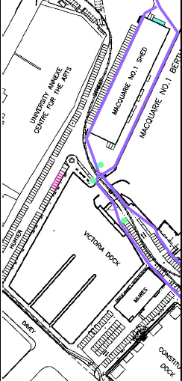

Independent tour operator parking spaces (6 spaces)