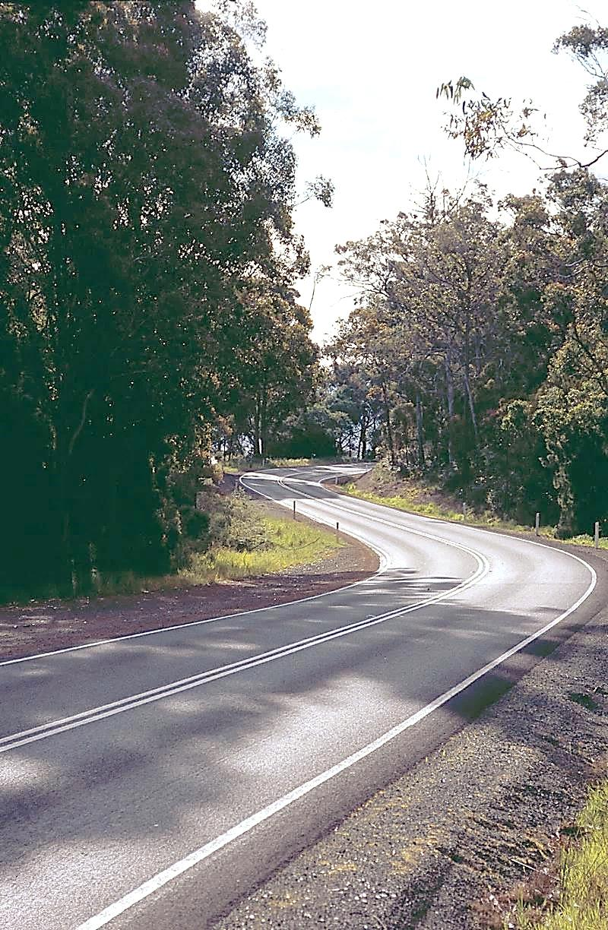

**TRANSPRTER**



Department of State Growth



**APRIL 2016**



**THE YEAR IS FLYING**

Autumn is here and first term of the school year is over. With three months gone, and now well into the fourth, there have been many exciting developments in the Passenger Transport area:

**PUBLIC BUS SERVICE RECONTRACTING PROJECT (PROJECT 2018)**

Existing contracts for public transport bus services begin to expire in February 2018, with the majority of Rural School Bus contracts expiring between February 2018 and July 2018 and the majority of other contract types expiring between October 2018 and April 2019.

A project (referred to as Project 2018) has commenced in the Department to review future public (including students) passenger network needs, and to deliver the Tasmanian Government’s commitment to provide a further 5 + 5 year contract for incumbent operators, providing key conditions are met and there is an ongoing need for a particular service in a particular area.

All operators can expect to be contacted over the next month by the Project 2018 team as they start gathering bus operators input into this process, and in particular your knowledge of the routes you currently service.

In the interim, more information on Project 2018, and the Tasmanian Government’s commitments around recontracting, are available on our website at [www.stategrowth.tas.gov.au/passenger/reviews/bus_service_recontracting_project](http://www.stategrowth.tas.gov.au/passenger/reviews/bus_service_recontracting_project) or by searching Google for ‘state growth bus recontracting’.

**RURAL BUS STOP PROGRAM**

As some of you may be aware, the Tasmanian Government has allocated $300,000 to construct up to 10 newer, safer bus stops in regional areas in order to reduce risks to students and other bus users. Application for funding contributions are currently being sought from local councils.

Please take the time to consider opportunities for improvements in your area and encourage your local council to provide a submission to the program. Priority will be given to submissions at bus stops that have strong patronage levels, especially student usage, and that demonstrate that the council has worked with operators to ensure that the most appropriate sites are identified. Funding will be limited to projects that will improve ground-level infrastructure such as hard stand and lay-by areas, road strengthening, road delineation and marking of bus stops.

The closing date for applications from local councils is 12:00pm on Tuesday 14 June 2016.

**FARE PAYING STUDENT CLAIMS**

All fare paying operators should now be offering the discounted student fare of $1.28 in the form of a 10 ride ticket. Any student who does not purchase a 10 ride ticket, or gets on the bus without handing over a ticket, should be charged the full student rate of $1.60.

Please do not forget to separate these two different fares on the top-up claim form, as they attract a different payment rate. The new top-up claim forms issued earlier this year include a column for the full student fare and a column for the discounted student fare. Please ensure you are using the new form when submitting claims.

Should you require a copy of the new form, in either hardcopy or digital format, please contact Lauren on 6166 3336.

**NOTIFICATION OF NON-COMPLIANCE**

Operators are reminded that clause 5.9(a) of the Contract sets out the obligations for notifying the Department of any non-compliance with a Performance Standard under the contract.

A Contractor is required to notify the Delegate no later than the next business day after becoming aware that a Performance Standard has not been met. This includes but is not limited to; a deviation from the approved route, not completing the full approved route, a delay to the beginning or end of the approved timetable, or a temporary vehicle change. The categories of non-compliance events are outlined in Schedule 3 of the Contract.

If the Department becomes aware that a Performance Standard has not been met, it could result in the issue of a minor, serious or major non-compliance notice.

**CAPITAL RATES**

The Capital Payment rates have been calculated for the quarter commencing April 2016. Please consider these rates before making changes to your contract.

For all fare-paying operators, the rates applicable to your monthly contract payment can be found on your Statement of Payment.

|  |  |  |
| --- | --- | --- |
|  | JAN 2016 | APR 2016 |
| Urban Fringe Student Only | **$1.70** | **$1.70** |
| Rural Fare Paying | **$1.70** | **$1.70** |
| Long Distance Student Only | **$1.70** | **$1.70** |
| Long Distance General Access | **$3.16** | **TBA** |
| Urban Fringe General Access | **$3.16** | **TBA** |
| Urban | **$0.92** | **$0.92** |
| Town | **$0.92** | **$0.92** |

**BUS COST MODEL INDEX (BCMI)**

The BCMI has been calculated for April 2016 and is 115.0

**WORKING WITH CHILDREN**

The Department of Justice has updated its website on the registration timeline for ancillary certificate holders. All ancillary certificate holders will require Registration to Work with Vulnerable People from 1 May 2016.

Further information about Working with Children is available from the Department of Justice website at [www.justice.tas.gov.au/working_with_children](http://www.justice.tas.gov.au/working_with_children) by phoning 1300 135 513 or via email at [workingwithchildren@justice.tas.gov.au](mailto:workingwithchildren@justice.tas.gov.au).

It is the responsibility of Contracted Bus Operators to ensure they have sufficient drivers with the required registration to operate all contracted services. If you believe that you will not have sufficient drivers who meet all of the requirements to deliver your contracted services on 1 May 2016, please contact Andrew Mullen on 6166 3343 as soon as possible.

**STAFF UPDATE**

Passenger Transport is extremely pleased to welcome a new member to the Contracts team. Leanne Dac recently joined us to take up the role of Contract Administration Officer.

**NEW FAX NUMBER**

Just a reminder that Passenger Transport has a new fax number (03) 6173 0260.

**CONTACT US**

Should you have a query for any member of the Contracts team, please don’t hesitate to get in touch with us:

|  |  |  |  |
| --- | --- | --- | --- |
| Babette Moate | Manager | 6166 3332 | [babette.moate@stategrowth.tas.gov.au](mailto:babette.moate@stategrowth.tas.gov.au) |
| Andrew Mullen | Manager Contracts | 6166 3343 | [andrew.mullen@stategrowth.tas.gov.au](mailto:andrew.mullen@stategrowth.tas.gov.au) |
| Craig Elliot | Principal Contracts Officer | 6166 3334 | [craig.elliot@stategrowth.tas.gov.au](mailto:craig.elliot@stategrowth.tas.gov.au) |
| Kim Harris | Senior Contracts Admin | 6166 3340 | [kim.harris@stategrowth.tas.gov.au](mailto:kim.harris@stategrowth.tas.gov.au) |
| Lauren Stewart | Payments | 6166 3336 | [lauren.stewart@stategrowth.tas.gov.au](mailto:lauren.stewart@stategrowth.tas.gov.au) |
| Leanne Dac | Contracts Admin | 6166 3334 | [leanne.dac@stategrowth.tas.gov.au](mailto:leanne.dac@stategrowth.tas.gov.au) |
| Andy Hall | Contracts Admin | 6166 3342 | [andrew.hall@stategrowth.tas.gov.au](mailto:andrew.hall@stategrowth.tas.gov.au) |
| Geoff Reason | Contracts Admin | 6166 3341 | [geoffrey.reason@stategrowth.tas.gov.au](mailto:geoffrey.reason@stategrowth.tas.gov.au) |
| Lisa Cairns | Bus Passes | 6166 3333 | [lisa.cairns@stategrowth.tas.gov.au](mailto:lisa.cairns@stategrowth.tas.gov.au) |
| Trish Reardon | Black Box | 6166 3347 | [trisha.reardon@stategrowth.tas.gov.au](mailto:trisha.reardon@stategrowth.tas.gov.au) |