Transporter

April 2017

Happy Easter
Daylight saving is over, the end of Term 1 is upon us and the Easter Bunny approaches with lots of chocolate. The days are getting shorter and trees are putting on a wonderful display of colour before dropping their leaves. The rest of 2017 is shaping up to be a very busy time here in the Passenger Transport Branch.

Upcoming request for tender for a bus contract
The Department of State Growth will soon be releasing a Request for Tender for the provision of a regular passenger transport service.
The Department seeks to engage with a service provider for the provision of a fare charging Urban Fringe Student Only school bus service between Gagebrook and Brighton Primary School (via Herdsmans Cove, Old Beach and Honeywood) for the period commencing Term 3, 2017 to the end of the 2018 school year.
In the interests of parity and fairness to all industry participants, and in keeping with the Government’s Procurement Principles, the Department will conduct an open tender process to achieve value for money, open and effective competition, compliance with ethical standards, and to enhance opportunities for local business.
The request for tender release date is anticipated to be during April 2017. It will be advertised via the Tasmanian Government Tenders website (https://www.tenders.tas.gov.au).
If you’re interested in tendering for the provision of this service, please register at the Tasmanian Government Tenders website or keep watch of the Open for Bids sections of the website.
We understand that you may want more information, however we ask that you please hold your questions until after the Request for Tender is released as many of your questions may be answered in the tender documents. We are not able to provide any further information about the tender until the release date.
Please direct any questions in relation to the tender to the Contact Officer, Kim Harris kim.harris@stategrowth.tas.gov.au or (03) 6166 3340. The Contact Officer is the only person who can answer your questions about this tender request.

Working with vulnerable people registration – A message from Registration & Licencing Services
It should be noted that to ensure all holders of Public Passenger Vehicle (PPV) Ancillary Certificates have the appropriate Working with Vulnerable People (WWVP) registration, the Registrar of Motor Vehicles (RMV) will now conduct a WWVP status check as part of the PPV Ancillary Certificate renewal process.
Further, as the requirement for all PPV Ancillary Certificate holders to obtain WWVP registration has now been in place for over 12 months, where the RMV identifies that a PPV Ancillary Certificate holder does not have the appropriate WWVP registration, this may have consequences for their PPV Ancillary Certificate such as suspension or even cancellation.
This is a timely reminder, that all drivers employed by bus operators must have the appropriate Working with Vulnerable People Registration. Operators can check the status of their drivers WWVP registration using the Department of Justice website at: https://wwcforms.justice.tas.gov.au/RegistrationSearch.aspx

Term dates and student free days
To assist you to plan ahead, below is a calendar showing all government school term dates and student free days (note that it does not show private and catholic school student free days). Please remember to seek advice and approval from Passenger Transport Branch prior to any alterations to routes or timetables.
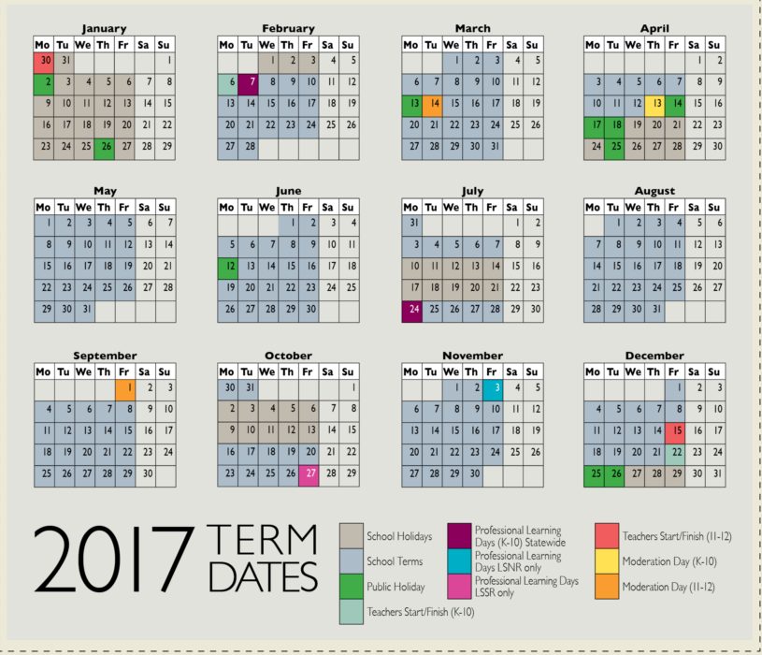
Further information can be found at:
https://www.education.tas.gov.au/documentcentre/Documents/Infosheet-SchoolCommunity-Term-Dates.pdf
For non-Government schools on your route, please contact schools to confirm dates.

Roadworks
Did you know that information about upcoming major roadworks, road closures and disruptions can be found on the Transport website? This information can be found at:
http://www.transport.tas.gov.au/road/closures_delays
http://www.transport.tas.gov.au/road/projects
This can assist with forward planning route and timetable alterations as a result of road work activity. As always, where possible, don’t forget to seek advice and approval prior to any route alterations and timetable changes, and provide notice as soon as possible after delays as a result of road work activity by emailing ptscontracts@stategrowth.tas.gov.au or calling 61663343.

Targa Tasmania
Targa Tasmania is on again around our beautiful state from Monday 24 April to Saturday 29 April. While this is during the school holidays, General Access services may be impacted by local road closures.
A Downloadable version of the full Targa Tasmania road closure list can be found at:
https://targa.com.au/tc/page_full.asp?asset_id=24144
Don’t forget to let us know if any of your services will be affected or routes altered as a result of Targa Tasmania road closures by emailing ptscontracts@stategrowth.tas.gov.au or by calling 6166 3343.

Insurance audit
We realise that it has been some time since the Passenger Transport Branch has reviewed insurances held by bus operators. Therefore we will soon be reviewing our files to ensure we have current information on your insurance policies which are required as part of your contract. As a result, we may write to you requesting that you provide your current insurance information so that we may update our records.

Student free travel
The peak processing period for student bus pass for free travel applications has now ended with all passes being issued within our estimated timeframe. This means that all students that have applied for their free travel and have been approved should have received their new cards unless they have only applied within the last 10-14 days due to postal timeframes.
Students must carry their free travel student bus pass at all times and present it to the driver each time they board a bus to travel for free. It is the student’s responsibility to keep and present their student bus pass for free travel. Bus passes should never be looked after by the bus driver. A fare should be charged if a current bus pass is not presented.
To assist drivers to identify valid free travel cards for 2017, a chart of currently accepted bus passes is available at http://www.transport.tas.gov.au/__data/assets/pdf_file/0017/141560/Accepted_bus_passes_for_student_travel_in_2017.pdf

Staff update
Leanne Dac is leaving us this week to embark on a big adventure in a new position. We wish her all the best in her new role.
Bus cost model index (BCMI) and capital rates
The BCMI has been calculated for April 2017 and is 121.8
Capital rates remain the same for the April quarter.
Contract Type |  | January 2017 | April 2017
Urban Fringe Student Only |  | $1.62 | $1.62
Rural Fare Paying |  | $1.62 | $1.62
Long Distance Student Only |  | $1.62 | $1.62
Long Distance General Access |  | $2.90 | $2.90
Urban Fringe General Access |  | $2.90 | $2.90
Urban |  | $1.01 | $1.01
Town |  | $1.01 | $1.01

Contacting State Growth
For all enquiries or notifications regarding a current contract (a service you currently provide) such as routes, timetables, payments, contact Passenger Transport Branch via email ptscontracts@stategrowth.tas.gov.au or phone 6166 3343.
For enquires about bus passes and free travel, contact us at bus.passes@stategrowth.tas.gov.au or phone 6166 3333.
Please remember to quote the contract number when contacting us.

Project 2018 update

Rural School Bus Services
Although we understand that all operators are keen to gain certainty over whether they will receive future contract offers and the terms of any such offer, the Project 2018 team also needs to ensure that schools have the opportunity to input into and understand any possible changes.
As indicated at the operator forums held late last year, our plan was to commence discussions on rural school bus services with school principals in semester one this year.
The approach we are taking is to first share the information provided to operators with school principals, in a confidential context, and then work with the school principals to decide the best way to approach communicating this information with affected parents and the wider school community.
With around 115 rural schools in Tasmania (including catholic and independent schools) this was always going to be a large process, however we are pleased to report that discussions to date have occurred with around 20 school principals, and we expect the wider school consultations to roll out in the second semester of this school year.
The Project 2018 team is prioritising discussions with schools where there is the greatest likelihood of some change to bus services so that these schools have the most time to consider these changes and engage with affected parents should the changes come to pass.
Information provided to operators remains confidential until the wider school consultation commences.

Urban Fringe, Urban and Town Services Review
A lot of effort in the last few months has been spent reviewing the information provided by operators on fare paying services (that is the urban fringe, urban and town services) in preparation for sending out initial advice to operators 18 months prior to these contracts expiring.
This initial review has now been completed and we are expecting that those operators who have signed their Negotiation Deed will be receiving their initial advice just after Easter. This will mean that all operators that have signed Negotiation Deeds will have received early advice on their contracts.
For those interested, there are 124 contracts (providing 149 services) for Urban Student Only (USO) and Urban Fringe Student Only (UFSO) services in Tasmania. Based on survey responses received, these services are carrying at least 8 000 students each day. There are also 19 Town-Based Student Only (TBSO) services in Tasmania carrying at least 800 students each day.
Indicatively, 41 per cent of these services have been identified as being likely to be re-contracted based on the information provided to date, 42 per cent require further review (many due to unreturned or incomplete surveys), and 17 per cent have been identified as being subject to possible service redesign. This breakdown is very similar to rural school buses where 44 per cent of operators were advised they were likely to be re-contracted with the other 56 per cent advised that their contracts were subject to review or possible service redesign.
The project team is planning a series of forums in Hobart, Launceston and the north-west in May, similar to those held for the Rural School Bus services, where operators will have the opportunity to discuss progress with contracts with the team. More information will be released to operators when dates and venues are confirmed.
Operators who want to check if they’ve signed their Negotiation Deed should contact Andrew Mullen on 03 6166 4470.

General Access Services
The Minister for Infrastructure and the Project Director spent much of January talking to Mayors and General Managers about Project 2018 and the process for engaging the local community in the discussion on possible future changes to the general access network.
This process proved invaluable in understanding the local issues and needs around bus services, with four Mayors already having organised follow up briefings with the wider councils and several other Councils having identified key stakeholder groups, or public forums, for the Project 2018 team to attend over the coming months.
As each of these meetings are influencing the possible future network, the Minister has asked the Project team to extend the consultation with these groups for a few more months so that he can again consider the possible future network around the middle of this year.
This also ties the development of the regional bus network more closely with the community consultation going on in Burnie and Devonport over the urban bus networks, with the initial reports on these networks expected around the middle of this year.

Sale of Contracts
The restrictions on discussing the advice provided by the Department in the context of novating contracts has been raised as an issue by TasBus on behalf of its members.
The Department has developed a process to enable conversations around novation as follows.
- The current contract holder needs to write to the Department, providing advice of their intention to novate the contract and requesting that the Department provide any confidential information relating to the contract that may have been provided to them. The current contract holder will need to provide the other parties name and contact details in the letter.
- The Department will then contact the potential purchaser, in writing, outlining requirements such as accreditation which must be in place before a contract can be novated. We will also provide a non-disclosure document which the potential purchaser will need to sign and return before the confidential information is released.
- Upon receipt of the signed non-disclosure document, the Department will provide the potential purchaser with the confidential information provided to the operator as per the current contract holder’s signed negotiation deed. This information, which may include the Department’s intention or otherwise to recontract, will be also be copied to the current contract holder.
- If, at this point, the potential purchaser decides not to continue with the purchase, they will still be bound by the non-disclosure document until after the new contracts have been awarded or the information provided has been made public (whichever comes first).
- If they decide to continue with purchasing the contract, then a standard novation process will follow. This process involves the potential purchaser meeting all due diligence requirements including accreditation, insurances, and bankruptcy checks, etc.
This information is also online at http://www.transport.tas.gov.au/project2018/operator_information

