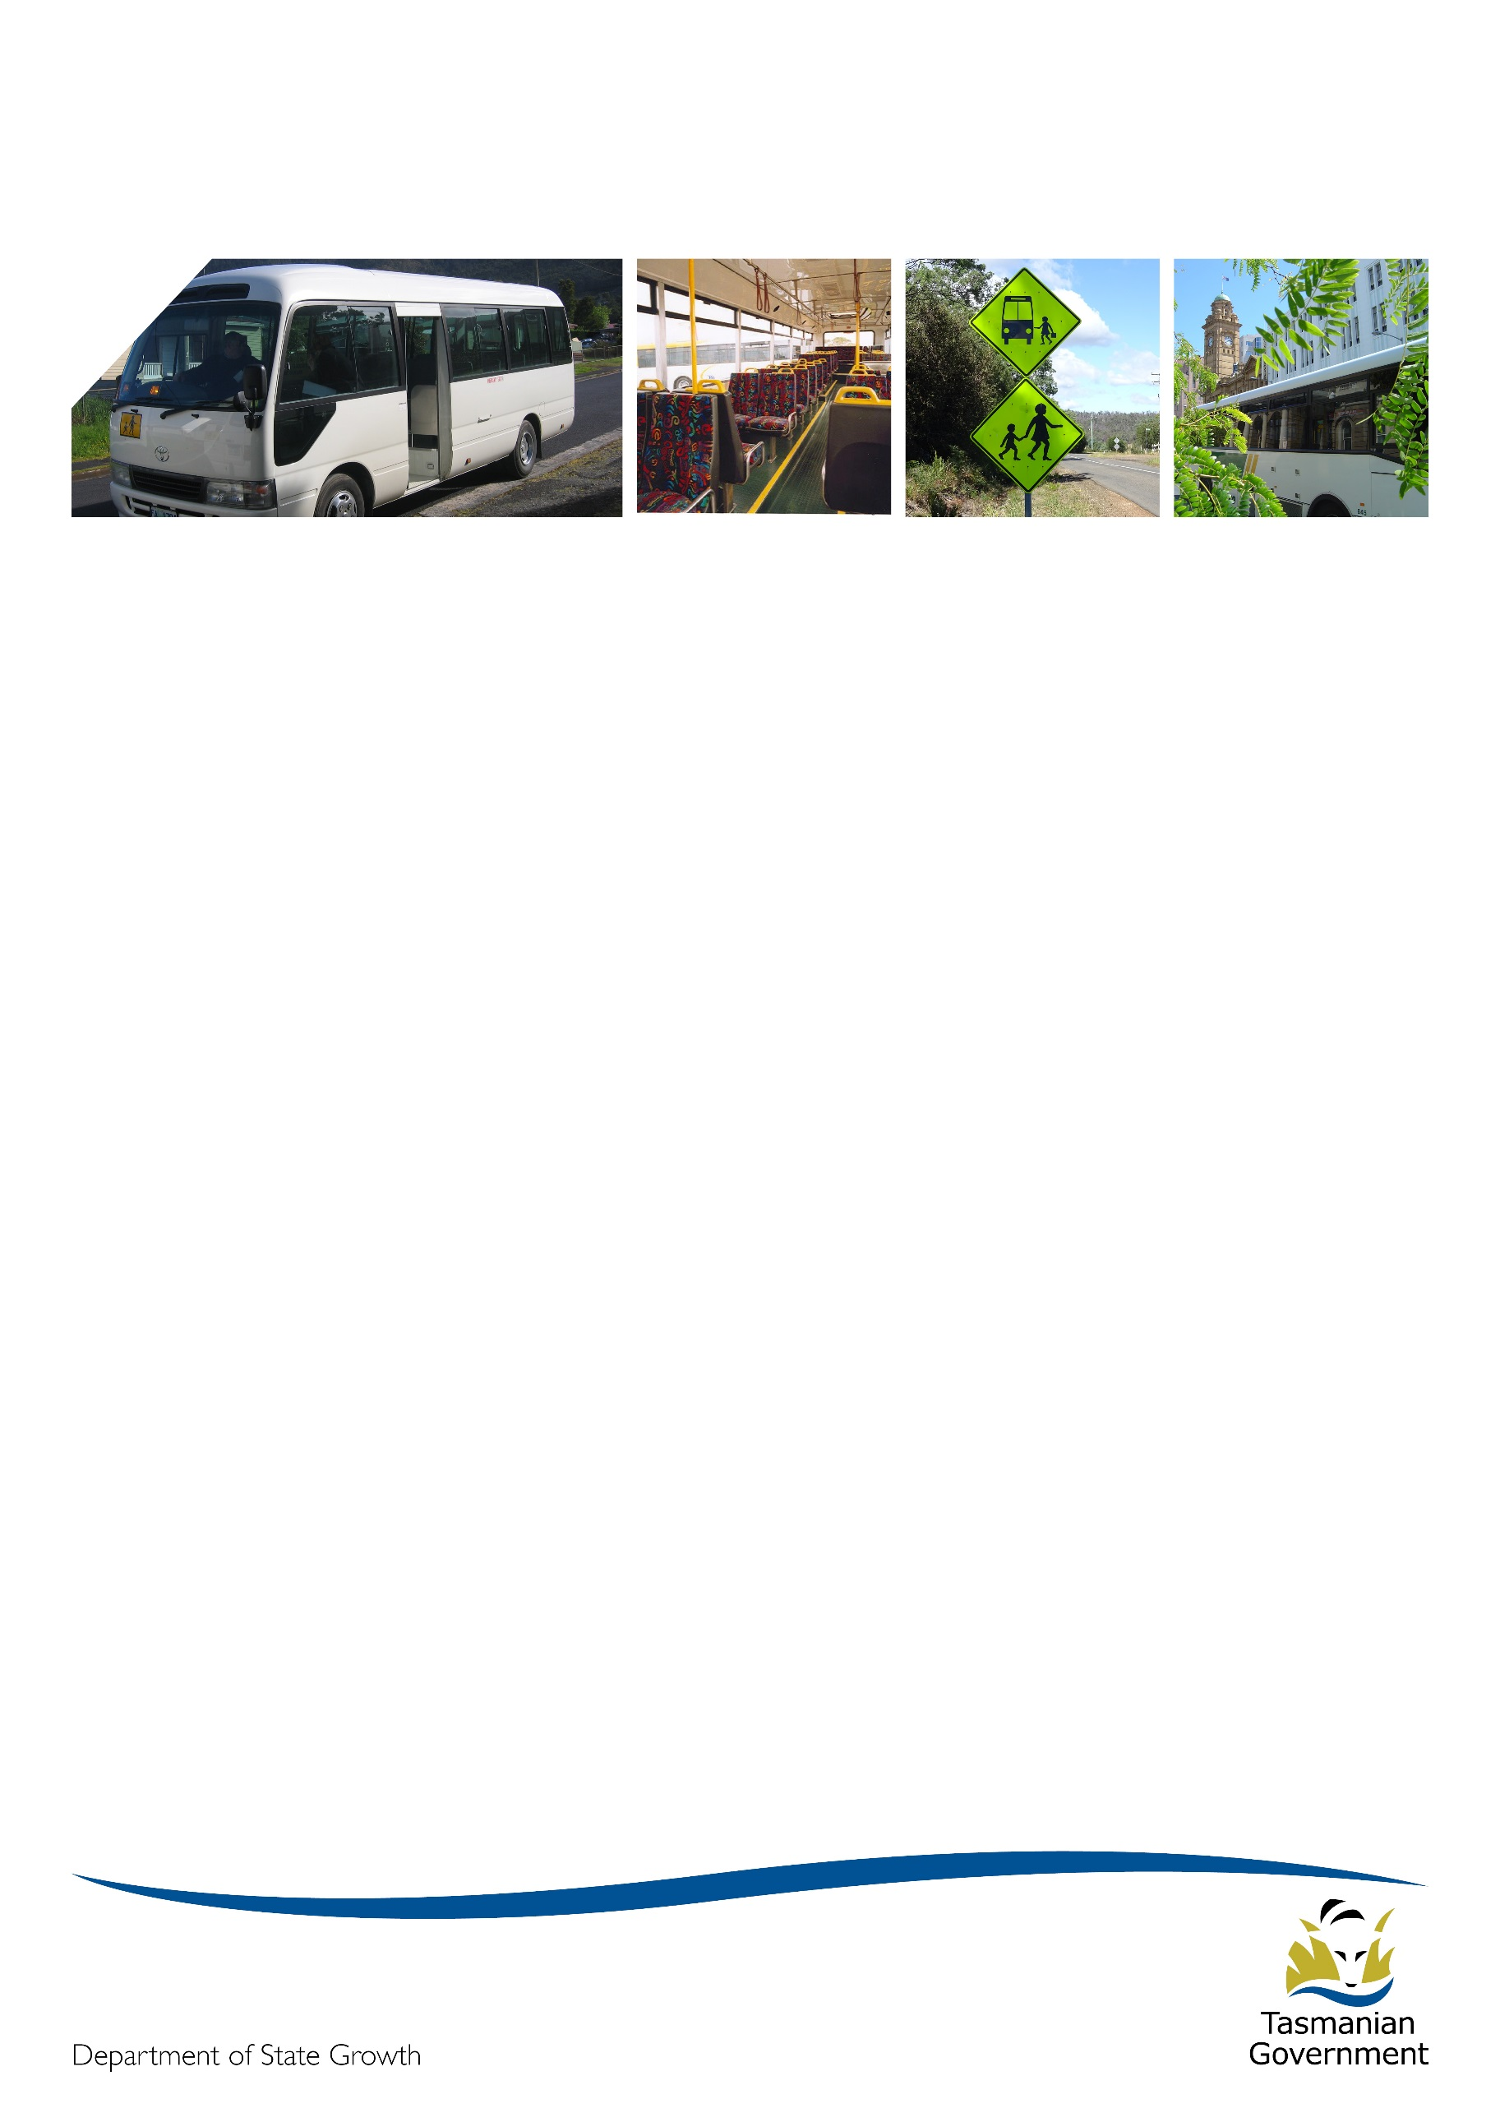
Transporter

July 2017

Winter warmers
Winter has well and truly made its impact this year with some very bracing conditions during June. Along with more challenging weather, the second half of the year will bring significant workloads to the Passenger Transport Branch. We look forward to working closely with you in achieving some major goals and seeing some major projects reach the first stages of implementation. Keep warm and keep well!

Upcoming request for tender for a bus contract
In February 2017, Minister Hidding announced that a new bus service would be established for the Kentish region. In line with this announcement, the Department of State Growth will soon be releasing a Request for Tender for the provision of a regular passenger transport service between Sheffield and Devonport (via Railton and Latrobe).
It is anticipated that the contract will be awarded in September 2017 with the new service to commence as soon as practicable after this date. The initial contract term will run from commencement until the end of 2018, however there will be one year extension option which will be entirely at State Growth’s discretion as to whether this option is exercised.
In the interests of parity and fairness to all industry participants, and in keeping with the Government’s Procurement Principles, State Growth will conduct an open tender process to achieve value for money, open and effective competition, compliance with ethical standards, and to enhance opportunities for local business.
The request for tender release date is anticipated to be during July 2017.
If you’re interested in tendering for the provision of this service, please register at the Tasmanian Government Tenders website https://www.tenders.tas.gov.au.
Information on preparing a Tender is available on the Tasmanian Government’s Purchasing website at www.purchasing.tas.gov.au under Winning Government Business.
We understand that you may want more information, however we ask that you please hold your questions until after the Request for Tender is released as many of your questions may be answered in the tender documents. We are not able to provide any further information about the tender until the release date.

Please direct any questions in relation to the tender to the Contact Officer, Kim Harris kim.harris@stategrowth.tas.gov.au or (03) 6166 3340. The Contact Officer is the only person who can answer your questions about this tender request.

Who to contact and when
When you need to contact the Department regarding a contract matter, the following will hopefully clarify who you should contact in what circumstance:
Queries relating to your CURRENT contract including:
- Replacement vehicle requests
- Map and timetable variation requests
- Route deviations
- Temporary vehicle changes
- Payment enquiries
Contact the Passenger Transport Contracts team via email ptscontracts@stategrowth.tas.gov.au or phone 6166 3343.

Queries relating to POST-2017 contract arrangements:
Any query or issue relating to bus contracting in 2018 onwards should be directed to the Project 2018 team by contacting John Dawson via email john.dawson@stategrowth.tas.gov.au or phone 6166 3488.

Bus stops on General Access contracts
By 2020, all General Access service bus stops must comply with the requirements and associated standards of the Disability Discrimination Act 1992 (Cwlth). Existing bus stops can be progressively upgraded to meet compliance requirements, however any new bus stops must be confirmed as meeting the requirements before they can be used. For this reason new bus stops will not be approved on any General Access service until they can be confirmed as meeting the requirements.
In light of this, please ensure that your service/s use only approved bus stops in accordance with your contracted timetable.

Requesting bus changes
If you wish to replace a bus on your contract, you are required to contact the Department prior to making any changes on your service to determine the specifications ie size/seating capacity as stipulated in clause 10.2 (c) and (d) of the contract.
Once a request is received and approved the paperwork will be issued to you, however please be aware your contract will not be updated until you have signed and returned the documents to the Department.

Payment adjustments
During the period February to May 2017, there was an error in the calculation of the Bus Cost Model Index (BCMI). This has resulted in an overpayment of approximately 1% of the contract payment value across the 4 months.
You will have now received a letter informing you of the overpayment and the subsequent adjustment that will occur in your July 2017 payment. Further to the initial advice you will be issued a detailed breakdown of the overpayment, including the monthly effect on each contract payment, with your July 2017 remittance advice.

Staff update
Nicole Trounce has been extended for a further 12 months in the role of Contracts Manager. Stephanie Katz will depart the team on 17 July for a new position within the Branch. Elizabeth Stacey joined us in June and is a welcome addition in the role of Contracts Administration Officer previously held by Leanne Dac.
Bus cost model index (BCMI) and capital rates
The BCMI has been calculated for July 2017 and is 121.4
The rates applicable to all fare-paying monthly contract payments can be found on the Statement of Payment.
Contract Type | April 2017 | July 2017
Urban Fringe Student Only | $1.62 | $1.23
Rural Fare Paying | $1.62 | $1.23
Long Distance Student Only | $1.62 | $1.23
Long Distance General Access | $2.90 | TBA
Urban Fringe General Access | $2.90 | TBA
Urban | $1.01 | $0.77
Town | $1.01 | $0.77

The rates for July 2017 will be applied commencing 21 August 2017. Until then, the April 2017 rates will be applied.

Project 2018 update
Two major announcements affecting Project 2018 were made by Minister Hidding at the TasBus Conference in June. You should have received information on these from the Project Director in June (if not please let us know). A quick update is below.
If you have any questions on any of the Project 2018 matters below, please either contact the nominated contact person, or contact John Dawson on 03 6166 3488 or john.dawson@stategrowth.tas.gov.au.

Offer of Short Term Interim Contracts
The first of these announcements was that operators with school bus contracts that expire before the end of the 2018 school year will have new ‘interim’ contracts offered to them that will allow those services to operate until the end of the school year (except in the case where the operator has 10 or more demerit points awarded against that contract). The 5 + 5 year contract will then start from the beginning of the 2019 school year.
This commitment applies to just over 75% of our school bus contracts (318 contracts) and is a very significant commitment from the Government.
We have provided a copy of the proposed interim contract to TasBus for comment. It is hoped that these contracts will start going out to operators next month (August).
It is important to understand that these interim contracts are new contracts, not an extension of existing contracts. However, the new contract has been drafted to minimise disruption to the operation and management of services and contracts. It is expected that there will be no changes to banking details, payments (other than normal contract indexing), routes or timetables between the two contracts as the new contract just continues what is in place on the last day of the existing contract.
One significant point of note is that if you have multiple contracts that expire before the end of the 2018 school year, you will be offered a single interim contract that will cover all of these contracts as they each expire.
As they are new contracts, demerit points will also be reset to zero on the start date of the new contract.
Early Rationalisation of Services Incentive Scheme
The other major announcement by the Minister was that the Government is now offering a scheme where contracted school bus operators can bring proposals to us to rationalise services. If these proposals:
- allow the removal of at least one bus;
- allow for the majority of students serviced by the current routes to still get to their schools within a reasonable timeframe and along a reasonable route; and
- are aligned with the objectives of Project 2018 and the relevant service eligibility guidelines;
then the Department will assist this transition with a payment of six months of the exited contract value and, where required, will modify any other identified service needed to cover the route.
This incentive scheme is only available this year and the change must be in place at the beginning of 2018 school year.
Andrew and Tom in the Project 2018 team have been busy reviewing services to identify those that we believe may be eligible for this scheme. They have identified around 30 services where we believe there is a potential opportunity for an operator to meet the criteria above.
We have so far written to a dozen operators about this opportunity, and we will be contacting the remaining operators where this opportunity has been identified by the end of July. You do not however need to wait for us to contact you if you are interested in this scheme. You can call Andrew Mullen on 6166 4470 to discuss this scheme, without committing yourself to an early exit, at any time.
We ask that operators interested in this scheme let Andrew know by the end of this month (July) to allow us time to discuss the proposal and determine if the change is viable, however we understand that some operators are away over school holidays, so the end of July is not a hard deadline. Any final decision on an early exit needs to be made no later than October 20, 2017 (the second week of term 4) to allow us sufficient time to notify parents and students before the end of the school year about any changes in services.
An important reminder for those operators who haven’t signed a Negotiation Deed: As you have not signed a deed, we are restricted in our ability to notify you under the deed of the potential for any early exits and hence the responsibility is on you to contact us about your interest in the scheme.

Update on School Bus Service Reviews.
The Project 2018 team held three workshops for fare paying operators around the State in May to discuss any issues of concern. As indicated at these workshops, the team will be focussing on rural school bus services over the next six months, and will return to fare paying service reviews early next year.
On the rural school front, the team has now met with 93 out of 119 rural school principals with the bulk of outstanding schools being in the Ulverstone – Wynyard – Penguin area where meetings are scheduled for early next term. These meetings have allowed us to firm up our advice on 179 of the 282 rural school and rural fare paying bus services. The remaining 103 contracts are either those services where we still need to talk to schools or which, after talking with the operators and the schools, still need further review.
We are now focussing our efforts on reviewing the contracts held by operators who have a contract that expires in February 2018 so that we can provide advice and contracts for these operators as soon as the contracts and funding model are finalised.
Update on Contracts and Funding Model
We have provided a draft of the proposed contract to TasBus, however two important attachments: the performance standards and funding model are still being drafted. It is expected to take the TasBus team a while to review and provide comment on the contract, and these attachments when they are provided.
Discussions also continue on the funding model, but there is little that can be reported at this point.

Matching Process Notifications
One of the requirements of the Project 2018 Re-contracting Process is that there will be a 30 day appeal period after any matching decision (regardless of whether it is a direct match or a closed or open tender) for other operators to appeal the matching decision.
To facilitate this, the following process has been proposed.
- If an existing service is expected to be merged with the loss of a bus or a service, then the Project 2018 team will make operators aware of the option of an early exit under the rationalisation incentive scheme (if the change meets the guidelines) as outlined in a previous section.
- In other cases where a trip may be removed or a service significantly changed, the Project 2018 team will discuss these changes with the affected operators before a final decision is made. These decisions will not come into effect until the 2019 school year.
- Once a decision is made, ‘matched’ operator(s) will be notified of the matching decision. This notification will be subject to the 30 day appeal period.
- Each week, all matching decisions made that week will be published on the Project 2018 webpages (http://www.transport.tas.gov.au/project2018) showing the route, service type (school or general access), the operator(s) that have been matched to that service and the close date of the appeal period for that service.
- An opt-in email service will also exist to notify operators of updates to this page, but the onus rests on operators to regularly review this page for notifications.
- If any operator believes they should have been matched to a route under the guidelines, they will be able to use the process outlined on the webpage to lodge an appeal within the 30 day period.
- The Chair of the Project 2018 Oversight Committee will nominate a Review Panel which will not include any members of the Project 2018 team or anyone involved in the original decision making process. Any appeals will be received by this panel, who will notify the ‘matched’ operator(s) and then undertake a review of the decision as per the guidelines.
- All parties involved will be notified of the decision of the review panel.
- Once resolved, direct contract offers or closed tenders will then be held as appropriate.
An independent probity advisor, Harvey Gibson from WLF, has been engaged to advise and monitor the Project 2018 procurement process.
Feedback or questions on this process are welcomed.

Update on General Access Services
A series of workshops have now been held in Burnie and Devonport to seek public input into the future public transport needs for these cities. The consultants doing this work (Philip Boyle and Associates) have one more round of consultations with the bus operators on the proposed draft network before providing their final report and recommendations to the project team. This is likely to be received in the next month or two.
Outside of this, the team has continued to discuss the possible new network with key interest groups and community groups. With the assistance of bus operators, we have just undertaken bus user surveys on several key services so we can better understand the current users of the network. These responses are currently being reviewed and will help inform future consultations and decisions.
This consultation, as well as ongoing timetable discussions, will continue.

Contacting State Growth
For all enquiries or notifications relating to your current contract (ie a service you currently provide) contact Passenger Transport Branch via email ptscontracts@stategrowth.tas.gov.au or phone 6166 3343.

