Department of State Growth
Road User Services Division
Form Number: MR106 06/16
Heavy Vehicle Classification Report
PLACE (X) IN BOX APPROPRIATE TO CONFIGURATION OF VEHICLE
REGISTRATION NUMBER
RIGID TRUCK not nominated to tow a heavy trailer |  |  |  |  |  | PRIME MOVER FOR SINGLE SEMI-TRAILER
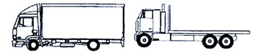

No of Axles | GVM |  | Fee Code |  |  | No of Axles on  P-Mover |  | Fee Code
2 | 12t or less |  | 1R2 |  |  | 2 |  | SP2
2 | More than 12t |  | 2R2 |  |  | 3 |  | SP3
3 | 16.5t or less |  | 1R3 |  |  | 4 |  | SP4
3 | More than 16.5t |  | 2R3
4 | 20t or less |  | 1R4
4 | More than 20t |  | 2R4
5 | 20t or less |  | 1R5
5 | More than 20t |  | 2R5
SHORT COMBINATION TRUCK |  |  |  |  |  | PRIME MOVER FOR B-DOUBLE
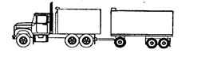 |  |  |  |  |  | 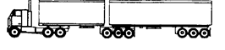
Nominated to tow a heavy trailer where the combination has no more than 6 axles in total operating up to 42.5 tonnes
No. of Axles on Truck |  | Fee Code |  |  |  | No of Axles on  P-Mover |  | Fee Code
2 |  | SR2 |  |  |  | 2 |  | MC2 (MP2)
3 |  | SR3 |  |  |  | 3 |  | MC3 (MP3)
4 |  | SR4 |  |  |  | 4 |  | MC4 (MP4)
MEDIUM COMBINATION TRUCK |  |  |  |  |  | BUS
 |  |  |  |  |  | 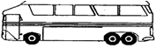
Nominated to tow a heavy trailer where the combination has more than 6 axles in total or operating at over 42.5 tonnes
No of Axles on Truck |  | Fee Code |  |  |  | No of Axles | GVM |  | Fee Code
2 |  | MR2 |  |  |  | 2 | 12t or less |  |  | 1B2
3 |  | MR3 |  |  |  | 2 | More than 12t |  |  | 2B2
4 |  | MR4 |  |  |  | 3 | More than 4.5t |  |  | 2B3
5 |  | MR5 |  |  |  | 3 | Articulated Bus |  |  | AB3
 |  |  |  |  |  | 4 Articulated Bus |  |  | AB4
I, ............................................................................................... THE REGISTERED OPERATOR/(S) AGENT, STATE
THAT –This vehicle is/is not nominated to tow a heavy trailer. The charging category for this vehicle is correct.
I also declare the vehicle above is appropriately certified to operate in the identified configuration.
Manufacture or Modification Plate number must be provided where indicated on matrix. It is the registered operators responsibility to provide correct details and ensure appropriate manufacturers ratings on all equipment.
Modification Plate Number(s):
(See page 2 of this form for requirements)

…………………………………………………………………………………………………………………………..
SIGNATURE OF REGISTERED OPERATOR/(S) WITNESS TO SIGN DATE

Page 1 of 2

J & P Modification - Requirement Guide
Use this chart to determine if alteration to vehicle configuration requires certification.

Applies to all changes to body types/towing couplings on Heavy Vehicles
from 01 July 2015, if not already certified.

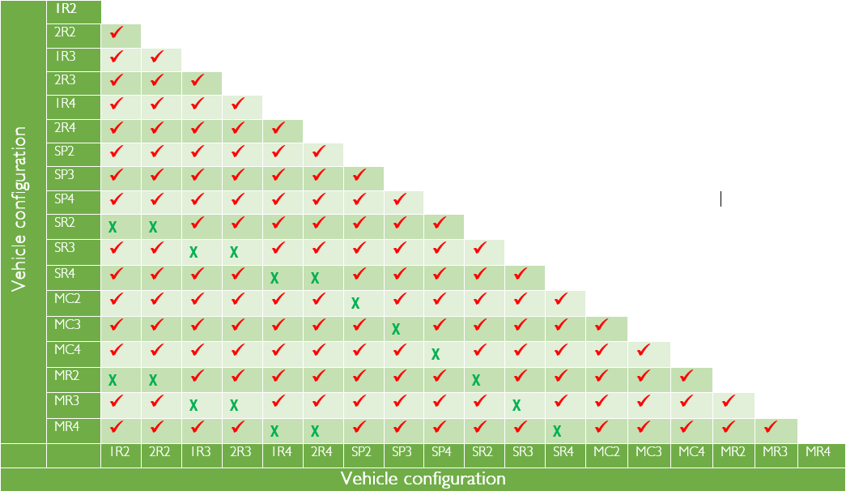

Key | Action Required
ᵡ | Vehicle classification or upgrade does not require certification. No modification or certification is required to issue the permit or process a vehicle configuration change.
 | Vehicle classification or upgrade requires a modification or manufacturers plate to be affixed to the vehicle identifying the type of modification and when it occurred. Customer will need to supply a valid modification or manufactures plate number or undertake an inspection. See Approved Inspection Stations – Heavy Vehicle for inspection locations.

