National Written-Off Vehicle Notification MR11 03 18

LOGO

This form must be completed and sent to the jurisdiction where the vehicle is, or was, last registered before disposing of the vehicle. It applies to all light motor vehicles, caravans, trailers and motorcycles. For reporting other classes of vehicle you should check with the registration authority.

* Mandatory information where applicable.
^ Mandatory for NSW, NT and QLD vehicles. Contact the registration authority if you do not have a client/customer number.
Vehicle

Make* Vehicle type* (please tick)

Model* Motor vehicle Caravan Trailer Motorcycle

Registration no. State or Territory Engine no. VIN* (17 characters)
Approval no.(SA) Label no.(TAS)
Notifier

Surname*/company name* Licence No. Given name(s)*/ABN* Mobile No.*
Address* Postcode

Type of notifier (please tick) Insurer Auction house Dealer Auto dismantler Assessor Owner Other

Client/customer no.^ Insurance claim no.
Incident details

Incident date Date write-off decision made* Notifier’s reference no.

Odometer reading Write-off type* (please tick) Repairable write-off Statutory write-off
Statutory declaration

I declare that the information given on this form is true and correct. Signature Date
Damage coding

Refer to reverse side of form for instructions.

1st Incident type Damage location 1 2 3 4 5 6 7 8 9 10 11 12 13 14
Damage severity

Damage location 15 16 17 18 19 20 21 22 23 24 25 26 27 28
Damage severity

Damage location 29 30 31 32 33 34 35 36 37 38 39 40 41
Damage severity

2nd Incident type Damage location 1 2 3 4 5 6 7 8 9 10 11 12 13 14
Damage severity

Damage location 15 16 17 18 19 20 21 22 23 24 25 26 27 28
Damage severity

Damage location 29 30 31 32 33 34 35 36 37 38 39 40 41
Damage severity

1. Incident type code: Select the ‘incident type’ that has resulted in the damage from one of the six kinds listed below and enter the code letter next to the 1st Incident type. If a second ‘incident type’ is involved, enter the applicable code letter next to the 2nd Incident type.
2. Damage location: Refer to the diagrams and list below and match an appropriate Damage severity code to each location where the vehicle is damaged. Enter the ‘damage severity codes’ against the numbered ‘damage locations’ in the 1st Incident type table below. Only use the second table if a second incident type has also caused damage.

Incident type code

D Dismantled/Stripped F Fire H Hail I Impact M Malicious W Water (salt or fresh)

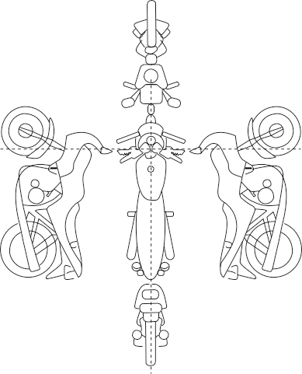
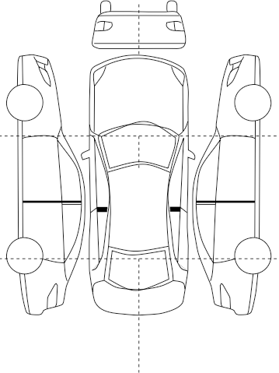

Damage location

Motor vehicle Caravan/trailer Motorcycle

1 Passenger
2 Driver 10 10 Front

front
front Front

7 Engine

Passenger side
6
8 Roof

Driver side
3

Passenger rear
5

9 Interior

Driver rear
4

11 Rear

Left rear
12

Right rear
13

Damage details* (up to two incident types may be recorded)
14 Whole vehicle 21 Chassis/structural rails (driver) 28 D pillar passenger 35 Suspension (driver front)
15 Floor pan (passenger front) 22 A pillar passenger 29 D pillar driver 36 Suspension (passenger rear)
16 Floor pan (driver front) 23 A pillar driver 30 Engine block (cracked, fractured) 37 Suspension (driver rear)
17 Floor pan (passenger rear) 24 B pillar passenger 31 Transmission case 38 Airbag front
18 Floor pan (driver rear) 25 B pillar driver 32 Differential case 39 Airbag side
19 Fire wall 26 C pillar passenger 33 Axle housing 40 Airbag curtain
20 Chassis/structural rails (passenger) 27 C pillar driver 34 Suspension (passenger front) 41 Seat belt pre-tensioner

Damage severity code

A | Heavy panel | E | Unrepairable | I | Minor stripping | M | Water (fresh)
B | Light panel | F | Major mechanical damage | J | Major vandalism | N | Burnt/blistered
C | Heavy structural | G | Minor mechanical damage | K | Minor vandalism | O | Smoke and heat
D | Light structural | H | Major stripping | L | Water (salt) | P | Minor smoke

Registration Authority contact

Registration and Licensing Services
GPO Box 1002
HOBART TAS 7001
Telephone: 1300 135 513
tes@stategrowth.tas.gov.au

A full description of the national damage assessment criteria and how to apply them is set out in the publication Damage Assessment Criteria for the Classification of Statutory Write-Offs (2011)
published by the National Motor Vehicle Theft Reduction Council and Austroads. A PDF version of the publication can be downloaded free of charge from carsafe.com.au or austroads.com.au

Confidentiality Notice
The information contained in this form is required by law to be recorded on a written-off vehicle register and may be disclosed or used for investigation, law enforcement or other purposes in accordance with the legislation of the State or Territory concerned. It will not be disclosed to any third parties without consent unless authorised by law. Check with your registration authority for details of any local variation from these general provisions.
PERSONAL INFORMATION PROTECTION STATEMENT You are providing personal information to the Registrar of Motor Vehicles, who will manage that information in accordance with the Personal Information Protection Act 2004 and relevant provisions of the Vehicle and Traffic Act 1999. The personal information collected here will be used by the Registrar of Motor Vehicles for driver licensing and vehicle registration purposes, and related purposes under the Vehicle and Traffic Act 1999 and associated laws, including for national identity matching and verification purposes. Failure to provide this information may result in your application not being processed, or records not being properly maintained. The Registrar of Motor Vehicles may also use the information for related purposes, or disclose it to third parties in circumstances allowed for by law. You have the right to access your personal information by request to the Registrar of Motor Vehicles and you may be charged a fee for this service.

