Driver Knowledge Test Questions
Driver Knowledge Test Questions

Questions are correct at the time of publishing, but may be subject to change. Page references are provided for the
Tasmanian Road Rules Handbook to help you find the rules relating to the questions. You will need to answer 35 questions for the car driver knowledge test.

Diagram | Question | Choices (page references for answers in brackets)
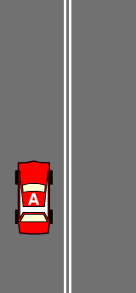 | 1. Can Car A cross the double lines? | A. Yes - to overtake another vehicle.  B. Yes - to turn into a driveway.  C. Yes - to pass a cyclist if it’s safe to do so. D. Yes - to do a U-turn.  (p. 6)
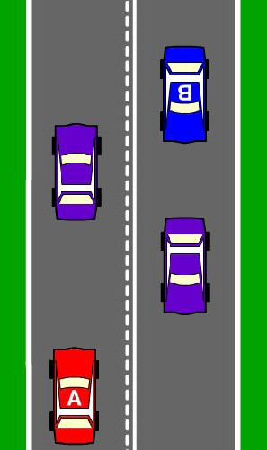 | 2. Which car(s) can cross the lines to overtake (when it’s safe)? | A. Car A. B. Car B.  C. Both Cars A and B can cross the lines to overtake.  (p. 7-8)
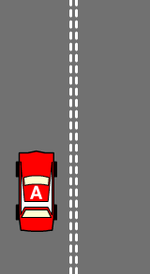 | 3. You are driving Car A. When can’t you cross the double broken lines? | A. To overtake another vehicle if safe to do so.  B. To turn into a driveway. C. To turn into a road.  D. To avoid an obstruction on the road.  (p. 7)
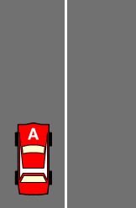 | 4. You are driving Car A. When can’t you cross the single continuous line? | A. To overtake another vehicle if it is safe to do so  B. To turn into a driveway  C. To turn into a road  D. To avoid an obstruction on the road  (p. 6)
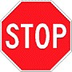 | 5. This sign means? | A. Stop only if traffic or pedestrians are coming from the right. B. Slow down and if it is safe, drive through the intersection. C. Stop, only for pedestrians.  D. Stop at the solid white line at the intersection and give way to vehicles on your left and right and any pedestrians.  (p. 18)
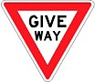 | 6. This sign means? | A. Give way only to traffic on your right.  B. It is a warning sign indicating that drivers may stop if they choose to.  C. Come to a complete stop and then give way to all vehicles and pedestrians before driving into the intersection.  D. Slow down and be prepared to stop to give way to traffic on your left and right and pedestrians.  (p. 18)
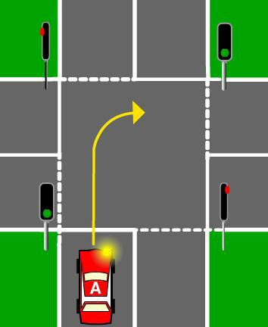 | 7. Car A wants to turn right at an intersection with green traffic lights. It should indicate and - | A. Give way to oncoming traffic (including vehicles turning left) and pedestrians. B. Wait for the yellow light, oncoming traffic must stop and give way.  C. Turn quickly, oncoming traffic must give way. D. Wait for 5 seconds then turn quickly.  (p. 14)

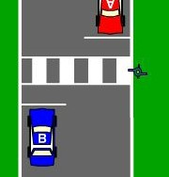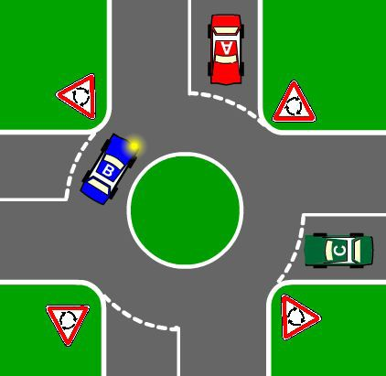
Diagram | Question | Choices (page references for answers in brackets)
 | 8. When approaching an intersection with a single flashing yellow traffic light. You must - | A. Slow down and sound the horn.  B. Stop and give way to all traffic.  C. Slow down; be prepared to stop and give way to vehicles on the right then drive on cautiously.  D. Accelerate through the intersection.  (p. 14)
 | 9. Who must give way at a pedestrian crossing? | A. Only the driver of Car A, which is travelling on the same side of the road as the pedestrian.  B. Neither Car A or Car B must give way if the pedestrian is in the middle of the road.  C. Car A and Car B must stop and give way to any pedestrian on the crossing.  D. The pedestrian must give way to all traffic. (p. 28)
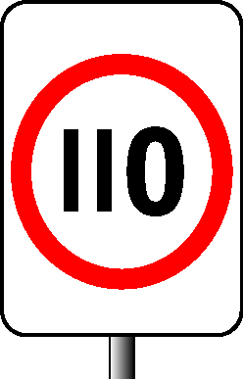 | 10. What is the maximum speed an L1 licence holder can drive in a 110 km/h speed zone? | A. 110 km/h. B. 90 km/h. C. 100 km/h. D. 80 km/h.  (p. 2, 50)
 | 11. What is the maximum blood-alcohol content (B.A.C) for a learner driver? | A. .05%. B. .02%. C. .08%. D. Zero.  (p. 50, 70)
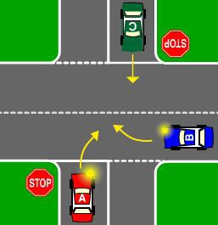 | 12. In what order should the cars go through the intersection? | A. Car C, then Car B, then, Car A. B. Car B, then Car C, then Car A. C. Car B, then Car A, then Car C. D. Car A, then Car B, then, Car C.  (p. 24)
 | 13. In what order should the cars go through the roundabout? (Car A and car C are travelling straight ahead. Car B is turning right.) | A. Car B, then Car C, then Car A. B. Car B, then Car A, then Car C. C. Car A, then Car B, then, Car C. D. Car C, then Car A, then Car B.  (p. 36)
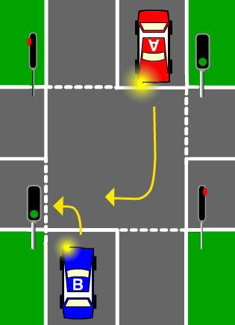 | 14. Which car gives way? | A. Car A. B. Car B.  (p. 14)

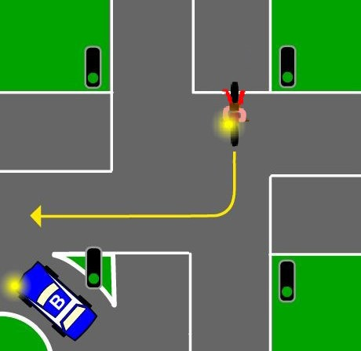
Driver Knowledge Test Questions
Diagram | Question | Choices (page references for answers in brackets)
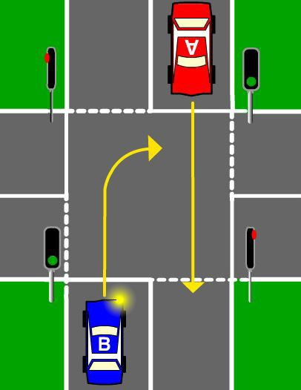 | 15. Which car gives way? | A. Car A. B. Car B.  (p. 14)
 | 16. Which vehicle gives way? | A. Motor cyclist. B. Car B  (p. 14, 27)
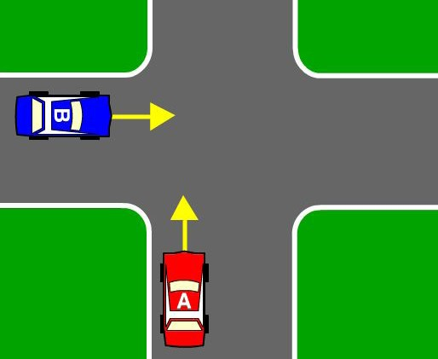 | 17. Which car must give way? | A. Car A B. Car B  (p. 23)
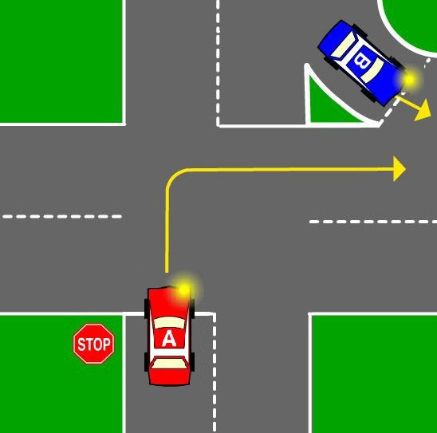 | 18. Which car must give way? | A. Car A B. Car B  (p. 24, 27)
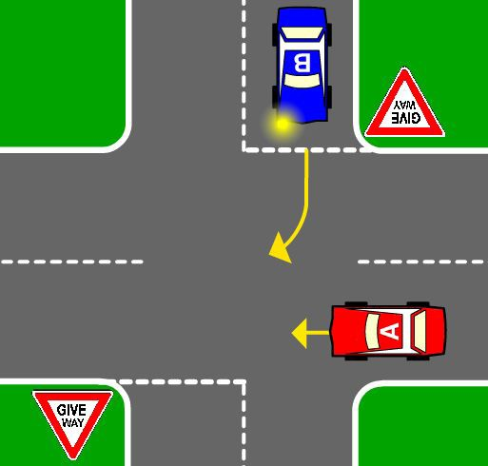 | 19. Which car goes first? | A. Car A B. Car B  (p. 25)
 | 20. Which of the following statements is true? | A. It is safe to drive after taking medications prescribed by a doctor.  B. Medicines bought over the counter do not affect your driving.  C. Some medications taken in combination with alcohol cause increased drowsiness.  D. It is safe to drive after taking medications if you take less than the suggested dosage.  (p. 71)
 | 21. Which of the following statements is true? | A. Medication taken with alcohol does not increase the effect of the alcohol on your driving ability.  B. You should ask your doctor or pharmacist about how your medication may affect your driving ability.  C. There are no medications with side-effects which will affect your driving ability.  D. If a doctor prescribes your medication then it will enhance your driving ability.  (p. 71)

Question | Choices (page references for answers in brackets)
22. Which of the following statements is true? | A. You should start a long trip after a long period of work. B. It is best to drive on a long trip during the night or early mornings.  C. Taking breaks from driving during a long trip will make you more tired.  D. You should take regular, 10 minute breaks on a long trip.  (p. 74)
23. If you have not slept for 24 hours | A. You have the same crash risk as a driver with a blood alcohol content of twice the legal limit.  B. It has no real effect on your driving.  C. You should turn up the music to keep you alert.  D. Your driving ability will be increased.  (p. 75)
24. Which of the following statements is true? | A. You should only adjust your radio/CD/DVD/Music Player while driving if you are good at multi-tasking.  B. You should limit distractions by spending a few minutes getting organized before starting your journey.  C. You should only check text messages at the traffic lights.  D. As long as you keep one hand on the steering wheel, it is OK to check your mobile phone.  (p. 78)
25. Before you drive a car, you should check that – | A. It is registered. B. It is roadworthy.  C. It is registered and roadworthy.  D. Whether the previous driver had committed a traffic offence in it.  (p. 63)
26. You have a driver licence and you change your home (residential) address. You need to – | A. Do nothing until your driver licence expires. B. Contact Service Tasmania within one month. C. Do nothing.  D. Contact Service Tasmania within 14 days.  (p. 59)
27. Which of the following statements is true? | A car learner driver may only drive:  A. With a current Australian full (not provisional or overseas) licensed driver who has not been suspended or disqualified in the previous 2 years.  B. During daylight hours.  C. With a provisional driver.  D. With a driver who is at least 25 years of age.  (p. 50-51)
28. Which of the following statements is true? | A. Ecstasy, marijuana (cannabis) and heroin have no effect on your ability to safely control your car.  B. The effect of drugs like speed or ecstasy makes you over confident, so you take risks while driving.  C. Small amounts of marijuana and alcohol enable you to respond quicker in emergency situations.  D. The use of recreational drugs has no impact on your driving ability.  (p. 70)
29. If you are taking several medications and you want to drive you should – | A. Ask your passengers to let you know if you are not driving as well as you should.  B. Ask your doctor if the combination of drugs will make it dangerous to drive.  C. Drive carefully around your local streets to see if you are affected.  D. Drive as normal since all medications are safe and will not affect your driving ability.  (p. 71)

Driver Knowledge Test Questions
Question | Choices (page references for answers in brackets)
30. Your driver licence has a condition that you must wear visual aids (such as glasses) when driving, you - | A. Must wear visual aids when driving.  B. Must wear visual aids when you have them with you.  C. Do not have to wear visual aids if your optometrist says that you do not need to them anymore. D. Don’t have to wear visual aids.  (p. 59)
31. What does a car licence allow you to drive? | A. A motor vehicle (other than a motorcycle) with a GVM of 4.5 tonnes or less, seating no more than 12 adults (including the driver).  B. Any vehicle registered as a car or motorcycle.  C. Any motor vehicle or combination of motor vehicles.  D. Any motor vehicle (other than a motorcycle) with a GVM greater than 4.5 tonnes.  (p. 49)
32. A car learner driver can NOT - | A. Drive during night time hours. B. Drive in wet conditions.  C. Tow another vehicle including a trailer. D. Drive on a highway.  (p. 50-51)
33. The blood alcohol content for a fully (non-provisional) licensed driver must be below - | A. .05%. B. .08%. C. Zero. D. .10%.  (p. 70)
34. A learner or provisional (P1 and P2) driver’s maximum blood alcohol content is - | A. .05%. B. .08%. C. Zero. D. .10%.  (p. 56-57, 70)
35. You have a car learner licence, so you – | A. Must only display one ‘L’ plate so that it can be clearly seen from the front of the vehicle. B. Must only display one ‘L’ plate so that it can be clearly seen from the rear of the vehicle. C. Are not required to display L-plates when accompanied by a supervising driver.  D. Must display ‘L’ plates so that they can be clearly seen from the front and the rear of the vehicle.  (p. 50-54)
36. You have a car provisional licence for less than one year (P1 licence), so you – | A. Must display one ‘P’ plate so that it can be clearly seen from the front of the vehicle. B. Must display one ‘P’ plate so that it can be clearly seen from the rear of the vehicle.  C. Must display ‘P’ plates so that they can be clearly seen from the front and the rear of the vehicle.  D. Are not required to display P plates when accompanied by a passenger over 25 years old.  (p. 56-57)
37. You set out on a fairly long drive to see some friends. After a while you start feeling tired. What should you do? | A. Turn the music up louder to keep you alert.  B. Take regular, 10 minute breaks throughout the long trip.  C. Stop at a shop and get a drink that contains caffeine to help you keep awake.  D. Make sure you get plenty of fresh air circulating inside the car by winding down the window.  (p. 75)

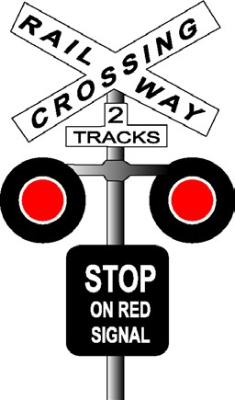
Diagram | Question | Choices (page references for answers in brackets)
 | 38. If you are involved in a crash and a vehicle is damaged but no one is injured you must – | A. Stop at the crash exchange names, addresses and registration numbers and any other information to identify the vehicle with the driver of the other vehicle as soon as possible, and within 24 hours.  B. Continue driving as no one had been injured. C. Stop only during daylight hours.  D. Only stop to give your details if you caused the accident.  (p. 81)
 | 39. If you are involved in a crash and someone is injured, you must – | A. Drive to the nearest Police station. B. Look for a witness to the accident. C. Drive on, you are not injured.  D. Stop your vehicle immediately and give assistance. If you need to get help, leave a responsible person at the accident scene.  (p. 81)
 | 40. When driving, you must carry your licence – | A. Only when towing a trailer. B. During daylight hours only. C. When you remember it.  D. At all times.  (p. 59)
 | 41. What is the minimum continuous period that you must hold an L1 licence before progressing to an L2 licence? | A. 3 continuous months. B. 6 continuous months. C. 9 continuous months. D. 12 continuous months.  (p. 50)
 | 42. What is the minimum continuous period that you must hold an L2 licence before progressing to a P1 licence? | A. 3 continuous months. B. 6 continuous months. C. 9 continuous months. D. 12 continuous months.  (p. 51)
 | 43. When driving at night, you must dip your headlights – | A. Only when another vehicle is approaching you from the opposite direction and is within 50 metres.  B. Within 200 metres when approaching another vehicle from either the opposite direction or from behind.  C. Within 3 metres when approaching another vehicle from either the opposite direction or from behind.  D. You never need to dip your headlights.  (p. 42)
 | 44. At a railway crossing with red lights flashing, you must – | A. Slow down and cross with care.  B. Stop and wait until the red lights stop flashing and the train passes before driving on.  C. Cross only if there is no train visible.  D. Speed up and quickly go through the crossing before the train passes. (p. 29)

Driver Knowledge Test Questions
Diagram | Question | Choices (page references for answers in brackets)
 | 45. An emergency vehicle (e.g. ambulance or fire engine) is sounding its siren and quickly approaching your vehicle from behind. You must – | A. Immediately turn on your vehicles hazard lights.  B. Immediately sound your horn to warn other vehicles of the approaching emergency vehicle.  C. Immediately accelerate.  D. Give way by either pulling over to the side of the road or moving into another lane to enable the emergency vehicle to pass.  (p. 29)
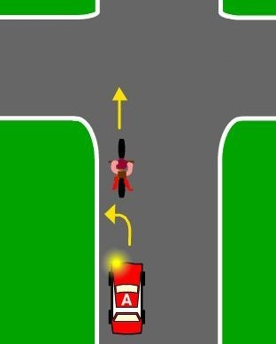 | 46. You are driving Car A. You are approaching an uncontrolled intersection and want to turn left. There is a cyclist in front of you. You must – | A. Sound your horn to warn the cyclist that you are behind and the cyclist must give way.  B. Allow the cyclist to go through the intersection safely then turn left at the intersection.  C. Accelerate and pass the cyclist then turn left in front of the cyclist.  D. Accelerate, indicate and sound your horn to warn the cyclist then turn left in front of the cyclist.  (p. 79)
 | 47. Who, apart from cyclists, can use a bicycle path? | A. Any vehicle.  B. If signs don’t say otherwise, a person in a wheelchair or pushing a wheelchair or a person using roller blades or roller-skates.  C. Motorcyclists. D. Courier vans.  (p. 46)
 | 48. You can use a mobile telephone (not hands free) when sitting in the driver’s seat - | A. At any time, when you are driving an automatic vehicle.  B. At any time, when the phone call is less than 5 minutes long.  C. When you are stopped at traffic lights or stopped in traffic. D. Only when your vehicle is parked.  (p. 43)
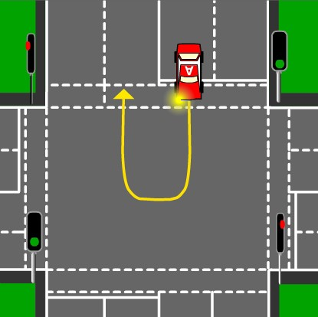 | 49. You can do a U-turn at an intersection with traffic lights – | A. Between 9 p.m. and 6 a.m.  B. Only when there is “U-turn permitted” sign.  C. If there is no oncoming traffic. D. If the traffic lights are green.  (p. 34)
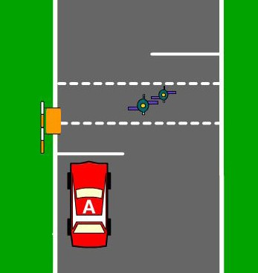 | 50. You are driving Car A. You are stopped at a children’s crossing displaying an orange flag. You can drive on when – | A. The pedestrians have left the crossing.  B. The pedestrians are not in your car’s path.  C. The pedestrians are about to step onto the crossing.  (p. 28)
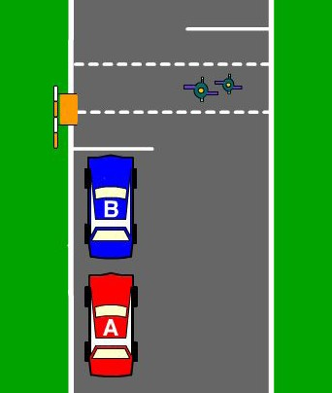 | 51. You are driving Car A. Car B In front of you has stopped at a pedestrian crossing, you must – | A. Overtake Car B.  B. Overtake with care if satisfied there is no pedestrian on the crossing.  C. Stop behind Car B.  D. Indicate and sound your horn to warn Car B and any pedestrians that you are overtaking.  (p. 28)

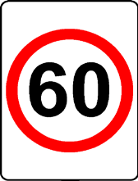
Diagram | Question | Choices (page references for answers in brackets)
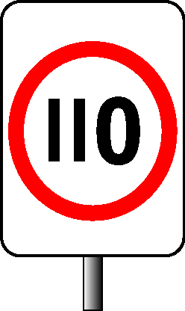 | 52. As a P1 licence holder, what is the maximum speed you can drive on a road with this sign? | A. 80 km/h. B. 90 km/h. C. 100 km/h. D. 110 km/h.  (p. 2, 56-57)
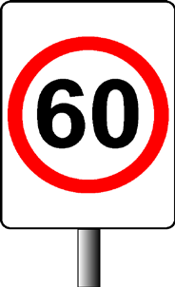 | 53. This sign means? | A. You must travel more than 60 km/h.  B. You must not travel more than 60 km/h.  C. You are on Highway number 60. D. Children’s crossing, slow down.  (p. 1)
 | 54. What is the maximum speed limit (unless signposted otherwise) for vehicles in a built-up area (like a town or a city)? | A. 70 km/h. B. 80 km/h. C. 60 km/h. D. 50 km/h.  (p. 1)
 | 55. What is the maximum speed limit for vehicles turning at an intersection controlled by traffic lights? | A. 20 km/h. B. 10 km/h. C. 15 km/h. D. 50 km/h.  (p. 3)
 | 56. When approaching a stopped school bus with amber flashing lights that is letting off children (on a country road), you must - | A. Slow down to 10 km/h within 10 metres of the bus and watch for pedestrians.  B. Drive within the posted speed limit and watch for pedestrians.  C. Slow down to 5 km/h within 10 metres of the bus and watch for pedestrians. D. Slow down to 40 km/h 50 metres before you overtake the bus and watch for  pedestrians.  (p. 3)
ROAD WORK | 57. This sign means? | A. You must not travel more than 60 km/h.  B. You can travel at the speed that normally applies to the road, as it is a warning sign suggesting that you slow down.  C. You can travel at any speed as it only applies to road construction vehicles.  D. You can travel at any speed if you are driving to or from your work.  (p. 2)
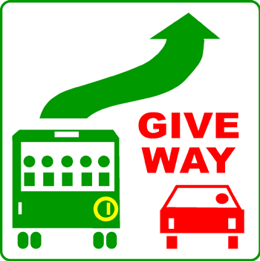 | 58. You are driving in a built-up area (like a city or town). A bus is stopped at a bus stop in the left lane next to you and has this sign displayed. There are parked vehicles in front of the bus and it has signalled right. What must you do? | A. Allow the bus to move off from the kerb into your lane. B. Continue ahead at the speed limit, providing it is safe. C. Slow to 60 km/h and give way to pedestrians only.  D. Slow to 50 km/h and only stop to give way to pedestrians.  (p. 30)

Driver Knowledge Test Questions
Diagram | Question | Choices (page references for answers in brackets)
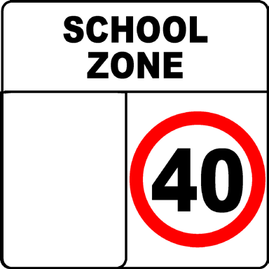 | 59. What is the maximum speed limit in a school zone during school days? | A. 45 km/h. B. 60 km/h. C. 40 km/h. D. 50 km/h.  (p. 2)
 | 60. Which ONE of the following statements is true? | A. The speed limit in School Zones does not apply if there are no children around.  B. The speed limit in School Zones only applies to children from within that school zone  C. The speed limit applies on weekdays only.  D. The speed limit in school zones applies on official school days and during designated times.  (p. 2)
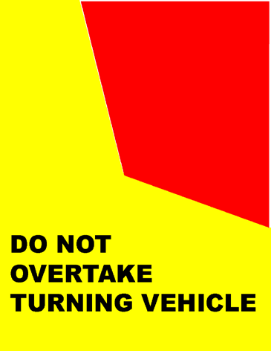 | 61. You are behind a long vehicle (7.5 m or more in length) that is signalling and starting to turn left. The truck is displaying a ‘Do not overtake turning vehicle’ sign and is in the second lane from the left side of the road. You also want to turn left. What must you do? | A. Use the far left lane to pass the truck and turn left.  B. Sound your horn and quickly pass the truck on the left before the truck turns.  C. Allow the truck to complete its turn before you turn left.  D. Indicate and quickly pass the truck on the right hand side before the truck turns.  (p. 11)
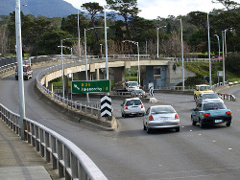 | 62. You are driving a vehicle along a multi-lane road and the speed limit is 80km/h or less, which lane should you travel in? | A. In the left-hand lane unless overtaking another vehicle in the left lane.  B. In the left-hand lane unless you are turning right.  C. In either lane.  D. You must travel in the left-hand lane.  (p. 5)
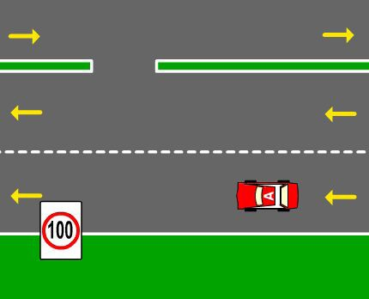 | 63. You are driving Car A along a multi-lane road and the speed limit is more than 80 km/h, which of the following statements is WRONG? | A. You must drive in the left hand lane unless you are turning right.  B. You must travel in the left hand lane unless you are overtaking a vehicle in the left hand lane.  C. You must travel in the left hand lane unless avoiding an obstruction. D. You can travel in either lane.  (p. 5)
 | 64. Where there are no line markings on the road where should you drive? | A. In the centre of the road. B. On any part of the road.  C. Within two metres of the left-hand side of the road. D. As close as practical to the left side of the road.  (p. 4)

Diagram | Question | Choices (page references for answers in brackets)
 | 65. Which of the following statements is correct? | On a multi-laned road (with two or more lanes travelling in the same direction)  drivers may:  A. Make a U-turn across lanes travelling in the same direction.  B. Change lanes without indicating.  C. Change lanes when it is safe to do so.  D. Change lanes at any time, as other drivers must show courtesy and give way to you.  (p. 22)
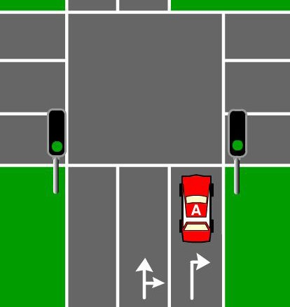 | 66. You are driving car A. In what direction must you travel? | A. Turn right only. B. Turn left only.  C. Straight ahead or make a right turn.  D. Straight ahead only.  (p. 15)
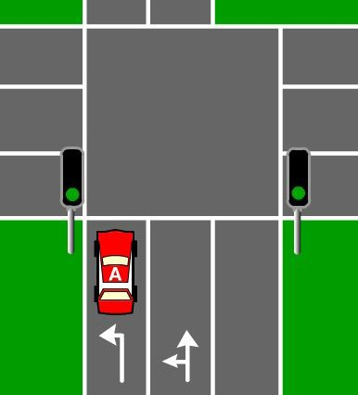 | 67. You are driving Car A. In what direction must you travel? | A. Turn left or go straight ahead.  B. Turn left only when there is traffic in the other lane.  C. Go straight ahead. D. Turn left.  (p. 16)
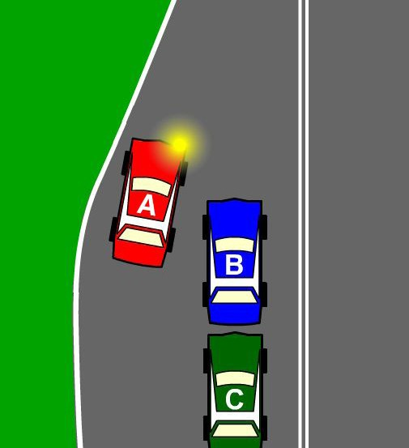 | 68. You are driving Car A and you want to merge with another line of traffic travelling in the same direction (there are no marked lanes) – | A. You must give way to Car B as it is on your right  B. You have right of way, as you are travelling ahead of Cars B and C. C. You have to give way to Cars B and C as they are to your right.  D. You have to give way to cars B and C as you are travelling ahead of them.  (p. 22)
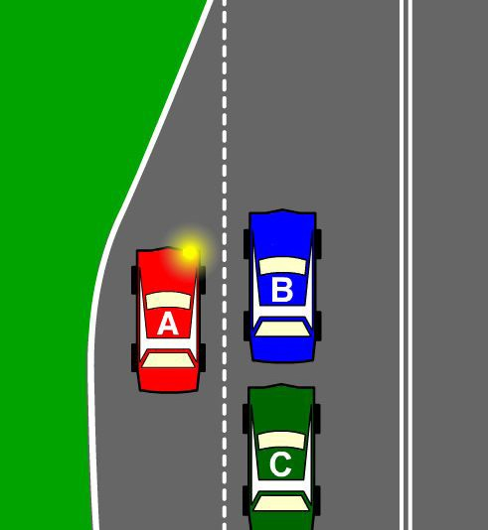 | 69. You are driving Car A in a 60 km/h speed zone. Your lane ends and you must merge with another lane of traffic travelling in the same direction (there are line markings) - | A. Cars B and C have to give way to you as they are in the right lane  B. You have to give way to Cars B and C as you are moving into their lane.  C. Cars B and C have to give way to you as you are travelling ahead of them. D. You have to give way to Car B as it is travelling ahead of you.  (p. 22)
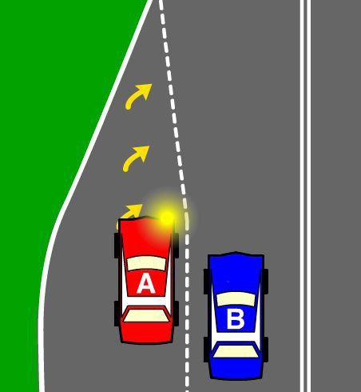 | 70. You are driving Car A in a 100 km/hr speed zone. Your lane has come to an end and you want to merge into another lane of traffic. There are road markings. | A. You must give way to Car B as you are moving into the lane it is travelling in. B. Car B has to give way to you as you are travelling ahead of it.  C. Car B has to give way to you as it is in the right lane.  (p. 22)

Driver Knowledge Test Questions
Diagram | Question | Choices (page references for answers in brackets)
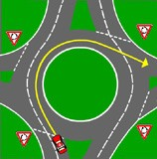 | 71. You are driving towards a large roundabout that has multi-lanes. At the roundabout, you intend to turn off more than halfway around the roundabout. What signals must you give? | A. On approach to the roundabout, give a right signal and, just before you the exit road, give a left signal.  B. Only give a right signal on the approach to the roundabout, as no other signal is required.  C. Providing it is safe, a signal is not required at all.  D. On approach to the roundabout, give a left signal then a right signal when turning off.  (p. 35)
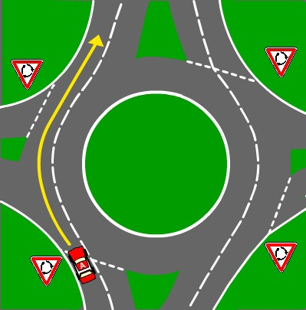 | 72. You are driving a motor vehicle towards a marked multi-laned roundabout. You want to travel straight on through the roundabout to the road opposite. What lane must you take? | A. You must enter and leave the roundabout in the left lane. B. You may enter and leave the roundabout in either lane.  C. You must enter and leave the roundabout in the right lane.  D. Move to the left lane before the roundabout then leave by the right lane.  (p. 35)
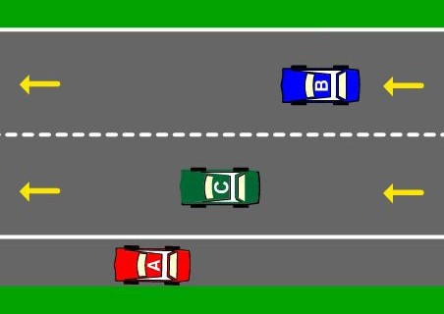 | 73. You are driving Car A. You want to move from the side of the road into a line of traffic, you must indicate – | A. For one second and give way to all traffic B. For 3 seconds and give way to all traffic C. For 5 seconds and give way to all traffic D. Only if there is traffic coming  (p. 12)
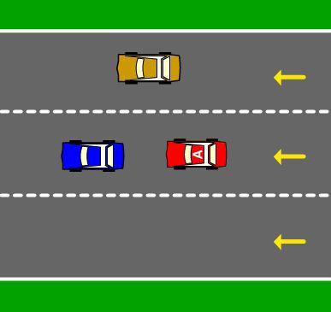 | 74. You are driving Car A. You want to move to the right hand lane. You must – | A. Indicate to the right and give way to traffic in the right hand lane. B. Give way to traffic in the right hand lane without indicating.  C. Indicate to the left.  D. Indicate to the right without giving way.  (p. 22)
 | 75. Does a Police Officer’s directions overrule Stop and Give Way signs? | A. No. B. Yes.  C. Yes, only at Give Way Signs. D. Yes, only at Stop Signs.  (p. 21)
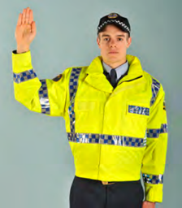 | 76. At an intersection with a Police Officer who has one hand raised and one hand to his side as shown, do you - | A. Turn right.  B. Stop at the intersection.  C. Slow down and continue through the intersection.  D. Obey the traffic lights.  (p. 21)
 | 77. At what age do you have to wear a seatbelt or suitable child restraint? | A. All ages.  B. Age 1 year and over.  C. Age 8 years and over  D. Under the age of 65.  (p. 72)

Diagram | Question | Choices (page references for answers in brackets)
 | 78. Who will be fined if a passenger under the age of 16 is not wearing a seat belt or suitable child restraint? | A. The driver of the vehicle. B. The passenger.  C. The owner of the vehicle. D. Everyone in the vehicle.  (p. 64)
 | 79. When is the driver of a motor vehicle allowed to use a mobile phone? | A. When they are certain they will not lose concentration for more than 5 seconds.  B. When the traffic is stationary or moving at less than 20kms per hour.  C. When the vehicle is parked with the engine off, or when the mobile phone is in a commercially designed holder and is fixed to the vehicle, or when it can be operated without being touched.  D. Any time as long as one hand remains on the steering wheel at all times  (p. 43)
 | 80. Seatbelts – | A. Must be worn by drivers and passengers when travelling forward or stationary in traffic.  B. Only need to be worn when travelling over 50km/h.  C. Do not need to be worn by passengers.  D. Do not need to be worn by passengers under the age of 12 years.  (p. 72)
 | 81. As a driver, you must wear a seatbelt – | A. When travelling over 60 km/h.  B. When convenient. C. At all times.  D. When the vehicle is moving or stationary in traffic, unless reversing.  (p. 72)
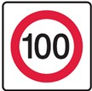 | 82. What is the maximum speed an L1 driver can drive in a 100 km/h speed zone? | A. 110 km/h B. 90 km/h C. 100 km/h D. 80 km/h  (p. 2)
 | 83. As an L2 or P1 licence holder, what is the maximum speed you can drive on a road with this sign? | A. 110 km/h B. 90 km/h C. 100 km/h D. 80 km/h  (p. 2)
 | 84. What is the minimum recommended distance to leave between your vehicle and a cyclist when passing in a 50 km/h zone? | A. 1 metre  B. 2 metres  C. No distance  (p. 8)
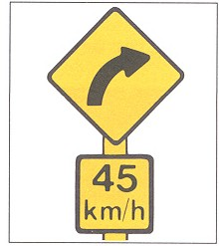 | 85. This sign means? | A. 45 km/h is the advised maximum speed to travel around the curve ahead under good driving conditions.  B. Winding road for next 45 kilometres.  C. 45 km/h is the legal maximum speed limit for the curve ahead. D. You can only turn right for the next 45 km.  (p. 19)

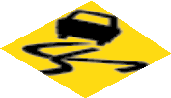

Driver Knowledge Test Questions
Diagram | Question | Choices (page references for answers in brackets)
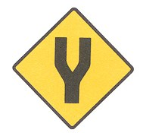 | 86. This sign means? | A. Road incomplete.  B. Divided road ahead.  C. Incomplete roundabout ahead.  D. Modified ‘T’ intersection ahead.  (p. 19)
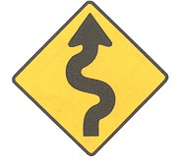 | 87. This sign means? | A. Steep hill ahead.  B. Unmade road ahead. C. Slippery road ahead. D. Winding road ahead  (p. 19)
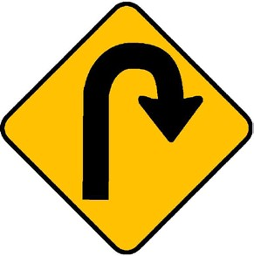 | 88. This sign means? | A. Hairpin bend to the right. B. ‘U’ turns allowed.  C. You must turn right.  D. Road ends – turn around  (p. 19)
 | 89. This sign means? | A. Helicopter landing pad ahead. B. Ambulance Station ahead.  C. Hospital emergency entrance ahead. D. A crossroad intersection ahead.  (p. 19)
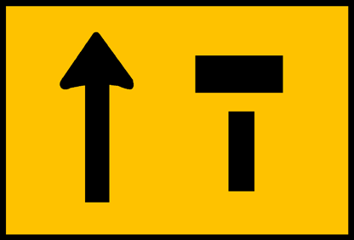 | 90. This sign means? | A. Left lane closed, right lane open. B. Left lane open, right lane closed. C. Trucks must use right lane.  D. “T” intersection ahead.  (p. 19)
 | 91. This sign means? | A. Bends ahead.  B. Road slopes ahead.  C. Slippery surface ahead.  D. Steep winding road ahead.  (p. 19)
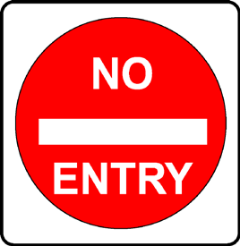 | 92. This sign means? | A. Do not pass another vehicle.  B. Stop and give way to all traffic and pedestrians.  C. Do not drive beyond this sign. D. Allowed to enter.  (p. 18)
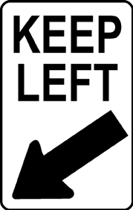 | 93. This sign means? | A. No right turn.  B. One way traffic.  C. Left turn only sign.  D. Keep to the left of the sign.  (p. 18)
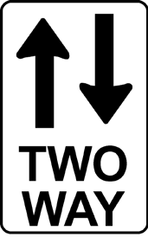 | 94. This sign means? | A. Vehicles travel in both directions on this road. B. No right or left turns.  C. No 3 point turns allowed. D. No U-turns allowed.  (p. 18)

Diagram | Question | Choices (page references for answers in brackets)
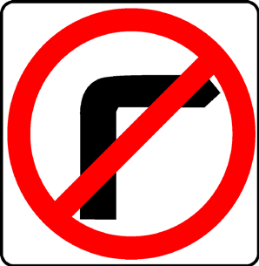 | 95. This sign means? | A. Danger, road bends sharply right. B. Speed zone ends.  C. You must not turn right.  D. No sharp right hand bends ahead.  (p. 18)
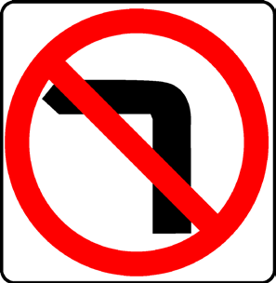 | 96. This sign means? | A. Danger, road bends sharply left. B. Speed zone ends.  C. No sharp left hand bends ahead. D. You must not turn left.  (p. 18)
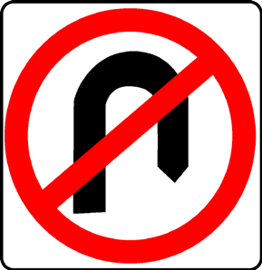 | 97. This sign means? | A. Danger road ends.  B. You must not turn right. C. No U-Turn Allowed.  D. Speed zone ends.  (p. 18)
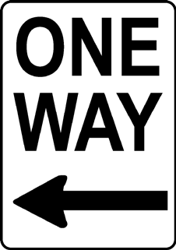 | 98. This sign means? | A. Traffic must travel along the road only in the direction of the arrow.  B. Left turn at any time with care. C. Right turn at any time with care.  D. Traffic can travel along the road in either direction. (p. 18)
 | 99. There are two types of road signs - warning and regulatory. What is the difference between them? | A. No difference, they don’t need to be obeyed.  B. Regulatory signs alert drivers to road conditions and should be obeyed. Warning signs should be ignored.  C. Warning signs alert drivers to road conditions and should be obeyed. Regulatory signs must be obeyed.  D. No difference, they are both the same.  (p. 18-19)
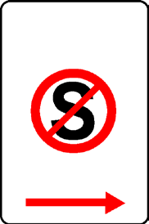 | 100. This sign means? | A. Do not stop in the area covered by the sign for any reason.  B. You can park for a short time.  C. Stop to pick up or drop off passengers or goods.  D. Do not stand during the hours 8.30 a.m. to 4.30 p.m.  (p. 18)
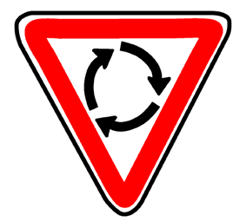 | 101. This sign means? | A. U-turns allowed.  B. 3 point turn allowed.  C. Turning area for heavy vehicles – give way. D. You are at a roundabout.  (p. 35)
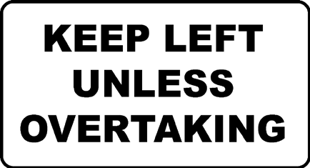 | 102. This sign means on a multi-laned road? | A. Keep left at all times.  B. Drivers must only overtake using the left lane.  C. Drivers must not use the right lane unless they are overtaking, turning right or the traffic is congested.  D. Drivers must not use the right lane at any time.  (p. 4, 5)

Driver Knowledge Test Questions
Diagram | Question | Choices (page references for answers in brackets)
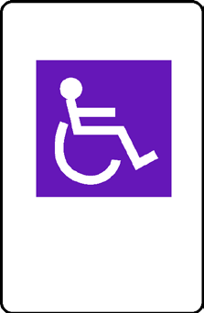 | 103. This sign means? | A. Parking permitted only for people in wheelchairs.  B. Parking permitted for people with disabilities that have a current disability parking permit.  C. Anyone may stop but only for a maximum of 2 minutes to pick up or drop off passengers or goods.  D. Parking permitted for people with prams. (p. 40)
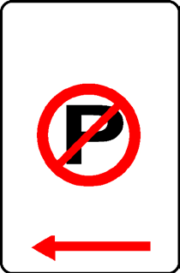 | 104. This sign means? | A. Parking permitted during non-peak hours. B. Parking for buses only.  C. No parking for any reason.  D. No parking unless you are stopping for a maximum of 2 minutes to pick up or drop off passengers or goods.  (p. 37)
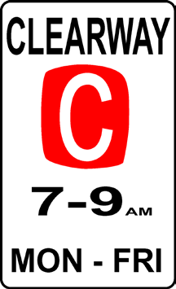 | 105. This sign means? | A. Drivers cannot stop for more than five minutes to pick up or drop off passengers.  B. Drivers cannot stop during the times and days stated. C. Drivers must not stop at any time.  D. Drivers can only stop during the times and days stated.  (p. 40)
 | 106. How close to a junction or an intersection without traffic lights can you legally park? | A. 10 metres. B. 9 metres. C. 3 metres. D. 15 metres.  (p. 39)
 | 107. Can you park on a road over your own private driveway? | A. Yes, but only for 10 minutes. B. Yes.  C. No (unless dropping off or picking up passengers or goods)  (p. 41)
 | 108. How must you park in a two-way street that has no signposted parking restrictions? | A. You must park parallel and as close as practical to the right-hand kerb.  B. You must park parallel and as close as practical to the left-hand kerb but not within 10 metres of a junction or intersection or on a yellow single line.  C. You must park parallel and as close as practical to the left-hand kerb, and within 10 metres of an intersection.  D. As close to the centre of the road as practical.  (p. 38, 39)
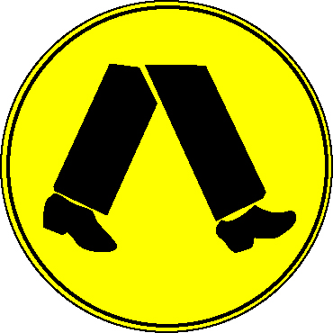 | 109. How close to a pedestrian crossing can you legally park? | A. 20 metres before and 10 metres after the crossing. B. 3 metres before and 5 metres after the crossing.  C. 5 metres on either side. D. 15 metres on either side.  (p. 40)
 | 110. If you are turning at an intersection must you give way to pedestrians? | A. Only if the pedestrians are under the age of 16 years. B. Yes.  C. No.  D. Only if the pedestrians are over the age of 16 years.  (p. 31, 32)

Diagram | Question | Choices (page references for answers in brackets)
 | 111. A yellow line along the side of the road means – | A. Parking for taxis only.  B. Stopping not allowed during peak traffic hours.  C. Fire hydrant indicator.  D. No stopping or parking.  (p. 39)
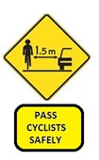 | 112. What does this sign mean? | A. Cyclists cannot use the road  B. You should give bicycle riders at least 1.5 metres when you pass. C. You must wait 1.5 metres behind a cyclist before passing.  (p. 8)
 | 113. What must you do at an intersection with green traffic lights, which is blocked by other vehicles? | A. Enter the intersection.  B. Enter the intersection if you think the traffic will clear before the traffic lights change to red.  C. Do not enter the intersection until the traffic has cleared and you can safely drive through to the other side, and the traffic lights are green.  D. Do not enter the intersection unless the lights change to red.  (p. 40)
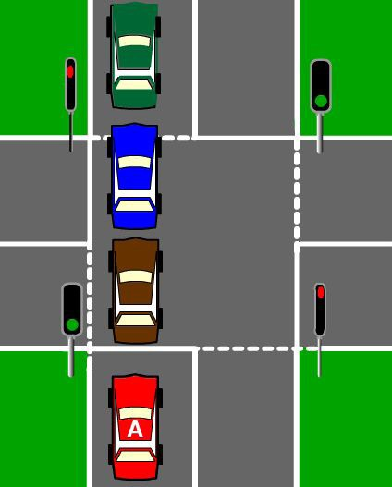 | 114. You are driving Car A. The vehicles in front of you have stopped. When can you drive through the intersection? | A. At any time when there is a green light if you think that you won’t block it. B. At any time when the light is green even if you may block the intersection. C. At any time when the light is green and the intersection is clear of traffic. D. When the lights are red.  (p. 40)
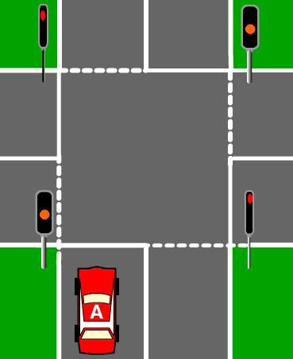 | 115. When traffic lights turn from green to yellow you should – | A. Speed up and go through the lights before they turn red.  B. Stop, even if you must stop on the intersection and then reverse back to the stop line.  C. Stop, even if you are in the intersection.  D. Stop, if you can do so safely before the stop line.  (p. 14)
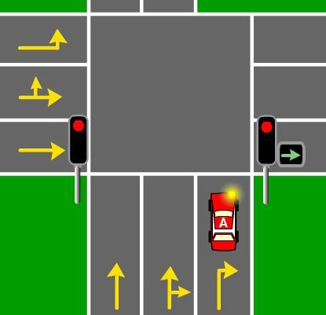 | 116. You are approaching an intersection controlled by traffic lights. There is a red circular light and a green arrow pointing to the right. Can you turn right? | A. No, not at any time. B. Yes.  C. No, only when both lights are green. D. No, but you can go straight ahead.  (p. 15)
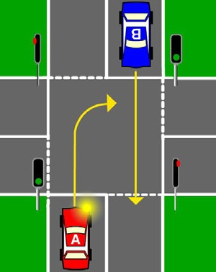 | 117. Which car gives way? | A. Car A.  B. Car B.  (p. 14)

Driver Knowledge Test Questions
Diagram | Question | Choices (page references for answers in brackets)
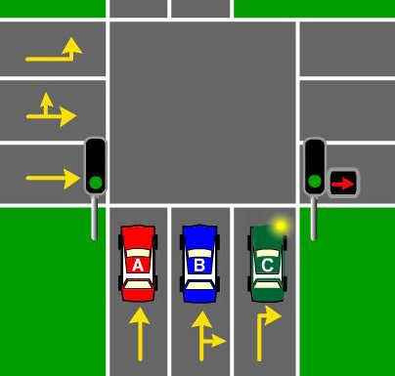 | 118. The traffic lights are green and there is a red right arrow. Cars A and B are going straight ahead, Car C is turning right. Which car(s) go first? | A. Car A and Car C. B. Car B and Car C. C. Car C.  D. Car A and Car B.  (p. 15)
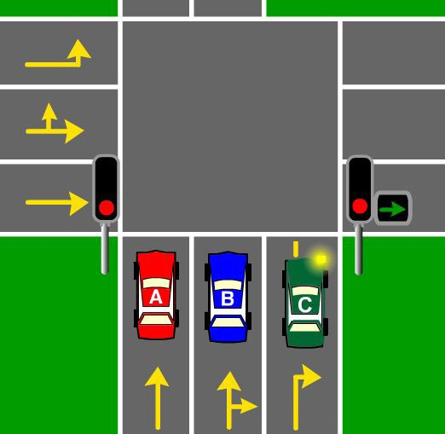 | 119. There are red traffic lights and a green right arrow. Cars A and B are going straight ahead, Car C is turning right. Which car(s) go first? | A. Car A and Car C. B. Car A and Car B. C. Car A.  D. Car C.  (p. 15)
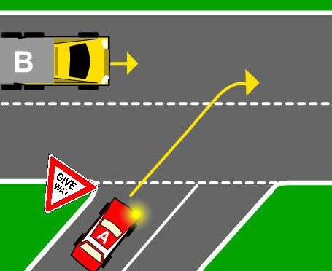 | 120. Which vehicle gives way? | A. Car A  B. Truck B  (p. 26-27)
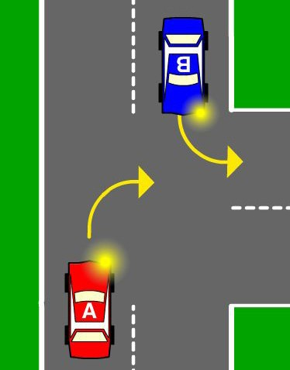 | 121. Which car goes first? | A. Car A. B. Car B.  (p. 26-27)
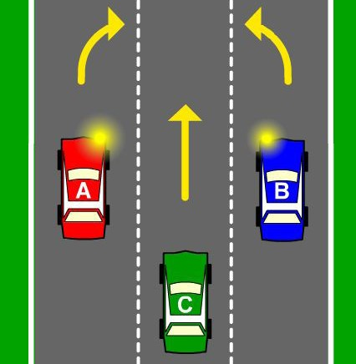 | 122. On a multi-laned road, Car A and Car B want to change to the centre lane. Which car can change lanes first? | A. Car A - as it is changing into the right hand lane  B. Car B - as Car C has to give way to a car on its right  C. Neither Car A or Car B has priority for that lane  (p. 22)
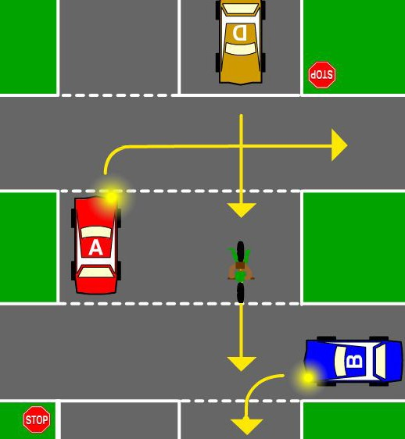 | 123. Which vehicle goes first? | A. Car D.  B. Cyclist C. C. Car B.  D. Car A.  (p. 24)
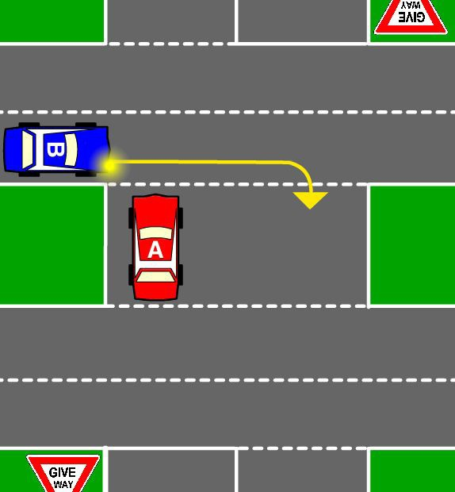 | 124. Which car goes first? | A. Car A. B. Car B.  (p. 25)

Diagram | Question | Choices (page references for answers in brackets)
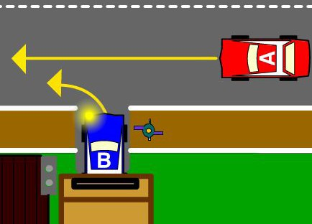 | 125. You are driving Car B. You must give way to - | A. No one (you pull out first).  B. The pedestrian.  C. The pedestrian and Car A. D. Car A.  (p. 30)
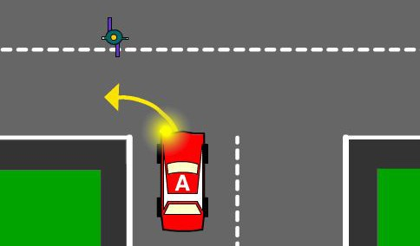 | 126. Who must give way? | A. Car A.  B. The pedestrian.  (p. 22)
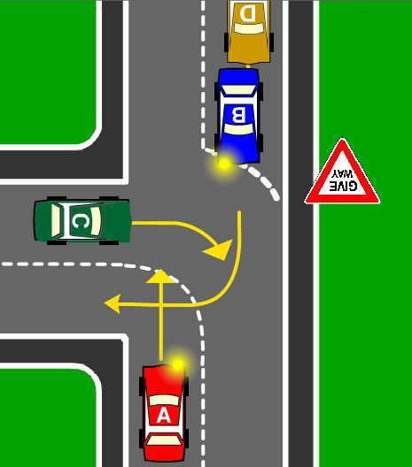 | 127. In what order do the cars go? | A. Car C, Car A, Car B and Car D B. Car C, Car B, Car A and Car D. C. Car B, Car A, Car C and Car D.  (p. 27)
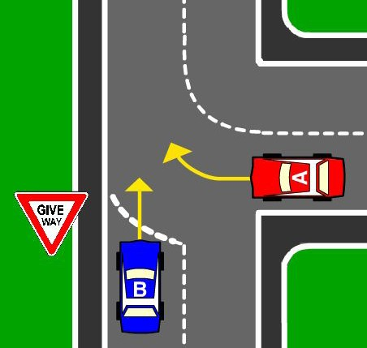 | 128. Which car goes first? | A. Car A. B. Car B.  (p. 27)
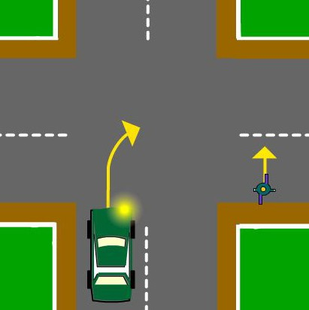 | 129. Does the car or the pedestrian have to give way? | A. The Pedestrian. B. The Car.  (p. 22)
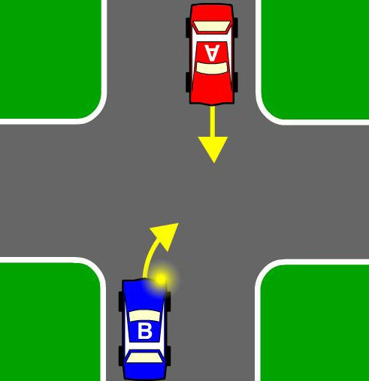 | 130. Which car must give way? | A. Car A B. Car B  (p. 22)
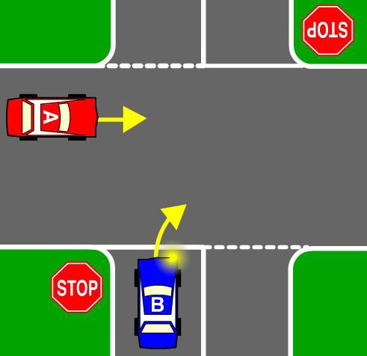 | 131. Which car must give way? | A. Car A B. Car B  (p. 24)
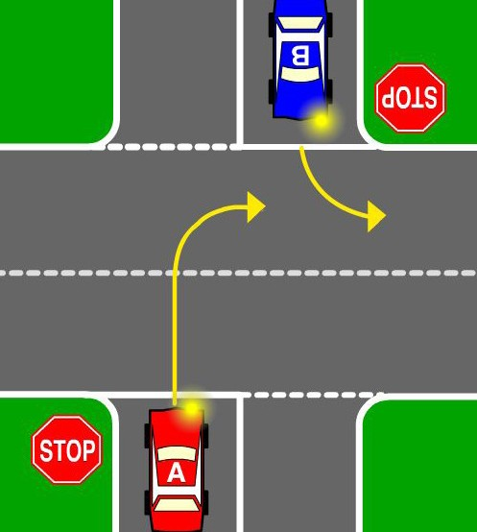 | 132. Which car must give way? | A. Car A B. Car B  (p. 24)

Driver Knowledge Test Questions
Diagram | Question | Choices (page references for answers in brackets)
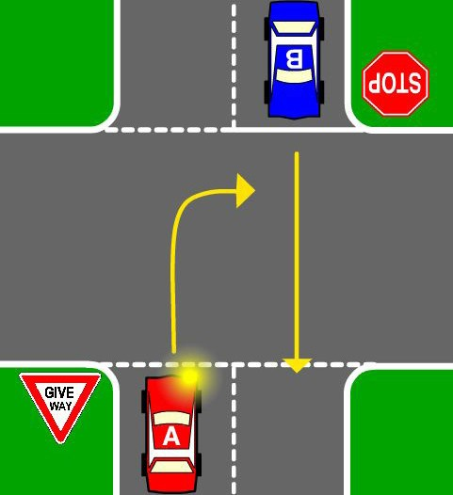 | 133. Which car must give way? | A. Car A B. Car B  (p. 24)
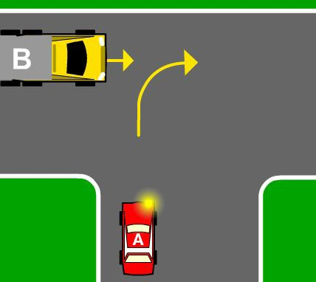 | 134. Which vehicle goes first? | A. Car A  B. Truck B  (p. 26)
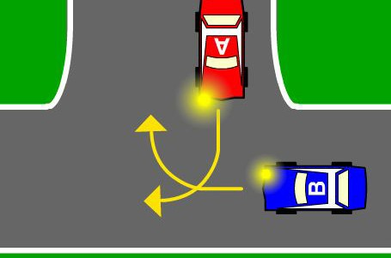 | 135. Which car goes first? | A. Car A B. Car B  (p. 26)
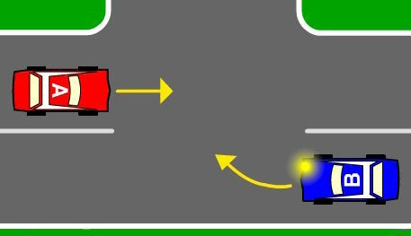 | 136. Which car gives way? | A. Car A B. Car B  (p. 27)
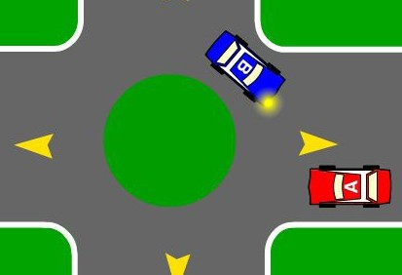 | 137. Which car gives way? | A. Car A B. Car B  (p. 36)
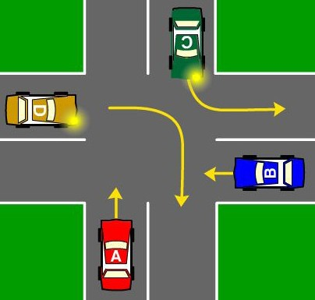 | 138. You are driving Car A. You must give way to - | A. No one, the other cars must give way to you. B. Car D  C. Cars B, C and D D. Car B  (p. 23)
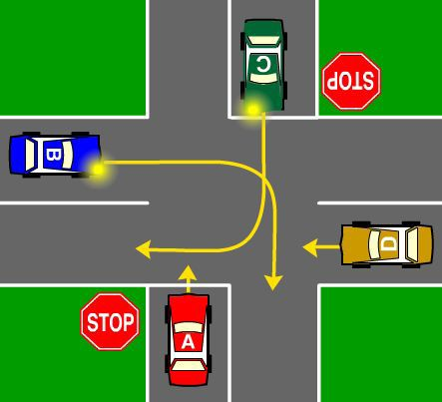 | 139. You are driving Car A. You must give way to - | A. Cars B, C and D B. Cars C and B  C. Car B  D. Cars B and D  (p. 24)
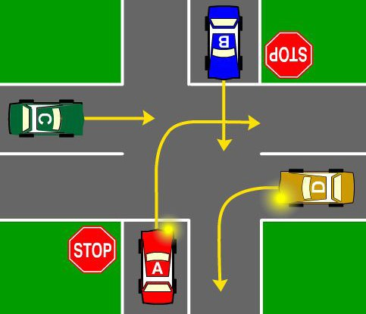 | 140. You are driving Car A. You must give way to - | A. Cars C then B, make sure D is turning left  B. Cars B and D  C. Cars D, C and B D. Cars D and C  (p. 24)
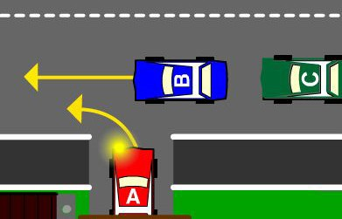 | 141. You are driving Car A. You must give way to - | A. Car B  B. No one, the other cars must give way to you  C. Both Cars B and C  (p. 30)

Diagram | Question | Choices (page references for answers in brackets)
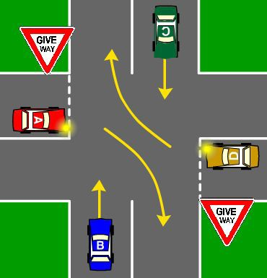 | 142. You are driving Car A. You must give way to - | A. Car D B. Car B  C. Cars B and D D. Cars B and C  (p. 25)
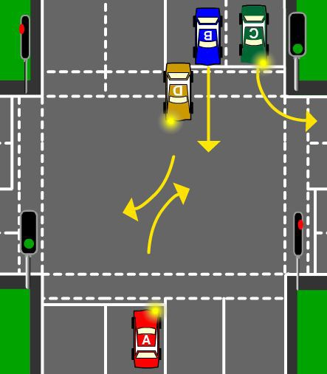 | 143. You are driving Car A. You must give way to - | A. Cars B and C B. Cars B and D C. Cars D and C  (p. 15)
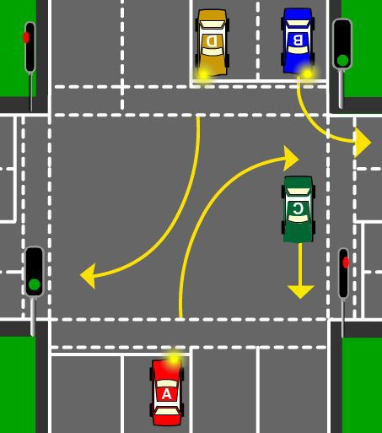 | 144. You are driving Car A. You must give way to - | A. Cars B and C B. D and C  C. Car C D. Car D  (p. 16)
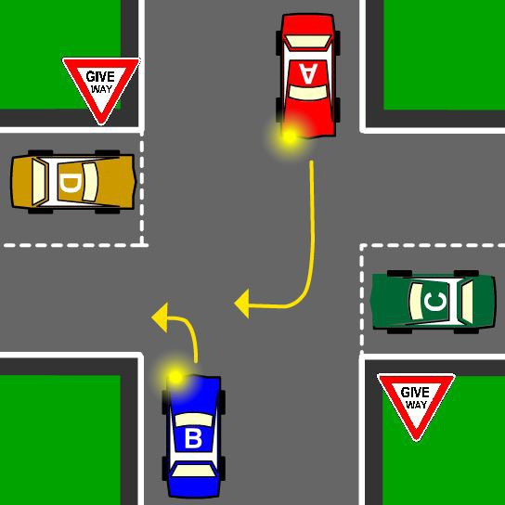 | 145. You are driving Car A. You must give way to - | A. Car C  B. No one, the other cars must give way to you  C. Car B D. Car D  (p. 25)
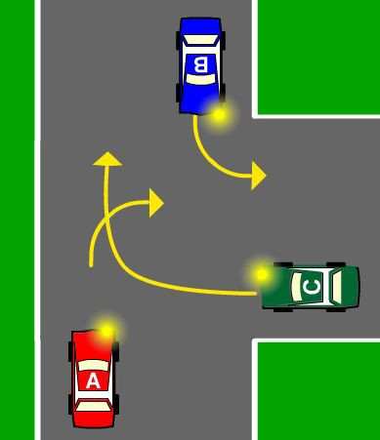 | 146. You are driving Car A. You must give way to - | A. Cars B and C B. Car B  C. Car C  (p. 26)
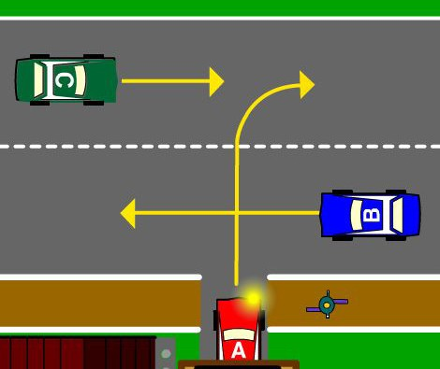 | 147. You are driving Car A. You must give way to - | A. Car C  B. Car B and the pedestrian  C. The pedestrian and Cars B and C D. Car B  (p. 30)

Driver Knowledge Test Questions
Diagram | Question | Choices (page references for answers in brackets)
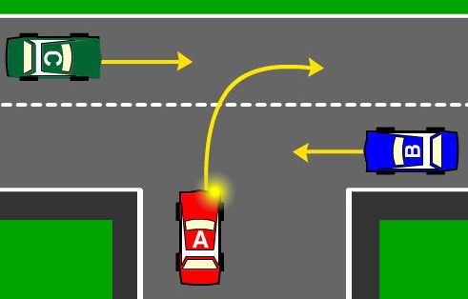 | 148. You are driving Car A. You must give way to - | A. Car C B. Car B  C. No one, the other cars must give way to you. D. Cars B and C  (p. 26)
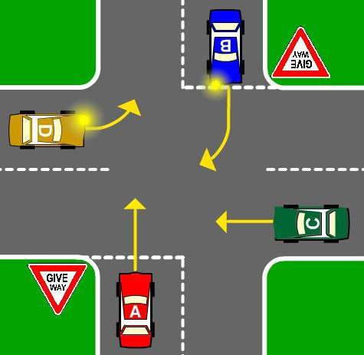 | 149. You are driving Car A. Which cars must you give way to? | A. Cars B and C  B. Cars B, C and D C. Cars D and C  D. Cars D and B  (p. 25)
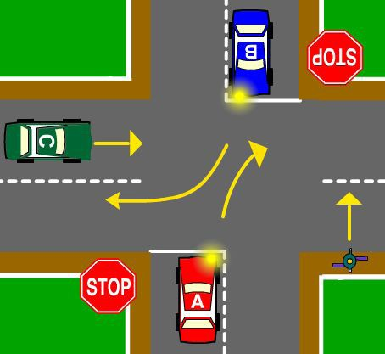 | 150. You are driving Car A. You want to turn right. You must give way to - | A. Cars B and C  B. Cars B and C and the pedestrian  C. Car C and the pedestrian  D. Car B and the pedestrian  (p. 24)
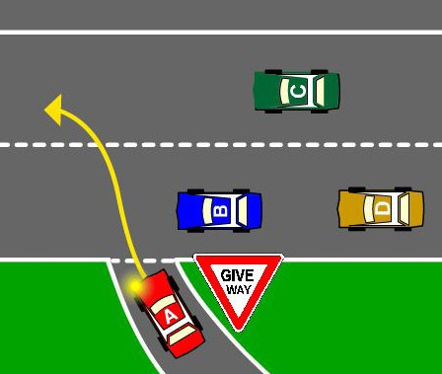 | 151. You are driving Car A. You must give way to - | A. No one (you go first)  B. Car B  C. Cars B, C and D D. Cars B and C  (p. 27)
 | 152. Can you legally drive over the speed limit? | A. Yes, at any time as long as the driver does not go over the speed limit by 10 km/h.  B. Yes, when the driver is overtaking a slower moving vehicle.  C. No.  D. Yes, when the driver has a good excuse.  (p. 1)
 | 153. When following another vehicle in a lane of traffic, what distance is a useful guide to estimate the minimum safe following distance for dry road conditions? | A. Leave a 2-second time gap between you and the other vehicle. B. Leave a 3-minute time gap between you and the other vehicle. C. Leave a 5-minute time gap between you and the other vehicle. D. Leave a 7-second time gap between you and the other vehicle.  (p. 78)
 | 154. Which one of the following statements is true? | A. Provided you do not exceed the speed the limit you are always driving safely.  B. In certain situations and conditions driving at the speed limit may be dangerous.  C. Speed limits can be exceeded by up to 10km/h if the road and weather conditions are good.  D. Speed limits can be exceeded if you have a lawful excuse.  (p. 76)

Question | Choices (page references for answers in brackets)
155. If you feel drowsy when driving what should you do? | A. Open the window and turn the radio on.  B. Drink lots of coffee whilst driving.  C. Turn the radio up loud.  D. Stop driving and have a break. (p. 75-76)
156. If you are taking prescription drugs and you want to drive, you – | A. Should check the labelling to see if it is a non-drowsy medication and only drive if it is a non-drowsy formula.  B. Can drive because it is not a recreational drug. C. Can drive during daylight hours but not at night.  D. Can drive but you should drink coffee to keep you alert. (p. 71)
157. What should you do when you see animals on the road at night? | A. Slow down and be prepared to avoid the animal. B. Sound you horn.  C. Swerve violently.  D. Speed up to pass them quickly. (p. 76)
158. Which of the following statements is true? | A. Drinking alcohol increases your concentration when driving.  B. Driving with a blood alcohol content over .05 is legal.  C. You can only drink and drive while you have your learner licence.  D. The risk of causing a crash increases as your blood alcohol content rises. (p. 68)
159. If a seatbelt has been used in a severe crash - | A. It must be replaced.  B. It needs to be tested by a mechanic.  C. It is still fine to be worn.  D. It can be worn as long as it doesn’t look damaged. (p. 72)
160. Which of the following statements is correct? | A. If you have been drinking alcohol, it is better not to drive.  B. Taking prescribed drugs may reduce the effects of alcohol on the body. C. Drinking coffee helps reduce the effects of alcohol on your body.  D. Having a shower may reduce the effects of alcohol on your body.  (p. 69)
161. Can medication used for hay fever or travel sickness affect your driving? | A. No, unless it has been prescribed by a doctor.  B. No C. Yes.  D. Yes, but only if you’ve had no sleep the night before  (p. 71)
162. What should you do when driving in wet conditions? | A. Drive with the handbrake on.  B. Drive closer to vehicles to avoid back splash from the other vehicle.  C. Slow down as you need to allow much longer for stopping to avoid other vehicles and pedestrians. D. As long as you are driving at the speed limit, you are driving safely.  (p. 76, 82)
163. Speeding is dangerous because - | A. The faster you drive the more time and space you need to stop. B. Increasing speed also increases the severity of crashes.  C. Driving too fast around a corner can affect the car’s stability. D. All of the above.  (p. 77)

Driver Knowledge Test Questions
Question | Choices (page references for answers in brackets)
164. If an oncoming car’s headlights dazzle you, what should you do? | A. Keep driving and looking at oncoming lights, your eyes will adjust.  B. Put your high beam on.  C. Keep your eyes on the left-hand side of the road, slow down or stop. D. Turn your lights off.  (p. 42)
165. Which of the following statements is true? | A. Driving with a talkative passenger will overcome your fatigue.  B. You will feel more tired if you make stops on long trips.  C. You are more likely to become fatigued on short curving roads.  D. You should not drive if you are tired.  (p. 74)
166. If one of your tyres has a blowout what should you do? | A. Accelerate to regain control.  B. Quickly apply the hand brake.  C. Brake gently and bring the car to a stop.  D. Sound your horn.  (p. 82)
167. Which of the following statements is true? | A. If there are not enough seat belts then it is OK to share one.  B. Passengers in rear seats of a vehicle are not required to wear seat belts.  C. It is OK to hold the seat belt around you if you cannot find the clasp under the seat to secure it properly.  D. Passengers in vehicles are less likely to be injured in a crash if they are wearing seat belts.  (p. 71)
168. Which of the following statements is true? | A. Ornaments hanging from the rear view mirror will stop you becoming fatigued when you are driving.  B. Sunglasses worn at night will reduce the glare from the headlights of oncoming vehicles.  C. You should take extra care looking for cyclists or pedestrians at night.  D. You should rev your engine when approaching a cyclist to alert them of your approach.  (p. 42, 74, 78, 79)
169. Which statement is true? | A. Speeding never causes crashes.  B. Factors like road and weather conditions can affect a car’s stopping distance. C. It is legal to travel 10 km/h over the speed limit.  D. When it’s raining, you need to reduce your following distance.  (p. 77)
170. Which one of the following statements for a car learner driver is correct? | A. You must have only one passenger in the car. B. You must drive only during daylight hours.  C. You need to get lots of supervised driving experience in a variety of road conditions  (p. 77)

