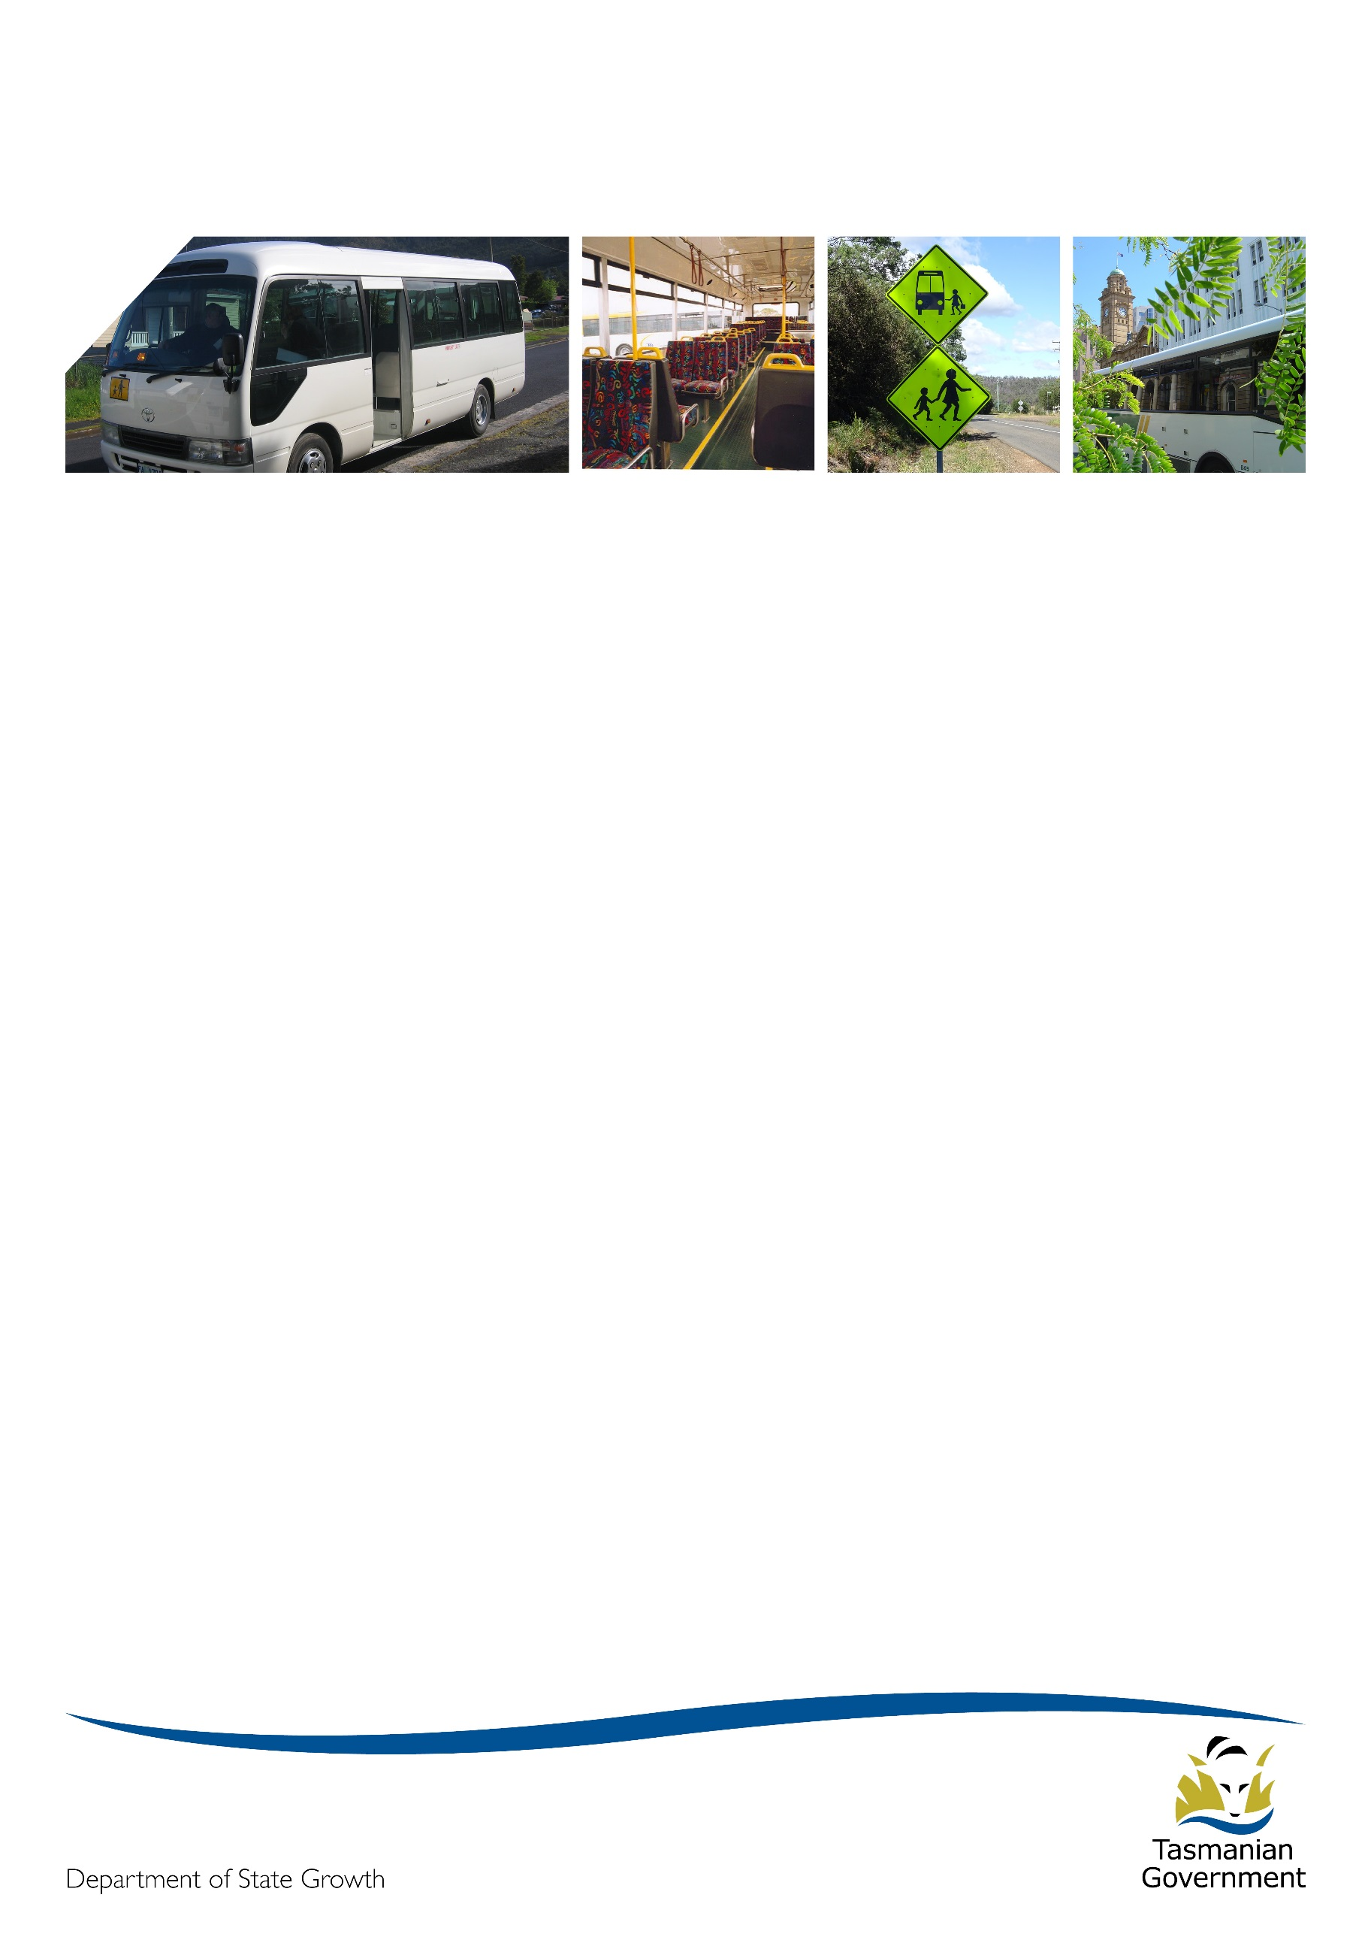Transporter

# January 2018

# Summer fun times!

Happy New Year!

2018 has arrived with a burst of hot summer days. Hopefully you had a break over the Christmas and New Year period and are feeling refreshed and energised from long, lazy days at the beach and enjoying the time to make use of your Christmas presents.

The year ahead is uncharted territory with interim contracts coming into effect prior to the new contracts commencing in 2019. We look forward to the challenges and rewards this year will herald.

# Project 2018 update

On the school bus front, the last two months have been largely consumed with negotiations around the Early Exit Program. This Program has involved complex negotiations and consultations with operators, schools and parents all around the State and, despite some local difficulties, has resulted in the signing of 26 exit deeds and 37 variation deeds which should greatly reduce the impact next year of service changes on both operators, schools and parents.

However this work is not finished, as we are busy preparing communications to be sent out to schools to remind parents of school route and timetable changes before the start of the 2018 school year. This will include the publication of online maps and timetables for every school route that will change so that schools and operators can share this information.

Due to the large workload involved in the Early Exit Program, and also reflecting that many operators take a break over the Christmas period, we decided to suspend Operator Matching Decisions until after the start of term one this year. We are still expecting publication of matching decisions to recommence in the week starting 5 February.

As a reminder, details of the Operator Matching Process can be found at this URL:

<http://www.transport.tas.gov.au/project2018/public_transport_bus_services_procurement>

The actual register of decisions is available at:

<http://www.transport.tas.gov.au/project2018/public_transport_bus_services_procurement/register_of_decisions>

There is not much to report on regarding the contracts and funding model negotiations, however if discussions with the TasBus negotiating team go well over the next two weeks the project team is hoping to get sign off on the final draft of both the contract and funding model in the next month. The intention would then be to do a series of consultation and briefing sessions around the State where the team presents both the contract and school bus funding model to operators for questions and feedback before the final version is confirmed.

Understanding your Schedule 4

Occasionally, we get questions regarding bus contract payments. The diagram below will hopefully demonstrate how to read the payment Schedule relating to Rural School Bus or Special Needs contracts. Remember that you are equally responsible for making sure your operated trips match your contracted route maps, timetables and payment schedule and for making sure the payment details match your route and timetable details.



Specified in the contract

Capital Payment is not affected by the BCMI

Gross Price using BCMI of 100.0.

To work out current payment: Non Capital + Performance / 100.0 x current BCMI + Capital

Student bus fares 2018

As previously advised, the student fare for 2018 will remain at $1.70.

Fare-paying students can still access the discounted fare of $1.36 by purchasing a 10-ride ticket or by using electronic ticketing where available.

Offering food to students on buses

Whilst it is a thoughtful and generous sentiment, especially at Christmas time, food of any kind should not be offered or shared with students on the school bus. Food allergies present a significant health risk and the safest option, to ensure there are no unfortunate incidents, is to refrain from having food available to students on the bus.

Bus cost model index (BCMI)

The BCMI has been calculated for January 2018 and is 122.9.

Capital rates

The Capital Payment rates have been calculated for the quarter commencing January 2018. Please consider these rates before requesting bus changes on your contract.

For all fare-paying operators, the rates applicable to your monthly contract payment can be found on your Statement of Payment.

We realise that the changes to capital rates may have an impact on your planning for the school year ahead, and so have decided that these rates will not come into effect until 12 February 2018.

|  |  |  |
| --- | --- | --- |
| Contract Type | October 2017 | January 2018 |
| Urban Fringe Student Only | $1.23 | $1.01 |
| Rural Fare Paying | $1.23 | $1.01 |
| Long Distance Student Only | $1.23 | $1.01 |
| Long Distance General Access | $2.90 | TBA |
| Urban Fringe General Access | $2.90 | TBA |
| Urban | $0.77 | $0.86 |
| Town | $0.77 | $0.86 |

# Contacting Passenger Transport

For all enquiries or notifications relating to your current contract (i.e. a service you currently provide) contact Passenger Transport via email [ptscontracts@stategrowth.tas.gov.au](mailto:ptscontracts@stategrowth.tas.gov.au) or phone 6166 3343.