Cycle Route Directional Signage Example

Department of Infrastructure, Energy and Resources
This is an example of the process that can be used to map and plan the direction signs required to navigate along a cycle route. The example used is the Battery Point section of the Sandy Bay to Hobart and return route.
SANDY BAY TO HOBART – FOCAL POINT MAP
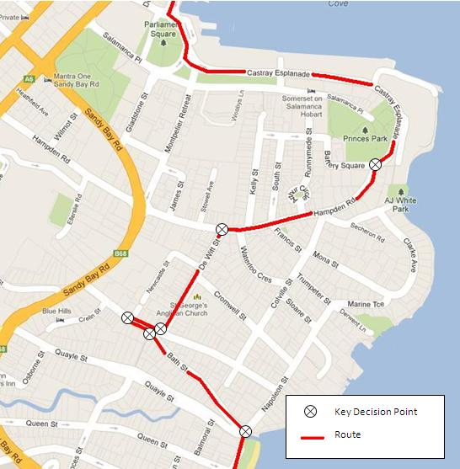

HOBART TO SANDY BAY – FOCAL POINT MAP
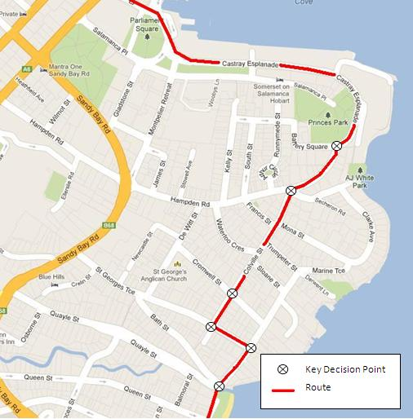
ROUTE SIGNING SUMMARY
Sandy Bay to Institute for Marine and Antarctic Studies (IMAS)/Hobart
Area | Sign | Observations/Instructions
Jcn Bath St/Napoleon St | Fingerboard  IMAS  Hobart | - Cycle route direction sign can be mounted to existing stop sign pole as it does not interfere with sighting the stop sign.  - Street name sign must go above cycling direction sign. There needs to be at least a 2.5metre clearance between the bottom of the cycle route sign and the ground. Therefore longer pole may need to be installed.  - There should be a 15cm gap between bottom of street naming sign and top of next sign.
Jcn Bath St and St Georges Tce | Fingerboard  IMAS  Hobart | - Street sign can be added to wall at the same height as the one way sign.
Jcn St Georges Tce(one way part) and St Georges Tce (two way part) | Fingerboard  IMAS  Hobart | - Add cycle route sign to existing pole with parking instruction sign attached.  - There must be a clearance of at least 2.5metres between the bottom of cycle route sign and footpath.
Jcn St Georges Tce and De Witt St | Fingerboard  IMAS  Hobart | - Cycle route sign can be mounted to existing pole.  - Street name sign must go above cycling direction sign. There needs to be at least a 2.5metre clearance between the bottom of the cycle route sign and the footpath. Therefore longer pole may need to be installed.  - There should be a 15cm gap between bottom of street name sign and top of cycling direction sign.
Jcn De Witt St and Hampden Rd | Fingerboard  IMAS  Hobart | - No suitable existing pole/infrastructure.  - Erect new pole for cycle route sign. Possibility to move street name sign to new pole to be more in line of sight of approaching drivers.
Jcn Hampden Rd and Castray Esp | Fingerboard  IMAS  Hobart | - Cycle route sign can be mounted to existing pole.  - Street name sign must go above cycling direction sign. There needs to be at least a 2.5metre clearance between the bottom of the cycle route sign and the ground. Therefore a longer pole may need to be installed.  - There should be a 15cm gap between bottom of street name sign and top of cycling direction sign.
IMAS/Hobart to Sandy Bay
Jcn Castray Esp and Hampden Rd | Fingerboard  Sandy Bay  University | - No suitable existing pole/infrastructure.  - Erect new pole for cycle route sign. Possibly move street name signs to new pole so that they are more in motorist’s line of sight and to minimise infrastructure.  - There should be a 15cm gap between bottom of street name sign and top of cycling direction sign.
Jcn Hampden Rd and Colville St | Fingerboard  Sandy Bay  University | - No suitable existing pole/infrastructure.  - Erect new pole for cycle route sign.  - Make sure mirror is not obscured by new sign.
Intersection Colville St and Cromwell St | Reassurance Sign  Sandy Bay  University | - Reassurance direction style of sign, consider need for direction arrow.  - Cycle route sign can be attached to existing pole.
Intersection Colville St and St Georges Tce | Fingerboard  Sandy Bay  University | - Cycle route sign can be mounted to existing pole site.  - Longer pole needs to be erected as there is insufficient room above current attached signs.
Intersection St Georges Tce and Napoleon St | Fingerboard  Sandy Bay  University | - Permission has to be given by owner of utility pole when mounting anything to it.  - If approved by utility owner, mount cycle sign to existing power pole.  - If needed, mount cycle sign on separate pole behind safety barrier.
Napoleon St – halfway down | Advance Direction Sign  Sandy Bay  University | - No suitable existing pole/infrastructure.  - Erect new pole with sign attached.
Jcn Napoleon St and Quayle St | Fingerboard  Sandy Bay  University | - Mount sign to guardrail

SITE LOCATIONS – Sandy Bay to the Institute for Marine and Antarctic Studies (IMAS) and Hobart
Please note: These pictures are examples only and signs are not constructed to correct measurements and clearances. Some observations are noted below the pictures, however, when signing cycle routes; further reference to the Australian Standards, the Cycle Route Directional Signage Manual and other local manuals/instructions (where applicable) should be made before erecting signage.
Junction of Bath St and Napoleon St, Battery Point
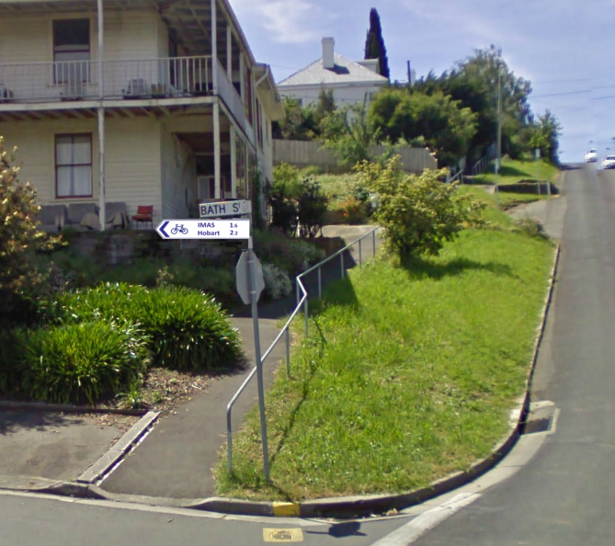

- Cycle route direction sign can be mounted to existing stop sign pole as it does not interfere with sighting the stop sign.
- Street name sign must go above cycling direction sign. There needs to be at least a 2.5 metre clearance between the bottom of the cycle route sign and the ground. Therefore a longer pole may need to be installed.
- There should be a 15cm gap between bottom of street naming sign and top of next sign.

Junction of Bath St and St Georges Tce, Battery Point
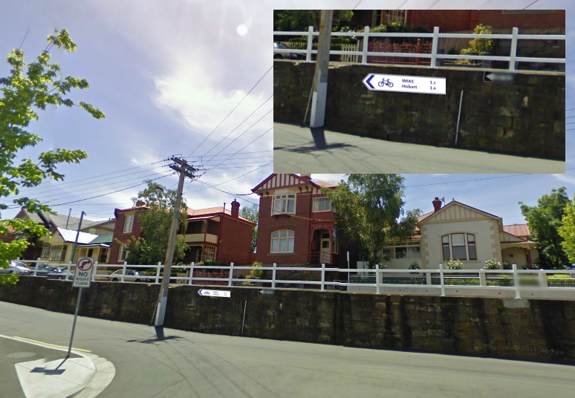

- Street sign can be added to wall at the same height as the one-way sign.

St Georges Tce, Battery Point
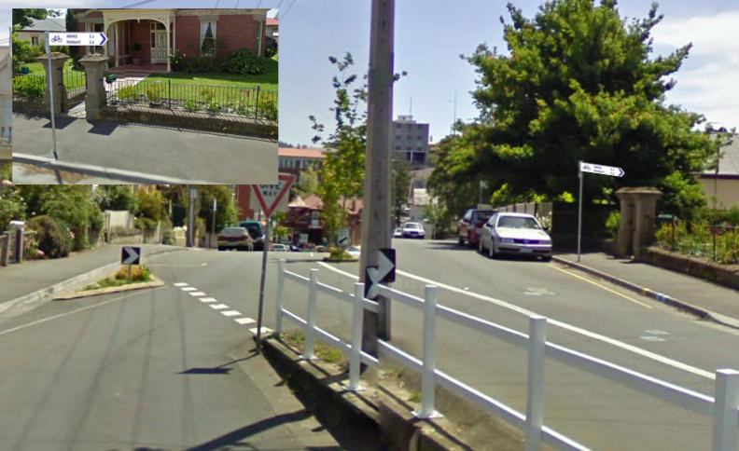

- Add cycle route sign to existing pole with parking instruction sign attached.
- There should be a clearance of at least 2.5 metres between the bottom of cycle route sign and footpath.

Junction of St Georges Tce and De Witt St, Battery Point
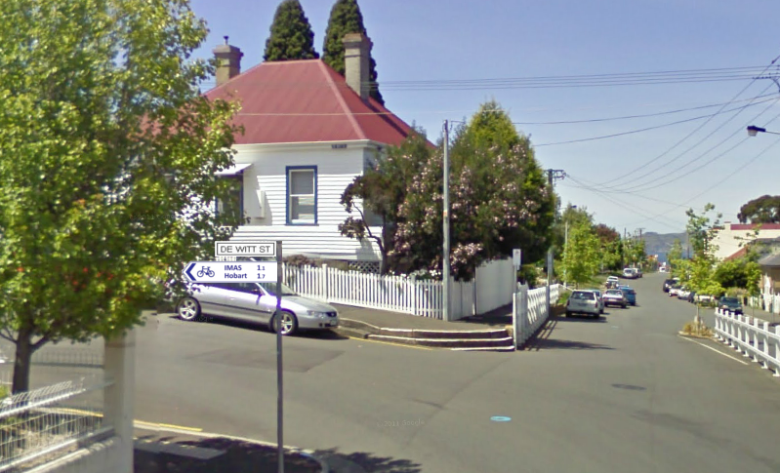

- Cycle route sign can be mounted to existing pole.
- Street name sign must go above cycling direction sign. There needs to be at least a 2.5 metre clearance between the bottom of the cycle route sign and the footpath. Therefore a longer pole may need to be installed.
- There should be a 15cm gap between bottom of street name sign and top of cycling direction sign.

Junction of De Witt St and Hampden Rd, Battery Point
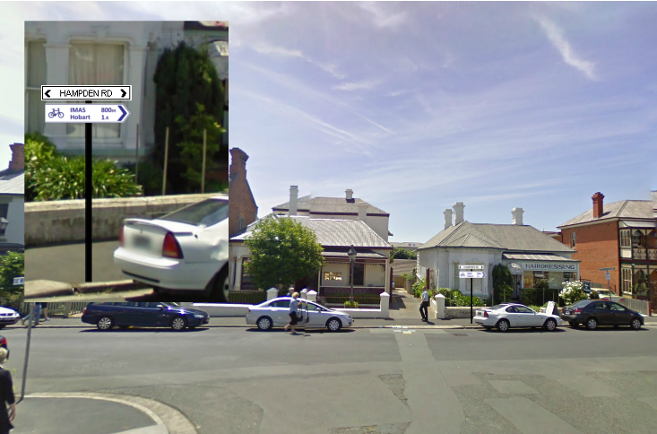

- No suitable existing pole/infrastructure.
- Erect new pole for cycle route sign. Possibility to move street name sign to new pole to be more in line of sight of approaching drivers.

Junction of Castray Esp and Hampden Rd, Battery Point
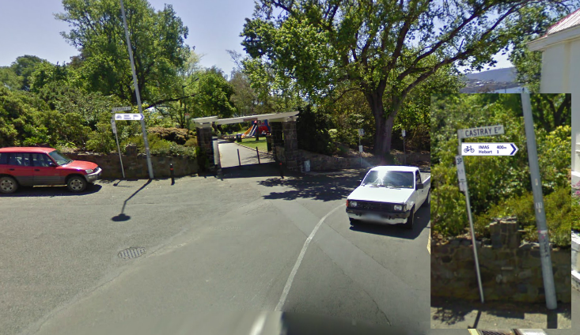

- Cycle route sign can be mounted to existing pole.
- Street name sign must go above cycling direction sign. There needs to be at least a 2.5 metre clearance between the bottom of the cycle route sign and the ground. Therefore a longer pole may need to be installed.
- There should be a 15cm gap between bottom of street name sign and top of cycling direction sign.

SITE LOCATIONS – The Institute for Marine and Antarctic Studies (IMAS) to Sandy Bay and University
Junction of Castray Esp and Battery Square, Battery Point
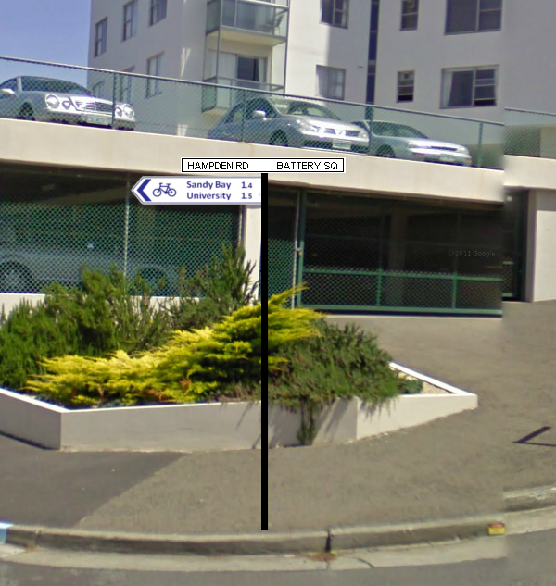

- No suitable existing pole/infrastructure.
- Erect new pole for cycle route sign. Possibly move street name signs to new pole so that they are more in motorist’s line of sight and to minimise infrastructure.
- There should be a 15cm gap between bottom of street name sign and top of cycling direction sign.

Junction of Hampden Rd and Colville St, Battery Point
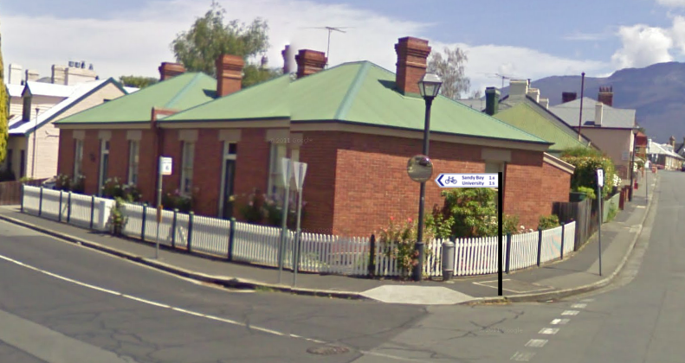

- No suitable existing pole/infrastructure.
- Erect new pole for cycle route sign.
- Ensure mirror is not obscured by new sign.

Intersection of Cromwell St and Colville St, Battery Point
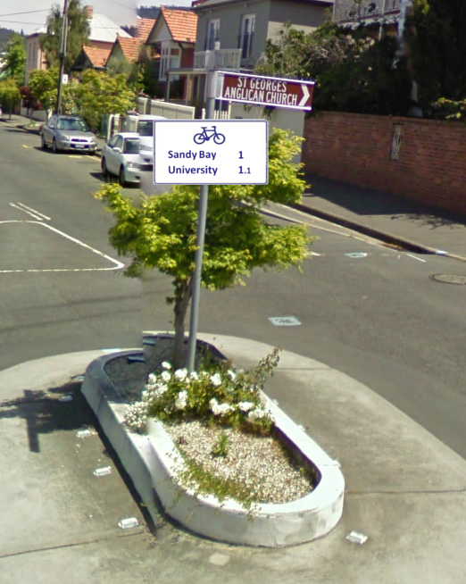

- Reassurance direction style of sign, consider need for direction arrow.
- Cycle route sign can be attached to existing pole.

Intersection of Colville St and St Georges Tce, Battery Point
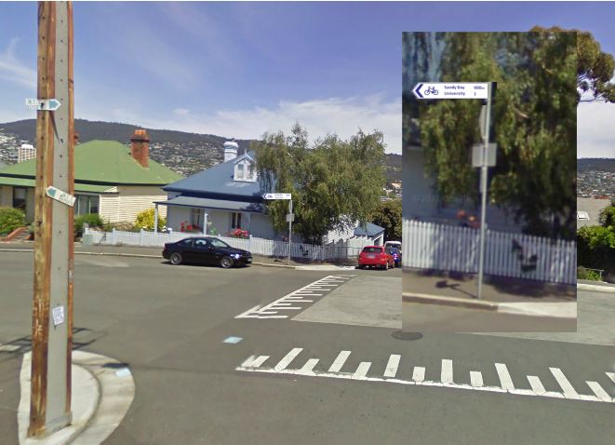

- Cycle route sign can be mounted to existing pole site.
- A longer pole needs to be erected as there is insufficient room above current attached signs.

Junction of St Georges Tce and Napoleon St, Battery Point
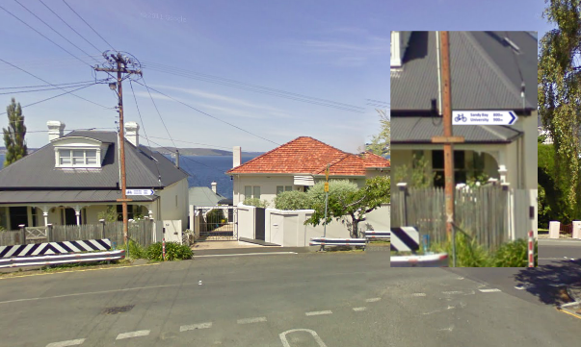

- Permission has to be given by owner of utility pole when mounting anything to it.
- If approved by utility owner, mount cycle sign to existing power pole.
- If needed, mount cycle sign on separate pole behind safety barrier.

Napoleon St, Battery Point
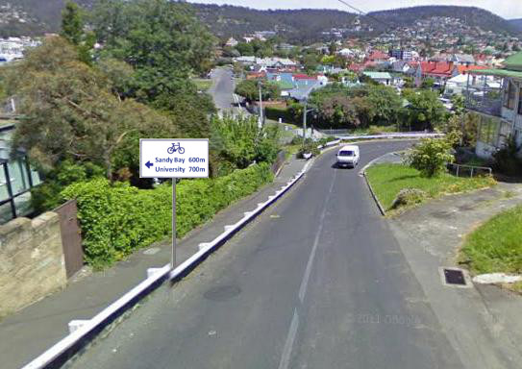

- No suitable existing pole/infrastructure.
- Erect new pole with sign attached.

Corner of Napoleon St and Quayle St, Battery Point
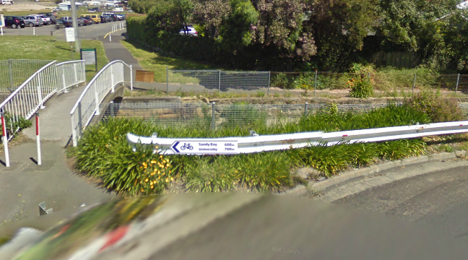

- Mount sign to guardrail

