Launceston
Traffic Review
  - Transport Issues Paper

November 2012
Department of Infrastructure,
Energy and Resources
Contents
Executive Summary 3
Terms and Definitions 7
1. Introduction and background 8
1.1. Background 8
1.2. Study Area 8
1.3. Transport Network 10
1.3.1. State Road Network 10
1.3.2. Local Road Network 12
1.4. Review of Previous Reports 14
1.4.1. Launceston Area Transportation Study (1968) 14
1.4.2. Launceston Traffic Model (1999, 2007) 15
1.4.3. Northern Tasmanian Integrated Transport Plan (2003) 16
1.4.4. Pulp Mill Transport Impact Assessment (2007) 16
1.4.5. Bell Bay Pulp Mill Launceston Traffic Study (2012) 17
1.4.6. Goderich Street/ Lindsay Street Intersection Modelling (2012) 18
1.4.7. Charles Street/ Esplanade Intersection Assessment (2012) 18
1.4.8. Traffic Management Options Study, Kings Meadows (2012) 19
1.4.9. Stakeholder Concerns 19
2. Traffic Volumes 21
2.1. Existing Traffic Volumes 21
2.2. Council Cordon Movement Data 23
2.3. Impact of Proposed Developments 24
3. Road Safety Performance 25
3.1. Overall Crash Trends 25
3.2. Intersection Crashes 28
3.3. Mid-Block Crashes 32
4. Travel Time Analysis 34
4.1. Travel Time Reliability 34
4.2. Travel Time Surveys 34
5. SCATS Congested Minutes Analysis 16
5.1. Introduction 16
5.2. SCATS Congested Minutes 16
5.3. Methodology 17
5.4. Results and Analysis 18
6. Freight Demand 28
6.1. Overview 28
6.2. Freight Routes 28
6.3. Freight Road Safety Analysis 31
7. Conclusions 32
7.1. Traffic Volumes 32
7.2. Road Safety Performance 32
7.3. Travel Time Analysis 33
7.4. Congested Minutes Analysis 33
7.5. Freight Demand 34
8. Recommendations 35
8.1. North Esk River Crossing 35
8.2. East-West Connectivity 35
8.3. Wellington Street/ Bathurst Street Couplet 36
8.4. Hobart Road 36
Appendix A- Travel Time Survey Routes 39
Appendix B- List of intersections analysed in SCATS congested minutes report 42
References 44

Executive Summary
The Department of Infrastructure Energy and Resources (DIER) and Launceston City Council (LCC) engaged Sinclair Knight Merz (SKM) to produce a Launceston Traffic Review for the City of Launceston. The purpose of this report was to analyse the performance of the existing transport network. The report presents quantified traffic and transport data as a basis for informed decision making for future transport infrastructure projects in Launceston urban area.
The project focused on technical assessments of existing traffic conditions, with analysis of the following sets of data providing the basis of the recommendations:
- Traffic Volume Data
- Crash Data
- Travel Time Data
- SCATS (Congestion) Data
- Freight Demand
The aim of the Report was to identify the key problem zones which require further investigation. The report is based on historical technical data and only issues identified through this data set are discussed in the report. It is acknowledged that trends may appear in the future and it is recommended that this assessment be undertaken on a regular basis.
The major outcome of this report was the identification four key problem zones:
- North Esk river crossing
- East-west connectivity
- Wellington/ Bathurst Street Couplet
- Hobart Road
The two bridges over the North Esk River, Charles Street and Victoria Street bridges, are experiencing relatively high traffic demands. Charles Street Bridge also carries a high volume of freight. The two bridges operate at a relatively high level of congestion during peak periods. The road safety assessment also identified that the junction of Goderich Street/ Lindsay Street/ Charles Street had the second highest crash rate of all junction locations in the study area. With commercial development flagged in Lindsay Street, this junction will be placed under increasing pressure in the future. This report recommends that further investigations be undertaken to determine ways of reducing congestion and crash rates at the two bridges as a high priority.
One of the key findings of this study was the deterioration of travel times along the east-west routes through Launceston. The cause of this increased congestion appears to be linked to several key intersections along these routes. It is likely that the dominance of north-south freight and traffic movements has contributed to the deterioration of east-west traffic flow efficiency. The crash analysis also highlighted that the intersections of the east-west routes with the Couplet had relatively poor road safety performances. This report recommends that further investigations be undertaken to improve efficiency of east-west travel through Launceston.
The Wellington Street/ Bathurst Street couplet carries the highest traffic and freight volume of all routes through Launceston and also has the highest proportion of all crashes in Launceston. The issue of car/ heavy vehicle conflict was raised as an issue for many respondents of the ‘Your Voice, Your Launceston’ survey. This report recommends further investigation of measures to improve accessibility of the Couplet, and reduce crash rates whilst maintaining an emphasis on retaining the corridor as a strategically important freight link for Tasmania.
Hobart Road provides connectivity between Launceston CBD and Kings Meadows and Youngtown residential, commercial and industrial areas and provides an alternative connects to the Midland Highway at the Breadalbane Roundabout. With further development proposed in the Kings Meadows area, side friction will result in a decreased level of service of the corridor, as well as increased congestion along the route. Investigation of further measures is therefore recommended to ensure that congestion levels are maintained at acceptable levels along the Hobart Road corridor.
For the purposes of this project, a high level analysis was undertaken of the local road network performance and the major arterial approaches to the CBD. The initial outcomes of the study highlight four problem zones in Launceston. Some zones identify local traffic issues specific to the CBD area whilst others relate to broader issues including inter-regional freight movement. More detailed investigations are required in each of the key problem areas identified in order to draw more specific conclusions. Solutions would be progressed by the appropriate authority depending on the issues identified.
Recommended next steps:
While these next steps are not developed in this report, separate discussions between DIER and LCC have suggested that:
- A DIER/ LCC workshop to identify options to improve transport at the identified zones
- Preferred consultant to undertake Traffic modelling of options
- Options evaluated
- Preferred option agreed and identify issues that require detailed planning
- A Development stage - Project Proposal Report prepared for submission to the Australian Government for Tier 3 of Nation Building 2 by August 2013.
The Development stage - Project Proposal Report submission to the Australian Government will seek funding for planning activities included in the preliminary design for a project of regional significance.
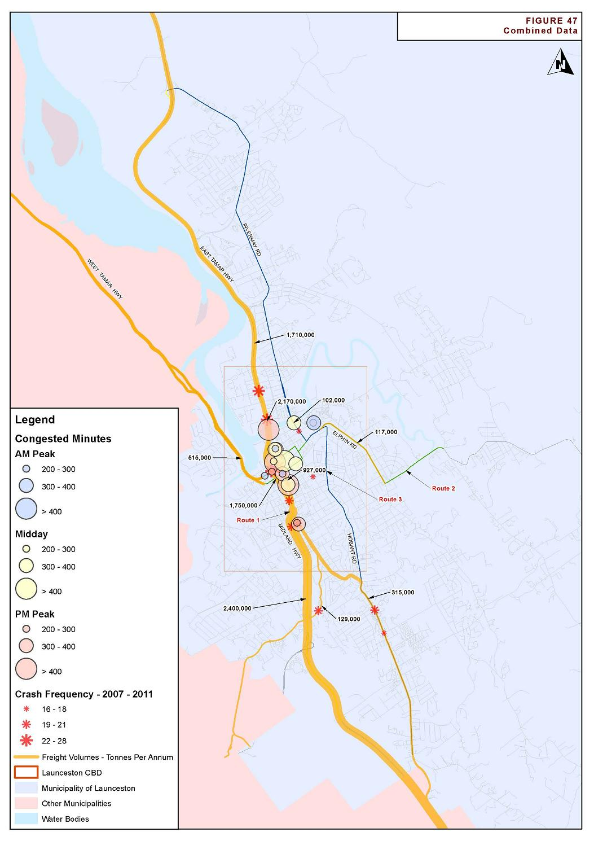

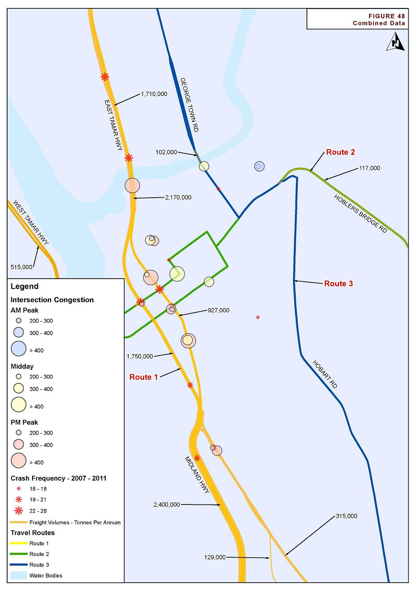

Terms and Definitions
Abbreviation | Description
AADT | Average annual daily traffic
AM | Morning peak period
CBD | Central business district
Cres | Crescent
CV | Commercial vehicle
DIER | Department of Infrastructure, Energy and Resources
Dr | Drive
E | East
HML | Higher mass limits
Hwy | Highway
IIS | Integrated Impact Statement
km | Kilometres
km/h | Kilometres per hour
LCC | Launceston City Council
m | Metres
N | North
NTITP | The Northern Tasmanian Integrated Transport Plan
PM | Afternoon or evening peak period
Pde | Parade
Rd | Road
s | Seconds
S | South
SCATS | Sydney Coordinated Adaptive Traffic System
SKM | Sinclair Knight Merz
St | Street
W | West

Introduction and background

Background
Sinclair Knight Merz (SKM) was engaged by the Department of Infrastructure Energy and Resources (DIER) and Launceston City Council (LCC) to produce a Transport Issues Paper for the city of Launceston. The project reviewed the movement of freight and traffic in the Launceston metropolitan area.
This project is part of an overall scheme to address traffic issues in Launceston and will support a number of transport strategies being produced by LCC and DIER.
The purpose of this project was to provide a quantitative base for the discussion of potential transport infrastructure projects. Analysis of the following sets of data provided the basis of the recommendations:
- Traffic Volume Data
- Crash Data
- Travel Time Data
- SCATS (Congestion) Data
- Freight Demand
The project focused on technical assessments of existing traffic conditions. It should be noted that only issues that are identified through the dataset above are considered in this report. Some preliminary public consultation regarding transport issues in Launceston has been conducted, however further consultation will be required as DIER and LCC move towards a specific Project Proposal.
The aim of the project was to identify the key problem areas in the Launceston metropolitan area. Identification and analysis of solutions to these problems will be undertaken in subsequent stages of the project.

Study Area
The study area is shown in Figure 1.

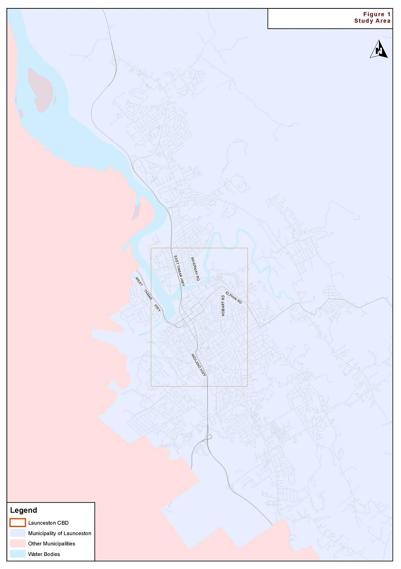

Transport Network

State Road Network
The State Road Network consists of the major roads leading into and out of Launceston. These roads, detailed in Table 1, are defined in the DIER publication, Tasmanian State Road Hierarchy, 2007. The road hierarchy classification is shown in Table 2.
- Table 1 State Road Network (DIER)
Road | Category | Comments
Midland Highway/ Southern Outlet | Category 1- Trunk Road | The Midland Highway connects between Launceston and Hobart. For the majority of its length, the Midland Highway is a two-lane, two-way rural road with overtaking lanes at regular intervals. In the vicinity of Launceston, it is a four-lane, dual carriageway highway with grade separated interchanges and is also known as the Southern Outlet.
Bass Highway | Category 1- Trunk Road | Connects between the Midland Highway, Launceston, and the north-west coast of Tasmania. For the majority of its length, the Bass Highway is a two-lane, two-way road with overtaking lanes at regular intervals. In the vicinity of Launceston, it is a four-lane, dual carriageway highway with grade separated interchanges.
East Tamar Highway | Category 1- Trunk Road | The East Tamar Highway connects between Launceston and George Town along the eastern edge of the Tamar River. For the majority of its length, the East Tamar Highway is a two-lane, two-way road with overtaking lanes at intervals. In the vicinity of Launceston, it is a four-lane, dual carriageway highway.
Goderich Street | Category 1- Trunk Road | Goderich Street connects between the Launceston Couplet and the East Tamar Highway through the suburb of Invermay. Goderich Street has four lanes.
West Tamar Highway | Category 3 – Regional Access Road | The West Tamar Highway connects between Launceston and Beauty Point along the western edge of the Tamar River. For the majority of its length, the West Tamar Highway is a two-lane, two-way road with occasional overtaking opportunities. Between Legana and Launceston, the highway is a four-lane, dual carriageway road.
Tasman Highway | Category 4 – Feeder Road | The Tasman Highway connects between Launceston and Hobart, wrapping around the state’s east coast providing access to Scottsdale and the north-east region of Tasmania. For the majority of its length, the Tasman Highway is a two-lane, two-way road.

- Table 2 Tasmanian State Road Hierarchy Definitions (DIER)
Category | Definition
Category 1- Trunk Road | Trunk Roads are the State’s major highways and are crucial to the effective functioning of Tasmanian industry, commerce and the community. They carry large numbers of heavy freight and passenger vehicles and are the key links supporting future economic development in Tasmania.  Trunk Roads facilitate:  -inter-regional freight movement; and  -business interaction.  The Trunk Roads connect the largest population centres, major sea and air ports, and key industrial locations.
Category 2 – Regional Freight Routes | Regional Freight Roads link major production catchments to the Trunk Roads -for example, the Circular Head, Dorset, Huon Valley and Derwent Valley areas. They carry a large number of both heavy freight and passenger vehicles. Together with Regional Access Roads, they provide safe and efficient access to Tasmania’s Regions.  Regional Freight Roads facilitate:  -heavy inter-regional and sub-regional freight movement;  -passenger vehicle movement;  - commercial interaction; and  - tourist movement.  They are also the Tasmanian Government’s preferred heavy freight vehicle routes where alternative routes exist.
Category 3 – Regional Access Road | Regional Access Roads are of strategic importance to regional and local communities and economies; they link important towns to the Category 1 and Category 2 roads. While they are used by heavy freight vehicles, this use is less than that of Regional Freight Roads. Together with Regional Freight Roads, the Regional Access Roads also provide safe and efficient access to Tasmania’s Regions.  Regional Access Roads facilitate:  -connection of smaller regional resource bases with trunk and regional freight roads;  -local commercial interaction;  -sub-regional and inter-regional freight movement by connecting with trunk and regional freight roads;  -sub-regional passenger vehicle movement and connection to trunk and regional freight roads; and  -sub-regional tourist movement and connection to trunk and regional freight roads.
Category 4 – Feeder Road | Feeder Roads provide safe passenger vehicle and tourist movement within the regions of Tasmania. Where the main road servicing the town is a State Road, Feeder Roads connect towns with a population of around 1,000 or more to Trunk, Regional Freight and Regional Access Roads.  While some of these roads currently carry heavy freight traffic, they duplicate existing Trunk Regional Freight or Regional Access Roads and are not DIER’s strategically preferred heavy vehicle routes.  Feeder Roads facilitate connection to Trunk, Regional Freight and Regional Access roads for:  -local commercial interaction;  -local freight movement;  -smaller regional resource bases;  -local passenger vehicle movement; and  -tourists and major tourist destinations.
Category 5 –Other Road | Other Roads are primarily access roads for private properties.  Some may be used for comparatively low frequency heavy freight vehicle transport, for example:  -log transport – but they are not the most important log transport roads, and experience fluctuation in use; and  - farm property access – for purposes including delivery of fuel and supplies, stock transport, crop delivery and milk pick-up.  While a few of these roads may currently carry larger numbers of heavy freight vehicles, they may duplicate existing Trunk, Regional Freight or Regional Access Roads and are not DIER’s strategically preferred heavy freight vehicle routes.

Local Road Network
The Local Road Network consists of the major roads running through Launceston. All roads in the local road network are Council owned and maintained, and are categorised according to their traffic carrying and access function in the Launceston Planning Scheme 1996.
The main local roads considered as part of this report are detailed in Table 3. The road hierarchy classification according to the Planning Scheme is shown in Table 4.

- Table 3 Launceston City Council Road Network
Road | Category | Comments
Launceston Couplet | Class 1- Primary Arterial | Consists of Wellington Street, travelling in the southern direction, and Bathurst Street, in the northerly direction. Connects between Goderich Street at the Charles Street Bridge and the Southern Outlet, providing the main north-south transport corridor through Launceston.  Three lanes travelling in each direction, with additional turning lanes at key intersections. Substantial amount of on-street parking and pedestrian infrastructure available. Traffic signals provided at most major intersections.
Cimitiere Street | Class 2- Sub Arterial | Connects between the Launceston Couplet and Racecourse Crescent. The Cimitiere Street/ Launceston Couplet connection only allows access to and from the south. Access from the north is via either the Esplanade or William Street.
Elphin Road | Class 1- Primary Arterial | Connects between Brisbane Street and the Hoblers Bridge Road/ Penquite Road intersection, providing access to the eastern suburbs of Launceston.
Hoblers Bridge Road | Class 1- Primary Arterial | Connects between Elphin Road and the Tasman Highway/ St Leonard’s Road roundabout.
George Town Road | Class 1- Primary Arterial- East Tamar Highway- Lilydale Road  Class 2- Sub Arterial- Lilydale Road- Grubb Street | Connects between the East Tamar Highway (via the Newnham Link) and Grubb Street in Mowbray.
Invermay Road | Class 2- Sub Arterial | Connects between Tamar Street, Launceston, and Grubb Street, Mowbray, through the suburb of Invermay.
Vermont Road/ Wildor Crescent | Class 3- Collector | Connects between Invermay Road, Mowbray and Henry Street, Ravenswood, providing an alternative route around the north-east of the city.
Ravenswood Road | Class 3- Collector | Connects between Henry Street, Ravenswood, and the Hoblers Bridge Road slightly north of the Tasman Highway/ St Leonard’s Rd roundabout.
Boland Street | Class 2- Sub Arterial | Connects between Esplanade and Racecourse Crescent.
Henry Street | Class 3- Collector | Connects between Boland Crescent and Vermont Road, providing access to Ravenswood.

- Table 4 Road Hierarchy Classifications, Launceston Planning Scheme
Category | Definition
Class 1- Primary Arterial | Regional roads of State importance and/ or provide inter-urban links
Class 2- Sub Arterial | Provide accessibility to outlying areas and/ or significant intra-urban links
Class 3- Collector | Collector/ distributor roads that link local roads to arterial and sub-arterial roads
Class 4- Local | Primarily property access or local traffic carrier

Review of Previous Reports
A number of studies have been commissioned over several decades to identify the transport issues surrounding the City of Launceston including those examined in the following sections.

Launceston Area Transportation Study (1968)
The Launceston Area Transportation Study was completed in December, 1968, by P. G. Pak-Poy & Associates and formed the basis for many of the arterial road links that have since been constructed in and around Launceston. The study developed transport plans for the design year of 1987.
The study examined historical traffic counts, existing and future land use, and population growth to develop recommendations for new routes through and around the City of Launceston. Specifically, the study recommended the construction of the following arterial road links:
- The West Tamar Expressway, connecting from the York Street/ Brisbane Street couplet to the existing West Tamar Highway, and involving the construction of the Paterson Bridge adjacent to Kings Bridge. This project was completed.
- The East Tamar Expressway, connecting from Charles Street to the existing East Tamar Highway north of Newnham including the Mowbray Link and the Newnham (or Alanvale) Link. This project was completed.
- The Midland Expressway, connecting from the Bathurst Street/ Wellington Street couplet to the existing Midland Highway to bypass Kings Meadows and Youngtown. This also included the Southern Outlet and the Kings Meadows Link. This project was completed.
- The Bass Expressway, connecting from the new Midland Expressway to the existing Bass Highway to bypass Prospect and Prospect Vale. This also included the Westbury Road Interchange. This project was completed.
- The Eastern Expressway, which was never constructed. It was to connect between the Midland Expressway and the East Tamar Highway, looping around the eastern side of Launceston to connect to the back of Mowbray. Much of the land required to construct this link is now no longer available, hence there is little opportunity to construct this bypass.
The study also recommended the upgrade of several existing arterial roads including Talbot Road/ High Street, Cimitiere Street, Tamar Street, Tasman Highway, Bathurst Street/ Wellington Street, Howick Street/ Connaught Crescent and Glen Dhu Street.

Launceston Traffic Model (1999, 2007)
The Launceston Traffic Model, developed by ARUP in 1999 and later revised in March, 2007, modelled existing and future traffic volumes for various road network scenarios. The modelling was undertaken using EMME2 strategic modelling software. The options considered in the modelling included:
- New road links from St Leonards Road to Henry Street and from Racecourse Crescent to Churchill Park Drive;
- Re-alignment of the Hoblers Bridge Road/ David Street intersection and a tunnel connecting David Street to Howick Street;
- The implementation of clearways along the Bathurst Street/ Wellington Street couplet;
- Modified intersection priority at the Elphin Road/ Dowling Street intersection and the Brisbane Street/ High Street intersection;
- Banning all private vehicles (buses and taxis excepted) along St John Street between Paterson Street and York Street;
- Providing on-street parking along Invermay Road, thereby reducing the capacity of Invermay Road to one lane in each direction;
- A new road link between Churchill Park Drive and Vermont Road;
- A new interchange on the Bass Highway connecting to Oakden Road near the Silverdome;
- Construction of a new bridge over the Tamar River connecting Forster Street to the West Tamar Highway;
- A new road link between the Midland Highway near the Kings Meadows Link and the Bass Highway; and
- Construction of a Launceston by-pass connecting between Youngtown and Newnham around the eastern side of the city.
The key output of the model was the change in traffic volume on the road network as a result of each of the above options.
Travel times along key routes through Launceston were recorded using the floating car technique. These travel times were used to calibrate the model and provide a good reference dataset to compare with current travel conditions.

Northern Tasmanian Integrated Transport Plan (2003)
The Northern Tasmanian Integrated Transport Plan (NTITP) was completed in 2003 through a partnership between the Tasmanian Government, Region North and member councils of Region North (Launceston, Meander Valley, Northern Midlands, West Tamar, George Town, Dorset, Break O’Day and Flinders). The NTITP is a long-term strategic plan providing the framework for a co-ordinated approach to the development of the transport system with a 20 year horizon.
The development of the NTITP involved public consultation through workshops which included representatives from industry, transport providers, State Government agencies, local Government, non-motorised transport and the general community. It also incorporated the findings of supporting road corridor and transportation studies.
The main transport issues identified through the study were:
- Resolving conflict between the movement of freight and other road users such as commuters, tourists, school buses and cyclists;
- Providing additional climbing/ passing lanes on the major regional arterial roads;
- Providing an appropriate level of bus service to rural areas;
- Developing a strategic road network based on a road hierarchy incorporating both State and local Government roads;
- Road and bridge upgrading to enable extensions to approved B-double routes;
- Reducing the high capital costs for the short-term use of rural roads and bridges by road freight;
- Encouraging a greater use of rail for the movement of heavy freight;
- Improving the road corridor between Launceston Airport and the Western Junction industrial area;
- Providing better infrastructure for non-motorised transport; and
- Integrating transport and land use planning.
The NTITP is currently being reviewed.

Pulp Mill Transport Impact Assessment (2007)
An Integrated Impact Statement (IIS) for the proposed Gunns Pulp Mill was released in 2007. As part of the IIS process, a comprehensive state-wide transport assessment was undertaken by GHD. This report detailed the traffic generation, freight logistics, impacts and mitigation measures associated with the Pulp Mill. The findings of the report are broadly summarised as follows:
- It was assessed that there will be a relatively high traffic generation associated with the construction phase of the pulp mill. The East Tamar Highway was assessed as being able to accommodate this traffic generation with some minor alterations to the mill’s access road and other potential traffic management measures.
- The worst case scenario of the Plantation Strategy without the utilisation of rail will result in some large increases in log truck volumes that may require mitigation measures on some identified routes. None of these identified routes were in Launceston.
- The preferred scenario of the Anticipated Strategy in conjunction with the use of rail results in a net decrease of log truck volumes and distance travelled on Tasmania’s roads as whole.
- There will be an increase in log truck movements associated with the ongoing operation of the existing wood chip mill at Long Reach if the pulp mill does not proceed.
Since the preparation of this Transport Assessment, many refinements have provided more certainty with regards to the various phases of the pulp mill. Several of these are discussed in the next section.

Bell Bay Pulp Mill Launceston Traffic Study (2012)
In February 2012 Midson Traffic Pty Ltd completed an assessment of the potential traffic, transport and infrastructure impacts on the Launceston City Council transport network as a result of the construction of the proposed Gunns Pulp Mill in Long Reach. The assessment included both the construction and operational phases of the Pulp Mill.
The study found that many changes which have been made to the proposed Gunns pulp mill will result in an overall decreased impact on Launceston’s transport network compared to the original proposal in 2007. These changes include:
- Gunns’ policy to use only plantation timber;
- The impacts associated with the Regional Forestry Agreement;
- Sourcing a proportion of woodchips from interstate;
- More disbursed freight movements throughout the State;
- Refined freight logistics (particularly a greater spread of operating hours);
- The use of Higher Mass Limits (HML) vehicles for freight movements; and
- The permanent closure of the Triabunna chip mill.
The study concluded minimal transport impacts will be experienced as a result of the change in log truck movements on Launceston roads. The anticipated increase in log truck movements due to the pulp mill is relatively small compared to the existing woodchip mill operations. The movement of all freight is forecast to increase on Launceston roads and the expected increase in log truck traffic associated with the pulp mill is minimal in comparison to this likely overall increase.

Goderich Street/ Lindsay Street Intersection Modelling (2012)
The Goderich Street/ Lindsay Street Intersection Modelling was completed by Midson Traffic Pty Ltd in March 2012. The report assessed the intersection of Goderich Street, Lindsay Street and Charles Street for present day and forecast traffic volumes taking into consideration future development of the land on the north-western corner of the intersection. A new hardware store, in addition to a number of other, smaller developments are proposed for the adjacent land.
SIDRA Intersection Analysis software was used to model various scenarios and three minor intersection modifications as follows:
- Option 1- Existing intersection configuration (i.e. no modifications to the intersection)
- Option 2- Ban right turns from Charles Street (south) into Lindsay Street (east)
- Option 3- Ban right turns from Goderich Street (north) into Lindsay Street (west) in addition to Option 2
- Option 4- Construct a two-lane roundabout at the intersection
The modelling indicated that Option 2 and Option 3 were both viable short-term solutions, providing reasonable reductions in delays for all vehicles. Option 4 (roundabout) was found to result in high delays for vehicles on the Lindsay Street approaches due to the high flow on the Goderich Street- Charles Street through route.
The Traffic Impact Assessment report prepared for this development concluded that major infrastructure modifications to the surrounding road network may be required in order to remove traffic from Charles Street and to provide adequate intersection performance in the future.

Charles Street/ Esplanade Intersection Assessment (2012)
Midson Traffic completed an assessment of proposed modifications to the Lower Charles Street/ Esplanade intersection in April 2012. The intersection has been identified as a potential Black Spot and modifications are proposed to remove the traffic signals to increase efficiency and reduce the incidence of crashes.
The existing Charles Street/ Esplanade intersection is a signalised T-junction. It is proposed to remove the traffic signals at the Charles Street/ Esplanade intersection and change the configuration to a left-in/ left-out only, give-way controlled junction. The existing traffic signals on Charles Street are to be converted to a pedestrian crossing on the northern side of the intersection. A key objective of the scheme is to improve traffic flow along the congested section of Charles Street, immediately south of Charles Street Bridge.
SIDRA modelling undertaken indicates the intersection is currently approaching capacity during peak times. The results indicate the proposed configuration will generally reduce delays and queues for Charles Street through movements while improving the level of service on Esplanade and reducing delays for pedestrians. A road safety assessment concluded a 13.5% reduction in total crash incidents is expected as a result of the proposed modifications.
The installation of these changes will modify traffic flow patterns on the surrounding road network. Banning right turns at this intersection will have the impact of redirecting traffic onto William Street and Lindsay Street or Forster Street. This redirection is expected to reduce total traffic on Charles Street to some extent, however modelling of these network impacts has not been undertaken. The report recommends examining the impacts of additional traffic on William Street, Lindsay Street and Forster Street in more detail prior to undertaking the junction modifications. Consultation with road users would also be required to evaluate any potential impacts that may arise from these changes.

Traffic Management Options Study, Kings Meadows (2012)
GHD completed a Traffic Management study of Hobart Road through Kings Meadows in May 2012. The report assessed the feasibility of various projects for the improvement of the Hobart Road corridor and surrounding road network.
Kings Meadows experiences heavy congestion during peak times, particularly on Hobart Road through the Kings Meadows CBD area. Launceston City Council plans to allow development of a new discount department store next to the existing Woolworths Supermarket on Hobart Road in the Kings Meadows CBD. This will generate additional traffic onto the network and will require a reconfiguration of shopping centre accesses in order to maintain an appropriate level of service.
The report assessed the proposed discount department store, concluding it can be accommodated at the site on Hobart Road in Kings Meadows. It is proposed to perform modifications to the segment of Hobart Road between Punchbowl Road/ Talbot Road and Innocent Street/ Riseley Street, including the intersections. The upgrades will involve reducing Hobart Road to a single lane, with a bicycle lane, in each direction and the provision of a central median lane. The proposed modifications provide a safer environment for both passenger cars and cyclists with a general reduction in crash rates expected.
A number of projects that might be undertaken in order to reduce the traffic on Hobart Road through the Kings Meadows CBD were also assessed. The report concluded, if all projects are undertaken, traffic volumes on Hobart Road near the Kings Meadows CBD could be reduced by approximately 20% during peak times.

Stakeholder Concerns
Whilst this study is investigating and quantifying the transport issues in Launceston, there are a number of key issues that have previously been documented in the past studies discussed above. Broadly speaking, these are:
- Congestion during peak times along the Wellington Street/ Bathurst Street couplet. The couplet connects directly between the Southern Outlet and the East Tamar Highway, as well as providing links to the CBD and the West Tamar Highway. There is a conflict between local activity and through traffic and freight along this corridor.
- There is dependence for freight traffic and through traffic to utilise the CBD road network. Reducing the reliance on this network for freight and through traffic will ultimately improve the strategy for inner city living and quality of life for residents. The reduction of traffic in these areas may create benefits of reduced congestion and greenhouse gas emissions.
- There are capacity issues at Hoblers Bridge and Elphin Road. Much traffic from the eastern suburbs (including Newstead, Ravenswood, Waverley, etc) needs to utilise this connection to travel into Launceston CBD, or other Highways. There is significant residential and commercial development proposed near this area, which is likely to compound this issue.
A stakeholder consultation survey was undertaken by Launceston City Council in June and July 2012. The survey was posted on the Council’s website “Your Voice , Your Launceston”, allowing the public to make comment over the two month period. The survey was advertised through the Examiner newspaper, local radio stations, and the Council newsletter. The survey asked 42 questions relating to traffic and transport in the Launceston area. The response rate for each of the questions varied between 3 and 77 responses.
The survey confirmed that:
- DIER and LCC’s emphasis on improving strategy and facilities for pedestrian and cycling infrastructure has a level of community support.
- Concerns about congestion were typically directed at single junctions rather than proposing radical schemes.
- There was a consistent concern raised regarding the interaction between cars and heavy vehicles.
- A different survey technique would be required to gather sufficiently large number of responses to enable generalised conclusions.

Traffic Volumes

Existing Traffic Volumes
Known traffic volumes on State roads are provided in Table 5
- Table 5 Existing Traffic Volumes, State Roads
Road | AADT | Survey Date | CV% | Compound Growth % | Comments
Midland Highway/ Southern Outlet S of Glen Dhu Connector | 25,890 | 2011 | 8.5 | 2.0 (2005-2011) | High utilisation left lane south (59%), High utilisation left lane north (61%)
Bass Highway- W of Midland Highway | 18,639 | 2010 | 8.8 | 1.5 (2005-2010) | High utilisation left lane east (82%), high utilisation left lane west (79%).
East Tamar Highway- Charles Street Bridge | 30,818 | 2010 | 14.7 | 0.4% (2003-2010)
East Tamar Highway- N of Forster Street | 25,612 | 2010 | 7.1 | -0.4 (2004-2010) | High utilisation left lane south (63%),
West Tamar Highway- 358m N of Margaret St | 24,648 | 2011 | 5.1 | 1.5 (2005-2011) | High utilisation left lane north (59%), high utilisation right lane south (56%).
Tasman Highway - W of Killafaddy Rd | 9,175 | 2011 | 4.6 | 2.0 (2005-2011)
Blessington Main Road, S of Tasman Highway | 5,941 | 2009

Known traffic volumes on Council roads are provided in Table 6.
- Table 6 Existing Traffic Volumes, Council Roads
Road | AADT | Survey Date | CV%
Launceston Couplet | 45,396 | 2011 | 7.9
Charles Street Bridge | 29,400 | 2009
Charles Street | 10,039 | 2011
Victoria Street Bridge | 19,320 | 2009
Cimitiere Street | 11,527 | 2009 | 8
Elphin Road | 16,808 | 2011
Hobart Road | 16,656 | 2011
Westbury Road | 11,612 | 2011
Frederick Street | 8,126 | 2011
Kings Bridge | 8,807 | 2011
Hoblers Bridge Road | 8,788 | 2011 | 6.5
Invermay Road | 17,014 | 2011 | 6.5
Vermont Road | 7,018 | 2011 | 10.1
Ravenswood Road | 5,135 | 2011 | 4.9
Boland Street | 14,296 | 2009 | 7
High Street | 13,376 | 2011

Council Cordon Movement Data
LCC recorded 24 hour inward and outward vehicle movements at eight key cordon locations around Launceston at six-monthly intervals (the months of March and September) between 2009 and 2011. The total vehicle movements at these locations provide an indication of background traffic growth in Launceston. The location of the cordon stations were:
- Boland Street
- Elphin Road
- High Street
- Charles Street
- Hobart Road
- Westbury Road
- Frederick Street
- Kings Bridge
The total of all traffic movements (the sum of inward and outward movements) at these locations is shown in Figure 2.
- Figure 2 Total Vehicle Movements

The month of March was consistently higher than September across the three years. An overall growth rate of 0.5% per annum was noted over the six timeframes, although seasonal variations are relatively significant and may influence these results.

Impact of Proposed Developments
Launceston is experiencing an increased rate of land use development. There are several projects that have relatively large traffic generating potential and are likely to impact on Launceston’s transport infrastructure and are therefore discussed in broad terms as follows:
- Bell Bay Pulp Mill. This potential project, situated in Bell Bay, would likely affect traffic and heavy vehicle movements through Launceston. Detailed impacts on Launceston’s transport network were investigated through the Midson Traffic report prepared for Launceston City Council in February 2012.
- Hardware store and commercial development, Lindsay Street. A large hardware store is proposed in Lindsay Street, along with a commercial subdivision. This is likely to significantly alter the traffic flows at the intersection of Lindsay Street/ Goderich Street/ Charles Street. This intersection is currently operating at a high level of saturation and therefore changes to this intersection may be required as part of the development.
- Department Store, Hobart Road. A large department store is proposed on Hobart Road in Kings Meadows. This development is likely to be a large traffic generator and may have impacts on the operation of the Kings Meadows Junction on Hobart Road. The development may also have broader impacts on the Kings Meadows interchange on the Southern Outlet, as well as the Bathurst Street connection with the Southern Outlet.
- Subdivision activity near Waverley. A large area of land is proposed to be subdivided in Waverley. This is likely to cause relatively large increases of traffic on Hoblers Bridge Road, St Leonards Road, Elphin Road and the surrounding network.

Road Safety Performance

Overall Crash Trends
DIER crash data was obtained for all crashes in the Launceston local government area between 2007 and 2011.
During this time, a total of 4,874 crashes were reported to Tasmania Police. This represents an average of 975 crashes per year over this timeframe. Of these crashes, 775 crashes (15.9%) involved injury, 224 required first aid (4.6%) and 3,875 (79.5%) resulted in property damage only (including crashes where severity not recorded).
The breakdown of crashes by year is shown in Figure 3. It can be seen that there has been a decline in the crash rate since 2009, with a higher incidence of crashes reported in 2008 and 2009. It should be noted that the scale of the total crashes has been cropped between 820 and 1,020 to highlight the differences between each year. The overall change between the years is therefore relatively minor.
- Figure 3 Crashes by Year
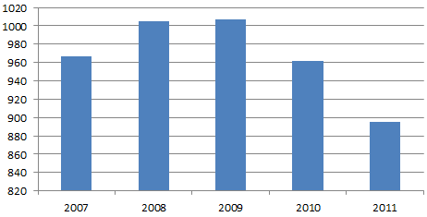
Launceston’s overall crash rates between 2007 and 2011 are similar to State crash trends, which are shown in Figure 4. Again the scale has been cropped to highlight the differences between each year. The overall crash trends for Tasmania show a peak in 2009 with a subsequent decline in 2010 and 2011.

- Figure 4 Tasmanian Total Crashes- 2007-2011

When breaking down the total crashes by month of year and day of week, no clear trends appear to be evident. A slightly higher frequency of crashes was noted during the months of May and July, and a tendency for slightly elevated crash rates towards the end of the working week were noted. The graphs of month of the year and day of the week are shown in Figure 5 and Figure 6 respectively.
- Figure 5 Crashes by Month of Year
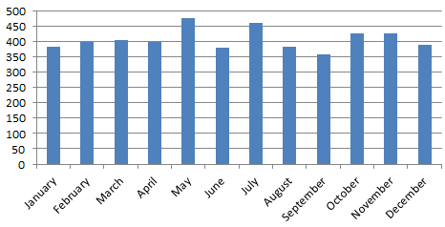
- Figure 6 Crashes by Day of Week
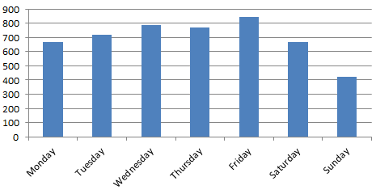
The breakdown of the severity of all crashes is shown in Figure 7. It can be seen that the majority of crashes are property damage only, and the most frequent injury crash being ‘minor injury’.
A total of ten fatalities were reported during the five year timeframe. These fatalities were relatively evenly spread over the five years, with a peak of three fatalities reported in 2011. Nine of the fatalities were reported on mid-block locations, and one at an intersection. There were no trends regarding the location or timing of the fatalities.
- Figure 7 Crashes by Severity
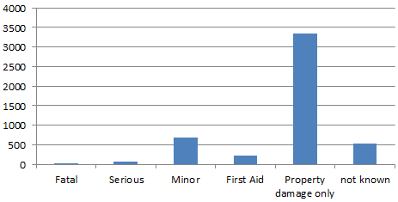
The breakdown of casualties by user groups is shown in Figure 8. Note that Figure 8 represents the total number of road users that were injured in crashes, and more than one person may be injured in one vehicle crash.
- Figure 8 Crashes by Road User Classification
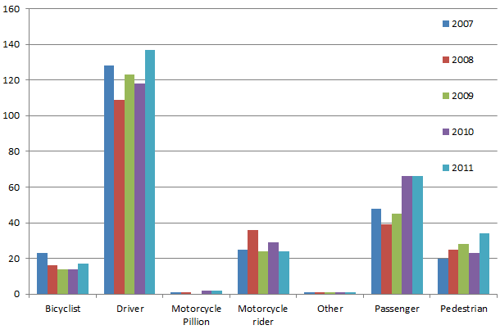
It can be seen from Figure 8 that there is a relatively high proportion of bicyclist and motorcyclist crashes reported. Whilst these road users are defined as ‘vulnerable road users’, their relative frequency of injury appears to be over-represented.

Intersection Crashes
In terms of crash locations, the most frequent crash sites were generally on higher volume roads. The most frequent intersection crash locations are summarised in Table 7.

- Table 7 Most Frequent Intersection Crash Sites (2007-2011)
Intersection Location | Frequency | Number of Injury Crashes
Brisbane/Wellington | 28 | 1
Goderich/Lindsay/Lower Charles | 27 | 5
Bathurst/Brisbane | 24 | 3
Forster/Goderich | 24 | 4
Howick/Midland | 21 | 1
Howick/Wellington | 21 | 4
Wellington/York | 20 | 3
Hobart/Innocent/Riseley | 19 | 4
Normanstone/Westbury | 19 | 2
Balfour/Bathurst | 19 | 3
Charles/Paterson | 18 | 4
Cimitiere/Tamar | 18 | 4
Hobart/Opossum | 18 | 4
Frederick/Wellington | 17 | 4
Canning/George | 16 | 4
Paterson/Wellington | 15 | 4
Cimitiere/St John | 14 | 0
Invermay/Lindsay/Tamar | 14 | 0
Bathurst/York | 13 | 4
George/York | 13 | 6
Paterson/St John | 13 | 4
Arthur/High | 12 | 2
Bathurst/Canning | 12 | 2
East Tamar/Mowbray Link | 12 | 3
Gleadow/Holbrook | 12 | 3
Brisbane/Margaret/West Tamar | 11 | 2
Canning/Wellington | 11 | 0
Charles/Cimitiere | 11 | 0
Cimitiere/Lawrence | 11 | 2
Bathurst/Frederick | 10 | 4
Elizabeth/Wellington | 10 | 1
Hobart/Kings Meadows Link | 10 | 1
Hobart/Meredith/Normanstone/Wellington | 10 | 3
Wellington/Westbury | 10 | 1
In most cases, the dominant crash types at these intersections were cross-intersection and rear-end related crashes, which are considered typical for busy urban junctions.
Figure 9 and Figure 10 show the location of intersections with greater than 15 crashes between 2007 and 2011.

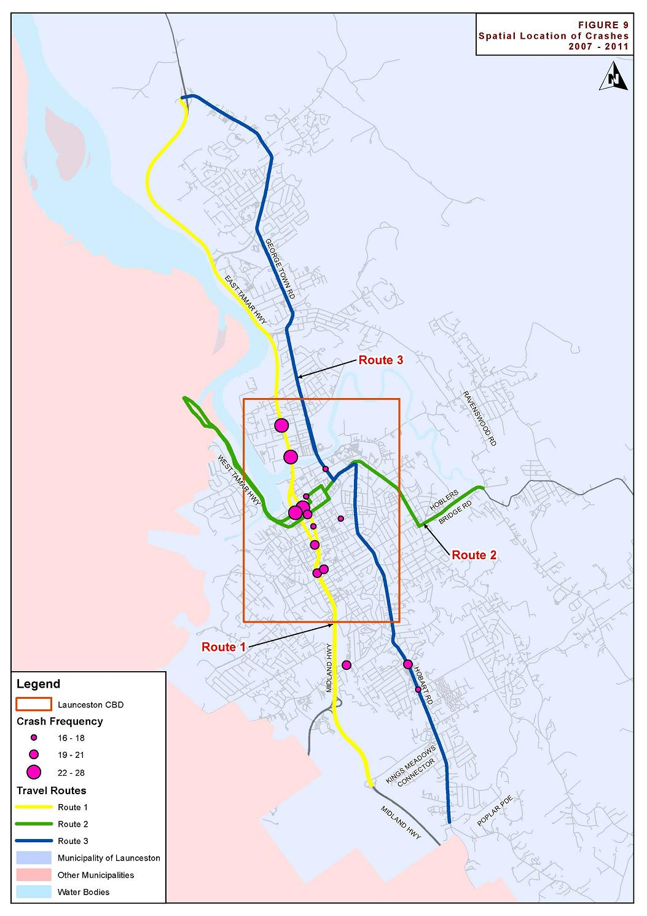

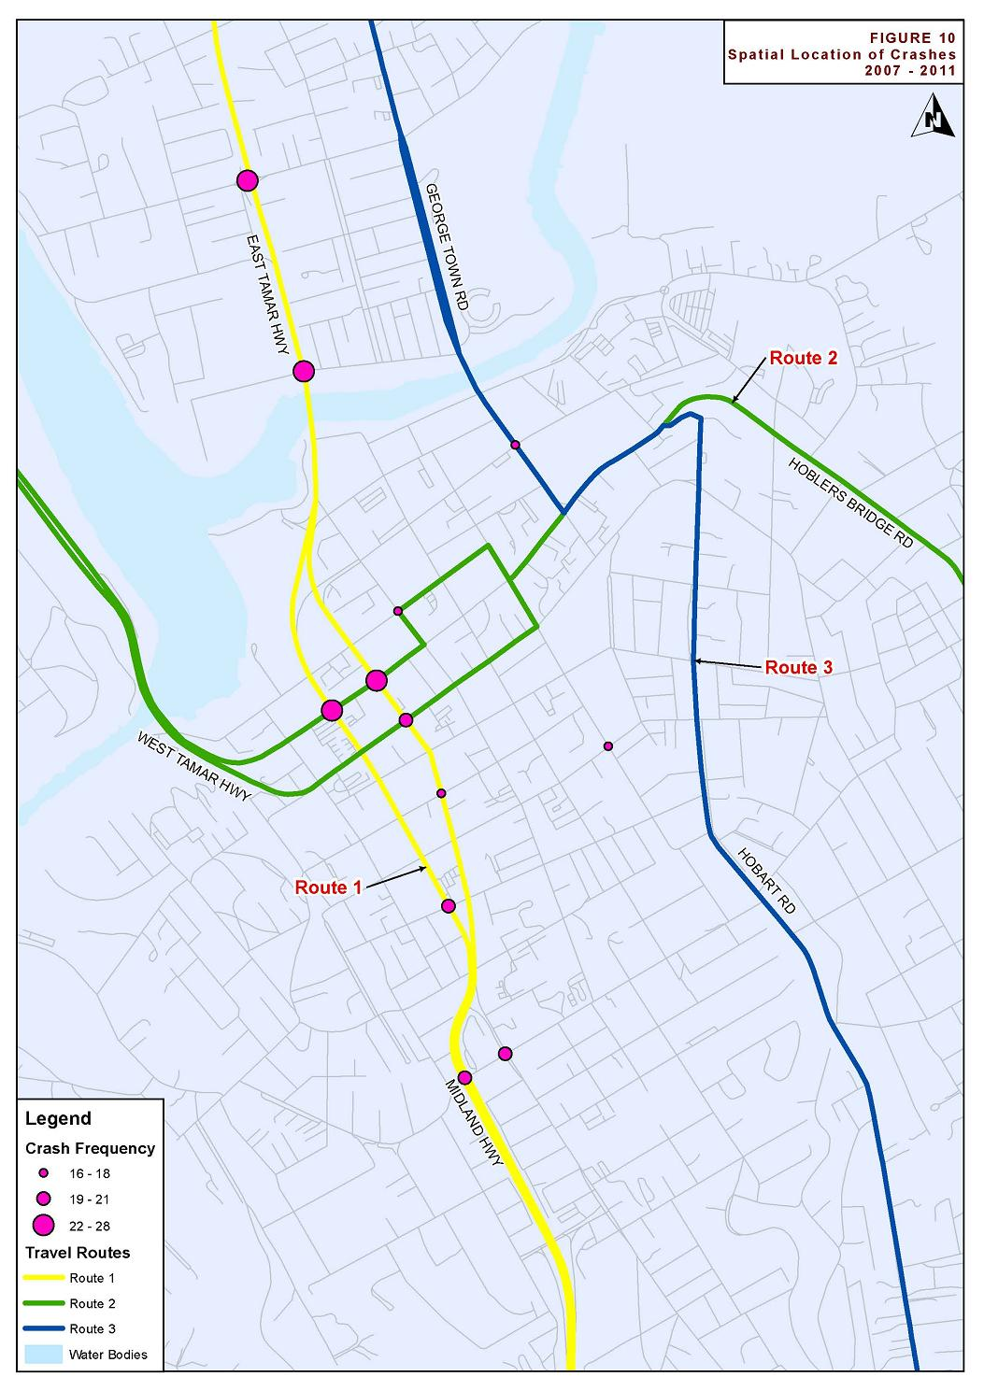
The majority of crashes occurred on the main routes through the city (notably Southern Outlet/ Couplet/ East Tamar Highway), as well as the main routes around the CBD area (notably Paterson Street, George Street, and Cimitiere Street).
The most dominant crash region was the Launceston Couplet, which consists of Wellington Street and Bathurst Street, connecting between the Southern Outlet and the East Tamar Highway. Whilst a substantially higher crash rate was noted in Wellington Street compared to Bathurst Street (366 crashes compared to 176 crashes respectively), when comparing the section of Wellington Street between Charles Street and the Southern Outlet, the total number of crashes was 176 (identical to the Bathurst Street recorded crashes).

Mid-Block Crashes
A total of 3,321 crashes occurred at non-intersection locations between 2007 and 2011, representing a total of 58% of all reported crashes in Launceston. Of these crashes, 9 were fatal, 478 resulted in injury and 142 resulted in first aid at the scene.
The most frequent mid-block crash locations are shown in Table 8.

- Table 8: Most Frequent Mid-Block Crash Locations (2007-2011)
Location | Total Mid-Block Crashes | Mid-Block Crashes per kilometre
Wellington Street | 185 | 53
Invermay Road | 164 | 46
Hobart Road | 115 | 17
East Tamar Highway | 98 | 4
York Street | 88 | 59
Midland Highway | 87 | 16
Charles Street | 75 | 38
Lilydale Road | 74 | 4
Bathurst Street | 72 | 42
Brisbane Street | 68 | 43
Paterson Street | 47 | 59
George Town Road | 47 | 9
Westbury Road | 46 | 15
West Tamar Highway | 45 | 24
Tasman Highway | 45 | 1
Elphin Road | 44 | 23
Cimitiere Street | 40 | 29
Goderich Street | 37 | 37
George Street | 31 | 22
Golconda Road | 30 | 2
Penquite Road | 28 | 8
Pipers River Road | 26 | 4
Vermont Road | 24 | 7
Lower Charles Street | 23 | 58
Alanvale Road | 23 | 10
High Street | 23 | 12
Blessington Road | 22 | 1
St Leonards Road | 22 | 6
Cameron Street | 20 | 25

Travel Time Analysis

Travel Time Reliability
Discussing average conditions in a transport network provides only a partial understanding of the network’s performance. Travel time reliability, the consistency of travel conditions from day to day, is a key performance measure. Variation in travel times is a separate component of commuters’ frustration with congestion.
A formal definition for travel time reliability is: ‘the consistency or dependability in travel times, as measured from day-to-day and/ or across different times of the day’ (US Department of Transportation 2009).
Personal and business travellers value reliability because it allows them to make better use of their own time. Commuters must build a buffer in to their trip planning to account for variability. If they build in a buffer, they will arrive early on some days, which is time that could otherwise be spent on pursuits besides commuting. Travel time reliability is also important for freight carriers to remain competitive.
Travel time reliability is most commonly expressed in the following ways (Margiotta and Taylor 2006):
- Planning time = the 95% percentile travel time- the time required to accomplish the trip 19 times out of 20 chances.
- Planning time index = how much larger the planning time is than the ideal (free-flow) travel time- the ratio of the 95th percentile to the ideal.
- Buffer index = the size of the buffer as a percentage of the average travel time- the 95th percentile minus the average, divided by the average.

Travel Time Surveys
In September 2005 ARUP undertook travel time surveys for three key routes through the city of Launceston. The surveys were undertaken over four weekdays, with approximately six runs in total carried out in each direction of each route. Times were recorded at key intersections allowing travel to be tracked along the routes.
The three routes chosen were:
- Route 1: Southern Outlet (Midlands Highway)/East Tamar Highway from Kings Meadow Connector to George Town Road.
- Route 2: West Tamar Road to Hoblers Bridge/ Ravenswood Road via Paterson Bridge
- Route 3: George Town Road/ East Tamar Highway to Hobart Road/ Poplar Parade.

The three routes are illustrated in Figure 11, with more detailed maps provided in Appendix A.
Comparison data using the same methodology was collected as part of this project in February 2012. The survey was undertaken after the school holiday period to ensure ‘typical’ traffic conditions.
Table 9 compares the overall travel times from the two collection years, considering AM peak, PM peak, interpeak and all runs across the day. The comparison measure used is the 85th percentile travel time which represents the worst case scenario (the travel time that is not exceeded 85 percent of the time). Figure 12 illustrates the percentage increase in 85th percentile travel time for each route. Note negative values indicate the travel time has decreased from 2005 to 2012.
In a number of cases the travel times appear to have decreased slightly, however the decreases are small and are not considered significant. Figure 13 illustrates the routes with increases in 85th percentile travel time of more than 5%.
A substantial increase is travel time is evident for Route 2 in the westbound direction, with an increase of approximately 50% during both morning and evening peak periods. Smaller increases are evident in the eastbound direction with 17% during AM peak and 12% during interpeak.
Increases in travel time are evident in the southbound direction for both Route 1 and Route 3 during PM peak. An 8% increase in travel time is also evident for Route 3 during interpeak.

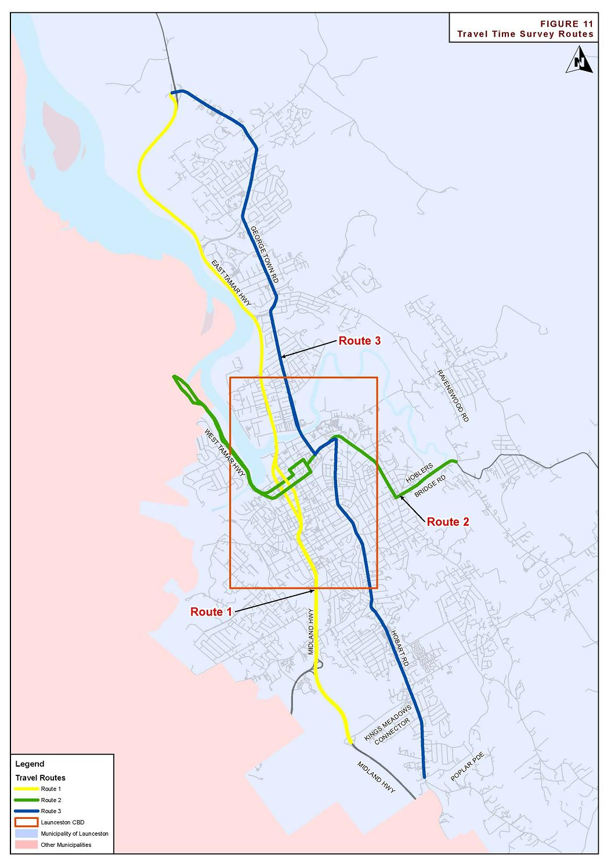

- Table 9 Comparison of 2005 and 2012 Travel Times
Route | Direction | Time | 85th Percentile 2005 | 85th Percentile 2012 | % Increase | Difference
Southern Outlet/ East Tamar Hwy from Kings Meadow Connect to George Town Rd | Northbound | AM Peak | 0:13:30 | 0:12:35 | -6.78% | 0:00:55
 |  | PM Peak | 0:13:52 | 0:13:16 | -4.30% | 0:00:36
 |  | Interpeak | 0:12:20 | 0:12:36 | 2.05% | 0:00:15
 |  | All | 0:13:39 | 0:12:53 | -5.68% | 0:00:47
 | Southbound | AM Peak | 0:14:13 | 0:14:26 | 1.55% | 0:00:13
 |  | PM Peak | 0:16:43 | 0:18:14 | 9.09% | 0:01:31
 |  | Interpeak | 0:13:51 | 0:14:06 | 1.85% | 0:00:15
 |  | All | 0:15:00 | 0:17:52 | 19.17% | 0:02:52
West Tamar Hwy to Hoblers Bridge Road/ Ravenswood Rd via Paterson Bridge | Eastbound | AM Peak | 0:13:21 | 0:15:36 | 16.86% | 0:02:15
 |  | PM Peak | 0:14:35 | 0:13:30 | -7.52% | 0:01:06
 |  | Interpeak | 0:11:33 | 0:12:57 | 12.07% | 0:01:24
 |  | All | 0:14:01 | 0:14:07 | 0.65% | 0:00:05
 | Westbound | AM Peak | 0:10:19 | 0:15:34 | 50.88% | 0:05:15
 |  | PM Peak | 0:11:24 | 0:16:50 | 47.76% | 0:05:27
 |  | Interpeak | 0:11:43 | 0:12:17 | 4.81% | 0:00:34
 |  | All | 0:11:39 | 0:16:07 | 38.17% | 0:04:27
George Town Rd/ East Tamar Hwy to Hobart Rd/ Poplar Pde | Northbound | AM Peak | 0:24:12 | 0:23:36 | -2.46% | 0:00:36
 |  | PM Peak | 0:25:41 | 0:24:26 | -4.87% | 0:01:15
 |  | Interpeak | 0:23:52 | 0:25:42 | 7.68% | 0:01:50
 |  | All | 0:25:28 | 0:24:58 | -1.93% | 0:00:30
 | Southbound | AM Peak | 0:27:12 | 0:26:08 | -3.97% | 0:01:05
 |  | PM Peak | 0:26:05 | 0:27:22 | 4.89% | 0:01:16
 |  | Interpeak | 0:24:20 | 0:24:10 | -0.64% | 0:00:09
 |  | All | 0:26:49 | 0:26:50 | 0.05% | 0:00:01

- Figure 12 Increase in 85th Percentile Travel Time 2005-2012

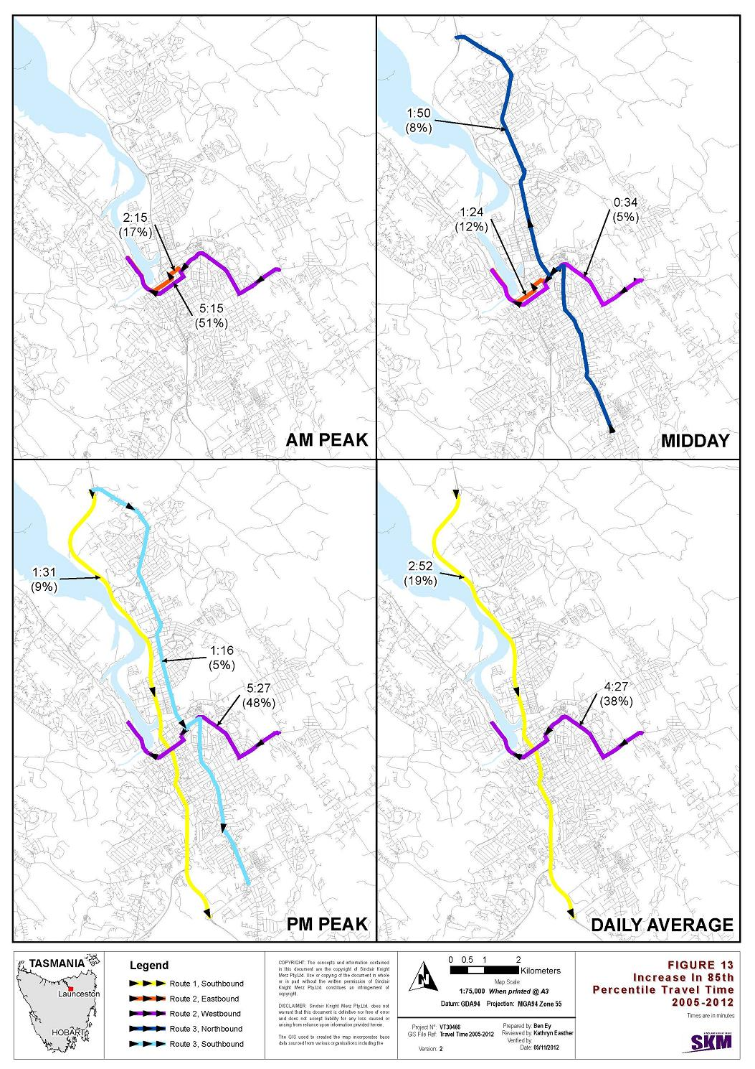

Average speeds between key locations have been calculated in order to determine where delays are occurring along the routes. The following diagrams (Figure 14 to Figure 37) show the speeds as being uniform between these points, although in reality the instantaneous speeds along the route will vary as vehicles accelerate and decelerate.
Figure 14 illustrates average speeds in the northbound direction along Route 1 in 2012. Figure 15, Figure 16 and Figure 17 illustrate the change in average speeds between 2005 and 2012 across different times of the day. Note a negative change in speed indicates average speeds have decreased on this section of the road network.
Figure 18 illustrates average speeds in the southbound direction along Route 1 in 2012
Figure 19, Figure 20 and Figure 21 illustrate the change in average speeds between 2005 and 2012.
The lowest speeds on this route occur between the Southern Outlet/ Howick St intersection and the Forster Street/ Goderich St intersection. This section of the route largely consists of the Bathurst/ Wellington couplet. Speeds on this section average less than 40 km/h across all times of time, in both directions. Speeds are particularly slow in the southbound direction, with average speeds dropping to 20 km/h during evening peak.
Speeds on the southern outlet between the Kings Meadows Connector and Howick St are variable across the day. Average speeds in the northbound direction during morning peak are 20 km/h less than during the middle of the day. Speeds are also particularly variable southbound between the Forster Street/ Goderich Street intersection and the Southern Outlet/ Howick St intersection. Speeds during evening peak are 20 km/h less than during the middle of the day.
A drop in speed from 2005 to 2012 is evident on the southern outlet between the Kings Meadows Connector and Howick St. A drop of 15 km/h is evident in the southbound direction during interpeak.

- Figure 14 Average Speeds- Route 1 Northbound 2012

- Figure 15 Change in Speed 2005 to 2012- Route 1 Northbound AM

- Figure 16 Change in Speed 2005 to 2012- Route 1 Northbound PM

- Figure 17 Change in Speed 2005 to 2012- Route 1 Northbound Interpeak

- Figure 18 Average Speeds- Route 1 Southbound 2012

- Figure 19 Change in Speed 2005 to 2012- Route 1 Southbound AM

- Figure 20 Change in Speed 2005 to 2012- Route 1 Southbound PM

- Figure 21 Change in Speed 2005 to 2012- Route 1 Southbound Interpeak

Figure 22 illustrates average speeds in the eastbound direction along Route 2 in 2012. Figure 23, Figure 24 and Figure 25 illustrate the change in average speeds between 2005 and 2012 across different times of the day.
Figure 26 illustrates average speeds in the westbound direction along Route 2 in 2012.
Figure 27, Figure 28 and Figure 29 illustrate the change in average speeds between 2005 and 2012.
The slowest speeds on this route occur through Launceston CBD, between Margaret Street and Tamar Street, with speeds dropping to 20 km/h. Speeds are fairly consistent across the day for most of the route. Speeds are 15 km/h slower during the morning westbound along Elphin Road and Brisbane Street between Hoblers Bridge Road and Tamar Street. Speeds are 20 km/h slower during the morning eastbound on the West Tamar Highway between Charles Street Bridge and Margaret Street.
A significant drop in speed of 30 km/h from 2005 to 2012 is evident on the West Tamar Highway, in both directions across all times of the day. This is consistent with reports of queuing on the West Tamar Highway.
Table 10 indicates the change in traffic volumes on the West Tamar Highway over approximately the same time period. Traffic growth is moderate with no significant changes in lane utilisation.
- Table 10 Traffic Growth West Tamar Highway
Location | Year | Number of Vehicles |  |  |  |  | Annual Growth Rate
 |  | Left N | Right N | Right S | Left S | Total
358m N of Margaret St | 2011 | 7,324 | 5,174 | 6,802 | 5,348 | 24,648 | 1.5%
 | 2005 | 6,726 | 4,581 | 6,074 | 5,185 | 22,566
184m S of Pomona Rd | 2011 | 7,456 | 4,187 | 4,648 | 7,036 | 23,327 | 2.2%
 | 2004 | 6,523 | 3,498 | 3,741 | 6,257 | 20,019
A drop in speed of 10 km/h is also evident from 2005 to 2012 eastbound from the beginning of Route 2 to the Margaret St/ York St intersection during morning peak. A similar drop is seen during evening peak, beginning at the Elphin Road/ Hoblers Road intersection.

- Figure 22 Average Speeds- Route 2 Eastbound 2012

- Figure 23 Change in Speed 2005 to 2012- Route 2 Eastbound AM

- Figure 24 Change in Speed 2005 to 2012- Route 2 Eastbound PM

- Figure 25 Change in Speed 2005 to 2012- Route 2 Eastbound Interpeak

- Figure 26 Change in Speed 2005 to 2012- Route 2 Westbound AM

- Figure 27 Change in Speed 2005 to 2012- Route 2 Westbound AM

- Figure 28 Change in Speed 2005 to 2012- Route 2 Westbound PM

- Figure 29 Change in Speed 2005 to 2012- Route 2 Westbound Interpeak

Figure 30 illustrates average speeds in the northbound direction along Route 3 in 2012. Figure 31, Figure 32 and Figure 33 illustrate the change in average speeds between 2005 and 2012 in the northbound direction.
Figure 34 illustrates average speeds in the southbound direction along Route 3 in 2012.
Figure 35, Figure 36 and Figure 37 illustrate the change in average speeds between 2005 and 2012.
Speeds along Route 3 are generally 50 km/h or less. This is considerably slower than Route 1, the major north/ south route. The slowest sections on this route are along Hobart Road between Opossum Road and Punchbowl Road and between the High Street/ Clarence Street intersection and the Invermay Road/ Lindsay Street intersection.
Speeds are fairly consistent across the day along Route 3. Speeds are 10 km/h faster southbound during the evening on Invermay Road between the Mowbray Connector and Lindsay Street.
Speeds along Route 3 have not changed significantly between 2005 and 2012, with variations within 10 km/h across the entire route. Speeds in the northbound direction on Hobart Road between Poplar Parade and Opossum Road have dropped by 10 km/h between 2005 and 2012.

- Figure 30 Average Speeds- Route 3 Northbound 2012

- Figure 31 Change in Speed 2005 to 2012- Route 3 Northbound AM

- Figure 32 Change in Speed 2005 to 2012- Route 3 Northbound PM

- Figure 33 Change in Speed 2005 to 2012- Route 3 Northbound Interpeak

- Figure 34 Average Speeds- Route 3 Southbound 2012

- Figure 35 Change in Speed 2005 to 2012- Route 3 Southbound AM

- Figure 36 Change in Speed 2005 to 2012- Route 3 Southbound PM

- Figure 37 Change in Speed 2005 to 2012- Route 3 Southbound Interpeak

SCATS Congested Minutes Analysis

Introduction
This section summarises the results of the congested minutes analysis undertaken for all signalised intersections in the Launceston area. The aim of the analysis was to identify locations of congestion in the road network.

SCATS Congested Minutes
The Sydney Coordinated Adaptive Traffic System (SCATS) is a computerised traffic management system, developed and maintained by Roads and Maritime Services. The system uses sensors at each traffic signal to detect vehicle presence in each lane and pedestrians waiting to cross. Information collected from the vehicle sensors allows SCATS to calculate and adapt the timing of traffic signals in the network.
There is a facility in SCATS called Unusually Congested Minutes that monitors the durations of congestion on arterial roads in real time using stop line detectors. Congested minutes are a measure used to provide an indication of traveller efficiency on the road network.
To identify congestion on arterial roads, SCATS calculates a ‘degree of saturation’ (DS) term based on the following formula:
where
GT is the green time (seconds)
S_{act} is the total space time (time during which vehicles were not passing over the detectors) in that green period (seconds)
n is the number of spaces counted (vehicles)
S_{MF} is the space at saturation or maximum flow (seconds/ vehicle)
The above equation provides a measure of how fully a green period is being used.
SCATS also uses two traffic volumes: V_{o} is the number of vehicles recorded in a green period and V_{k} which is the reconstituted volume in that green period and is given by the equation:
where MF is the maximum flow (vehicles/ second).
The identification of congested minutes is illustrated in Figure 38. The ratio V_{o}/ V_{k} must exceed 2.4 and the DS must exceed 0.95. This top right-hand quadrant represents situations when the stop line detectors reliably indicate congestion.
- Figure 38 The identification of congested minutes in SCATS
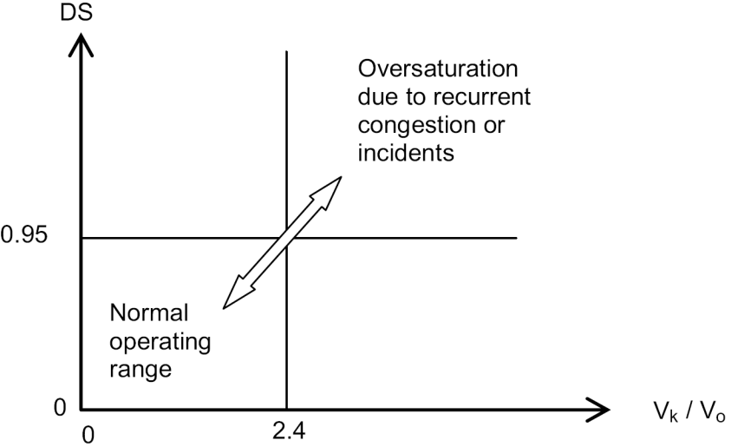
Source: Austroads Research Report – National Performance Indicators for Network Operations, 2007 (represented as Figure 4.3).
Other constraints include those on cycle lengths. There are RL > CL and CL > XL, where CL is the current operating cycle length and RL is the required cycle length based on the level of demand. XL is the stretched cycle length, which is a preset cycle length that allows the difference (CL-XL) to be added to the ‘stretch phase’ (usually the through/major movement phase). These conditions represent the requirement that the approach is operating in oversaturated conditions.
Congested minutes are therefore recorded by SCATS if the conditions in the top right-hand quadrant are satisfied, i.e. if the ratio V_{o}/ V_{k} exceeds 2.4 and the DS exceed 0.95, and also if the cycle length requirements are satisfied.

Methodology
Congestion minutes data was analysed for all signalised intersections in the Launceston area. The list of intersections that were analysed is presented in Appendix B.
The methodology of analysis corresponds to that outlined in Table 4.4 of Austroads’ National Performance Indicators for Network Operations (2007):
- Congested minutes were extracted from the SCATS database for 20 weekdays (Monday to Friday) in May 2011 over three time periods (AM peak (6:00AM to 10:00AM), PM peak (3:00PM to 7:00PM) and interpeak (10:00AM to 3:00PM)).
- The number of congested minutes accumulated in a measurement period of each approach was slotted into various bins of congested minutes, <10 minutes, 10-<20 minutes, etc.
- The results were presented in a histogram showing the proportion of the network at different amounts (bins) of congested minutes. The proportion of a network at a particular congestion minute bin is the ratio of the number of intersection approaches in that bin to the number of intersection approaches in all bins.

Results and Analysis
A histogram showing the proportion of all intersection approaches in Launceston at different amounts of congested minutes during the three analysed time periods is presented in Figure 39. The data is also presented in tabular form in Table 11.
- Figure 39 Arterial Intersection Performance
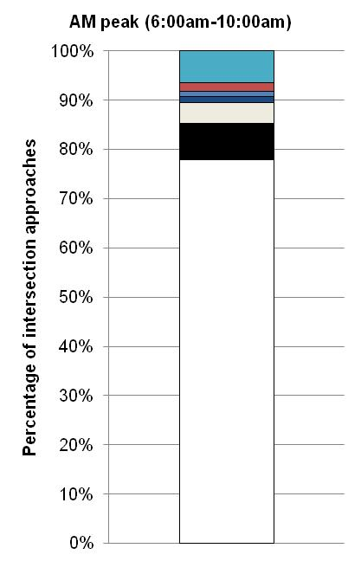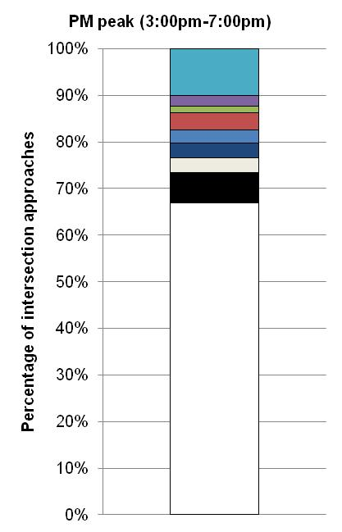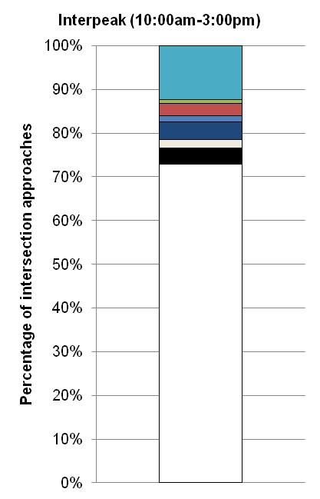
- Table 11 Arterial Intersection Performance
 |  | Congested minute bins
 |  | <10 | 10-<20 | 20-<30 | 30-<40 | 40-<50 | 50-<60 | 60-<70 | 70-<80 | 80+
AM peak (6:00am-10:00am) | Number of approaches | 170 | 16 | 9 | 3 | 2 | 4 | 0 | 0 | 14
 | % of approaches* | 78% | 7% | 4% | 1% | 1% | 2% | 0% | 0% | 6%
PM peak (3:00pm-7:00pm) | Number of approaches | 146 | 14 | 7 | 7 | 6 | 8 | 3 | 5 | 22
 | % of approaches* | 67% | 6% | 3% | 3% | 3% | 4% | 1% | 2% | 10%
Interpeak (10:00am-3:00pm) | Number of approaches | 159 | 8 | 4 | 9 | 3 | 6 | 2 | 0 | 27
 | % of approaches* | 73% | 4% | 2% | 4% | 1% | 3% | 1% | 0% | 12%
*Sums may not equal 100% due to rounding.
The results show that network performance is best in the AM peak, with 78% of intersection approaches having a cumulative congestion of less than ten minutes during the 20-day analysis period. This is compared to 67% of intersection approaches in the PM peak and 73% in the interpeak. The number of approaches having a cumulative congestion exceeding 80 minutes is greatest in the interpeak (12%), followed by the PM peak (10%) and the AM peak (6%).
Table 12, Table 13 and Table 14 list the intersection approaches which had a cumulative congestion exceeding 80 minutes during AM, PM and interpeak respectively. Figures 40 to 45 illustrate the intersection approaches experiencing the most congestion, with a cumulative congestion exceeding 200 minutes during the analysis period. The three travel time survey routes are also illustrated on these maps.
The majority of the intersection approaches with a cumulative congestion exceeding 80 minutes are right turn lanes. It can be seen on the maps the majority of intersections experiencing the most delay fall on one of the three travel time survey routes, particularly routes 1 and 2.
A cumulative congestion exceeding 80 minutes is evident across all times of day on the main north/ south route at intersections with the main east/ west route (York St/ Wellington St and Bathurst St/ Brisbane St). Congestion on the main north/ south corridor is also seen across all times of day at the intersection with Esplanade.
During PM peak and interpeak congestion is also evident on a number of east/ west approaches to the main north/ south corridor, particularly on Frederick St and Paterson St.
A cumulative congestion greater than 200 minutes is evident on Cimitiere St at the intersection with Charles Street across all times of day.
- Table 12 Intersection Approaches with ≥ 80 Congested Minutes- AM Peak
Intersection | Approach |  | Number of congested minutes
Lawrence St/ Cimitiere St | Lawrence St, northbound | Left lane (straight/ left) | 308
Wellington St/ York St | Wellington St, southbound | Middle right lane (straight/ right) | 264
Brisbane St/ Margaret St | Margaret St, southbound | Right lane (straight) | 243
Charles St/ Cimitiere St | Cimitiere St, westbound | Right lane (straight/ right) | 234
Wellington St/ Howick St | Howick St, westbound | Right lane (straight/ right) | 177
Brisbane St/ Tamar St | Brisbane St, westbound | Right lane (right) | 146
 | Tamar St, southbound | Right lane (straight/ right) | 89
Bathurst St/Brisbane St | Bathurst St, northbound | Middle right lane (straight/ right) | 142
East Tamar Hwy/ Esplanade | East Tamar Hwy, southbound | Right lane (straight) | 115
Wellington St/ Westbury Rd | Wellington St, northbound | Left lane (straight) | 110
 | Westbury Rd, eastbound | Left lane (left) | 88
East Tamar Hwy/ Forster St | Forster St, eastbound | Right lane (right) | 106
George St/ York St | George St, northbound | Right lane (right) | 86
 | George St, northbound | Left lane (left) | 85
St John St/ William St | St John St, northbound | Right lane (straight/ right) | 81
- Table 13 Intersection Approaches with ≥ 80 Congested Minutes- PM Peak
Intersection | Approach |  | Number of congested minutes
Wellington St/ Frederick St | Frederick St, eastbound | Right lane (straight/ right) | 577
Wellington St/ Paterson St | Paterson St, eastbound | Right lane (straight/ right) | 513
 | Wellington St, southbound | Middle right lane (straight) | 94
East Tamar Hwy/ Esplanade | East Tamar Hwy, southbound | Right lane (straight) | 478
Wellington St/ York St | Wellington St, southbound | Middle right lane (straight/ right) | 379
Charles St/ Cimitiere St | Cimitiere St, westbound | Right lane (straight/ right) | 367
 | Charles St, northbound | Right Lane (straight/ right) | 101
Wellington St/ Howick St | Howick St, eastbound | Right lane (straight/ right) | 361
 | Howick St, westbound | Right lane (straight/ right) | 262
Lawrence St/ Cimitiere St | Lawrence St, northbound | Left Lane (straight/ left) | 237
 | Lawrence St, northbound | Right Lane (right) | 93
Bathurst St/ Brisbane St | Bathurst St, northbound | Right lane (right) | 236
 | Bathurst St, northbound | Middle right lane (straight/ right) | 182
Brisbane St/ Tamar St | Brisbane St, westbound | Right lane (right) | 188
 | Tamar St, southbound | Right lane (straight/ right) | 147
Wellington St/ Elizabeth St | Elizabeth St, eastbound | Right lane (straight/ right) | 132
Brisbane St/ Margaret St | Margaret St, southbound | Right lane (straight) | 127
Wellington St/ Cimitiere St | Wellington St, southbound | Right lane (straight) | 113
Southern Outlet/ Connaught Cres/ Howick St | Connaught Cres, eastbound | Right Lane (straight/ right) | 110
Brisbane St/ Charles St | Brisbane St, eastbound | Left lane (left) | 100
Bathurst St/ Frederick St | Frederick St, westbound | Right lane (straight/ right) | 88
Tamar St/ Victoria Bridge/ Esplanade | Victoria Bridge, southbound | Left lane (left) | 82
St John St/ William St | St John St, northbound | Right lane (straight/ right) | 81
George St/ Cimitiere St | Cimitiere St, eastbound | Right Lane (straight/ right) | 80

- Table 14 Intersection Approaches with ≥ 80 Congested Minutes- Interpeak
Intersection | Approach |  | Number of congested minutes
Brisbane St/ Charles St | Brisbane St, eastbound | Left lane (left) | 427
Wellington St/ Frederick St | Frederick St, eastbound | Right lane (straight/ right) | 349
Charles St/ Cimitiere St | Cimitiere St, westbound | Right lane (straight/ right) | 325
 | Charles St, northbound | Right Lane (straight/ right) | 118
York St/ St John St | York St, westbound | Left lane (straight/ left) | 317
 | St John St, northbound | Right lane (straight) | 94
Tamar St/ Victoria Bridge/ Esplanade | Victoria Bridge, southbound | Left lane (left) | 309
 | Esplanade, westbound | Right lane (right) | 167
 | Tamar St, northbound | Right Lane (straight/ right) | 132
Wellington St/ Paterson St | Paterson St, eastbound | Right lane (straight/ right) | 270
 | Paterson St, westbound | Left lane (left) | 152
Brisbane St/ Tamar St | Tamar St, southbound | Right lane (straight/ right) | 182
 | Brisbane St, westbound | Right lane (right) | 164
Bathurst St/ Brisbane St | Bathurst St, northbound | Middle right lane (straight/ right) | 173
Wellington St/ York St | Wellington St, southbound | Middle right lane, (straight/ right) | 151
 | York St, westbound | Left lane (left) | 135
St John St/ William St | St John St, northbound | Right lane (straight/ right) | 147
Bathurst St/ Frederick St | Frederick St, westbound | Right lane (straight/ right) | 146
Paterson St/ Charles St | Paterson St, eastbound | Left lane (straight/ left) | 138
George St/ York St | George St, northbound | Right lane (right) | 127
 | George St, northbound | Left lane (left) | 118
Goderich St/ Charles St Bridge/ Lindsay St | Charles St Bridge, northbound | Right lane (right) | 122
Southern Outlet/ Connaught Cres/ Howick St | Southern Outlet, northbound | Right lane (right) | 98
Bathurst St/ Wellington St/ William St/ Alexandra Wharf Rd | Bathurst St, northbound | Middle lane (straight) | 96
East Tamar Hwy/ Esplanade | East Tamar Hwy, southbound | Right lane (straight) | 94
Wellington St/ Elizabeth St | Elizabeth St, eastbound | Right lane (straight/ right) | 89
York St/ Charles St | York St, westbound | Left lane (straight/ left) | 89
Charles St/ Elizabeth St | Elizabeth St, westbound | Right Lane (straight/ right) | 83

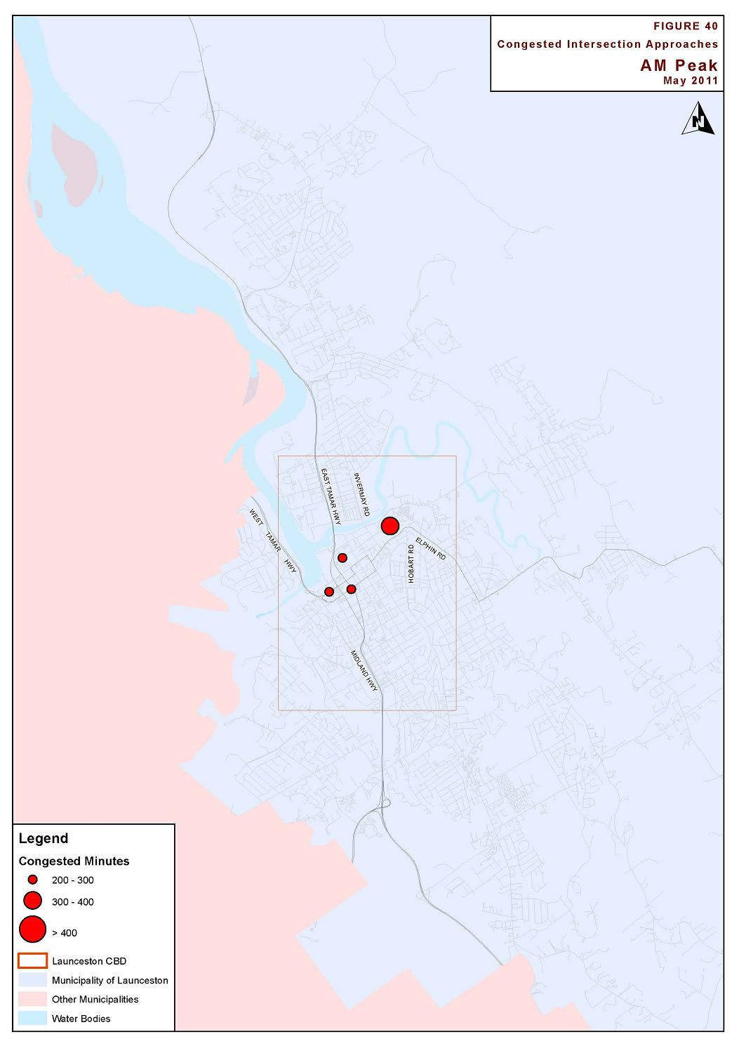

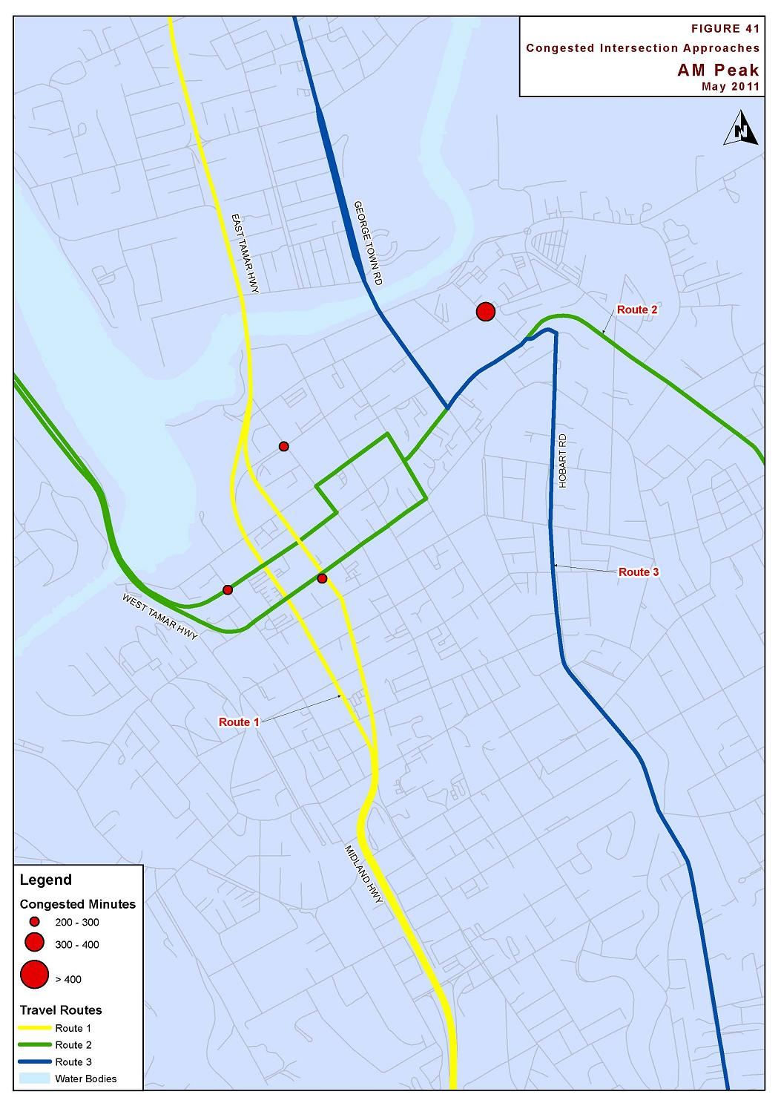

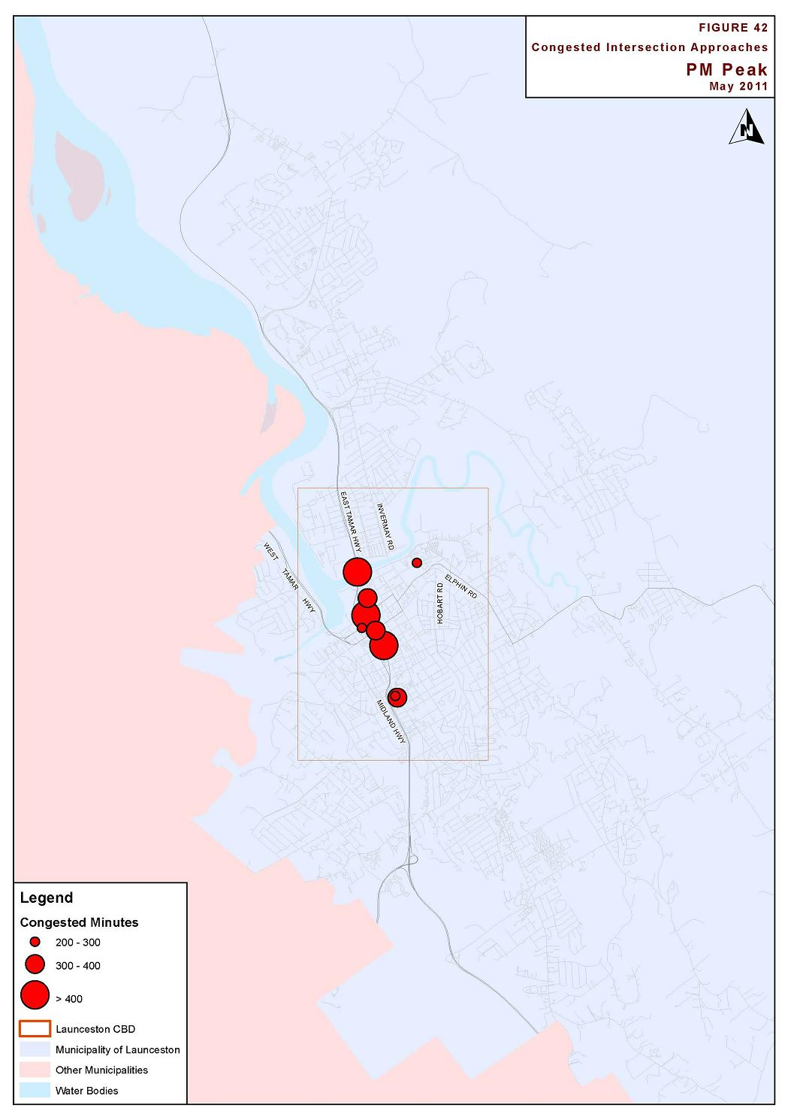

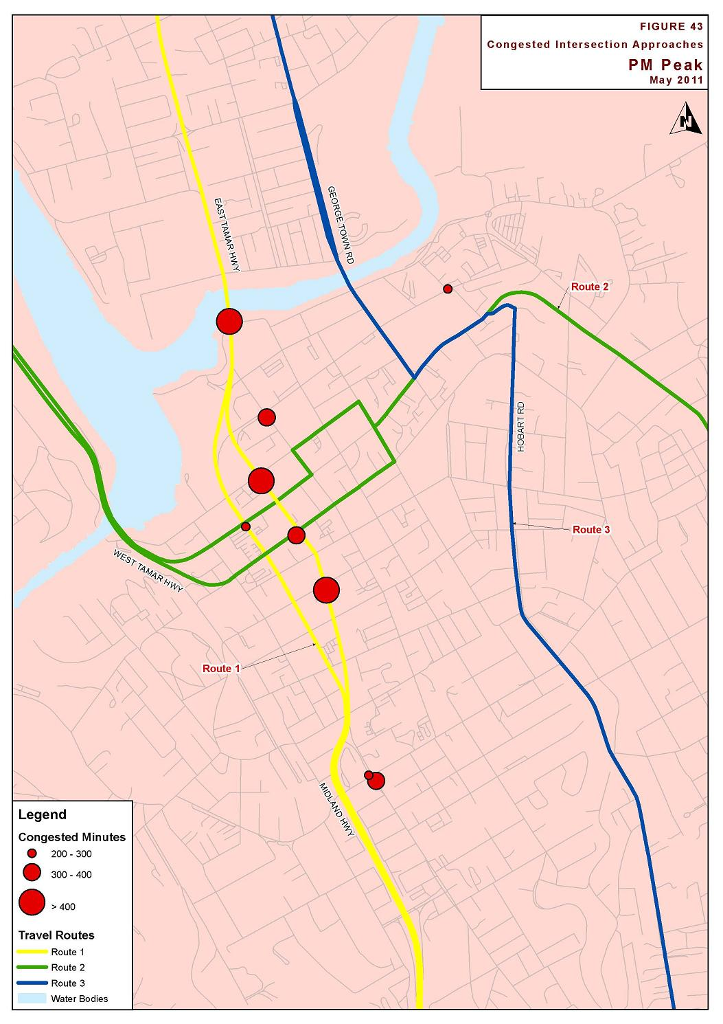

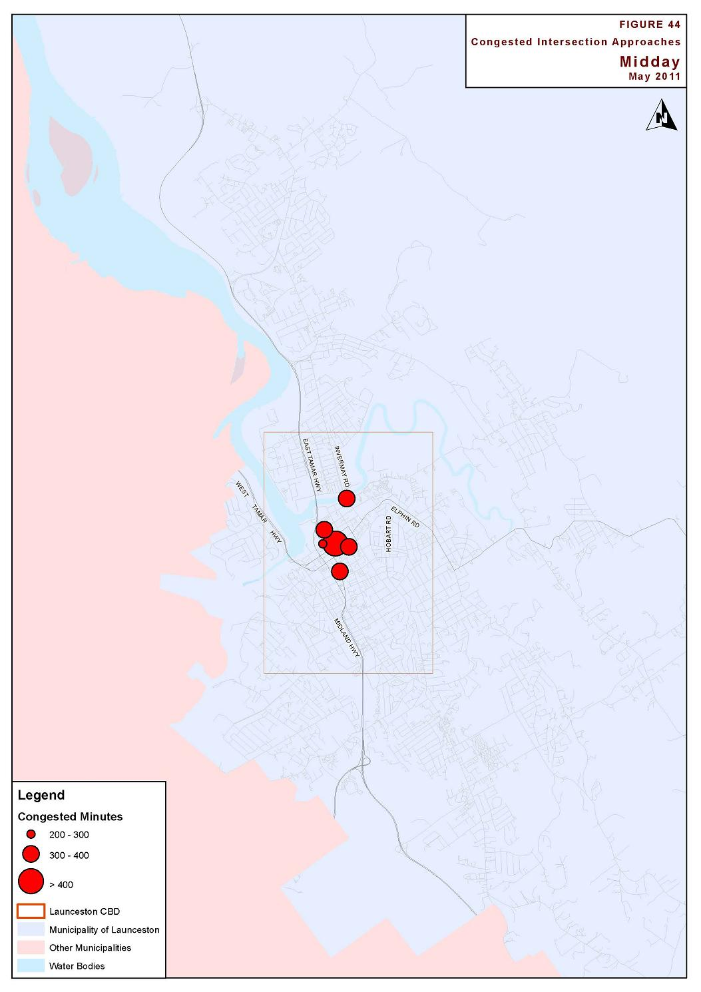

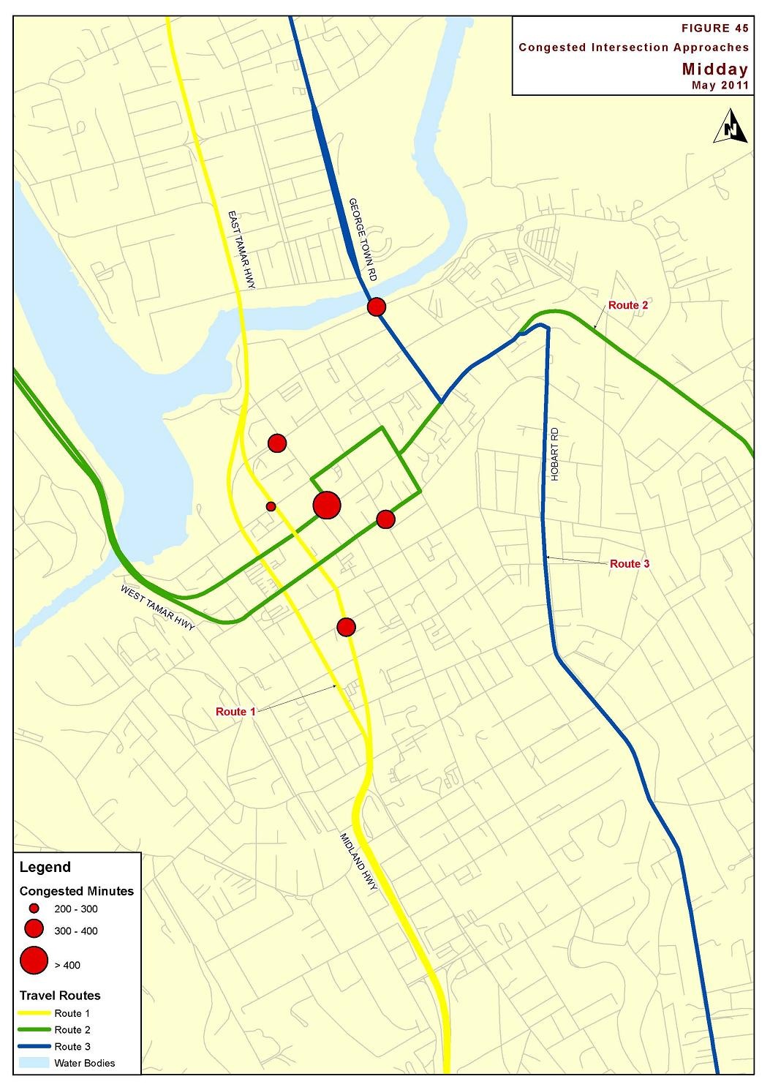

Freight Demand

Overview
Launceston’s transport network plays an important role in the movement of freight into, out of, and through Launceston. As well as servicing the city itself, Launceston is located at the confluence of the Bass, Tasman, Midland, West Tamar, and East Tamar Highways. A relatively large portion of freight therefore passes through Launceston as it connects between the respective highways.
One of the dominant freight generators in the region is Bell Bay. Bell Bay is Tasmania’s largest port in terms of tonnages, and is a major container and bulk goods port. The Bell Bay industrial area is a key location for forestry freight processing, and the port moved significant volumes of forestry freight in 2009. In the 2008-09 financial year, Bell Bay imported and exported 1.60MT and 3.11MT respectively. The primary products freighted into and out of Bell Bay are timber products.
Bell Bay is the main destination for the log task in the northern region, with over 1.8 million tonnes of hardwood logs and nearly half a million tonnes of softwood logs moving to the Bell Bay area in 2009. The majority of hardwood logs moving through Bell Bay port are chipped on site prior to export.

Freight Routes
The main freight routes through Launceston CBD are illustrated in Figure 46. The volumes indicated are from the 2009 Tasmanian Freight Survey. The majority of freight moves north/ south through the city, with fewer east/ west freight movements. The primary freight route is the Midland Highway/ Launceston Couplet/ East Tamar Highway.
In 2009 tonnages travelling north on Bathurst Street were approximately double that travelling south on Wellington Street. This is predominantly due to laden trucks heading north to the Bell Bay industrial area with unladen trips returning in the southern direction. Exports from Bell Bay are significantly higher than imports. Heavy vehicle volumes on the Charles Street Bridge were significantly higher than on Victoria Bridge, confirming the Midland Highway/East Tamar Highway as the major freight route. This imbalance is largely due to the local nature of Invermay Road.
Freight volumes from the east of Launceston were relatively low. The Tasman Highway is not the preferred freight route from the north-east with Bridport Main Road/ East Tamar Highway being preferred instead. Forest product from the Camden Hills area is generally transported via Prossers Forest Road and Lilydale Road bypassing Launceston CBD. Freight volumes from the west of Launceston were also relatively low. Freight moving from the West to the Bell Bay industrial area is transported across the Batman Bridge.
Table 15 indicates the major commodities on the key freight routes through Launceston in 2009. Timber products were the main commodity moving through Launceston, with the majority travelling north to Bell Bay. Due to a slowdown in the forestry industry, current timber volumes are expected to be considerably lower than shown in Table 15. The scale of difference between north/ south and east/ west flow is therefore expected to be lower currently. It is possible future developments such as the proposed pulp mill will result in timber volumes returning to levels similar to 2009.
The Tasmanian Freight Survey is undertaken by DIER to inform planning for Tasmania’s future freight transport system. In 2008-09 the survey comprised information from interviews of over 100 companies across Tasmania representing the highest freight demanding companies, along with additional freight movements ‘rolled over’ from the previous surveys from companies with lower or static freight demand. However, several companies with demands lower than 25 to 50 thousand tonnes per year are not included, nor are movements involving smaller trucks such as light commercial vehicles. For this reason the tonnages and commodities reported are neither exact nor exhaustive.
Weight in Motion (WIM) data is derived from sensors on major highways outside the urban extent (eg Midland Highway at Epping Forest and Bass Highway at Sassafras). A comparison of this data indicates around two thirds of freight tonnage and truck movements are captured by the survey at these locations, whereas over 85% of freight is captured through the major ports.
In the urban areas such as Launceston, traffic count data (for trucks) suggest the survey captures a lower percentage of freight movements compared to the non-urban roads. This corresponds with the presence in these locations of additional smaller scale companies which were not surveyed, higher numbers of smaller freight vehicles used and more complex transport movements which are not always mapped well.
The freight data should be considered in this context – the data is likely to be lower than two thirds of the actual freight total on the roads.
- Table 15 Main Commodities on Key Freight Routes, Tonnes Per Annum (2009 Freight Survey)
Commodities | Charles St Bridge | Midland Hwy | Bathurst St | Wellington St
Timber Products | 1,043,411 | 1,118,811 | 921,699 | 213,683
Stone, Sand, Clay | 357,300 | 230,500 | 291,800 | 147,000
Groceries, Food | 89,590 | 262,704 | 137,917 | 96,179
Metals, Minerals | 145,384 | 190,504 | 83,120 | 108,384
Concrete, Cement | 226,500 | 75,700 | 38,300 | 75,400
Petroleum, Diesel | 85,857 | 72,790 | 90,566 | 27,596
Beverages | - | 130,871 | 2,600 | 121,880
Paper, Newsprint | 27,454 | 28,026 | 12,870 | 14,584
Coal, Briquettes | 23,454 | 23,855 | 23,855 | -
Bitumen, Asphaltic Mixtures | 31,859 | 22,459 | 240 | 22,219

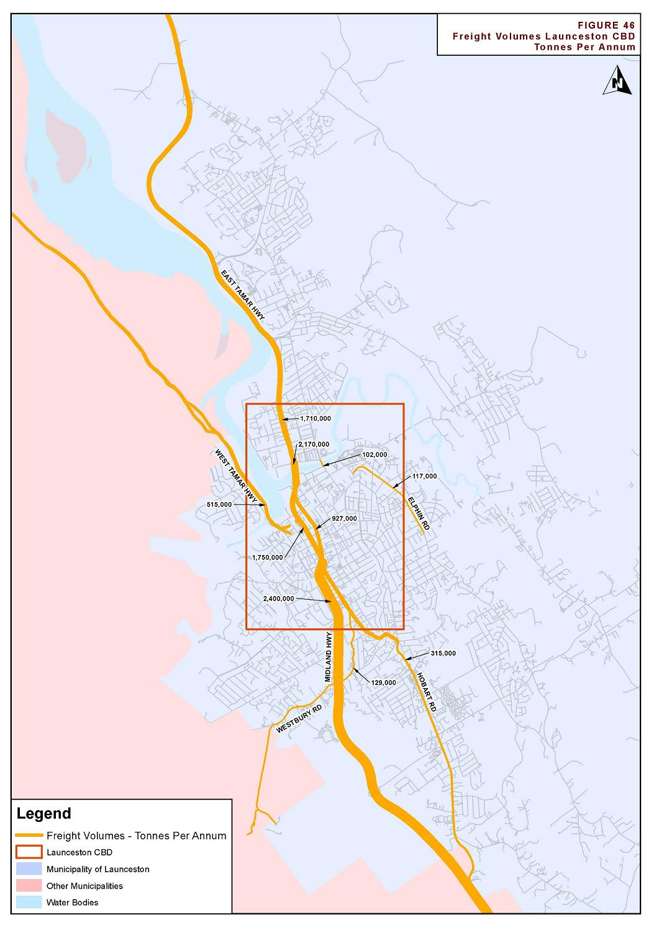

Freight Road Safety Analysis
A road safety analysis of freight movements was undertaken as a subset of the crash data analysis provided in Section 3.
Heavy vehicle crashes make up approximately 6% of all reported crashes in Launceston. A total of 288 heavy vehicle crashes were reported between 2007 and 2011. Of these crashes, 2 resulted in a fatality, 4 serious injury, 26 minor injury and 10 first aid.
The most frequent heavy vehicle crash types were as follows:
- 34 vehicles in same lane/ rear-end
- 26 parked vehicle
- 25 vehicles in parallel lane/ left change
- 20 cross traffic
- 19 lane side swipe
- 14 left turn side swipe
- 11 other manoeuvring
These crash types are considered typical of heavy vehicle crashes in urban environments. Notably, most heavy vehicle crashes involved multiple vehicles, rather than single vehicle crashes (such as ‘off-carriageway’, etc).
In terms of spatial location of the reported crashes, the majority of these crashes were reported on or near major arterial roads. The most frequent crash locations were:
- 35 crashes reported in Bathurst Street
- 21 crashes reported in Wellington Street
- 16 crashes reported in Invermay Road
- 15 crashes reported in Midland Highway (Southern Outlet)
- 8 crashes reported in East Tamar Highway
- 7 crashes reported in York Street
- 5 crashes reported in Hobart Road
- 5 crashes reported in Cimitiere Street
It is clear that the most frequent crashes were reported along the key freight routes through the city, with the Midland Highway/ East Tamar Highway route dominating the crash data. The freight routes and associated freight volumes are highlighted in Section 6.2.
It is further noted that a higher proportion of crashes were reported in Bathurst Street compared to Wellington Street, an opposite trend to the overall crash data and despite the fact that Wellington Street is significantly longer than Bathurst Street. This may be partly due to the fact that a large proportion of heavy vehicles do not travel the section of Wellington Street south of the Southern Outlet junction. It may also indicate that laden trucks have a higher propensity to be involved in a crash compared to unladen vehicles, particularly with crash types such as rear-end.

Conclusions
This report documents the findings of analysis of traffic data and information to identify and quantify transport issues in Launceston.
One of the key findings of this study is the deterioration of travel times along the east/ west routes through Launceston. Whilst it is not quantified whether there has been a corresponding increase in traffic volumes along this route, the cause appears to be linked to congestion at several key intersections along these routes. This was noted in the congested minutes analysis undertaken in this report, where a large proportion of signalised intersections with identified delays were located along the east/ west travel time route.
It was clear through the analysis in this report that the route between the Midland Highway (Southern Outlet) and the East Tamar Highway was a dominant freight route. This route also carried the highest traffic volumes and highest reported crash rates within the study area.
Key issues identified are outlined in the following sections.

Traffic Volumes
There are several areas in Launceston that have relatively high traffic volumes, and/ or are experiencing relatively high traffic growth. Some key identified areas were as follows:
- Charles Street Bridge. The capacity of Charles Street is constrained by the intersection of Lindsay Street and Goderich Street. Queuing often extends on the Charles Street approach from the right turn lane that services Lindsay Street, blocking through traffic on the Charles Street Bridge. Queuing also frequently extends along Goderich Street during peak periods.
- Hobart Road. High levels of traffic volume coupled with associated side friction in the form of parking activity and access manoeuvres causes general congestion along this route. Commercial development in this area is exacerbating this issue over time.
- Victoria Bridge. This route is carrying a relatively high volume of traffic and links to the eastern end of the CBD and some key industrial sites. Queuing often extends over the bridge, and some side roads have poor levels of service that connect to Invermay Road and Tamar Street on either side of the bridge.

Road Safety Performance
A total of 4,874 crashes were reported in the Launceston local government area between 2007 and 2011. Of these crashes, 775 resulted in injury. The majority of crashes occurred on the arterial road network.
The intersection locations with crash frequencies of 20 or more reported crashes are summarised as follows:
- Brisbane Street/ Wellington Street 28 crashes (1 injury)
- Goderich Street/ Lindsay Street/ Charles Street 27 crashes (5 injury)
- Bathurst Street/ Brisbane Street 24 crashes (3 injury)
- Forster Street/ Goderich Street 24 crashes (4 injury)
- Howick Street/ Wellington Street 21 crashes (4 injury)
- Howick Street/ Southern Outlet 21 crashes (1 injury)
- Wellington Street/ York Street 20 crashes (3 injury)
In most cases, the dominant crash types at the intersections were cross-intersection and rear-end related crashes, which are considered typical for busy urban junctions. Generally, crashes at high frequency crash sites had crash types that were typical of busy urban junctions.
Similarly, crashes involving heavy vehicles were located along the key freight corridors, particularly along the Southern Outlet/ Charles Street/ East Tamar corridor. Heavy vehicle crashes represented around 6% of all reported crashes, which is approximately the same proportion of this user group in the traffic system.

Travel Time Analysis
Travel times were compared between 2005 and 2012 for three key routes through Launceston CBD. Travel times were observed to have increased appreciably on the east/ west route between West Tamar Highway/ Riverview Road and Hoblers Bridge Road/ Ravenswood Road. Delays in the westbound direction appear to be particularly significant, with observed travel times increasing by approximately 50% during both morning and evening peak periods. Variations in travel time on the two north/ south routes were less significant.
Analysis of average speeds identified a significant drop in speed along the West Tamar Highway, in both directions and across all times of day. This is consistent with reported queuing on the West Tamar Highway.
The travel time data provided a valuable reference to measure the performance and efficiency of the transport network. It is therefore recommended that travel time surveys be undertaken regularly along the three routes to monitor changes in travel time patterns. This will assist in determining the changes in congestion over time and also to determine the overall effectiveness of strategies adopted over time. It is recommended that the surveys are undertaken at the same time of year to ensure a direct comparison and the time period should be outside of school holidays to ensure ‘typical’ traffic conditions.

Congested Minutes Analysis
A congested minutes analysis was undertaken for all signalised intersections in the Launceston area. Overall the network performed the best during AM peak. The number of approaches having a cumulative congestion exceeding 80 minutes is greatest in the interpeak (12%), followed by the PM peak (10%) and the AM peak (6%).
The majority of the intersection approaches experiencing delay are right turn lanes. The majority of these locations fall on Route 1, the main north/ south route through the CBD, or Route 2, the main east/ west route.
It is recommended that Congested Minutes reports be undertaken regularly in future years corresponding to further travel time surveys. Cross-referencing the Congested Minutes reports with the travel time surveys would provide valuable information on the performance of the network over time.

Freight Demand
The majority of freight moves north/ south through Launceston with fewer east/ west freight movements. The primary freight route is the Midland Highway/ Launceston Couplet/ East Tamar Highway. This route provides access to Bell Bay Port, Tasmania’s largest port in terms of tonnages, as well as the Bell Bay industrial area. Timber products are the dominant commodity transported on this route.

Recommendations
The analysis undertaken in this report identified a number of key issues that require further investigation. These issues are summarised in the following sections. Figures 47 and 48 show combined data of crashes, congestion and freight volumes, highlighting the key problem areas.

North Esk River Crossing
There are two main road bridges over the North Esk River near Launceston CBD. These are Charles Street and Victoria Street bridges. These form the primary crossing locations for traffic travelling from the city to East Tamar Highway or Invermay Road. The limited locations for traffic to cross the North Esk River places relatively high traffic demands at these two locations. Charles Street Bridge carries approximately 29,400 vehicles per day, and Victoria Street Bridge carries approximately 19,300 vehicles per day.
The Charles Street Bridge carries a very high volume of freight, carrying the second highest volume of freight within the study area (Southern Outlet carries the highest volume).
The two bridges operate at a relatively high level of congestion during peak periods. This is largely due to the high traffic volumes utilising the bridges, as well as the relatively high side road traffic volumes at the junctions at either end of both bridges. To highlight this, the junction of East Tamar Highway (Charles Street) and the Esplanade recorded the third highest congested minutes result during the PM peak period.
The road safety assessment also identified that the junction of Goderich Street/ Lindsay Street/ Charles Street had the second highest crash rate of all junction locations in the study area. With commercial development flagged in Lindsay Street, this junction will be placed under increasing pressure in the future.
This report recommends that further investigations be undertaken to determine ways of reducing congestion and crash rates at the two bridges as a high priority.

East-West Connectivity
One of the key findings of this study was the deterioration of travel times along the east-west routes through Launceston. The cause of this increased congestion appears to be linked to several key intersections along these routes. Travel times along these routes were measured in 2005 and 2012. Results indicated that traffic performance along these routes has deteriorated during this timeframe. It is likely that the dominance of north-south freight and traffic movements has contributed to the deterioration of east-west traffic flow efficiency.
The crash analysis also highlighted that the intersection of the east-west routes with the Couplet had relatively poor road safety performance. Specifically, high crash rates were reported at the York Street and Brisbane Street junctions with the Wellington Street/ Bathurst Street couplet. The road links of York Street and Brisbane Street also had relatively poor road safety performances in terms of non-intersection crashes.
This report therefore recommends that further investigations be undertaken to improve efficiency of east-west travel through Launceston.

Wellington Street/ Bathurst Street Couplet
The Wellington Street/ Bathurst Street couplet carries the highest traffic volume of all routes through Launceston and also has the highest proportion of all crashes in Launceston. The couplet also connects the Midland Highway to the East Tamar Highway and therefore carries the highest volume of freight in the study area. The issue of car/ heavy vehicle conflict was raised as an issue for many respondents of the ‘Your Voice, Your Launceston’ survey.
In addition to these factors, the Couplet acts as an impediment for east-west traffic as well as pedestrian movements.
This report therefore recommends further investigation of measures to improve accessibility of the Couplet, and reduce crash rates whilst maintaining an emphasis on retaining the corridor as a strategically important freight link.

Hobart Road
Hobart Road provides connectivity between Launceston CBD and Kings Meadows through to the Southern Outlet at the Breadalbane Roundabout. It provides an arterial function, whilst having a strategically important role in providing an access to the Kings Meadows shopping district.
The crash analysis identified that there were two junctions on Hobart Road with crash frequencies greater than 15 crashes. The Hobart Road corridor also carries a relatively high traffic volume of approximately 16,600 vehicles per day.
With further development proposed in the Kings Meadows area, side friction will result in a decreased level of service of the corridor, as well as increased congestion along the route. Investigation of further measures is therefore recommended to ensure that congestion levels are maintained at acceptable levels along the Hobart Road corridor.

Appendix A- Travel Time Survey Routes
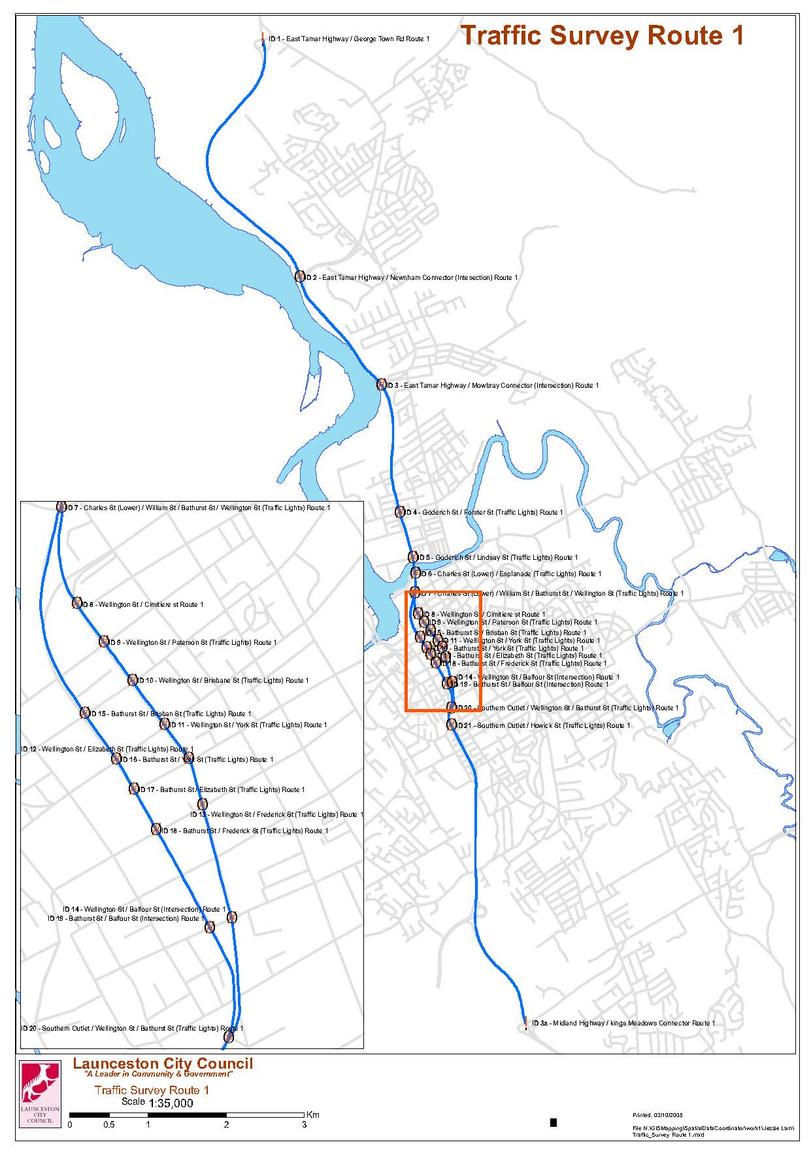

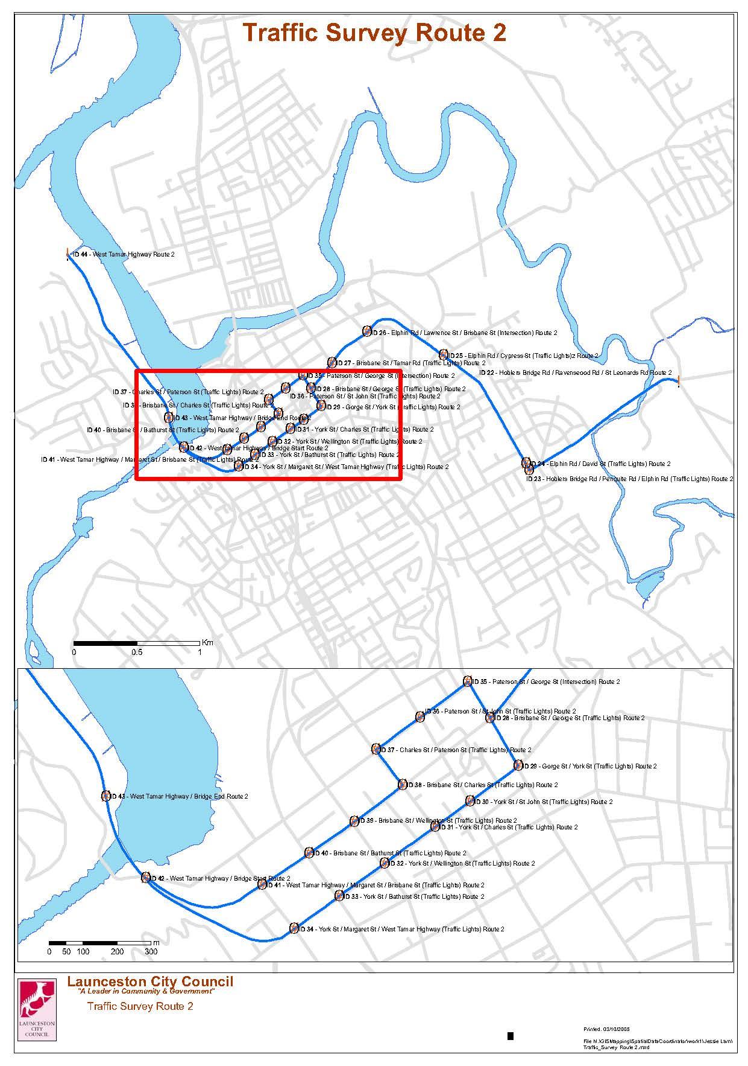
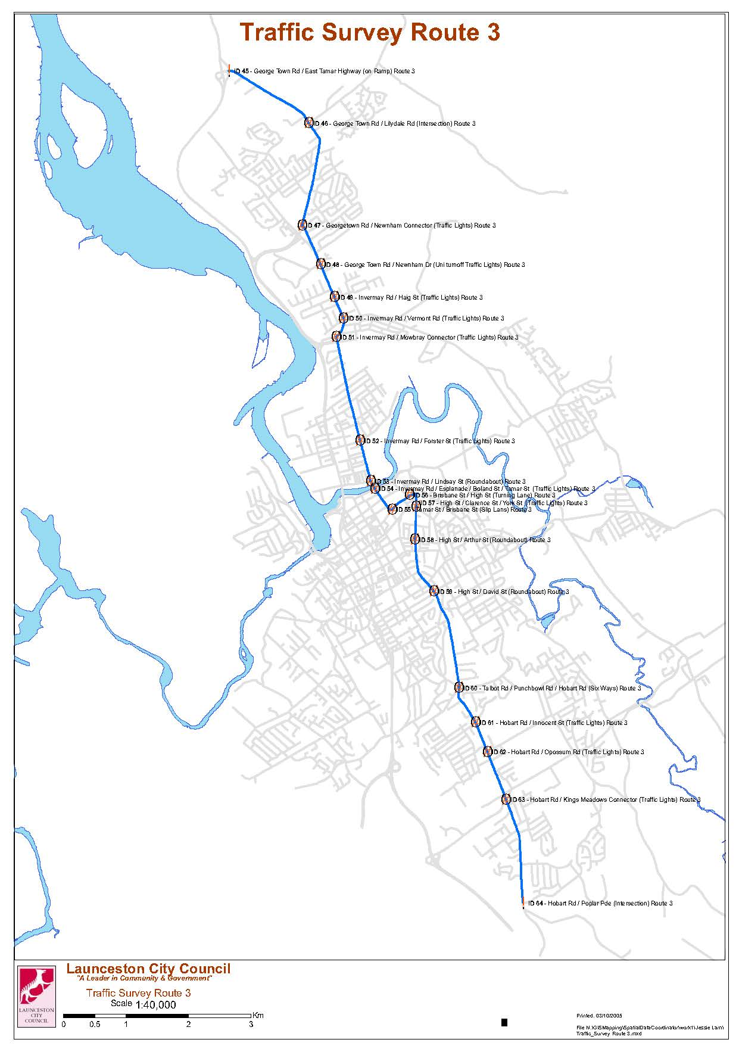

Appendix B- List of intersections analysed in SCATS congested minutes report
Intersection ID | Intersection name | Total number of approaches
275 | Wellington Street/Pipeworks Road | 4
238 | Wellington Street/Westbury Road | 3
232 | Wellington Street/Howick Street | 4
282 | Wellington Street/Bathurst Street/Midland Highway | 4
297 | Bathurst Street/Balfour Street | 3
268 | Bathurst Street/Canning Street | 3
255 | Bathurst Street/Frederick Street | 3
277 | Bathurst Street/Elizabeth Street | 3
235 | Bathurst Street/York Street | 2
236 | Bathurst Street/Brisbane Street | 3
267 | Wellington Street/Bathurst Street/William Street/Home Point Parade | 4
263 | Charles Street/Esplanade | 3
9208 | Charles Street/Goderich Street/Lindsay Street | 4
9252 | Goderich Street/Forster Street | 4
285 | Wellington Street/Cimitiere Street | 2
214 | Wellington Street/Paterson Street | 3
221 | Wellington Street/Brisbane Street | 2
222 | Wellington Street/York Street | 2
223 | Wellington Street/Elizabeth Street | 3
276 | Wellington Street/Frederick Street | 3
269 | Wellington Street/Canning Street | 3
229 | Wellington Street/Balfour Street | 3
205 | Pelican crossing on West Tamar Highway near Launceston Christian School | 2
9295 | West Tamar Highway/Ecclestone Road | 4
9294 | West Tamar Highway/Riverside Drive | 3
9293 | West Tamar Highway/Pomona Road | 3
241 | Brisbane Street/Margaret Street | 4
212 | Brisbane Street/Charles Street | 2
211 | Charles Street/Paterson Street | 3
227 | Paterson Street/St John Street | 3
210 | Brisbane Street/George Street | 3
240 | George Street/York Street | 3
226 | York Street/St John Street | 3
215 | York Street/Charles Street | 2
245 | York Street/Margaret Street | 3
219 | Brisbane Street/Tamar Street | 4
296 | York Street/High Street/Clarence Street | 5
207 | Elphin Road/Cypress Street | 3
233 | Elphin Road/Penquite Road/David Street/Hoblers Bridge Road | 6
239 | Hobart Road/Talbot Road/Punchbowl Road | 4
265 | Hobart Road/Riseley Street/Innocent Street | 4
288 | Hobart Road/Kings Meadow Connection/Quarantine Road | 4
258 | Hobart Road/Blaydon Street/Opossum Road | 7
244 | Tamar Street/Cameron Street | 3
220 | Tamar Street/Cimitiere Street | 4
281 | Tamar Street/Esplanade | 4
202 | Pelican crossing on Invermay Road near Landale Street | 2
9247 | Invermay Road/Forster Street | 4
251 | Invermay Road/Mowbray Link/Jackson Street | 4
234 | Invermay Road/Haig Street/Beatty Street | 4
273 | Pipeworks Road/Midland Highway off-ramp | 3
218 | William Street/St John Street | 4
225 | Elizabeth Street/Charles Street | 4
243 | Cameron Street/George Street | 4
278 | Cimitiere Street/Charles Street | 4
279 | Midland Highway/Connaught Crescent/Howick Street | 4
280 | Elizabeth Street/St John Street | 4
283 | Cimitiere Street/George Street | 4
286 | Frederick Street/Charles Street | 4
287 | Elizabeth Street/George Street | 4
289 | Frederick Street/Margaret Street | 4
292 | Cimitiere Street/Lawrence Street | 4
299 | Margaret Street/Bridge Road/Paterson Street | 3

References
ARUP (2007), Launceston Traffic Model
Department of Infrastructure, Energy and Resources (2006), Tasmanian State Road Hierarchy
Department of Infrastructure, Energy and Resources, Tasmanian Freight Survey 2008-09 Data Summary
GHD (2007), Pulp Mill Transport Impact Assessment
GHD (2012), Report for Kings Meadows Area, Traffic Management Options Study
Launceston City Council (1996), Launceston Planning Scheme
Launceston City Council (2012), Transport in Launceston Research Report, August 2012
Midson Traffic Pty Lty (2012), Bell Bay Pulp Mill Launceston Traffic Study
Midson Traffic Pty Lty (2012), Charles Street/ Esplanade Intersection Assessment
Midson Traffic Pty Lty (2012), Goderich Street/ Lindsay Street Intersection Modelling
Margiotta, R & Taylor, R (2006), Traffic Congestion and Reliability: Making the Connection with Operations, Part 1: Measuring and Tracking Reliability, ITE Journal, pp. 24-28.
P. G. Pak-Poy & Associates (1968), Launceston Area Transportation Study
Region North (2003), Northern Tasmanian Integrated Transport Plan
US Department of Transportation (2009), Travel Time Reliability: Making it There On Time, All The Time, http://www.ops.fhwa.dot.gov/publications/tt_reliability/TTR_Report.htm

Department of Infrastructure,
Energy and Resources
10 Murray Street
Hobart
GPO BOX 936
Hobart TAS 7001
www.dier.tas.gov.au
Phone: 1300 135 513

