HAPPY EASTER!
As promised, the second instalment of the Transporter is here! We have reinstated the quarterly publication of the Transporter newsletter and we are looking to hear from operators for what you want to see included.
SCHOOL TERMS

Just a reminder about key dates for the public schools in 2014. Student free days are not included in the below table and should be confirmed directly with schools. Please note: the Easter break falls between Term 1 and 2.
 | Start | Finish
TERM 1 | Wednesday 5 February | Thursday 17 April
TERM 2 | Monday 5 May | Friday 4 July
TERM 3 | Monday 21 July | Friday 26 September
TERM 4 | Monday 13 October | Thursday 18 December
TOP UP CLAIMING

Fare paying operators are still required to submit manual passenger figures. In accordance with the contract, these top-up claims must be submitted by the fifth working day of each month. Claims submitted after this time will not be processed until the following month. Please email your claim to ptscontracts@dier.tas.gov.au
TARGA TASMANIA 2014

Targa Tasmania kicks off from the 6-11 May, coinciding with the beginning of Term 2. With road closures and delays expected, operators are urged to check the map on the Targa website to see if any of their routes will be affected. If a school route will be impacted by the race, please contact relevant schools for alternative arrangements for the days affected. Don’t forget to notify us of any changes also.
Website: http://targa.com.au/tc/
Contact number: 6221 8800

CAPITAL PAYMENT RATES
 | Jan-14 | Apr-14
Urban Fringe Student Only  There has been no change in the top up capital payment rates for the first quarter of 2014, with interest rates holding steady. Free to the user rates remain unchanged also.  If you are looking at changing your bus, selling or buying a contract, or considering changes to your route please contact one of the contracts team to make sure you have all correct information and the correct new payment calculations to better inform your decision. | 1.48 | 1.48
Rural Fare Paying | 1.48 | 1.48
Long Distance Student Only | 1.48 | 1.48
Long Distance General Access | 2.8 | 2.8
Urban Fringe General Access | 2.8 | 2.8
Urban | 0.83 | 0.83
Town | 0.83 | 0.83
GREENCARDS

The processing and distribution of Greencards so far in 2014 has been dramatically improved from the 2012-2013 school year, with the majority of passes issued within the estimated time frame. As the school year continues we expect the number of New/renewal applications to reduce, but the number of Replacement Greencards to increase.
All fare paying students can obtain a replacement Greencard from Metro for a fee of $5.00. All free travel students (excluding Metro Travel) need to get a Replacement Greencard or Smart Card from Service Tasmania for a fee of $11.00.
There are new posters available that outline where students can get a replacement Greencard from. For copies of this poster, please email your request to ptscontracts@dier.tas.gov.au.
We also have clear Greencard holders available upon request. If you would like some, please email your request to ptscontracts@dier.tas.gov.au.

COMMENTS
If you would like to participate in the newsletter, please email us at ptscontacts@dier.tas.gov.au

STAFF CONTACT DETAILS
Just a reminder about the change of phone numbers:
MARTIN GRACE Manager 6166 3332 martin.grace@dier.tas.gov.au
CRAIG ELLIOT Contracts Manager (A/g) 6166 3343 craig.elliot@dier.tas.gov.au
MANDY BROWN Senior Contracts Admin 6166 3335 mandy.brown@dier.tas.gov.au
KIM HARRIS Contracts Admin 6166 3340 kim.harris@dier.tas.gov.au
LAUREN STEWART Contracts Admin / Payments 6166 3336 lauren.stewart@dier.tas.gov.au
GEOFF REASON Contracts Admin 6166 3341 geoff.reason@dier.tas.gov.au
LISA CAIRNS GREENCARD 6166 3333 lisa.cairns@dier.tas.gov.au
ANDY HALL Contracts Admin / Payments 6166 3342 andrew.hall@dier.tas.gov.au

CARDS IN CIRCULATION
Below is a list of all current Greencards, Smart Cards and Transfer Passes in circulation that should be accepted. The corresponding comments identify the fare that is attached to each card type.
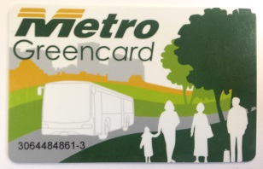 | 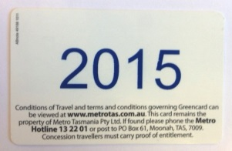 | Non-Metro Free Travel: This Greencard has non-Metro Free travel attached to it until the end of 2015.
 | 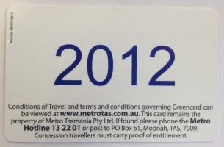 | Fare Paying: The free travel expired on this Greencard in 2012, but it can be used on any bus service to access the $1 discount fare.
 | 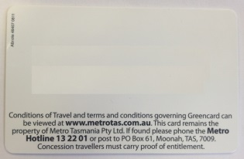 | Fare Paying: This is a fare paying Greencard and attracts the $1 discount fare.
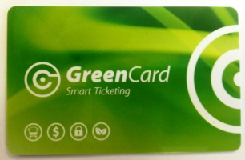 | 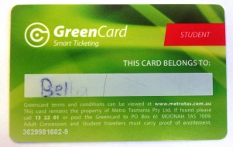 | Fare Paying: This is a fare paying Greencard and attracts the $1 discount fare.
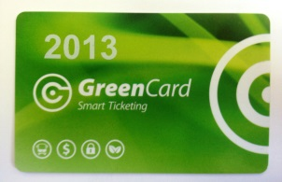 |  | Fare Paying: The free travel expired on this Greencard in 2013, but it can be used on any bus service to access the $1 discount fare.
 |  | Non-Metro Free Travel: This Greencard has non-Metro Free travel attached to it until the end of 2015.
 |  | Merseylink Free Travel: This Smart Card has Free Travel on Merseylink until the end of 2017.
 |  | Tassielink Free Travel: This Smart Card has Free Travel on Tassielink until the end of 2017.
 |  | PVC Transfer Pass: The Trip listed on the PVC Transfer Pass is for Free Travel. Any other services used will attract the standard $1 discount fare when a Greencard or Smart Card is used.
 |  | Adult Student Greencard: Attracts the $1 discount student rate for students over the age of 18, who have been approved as a Special Circumstance Bus Pass.
Adult Student Free Travel: A Free travel Student Greencard

PLUS

An Adult Student Bus Pass allows Adult Students to Travel for Free on non-Metro services.

