INNOVATION
Department of State Growth
MAKING OUR ROADS SAFER

Driving to the Conditions

Conditions on Tasmania’s roads change frequently. There are a range of innovations either already in place or coming soon to alert drivers to possible hazards.

Wet and Icy Traffic System
The Wet and Icy Traffic System on the Midland Highway at Constitution Hill combines a weather system, vehicle speed detectors and 3 high visibility LED signs.
Sign 1 is blank while conditions are clear.
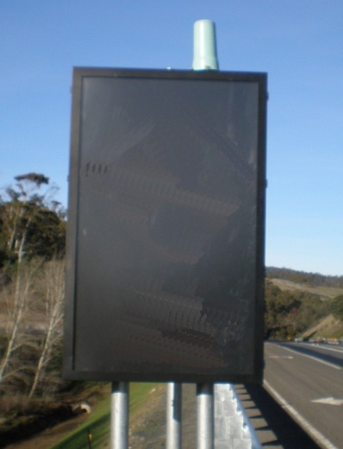 | When conditions change, the sign displays an appropriate warning message: |  |  |  |  |  |  |  | or
Sign 2 further along the road only comes on in response to Sign 1. It will show an advisory speed to match the conditions.  For example: | Wet road: |  | 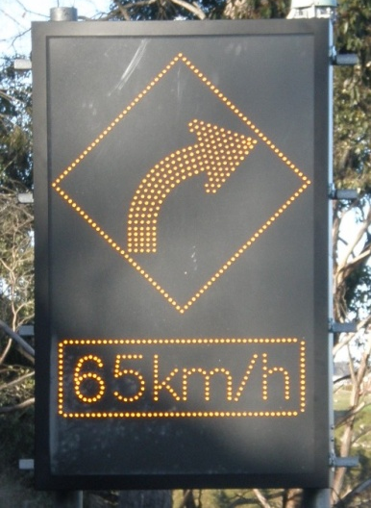 |  |  |  | Icy road: |  |  | 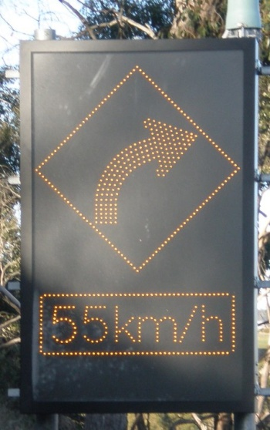
Sign 3 is closer to the sharp bend in the Highway. In dry conditions the sign is activated by vehicles travelling faster than the posted speed limit. In wet or icy conditions the sign is activated by vehicles travelling faster than the displayed advisory speed limit. |  | First |  |  | 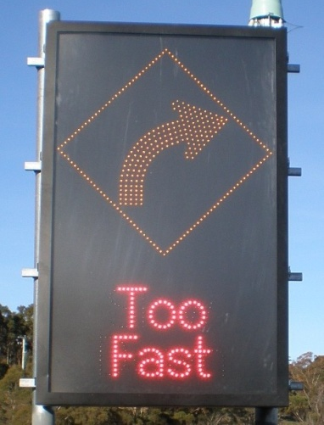 |  |  | and then |  |  | 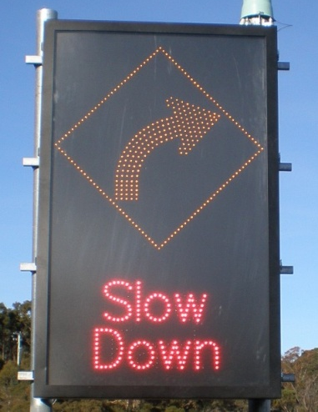
The Wet and Icy Traffic System displays advisory information only and is not used for enforcement.
The system may be considered for use at other sites that have a demonstrated crash history in wet or icy conditions.

