
Department of Infrastructure, Energy and Resources
Land Transport Safety Division
Vehicle Operations Branch

Taxi and Luxury Hire Car Newsletter

Department of Infrastructure, Energy and Resources

Issue 68 – February 2013

In this Issue:
Review of Taxi Licence Release Arrangements | Page 1
Taxi Fare Inquiry | Page 3

Review of Taxi Licence Release Arrangements
Initial Consultation Phase
As detailed in the previous issue of The Taxi and Luxury Hire car Newsletter (Issue 67 – Dec 2012), KPMG has been appointed by DIER to undertake the Review of Taxi Licence Release Arrangements Project (the Review).
To date, KPMG has undertaken background research as well as consulted with a number of Tasmanian taxi industry and taxi-user representatives.
Regional Forums
The next phase of the Review involves a series of regional forums to hear the views of any interested parties on the matters covered in this review.

Forums will be held in the North West (Ulverstone), North (Launceston) and South (Hobart).

Industry and community input will be important to enable DIER’s consultant KPMG to fully understand the outcomes of the current taxi licence release arrangements on a range of factors, including:

- Availability, reliability and quality of taxi services;
- Taxi driver and operator viability; and
- Competition within the taxi industry and between taxis and other forms of passenger transport;

Participants in the taxi industry (licence owners, licence lessees, operators, drivers, etc.) and any members of the general community, are therefore invited to participate in one of the regional forums.

Afternoon and evening sessions will be run in each location. Please choose the time that is most suitable for you.

The forums will operate in an informal, but structured format with opportunities for group and one-on-one discussions.

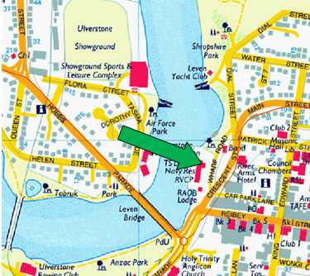
North-West
Tuesday 12 February,

2:00pm – 5:00pm (Session 1); and
6:30pm – 9:30pm (Session 2).

Venue: Wharf Precinct Community Space,
Wharf St, Ulverstone.

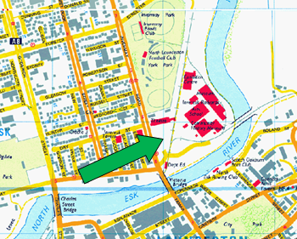
Launceston
Wednesday 13 February,

2:00pm – 5:00pm (Session 1); and
6:30pm – 9:30pm (Session 2).

Venue: No.28 Tram Room, The Tramsheds, Inveresk Rail Yards, 4 Invermay Rd, Inveresk, Launceston.

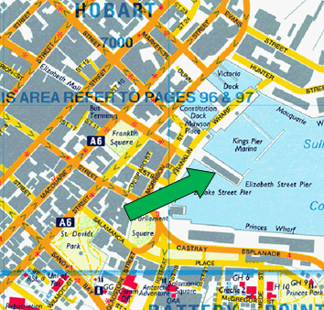
Hobart
Thursday 14 February,

2:00pm – 5:00pm (Session 1); and
6:30pm – 9:30pm (Session 2).

Venue: Marina Room, Hobart Function and Conference Centre, 1 Elizabeth St, Hobart.

Written Submissions
In addition to the regional forums detailed above, members of the taxi industry and general community are invited to lodge written submissions which address issues contained in the Review’s Terms of Reference (ToR). The ToR is provided as an attachment to this newsletter.
Written submissions should be forwarded to KPMG at:
Review of Taxi Licence Release Arrangements
GPO Box 1231M
Hobart TAS 7001
Or by fax on (03) 6230 4040

Or emailed to: dbrichardson@kpmg.com.au
The deadline for the lodgement of written submissions is 5pm, 22 February 2013.
People with an interest in the taxi industry, are encouraged to make use of the various opportunities detailed above to share their views with KPMG as the Review progresses.
Further Information
Further information on the status of the Review will be provided to the industry via future issues of the Taxi and Luxury Hire Car Newsletter.

Taxi Fare Inquiry
The Tasmania Economic Regulator is in the final stages of preparing of its Consultation Paper for the Taxi Fare Methodology Inquiry. The Regulator intends releasing its Consultation Paper in mid February 2013, along with the draft report prepared by its consultant (The Centre for International Economics).
The Consultation Paper and The CIE’s accompanying draft report discusses issues associated with the current approach to setting fares and options for future arrangements.
At this stage, the Regulator has not formed any views on whether it is appropriate to change the current approach, but has raised a number of issues and options for public comment and input.
The Regulator invites and encourages all interested parties, to make submissions to the Inquiry on the issues highlighted in the Consultation Paper, as well as on any other matters relevant to the Terms of Reference.
Submissions will be due by early April 2013. Further information can be found at the website of the Office of the Tasmanian Economic Regulator: www.economicregulator.tas.gov.au.

Previous Newsletters
These may be viewed on the DIER website, at the following link;

http://www.transport.tas.gov.au/publications/taxi__and__luxury_hire_car_newsletter2

This newsletter is also sent to all radio networks and taxi fleet managers, who will make copies available on request. Please make the Newsletter available to drivers.

NOTE: DIER issues this Newsletter to operators by email ONLY, as it is easier, cheaper and quicker to do so. If you change your email address, please advise Phil or Alan as under.

DIER Contacts

Vehicle Operations Branch
Danny Johnson, Manager, 6233 5390

Transport Operator Accreditation
Jeremy Gleeson (Manager) – 6233 5198
Phil Harvey - 6233 5376
Alan Kearsley - 6233 5396

Branch Fax: (03) 6233 5210
Operators should note that queries on all general operational and housekeeping matters should be directed to Phil.

E-mail: Phil.harvey@dier.tas.gov.au

Vehicle Standards and vehicle technical matters;
6233 5214 or 6233 5314

Driver licence and ancillary certificate queries;
6233 5195

Regional Managers – Transport Compliance
South – Mark Kramer – 6233 5280
North – Pat Quarrell– 6336 2696
North-West – Harry Marshall – 6434 6486

Taxi and Luxury Hire Car Industries Act 2008 –
Review of Taxi Licence Release Arrangements (and Associated Issues).
Terms of Reference

Review Tasks
The Consultant will be required to undertake consultation with industry and taxi users and perform a critical analysis of the current arrangements for the release of new taxi licences in Tasmania to evaluate the impact of these arrangements on:
- Availability, reliability and quality of taxi services;
- Taxi driver and operator viability; and
- Competition within the taxi industry and between taxis and other forms of passenger transport;
Where it deems it to be relevant, the Consultant will undertake analysis that distinguishes between each of Tasmania’s taxi areas, or between different groupings of taxi areas.
In particular, the situation in the Hobart taxi area will be examined in respect to evidence of market failure arising from the increase in taxi numbers in recent years.
In addition, the Consultant will examine the relative success of the licensing arrangements introduced by the Taxi and Luxury Hire Car Industries Act 2008 in achieving the policy aims of that legislation in respect to:
1. Owner-operator/standard taxi licences:
- greater opportunities for taxi operators and drivers (existing and new) to become established in the taxi industry as taxi licence holders, rather than investors with no interest in actually operating a taxi business;
- improving returns to the licence holder, thereby providing the opportunity for them to reinvest more resources in the enhancement of their taxi service, including the potential for improved driver remuneration to taxi drivers;
- providing a predictable, regular opportunity to access a new taxi licence, whether to enter the industry or expand an existing operation.
2. Wheelchair accessible taxi (WAT) licences:
- facilitating a means by which new WAT licences could be released, to ensure that the proportion of these taxis in the overall taxi fleet is, at least, maintained;
- ensuring adequate means for networks’ compliance with Disability Discrimination Act 1992 obligations;
- expanding the WAT fleet to regional areas of Tasmania, through (i) the relaxation of initial vehicle standards in those taxi areas deemed to be ‘remote’; and (ii) the introduction of provisions enabling operators of standard taxis to use wheelchair accessible vehicles in areas where no WAT service is operating; and
- introducing arrangements by which WAT vehicles could be replaced with substitute vehicles to address temporary operational problems.

Following this evaluation process, if warranted the Consultant is to identify alternative licence release arrangements that are likely to improve policy outcomes and make recommendations as to any reforms that should be considered by DIER.
In developing its recommendations, the Consultant will examine relevant regulatory systems in other jurisdictions (including outside Australia) and assess the suitability of these to Tasmania.
If appropriate, the Consultant should make recommendations that are specific to individual taxi areas, or groupings of taxi areas.
With specific reference to the consequences for taxi driver income of the present legislative arrangements, the Consultant is to recommend any appropriate strategies in the case of both: (i) a recommendation to make significant changes to the current licence release system; and (ii) a recommendation to leave the current licence release system largely intact.
This task will include an examination of the causal link between taxi driver income and taxi licence numbers, together with the influence of external factors on incomes (in particular since 2007).
In devising recommendations, the Consultant should assess:

(1) the degree to which alternatives will align with the overall policy objectives of the existing legislation; and

(2) the implications of alternatives in terms of Government resources, for example in respect to ongoing administrative processes,

and provide detailed comments on these issues in respect to the options that are examined.

Additional issues to be examined
- Performance measures for standard taxis and WATs – what, if any, measures should be established and periodically collected that are capable of being audited;

- Changes to regulatory arrangements which would:

- improve WAT performance in respect to WAT operators and radio networks according appropriate priority to wheelchair-reliant customers; and

- assist radio networks in meeting the response time performance standards in place under the Disability Standards for Accessible Public Transport 2002 (Cth).

This would include an assessment of whether limitations on demand for this type of taxi service, or other institutional factors, are creating a legitimate barrier to some WAT operators undertaking a significant amount of such work.

- The case for existing PTLs to be converted to OOTLs/WATs over time, plus (if justified) examination of possible methods for doing so

- Any practical and/or operational implications of the increase in taxis operating, including such matters as the distribution and capacity of taxi ranks and traffic congestion and/or other negative outcomes at specific locations (e.g. airports).
Contact details
Vehicle Operations Branch, DIER, 6261 5376

