|  |  |  |  |  |
| --- | --- | --- | --- | --- |
| **Item** | **Road Manager** | **Road** | **Comments and Restrictions** | **Conditions** |
| **1** | Break O’Day Council | All roads |  |  |
| **2** | Brighton Council Area | Back Tea Tree Road | Between Tea Tree Road intersection and Briar Banks Road intersection |  |
| **2.a** | Brighton Council Area | Baskerville Road | From the intersection for Baskerville Road and the East Derwent Highway to 100 Baskerville Road |  |
| **3** | Brighton Council Area | Bluemetal Drive |  |  |
| **4** | Brighton Council Area | Brighton Road | Between the Elderslie Road intersection and Glenstone Road |  |
| **5** | Brighton Council Area | Cove Hill Road | Between East Derwent Highway and Cowle Road |  |
| **6** | Brighton Council Area | Crooked Billet Drive |  |  |
| **7** | Brighton Council | Elderslie Road | Between Brighton Road and Millvale Road |  |
| **9** | Brighton Council | Greenbanks Road | Brighton Council Area |  |
| **10** | Brighton Council | Hurst Street | Between Cove Hill Road and Paice Street |  |
| **11** | Brighton Council | Lukaarlia Drive |  |  |
| **12** | Brighton Council | Possum Road |  |  |
| **13** | Brighton Council | Strong Street |  |  |
| **14** | Brighton Council | Woodrieve Road |  |  |
| **15** | Burnie City Council | Anglesea Street |  |  |
| **16** | Burnie City Council | Applebys Road |  |  |
| **17** | Burnie City Council | Baztek Road |  |  |
| **18** | Burnie City Council | Besser Crescent | Access only from East Cam Road |  |
| **19** | Burnie City Council | Bianci Road |  |  |
| **20** | Burnie City Council | Camena Road |  |  |
| **21** | Burnie City Council | Cartledge Road |  |  |
| **22** | Burnie City Council | Clarkes Road |  |  |
| **23** | Burnie City Council | Colchester Street |  |  |
| **24** | Burnie City Council | Cooee Point Road |  |  |
| **25** | Burnie City Council | Corcellis Street |  |  |
| **26** | Burnie City Council | Darling Road |  |  |
| **27** | Burnie City Council | Dedham Street |  |  |
| **28** | Burnie City Council | Devon Street |  |  |
| **29** | Burnie City Council | East Cam Road |  |  |
| **30** | Burnie City Council | Eighteen Mile Road |  |  |
| **31** | Burnie City Council | Falls Road |  |  |
| **32** | Burnie City Council | Greta Road |  |  |
| **33** | Burnie City Council | Grooms Road |  |  |
| **34** | Burnie City Council | Guide Road |  |  |
| **35** | Burnie City Council | Jameson Road |  |  |
| **36** | Burnie City Council | Kara Road |  |  |
| **37** | Burnie City Council | Kingsclere Road |  |  |
| **38** | Burnie City Council | Liapota Road |  |  |
| **39** | Burnie City Council | Loynee Road |  |  |
| **40** | Burnie City Council | Main Road Wivenhoe |  |  |
| **41** | Burnie City Council | Natone Road |  |  |
| **42** | Burnie City Council | Neena Road |  |  |
| **43** | Burnie City Council | North Prospect Road |  |  |
| **44** | Burnie City Council | Oonah Road |  |  |
| **45** | Burnie City Council | Ormsby Street |  |  |
| **46** | Burnie City Council | Osborn Road |  |  |
| **47** | Burnie City Council | Pet Road |  |  |
| **48** | Burnie City Council | Phillip Street |  |  |
| **49** | Burnie City Council | Ready Street |  |  |
| **50** | Burnie City Council | Reeves Street |  |  |
| **51** | Burnie City Council | River Road |  |  |
| **52** | Burnie City Council | Rogetta Road |  |  |
| **53** | Burnie City Council | Scarfe Street |  |  |
| **54** | Burnie City Council | Serpintine Road |  |  |
| **55** | Burnie City Council | Smith Street |  |  |
| **56** | Burnie City Council | South Prospect Road |  |  |
| **57** | Burnie City Council | South Riana Road |  |  |
| **58** | Burnie City Council | Stowport Road |  |  |
| **59** | Burnie City Council | Strahan Street |  |  |
| **60** | Burnie City Council | Sushames Road |  |  |
| **61** | Burnie City Council | Talunah Road |  |  |
| **62** | Burnie City Council | Tena Road |  |  |
| **63** | Burnie City Council | Three Mile Line Road |  |  |
| **64** | Burnie City Council | Upper Stowport Road |  |  |
| **65** | Burnie City Council | Wellington Street |  |  |
| **66** | Burnie City Council | West Ridgely Road |  |  |
| **67** | Burnie City Council | Youralla Road |  |  |
| **68** | Burnie City Council | Brickport Road | Bass Highway to Hospital Access Road |  |
| **69** | Burnie City Council | Circular Road | Ridgely Highway to Kingsclere Road |  |
| **70** | Burnie City Council | Devonshire Driver | Bass Highway to Speed Street |  |
| **71** | Burnie City Council | Hopkinson Street | Bass Highway to Devon Street |  |
| **72** | Burnie City Council | Hospital Access Road | Brickport Road to hospital maintained portion of access road |  |
| **73** | Burnie City Council | Minna Road | Bass Highway to Devonshire Drive |  |
| **74** | Burnie City Council | Mooreville Road | Three Mile Line Road to Waste Management Centre |  |
| **75** | Burnie City Council | Old Surrey Road | Mount Street to 10 tonne load limit zone near Lion Factory |  |
| **76** | Burnie City Council | Pearl Street | Main Road to Ready Street (Anglesea Street to Ormsby Street Railway Overpass NOT APPROVED) |  |
| **77** | Burnie City Council | West Mooreville Road | East Cam Road to Ridgley Highway |  |
| **78** | Burnie City Council | Wilson Street | 196 Wilson Street to Wellington Street |  |
| **79** | Burnie City Council | Upper Natone Road | All except for section across Tittee Gee Creek Bridge. Access NOT APPROVED between Bianci Road and Sushames Road. |  |
| **80** | Central Coast Council | All roads |  |  |
| **81** | Circular Head Council | All roads |  |  |
| **82** | Clarence City Council | All roads |  |  |
| **83** | Derwent Valley Council | Molesworth Road | From Lyell Highway to Wyre Forest Road |  |
| **84** | Derwent Valley Council | Lachlan Road | From Humphrey Street to White Timber Road |  |
| **85** | Derwent Valley Council | Plenty Valley Road | From Glenfern Road to Moogara Road |  |
| **86** | Derwent Valley Council | Glenfern Road | From Glenora Road to Glenfern Road |  |
| **87** | Derwent Valley Council | Montagu St | From Blair Street to Glenora Road |  |
| **88** | Derwent Valley Council | Glenora Road | From Montagu Street to Glenfern Road |  |
| **89** | Derwent Valley Council | Blair St | From Montagu Street to George Street |  |
| **90** | Derwent Valley Council | George St | From Blair Street to Humphrey Street |  |
| **91** | Derwent Valley Council | Humphrey St | From George Street to Lachlan Road |  |
| **92** | Derwent Valley Council | Back River Road | From Lyell Highway to Blackwells Road |  |
| **93** | Devonport City Council | All roads |  |  |
| **94** | Dorset Council | All roads |  | Travel is not permitted on the state Dorset Council Roads between 8 to 9am and 3 to 4.30pm on official school days. |
| **95** | Flinders Island Council | No roads | Road Manager consent not provided |  |
| **96** | George Town Council | All roads *except* Agnes Street. |  | Travel is not permitted through school zones or school crossings between 8 to 9am and 3 to 4.30pm on official school days. |
| **97** | Glamorgan Spring Bay Council | All roads |  |  |
| **98** | Glenorchy City Council | Bender Drive |  |  |
| **99** | Glenorchy City Council | Cadbury Road |  |  |
| **100** | Glenorchy City Council | Chapel Street | Between Main Road and Jackson Street |  |
| **101** | Glenorchy City Council | Claremont Link Road |  |  |
| **102** | Glenorchy City Council | Derwent Park Road | Between Bender Drive, Derwent Park and Main Road, Moonah |  |
| **103** | Glenorchy City Council | Elwick Road | Between the Brooker Highway and King George V Avenue |  |
| **104** | Glenorchy City Council | Farley Street |  |  |
| **105** | Glenorchy City Council | Gormanston Road | Moonah, between Derwent Park Road and Pear Avenue |  |
| **106** | Glenorchy City Council | Hale Street | Derwent Park, for a distance of 75 metres from the junction with Sunderland Street |  |
| **107** | Glenorchy City Council | Howard Road |  |  |
| **108** | Glenorchy City Council | Jackson Street |  |  |
| **109** | Glenorchy City Council | King George V Avenue |  |  |
| **110** | Glenorchy City Council | Linear Court | Derwent Park (off Sunderland Street) |  |
| **111** | Glenorchy City Council | Main Road | Berriedale, between the Brooker Highway and Claremont Link Road and Cadbury Road |  |
| **112** | Glenorchy City Council | Main Road | Between Claremont Link Road, Claremont and Gunns Sawmills, Austins Ferry |  |
| **113** | Glenorchy City Council | Pear Avenue | Moonah |  |
| **114** | Glenorchy City Council | Risdon Road | Lutana, between the Brooker Highway and Queens Walk |  |
| **115** | Glenorchy City Council | Sunderland Street | Moonah, between Derwent Park Road and Lampton Avenue |  |
| **116[1]** | Hobart City Council | Brooker Avenue | Between Burnett Street and Davey Street | *** No access to these streets/roads between 7.30am - 9.30am and  3.30pm - 5.30pm, Monday to Friday.  The vehicle is limited to 20km/h when turning at intersections. |
| **117** | Hobart City Council | Davey Street | Between Brooker Ave and Southern Outlet |
| **118** | Hobart City Council | Macquarie Street |  |
| **119** | Hobart City Council | Southern Outlet | Between Davey Street and Macquarie Street |
| **120** | Hobart City Council | Evans Street |  |
| **121** | Hobart City Council | Cascade Road |  |
| **122** | Hobart City Council | ***Campbell Street |  |
| **123** | Hobart City Council | Burnett Street | Between Brooker Avenue and Argyle Street |
| **124** | Hobart City Council | ***Argyle Street | Between Davey Street and Federal Street |
| **125** | Hobart City Council | ***Sandy Bay Road |  |
| **126** | Hobart City Council | Risdon Road |  |
| **127** | Hobart City Council | Forster Street |  |
| **128** | Hobart City Council | Giblin Street | Between Augusta Road and Forster Street |
| **129** | Hobart City Council | Augusta Road |  |
| **130** | Hobart City Council | New Town Road | Between Elizabeth Street and Risdon Road |
| **131** | Hobart City Council | Brisbane Street | Between Brooker Avenue and Argyle Street |
| **132** | Hobart City Council | Warwick Street | Between Brooker Avenue and Argyle Street |
| **133** | Hobart City Council | Federal Street | Between Brooker Avenue and Argyle Street |
| **134** | Hobart City Council | Tasma Street | Between Elizabeth Street and Argyle Street |
| **135** | Huon Valley Council | No roads | Road Manager consent not provided |  |
| **136** | Kentish Council | All roads |  |  |
| **137** | Kingborough Council | All roads |  |  |
| **138** | King Island Council | All roads |  |  |
| **139** | Latrobe Council | All roads |  |  |
| **140** | Launceston City Council | All roads |  |  |
| **141** | Meander Valley Council | All roads |  |  |
| **142** | Northern Midlands Council | No roads | Road Manager consent not provided |  |
| **143** | Sorell Council | Brinktop Road |  |  |
| **144** | Sorell Council | Penna Road |  |  |
| **145** | Sorell Council | Old Forcett Road |  |  |
| **146** | Sorell Council | Carlton Beach Road |  |  |
| **147** | Sorell Council | Primrose Sands Road |  |  |
| **148** | Sorell Council | Lewisham Road |  |  |
| **149** | Southern Midlands Council | All roads |  |  |
| **150** | Tasman Council | All roads |  |  |
| **151** | West Coast Council | Harvey Street | Strahan |  |
| **152** | West Coast Council | Reid Street | Strahan |  |
| **153** | West Coast Council | Ocean Beach Road | Strahan |  |
| **154** | West Coast Council | Macquarie Heads Road | Strahan, Initial 2.4km section only |  |
| **155** | West Coast Council | Andrew Street | Strahan, Henty Road to Harvey Street |  |
| **156** | West Coast Council | Main Street | Zeehan |  |
| **157** | West Coast Council | Arthur Street | Roseberry |  |
| **158** | West Coast Council | Primrose Road | Roseberry |  |
| **159** | West Coast Council | Bachelor Street | Queenstown |  |
| **160** | West Coast Council | Conlan Street | Queenstown |  |
| **161** | West Coast Council | Driffield Street | Queenstown |  |
| **162** | West Coast Council | Penghana Street | Queenstown |  |
| **163** | West Tamar Council | No roads | Road Manager consent not provided |  |
| **164** | Hydro Tasmania | Pieman Road | Between Murchison Highway and Reece Dam |  |
| **165** | Tas Ports | All roads |  |  |

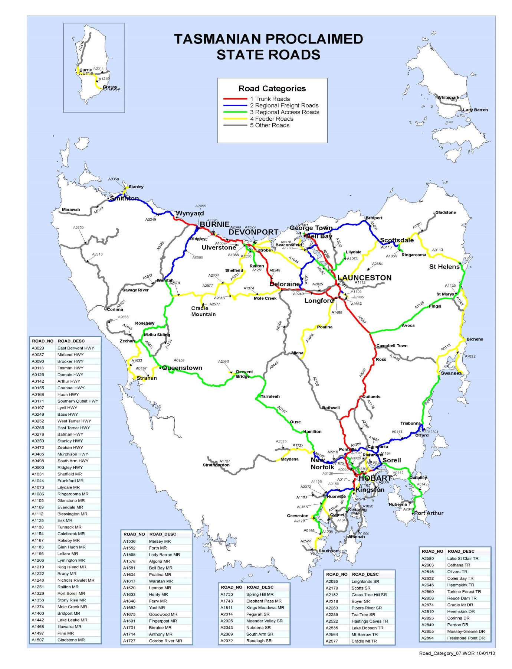

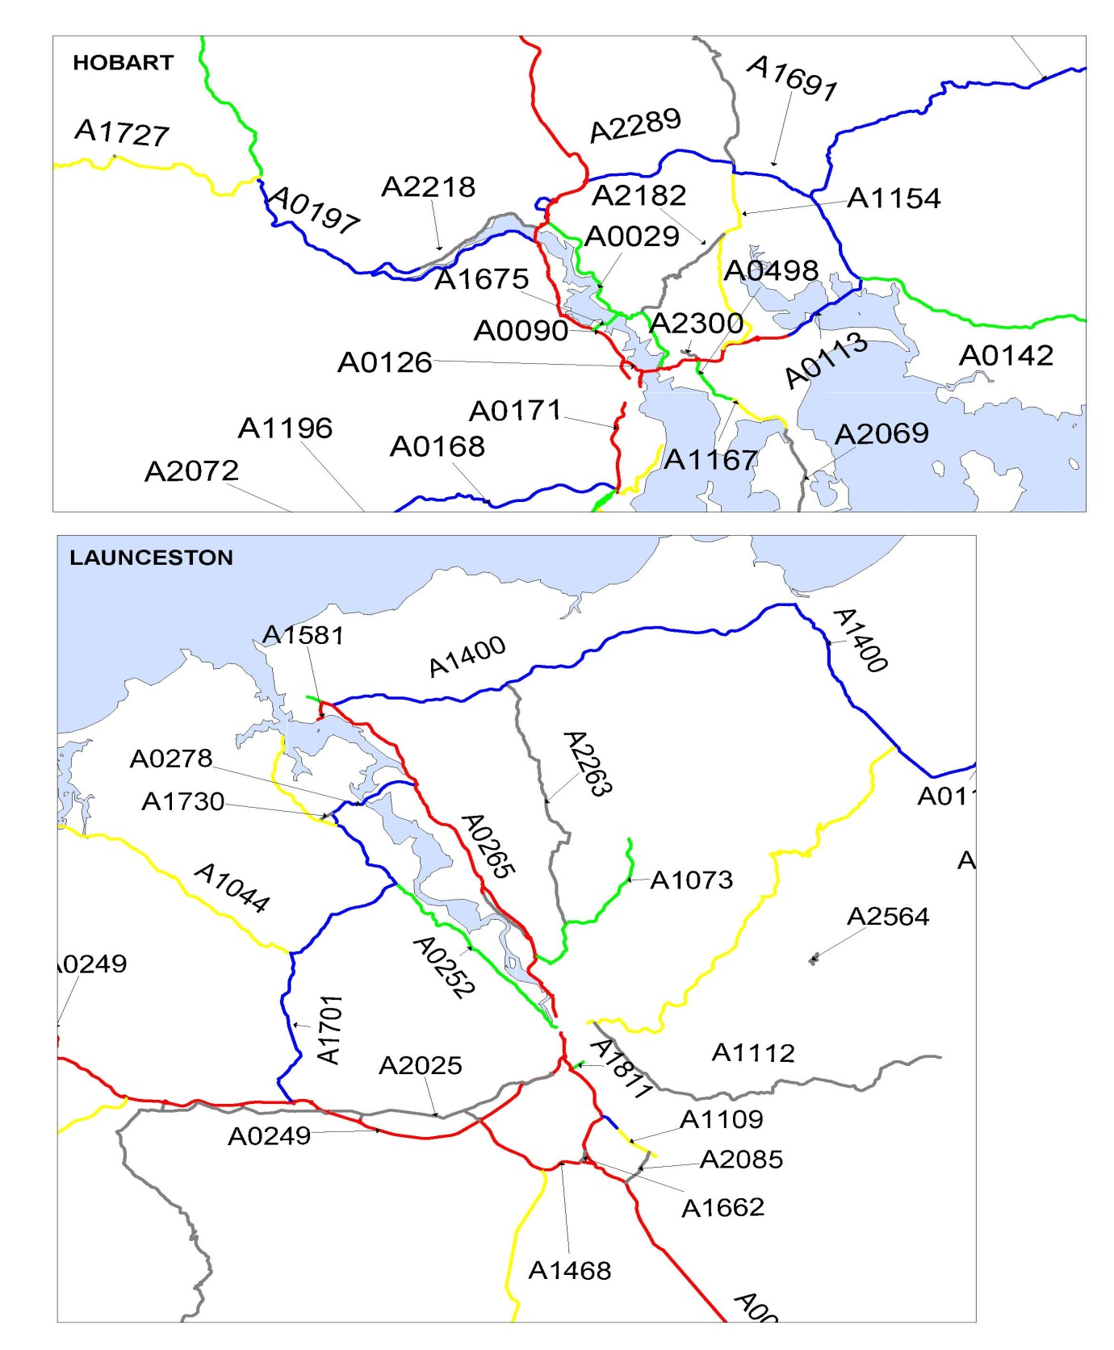

1. Note amended conditions applied to Hobart City Council Routes. Effective 6 March 2015