INNOVATION
MAKING OUR ROADS SAFER

Pedestrian Signals – Getting the Green Light

We’re all familiar with pedestrian signals, but did you know that the timing of traffic lights is set to balance traffic flow and enhance pedestrian safety?
 | Who Goes First?
 | The green ‘walk’ and flashing red ‘finish crossing’ signals can be set for longer to give people more time to cross. (Remember, you have until the end of the flashing red phase to finish crossing.) Increasing the time for people to cross is used where there are lots of pedestrians with special needs.
Vehicles can be made to wait for pedestrians to start crossing, before they are allowed to turn.
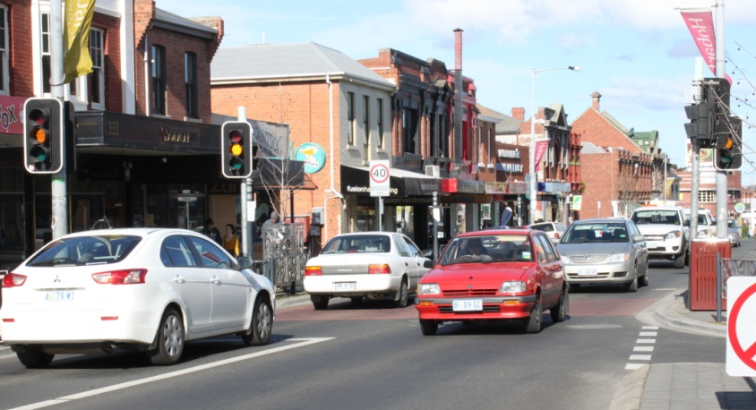 |  |  |  |  | The vehicle amber light can be set to flash after the pedestrian green ‘walk’ signal has finished, letting drivers go through the crossing as soon as it is clear of pedestrians. This is used to improve traffic flow at narrow crossings, such as a slip lane, or through a single-carriageway shopping zone.
Extra Help…
Many of us have heard the beeping noise at pedestrian lights – this assists pedestrians with visual impairments. But you might not know that the arrow section above the button also pulses in time with the beeps, providing extra help to those with a hearing impairment.
Remember…
 |  | DO NOT cross |  | 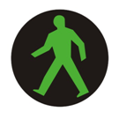 |  | START  to cross WITH CARE |  |  |  |  | FINISH crossing  DO NOT START crossing
… even if you have right of way, always cross WITH CARE
Department of State Growth

