Purpose
The purpose of this information bulletin is to provide information for owners and operators in selecting an appropriate safety chain connection device for a road trailer of up to 3500KG.

Background
- Austrian Design Rule (ADR) 62, AS/NZ 4177 and AS/NZ 2321 outlines the requirements for chain/cable strength and attachment points on the trailer and the towbar.
- Vehicle Standards Bulletin (VSB1) defines the safety chain requirements for all light trailers manufactured after 1 Jul 1991.
- Trailers manufactured prior to 1 Jul 1991 require fitment of at least 1 safety chain in accordance with the Vehicle Standards Regulations.
- Vehicle and Traffic (Vehicle Standards) Regulations 2014, Regulation 137 requires:
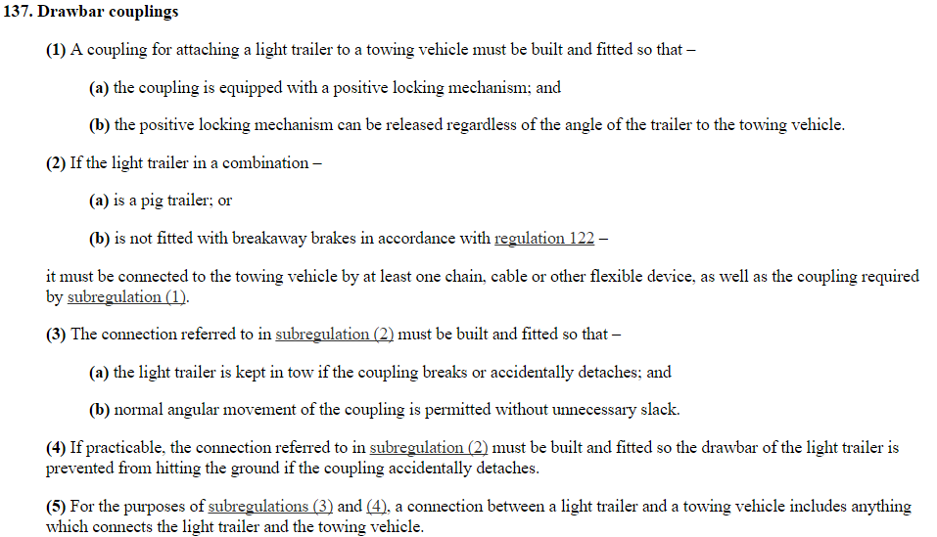

Shackles
Bow shackles and D shackles that comply with Australian Standard (AS) 2741 are rated for lifting applications and have a breaking load marked on the shackle that is higher than the Working Load Limit (WLL). Since the loading on these shackles is different when used to attach a safety chain to a road vehicle as compared to when used in a lifting application, a road trailer may be towed that is heavier than the shackle’s WLL.
The relationship between the WLL and the towing capacity is given in the table on page 2.

Recommendation
Safety chains may be attached to the towbar attachment points with a bow, D or pin shackles. As they are considered integral with the towbar, safety chain attachment points on the towbar that include a pin shackle or bolt for attaching the chain are subject to performance requirements as per ADR62/01 or 02 – Mechanical Couplings between Vehicles.
Shackles used to attach safety chains to towbar attachment points should at a minimum exceed the required rating of the safety chain, as determined by the ATM of the road trailer. Additionally, the shackle should be fit for purpose and compatible with the safety chain in terms of strength and size.
This may be fulfilled by:
a) The use of a shackle that is compatible with the safety chain and complying with AS2741. In this case, the shackle must have the appropriate markings, as identified below:
- Manufacturers Identification, and
- Quality or Grade as M or 4, or S or 6, and
- Working Load Limit (WLL), the maximum load that may be applied to the shackle,
- Identification marking to correlate the shackle to test certificate.

Shackle Selection:
Trailer ATM (kg) | Chain Size Classification AS4177.4 -2004 | Chain Marking AS4177.4 - 2004 | Minimum size of Shackles (Body diameter not pin size).  For Bow or D-shackles complying with AS2741
 |  |  | Grade M (or4) D Shackle | Grade S (or 6) D Shackle | Grade S (or 6)  Bow Shackle
Up to 1000Kg | 1000 | 4177-10 | 6mm WLL 250kg | 6mm WLL 250kg | 5mm WLL 250kg
1001 to 1600Kg | 1600 | 4177-16 | 10mm WLL 400kg | 6mm WLL 400kg | 6mm WLL 400kg
1601 to 2500Kg | 2500 | 4177-25 | 13mm WLL 625kg | 8mm WLL 625kg | 8mm WLL 625kg
2501 to 3500Kg | 3500 | 4177-35 | 16mm WLL 875kg | 10mm WLL 875kg | 10mm WLL 875kg

b) Alternatively the use of a shackle that is compatible with the safety chain and is of a reputable brand. In this case the shackle will have appropriate markings to show the brand and or part identification sufficient to trace its brand and strength back to the original manufacturer.
The original document produced by the Australian Government and further information can be found here: https://infrastructure.gov.au/vehicles/administrators_circulars/index.aspx

Definitions
For definitions used in this Information Bulletin, refer to Vehicle Standard (Australian Design Rule Definitions and Vehicle Categories) 2005, as well as the following:

Australian Design Rules (ADR): The Australian Design Rules (ADRs) are national standards for vehicle safety, anti-theft and emissions. The ADRs are generally performance based and cover issues such as occupant protection, structures, lighting, noise, engine exhaust emissions, braking and a range of miscellaneous items - https://infrastructure.gov.au/roads/motor/design/

AGGREGATE TRAILER MASS (ATM) - the total mass of the laden trailer when carrying the maximum load recommended by the ‘Manufacturer’. This will include any mass imposed onto the drawing vehicle when the Combination Vehicle is resting on a horizontal supporting plane.

AUSTRALIAN STANDARD 2741-2002 “SHACKLES” (AS 2741) - Specifies requirements for forged shackles.

AUSTRALIAN STANDARD 4177.4-2004 “CARAVAN AND LIGHT TRAILER TOWING COMPONENTS - SAFETY CHAINS UP TO 3,500KG CAPACITY” (AS 4177.4) - Specifies requirements for safety chains.
BOW-SHACKLE – “O” shaped body that is enclosed at the end by either a threaded clevis or cotter pin and used to connect a safety chain between a road motor vehicle and road trailer.

D-SHACKLE – “U” shaped body that is enclosed at the end by either a threaded clevis or cotter pin and used to connect a safety chain between a road motor vehicle and road trailer.

PIN-SHACKLE – a device integral to a tow bar, which may consist of brackets and a bolt, clevis or cotter pin and used to connect a safety chain between a road motor vehicle and road trailer.

ROAD TRAILER - a vehicle without motive power designed for attachment to a road motor vehicle; or a piece of machinery or equipment that is equipped with wheels and designed to be towed behind a road motor vehicle.

SAFETY CHAIN – a chain, which is attached between the towbar of a road motor vehicle and the drawbar of a road trailer and, which for a road trailer with a ATM of up to 3,500kg meets the requirements of AS 4177.4, or is a cable which is appropriate for the application; and for a road trailer with a ATM exceeding 3,500kg a steel chain with a minimum of 800MPa breaking stress that conforms to the mechanical properties of Grade T chain.

SAFETY CHAIN CONNECTION DEVICE – a device that connects a safety chain to the towbar (mechanical connection) of a road motor vehicle, for example a D-shackle, Bow-Shackle or Pin shackle.
TOWBAR - a device attached to a road motor vehicle provided for connection of a road motor vehicle to a ‘Coupling’ for the towing of a road trailer.

VEHICLE STANDARDS BULLETIN 1 (VSB1): Building small trailers information for manufacturers and summarised construction requirements for trailers less than 4.5 tonnes aggregate trailer mass - https://infrastructure.gov.au/roads/vehicle_regulation/bulletin/vsb1/index.aspx

WORKING LOAD LIMIT (WLL) – the maximum load that may be applied to a Bow, D, or Pin-Shackle.

