Welcome to the September 2018 edition of the Taxi Newsletter. Due to a range of emerging issues, this edition has been issued to supplement the August 2018 issue.
New Regulations
The Taxi Industry Regulations 2018 and Luxury Hire Car Industry Regulations 2018 commenced on 20 September 2018. These replace the earlier regulations which expired. There are no substantive changes, other than the renumbering of the clauses within the Regulations.
As a taxi operator it is your responsibility to know the laws that effect your taxi service. With the commencement of these regulations, it is a good opportunity for you to read over the laws relating to your taxi service. They can be found at www.thelaw.tas.gov.au.
Release of owner-operator taxi licences for 2018
The Transport Commission has made available owner operator taxi licences (OOTLs) in Tasmanian taxi areas, except for the Hobart taxi area. The OOTLs have been made available by way of tender which commences on 29 September 2018 and will close on 17 October 2018 at 2.00pm.
The number of OOTLS to be released in a particular taxi area will be as follows:
Taxi Area | Number of OOTLs to be released in 2018
Launceston | 5
Devonport | 1
Burnie | 1
All other taxi areas (except Hobart) | 1
The tender will be advertised in the major Tasmanian newspapers and on www.tenders.tas.gov.au. A total of 27 OOTLs will be made available for Tasmanian taxi areas with the exception of the Hobart taxi area.
To place a tender for one or more of the OOTLs you will need to follow the procedure set out for the OOTL tender at www.tenders.tas.gov.au.

The Transport Commission has made these OOTLs available in accordance with the Ministerial Notice to allow for OOTLS to be released for tender in all taxi areas across the State, except for the Hobart taxi area, issued by the Minister for Infrastructure on 25 January 2018.
The Minister for Infrastructure had earlier declared on 21 September 2016 that there would be no additional owner-operator taxi licences made available in a Tasmanian taxi area for the years 2016, 2017 and 2018, in response to the commencement of ride-sourcing services in Hobart.
The contact officer for all questions about the tender or submitting a tender is Anne-Maree Mills, Manager Regulations and Concessions. She may be contacted by email at anne-maree.mills@stategrowth.tas.gov.au. Please note that all inquiries about the tender should only be directed to the contact officer.
2018 - 2019 Hobart Cruise Ship Season
The impending Hobart cruise ship season has 65 cruise ships scheduled to be docked at the Port of Hobart between 4 October 2018 and 21 June 2019. This represents an increase from the 60 and 48 cruise ships docked in the 2017-2018 and 2016-17 seasons, respectively.
For the 2018-19 cruise ship season the following arrangements have been put in place:
- Tas Ports have made available parking areas which are set aside as a taxi rank, a taxi feeder rank and a drop-off-pick up area for private passenger vehicles including UBER vehicles.
- Tas Ports have made available a parking area for vehicles and a separate area of the waterfront near to the cruise ship terminal to be set aside for certain operators to solicit passengers. The operators that can use these areas have applied, and been selected by Destination South Tasmania Ltd to use the Hawking Area.
These parking areas are identified on the below map:
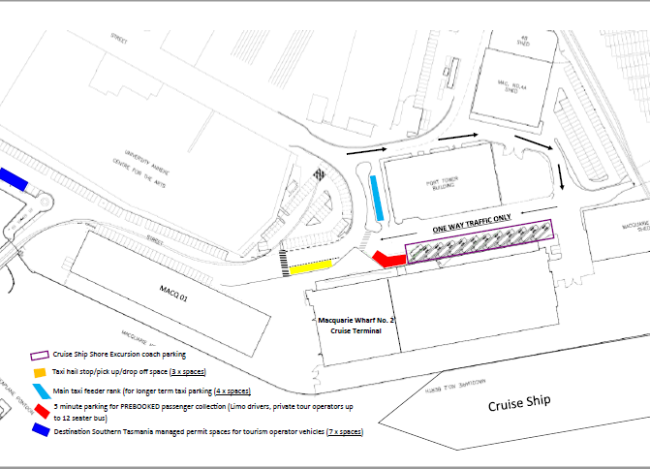
To find out the cruise ship schedule, you can visit the Tas Ports website.

Accreditation
The Transport Commission, the Department of State Growth and operators all want a safe passenger transport service so that the travelling public have confidence in Tasmania’s public passenger transport network.
The purpose of passenger transport service operator accreditation to ensure safety. The Commission must be satisfied that the operator of a passenger transport service:
- is a fit and proper person to operate the service
- implements appropriate safety, security and related systems (Systems) for the service
- has the requisite competence and capacity to manage the safety, security and related risks associated with operating the service and
- is held accountable for any deficiencies in the safety, security or related performance of the service
When the Systems are not in place or the operator does not have the competence to manage the service, there is a risk that the service is unsafe and passengers, drivers and road users are exposed to danger by way of unsafe service, vehicle and/or driver.
When there is information supporting that the Systems are not appropriate for the service, the Commission will take the appropriate action. This may include steps to require that the Systems are improved. If the Systems are not improved and the Commission is satisfied that there is a risk to the travelling public, then the Commission will respond with significant action. This action can include the cancellation of an accreditation. When an accreditation is cancelled, the passenger transport service is no longer able to operate.
Accreditation Certificate
Accreditation certificates issued by the Transport Commission are very important. They identify to passengers and enforcement officers that a vehicle and its driver, are part of an accredited passenger transport service and they can expect that the safety, security and related systems are in place to ensure the service is safe. Accreditation certificates don’t expire.
A new design for the accreditation certificate is being developed which will replace the existing design.
The new certificate will be issued when:
- a new accreditation is approved; or
- an audit report or National Police Certificate (NPC) is submitted for an existing accreditation (in accordance with the conditions of accreditation) over the next three years.
The conditions that apply to the accreditation certificate will still be described on the certificate.
When an accreditation certificate with the new design is issued, a further certificate will NOT be issued unless there is any change to the conditions of the accreditation. (The Responsible Person or the Accredited Operator will need to visit a Service Tasmania shop and pay a fee, currently $31.60). The new certificate will be forwarded by mail or email from the Regulations and Concessions Unit.
Operators will not need to wait for a new certificate when they submit an audit report or NPC.
The original of the accreditation certificate must be kept with the accreditation records in accordance with the Accreditation Standards. A copy of the certificate must be displayed prominently in each vehicle that is used for the Service in accordance with the written instructions of the Commission.
Regulations and Concessions Unit
For operator accreditation or taxi licence enquiries:
Email: operator.accreditation@stategrowth.tas.gov.au

