Moving towards more accessible bus stops

Moving towards more accessible bus stops
  - DDA bus stop guidelines

Contents
Background 1
DDA compliance background 1
Responsibility for DDA compliance 1
What does DDA compliance look like? 2
Provision of DDA compliant bus shelters 2
Bus stop planning and design 3
Bus stop infrastructure 3
Bus stop boarding point 3
Boarding point width 3
Level boarding point 4
Surface material 5
Provision of kerbs 5
Providing a connection from the bus stop to connecting footpaths 6
Providing tactile ground surface indicators (TGSIs) 6
TGSIs at multiple boarding points 7
TGSI’s at single boarding points 7
Larger bus stops 9
Providing unobstructed access to bus stops 10
Bus stop signage 10
Set-back of bus stop signage 10
Bus stop timetables 12
Bus stop poles 12
Bus shelters and seating 12
Provision of lighting at bus stops and shelters 13
Summary of bus stop DDA compliance requirements 13
Useful resources 15

Background
This guide has been developed by the Department of State Growth to guide the planning and design and construction of general access bus stops across Tasmania. It is based on the Australian Human Rights Commission guidelines for promoting bus stop compliance; it should be noted that these guidelines are based on the minimum requirements for a Disability Discrimination Act 1992 (DDA) bus stop.
All new general access bus stops need to be DDA compliant, and by the end of 2022 all existing general access bus stops need to be upgraded to be made compliant.
DDA compliant bus stop infrastructure will increase access to public transport particularly for young families with prams, older Tasmanians and people living with a disability. Better bus stop infrastructure will also enhance the passenger experience leading to greater public transport patronage and reduced traffic congestion.

DDA compliance background
The Disability Discrimination Act 1992 is Australian Government legislation that seeks to eliminate discrimination, ‘as far as possible’, against people with a disability. Public transport is a service covered by the DDA.
Under the DDA the Australian Government has developed the Disability Standards for Accessible Public Transport 2002 (DSAPT) which covers public transport, including buses. All of Tasmania’s general access bus network and associated infrastructure such as bus stops is required to be compliant by the end of 2022. School bus services and infrastructure are not required to be DDA compliant. The DDA makes it unlawful for any person to contravene a Disability Standard (including the DSAPT).
The Australian Human Rights Commission has developed guidelines to assist public transport operators and providers to meet their obligations under the DDA in respect of bus stop infrastructure. The guidelines do not replace the provisions of the DSAPT.
The DDA uses a complaints-based framework to determine compliance. Compliance is only determined once a complaint of non-compliance is received by the Australian Human Rights Commission and a process of mediation and/or arbitration is completed.
Can all bus stop infrastructure be made DDA compliant?
There will be some locations where it is not possible to provide a DDA compliant bus stop. This is particularly the case in Tasmania where there is challenging topography. Other factors may include urban areas where the road space is limited and the width available for a footpath or boarding point is very narrow. In such cases, the road authority should do as much as possible to make the bus stop compliant or investigate alternative locations for the bus stop which may be more suitable in terms of DDA compliance.

Responsibility for DDA compliance
Both State Growth and councils are relevant road managers responsible for ensuring bus stops are DDA compliant. It is acknowledged that upgrading bus stops to be DDA compliant is a significant challenge and that all parties are dealing with a legacy issue of stops which are not built to compliant standard.

What does DDA compliance look like?
The following are the key components of a DDA compliant bus stop:
DDA requirements for a standard bus stop
Bus stop DDA component | DDA requirements
Bus stop signage which includes pole and blade
Signage has the appropriate text size and any text or graphics has a luminance contrast against the background
TGSI (tactile ground surface indicators), also known as tactiles
Seamless and unobstructed transition between the bus stop (including from a shelter) and footpath and/or road
Firm (usually hardstand), as level as possible boarding point, with sufficient width
The provision of bus shelters is not a requirement under the DDA Standards. However, when a shelter is provided it needs to have the following:
DDA requirements for a bus shelter
Bus shelter DDA component | DDA requirements
Space for at least two wheelchairs within the shelter. The space should be firm, usually hardstand
Appropriate seat heights
Priority seating for people with disabilities and other groups in need of special assistance (e.g. older Tasmanians)
Seating spaces must not affect the width of the boarding point

Provision of DDA compliant bus shelters
If a bus shelter is provided it should be DDA compliant. There is also a requirement that if a bus stop is being substantially upgraded and if there is an existing bus shelter, it should also be upgraded or replaced with a DDA compliant shelter.
Maintenance or repair of bus shelters is not considered a substantial upgrade and therefore would not trigger a need to upgrade the whole bus stop shelter to be DDA compliant. However, if the footpath was being replaced which involves digging up the foundation of the shelter, it would be a substantial upgrade and the shelter should be made DDA compliant.
Within Tasmania, some bus shelters only have one designated space for a wheelchair and not the two required spaces. This may be because the shelter had limited space or the ongoing usage of the shelter was expected to be low. There is an expectation that if the shelter is due to be replaced then additional allocated spaces for wheelchair passengers should be provided in conjunction with the upgrade.
It should be noted that complaints may still be received due to a shelter not having the required number of spaces.
There is also a need to clearly identify allocated spaces for people using a wheelchair; this can be done through labelling of the spaces through regular maintenance programs. When allocated spaces are not being used by people using a wheelchair, the area is available for all passengers.

Bus stop planning and design
This guide has been developed in relation to DDA compliance of the bus stop. It does not cover issues regarding suitability of the site for a bus stop in terms of location or the bus stop configuration on the actual road. A range of site-specific issues need to be considered when planning and designing a new stop or upgrading an existing stop, including:
- safety in terms of pedestrians, traffic speed and traffic volumes
- sight lines
- road width and space for passenger waiting areas
- adjoining land use.
These issues will help identify the type of bus stop configuration that may be required such as an indented bus bay and length of road tapers.
Generally, it is State Growth’s preference that the length of a single bus stop is a minimum of 30m. Under the Tasmanian Road Rules 2019 a bus can stop to pick up and drop off passengers over a driveway, so the length can include a driveway access. For bus stops where there are multiple services using the stop around the same time the stop may need to be longer to fit all buses.
It is State Growth’s preference that a bus stop is clearly marked by a road line-marking in the form of white brackets.
For more information on bus stop configuration on the road see State Growth’s standard bus stop drawings.

Bus stop infrastructure

Bus stop boarding point
All general access bus stops require a boarding point. The boarding point needs to have a firm surface, be evenly graded and be as level as possible.

Boarding point width
An appropriate boarding point width is required to allow a person using a wheelchair to manoeuvre their wheelchair so that they can get on and off the bus and for a boarding ramp to be deployed.
The width needs to comply with AS1428.2-1992, which means that the minimum space necessary for a 180 degree turn is 2070mm x 1540mm wide. The 2070mm needs to be in the direction of passenger travel (i.e. to the bus door) – see figure 1.
If the site is constrained, a space of 1500mm x 1500mm, which permits a 90 degree turn in a wheelchair, is considered acceptable.
The wheelchair manoeuvring space can be located away from the kerb provided it is connected by an access path, which is 1200mm wide (figure 2).
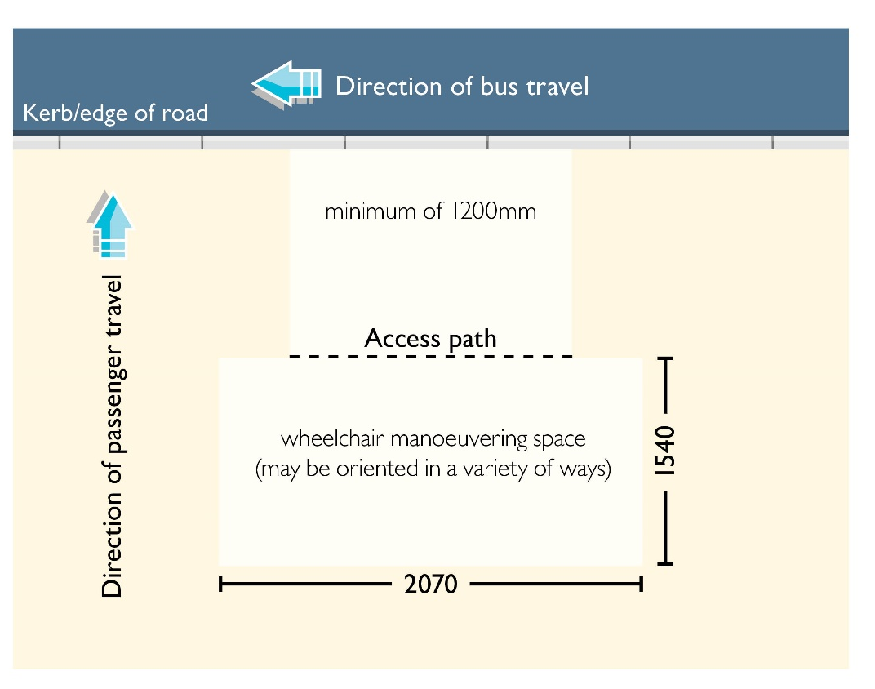
Figure 1bus stop boarding point dimensions for 180 degree wheelchair turn
Not to scale, for illustrative purposes only, refer to technical drawings for specifications. Drawings are based on the Australian Human Rights Commission accessible bus stop guidelines.
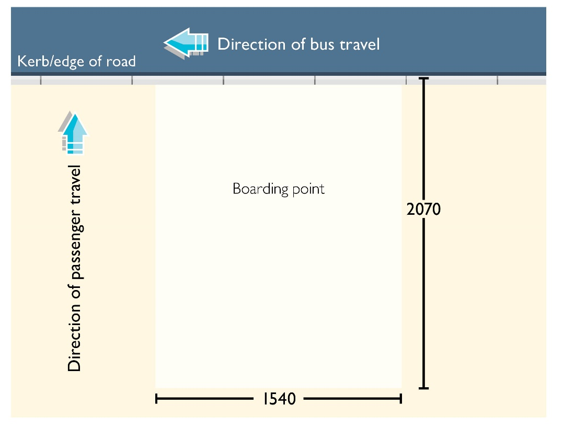
Figure 2 boarding point configuration based on access path provided to the bus stop
Not to scale, for illustrative purposes only, refer to technical drawings for specifications. Drawings are based on the Australian Human Rights Commission accessible bus stop guidelines.

Level boarding point
Bus stops are required to have a level boarding point. The boarding point and the path of travel to the boarding point should not have a gradient or crossfall greater than 1 in 40.
From a Tasmanian context given our steep topography, it is not always achievable to have a bus stop on a gradient of less than 1 in 40. In these situations, it is important to ensure that the crossfall to the road is less than 1 in 40 to ensure passengers using a wheelchair can still get on and off a bus, via a boarding ramp.
Consideration should also be given to relocating the bus stop to a site which is less steep, noting that this may not be possible in hilly areas. It should be noted that it is important to balance DDA compliance requirements against broader community accessibility needs. Passengers may need to be alerted where steep gradients mean that the bus stop may not be suitable for people using wheelchairs.

Surface material
The boarding point and any access path must be non-slip. The following surfaces are considered suitable:
- concrete or bitumen
- natural stone with rough finish
- textured paving
- slip resistant tiles.
Grass and pebbles are not considered suitable.

Provision of kerbs
There is no requirement to install a kerb at a bus stop boarding point. However, if a kerb is installed, it must be at least 150mm higher than the road. This ensures passengers can easily get on an off a bus with a boarding ramp.
Most bus operators in Tasmania use low floor buses with built-in boarding ramps particularly in urban areas, such as Metro, Mersey-link and O’Driscolls Coaches. In rural areas and for long distance trips, operators use a mixture of low floor and high floor buses. Most high floor buses have a wheelchair lift.
It is our understanding that high floor buses can easily access both bus stops with a kerb and bus stops without kerbs, while generally low floor buses can usually only access bus stops with a kerb, especially if they have a built-in boarding ramp rather than a portable boarding ramp on the bus.
Where a bus route has a mix of kerbs and no kerbs and a low floor bus is used, there is a need to progressively upgrade bus stops to have a kerbed boarding point, especially in urban areas. This can be in the form of providing a raised boarding point with suitable ramps in that section of the road/footpath layout.

For a new bus stop on a route which uses low floor buses, the bus stop should be constructed to have a kerb, provided it is safe from a road safety perspective.

Providing a connection from the bus stop to connecting footpaths
The bus stop boarding point needs to connect to an adjacent footpath, or if there is no existing footpath it needs to connect to the road. This is to provide a seamless transition between the bus stop and any footpath or road infrastructure.
Provision of an access or kerb ramp may need to be provided to connect the boarding point to an adjacent footpath or road. Although the use of driveways as a kerb ramp is considered acceptable for passengers to get access to the road or from the footpath to the road, the provision of kerb ramps is highly desirable.
Guidelines for access and kerb ramps in terms of slope are contained under AS1428.2-1992, which specifies a maximum slope of 1:8 for ramps up to 1520mm long. For longer ramps the maximum slope of 1:14 (with landings every 6m) and 1:19 (with landings every 14m) is considered appropriate.

Providing Tactile Ground Surface Indicators (TGSIs)
Tactile ground surface indicators (TGSIs) or tactiles are required to assist people who are vision impaired to identify the bus stop and the location of the boarding point.
TGSIs can be either warning (raised dots) and/or directional (raised bars) and should be colour contrasted against the ground surface (see figure 3). These textural changes allow vision impaired people to identify hazards and navigate them to the bus stop, while passengers with limited vision use the colour contrast to aid them.
The location, style and dimensions must comply with AS1428.2-1992 and the updated version of AS1428.4.1:2009.
It is preferable that TGSIs are fixed to the boarding pad or footpath by drilled screws, as this results in less wear and tear to individual TGSIs, than those which are glued onto a surface, lessening the cost of maintenance.
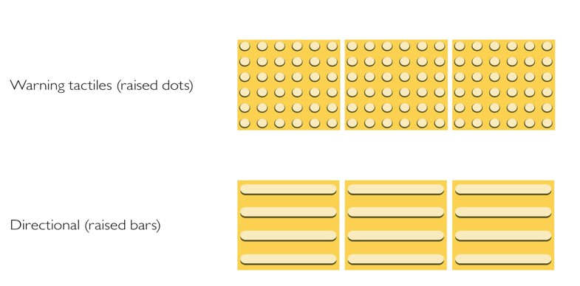
Figure 3 Warning and directional TGSIs
Not to scale, for illustrative purposes only
The application of TGSIs should take into account the number of people using the stop and the location of any connecting paths.
Generally TGSIs are not required at bus stops which are used solely for passengers getting off the bus.

TGSIs at multiple boarding points
In busier locations such as CBD interchanges there are often multiple boarding points. The configuration of TGSI’s in these locations can often be complex to ensure wayfinding is practical. There may be a need to consult with disability groups to ensure the design configuration of TGSI’s is practical for users.
Figure 4 below provides an example of a configuration that could be applicable where there is a footpath directly adjacent to a bus stop. Based on this, there should be a 600mm wide row of directional TGSIs across the footpath leading to a 600mm square block of warning TGSIs at the boarding point.
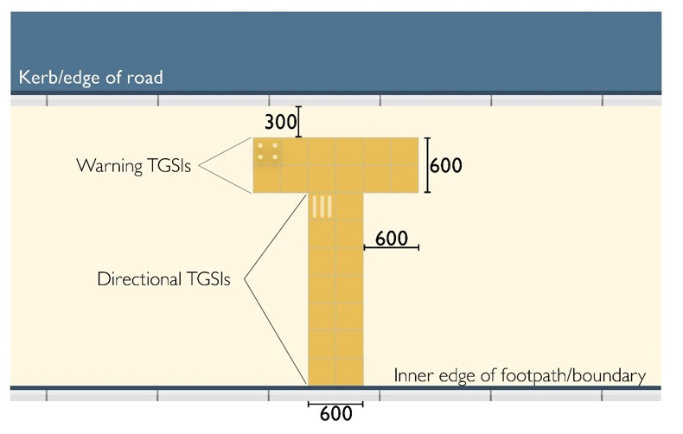
Figure 4 TGSI configuration for CBD interchanges
Not to scale, for illustrative purposes only, refer to technical drawings for specifications. Drawings are based on the Australian Human Rights Commission accessible bus stop guidelines.

TGSI’s at single boarding points
For single bus stops where there is an existing footpath alongside a bus stop, there should be:
- 600mm wide row of directional TGSIs across the adjacent footpath
- 600mm square block of warning TGSIs at the boarding point. Warning TGSIs extending along the kerb are not generally required at single boarding points. See figure 5.
If the footpath and boarding point are separated, for example by a nature strip:
- 600mm wide row of directional TGSIs across the footpath, then a connecting 300mm wide row of directional TGSIs to the warning TGSIs at the boarding point which are 600mm x 600mm. See figure 6.
Where there is no footpath:
- 600mm x 600mm square block of warning TGSIs at the boarding point. See figure 7.

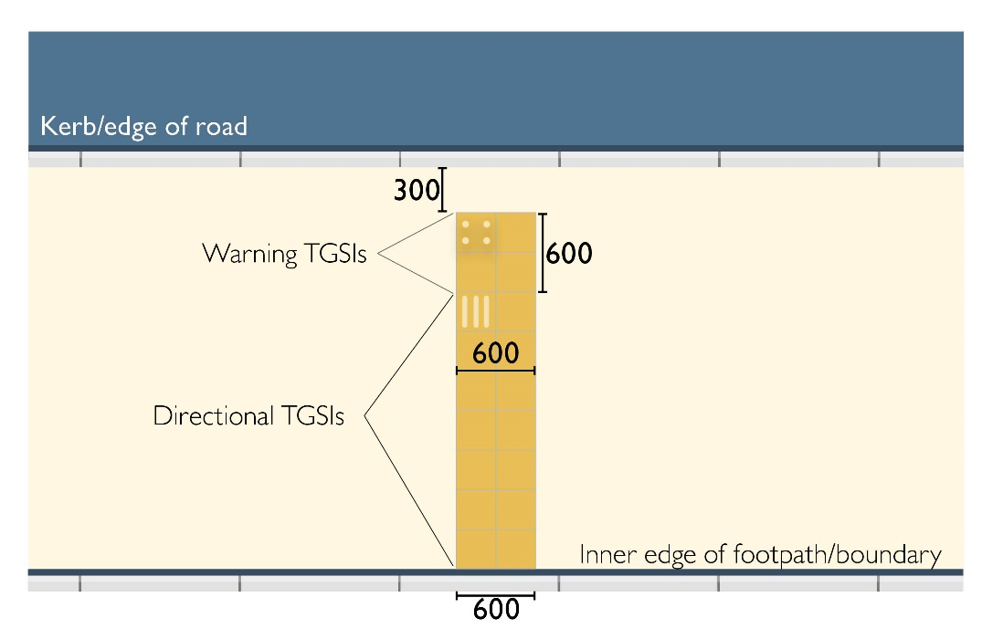
Figure 5 TGSI configuration for single boarding points, when the footpath is part of the bus stop
Not to scale, for illustrative purposes only, refer to technical drawings for specifications. Drawings are based on the Australian Human Rights Commission accessible bus stop guidelines.
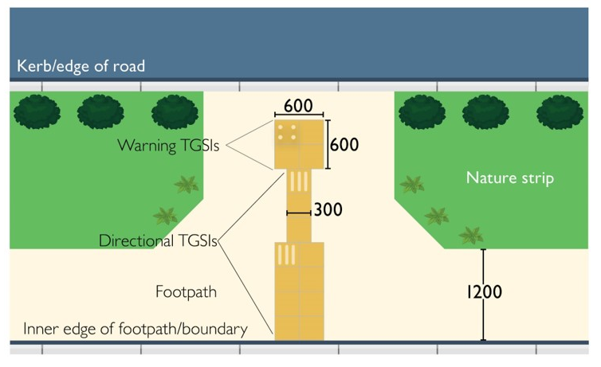
Figure 6 TGSI configuration if the footpath is separated from the boarding point
Not to scale, for illustrative purposes only, refer to technical drawings for specifications. Drawings are based on the Australian Human Rights Commission accessible bus stop guidelines.

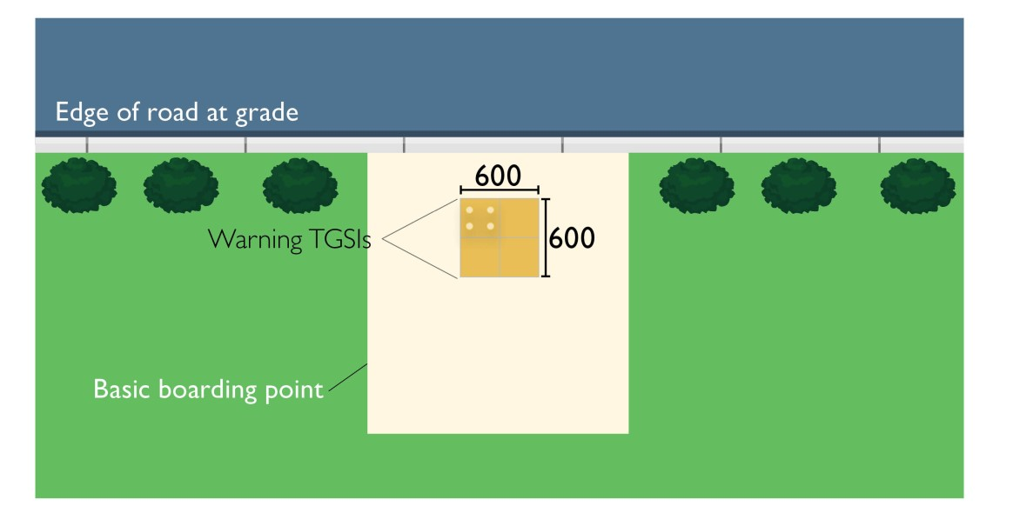
Figure 7 TGSI configuration where there is no footpath
Not to scale, for illustrative purposes only, refer to technical drawings for specifications. Drawings are based on the Australian Human Rights Commission accessible bus stop guidelines.
Setback of TGSIs:
- Warning TGSIs should be set back at least a minimum of 300mm from the kerb or even more in particular locations if there are concerns about passengers being too close to the road.

Larger bus stops
Bus stops in certain locations may be longer and wider than the basic boarding point. This includes locations where there may be several buses stopping at once, such as CBD interchanges or high passenger volume stops.
If a bus stop is wider than basic boarding point, the connecting footpath between the different boarding points must be upgraded so that it is at least 1200mm wide.

Providing unobstructed access to bus stops
It is important to provide unobstructed access to the bus stop in terms of having an access path with an appropriate width, and also ensuring the access path is free from obstructions such as street furniture or power poles.
The basic boarding point should be positioned so that:
- any adjacent access path is at least 1200mm wide and provides unhindered through access
- if the access path is unable to meet the minimum width, the path can pass through the boarding point, provided that the access path then meets the minimum width of 1200mm.
Where there is insufficient access width to the boarding point, the area in and around the bus stop should be kept as free as possible from obstructions. This means locating any street furniture such as seating, bus shelters, signage or rubbish bins closer to the kerb side of the footpath so that there is a clear path of travel along the building/fence line. Care should be taken that any kerbside street furniture does not obstruct the actual boarding point itself.

Bus stop signage
State Growth is responsible for the design of bus stop signs, which are also known as blades or flags. The bus stop signage has been designed so that it meets the requirements for people who are vision impaired. Bus stop signage must meet AS1428.2-1992 which covers text height requirements. Any text or symbols must have a 0.3 or 30% luminance contrast with the background colour.
Bus stop plinths can be used instead of a blade and pole and are typically used in CBD interchanges or on key public transport corridors.
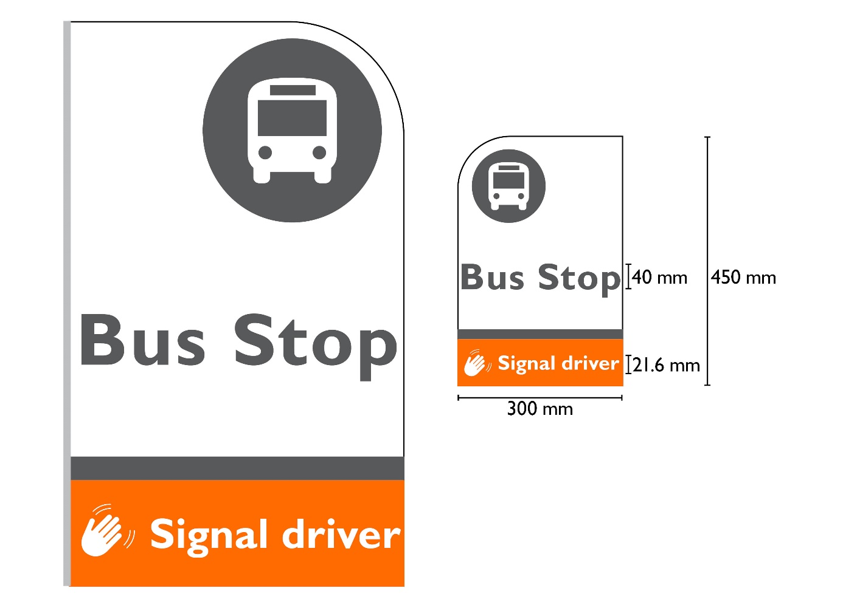
Figure 8 State Growth bus stop signage
Not to scale, for illustrative purposes only, refer to technical drawings for specifications
Set-back of bus stop signage
From a DDA perspective all parts of the bus stop sign should be set-back at least a minimum of 300mm from the kerb. It is State Growth’s preference that signs are set even further back - at least 500mm to avoid collisions from parts of the bus such as bus mirrors or other vehicles.
For bus stops which do not have a kerb or sealed shoulders, particularly in rural areas and on high speed roads it may be advisable to locate the sign even further back than 500mm from the road to reduce the risk of collisions with vehicles.
The blade should be positioned on one side of the pole, with the blade facing away from the kerb, to avoid collisions from vehicles.

Locating the blade to the side of the pole, rather than in the middle ensures it is visible from the front and the back and can be fitted with brackets (see figure 9).

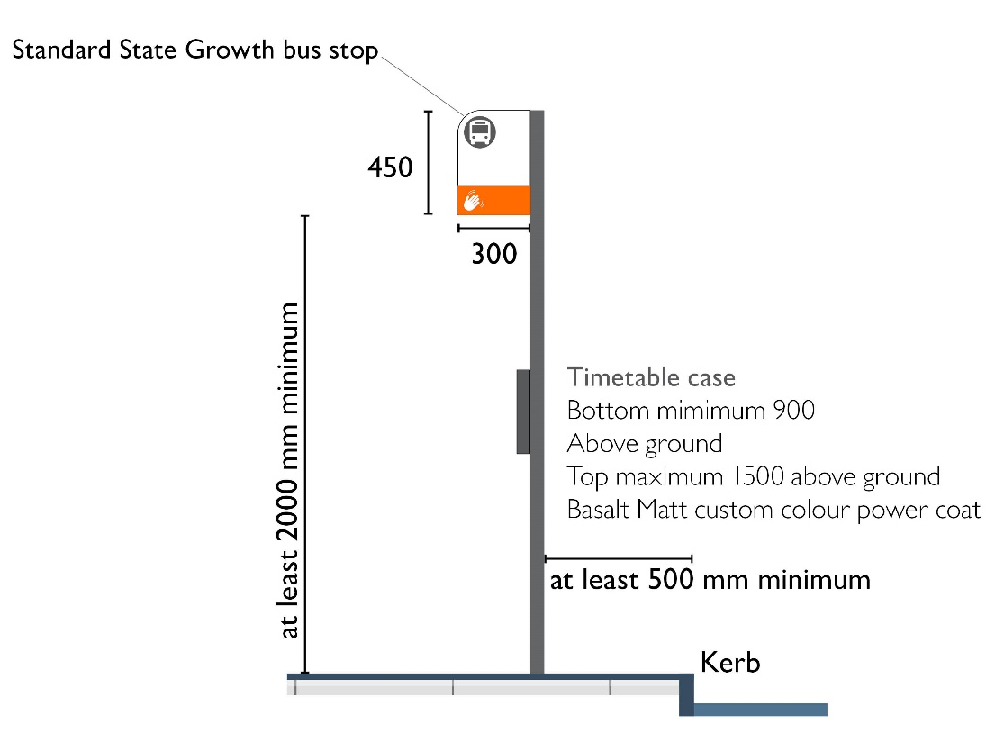
Figure 9 bus stop sign placement
Not to scale, for illustrative purposes only, refer to technical drawings for specifications
There is no DDA guideline on where the bus stop sign should be placed in relation to the boarding point. However, signs should be placed so that they are:
- clearly visible to people either sitting or standing at the bus stop
- preferably at the head of the bus stop – this is because the signage is also used to clearly mark the location of the stop in order to prevent people from parking in the bus stop. Under the Tasmanian Road Rules 2019 drivers except for buses must not stop within 20 metres before a bus stop sign or 10 metres after the sign.
- not an obstruction to pedestrians.

Bus stop timetables
Bus stop timetables are not required to be provided at bus stops from a DDA perspective.
Where timetables are provided these are either located:
- on bus stop shelters
- as part of the bus stop plinth
- in a bus stop timetable case on a bus stop pole. The timetable case (preferably A3 size) should be secured to the pole in portrait position so that it is not an obstruction to pedestrians. Consideration should also be given to how the timetable is positioned on the pole so that it can be viewed to waiting passengers, eg facing the footpath.
All printed timetable information is provided in a format approved by State Growth.

Bus stop poles
It is recommended that bus stop signage has a minimum vertical clearance of 2000mm from the bottom of the bus stop blade (this is based on AS1428.2-1992).
All bus stop poles should have a concrete sleeve in the ground to ensure that they are stable.

The poles and fittings should be adaptable so that future blade changes can be retrofitted easily.

Bus shelters and seating
The provision of bus shelters and seating is not a requirement under the DDA Standards. However, when shelter and seating are provided, they need to have the following requirements.
- Minimum number of seats available for those with a disability: If seating is provided, there should be a minimum number of seats/spaces available for the use of passengers with a disability, including wheelchair passengers. This is a minimum of two spaces or 5% of the seats available if more than two seats are provided. It is recommended that spaces be clearly identified and labelled as ‘priority seating’. It is noted that some existing bus shelters only have space for one wheelchair passenger. It is recommended that when the shelter is due for replacement or significant upgrade that consideration be given to making two spaces available.
- Size of allocated space for wheelchairs: The minimum size for an ‘allocated space’ is 800mm by 1300mm for people using wheelchairs or other mobility aids.
- Seat height: Seats should have a height between 400mm to 450mm above the ground (AS1428.2-1992). It is recommended that the seat height should be higher (520mm) in areas where there is a larger number of older passengers or passengers with a disability.
- Provision of arm rests: Arm rests are not required to be provided, however it is noted that arm rests can assist older people or those with disabilities to get in and out of seats more easily.
- Circulation space: The seating spaces must not intrude into the circulation space required for the boarding point.
The shelter (including any overhang from the roof) should be located a minimum of 500mm away from the existing kerb or road to avoid collisions from vehicles.
The position of the shelter and or any seating should also not obstruct access paths or walkways or conflict with passengers getting on or off the bus, including wheelchair passengers.

Provision of lighting at bus stops and shelters
There is no DDA requirement for provision of lighting at bus stops or in shelters. Under the DSAPT it states that a light level of 150 Lux is considered to be the minimum lighting level necessary.

State Growth considers that 150 Lux is very high to be provided in a shelter – it has the potential to be obtrusive and affect driver and passengers’ (waiting at a shelter) vision. If lighting is to be provided within a shelter, State Growth recommends that a lighting level of between 20 to 25 Lux is more appropriate.

Summary of bus stop DDA compliance requirements
The checklist below provides a summary of the DDA requirements for bus stops
Checklist for bus stop DDA compliance
Item | DDA requirement
Width of boarding point | Minimum dimensions: 2070mm x 1540mm for a 180 degree turn.  Where space is constrained this can be reduced to a 1500mm x 1500mm area for a 90 degree turn.
Surface of boarding point | Firm and non-slip surface. Either concrete, bitumen, natural stone with rough finish, textured paving or slip resistant tiles.
Kerb at boarding point | Kerb height not less than 150mm (only if kerb is installed).
Access path width through the stop area and to and from bus stop | Minimum width of path: 1200mm
Access ramp to bus stop required if boarding point is not the same level as the access path | If the bus stop is connected to the adjacent footpath or roadway by a kerb ramp, the ramp needs to be designed to Australian Standards specifications with a maximum gradient of 1:8 for ramps no longer than 1520 mm or 1:14 for longer ramps.
Access to the bus stop if there is no footpath | If the bus stop is located where there is no footpath there needs to be appropriate access to the boarding point from the roadway, such as a driveway or kerb ramps.
Unobstructed access to the bus stop | Access path to the bus stop should be unobstructed from street furniture and rubbish bins, etc.
Position of bus stop sign | The sign should be set-back at least a 300mm from kerb from a DDA perspective. State Growth requires that the sign is set even further back - at least 500mm. The minimum clearance of the pole from the bottom of the bus stop blade should be at least a minimum of 2000mm.
Bus stop signage | Signage has an appropriate text size and any text or graphics has a luminance contrast against the background.
Bus shelter (if provided) | The shelter (including any overhang from the roof) to be located a minimum of 500mm away from the kerb or road.  The shelter should not obstruct access paths.
Seating (if provided), including in a bus shelter | If seating is provided at a waiting area or in a shelter, there needs to be a minimum of two seats/spaces or 5% of seats available that are identified as seating for people with disabilities, including people in wheelchairs.  The spaces allocated for people in wheelchairs require a minimum space of 1300mm long x 800mm wide.  If seating is provided at a waiting area the height of the seating should be a minimum of 400mm to 450mm above ground, with a preference of a seat height up to 520mm to cater for older people and people with disabilities.
Tactile Ground Surface Indicators (‘TGSIs’) | Where there is an existing footpath alongside a bus stop there should be:  - 600mm wide row of directional TGSIs across that adjacent footpath  - 600mm square block of warning TGSIs at boarding point.  If the footpath and boarding point are separated:  - 600mm wide row of directional TGSIs across the footpath, then a connecting 300mm wide row of directional TGSIs to the warning TGSIs at the boarding point which are 600mm x 600mm.  Where there is no footpath:  - 600mm square block of warning TGSIs at boarding point.  TGSIs should also be colour contrasted against the background colour of the ground.

Useful resources
DDA compliance information can be found at:
- Disability Discrimination Act 1992
https://www.legislation.gov.au/Details/C2016C00763
- Australian Human Rights Commission accessible bus stop guidelines
www.humanrights.gov.au/australian-human-rights-commission-accessible-bus-stops-guidelines#
- Disability Standards for Accessible Public Transport (DSAPT)
www.legislation.gov.au/Series/F2005B01059
- Standards Australia
www.standards.org.au/
- State Growth standard bus stop and shelter drawings
www.transport.tas.gov.au
- State Growth standard bus stop blade
www.transport.tas.gov.au

Department of State Growth
GPO Box 536
Hobart TAS 7001 Australia
 | Phone: | 1800 030 688
 | Email: | info@stategrowth.tas.gov.au
 | Web: | wtransport.tas.gov.au

