Survey Report

Title: XXXXXX

Company Name: Surveyors Pty Ltd

Date: DD/MM/YYYY

State Growth Reference: XXXXXX

1 PROJECT INFORMATION 3
1.1 Equipment and Survey Team 3
2 Survey Datum and Control 3
2.1 Project Datum 3
2.2 Combined Scale factor 3
2.3 Methodology 3
2.4 Control Network Diagram 3
3 Engineering Survey 4
4 Subsurface Utility Survey 4
5 Property Boundaries 4
6 Geo-referenced Aerial Imagery 4
7 Photography 5
8 Primary Survey Control Summary Table 6
8.1 Minor Survey Control Summary table 6
9 Pavement Surface model verification – quality assurance 7
10 deliverables supplied 7
11 non-standard codes Used and Provided 7
12 project issues 8
13 ATTACHMENTS 8

:

PROJECT INFORMATION

Equipment and Survey Team

Survey Datum and Control

Project Datum

Combined Scale factor

Methodology

Control Network Diagram

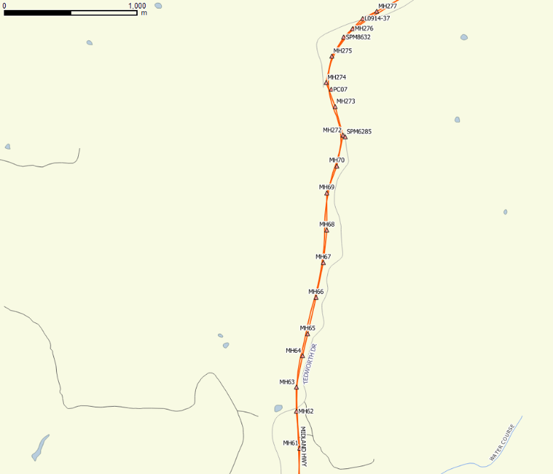

Engineering Survey

Subsurface Utility Survey

Property Boundaries

Geo-referenced Aerial Imagery

Photography

Primary Survey Control Summary Table

Datum GDA2020/MGA Coordinates, AHD83
PSC ID | Easting (m) | Northing (m) | Survey Uncertainty (Horizontal m) | Source | Height (m) | Survey Uncertainty (Vertical m) | Source | Constrained  (H/V) | Combined Scale Factor | Description
GED1 | 607858.308 | 5362297.055 | 0.010 | Surveyors | 31.593 | 0.010 | Surveyors |  | 0.999556 | 1350mm star picket
GED02 | 607533.427 | 5361924.719 | 0.010 | Surveyors | 48.579 | 0.010 | Surveyors |  | 0.999556 | 1350mm star picket
SPM10594 | 607954.558 | 5362479.967 | 0.010 | SURCOM | 25.837 | 0.010 | SURCOM | HV | 0.999556 | Bronze SPM disc in kerb
SPM10595 | 608410.910 | 5362557.653 | 0.010 | SURCOM | 7.956 | 0.010 | SURCOM | H | 0.999556 | Bronze SPM disc in rock

Minor Survey Control Summary table

Datum GDA2020/MGA Coordinates, AHD83
MSC ID | Easting (m) | Northing (m) | Survey Uncertainty (Horizontal m) | Height (m) | Survey Uncertainty (Vertical m) | Combined Scale Factor | Description
MSC1 | 607858.308 | 5362297.055 | 0.010 | 31.593 | 0.010 | 0.999556 | 1350mm star picket

Pavement Surface model verification – quality assurance

QQ Strings Table
Survey Quality Level | Total Points | Average  Difference (mm) | Compliant  Tolerance Range m  (+/-) | Percentage of Points in Tolerance | Compliant  Percentage level Difference
QL-B | 100 | 5mm | 10mm | 98% | 95%

deliverables supplied

Type | Name | Format
Engineering Feature Model | 3100B-4-8_ XXXXXX_ YYYYYYYY.ext | DWG

non-standard codes Used and Provided
Code | Description

project issues

Denied property access?
Culvert condition – inaccessible invert?  Culvert at  E55555  N1236547  Inaccessible invert  Heavily silted. Invert interpreted from obvert and diameter width measured across culvert | 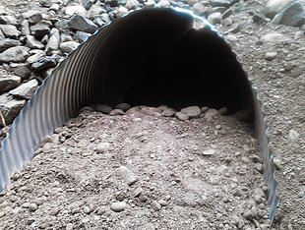

ATTACHMENTS
☐ Attachment A: Survey Request Form (Signed)
☐ Attachment B: Primary Survey Control Summary
☐ Attachment C: Metadata Statement
☐ Attachment D: Subsurface Utilities Metadata Statement

