INNOVATION
MAKING OUR ROADS SAFER

Vehicle Activated Signs

These are electronic signs that provide a safety message when a motorist approaches.
Too Fast – Slow Down
This sign, at the Mount Pleasant Interchange, is used to warn drivers approaching the Midland Highway.

A speed detection system turns the sign on when a vehicle is going too fast to safely negotiate the bend. The sign is blank until activated, when it will first display ‘Too Fast’ and then ‘Slow Down’.

School Bus Ahead  This system is in place on St Mary’s Pass, a narrow and winding road between Scamander and St Mary’s on the East Coast.  Signs at either end of St Mary’s Pass are activated when a school bus is in the Pass. | 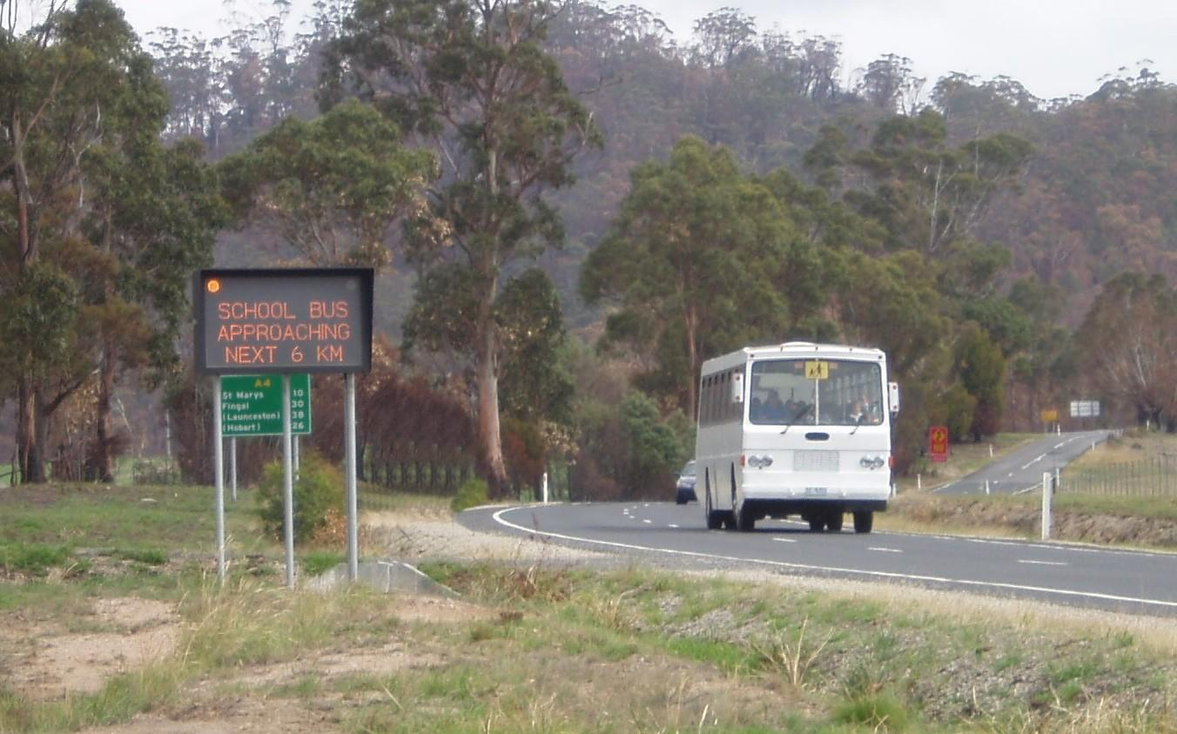
Slow Vehicles Ahead
These signs, used at various locations around the State, warn drivers that there may be slow moving vehicles ahead of them that they can’t see because of a bend or crest in the road.

The system detects the speed of passing vehicles and turns the sign on for a pre-set length of time if it detects a vehicle moving slower than 40 km/h.

