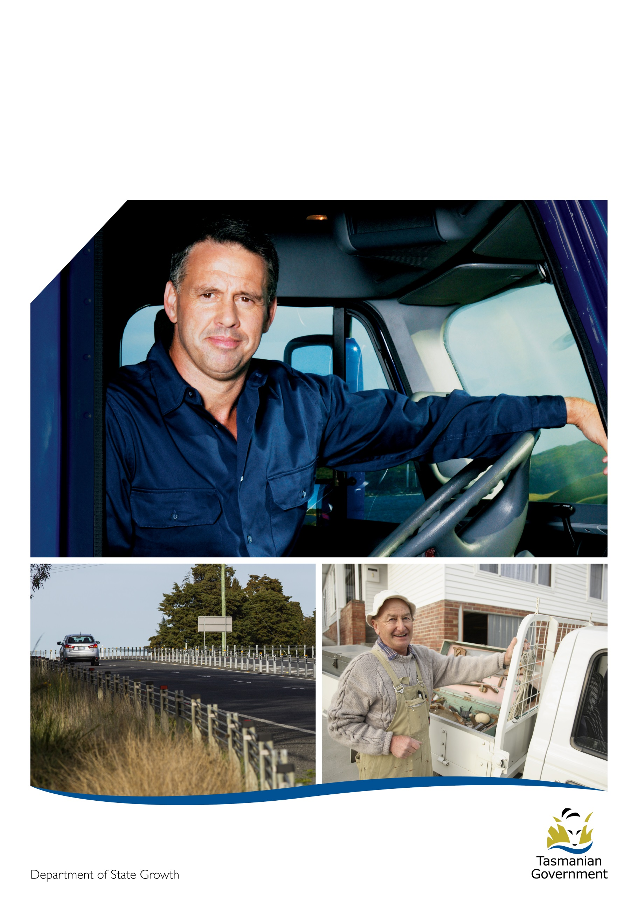
Ceasing compulsory medicals
for drivers aged 75 and
over in Tasmania
Frequently asked questions
Medical
assessments

Table of Contents
What is changing? 3
When do the changes start? 3
Why is it changing? 3
Why has it taken so long for the change to occur? 3
Who will be affected by the changes? 3
What if I hold an ancillary certificate? 4
What if I’m due for a medical after the change is introduced? 4
I have a condition on my licence because of my last medical – what happens now? 4
My licence was cancelled due to my previous medical – what happens now? 4
What if my licence is currently suspended for not doing a medical? 4
If compulsory medicals are abolished, how will you know if older drivers are safe to keep driving? 4
How do I know if I’m a safe driver? 5
I’m still not sure about whether I’m a safe driver – who can I talk to? 5
What if I still want to undertake a medical assessment? 5
Which medical conditions can affect driving ability? 6
What if I develop a condition that affects my ability to drive, or my existing condition changes? 6
What happens after I report my condition? 6
What if I’ve got concerns about someone’s driving? 7
Is this just a cost-cutting measure for government? 7
Is Tasmania the only state abolishing medical assessments for over 75s? 7
What if I have more questions about these changes? 7

What is changing?
Compulsory annual medical assessments for Tasmanian drivers aged 75 or older (without a medical condition affecting driving) will end in October 2014.

This change will place the responsibility of driving safely in the hands of the driver. All drivers will be encouraged to regularly self-assess their driving ability, and will be provided with materials on medical conditions and driving.

When do the changes start?
Compulsory age-based annual medical assessments for older drivers end in October 2014.

Why is it changing?
The Anti-Discrimination Commissioner has produced a report which claims that compulsory aged-based medical assessments are discriminatory against older drivers in Tasmania. As a result of this, Tasmania’s Older Driver Licensing System has been reviewed. The review identified four key factors:
- Older drivers are under-represented in crash statistics and are less likely to engage in dangerous driving behaviour.
- Research shows that medical conditions which affect driving develop at all stages of life, not just when a person becomes ‘old’.
- Normal ageing does not increase crash risk, as older drivers generally regulate their own driving and make sensible decisions as to driving capabilities.
- 75% of older drivers do not have a medical condition affecting driving. Resources would be better focused on drivers with a medical condition who are a known road safety risk.

Why has it taken so long for the change to occur?
In 2011, it was announced that in 2014 mandatory annual medical assessments for older drivers would cease. It was important that the right environment was created in this 3 year period for this change to occur, so the public, medical professionals and affected stakeholders understood the reasons behind the change and how road safety will be maintained.

In mid-2014, affected stakeholders (including Royal Automobile Club Tasmania, Motor Accidents Insurance Board, Police, Australian Medical Association, COTA (previously referred to as Council of the Aging), driving assessors and health associations) were consulted to provide comments on the change - the majority of stakeholders were largely supportive of the change, with any concerns raised addressed.

Who will be affected by the changes?
Anyone aged over 75 or about to turn 75 (without a medical condition) will no longer be required to undergo an annual medical assessment in order to retain their licence. This applies to drivers of light and heavy vehicles and motorcycle riders.

As a result of this change, all drivers will be required to take responsibility for road safety by regularly and honestly self-assessing their driving ability.

What if I hold an ancillary certificate?
Anyone who holds an ancillary certificate will still be required to undergo an annual medical assessment from age 65. As these drivers are responsible for driving instruction and transporting other people, there are stricter rules on medical fitness to drive.

What if I’m due for a medical after the change is introduced?
If your medical assessment would normally be due after 30 September 2014 (and you don’t have a medical condition affecting driving), you won’t need to undertake a medical assessment.

I have a condition on my licence because of my last medical – what happens now?
This condition will remain on your licence, and you will be required to pass a medical assessment to have the condition removed - the Registrar of Motor Vehicles (RMV) needs to be satisfied that you are safe to drive.
My licence was cancelled due to my previous medical – what happens now?
Your licence will remain cancelled. You can ring the Transport Enquiry Service on 1300 851 225 to discuss your options.

What if my licence is currently suspended for not doing a medical?
If your licence has been suspended because you did not provide a medical assessment when requested, your suspension may be lifted if you provide sufficient reasons as to why it was not done. In most cases, it is likely that a medical will need to be received before the suspension is lifted.

If compulsory medicals are abolished, how will you know if older drivers are safe to keep driving?
Older drivers are at no higher risk of crash than younger drivers for the following reasons:
- Older drivers are under-represented in crash statistics and are less likely to engage in dangerous driving behaviour.
- Research shows that medical conditions which affect driving develop at all stages of life, not just when a person becomes ‘old’.
- Normal ageing does not increase crash risk, as older drivers generally regulate their own driving and make sensible decisions as to driving capabilities. They tend to drive less, make shorter trips, drive in low traffic volumes, drive in good driving conditions and low speed zones and choose less hazardous road. They also drive less distance and less often than other drivers.

As a safety net, there are laws in place that require all drivers to notify the RMV of any changes in their medical fitness to drive. The RMV also receives notifications from police, doctors and the general public regarding drivers who may be unsafe to drive. All genuine reports are followed up and investigated.

How do I know if I’m a safe driver?
Assessing your own driving regularly will help you determine how safe you are on the road, and if there may be any issues affecting your driving. Drivers who accurately assess their driving skills are more likely to adjust their driving habits and stay safe on the road for longer.

You should regularly ask yourself these 10 questions:
- Are you having trouble seeing signs, road markings, kerbs, hazards, medians, other vehicles or pedestrians, especially at night?
- Are you comfortable looking back over your shoulder or does it take extra effort
- Do you sometimes feel confused, flustered or overwhelmed when driving, especially at intersections?
- Can you react quickly if you suddenly need to brake?
- Does driving make you feel more tired than it used to, even on short trips?
- Have you had a small collision in a car park, or with your mailbox, because you’re having trouble judging distances?
- Have you had a near miss or actual crash in the last three years?
- Has a friend or family member recently said they are worried about your driving?
- Do you sometimes get lost on familiar routes?
- Has your doctor suggested you limit your driving or think about stopping driving altogether?

If you answered ‘yes’ to some of these questions, it’s not necessarily a sign that it’s time to give up driving. But it may indicate areas where you need to take action to avoid endangering yourself or other road users – particularly if you answered ‘yes’ to any of the last five questions.
You should consider talking to your doctor first if you’re concerned about your driving, to rule out any medical issues. Your doctor may also be able to discuss ideas for regulating your driving so you feel safer, such as not driving at night or during busy times of the day.

I’m still not sure about whether I’m a safe driver – who can I talk to?
If you’re still not sure whether you’re a safe driver:
- talk to others about your driving - listen to the people who know you best and care about you most
- discuss your driving with your doctor
- consider brushing up on your road rules and driving skills anyway, just to be sure
- undertake a driving assessment or have a driving lesson with an instructor

What if I still want to undertake a medical assessment?
A medical assessment is the best way to determine if you are safe to continue driving. Make an appointment with your doctor if you wish to undertake an assessment and talk about whether a medical condition may be affecting your driving.

Which medical conditions can affect driving ability?
Common conditions which can affect driving ability are:
- Blackouts
- Cardiovascular conditions (heart disease, angina, stroke)
- Diabetes
- Musculoskeletal conditions (loss of limb, physical disabilities)
- Neurological conditions (Dementia, Epilepsy, Parkinson’s Disease, Multiple Sclerosis)
- Sleep Apnoea
- Psychiatric conditions (bipolar, anxiety)
- Visual impairments
- Substance misuse

What if I develop a condition that affects my ability to drive, or my existing condition changes?
If you develop a medical condition or your existing medical condition changes you should:
- Talk to your doctor about whether it may affect your driving ability.
- If your driving ability will be affected, notify the RMV of your condition (or changes to your current condition). This is your legal responsibility, not your doctor’s. You can do this by:
- Completing a Fitness to Drive Self Notification Form and returning it to our office.
- Calling the Transport Enquiry Service on 1300 851 225
- Emailing driver.licensing@stategrowth.tas.gov.au
- Writing to GPO Box 1002, Hobart TAS 7001 or faxing 6233 5262
All information we receive will be kept private and confidential, unless it’s disclosure to a third party is required by law. Access to this information is strictly limited to staff who are directly involved in assessing your fitness to drive.

What happens after I report my condition?
After you notify, you may be required to undertake a medical assessment with your doctor. You will need to return your assessment results to the RMV for consideration. Your medical fitness to drive will be determined on a case by case basis in accordance with National Assessing Fitness to Drive Standards. As part of this process, you may also be required to:
- Provide a specialist medical report
- Undertake a driving assessment
- Provide a report from an occupational therapy driving specialist
You are responsible for bearing the cost of any assessments undertaken. To find out whether you can claim for the cost of the consultation, contact Medicare.
A medical assessment of your fitness to drive may result in:
- Retaining your driver licence with no further action required
- Retaining your driver licence, subject to periodic medical assessments
- Being issued with a conditional licence (eg. Restrictions on driving at night and driving with glasses)
- Suspension or cancellation of your licence (this is very rare - it is possible to appeal these decisions)

What if I’ve got concerns about someone’s driving?
If you become aware of a driver who you believe is not safe to drive, you should:
- Firstly discuss your concerns with the driver directly – it may not be an easy conversation to have, but it may help the driver to realise that they need to take action. If the driver won’t discuss their driving with you, suggest they consult their doctor for an objective opinion.
- If you cannot speak with the driver, or the driver refuses to take action, notify the RMV for further investigation. You can do this by:
- Completing a Third Party Notification Form and returning it to our office.
- Emailing driver.licensing@stategrowth.tas.gov.au.
- Writing a letter addressed to the Registrar of Motor Vehicles, GPO Box 1002, Hobart TAS 7001.
- Fax letter to 6233 5262.
If writing to or emailing the RMV, please include your name, contact details, the details of the person you are concerned about the reasons for your concerns.
All notifications received will be treated confidentially – your details will not be disclosed to the reported driver unless you consent or it is required by law. You will also not receive any details concerning the outcome of the investigation.

Is this just a cost-cutting measure for government?
No. Abolishing compulsory medical assessments for older drivers will only result in a small saving for government, which will be used to focus on at-risk drivers with medical conditions who are a known road safety risk. Materials will also be developed on self-assessment techniques and the dangers involved in driving with a medical condition.

Is Tasmania the only state abolishing medical assessments for over 75s?
No. Victoria and Northern Territory do not have any compulsory age-based tests, and South Australia is abolishing compulsory medicals in 2015. Other states are also starting to move in this direction.

What if I have more questions about these changes?
You can ring the Transport Enquiry Service on 1300 851 225 or email questions to driver.licensing@stategrowth.tas.gov.au.

