This information bulletin provides information about the fitment of Vehicle Frontal Protection Systems (VFPS) (nudge bars, bull bars and similar devices) to light motor vehicles.
The Vehicle and Traffic (Vehicle Standards) Regulations 2014 states that:
An object fitted to a light vehicle must be designed, built, fitted to and maintained on the vehicle in a way that minimises the likelihood of injury to a person making contact with the vehicle.
A vehicle manufactured to an Australian Design Rule (ADR) must continue to meet the ADR requirements specific to that vehicle.
It is the owner’s responsibility to ensure all accessories and equipment attached to a motor vehicle is designed and fitted in a manner that complies with the regulatory requirements.
At all times the regulatory requirements take precedence over the information provided here.
The Australian Standard
The Australian Standard AS4876.1-2002 (Motor Vehicle Front Protection Systems) includes specific design, manufacture and testing obligations and requires the device to not adversely affect a vehicle’s compliance with applicable ADR’s. Various jurisdictions require a VFPS to comply with this standard.
If a VFPS is fitted, a device compliant with the Australian Standard is considered best practice.

Vehicle Frontal Protection Systems (VFPS): General requirements
VFPS must be designed and fitted so the safety of the vehicles occupants and any applicable Australian Design Rules (ADR) are not adversely affected.
The VFPS should;
- Conform to the actual shape of the vehicle to which it is fitted.
- Be securely mounted and supported.
- Be compatible with the vehicle it is fitted to.
Must be fitted in accordance with the VFPS manufacturer’s instructions.
They must not
- Constitute a danger to other road users.
- Obstruct the vision of the driver.
- Lean forward more than 75mm (see heading VFPS Offset).
- Protrude above the front of the bonnet line of the vehicle.
- Project further from the front of the vehicle than is necessary for its attachment.
- Add a significant load to the front suspension.
- Be a dangerous protrusion (includes accessory items fitted to the device).
- Be lower than 100mm from the ground.
- Protrude any wider than necessary from the side profile of the vehicle (excluding the vehicle manufacturer’s standard external rear vision mirrors). No regulatory dimensions must be exceeded.
- Adversely affect the vehicle compliance with applicable ADR.
The VFPS and attached items must be free of sharp protrusions and all exposed sections of the device and fittings must be rounded and deburred. Forward and side surfaces must be designed to reduce the risk of injury to any person who may come into contact with the device.
The VFPS must not obscure the vehicle head lights. The visibility of indicators and other lights at all viewing angles should not be reduced, however, additional lights (compliant with applicable standards) may be fitted or the original light relocated in accordance with the relevant legislation or ADR’s if the device does restrict visibility. Surfaces of the VFPS that could reflect light from the vehicle's headlights must treated to reduce glare.
If the device is not fitted as per the manufacturer’s instructions and the requirements of this bulletin are not adhered to, the device may not perform as intended and be detrimental to occupants and other road users safety.
NOTE: Diagrams in this bulletin are for illustrative purposes only and not drawn to any scale.

VFPS construction:
Ensure;
- The mandatory vehicle lighting is not obscured.
- The device does not protrude above bonnet line.
- No forward facing radius is less than 5mm.
- The device does not feature open frame members.
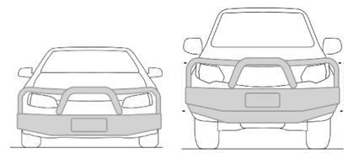
- All edges of the VFPS are free of burrs and sharp edges with accessory brackets facing rearward of the front face of the VFPS.

The maximum width of a vehicle is 2.5m
The VFPS must not increase the overall width of the vehicle (excluding vehicle manufacturer’s standard mirrors)

FPS Offset: Tolerances
Ensure;
- The mandatory vehicle lighting is not obscured.
- The device does not protrude above bonnet line.
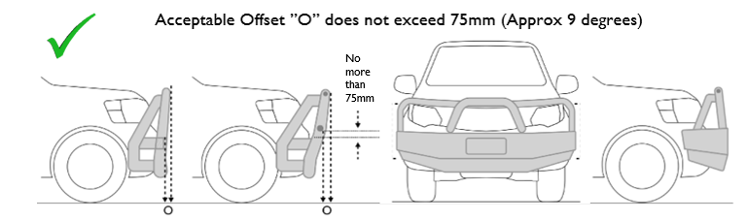

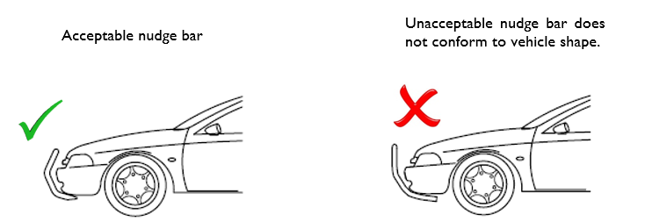

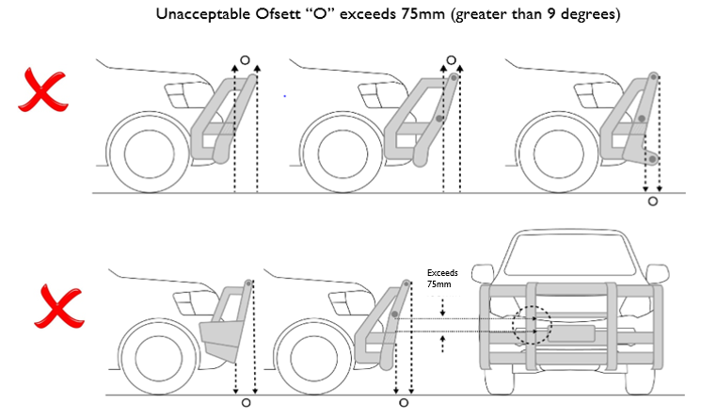

Corners and edges:
Ensure;
- The mandatory vehicle lighting is not obscured.
- The device does not protrude above bonnet line.
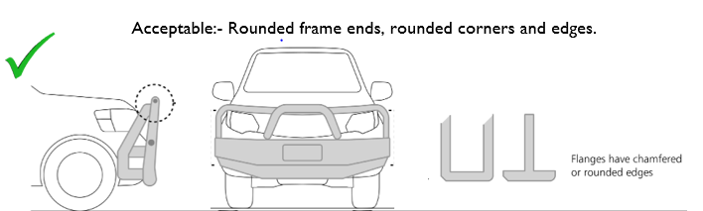

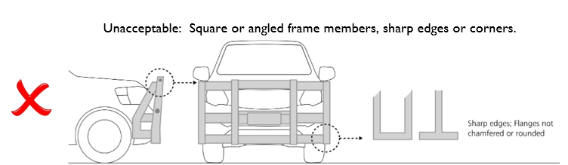

End shape:
Ensure the VFPS does not protrude wider than necessary.
Unacceptable: Device does not generally follow vehicle shape.
Unacceptable: Space between vehicle and device excessive
Acceptable: Device generally follows vehicle shape; device wraps around side of vehicle.

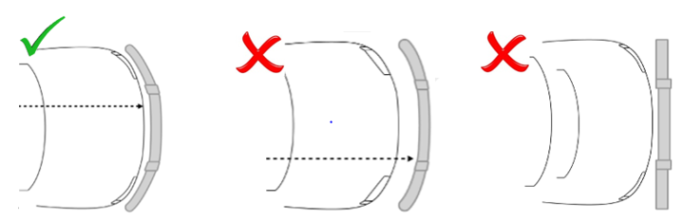

Brackets:
Additional brackets or components such as driving lamp brackets, fishing rod holders or aerial mounting brackets must not protrude above the top or forward of the device profile.
Brackets and other components are to be free of burrs and sharp edges and are fitted rearward of the front face of the device.
Acceptable; Unexposed bracket Unacceptable; Exposed brackets above and mounted forward of the VFPS
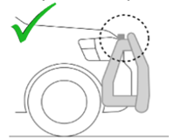
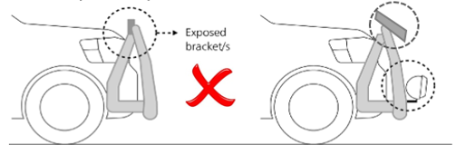

Unacceptable fishing rod holders – obscuring lights, above and mounted forward of the VFPS.
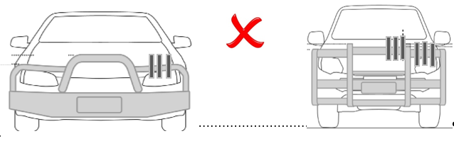

Forward view of the road:
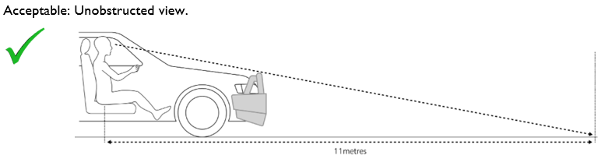

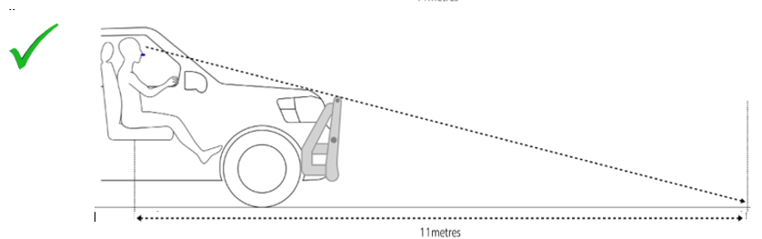

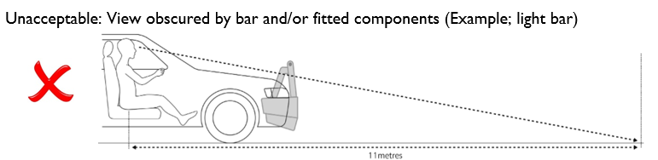

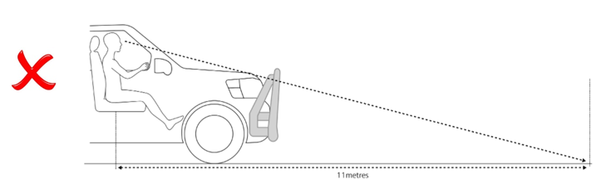

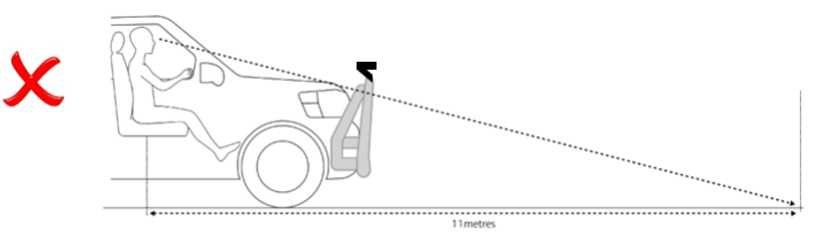

Ground Clearance
The minimum ground clearance is 100mm.
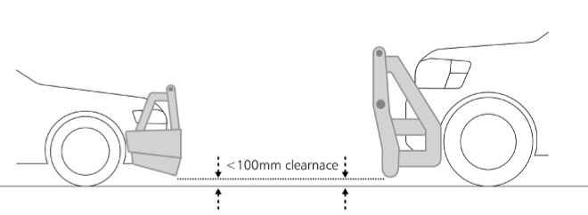

Vehicle Standards GPO Box 536
Hobart TAS 7001
Phone: (03) 6166 3263
Email: vehicle.standards@stategrowth.tas.gov.au
Web: www.transport.tas.gov.au

