INNOVATION
Department of State Growth
MAKING OUR ROADS SAFER

Trucks and Trains

There is new technology in place to keep drivers safe around trucks and trains.
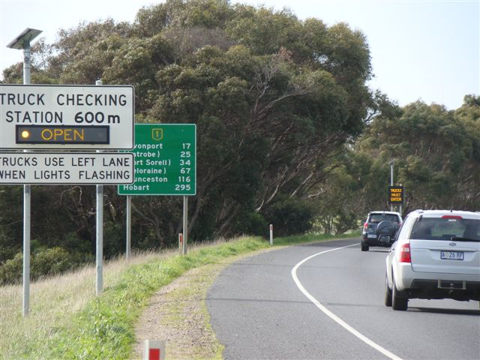 |  | Heavy Vehicle Checking Stations  Truck checking stations are important for safety. Transport Inspectors check roadworthiness, weight and driver fitness.  High visibility LED signs direct trucks into an inspection station next to the road. These signs are remote-controlled, so Transport Inspectors don’t have to manually open and close signs. The signs can easily be turned off when the site is full, so trucks won’t be queuing on the road waiting to get in.  At sites with limited visibility of the road ahead, a Vehicle Activated Sign is also used. The sign warns drivers that trucks are re-entering the road from the inspection station.
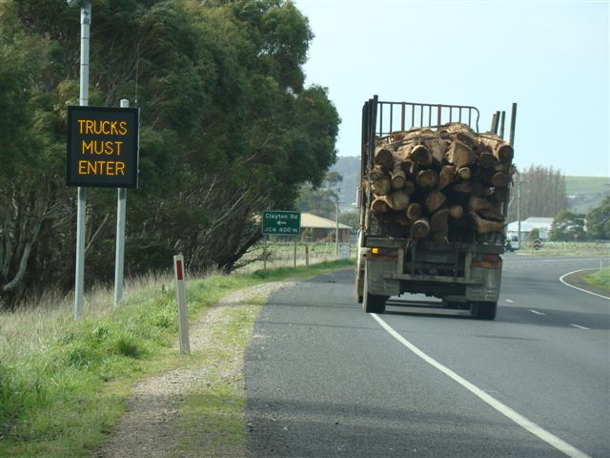
Rail Crossing Warning System  13 rail crossings have been upgraded to add an extra level of warning to the lights and bells already at the crossing.  The Active Advance warning system includes a sign with flashing lights before you reach the crossing and between the sign and the crossing there are in-road alert beacons. The lights on the sign and the beacons start flashing when a train is approaching. | 