

How to use your

Online Certification Portal

Contents

Introduction 3

About the portal 3

What the portal is never to be used for: 3

Contact details: 3

Accessing the portal 4

What happens if an AVC has forgotten their username and/or password? 4

Home page 5

Warnings 5

Yellow warnings: 5

Red warnings: 6

Recording a new certification 6

Vehicle identification – Page one 7

Certification station: 7

Vehicle Identification: 7

Vehicle details – Page two 8

Incorrect data - uneditable 10

Vehicle Modification Details – Page three 10

**Year and month of manufacture:** 11

**Engine number:** 11

Wheels and axles – Page four (applicable to heavy vehicles only) 12

Modification codes – Page five 13

Modification template – Page six 13

Serial number: 14

Ref no: 14

Modification by: 14

About the buttons on this page: 14

Third party classification codes: 15

Attachments 15

Attachment types 15

Attachments - Uploading 15

Removing or deleting attachments 15

Print template 16

Mistakes on auto generated documents: 17

Mistakes – AVCs can fix 17

Mistakes AVCs cannot fix 18

Completing a certification 19

Payment gateway – Page seven 19

About the pay button 19

Auto generated – Light Vehicle Modification Certificate 20

Viewing completed certification submissions – Page eight 20

View/search submissions 21

About certification entries on this page: 21

View and Edit buttons 22

Other important information: 22

Can an unapproved AVC log into the portal? 22

Session time out 22

What if the portal is not working? 22

Appendix A 24

The certification process 24

# Introduction

The purpose of this manual is to provide Approved Vehicle Certifiers Approved Inspection Stations (AVCAIS) and their Approved Vehicle Certifiers (AVCs) with instructions and administrative procedures regarding the AVC interface (here on in, the interface will be referred to as the portal). For a full overview of how to complete a modification certification please refer to: Appendix A – The certification process.

## About the portal

The Portal has limited connectivity with the Motor Registry System (MRS) and the National Exchange of Vehicle and Driver Information System (NEVDIS). Vehicles can be identified with either a Tasmanian registration plate or the vehicle identifier (VIN or Chassis). If a vehicle is or has recently been registered in Tasmania, information about the vehicle will be retrieved from the MRS. If the vehicle has never or not for a long time been registered in Tasmania, details about the vehicle will be retrieved from NEVDIS. More information about this is located under the section ‘vehicle identification’.

After a submission is completed, all relevant information is automatically uploaded onto the MRS, a copy of the certification submission is saved into the Departmental records database and AVC's are required to download a PDF version of each submission to supply to their client. In addition, a receipt is generated for each submission generated for the AVC/AVCAIS.

This handbook is to be read in conjunction with the current Vehicle Modification Certification Manual.

### What the portal is never to be used for:

AVC’s are never to use this portal just to find out information about a particular vehicle. This is not the purpose of the portal. Once a vehicle identifier is typed in, a submission is opened against that vehicle.

## Contact details:

All correspondence in relation the vehicle certification portal should be addressed to;

|  |
| --- |
| Registration and Licensing Services  Department of State Growth  GPO Box 536  Hobart Tasmania 7001  Ph: 6166 3266 |

# Accessing the portal

**Important note:** AVC’s are encouraged to use either Internet Explorer, Firefox or Safari when using this portal.

To complete a certification, AVC's must log into the website below;

<https://mrs-certification.stategrowth.tas.gov.au>

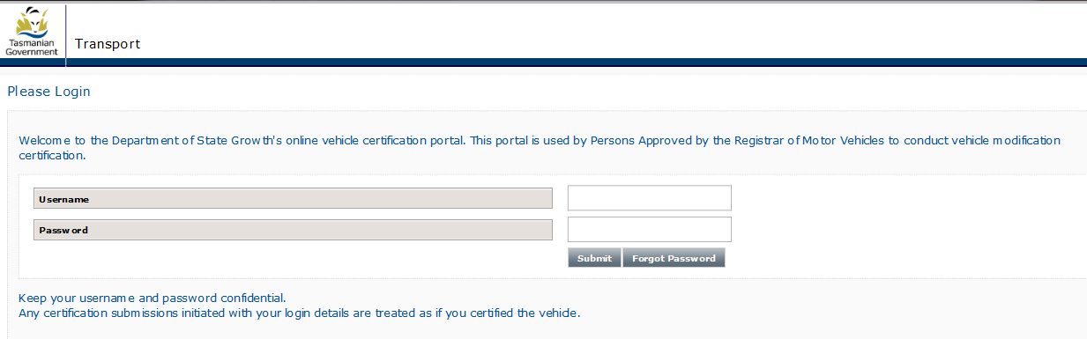

Each AVC will be issued with their own unique user name and password, this will be emailed to each user. Usernames and passwords must be keep secure and not shared, they are an AVC’s digital footprint. These details are used at the end of each certification as the declaration. The declaration is the formal point of completion. This is where the AVC is declaring this vehicle meets all applicable standards at the time of certification.

Important note: Action may be taken against any AVCAIS and/or AVC who allows another person to log into their portal and/or use the portal in any way to conduct any part of a vehicle certification.

## What happens if an AVC has forgotten their username and/or password?

If an AVC forgets their username and/or password, select the ‘forgotten username and password button, or contact Registration and Licencing Services on 6166 3266 or email: [avc@stategrowth.tas.gov.au](mailto:avc@stategrowth.tas.gov.au)

## Home page

After an AVC logs in, they will be directed the site's the home page.

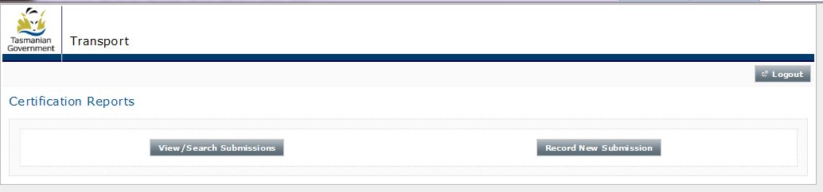

From this page, AVCs can ‘start’ a new modification certification submission and ‘search’ for any pending, in-progress or completed certifications, they or another AVC who is associated with their Approved Vehicle Certifier Approved Inspection Station (AVCAIS) has in the portal.

# Warnings

Warnings can appear at any point during the recording of a certification. These warnings are colour coded, yellow and red. AVCs must always take notice of and read any warnings displayed.

## Yellow warnings:

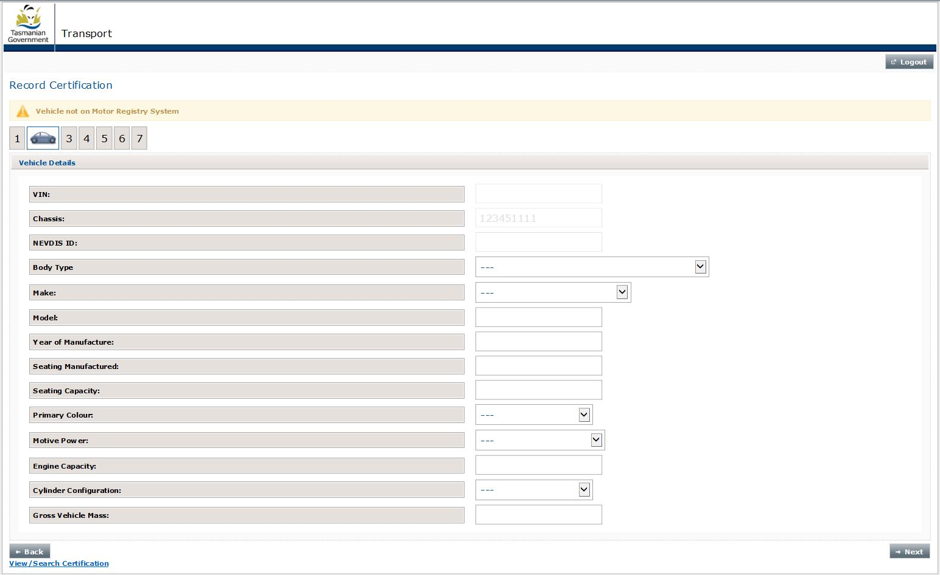These are for **your** information only. They do not stop the certification from continuing, however the AVC is required to manually enter all vehicle details on page two of the certification submission, see below screen shot for example:

## Red warnings:

**Stop:** When one of these appear the error must be fixed before the certification process can continue or be completed or the AVC may be required to complete the submission manually.

Red warnings are separated into two types;

1. Data error caused by AVC,
2. Data error beyond control of AVC.

Data entry errors caused by the AVC are self-explanatory and it is up to the AVC to rectify.

Data errors which are beyond the control of the AVC may not be self-explanatory, may not relate to the page in which it is appearing and in most cases, will be beyond the control of the AVC and the AVC will not be able to rectify the issue. This sort of error will look similar to the below;

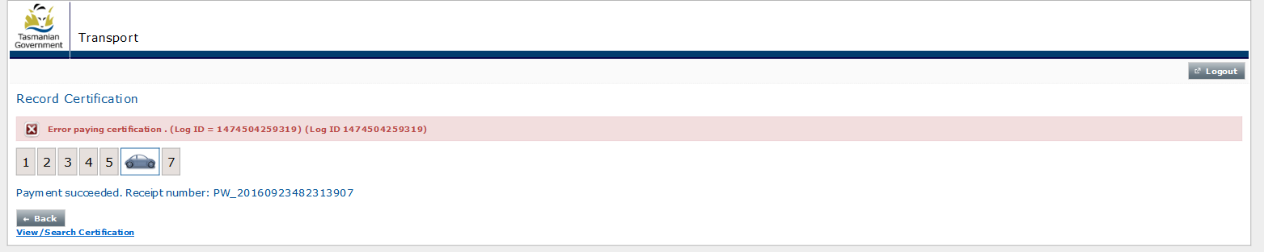

When a red warning appears, AVCs must take a screen shot of the entire web page (there is a print screen ‘print sc’ button on most keyboards), the screen shot must include the red warning and the date and time which is displayed on the bottom of your screen. Email the screen shot along with the following to: avc@stategrowth.tas.gov.au with the following in the subject heading: Red warning – Time and date – submission identifier – AVC number.

* Time and date of when the error occurred,
* Identifier of vehicle used on page one of the submission,
* Name of AVC and their AVC number,
* AVC’s preferred contact number.

AIS Compliance will investigate the error and advise the AVC of what action needs to be taken to complete the certification.

# Recording a new certification

The following explains how to record a new certification submission.

**Important note:** New certification submissions should only be started once the modifications which are being certified are complete and the AVC has the vehicle in front of them. This is to ensure the dates on the modification plate and the certificate align.

Each page in the certification submission is numbered. The specific page you are on at any point, is identified by a little car.

## Vehicle identification – Page one

### Certification station:

AVC’s must select the AVCAIS they are working under while performing the certification. If an AVC is associated with more than one AVCAIS, they must take care and always select the correct AVCAIS.

### Vehicle Identification:

AVC's must only enter a vehicle's registration number in the registration number field. Registration numbers must not be entered in the VIN or chassis field.

Only Tasmanian registration numbers can be entered into the registration number field. Non-Tasmanian registration numbers, VINs or chassis numbers are not to be used.

If a vehicle has been previously registered in Tasmania, post 2008 only, but it is not currently registered, the registration plate number can be entered into the registration field. When the certification is progressed to the following page always check the vehicle identification details which have been extracted from the MRS to ensure the correct vehicle is being certified.

If the vehicle is not registered in Tasmania, the AVC must select **no** to statement vehicle currently or previously registered in Tasmania and enter the full VIN or chassis number.

**Certifying a trailer (light or heavy)**

AVCs must indicate if the vehicle they are certifying is a trailer on this page. To do this, the AVC must select the trailer yes/no button on page one.

**Use of VINs**

All VINs must be valid, this means it must be already registered on either (or both) NEVDIS or MRS and NEVDIS. If an AVC types in a VIN and it is not recognised by MRS or NEVDIS, the AVC will not be able to proceed with the certification. When this occurs, the AVC must check the VIN on the vehicle and if still not recognised by the portal, the AVC must contact AIS Compliance.

Note: There are no I’s or O’s in any VIN.

**Use of chassis numbers**

There may be instances where an AVC cannot proceed with a certification, using a chassis number. This could be due to an issue with the data. In cases such as these AVCs must contact AIS Compliance.

If data for the vehicle is not available on the MRS, no data will be retrieved and page two of the certification (titled: vehicle details) will be blank and an AVC will be required to enter in all of the information.

**Incorrectly identified vehicles**

If a vehicle has been identified incorrectly, an AVC just needs to press the ‘cancel’ button which is located on page two and re-identify the vehicle. This can this button can be used prior to the mod plate template being downloaded.

## Vehicle details – Page two

This page is used by AVCs to confirm that the vehicle identifier typed in on the previous page matches the vehicle which is being certified. If the vehicle has never been registered in Australia before, AVCs are required to enter all vehicle details in.

If it is found that the vehicle identified is not correct, AVCs are required to select the ‘cancel’ button and re-identify the vehicle.

Vehicle details on this page relate to the vehicle prior to the modifications which are being certification were made. AVCs are to use this page to confirm that the vehicle they are certifying is the one they have started the certification submission on.

If a vehicle is identified with a VIN or Chassis, details about the vehicle will be editable on the vehicle details page. AVCs should only ever edit fields on this page if the information is incorrect.

If any vehicle data is incorrect, AVC’s should make a brief note of the incorrect data in the comments box which is on page three of the portal, this action should also be adhered to if the data is editable. AVC’s should never change the auto populated data which appears on this page.

Screen shot one:

A heavy trailer identified with at the beginning of a certification submission with its VIN. All fields, after the NEVDIS ID field are editable.

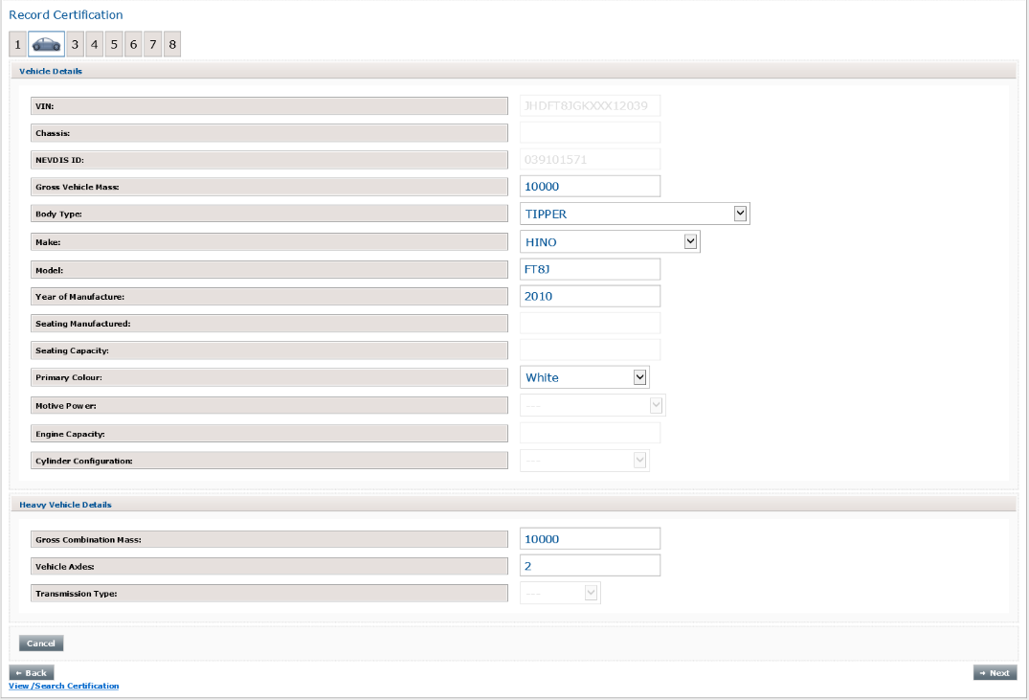

Screen shot two:

Vehicle identified with its Tasmanian Registration number. Fields are not editable.

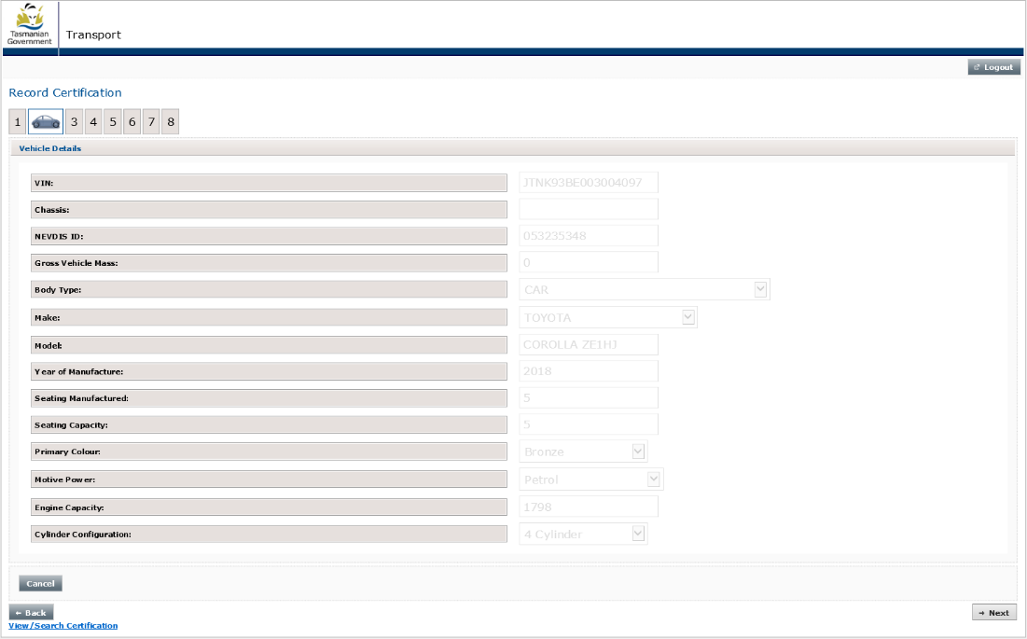

The amount of detail available on this page will depend on the following factors;

* Whether the vehicle is or has recently been registered in Tasmania,
* Whether the vehicle has ever been registered in Australia,
* What vehicle identifier was used to identify the vehicle on page one of the certification submission (VIN, chassis or Tasmanian registration number),
* What information is available on NEVDIS,
* What type of vehicle it is.

If manually entering the vehicles model, the number of characters entered cannot exceed 20 (this includes spaces).

AVC’s must always ensure all of the vehicle information recorded on this page is correct **before** continuing.

### Incorrect data - uneditable

If an AVC believes any of the data retrieved is incorrect and they are unable to edit the field, the AVC must contact AIS Compliance to discuss. AIS Compliance will advise the AVC how to complete the certification.

## Vehicle Modification Details – Page three

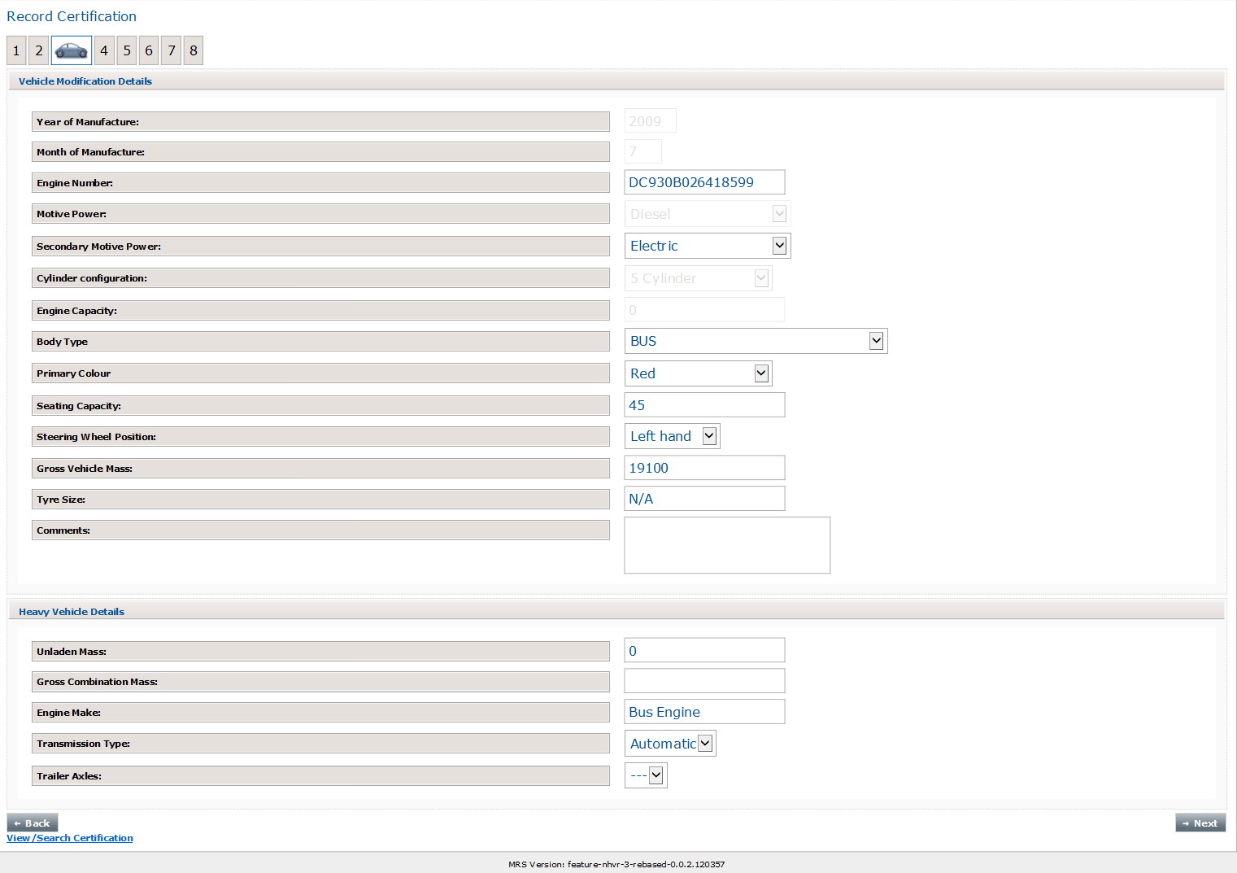This page onwards is where the certification details are entered by the AVC. All details regarding the modifications which are being certified are record from this page onwards.

Note: if you are certifying a trailer, all fields which are not relevant to trailers will be greyed out

This page is a mixture of editable free text fields and drop down boxes. AVC’s are only to change fields on this page which are directly part of the modification they are certifying.

### Year and month of manufacture:

AVC's will only be able to edit the month and year of manufacture, if the vehicle has never been registered before in Australia. AVCs **MUST** always enter all four digits of the year (i.e 2017).

### Engine number:

This field is editable, if this field is edited, the following three fields will unlock for an AVC to complete:

* Motive power
* Cylinder configuration
* Engine capacity

**Important note:** Changes to the engine number field are only recognised after the AVC taps/mouse clicks outside the box.

**Motive power**

There are two motive power fields – motive power and secondary motive power:

Motive power: This relates to the primary motive of power of the vehicle e.g. Diesel, NPG, Petrol or Electric

Secondary motive power: This is an optional field and relates to the secondary motive power of the vehicle.  If the vehicle does not have a secondary power option, the AVC must either leave as blank or select: not applicable.

Note: These two fields must contain different values. They cannot be the same.

**Body type,** primary **colour:**

Both of these are drop down boxes. No free text is allowed.

**Seating capacity:**

If there has been no change to the seating capacity, the data in this field is **not** to be changed. If the data is incorrect, the AVC must contact AIS Compliance.

It is very important that this field is used correctly as this field is used to populate the mod seating field on the modification plate template.

If an AVC uses this field incorrectly, the modification plate template will auto populate incorrectly.

**Gross** Vehicle **Mass:**

AVC’s are only permitted to perform GVM upgrades, via the MRS portal. It does not permit an AVC to enter a GMV reduction. If an AVC enters a lower number than what is originally recorded, a red warning will appear upon the AVC selecting the next button **not** allowing the certification to continue.

Where not modified, N/A **must** be added into the field.

Tyre size:

This is a free text field, only to be used if the tyres are changes as part of the modification. If both front and rear tyres have been changed, both sizes are to be specified, example: **F:** 215/65/R15, **R:** 225/70R15.

Where not modified, N/A **must** be added into the tyre size field.

**Comments box:**

A maximum of 200 characters is allowed in this box.

AVC’s use this box to add things such as, If there are a significant number of Modification codes the AVC may wish to replicate the codes here: It is suggested if there are more than 7 mod codes this is done., or if adaptive controls are fitted, a short description of the type as per the Vehicle Modification Certification Manual (VMCM) requirements, or details of any other mod plates affixed to the vehicle (including non-Tasmanian ones).

The comments box should also be used when incorrect data is displayed on page two of this form.

Large amounts of information must not be added here, brief & concise comments only. Large amounts of information should be added to the certification as a separate attachment, this is explained further on.

**If the vehicle is a heavy vehicle:**

If the vehicle is a heavy vehicle, the following additional fields will appear. AVCs are only to make changes to these fields if it relates to the modifications they are certifying. These additional fields are:

* Un-laden mass
* Gross combination mas
* Engine make
* Transition type

## Wheels and axles – Page four (applicable to heavy vehicles only)

This page will only appear when the vehicle being certified is a heavy vehicle (in excess of 4.5t GVM).

If you are certifying a heavy vehicle and the modifications relate to wheel and/or axles configurations, AVC’s are required to complete this page.

Each of the tyres & axles fields are drop down boxes and the load sharing is a tick box.

All mandatory fields on this page, contain a star. Example:

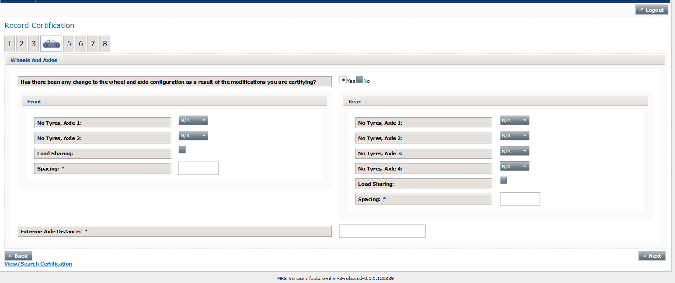

## 

## Modification codes – Page five

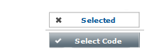On this page, AVC's must apply modification codes to a certification. To do this, simply tap or mouse check the select code button. If a code has been selected incorrectly, select the code button again and the code will be unselected.

AVC's will have access to modification codes that they can personally certify these are aligned to the VMCM Modification Matrix on the basis of their qualifications and experience.

Additional codes are available if third party documentation is obtained, more information about addition of third party codes is contained further on in this booklet.

If LA2 and/or LA3 are selected, additional information may be required, any information added here will be transcribed onto the modification plate template and therefore onto the modification plate itself. For example; where an engine substitution or turbo/supercharger is involved, relevant VSB code followed by a dash then number of cylinders or rotors then forward slash engine capacity in litres then a lower case l. For example LA2-8/5.7l. If a turbo (T) or supercharger (S) are fitted include a capital T or S. for example LA3-4/2.5T

**Important note:** After any additional information has been added to either LA2 or LA3 an AVC must tap/mouse click outside the box for the additional words to be validated within the portal and transcribed onto the modification plate template. AVCs will know when the additional information has been validated as it will reduce in size and change from blue to black.

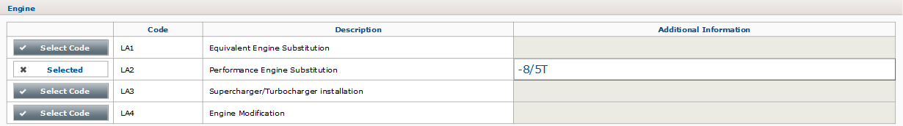

## 

## Modification template – Page six

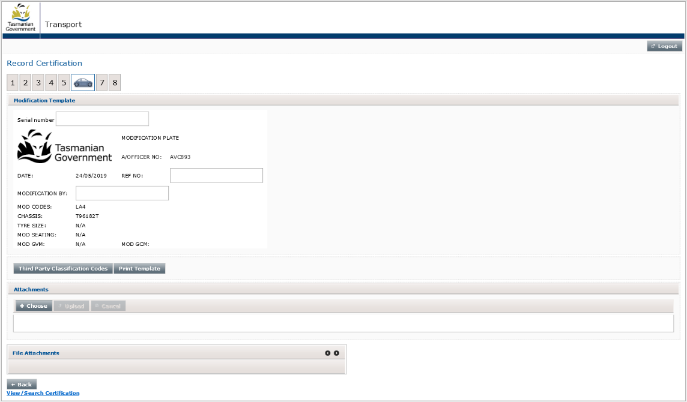

Most items on the modification plate template pre-populate with all of the required information. AVCs are only required to enter the following;

* Serial number,
* Ref no,
* Modification by.

If, modifications being certified relate to a seating configuration involving wheelchair spaces AVCs must do the following;

* AVCs are to start the certification submission. The number of seats recorded in the seating capacity field on page 3 is the amount of physical fitted only.
* The AVC continues through the submission and download the modification plate template.
* The AVC must pen amend this printed template, showing the full seating configuration
* Examples are; 10+2 w/chair or for alternate configurations 10 or 6+2 w/chairs.
* Manual override of this template is required. Email the amended template to: [avc@stategrowth.tas.gov.au](mailto:avc@stategrowth.tas.gov.au) with subject heading: replace template request.

### Serial number:

This is the five digit number located on the top right of each modification plate. AVC's must enter the number of the modification plate they will be allocating to the vehicle here.

### Ref no:

Also known as report number. AVC's must use the naming protocols as follows;

Prefix AVC followed by your individual number dash, prefix C followed by your AVCAIS station number, dash, your individual AVC report number. Example: AVC112-C100-001

### Modification by:

The name of a natural person or a registered company who modified the vehicle or if multiple parties involved name of the owner. The word “owner’’ is not acceptable, a natural person or a registered company must be identified in this field. If the person/s or registered company involved in modifying the vehicle are unknown, the name of the owner must be included.

### About the buttons on this page:

There are five buttons on this page:

* Third party classification codes
* Attachments
  + Choose
  + Upload
  + Cancel
* Print template

### Third party classification codes:

If a third party has provided documentation and approval to any aspect of a modification an AVC is unable to personally certify, the certifying AVC must select the third party classification code button and type the applicable mod codes into the field titled: third party mod codes. This field will appear within the mod plate template. When this button is selected, a new field will open up on the modification plate template and the button will disappear.

### Attachments

Each certification submission must contain a number of attachments. For information about what these should be please refer to the VMCM link: <https://www.transport.tas.gov.au/vehicles/vehicle_inspections/avcais>

Attachments can only be uploaded either before the modification plate template is completed or after the modification plate template button has been selected.

Each modification certification submission can have a maximum of 20 individual files attached.

### Attachment types

Attachments must accompany each certification. Further information about the attachments can be found in the VMCM.

The portal supports the following file types:

* PDF
* JPEG
* Word (DOC and DOCX)
* Excel (XLS and XLSX)

Zip files are not supported.

### Attachments - Uploading

Select the ‘choose’ button: and select the file. After the file has been selected, press the ‘upload’ button: to upload it. Prior to uploading any file, AVC’s must always check that the file they are uploading is the correct file. If the document chosen is incorrect, select the cancel button or the X which is beside each file.

**Only one document can be uploaded at a time.**

### Removing or deleting attachments

Documents can be removed prior to being uploaded or deleted after they have been uploaded.

**Removing prior to uploading:** This can only occur prior to being uploaded.

**Deleting after uploading:** Documents can be deleted by an AVC **on the same day** (prior to 10pm) it is uploaded, providing that the certification submission has not been completed. Documents uploaded **cannot** be deleted after 10pm on the night they are uploaded or after the submission has been completed.

If a document has been uploaded in error and the period in which an AVC can delete it has passed, the AVCs must email: [avc@stategrowth.tas.gov.au](mailto:avc@stategrowth.tas.gov.au) with the following information;

* Vehicle identifier used on page one of the certification submission,
* Name of AVC and their AVC number,
* Date certification submitted,
* Full title of all documents loaded in error.

AIS Compliance can assist with manual deletion of uploaded certification submission documents. Document deletion requests need to be email to [avc@stategrowth.tas.gov.au](mailto:avc@stategrowth.tas.gov.au) as per above.

### Print template

When all fields on the template have been completed and attachments uploaded, the modification plate template and style guide can be downloaded and printed.

To generate the PDF, select the Print Template button. After this button has been selected the document is available to download and print.

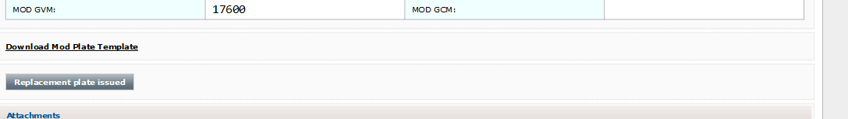

To access the PDF to download, select the download mod plate template link. When selected a new webpage will pop up with the mod plate template and style guide available in PDF for downloading.

When the print template button is selected, the modification plate template on the screen becomes ‘uneditable’ and the status of the certification becomes ‘waiting modification plate’.

In most instances, this is where the certification process will pause, to allow the modification plate to be engraved. When the modification certification is paused for this reason, the status of the modification certification becomes ‘waiting for modification plate’.

Certifications can only be submitted after the print template button has been selected.

AVCs must not complete (press submit certification) and make payment on any certifications before;

* All VMCM required documents are completed and added as attachments to the certification,
* The modification plate has been engraved and all data is correct, and
* The modification plate has been affixed to the vehicle.

## Mistakes on auto generated documents:

### Mistakes – AVCs can fix

Mistakes can and do occur. To assist AVCs in correcting mistakes the following functionalities have been built into the portal:

* A ‘back’ button on each page,
* A ‘Replacement plate issued’ button on the modification template page,
* Ability to remove (delete) attached documents, in line with parameters mentioned previously.

In many cases AVCs can correct errors made on previous pages, AVCs should always try to fix the errors themselves before ringing AIS Compliance.

To do this, AVCs need to select the ‘back’ button. This will take the AVC back to previous page, (or pages) and errors can be corrected. The back button is located at the bottom of each page, up until the modification plate template has been downloaded.

After the modification plate template has been downloaded, AVCs still have the ability to go back and correct mistakes, but they **must** select the replacement plate issued button first.

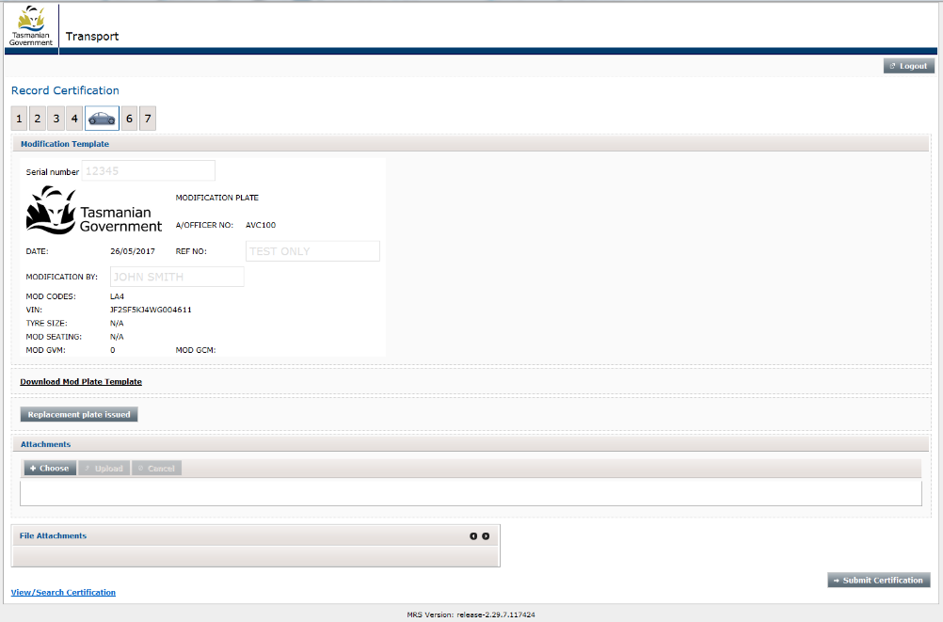

When the replacement plate issued button is selected, two things will occur:

1. The auto generated modification template document is removed and
2. A ‘back’ button will appear at the bottom of the modification template page.

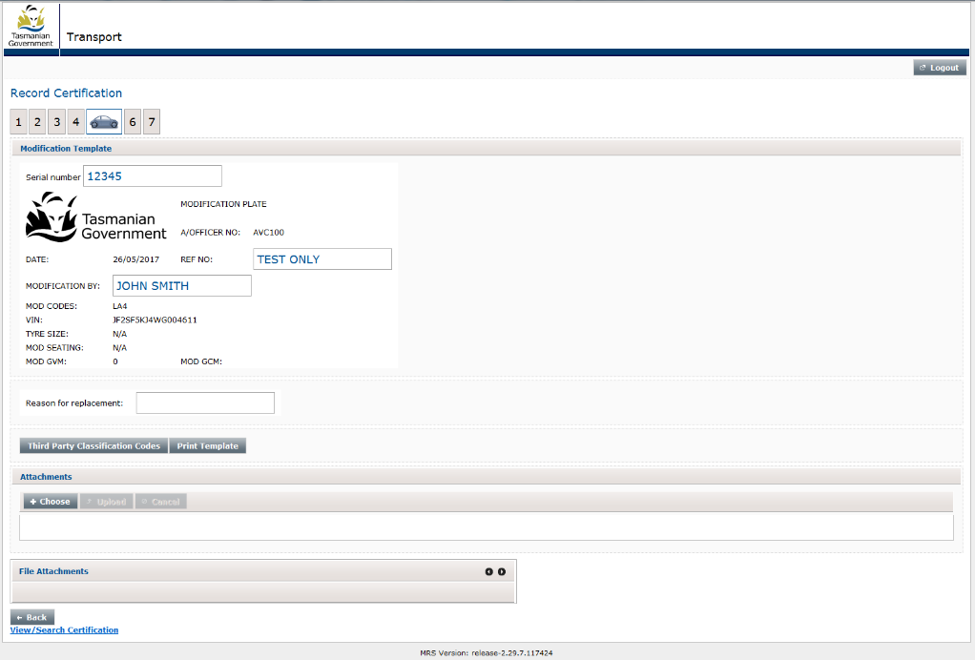

The AVC must supply a reason (i.e.: incorrect mod code selected, incorrect vehicle details entered). The reason **must** be brief, (a maximum of 200 characters are allowed in this field) and only typed in **after** all of the changes have been made.

Important note: If the modification plate has been engraved incorrectly, the serial number of the modification plate template must be corrected to reflect the new modification plate number which is going to be used to correct the engraving error. Incorrect modification plates **must not** be fitted.

### Mistakes AVCs cannot fix

There will be cases where the data on the auto generated documents contains errors and the errors cannot be rectified by the AVC (due to the certification being completed, or errors being in fields which the AVC cannot edit). If this occurs the AVC is to complete the following steps;

* Print and Email a copy of the document to: [avc@stategrowth.tas.gov.au](mailto:avc@stategrowth.tas.gov.au)
* In the email, list all of the incorrect items and what the correct information is,
* If a new mod plate is required, provide the new modification plate serial number,
* Name of AVC and their AVC number,
* AVC’s current contact number (in case we need to contact the AVC)

AIS Compliance will provide a manually generated replacement document. AVCs are never to pen any of the auto generated documents and supply them to either the engraver of their customer. All changes to auto generated documents must be approved by AIS Compliance. AIS Compliance will confirm the approval by supplying a typed amended template/s to the AVC.

## Completing a certification

AVCs must not complete (press submit certification) and make payment on any certifications before;

* All required documents as per the VMCM are completed and loaded as attachments to the certification,
* The modification plate has been engraved and all data is correct, and
* The modification plate has been affixed to the vehicle.

Only after the modification plate template button has been selected, can a certification be completed.

To complete a ‘waiting for mod plate’ certification, use the view/search certifications page to locate the certification select the edit button. To complete, select the next or submit certification button. In portal terms, an AVC has only completed a certification submission when they press the pay button.

Certifications are incomplete before the pay button is selected. AVCs are never to affix a modification plate to a vehicle and leave the certification submission unfinished.

## Payment gateway – Page seven

AVCs are required to pay for each certification upon submission. This is completed via a secure payment gateway. AVCs can only use Master Cards or Visa cards.

AVC must **never** go through the payment process before the modification plate has been engraved and affixed to the vehicle.

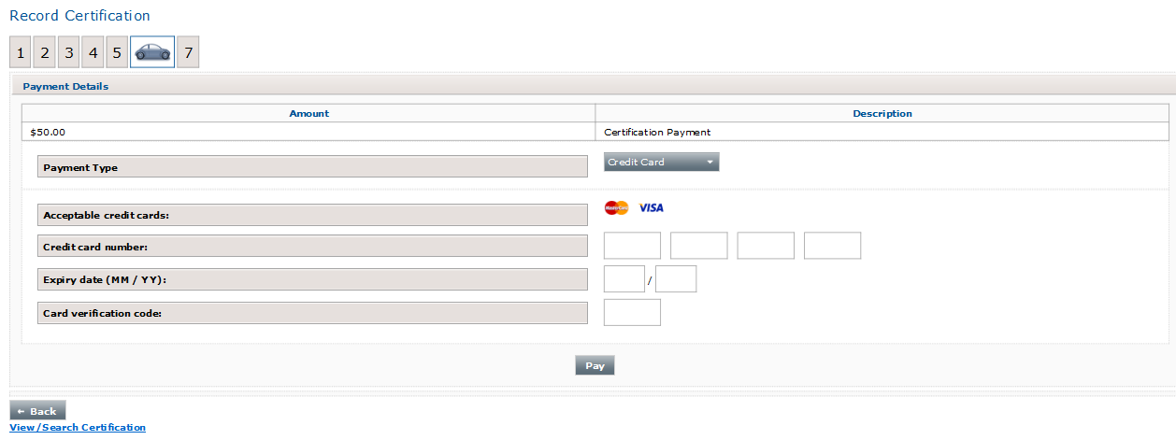

When all card details have been entered in, select the pay button.

Important note: This is the only payment option.

### About the pay button

When this is selected the following occurs:

* Payment is taken from the nominated credit card,
* Modification Certificate is generated (light vehicles only) – a copy of this **must** be given to the customer
* A receipt is generated for the AVCAIS,
* Certification details are uploaded onto the vehicles file on the MRS,
* Copies of the certification, modification certificate and all attachments supplied are uploaded into our Departmental database.

It will take a few moments for the above to occur, **do not** disrupt the process.

### Auto generated – Light Vehicle Modification Certificate

For all light vehicles, a modification certificate will be automatically generated after the certification has been completed identified by – Your AVC Details – ‘Certificate’.

Heavy Vehicle Modification Certificates are completed on the NHVR approved document as per the VMCM by the AVC and added to the certification as an attachment.

AVCs must always check each auto generated certificate before providing it to the customer. If any of the following populate with incorrect data – i.e. N/A or null, a copy of the certificate must be emailed to: [avc@stategrowth.tas.gov.au](mailto:avc@stategrowth.tas.gov.au) with errors with certificate in the subject line:

* Modification plate number,
* Make,
* Model,
* Name of AVC and AVC number,
* Preferred phone number of AVC.

AIS Compliance will email a manually generated revision of the certificate back to the AVC.

## Viewing completed certification submissions – Page eight

When payment of and processing of the certification has been completed, the following documents will be available for downloading (see below screen shot as example):

* Mod plate template (You are not required to print or supply this to your customer after the certification has been completed),
* A PDF copy of the Certification Report,
* Modification Certificate (applicable to light vehicles only) and
* A receipt for the AVCAIS.

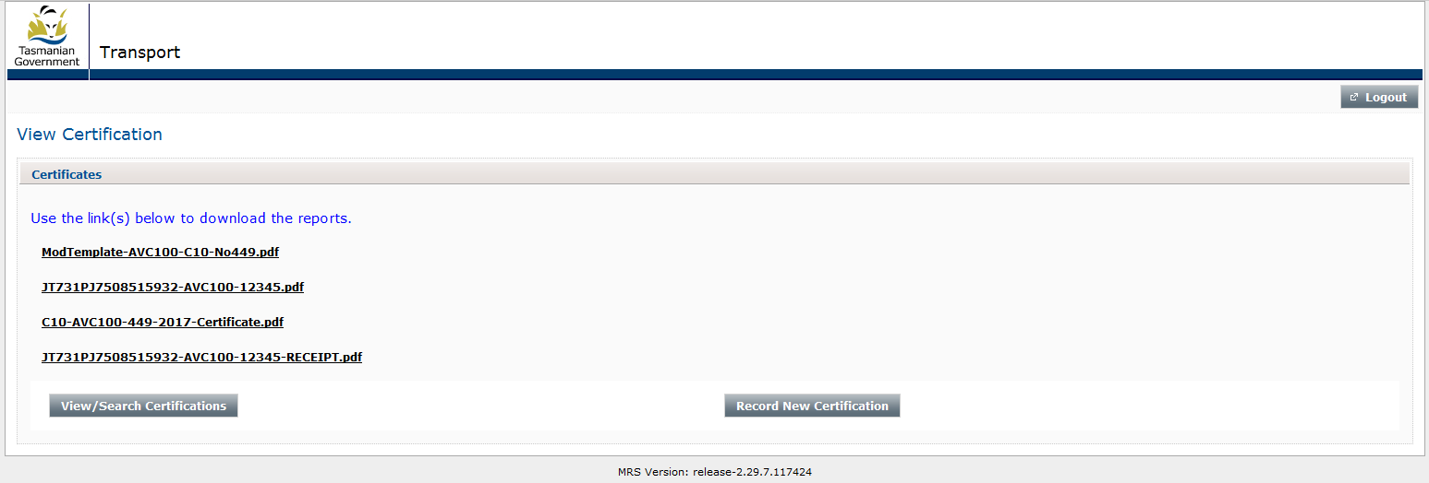AVC’s are required to supply each customer with a copy of their certification and modification certificate.

## View/search submissions

On this page, AVC's can search for any certification they have completed via the Portal and find submissions they are yet to complete.

With the exception of the ‘cert number search field’, anyone, or a combination of the search fields can be used, see screen shot below. When using any of the search fields, AVCs must select the search button - pressing enter on you keypad will not work. Date fields also have a built in calendar. The button to access the calendars is located on the right hand side of the date fields.

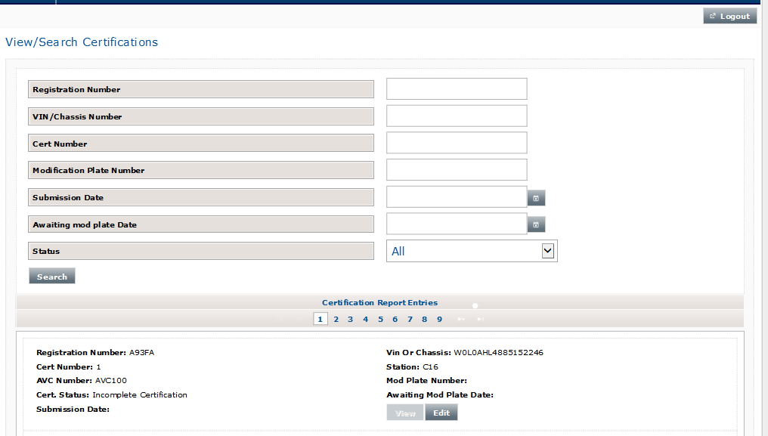

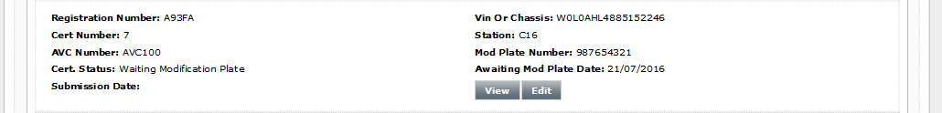

### About certification entries on this page:

Most of the features contained within the view/search certifications page are self-explanatory, two important features, all AVC's will need to understand are explained further below:

Certification status:

* Incomplete certification
* Waiting modification plate
* Submitted Certification

Incomplete certification:

This status is applied to any certification which has been shut down before the print modification plate template button has been selected.

Waiting modification plate:

Once the print modification plate template button has been selected, the certification will be given a status of: ‘waiting modification plate’.

Even if a modification plate is not required, the print modification plate template must be selected as this button is also the save and continuation point.

Submitted certification:

All certifications receive this status after they have been completed. The AVC has pressed the ‘Pay’ button.

### View and Edit buttons

Edit

This button is only available if a certification is shut down before the modification plate template has been generated or if the certification is in the status of: waiting mod plate. In both cases, a certification can be re-opened, edited if required and completed.

View

This allows an AVC to view PDFs of the following;

* Modification plate template

And if a certification has been completed, and AVC can also be able to access -

* Certification submission document,
* Certification certificate (for light vehicles only),
* Receipt.

AVCs cannot view documents they have uploaded.

# Other important information:

## Can an unapproved AVC log into the portal?

**No.** If an AVC is not approved they will not be able to log into the website.

## Session time out

If left unused for half an hour or more, the session will time out and the AVC will be required to log back in. AVCs may also be logged out if they refresh the web link. Session time out is in place for security reasons.

After an AVC logs back in after a session time out, they will not be directed to the same page they were on prior to the session timing out. Instead they will be redirected to the homepage. If an AVC was in the process of completing a certification prior to the session time out, the view/search certifications page must be used to locate the open certification.

## What if the portal is not working?

In instances where an AVC discovers that there portal is not working, they **must** contact AIS Compliance. This section also applies to certifying vehicles which have been fitted with dual controls used for the purposes of driver instruction, or vehicles being granted GVM Reductions.

AIS Compliance investigate/advise (where relevant) to engage in manual certification process.

**Important note:** AVC’s are only to use the manual process if they have been instructed by AIS Compliance. AVC’s must not begin a certification with manual documents. This is to ensure there is someone within AIS Compliance is on hand to process the manual certification within reasonable time frame.

Manual Process

* AVC attaches the following to an email and sends to: [avc@stategrowth.tas.gov.au](mailto:avc@stategrowth.tas.gov.au)
  + Completed AVC Report
  + Photos
  + National Heavy Vehicle Regulator Modification Certificate (if heavy vehicle)
  + All required VSB Checklists,
  + Any other documents required by the VMCM to meet the AVC Certification, and
  + Completed AVC Manual Input Modification Certification Submission (supplied by AIS Compliance via email on AVC request).
* AIS Compliance will supply a manually generated modification template with the style guide to AVC via (return), notification of invoicing arrangements for certification and it is a light vehicle a manually generated Light Vehicle Modification Certificate (LVMC).

After the Mod Plate is affixed and the AVC completes declaration of fitment on the AVC Manual Input Modification Certification Submission, and the AVC signs & dates the LVMC, and scans both documents back to AIS Compliance, providing the owner with a signed copy of LVMC the manual AVC Certification is deemed complete.

# Appendix A

## cid:image001.png@01D2D554.30A9CFD0The certification process

|  |  |  |
| --- | --- | --- |
| MKBK:Users:roland:My Desk:Business:RG Design:Jobs:DEDTA Jobs:DSG 14034 DSG A4 Document Template:B - Development:Exports:Back Gov Logo.png | Department of State Growth  GPO Box 536 Hobart TAS 7001 Australia | |
| Phone: | 6166 3266 |
| Email: | [ais@stategrowth.tas.gov.au](mailto:ais@stategrowth.tas.gov.au) |
| Web: | www.transport.tas.gov.au |