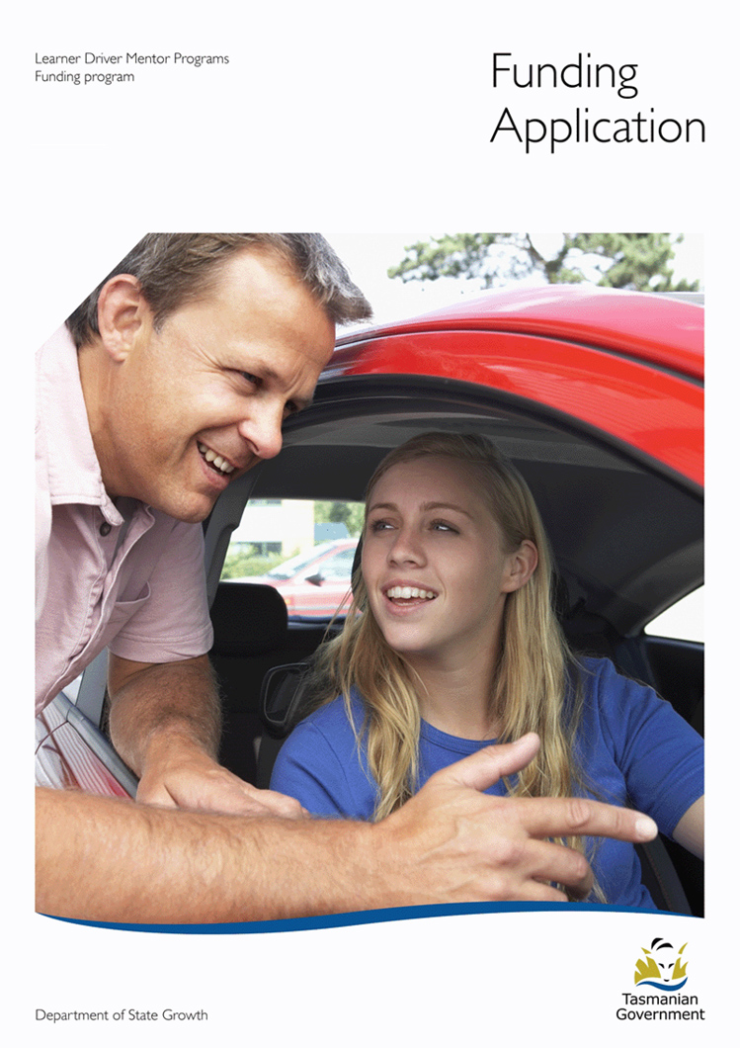

Section 1 – Applicants Details

LDMP Program:

ABN:

Street Address:

Postal Address:

Program Coordinator:

Phone:

Email:

Auspicing Body:

ABN:

Street Address:

Postal Address:

Key contact:

Position:

Telephone

Email:

Person responsible for signing Deed:

Position:

Phone:

Email:

**Amount of funding requested:**

Section 2 – Program Overview

This section requires you to provide a brief overview of how your LDMP is currently operating.

**Target Group**

* Describe how the target group for your program has been identified.
* Outline strategies used for engaging participants

**Learners**

* Detail current learner numbers, on road hours and retention strategies

**Mentors**

* Detail current number of active mentors, on road hours, screening processes, recruitment and retention strategies.

**Vehicles**

* Describe current vehicles, safety ratings, fuel, maintenance and insurance arrangements

**Program Management**

* Describe the Governance arrangements for the program including the involvement and commitment of the auspicing body.
* Describe the Program’s management arrangements (i.e Coordinator hours).
* Describe current data collection practices.
* Outline current policies and procedures including compliance with Working with Children Requirements.
* Outline the current liability and insurance cover arrangements for the program (if applicable).

## **Program Performance**

* Detail on road hours for each vehicle and how it is managed

**Evaluation**

* How is the program working towards becoming sustainable?
* How is success of the program measured?

Section 3 – Program Planning

This section allows you to tell us how you plan to use funding to improve your LDMP.

Please provide a Program Plan for the funding period using the table below. A Program Plan sets out the key activities you intend to undertake in order to continue to improve your LDMP. These activities must align with the key aspects of running your program. Refer to Page 6 for more information on key aspects of running an LDMP.

|  |  |  |  |
| --- | --- | --- | --- |
| **Activity** | **Goal** | **Strategy** | **Intended Outcome** |
| **Target Group** |  |  |  |
|  |  |  |  |
|  |  |  |  |
| **Learners** |  |  |  |
|  |  |  |  |
|  |  |  |  |
| **Mentors** |  |  |  |
|  |  |  |  |
|  |  |  |  |
| **Vehicles** |  |  |  |
|  |  |  |  |
|  |  |  |  |
| **Program Management** |  |  |  |
|  |  |  |  |
|  |  |  |  |
| **Evaluation** |  |  |  |
|  |  |  |  |
|  |  |  |  |

Section 4 – Budget

This section requires you to outline how much Government funding you are seeking and how you plan to spend that money over the funding period.

**Outline current financial position of program - including any other grants or funding received since 1 January 2014**

|  |  |  |  |  |
| --- | --- | --- | --- | --- |
| ***Items or services required*** | **Cost** | **Cost explanation** | **Funding sources** (including from any government, businesses, or other sources) | **Is funding: secured / unsecured / in-kind** |
|  | $ |  |  |  |
|  | $ |  |  |  |
|  | $ |  |  |  |
|  | $ |  |  |  |
|  | $ |  |  |  |
|  | $ |  |  |  |
|  | $ |  |  |  |
|  | $ |  |  |  |
|  | $ |  |  |  |
|  | $ |  |  |  |
|  | $ |  |  |  |

|  |  |
| --- | --- |
| **Total funding sought through this application** | **$** |
| Total secured – other funding | $ |
| Total unsecured – other funding | $ |
| Total in-kind support | $ |
| Total cost of project | $ |

Section 5 - Declaration

I, the undersigned, certify that I have been authorised by the Learner Driver Mentor Program (LDMP) and auspicing body named in this application (if applicable), to submit this application, that the LDMP is eligible for funding, that I agree to the funding and performance requirements and that the information contained herein and attached (if applicable) is to the best of my knowledge true and correct.

Grant writer



Auspicing body



**Please send all completed forms by mail or email (details below).**

Attention: Alysse Gavlik

Road Safety Branch

Department of State Growth

GPO Box 536

Hobart TAS 7000

Phone: (03) 6166 3245

Email: [alysse.gavlik@stategrowth.tas.gov.au](mailto:alysse.gavlik@stategrowth.tas.gov.au)

Web: www.transport.tas.gov.au