Transporter

August 2018

Time ticks on
Winter is nearly over, although if feels like it has just begun given the warmer than average temperatures we experienced in June and July. We can always count on August to remind us how cold it can get. With the colder weather comes more challenging driving conditions so please take care on the roads.

Transition of Heavy Vehicle Compliance and Enforcement to the NHVR
On 2 July 2018, the Department of State Growth (State Growth) transferred responsibility for heavy vehicle compliance and enforcement to the National Heavy Vehicle Regulator (NHVR). Tasmania is the second state or territory (after South Australia) to achieve this part of the national heavy vehicle reforms.
What do I have to do?
Nothing. There are no changes to the Heavy Vehicle National Law (HVNL) arising from this transition. There will be very little impact for day-to-day operations of the road transport industry.
There are some minor changes to the clearance of heavy vehicle defects. You can find out about these at the website listed below.
What services have transitioned to the NHVR?
As of 2 July, the NHVR now provides:
- On-road education and compliance for heavy vehicles (over 4.5 tonnes gross vehicle mass). This includes mass, dimension, vehicle standards, load restraints, route compliance and driver fatigue.
- Investigations and prosecution of offences under the HVNL.
What services are remaining with State Growth?
State Growth continues to provide:
- Escorts for Over Size Over Mass (OSOM) vehicles.
- Written-Off Vehicle Register (WOVR) identity checks for light vehicles.
- Light vehicle crash inspections for the Coroner.
- Public Passenger Vehicle compliance and enforcement.
- Other light vehicle compliance and enforcement with Tasmania Police.

Where can I go for more information?
You can find more information at: https://www.transport.tas.gov.au/latest_news/the_national_heavy_vehicle_regulator_update
If you have any queries, please contact either your relevant industry association, or don’t hesitate to get in touch with State Growth or the NHVR directly:

State Growth – Transport Safety and Investigation Unit
Phone: (03) 6777 1936
Email: transport.safety@stategrowth.tas.gov.au
Postal address: PO Box 1906, Launceston TAS 7250

NHVR
Phone: 1300 MYNHVR (1300 696 487)
Email: tasmania@nhvr.gov.au
Postal address: PO Box 1268, Launceston TAS 7250

Accreditation
Accreditation is important for the safety of passengers, drivers and other road users. Any person providing a passenger transport service in Tasmania must be accredited under the Passenger Transport Services Act 2011 (the Act).
The purpose of accreditation is to ensure that the person operating the service is a fit and proper person, has the appropriate safety, security and related systems in place for the service, and is competent to manage the risks associated with operating the service.
The accredited operator (if an individual) or the nominated responsible person (if the accredited operator is an organisation) is legally responsible for the accreditation and the day-to-day operation of the service.
The Transport Commission (Commission) has approved Accreditation Standards which are detailed in the Operator Accreditation Manual – Transport Services other than Taxis. The Manual is available on State Growth’s website at www.transport.tas.gov.au/passenger/operators. Standard 1.2 (Recordkeeping) requires that records for the service are kept up-to-date, stored in a readily accessible and secure place and are available on demand by an approved auditor.
The usual conditions of accreditation require that an audit report and National Police Certificate (NPC) for the operator (or nominated responsible person) is supplied to the Commission at regular, scheduled intervals. The dates by which an audit report and NPC are due to be supplied, are printed on the accreditation certificate. The Act makes it an offence for the person holding accreditation, or the nominated responsible person, to contravene a condition of accreditation.

When an audit report and/or NPC is received, the accreditation is reviewed. The Commission must be satisfied that the systems in place for the service conform to the Accreditation Standards and the service complies with the Regulatory Framework. All information available to the Passenger Transport Branch relating to the accreditation is considered. Concern about whether the appropriate systems are in place may arise for a number of reasons including if information suggests that a vehicle used to provide the service:
- was unregistered for a period of time;
- was not presented for a roadworthy inspection by the due date;
- did not meet vehicle standards when it is presented for inspection; and/or
- was issued a defect notice.
The Act gives the Commission power on a number of grounds to take action against an accreditation which may include:
- requiring information to be supplied;
- varying a condition of the accreditation to provide that an audit report is to be supplied;
- imposing probationary status on the accreditation; and
- suspending or cancelling the accreditation.
For any enquiries relating to passenger transport services operator accreditation, please contact the Regulations and Concessions Unit on (03) 6166 3269.

Making changes to your services
From time to time, you may get requests to change your service. For example, a school principal might ask you to change the time that you collect students after school, or a parent might ask you to detour up a road to collect their child.
It is very important for you to remember that any changes made to your service must be agreed to by the State Growth, and must be documented as a contract variation before the changes can commence.
Your contracted route and timetable is detailed in Schedule 1 (Approved Route and Approved Timetable) of your contract. If you operate your service differently to what is documented in Schedule 1 you could be at risk of having non-compliance points recorded against your contract, and performance payments deducted from your payment.
If you believe that a change is required to Schedule 1 of your contract, please submit a request to State Growth in writing to ptscontracts@stategrowth.tas.gov.au. State Growth will consider the request with reference to established Guidelines (where applicable) and/or principles for the provision of regular passenger transport services.
As you will appreciate, it is important that bus services remain reliable and consistent across Tasmania so State Growth is not always in a position to agree to variation requests. However, each request is considered on its merits and in line with the above-mentioned Guidelines and principles. For a copy of the Guidelines, please refer to the Transport website: https://www.transport.tas.gov.au/passenger/student_travel

Liaison Officers
We understand that all bus operators need to take holidays, however we would like to remind you that it is very important to have someone available at all times to deal with contractual matters, including someone that can sign contract documents. This is usually the Liaison Officer. If your usual Liaison Officer will be unavailable for a period, we would appreciate notification of alternative arrangements. This can be done by submitting a Liaison and Reporting form to nominate an alternative Liaison Officer. To obtain a new form contact the Contracts team on 6166 3343 or email ptscontracts@stategrowth.tas.gov.au

Bus cost model index (BCMI)
The BCMI for all months for 2018 is as follows:
Month | BCMI | Month | BCMI
January | 122.9 | May | 124.1
February | 123.1 | June | 124.9
March | 123.4 | July | 128.1
April | 123.1 | August | 127.6

Special note regarding the BCMI for July 2018
Please note the following message which was sent on 17 August 2018 to all operators who have supplied a valid email address, advising of an error to the July 2018 BCMI calculation.
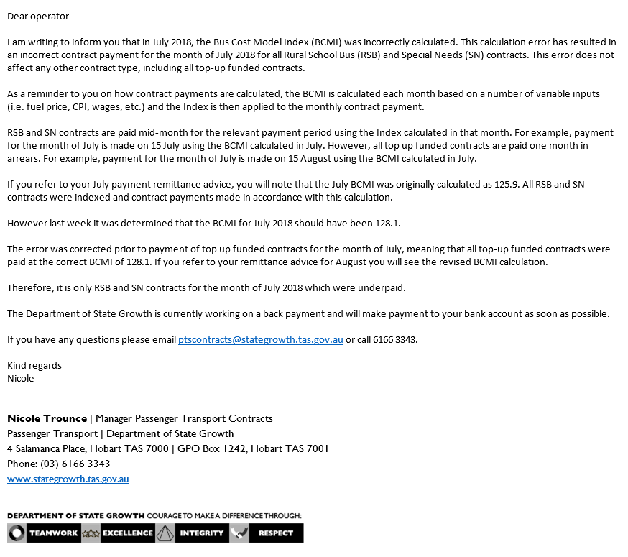

Capital rates
The capital rates for the quarters commencing January, April and July 2018 were calculated as per the table below. Please note that the only change to capital rates for 2018 is for general access services. Please consider these rates before requesting bus changes on your contract.

Contract Type | January 2018 | April 2018 | July 2018
Urban Fringe Student Only | $1.01 | $1.01 | $1.01
Rural Fare Paying | $1.01 | $1.01 | $1.01
Long Distance Student Only | $1.01 | $1.01 | $1.01
Long Distance General Access | $2.88 | $2.88 | $2.91
Urban Fringe General Access | $2.88 | $2.88 | $2.91
Urban | $0.86 | $0.86 | $0.86
Town | $0.86 | $0.86 | $0.86

For all fare-paying operators, the rates applicable to your monthly contract payment can be found on your Statement of Payment.

Contacting Passenger Transport
For all enquiries or notifications relating to your current contract (i.e. a service you currently provide) please contact the Passenger Transport Contracts unit via email ptscontracts@stategrowth.tas.gov.au or phone (03) 6166 3343.

