Transporter
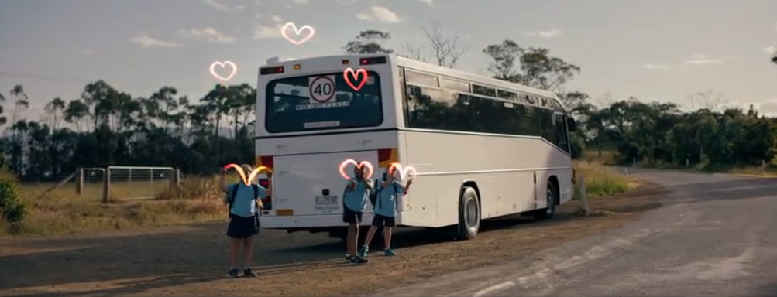

December 2019

Bright times ahead
We hope you’ve all been enjoying the occasional bursts of warmth and sunshine in your various corners of the isle. It’s been a long and busy year for passenger transport in Tasmania, but the holidays will be upon us before you know it!
It has been brought to our attention that the school bus picture we were using for Transporter didn’t display the legally required signage. We appreciate your eagle eyes and your feedback. As a replacement we’ve chose an image from the Road Safety Advisory Council’s ‘Love 40’ campaign which has run throughout 2019 and received a great response.

Bus Services Review project update
Registrations of buses in Operator’s name
If you plan to purchase a replacement vehicle to add to a contract, you will need to ensure that the vehicle is registered in the same name as the contract holder. There is a clause in the new contract (as part of the ‘Standard Conditions’) that states:
“Unless otherwise approved, in writing, by the Crown, the Operator (or if the Operator is a partnership, at least one of the partners) must be the registered operator (for the purposes of the Vehicle and Traffic Act 1999 (Tas)) of an Approved Vehicle.”
For example, if your contracts are held by your company XYZ Services Pty Ltd, then XYZ Services Pty Ltd must be the registered operator of the vehicle. You should not register the bus in your own name and then seek to have it added to a contract.
If you are uncertain about the correct name to be used for vehicle registration purposes, please contact the Department on 03 6166 3343.
Northern General Access Network
New plans for a reinvigorated and smarter bus network in northern Tasmania, including urban Launceston are in motion following a comprehensive public consultation period.
The consultation included Launceston urban services as well as the outer-urban and regional routes surrounding Launceston which are operated by Manions’ Coaches, Lee’s Coaches, RD & FH Sainty, Tassielink Transit, and Calow’s Coaches.
Members of the community and stakeholders provided valuable feedback during the consultation process. A total of 388 responses were received.

Overall the consultation confirmed that we are heading in the right direction and the new service offerings will have a very positive impact for communities. We are making adjustments to routes and timetables as a result of the consultation process.
New timetables and maps are expected to be available in early December 2019 to allow plenty of time for travellers to be informed before the changes take place in January 2020.
A copy of the public consultation report can be accessed at www.transport.tas.gov.au.
North West General Access Network
Public consultation for the North West coast and also long distance bus services between Devonport and Launceston and Launceston and Hobart closed on 27 October.
Once all feedback from the public consultation has been carefully analysed, a public consultation report will be published on the Transport website.
Following this, the finalised network will be communicated early next year.

Planning to sell your contract?
With the commencement of fresh 5 + 5 year contracts in the New Year, we anticipate that some operators may be interested in selling new contracts to another party and requesting that State Growth agree to novate the contract.
Although the novation process is not complicated, it requires the collection of a large amount of information and can take some time to complete. This will be compounded by the expected increase in workload for the Passenger Transport Branch at the beginning of next year as we manage requests for changes to Approved Vehicles and public enquiries.
Therefore, to assist us in meeting your needs and planning our workloads, we ask that any operators who intend on novating their new contracts inform Passenger Transport as soon as possible. While the contracts cannot be novated prior to their commencement date, early notification will reduce the time spent on the process during the busier months.
Please keep in mind that, if you choose to novate your new contract, you will still be required to see out the term of your current contract.

Black boxes
State Growth has made the decision not to renew its current agreement with BlackBox Control (BBC). The following information is relevant to operators who currently have In-Vehicle Units (IVU’s) installed on their buses.
Firstly, operators are welcome to continue using their IVU’s and receive fleet data via BBC. However, any such arrangement will need to be organised independently and will not be subsidised by State Growth. Operators who are interested in the continued use of their BlackBox technology can contact BBC Account Manager, Darren McNally on 0477 001 150.
For all other affected operators, we are currently in discussions with BlackBox Control as to when the IVU’s will be de-installed and will provide further updates as they develop.
When de-installation does take place, BBC has informed us that BlackBox technicians will de-install the IVU and the wiring harness and will isolate the power cable. The antenna will be left in the asset.

Payment enquiries
Your monthly Recipient Created Tax Invoice (RCTI) is now sent to you from the Department’s Finance branch. Please do not reply to this email as the Finance team member who sends through your RCTI may be unable to answer your Contract payment-related queries. For the fastest response, please continue to direct all payment related queries to the Passenger Transport Contracts team via email ptscontracts@stategrowth.tas.gov.au or by telephone (03) 6166 3343.

Bus Cost Model Index (BCMI)
The BCMI has been calculated for November 2019 and is 130.3.

Capital rates
The Capital Payment rates have been calculated for the quarter commencing October 2019. There have been decreases to the rates for all contract types, owing predominantly to a decrease in interest rates.
Please consider these rates before requesting bus changes on your contract. For all fare-paying operators, the rates applicable to your monthly contract payment can be found on your Statement of Payment.
Contract Type | July 2019 | October 2019
Urban Fringe Student Only | $0.99 | $0.97
Rural Fare Paying | $0.99 | $0.97
Long Distance Student Only | $0.99 | $0.97
Long Distance General Access | $2.89 | $2.79
Urban Fringe General Access | $2.89 | $2.79
Urban | $0.76 | $0.74
Town | $0.76 | $0.74

Contacting Passenger Transport
For all enquiries or notifications relating to your current contracts (i.e. a service you currently provide) contact Passenger Transport via email ptscontracts@stategrowth.tas.gov.au or phone 03 6166 3343.

