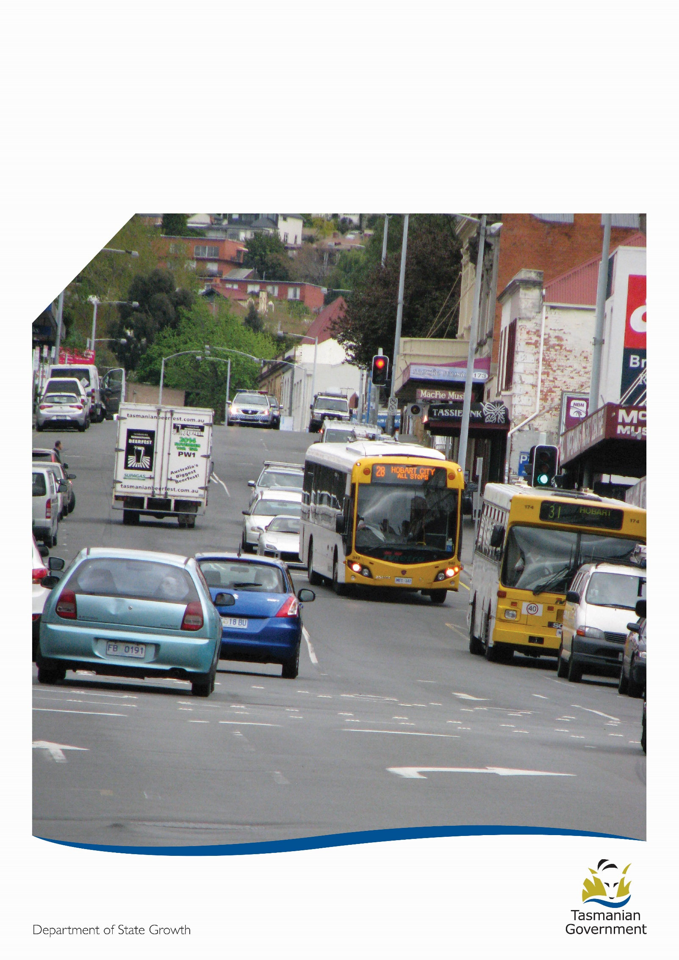
Decision Making
Guidelines
DETERMINATION OF WHO IS A “FIT AND PROPER” PERSON TO HOLD AN ANCILLARY CERTIFICATE

Preamble

This document outlines the decision making process when determining whether a person is ‘fit and proper’ to hold a Public Passenger Vehicle (PPV) Ancillary Certificate.
A PPV Ancillary Certificate must be obtained by any person wishing to operate a PPV, such as a bus or taxi. Pursuant to the Vehicle and Traffic (Driver Licensing and Vehicle Registration) Regulations 2010, part of this process is for the applicant to provide evidence to the Registrar of Motor Vehicles (RMV) to show that they are a ‘fit and proper’* person to operate such a vehicle within the community.
The RMV is responsible for overseeing driver licensing and the regulation of drivers of motor vehicles. The community has an expectation that they will be safe when using public transport. To endeavour to meet this expectation, the RMV applies the ‘fit and proper’ person test to every driver wishing to operate a PPV.
When the RMV makes a decision regarding a PPV Ancillary Certificate, the applicant will be notified of the decision in writing as well as their rights to apply for an internal review of the decision. If the applicant is not satisfied with the result of the internal review, they may appeal to the Magistrates Court.

*Fit and Proper - The RMV has determined that any person who is not issued with Working with Vulnerable Persons Registration (WWVPR) or Working with Children Registration (WWCR), will not be able to satisfy the requirements of ‘fit and proper’ to be issued with a PPV Ancillary Certificate.
It should be noted that obtaining Working with Children Registration or Working with Vulnerable Persons Registration does not automatically imply that an applicant will be issued with a PPV Ancillary Certificate. The applicant must still satisfy all the ‘fit and proper’ requirements as described in this guideline

* It must be emphasised that this document is a Guideline only – the factors and behaviours which are to be taken into consideration are not exhaustive, but provide a general framework of how administrative decisions are made. These factors apply equally to all decisions made concerning a PPV Ancillary Certificate.

Factors to consider
It must be understood that the circumstances of each individual case will be different. To determine whether a person is indeed ‘fit and proper’, the questions in the below chart should be considered, however, each may be given a different level of importance depending on the opinion of the decision maker:

Evidence to consider

When determining whether a person is ‘fit and proper’, all evidence supplied which informs the individual circumstances of the case will be considered. This evidence will support the basis and reasoning behind the decision, and should be considered in its entirety.
Evidence relative to ‘fit and proper’ may include (but is not limited to) the following:
- The person’s Application Form for a PPV Ancillary Certificate
- A National Criminal History Check specifying any past convictions of the person in any Australian State or Territory.
- Any pending charges against the person (note that as a conviction has not been recorded these may have little influence)
- The person’s driving record specifying any past driving offences.
- Evidence from a medical professional addressing relevant medical fitness to drive considerations and/or mental health issues.
- Any character references supplied by the person in support of their case. These may include references from a past/current employer, medical practitioner, social worker, educator, colleague or friend.
- A Personal Statement from the person stating why it is unlikely they will reoffend and why it is not contrary to the public interest to have the PPV Ancillary Certificate issued/renewed. Details of any rehabilitation, behavioural change, responsibility taken for actions and reasons behind the behaviour which are outlined in the letter should be considered.
- Evidence of any awareness training, education or community/charity work which may be relative to the person’s rehabilitation.

NOTE: The RMV recognises that suspending, cancelling or refusing to issue a PPV Ancillary Certificate may potentially impact on a person’s livelihood and income earning ability. Although this consideration does not necessarily apply to whether a person is ‘fit and proper’ to operate a PPV, the RMV may consider this factor as part of the overall decision.

Options

When all of the evidence in light of the individual circumstances of the case has been considered, the RMV may make one of the following decisions:
- Cancel the PPV Ancillary Certificate
- Refuse to issue the PPV Ancillary Certificate
- Refuse to renew the PPV Ancillary Certificate
- Suspend the PPV Ancillary Certificate
- Impose a condition on the PPV Ancillary Certificate
- Unconditionally issue the PPV Ancillary Certificate
The RMV may decide on an appropriate period of time to apply to cancellations, suspensions and refusals based on the circumstances of the case. However, applying this period of time does not preclude the person from reapplying for a PPV Ancillary Certificate at any stage, as it is possible that the decision maker may change in the interim and make a different determination.
The RMV may also determine if a condition is to be applied to the PPV Ancillary Certificate, or if any event is to occur before the PPV Ancillary Certificate can be considered for reissue. In these cases, the RMV is to explore all possible options and avenues which are appropriate in the circumstances.
The RMV will fully explain how he arrived at his decision in a Statement of Reasons which will be provided to the person.

Decision Making Checklist
Before a decision is finalised, the below points should be carefully considered:

