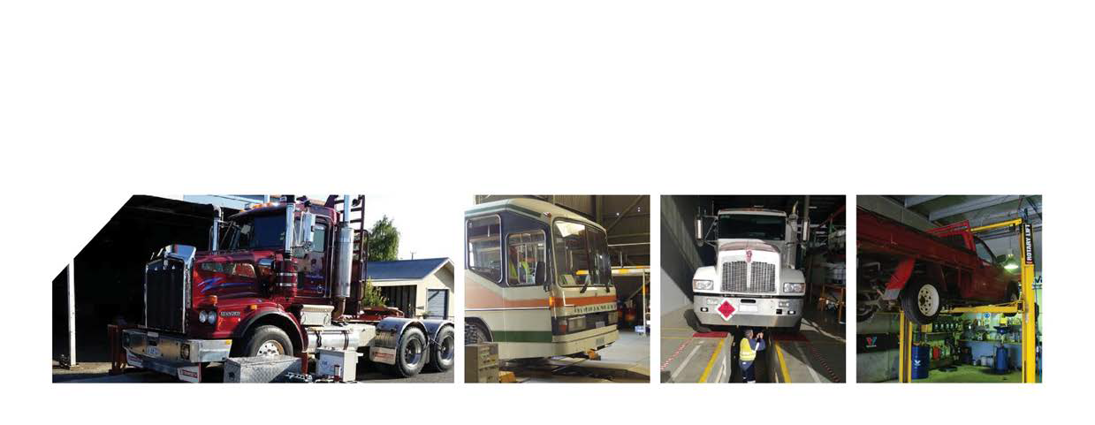Introduction;
Special Information Bulletin
03-2017
Takata SRS Airbag Recall
September 2017
AIS
This SIB has been developed to provide vehicle examiners, certifiers and proprietors with information regarding vehicles that are subject to a recall in relation to Takata airbags.
Background;
A number of recalls have been announced in Australia for motor vehicles containing Takata airbags. These recalls affect a large number of car makes and models and a small number of motorcycles and trucks.
There have been serious injuries and deaths from vehicles with faulty Takata airbags. The inflator components in Takata airbags may deteriorate and subsequently misdeploy in an incident, with the result of metal fragments from the inflator housing propelling out of the airbag, causing injury or death to the drivers/riders and/or passengers.
All makes and models that are currently affected by the Takata recalls can be found on the link below. A summary of the affected vehicles is also contained in the following pages of this bulletin. Consumers are strongly urged to check whether their vehicles are included in the recall by checking the list, or contacting the dealership or the vehicle manufacturer.
Actions;
If examiners become aware of an affected vehicle that is part of this recall, we request that they advise the owner to contact their local vehicle dealer if they have not already had the airbag assembly replaced. Failure to have the recall actioned is not a reason for rejection.
For up to date website recall information relating to this issue, refer to; https://www.productsafety.gov.au/news/takata-airbag-recalls-affecting-australian-consumers
Questions?
More information and frequently asked questions can be found at the following link; https://www.productsafety.gov.au/news/faqs-on-takata-airbag-recalls

Make & model | Year Range
BMW 5 Series E39, 3 Series E46, X5 E53 | 2002-2005
Chrysler 300C | 2005-2010
Dodge RAM | 2004-2010
Ferrari 458, California, FF | 2008-2011
Ford Mustang | 2006-2014
Honda Civic, CR-V, Jazz | 2001-2003
Honda Accord Euro, CR-V, Civic, Jazz | 2002-2011
Honda City, CR-V, Insight, Jazz | 2006-2014
Honda Accord Euro, City, CR-V, Jazz, Insight | 2007-2011
Honda Legend, Odyssey, Accord, MDX | 2001-2011
Honda Civic, Accord | 2001-2011
Jeep Wrangler JK | 2007-2012
Lexus SC430 | 2000-2003
Lexus IS 250, IS 350, IS 250C, IS-F, LFA | 2015-2012
Mazda 2, B Series, BT-50 | 2006-2011
Mazda 2, RX-8 | 2003-2014
Mazda 6, RX-8 | 2002-2014
Mazda 6, RX-8, B2500 ute/cab chassis, B2600 ute/cab chassis, BT-50 | 2002-2011
Mitsubishi GA & GB i-MiEV | 2010-2011
Mitsubishi Lancer | 2003-2008
Mitsubishi ML & MN Triton | 2007-2014
Mitsubishi Pajero NS, NT, NW, NX | 2006-2016
Nissan N16 Pulsar, Y61 Patrol, D22 Navara, T30 X-Trail | 2001-2004
Nissan N16 Pulsar, D22 Navara, Y61 Patrol, T30 X-Trail, J31 maxima | 2004-2008
Nissan D22 Navara, Y61 Patrol | 2008-2014
Nissan Tiida | 2006-2012
Peformax Silverado, Sierra, Mustang | 2007-2008
Subaru Impreza, Forester | 2004-2009
Subaru Tribeca, Liberty, Outback | 2004-2009
Toyota Corolla, Avensis Verso | 2000-2004
Toyota Echo, Rav 4 | 2002-2003
Toyota Corolla, Yaris, Avensis Verso | 2003-2011
Toyota Corolla, Yaris & Rukus | 2010-2012
Toyota Echo, Rav 4 | 2003-2005

MOTORCYCLES
American Honda Motor GL1800
Honda GL1800 Goldwing | 2012-2015
TRUCKS
Volvo UD Trucks Quon and Condor 2011-2016

