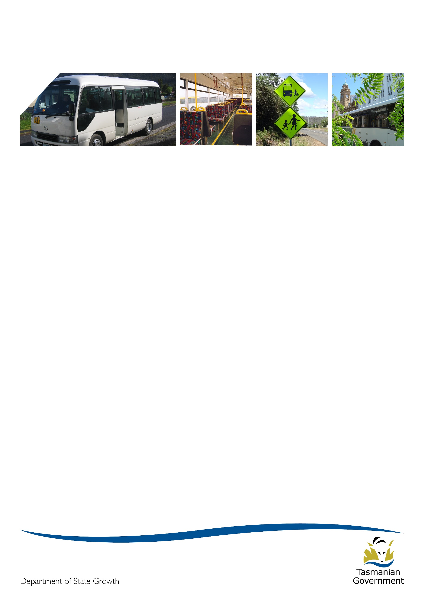
Transporter

May 2019

In gear
Term 2 and Autumn are both now underway, but there’s no sign of the colder weather yet - at least not in Hobart, maybe it’s colder where you are? We’ve been lucky with the weather but I’m sure some of us will be wanting rain soon.

Project 2018 update
School bus services
At the beginning of April, the Project 2018 team started sending out validation emails to operators. These emails contained all the contract specific information from which bus contract offers will be made (e.g. route, timetable, approved vehicle, and other elements of the school bus cost model). These emails also provided an estimate of the Annual Service Fee and Capital Payments that together make up the contract offer payment (as at 1 July 2018).
Operators are being sent these emails to check and confirm that all information is correct before contract offers are formally sent. Not every operator has been sent an email so if you haven’t received one, please don’t be concerned.
The Project 2018 team is asking that operators review the information and respond to these requests as soon as possible so they may expedite the contract offer process. However, they do realise that some operators may need time to review the information.
Also, with the volume of validation emails going out, please be aware that the Project 2018 team may not be able to respond to all enquiries coming in as quickly as operators may like.
The latest drafts of the contract documentation (the Formal Instrument of Agreement and Standard Contract conditions), as well as the School Bus Funding Model Calculator, have been published on the Transport website and can be found here: https://www.transport.tas.gov.au/project2018/new_contract_information
The validation email and the contract documents together will put you in a strong position to consider the formal contract offer that will be sent to you. You can also use the School Bus Funding Model Calculator to look at other cost estimate scenarios to see how they might affect your contract payment. You will need Microsoft Excel on your computer to do this.
Once you have received your formal contract offer, you will still be provided with two months to consider and decide whether to accept your contract offer.
General access services
The consultation process has commenced for the northern general access bus routes which service the towns and regions around Launceston and northern Tasmania. This includes a review of the outer-urban and regional routes surrounding Launceston which are operated by Manion’s Coaches, Lee’s Coaches, RD & FH Sainty, Tassielink Transit, and Calow’s Coaches.
The consultation documents and proposed changes can be viewed here: www.transport.tas.gov.au/haveyoursay
The proposed changes to routes, timetables and service frequency will make catching a bus faster, easier and more convenient for the majority of passengers, by ensuring there are buses where the majority of people need them.
Local Councils, community groups, the local tourism industry and business groups, welfare and service organisations, and bus service operators are all being directly consulted with on the proposed changes.
Consultation will also be occurring on the Launceston urban bus network, operated by Metro Tasmania.

Accreditation
The Transport Commission, the Department of State Growth and bus operators all want a safe passenger transport system so that passengers can have confidence in Tasmania’s public passenger transport. One element to ensure safety is that an operator has appropriate and effective safety, security and related systems that meet the Accreditation Standards.
The Accreditation Standards sets the minimum safety specification and requirements that an operator is required to meet. The Accreditation Standards reflect a systematic approach to managing risks by a set of actions that need to be undertaken by the operator to ensure on-going conformance, through:
- Identifying, assessing and controlling passenger transport safety risks (such as ensuring buses used for the Service are mechanically sound)
- Monitoring the system to maintain a safe operation (such as ensuring that drivers engaged by the operator understand how to report a vehicle defect that they detect as part of a pre-departure inspection or when driving it on road) and
- Continuing to improve the overall performance of the System.
Operators are required by law to ensure that their Systems conform with the Accreditation Standards. For the Systems to conform, each criterion of the applicable Accreditation Standard must be met. Operators are required to have implemented the appropriate systems and also to have embedded the proper use of the systems into the day to day management and operation of the service.
The Commission must assess whether the Systems conform to the Accreditation Standards. As part of forming this assessment the Commission uses the information gathered in an audit and detailed in the audit report to make a determination about the appropriateness and effectiveness of the Systems. The purpose of the audit is to:
- Verify objective evidence relating to the Systems
- Assess how successfully the Systems have been implemented and
- Evaluate the effectiveness of the Systems in meeting the Accreditation Standards.
The role of the auditor is an important one. The Transport Commission relies on the information submitted by an auditor in the audit report to determine the System’s level of conformance to the Accreditation Standards.
The list of approved auditors is available at https://www.transport.tas.gov.au/passenger/operator and passenger information/operators.
Operators should make an appointment for an audit to be conducted with enough time to ensure the audit report will be supplied to the Commission before the due date. Failure to supply an audit report leads to a contravention of a condition of accreditation which is an offence under the Passenger Transport Services Act.

5+5 year contracts - the ABN, contract, and accreditation holder details must match
It will be a requirement of the new contracts that the party name on your contract exactly matches the name on your accreditation and Australian Business Number (ABN) registration details.
Ahead of new contracts being sent out, please check the names you have used on your accreditation and ABN registration. If these names do not match or it is not the name you intend to use on your new contract, you will need to update these details to match the name that you do intend to use on your contract.
State Growth is required to make sure it enters into contracts with legal entities. We will do this by checking that your ABN and contract names match. You can check your ABN details here: https://abr.business.gov.au/
Second to this, it is a requirement that the contract holder also holds the appropriate accreditation. We will do this by providing details of the contracting party to the Transport Commission and requesting information about the accreditation held by that party.
Example:
An operator tells State Growth that its ABN is 86 002 933 642 and that it wants to enter into the contract as XYZ Coaches. State Growth will check the ABN details to confirm that XYZ Coaches is the holder of that ABN.
In this example, State Growth discovers that XYZ Coaches is the trading name and that the legal entity is XYZ Buses Pty Ltd. State Growth would not be able to accept XYZ Coaches as the contract holder but can accept XYZ Buses Pty Ltd.
State Growth would then check with the Transport Commission that XYZ Buses Pty Ltd holds the appropriate accreditation to operate a regular passenger service in Tasmania and if appropriate, would enter into the contract with XYZ Buses Pty Ltd.
If the operator wants to hold the contract in a name for which it doesn’t have an ABN or accreditation, the operator needs to make the necessary arrangements now. These arrangements take some time so you need to start this process now if you haven’t already done so.

Your contract numbers – old numbers and new numbers
Your old contract numbers are still your current contract numbers. For most contracts, these are numbers which fall between 1300 and 1900.
Most contract numbers starting with a 2 (i.e. in the 2000’s) are not yet active. These are the numbers that will be assigned to your 5+5 year contracts and because of this, Project 2018 are working with you using these numbers to design your new services.
Occasionally operators will refer to their new contract numbers when requesting changes or making enquiries about their current contracts. When you are emailing or calling the Passenger Transport Contracts team about a current contract (i.e. a service you currently provide), please refer to your existing contract number as listed on your Short Term Contract.

Your new contracts - emergency response plans
The new 5+5 year contracts require you to have an emergency response plan to deal with a variety of emergency situations. Information recently published by the Bus Industry Confederation may be of assistance to you in developing aspects of this plan relating to fire management.
Many of you may already have received a copy of the bus and coach industry’s Fire Evacuation Protocol Advisory, developed as part of a project led by the Bus Industry Confederation.
The number of bus fire incidents in Tasmania has historically been relatively low, particularly when compared to other Australian states. Notwithstanding this, the Advisory provides useful information and training packages to assist you in improving bus safety for drivers, passengers, pedestrians and other road users, and reducing the risks associated with bus fires.
A dedicated web page has been built to house a range of training templates, guidelines and video materials to assist you with the implication of fire evaluation protocols. The web page is available at www.ozebus.com/bus-fire-evac

Payment enquiries
Your monthly Recipient Created Tax Invoice (RCTI) are now sent to you from the Department’s Finance branch. Please do not reply to this email as the Finance team member who sends through your RCTI may be unable to answer your Contract payment-related queries. For the fastest response, please continue to direct all payment related queries to the Passenger Transport Contracts team via email ptscontracts@stategrowth.tas.gov.au or phone (03) 6166 3343.

Bus cost model index (BCMI)
The BCMI has been calculated for April 2019 and is 127.5.

Capital rates
The Capital Payment rates have been calculated for the quarter commencing April 2019. There have been no changes from the previous quarter. Please consider these rates before requesting bus changes on your contract. For all fare-paying operators, the rates applicable to your monthly contract payment can be found on your Statement of Payment.
Contract Type | October 2018 | January 2019 | April 2019
Urban Fringe Student Only | $1.01 | $1.18 | $1.18
Rural Fare Paying | $1.01 | $1.18 | $1.18
Long Distance Student Only | $1.01 | $1.18 | $1.18
Long Distance General Access | $2.91 | $3.03 | $3.03
Urban Fringe General Access | $2.91 | $3.03 | $3.03
Urban | $0.86 | $0.92 | $0.92
Town | $0.86 | $0.92 | $0.92

Contacting Passenger Transport
For all enquiries or notifications relating to your current contracts (i.e. a service you currently provide) contact Passenger Transport via email ptscontracts@stategrowth.tas.gov.au or phone 03 6166 3343.

