May 2013

Version 2.1

Department of Infrastructure, Energy and Resources

Department of Infrastructure, Energy and Resources

Contents

3

3

3

3

3

5

5

7

10

- 17

- Examples of Service Symbols and Tourist Shields 20

- Signage Dimensions and Signage Clearances 21

# Introduction

As part of the implementation of the *Walking and Cycling for Active Transport Strategy 2010,* this document aims to provide a resource for cycle infrastructure owners to utilise when developing and implementing directional signage for cycle routes.

# Scope

The focus of this Manual is to provide guidance in relation to directional signage principles, and to provide a suite of directional signage. A set of service symbols and tourist shields is also provided.

# Definitions

**Cycle Network:** Connected network of paths, cycleways, cycle lanes and streets that together provide a route for cyclists to move between destinations.

**Cycleway and Cyclepath:** For the purpose of this Manual a cycleway and cyclepath is defined as a purpose built and maintained facility for cyclists that is completely separate from a roadway.   Cycleways and cyclepaths may be shared by both cyclists and pedestrians.  Examples include:

* Intercity Cycleway in Hobart
* Turners Beach Off Road Path
* University Trail in Launceston

**On-Road Cycle Lane:** For the purpose of this Manual this refers to a space on the road marked for use by cyclists. Existing examples include:

* Cycle lanes in Argyle, Campbell and Molle Streets in Hobart
* Cycle lanes in Elphin Road, Charles Street, and George Town Road in Launceston
* Cycle lanes in Cooee

**Quiet streets that form part of cycle networks:** As cycle networks develop, it is likely that some ‘quiet streets’, generally those exhibiting low traffic volumes and speeds, can be signed as part of the cycle network.

# Purpose of Directional Signage

The purpose of cycle network directional signage is to help cyclists to find and use cycle routes, which may be made up of a combination of dedicated cycleways, together with shared pathways and roads.

Cycle network directional signage is an important element in encouraging people to use cycle facilities, and in providing cohesion and connectivity across cycle networks.

# Signing Principles

Signs are compact pieces of information placed in a road or cycleway environment which have to transmit their messages very quickly to the people who are using the transport facility. They are most effective due to the briefness of their messages.

Human beings are limited by their physiology. The way the brain operates, human beings cannot process large amounts of new information quickly. There is growing evidence that too many signs competing for a person’s attention can either distract them from the act of riding or driving or cause them to miss vital messages entirely.

Signs primarily communicate through graphics and symbolism. Though much of the content of road signs contain words, the letters which make up these words are in themselves complex graphical symbols. Unless the content of the lettering is immediately recognised and understood, it takes more time for the human brain to process a combination of letters than to recognise and react to shapes of whole words as the human eye usually sees words as graphical shapes, rather than combinations of separate letters. The most effective way signs communicate information is through their shape and colour.

Every signage location or intersection is subtly different with its own set of problems to resolve. It is essential when implementing any signing project to have a clear understanding of the key principles of good signage as most retro-fitting work will involve a wide range of challenges and unique signing situations.

A driver travelling at 50km/h sees in excess of 1200 pieces of information every minute. A slower travelling cyclist can take in more but, as discussed above, humans are limited by their capacity to filter and process new information. If a sign cannot be easily read, its message will go unheeded. The clarity and brevity of sign messages are essential components of legibility. Signage guidelines are formulated to ensure good legibility. Consequently, important factors such as typeface (font), size, sign and lettering colours and sign layout are specified to ensure a consistently high legibility of signage. Good signage brings cohesion to a cycle network. Even if the provision of facilities is in its early development phase, a well signed network of routes can provide people with the ability to more easily find their way around their city or town by bike.

Consistent signage helps to build user-confidence in the cycle network and cycling as a practical mode of transport.

# Photo 1: Intersection, Ghent, Belgium

# Communication without Clutter

In all aspects of sign layout, design, placement, mounting and maintenance it is important to consider human factors. The tendency to ‘solve’ a traffic management or road safety problem by placing a new sign in the road / street environment can often be counterproductive.

The human brain operates in two ways – conscious information processing and automatic information processing.

Conscious processing is: flexible, slow, easy to change, suited to new situations, requires energy, attention and conscious thought, and is error prone.

Automatic information processing is: rigid, fast, needs less attention, unsuited for new situations, dominated by expectations, hard to change, not consciously thought about, and is less error prone.

In learning to ride or drive we consciously learn many skills that with time become automatic. We don’t need to consider the Stop sign in the distance. We automatically respond to it and begin to slow down on approach and look for other vehicles or pedestrians in or near the intersection.

Sign clutter, poor placement, insufficient colour contrast (particularly in low light situations) and complicated or wordy messages are all factors which can decrease the effectiveness of signage. Badly designed signage can add complexity to the road environment and can increase the possibility of operating errors by drivers and riders.

# Signing Cycle Networks

A cycle network is a system of interconnected bicycle routes which enable people to satisfy their travel needs within their city or town and the surrounding region by bicycle.

Unlike the urban road network, which is predominately defined by its infrastructure (the main roads, regional roads and local roads which have been developed over time and interconnect our communities), a cycle network may use a combination of dedicated cycleways, pathways shared with pedestrians, and roads that are shared with cars.

It is the special system of signage, markings and engineering improvements applied to our urban paths, streets and roads which make cycle routes and enable them to function collectively as part of a transport network.

# Key Design Considerations

Consistent, accurate and unambiguous cycle network signage uses a methodology based on the established practice of highway network signage which embodies the following key signage objectives:

## 1. Ensure consistency of signage layout and quality across the network.

A consistent standard, location and quality of signage across cycle networks will assist people to identify cycle routes, minimise the risk of confusion and build community confidence in the system.

## 2. Identify primary and secondary destinations, and key decision points.

Primary and secondary destinations are the only places which are to be named on signage for a particular cycle route. Primary destinations include city centres and other high profile attractors. Secondary destinations may include major activity centres, starts of or intersections with other cycle routes, and major services.

As part of the process of planning cycle route signage, a Focal Point Signage Map should be prepared that identifies the *primary destinations,* *secondary destinations* and *decision points* that will be signed.

The Focal Point Signage Map provides the framework for directional signage on the cycle route and is an important tool in its ongoing development.

## 3. Maintain rigid consistency in naming locations.

Absolute consistency in naming locations must be maintained throughout the system. Once a destination has been signed it must appear on all subsequent destination signs until that destination has been reached.

## 4. In the event of alternate routes, sign the most direct route.

If more than one route to a destination is possible from a departure point, the most direct route should normally be the only one indicated on the signs. This may be varied if the alternative provides major advantages over the shorter route.

## 5. Signage should list all primary destinations on the route.

Primary destinations should appear on all signage on the relevant route. Primary destinations should be listed in order with the closest destination at the top. Once the destination is reached, it no longer appears on the signage. Once secondary destinations are listed on signage, they should appear on all signs until the destination is reached.

## 6. Major centres such as Hobart, Launceston, Burnie or Devonport are primary destinations and should always be identified.

Major centres should be signed right into the CBD.

7. Up to four primary and secondary destinations may be listed on each sign.

In addition to primary destinations, secondary destinations may be shown, but no more than 4 destinations should normally be included on any one sign.

8. Nearest destinations must be listed first.

The nearest destination in a given direction should be listed first, and the most distant destination should be listed last. In the case of Advance Direction Signs, ‘straight ahead’ destinations are listed at the top of the board in order of proximity, and side destinations are listed at the bottom (in order of proximity) with an arrow indicating the direction of the turn required.

9. Indicate distances in kilometres.Distances to destinations provide essential wayfinding and orientation information and should be indicated on all Fingerboards, Advance Direction Signs and Reassurance Signs. Where indicated distances are less than 10km, 100m increments should also be shown (e.g. 9.4, 4.2 etc). For greater legibility the numerals indicating 100m increments should be 75% of the height of the whole kilometre numerals.

10. Use map boards at key entry points.Map Display Boards provide additional navigational assistance to bicycle riders and can often indicate multiple route options and way finding possibilities.

# Directional Guidance Signs

The main purpose of this type of signage is to provide directional guidance to people using cycle networks. Directional signing reinforces system connectivity and coherence and gives high visibility and recognition to the routes which make up any network.

In the general traffic environment there are many directional signs provided for road users. This main road and highway signage is usually attuned to motorised traffic and may not adequately serve the needs of cyclists when a separate or parallel cycle network is in existence.

Adding cycle route information to existing road signage can create ambiguity and conflict for motorists and cyclists alike, so in line with best practice in Australia and overseas, a completely independent system of signing should be used to mark cycle routes. Where it will not create confusion or other issues, no other options are available and the asset owner gives approval, cycle route and motorist direction signs may be mounted on the same posts.

There are four categories of directional signage recommended for use on cycle networks:

* **Map Display Boards**
* **Advance Direction Signs**
* **Fingerboards**
* **Reassurance Signs**

It is recommended that cycle route directional signage should, where possible, follow the format and individual sign details described in the following pages of this Manual.

## Map Display Boards

Map Display Boards are useful aids to navigation, especially when located at key entry and exit points along cycle routes. Map Display Boards are of value in that they locate cycle routes within the context of their surroundings and provide information about trip distance, and relative distances between sub-destinations on the route. Map Display Boards are also useful for showing route alternatives.

Map Display Boards should be easily visible and accessible from the bicycle route. They should be placed in an area that is safe to allow users to examine the map and information.

Map Display Boards should be located so as to assist orientation, with the direction of travel facing up the map board for users.

Alternatively, a north point located on the ground nearby and/or on the map board may assist the viewer to orient the map.

When mounting Map Display Boards and other information boards, such as tourist information, care should also be taken to provide sufficient space and clearance from the path to ensure adequate space to inspect the map without interfering with the passage of other path users.

Map Display Boards should be mounted flush with their support posts and finished so that they do not present sharp edges to users or protrude into the operational space of the adjacent cycle route or pathway.

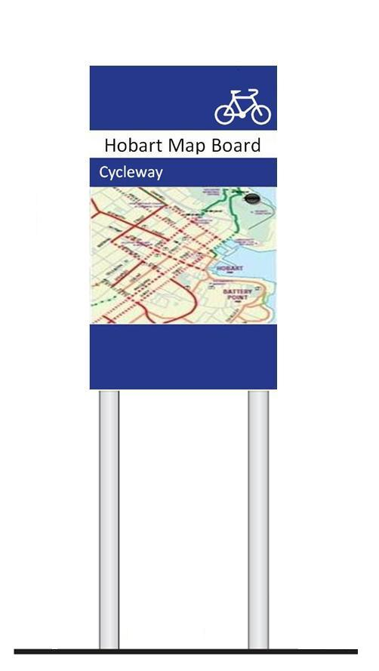

**Map** **Display Board**

**Advance Direction Signs**

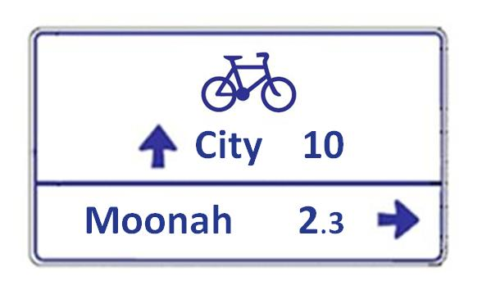

**Intersection Fingerboards**

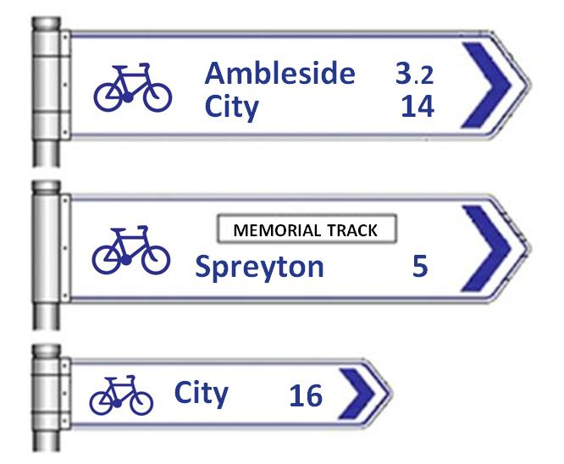

**Reassurance Signs**

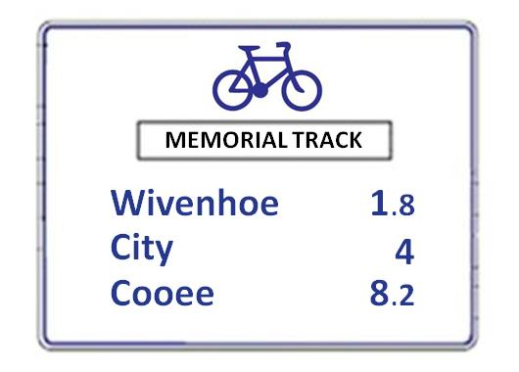

## Advance Direction Signs

These are cycling specific signs placed before *key* intersections/decision points to give advance warning of an upcoming intersection/decision point and to indicate the destination choices available. For cycle routes, no more than a total of 4 destinations should be cited on Advance Direction Signs.

## Fingerboards

Fingerboards are the primary means of indicating route direction at cycle route decision points or intersections. Fingerboards should be used at all significant intersections/decision points on the route. They should always indicate the direction to the primary destination on the route. They may also indicate a ‘turn off’ required to reach a secondary destination, or they may indicate a ‘turn off’ required to reach another cycle route.

Destinations shown on Fingerboards should be identical to those destinations used on Advance Direction Signs displayed on approach to the intersection. It is preferable to provide distance indication on Fingerboards even if Reassurance Signs are used beyond each leg of the intersection.

## Reassurance Signs

Reassurance Signs may be used in conjunction with Fingerboards to reassure cyclists that they are travelling towards their intended destination and to indicate the distances to those destinations. They are usually positioned after intersections or key decision points.

**Bicycle Route Indication Sign**

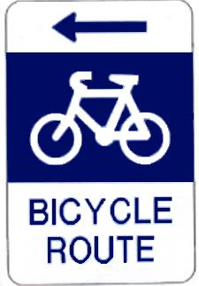

**Bicycle Parking Indication Signs**

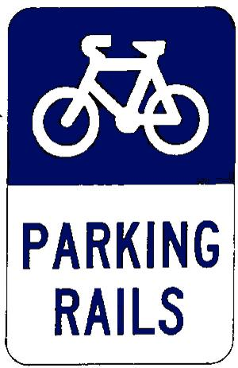

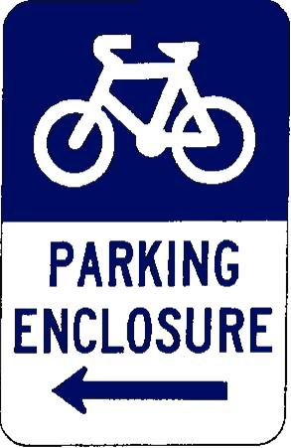

## Bicycle Route Indication Sign

This sign may be used, usually in an on-road context, to direct cyclists to the safest or most convenient route.

Currently this sign is used on the approaches to the Tasman Bridge in Hobart to assist cyclists to access the Bridge in the safest and most convenient manner. The sign is also used at Granton to direct cyclists away from the Brooker Highway and onto Main Rd which is a quieter route.

This sign should be used in conjunction with other directional signage that indicates destinations and distances to those destinations. Alternatively a primary destination and the distance to that destination may be marked on the sign.

**Bicycle Parking Indication Signs**

These signs may be used to direct cyclists to parking facilities.

## Service Information Symbols and Tourism Shields

Service symbols and tourism shields provide direction to facilities and services that may be sought by those using the cycle network. They are most usually applied as icons on Fingerboards.

Not more than 4 symbols or shields should be displayed on a sign. Only high priority services should be signed. Care should be taken to only sign to services that are reliable.

See Appendix 2 for details of the symbols and shields used in Tasmania. Appendix 3 show some examples of how to apply them to signage.

# Cycle Route Signing Process

Cycle route signing is a four stage process:

**1. Develop a Cycle Network Focal Point Map which identifies all primary and secondary destinations and key decision points for the network.**

**2. Assess the current physical condition of the route via a pre-signage and risk assessment survey. Arrange to rectify any significant issues with the physical condition of the route before installing signage.**

**3. Prepare a signing schedule specifying all signs, their locations and mounting.**

**4. Install the signs and inspect after installation to correct any errors and omissions. Review periodically to replace damaged or missing signs.**

A cycle network is usually signed route by route. However, before commencing any directional signing project, it is essential to determine the location and context of the route within the bicycle network so that interconnecting routes and the destinations they serve can be identified.

# Focal Point Mapping

A Cycle Network Focal Point Map is a planning document, used and maintained by the cycle network’s owner(s) to establish the destinations that will appear on directional signage for the cycle route.

A key aim of a Cycle Network Focal Point Map is to achieve consistency in the use of named locations so that a coherent system of signage can be developed which will enable direct and unambiguous navigation around the cycle network. Only those locations/destinations appearing on the focal point map will appear on the signage.

Developing the Cycle Network Focal Point Map is possibly the most important phase of the signage process, as the quality of the signage depends on the thoroughness of this process.

Table 1 shows the terminology used in focal point cycle route mapping. The following guidelines apply to focal point mapping methodology for cycle routes:

* Primary destinations are the key or most significant destinations on the route and they are indicated on the focal point map by a circle symbol. Primary destinations are listed on all signs on the relevant route until the destination is reached.
* Secondary destinations are important local centres along a route and they are marked on the map with a triangle. Once they appear on signage, they should appear on all signs until the destination is reached.
* On Focal Point Maps, decision points are marked by a cross. Identifying decision points is vital because this is where the signage needs to be located.
* To keep signage uncluttered and compact no more than 4 destinations should be signed on any one Advance Direction or Reassurance sign.

**Table 1: Destinations for focal point cycle network mapping**

**Location type Symbol Definition**

**Primary Destination** Key destination/s on the cycle route

**Secondary Destination** An important intermediate location

**Key decision points** Intersections on the cycle network where journey-makers need to make a decision about the direction they need to take to reach their destination.

# Cycle Network Focal Point Mapping Example

A Cycle Network Focal Point Map for part of the Inter-city Cycleway may look like the following:

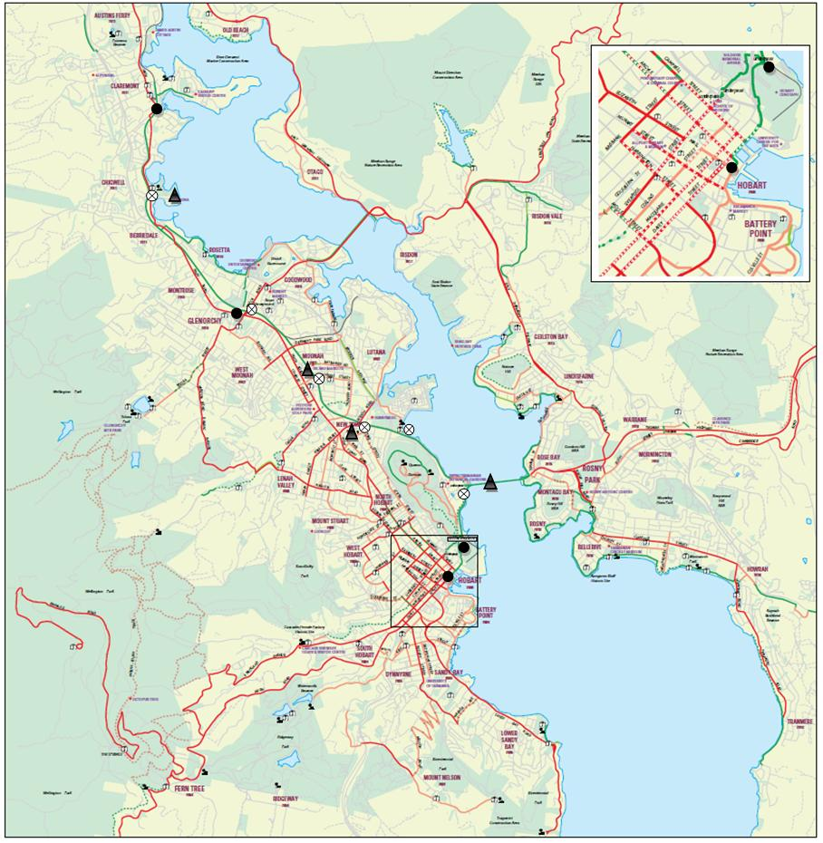

# Pre-Signing Assessment

Before signing a cycle route it is recommended that a risk assessment be undertaken so that any physical deficiencies can be corrected either prior to signing (if significant issues are identified), or as part of regular maintenance or planned route upgrading.

## Physical Assessment of the Cycle Route

A route assessment aims to identify any physical deficiencies which may present risks to cyclists. Issues to be considered include:

* The availability of operating space for cyclists. In an off-road situation this may include considering whether it is necessary to remove vegetation, posts, fences, inappropriate chicanes/bollards etc to ensure that the path width is sufficient and ensure appropriate sight lines around bends and corners.
* In an on-road situation this may include considering whether the cycling facilities provided are suitable in light of vehicle speed and traffic volume, including considering the suitability of intersection treatments.
* Pavement condition, including provision of bicycle-safe drainage grates and ensuring that there are no service lid or surface irregularities in the roadway or pathway that will create a hazard for cyclists.
* Availability of safe, manageable crossing opportunities where off-road paths cross roads. Consider siting kerb ramps to maximise visibility and ensure that roadside signage does not block cyclists view of cars or vice versa.
* Strategies for managing pedestrian and cyclist interaction at crossing points and other sites where conflict might arise.
* Potential squeeze points where traffic islands or kerb extensions may restrict cycle operating space.

## Signing routes with and without cycle infrastructure

## Bicycles are legally defined as vehicles and can use public roads unless specifically prohibited for operational safety reasons. The lack of bicycle infrastructure along a route, such as cycle lane markings, regulatory and warning signage and bicycle pavement symbols, does not necessarily mean that the route is unsuitable for cycling.

Fitting a route with a system of directional signage provides all cyclists with important wayfinding information which helps to more effectively use bicycles for a wide range of local and regional trips. Without this signage it is difficult to take full advantage of the road system and to use bicycles as an efficient means of transport.

A pre-signing assessment of a route with or without cycle infrastructure should aim to identify any specific road hazards which would cause unacceptable operating risks for cyclists using these streets and roads. These may be road narrowings where cyclists are ‘squeezed’ into risky situations, hazardous drainage grates and difficult turns on busy multi-lane roads.

Guidance is provided for optimal cycling operating conditions on streets and roads in the Austroads Guide to Road Design. The design of cycle paths is covered in Guide to Road Design - Part 6A Pedestrian and Cyclist Paths (Austroads 2009). Cycling Aspects of Austroads Guides (March 2011) is also useful.

The aim of the route assessment is to document road, street and path conditions and from that formulate a program of remedial actions with a defined time frame. High risk items will require immediate attention. Remedial actions may range from short-term signing and marking of hazards to longer term engineering works to physically remove the hazard.

# Cycle Route Signing Schedule

Once the decision has been taken to sign a cycle route, and a risk assessment has been completed, the next step is to prepare the signing schedules which will provide detailed information for the sign maker and installation crew.

## Route Signing Summary

The first stage in the formulation of a signing schedule is to prepare a signing summary for the cycle route. The signing summary is a preliminary list of signs based on the Cycle Network Focal Point Map and level of signing required for the signed route and any interconnecting routes. The signing summary provides the necessary documentation to take into the field to assist the collection of additional information needed to complete the signing schedule.

See Appendix 1 for an example of a (simplified) Focal Point Map.

The signing summary lists the primary destinations, secondary destinations and decision points (taken from Cycle Network Focal Point Map), and sets out a preliminary list of directional signs needed along the route, and their general siting.

It is important when signing each intersection along a route to include other routes which may cross or overlap the route being signed. This will make the future task of signing these other routes easier and avoid the costly need to redo signage to add additional destinations.

When determining the primary destination and secondary destinations to be listed on directional signage, it is important to note that a directional signage system should be closed. Once a destination has been used on a sign, it should appear on all subsequent signs, until that particular destination has been reached.

Destinations mentioned on previous signs are therefore given priority and should appear in strict order with the closest appearing at the top of any sequence listing.

No more than a total of 4 destinations should appear on any one sign, therefore it is vital to identify all the primary destinations for a given route, and then to work out which secondary destinations are to be included on each sign.

Where signs list destinations requiring a ‘turn’, all the ‘straight ahead’ destinations are listed together (at the top of the sign); and the destinations in the other direction(s) are listed underneath (also in order of distance).

## Site Assessment/Operational Issues

As part of the preparation of the signing schedule, a site inspection should be carried out to assess the precise locations for route signage. An important part of this process is to physically assess the safety issues relating to sign placement with a view to the following considerations:

## Sign Location and Placement

The placement of cycle network directional signage should adhere to the general principles of signage as detailed in Australian Standard *AS1742.5 Street Name and Community Facility Name Signs* and AS1742.2 *Traffic Control Devices for General Use* . Specific considerations relating to the installation of directional signage for cyclists are detailed below.

## Sign Clearances

The signage clearance images below show vertical and horizontal clearances applying to cycle network signage (see Appendix 3 for measurements and details). It is important to assess clearances correctly, taking into account the actual site conditions. Pedestrian desire lines (the routes normally taken by pedestrians) should be taken into account. Sign placement at intersections should be clear of existing pedestrian paths.

**Sign Clearances**

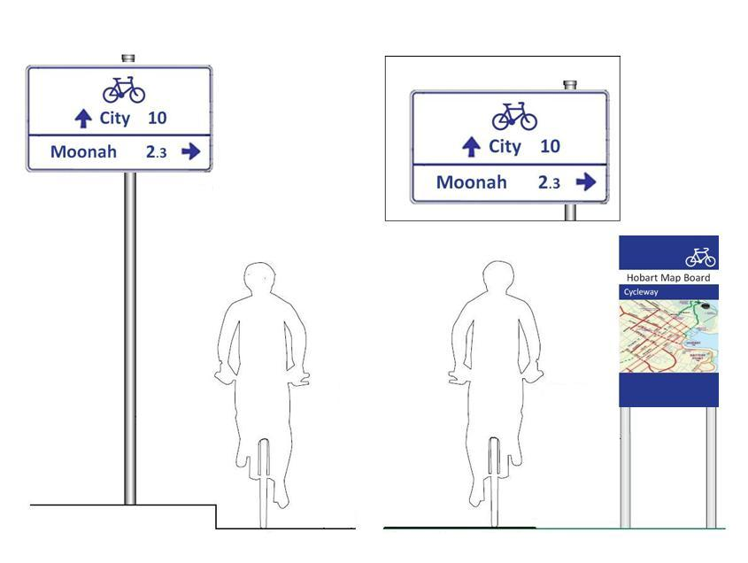

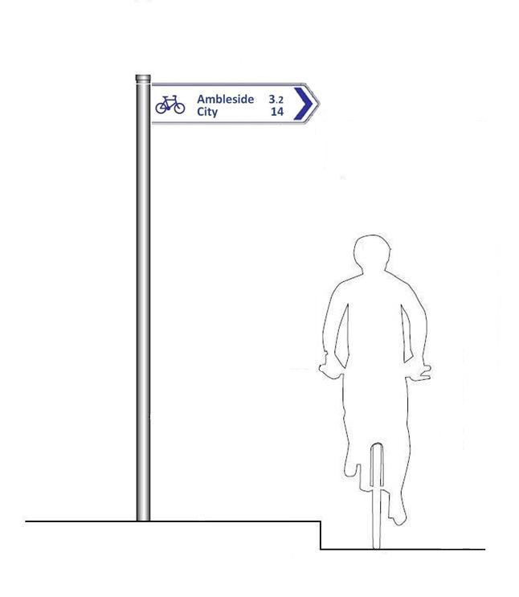

## Sight Distances and Sign Visibility

Signage should be positioned and sized so that cyclists can read the sign in time to make wayfinding decisions. Factors to consider include the speed at which cyclists are likely to be travelling and sight lines. For example, cyclists on the Intercity Cycleway in Hobart are moving at around 20km/h to 30km/h and require larger sized signs than those at sites where cyclists are likely to be going much slower.

Generally, it is recommended that Advance Directional Signage be positioned 35-50 metres from intersections. This distance is considered appropriate for a cyclist travelling at up to 30km/hr.

A greater distance should be applied where there is a downhill grade towards the intersection or where the approach visibility is restricted. Further advice on bicycle stopping distances and sight distances on curves can be found in Austroads *Guide to Road Design*.

Intersection fingerboard signage should be mounted in a highly visible location so that it can be clearly read by cyclists at a minimum of   
15 metres from the intersection. Signs should be placed consistently. If site conditions prevent two signs indicating separate directions from being mounted on the same pole on one corner of the intersection, consideration should be given to separately mounting these signs.

Consideration should also be given to mounting signage on existing sign poles (where an agreement exists between the road/street/path owning authority and the cycleway owner) provided that such mounting offers superior sight lines and visibility.

## Size of Signage

Size of signage should be determined with reference to factors such as the speed at which cyclists are likely to be travelling and sight distances. Consideration should also be given to factors such as the amount of space available for mounting the sign and the appearance of signs in the context of the surroundings.

While signage must be legible to be useful, aesthetic and practical considerations are also relevant.

Appendix 3 gives direction on the recommended signage dimensions and applicable clearances. Letters and numbers should be as per the criteria indicated in Appendix 3; however, where the size of the sign-boards are considered too small, the size may be scaled up proportionally by 25%.

Similarly, if the size of the sign-boards is considered too large, they may be scaled down proportionally by no more than 25%.

## Sign Legibility and Lighting

Direction signage should be easily readable in either day or night conditions, and must comply with the Australian Standards. Signs located in a normal urban environment will usually have adequate ambient lighting. In other areas it may be possible to locate signage under or adjacent to existing overhead lighting.

## Working in with Existing Road Signage

Cycle network signage, like highway signage, is a discrete system designed to guide cyclists through often complex road environments. Combining cycle network signage by including cycle destination information or routing details on normal road directional signage is to be avoided.

Cycle route directional signs should be located so as to not conflict with existing road directional signage, or create ambiguity at critical turning points or crossings. New signage should not add to existing clutter. Existing signage may need to be relocated at the time cycle network signage is installed to improve the overall scheme of signs.

Care should always be taken to place signs where they can be clearly seen by cyclists and in a location where their message will not be compromised or overwhelmed by proximity to other signage.

## Though the indication of street names does not form part of the cycle network signage system, it is vital for riders that they can see clearly legible street signs at every route turn or intersection to enable them to reach their destination as quickly as possible. Asset owners and their contractors will need to assess the fitting of new cycle network signage adjacent to street name signs and the repositioning or reinstallation of street names signs on a case by case basis.

Where placing a cycle route sign below a street name sign reduces clearance to less than 2.5m, alternative provision will have to be made. This may include re-installation of the existing street name sign on a longer pole. Additional information on the layout design and mounting of this type of signage can be obtained in *AS1742.5 Street Name and Community Facility Name Signs.*

## Working in with Existing Cycleway and Path Signage

When signing routes that adjoin cycle routes or paths with existing signage installed, cycle network signage should take into account the existing signage.

To strictly comply with legislative requirements, where it is proposed to remove the existing regulatory signage indicating a shared path (see picture of pedestrian and bicycle symbolic sign below) it will be necessary to apply shared pathway thermoplastic symbols on the path with appropriate directional arrows.

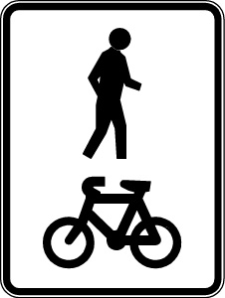

Where signage exists on adjoining cycle routes or paths the new cycle route signage should be installed only where the cycle route enters and exits the path or at any other path junction. Care should be taken to harmonise the use of standard cycle network signage with existing path signage systems through careful sign location and mounting.

## Preparing the Signing Schedule

Details needed for each sign to complete the signing schedule are:

* Details for each sign (destination, arrows, service symbols, tourism shields).
* Precise location of each sign (it is recommended that marked-up site photos be appended to the sign schedule to ensure an accurate communication of the intended siting of each sign).
* Mounting support (new pole, existing etc).
* Mounting fixing type.
* Additional path signs found necessary by the site assessment – services and facilities signs, signs indicating connecting paths to the street system and street name signs at intersecting streets.
* Additional work (installation where needed of new, longer street sign poles to replace existing poles).

Costs for signs and installation can be added to the schedule at this stage to produce a budgetary estimate.

# Installation and Maintenance

Responsibility for the design, manufacture, installation and maintenance of signs will generally rest with the infrastructure owner. Where cycle routes traverse infrastructure owned by more than one organisation, it will be necessary for the parties to reach formal agreement about responsibility for funding and arranging the initial installation, and managing the on-going maintenance task.

# Sign Manufacture

The signs described in this Manual and their usage should be manufactured in accordance with this Manual, the relevant sections of AS1742, as well the referenced documents in this Manual.

# Materials and Mounting

* Cycle Route Directional Signage is manufactured from 1.6mm thick aluminium alloy sheets.
* It must be free from scratches or other surface blemishes and the edges must be true and smooth.
* Sign sizing criteria are detailed in Appendix 3 of this Manual.
* Fingerboards should be fixed to galvanised steel pipe supports by means of galvanised steel or aluminium clamps.
* Fingerboard signs should be always attached to the mounting pole via the mounting clamp method.
* Anti-rotational fittings or fixing screws should be used on fingerboard clamps to prevent rotation by either wind or vandalism. This is particularly important on fingerboard signs which indicate travel direction at intersections.
* Advance Direction and Reassurance Signs are single sided, stiffened as required and usually mounted on two galvanised steel posts.
* In urban environments signs should be mounted sensitively to avoid sign clutter.
* Where intersections have existing signs in an untidy or cluttered state, it is wise to replan the layout and placement of all signage (including the new cycle route signs) so that the legibility and general appearance of the total signage installation is improved.
* Any redundant signage should be removed during new sign installation.

Back-to-back mounting is recommended when mounting Advance Direction and Reassurance Signs. This will be cost effective and reduce clutter on the cycle network.

For more information on materials and mounting, see the Department of Infrastructure, Energy and Resources (DIER) Tasmania,ROADWORKS SPECIFICATION R63 – SIGNS.

# Checking Installation

The accuracy of the signage installation and particularly the positioning of the signs and poles should be checked by the person who has prepared the signage schedule, following installation. Installation errors should be remedied promptly and prior to any public promotion of the route.

# Maintenance

On-going maintenance of cycle network infrastructure includes the maintenance of the sign system.

The maintenance of cycle route signage is generally the responsibility of the government agency, local government or private landowner which owns the infrastructure.

It is important that ongoing signage auditing and maintenance be carried out by the infrastructure owner, even where joint funding and partnership arrangements were developed for the initial sign implementation phase.

A system for public reporting of signage faults and damage due to vandalism, storm or crash damage is recommended as an additional aid to maintaining high quality cycle route information. This system can either be integrated into existing fault-reporting systems or set up as a new service on council or other government agency internet sites.

# Appendix 1

# Focal Point Mapping Example Using the Inter-City Cycleway



**Map legend**

Cycle Route **_________**

Primary Destination

Secondary Destination

Key decision point

**Example** **of Route Signing Summary Using Inter-City Cycleway**

Primary Destinations/Focal Points: Hobart (Cenotaph), Glenorchy, Claremont

Secondary Destinations: Tasman Bridge, New Town, Moonah, MONA

Decision Points: Tasman Bridge, Bay Road, Hopkins St, Wrights Avenue (Glenorchy), MONA

|  |  |  |
| --- | --- | --- |
| **Outward from City/Domain**  **Hobart** | | **Inward from Claremont**  **Hobart** |
| Castray Esplanade at Elizabeth St | **Map Board** |  |
| Cenotaph/Domain | **Map Board** | Fingerboard |
| Approach to Tasman Bridge | **Advance Direction Sign**  Tasman Bridge  New Town  Glenorchy  Claremont |  |
| Tasman Bridge | **Fingerboard**  Tasman Bridge  New Town  Glenorchy  Claremont | **Fingerboard**  Tasman Bridge  Hobart |
| Rowing shed | **Reassurance Sign**  New Town  Glenorchy  Claremont | **Advance Direction Sign**  Tasman Bridge  Hobart |
| Bay Road | **Fingerboard**  New Town  Moonah  Glenorchy  Claremont | **Fingerboard**  New Town  Tasman Bridge  Hobart |
| New Town - North of New Town High School | **Reassurance Sign**  Moonah  Glenorchy  Claremont | **Reassurance Sign**  New Town  Tasman Bridge  Hobart |
| Moonah - South of Hopkins St | **Advance Direction Sign**  Moonah  Glenorchy  Claremont |  |
| Hopkins St | **Fingerboard**  Moonah  Glenorchy  Claremont | **Fingerboard**  Moonah  New Town  Tasman Bridge  Hobart |
| Moonah - North of Hopkins St |  | **Advance Direction Sign**  Moonah  New Town  Tasman Bridge  Hobart |
| At KGV/Elwick Rd | **Advance Direction Sign**  Glenorchy  Claremont | **Reassurance Sign**  Moonah  Tasman Bridge  Hobart |

|  |  |  |
| --- | --- | --- |
| At safe exit (Wrights Ave or pedestrian crossing) | **Fingerboard**  Glenorchy  Claremont | **Fingerboard**  Glenorchy  Moonah  Tasman Bridge  Hobart |
| Between Grove Rd and Wrights Ave (Sawmill) | **Advance Direction Sign**  MONA  Claremont | **Advance Direction Sign**  Glenorchy  Moonah  Tasman Bridge  Hobart |
| Mona Exit | **Fingerboard**  MONA  Claremont |  |
| Cadbury’s | **Reassurance Sign**  Claremont | **Reassurance Sign**  Glenorchy  Hobart |
| Claremont |  | **Map Board** |

# Appendix 2

**Examples of Service Symbols and Tourist Shields**

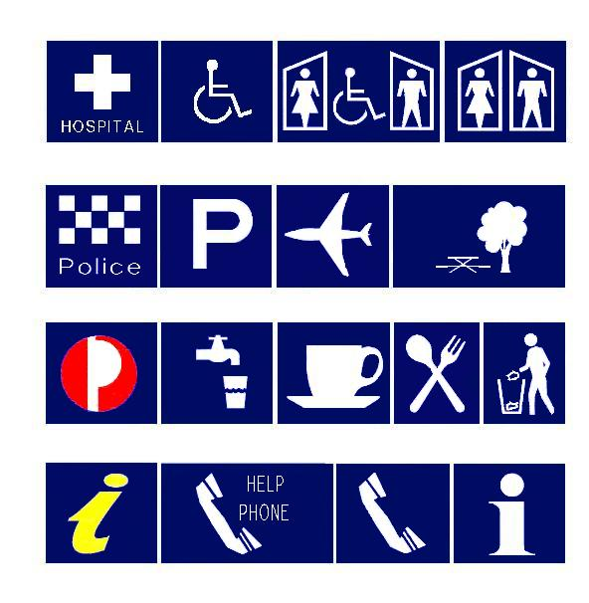

Public Toilet

Public Toilet with Facilities for Disabled Persons

Facilities for Disabled Persons

Hospital

Rest Area

Airport

Car Park

Police Station

Litter Bin

Restaurant

Refreshments

Drinking Water

Post Office

Information

Public Telephone

Help Phone

Tasmanian Visitor Information Centre











Historic Site

Wildlife Park

Scenic Feature

Historic Building

Historic Bridge

For a full range of service symbols and tourism shields available, please go to <http://www.transport.tas.gov.au/publications/tasmanian_roadside_signs_manual>

**Signage Dimensions**

Figure 1: Two destination Fingerboard

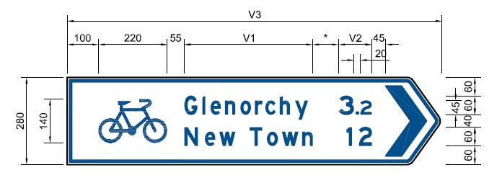

# Appendix 3

Figure 2: Three destination Fingerboard

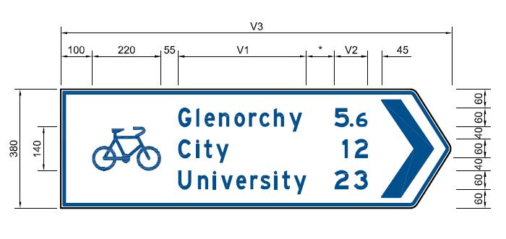

Figure 3: Reassurance Sign

Figure 4: Advance Direction Sign

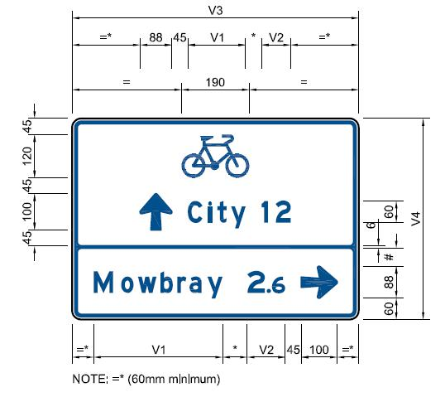

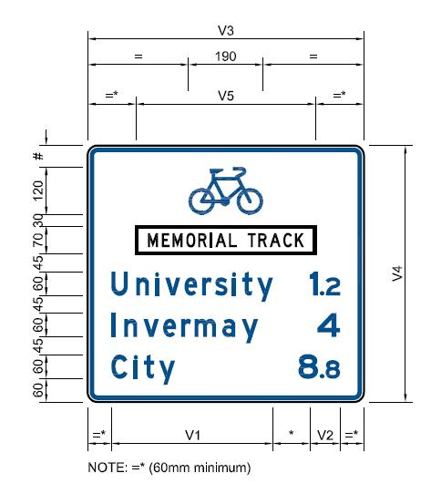

Figure 6: Arrow details

Figure 5: Single destination back-to-back Fingerboards

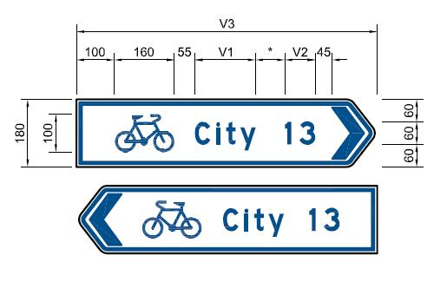

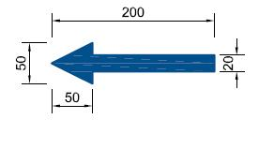

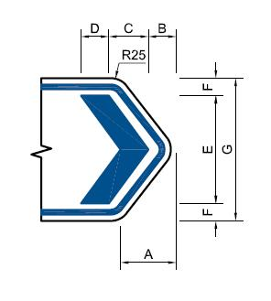



Figure 8: Bicycle Parking Indication Sign

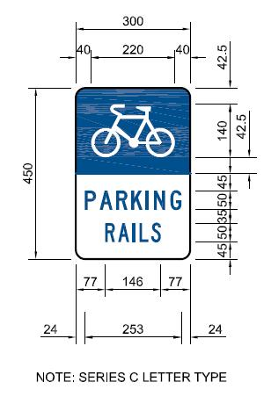

Figure 7: Name plate

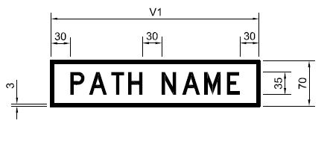

|  |  |  |  |  |  |  |  |
| --- | --- | --- | --- | --- | --- | --- | --- |
| DIMENSIONS | | | | | | | |
| DEPTH (G) | A | B | C | D | E | F | G |
| 180 | 70 | 35 | 50 | 35 | 136 | 22 | 180 |
| 280 | 100 | 50 | 80 | 50 | 224 | 28 | 280 |
| 380 | 120 | 60 | 105 | 60 | 310 | 35 | 380 |
| 480 | 150 | 75 | 130 | 75 | 390 | 45 | 480 |

**Notes of Variables**

1. Dimension * varies between 55mm and 100mm to allow for rounding off of overall sign length (V3) to a multiple of 50mm.
2. Dimension # varies between 45mm and 90mm to allow for rounding off of overall sign height (V4) to a multiple of 50mm.
3. Where a destination consists of two or more words, dimension “V1” is the total length of the words plus space(s).
4. Where a distance is less than 10km, dimension “V2” is the total length of the numeral, including the decimal point.
5. Dimensions “V1” and “V2” are selected by assessing the longest combination of a destination and distance on a single line.

Figure 9: Bicycle Route Indication Sign

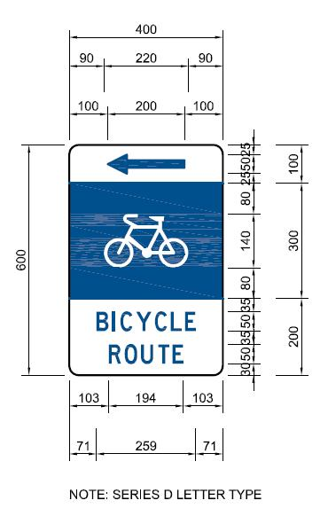

Figure 10: Map Display Board

**General Notes**

1. For full signage specifications refer to DIER Roads Specification R63 - Signs. This can be accessed from <http://www.transport.tas.gov.au/road/specifications> by clicking “I ACCEPT these conditions”, going to Roadworks Specifications and then to R63 - Signs.
2. Direction signs use Class 2 Blue reflective logos and arrows on Class 2 White retro-reflectorised background. Letter sizes are as shown.
3. Letter type for destinations/distances is AS1744 Series Modified E mixed capitals and lower case in the colour blue. Where the destination is comprised of two or more words, the space between words shall be 75% of the letter height.
4. Letter type for the name of the cycle route is AS1744 Series D Medium capital letters in the colour black. Where the destination is comprised of two or more words, the space between words is to be 30mm.
5. Where distances to the destination are less than 10km these are to be indicated to the nearest 100 metres. These are to be expressed in standard decimal form, with the decimal letter height 75% of the whole numeral letter height.
6. All letter spacing to be 50%.
7. On cycle route signage, distance numerals are located after the destination.
8. Direction arrows on Advance Direction Signs and Reassurance Signs are as per the short arrow in AS1743, scaled down to a height of 100mm.
9. The bicycle symbol to point in the direction of travel for fingerboard signs. The bicycle symbol to point right for both advance direction and reassurance signs.
10. Where the pedestrian symbol is used with the bike symbol, it should also point in the direction of travel.
11. For the Service Symbols and Tourist Shields used in Tasmania, see [http://www.transport.tas.gov.au/ publicationstasmanian_roadside_signs_manual](http://www.transport.tas.gov.au/%20publicationstasmanian_roadside_signs_manual). All symbols and shields used on cycle route signage should be consistent with the suite set out at the above URL.
12. Symbols and shields should only be used to indicate the location of key/important services or attractions.
13. Symbols and shields should be located as indicated on the diagrams shown.
14. Consideration should be given to ensuring that the size of the symbols/shields is large enough to be visible to cyclists travelling on the cycle route.
15. There should be no more than 4 symbols or shields used per sign. A large number of symbols or shields results in each symbol or shield being smaller, and creates visual confusion. Sign only key attractions.
16. Consideration should be given to lengthening fingerboards to accommodate symbols/shields where this is expedient.

(continues over)

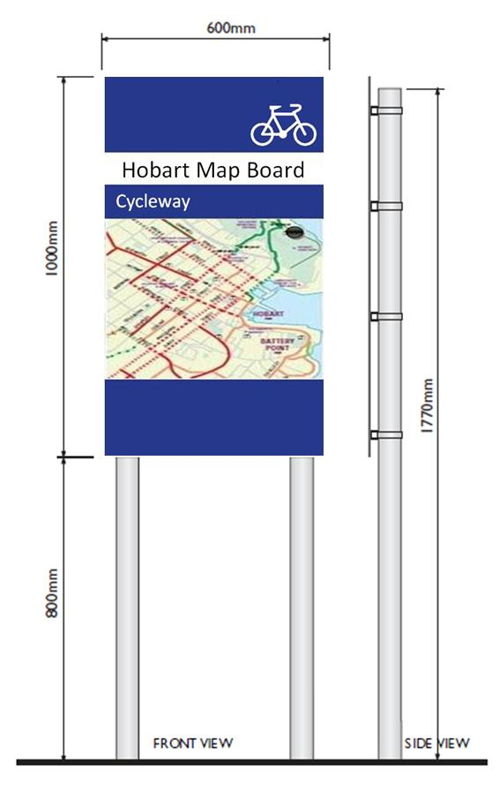

Figure 11: Example of Tourism Shields and Facilities Signs









# Signage Clearances

Figure 12: Standard intersection fingerboard sign pole layout

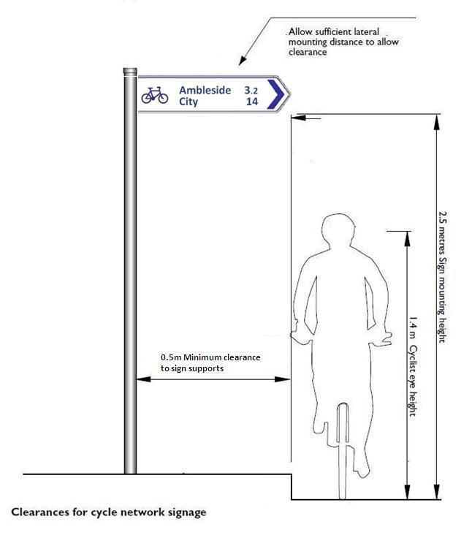

**General Notes** (from previous page)

1. See separate diagrams for individual sign layout, typical intersection sign layout and mounting methodology.
2. Fingerboards are mounted on poles using standard pipe clamps. Clamps should be pinned to prevent movement due to wind or vandalism.

Figure 13: Signs and map display boards - side and vertical clearances

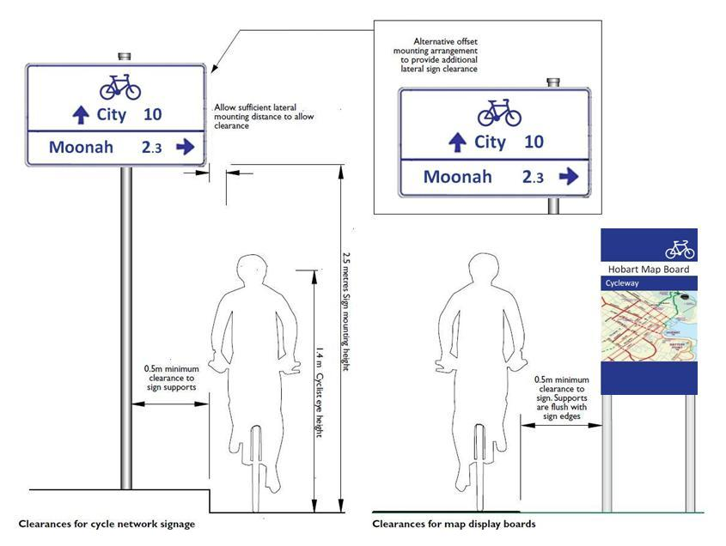

Figure 14: Bicycle symbol for use on all cycle network direction signage

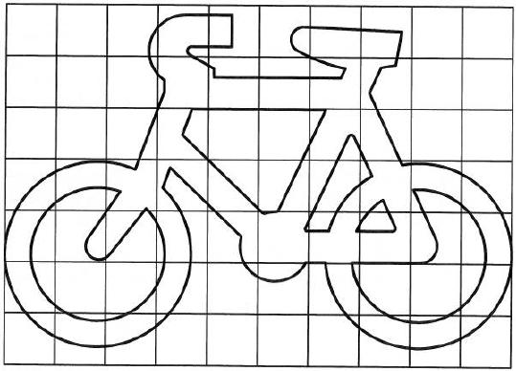

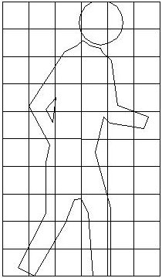

Figure 15: Pedestrian symbol for use on cycle network direction signage



Passenger Transport Division

Department of Infrastructure, Energy and Resources

GPO Box 936, Hobart 7001

Ph: 1300 135 513

Email: [dier@dier.tas.gov.au](mailto:janine.pearson@dier.tas.gov.au)

Visit: www.transport.tas.gov.au