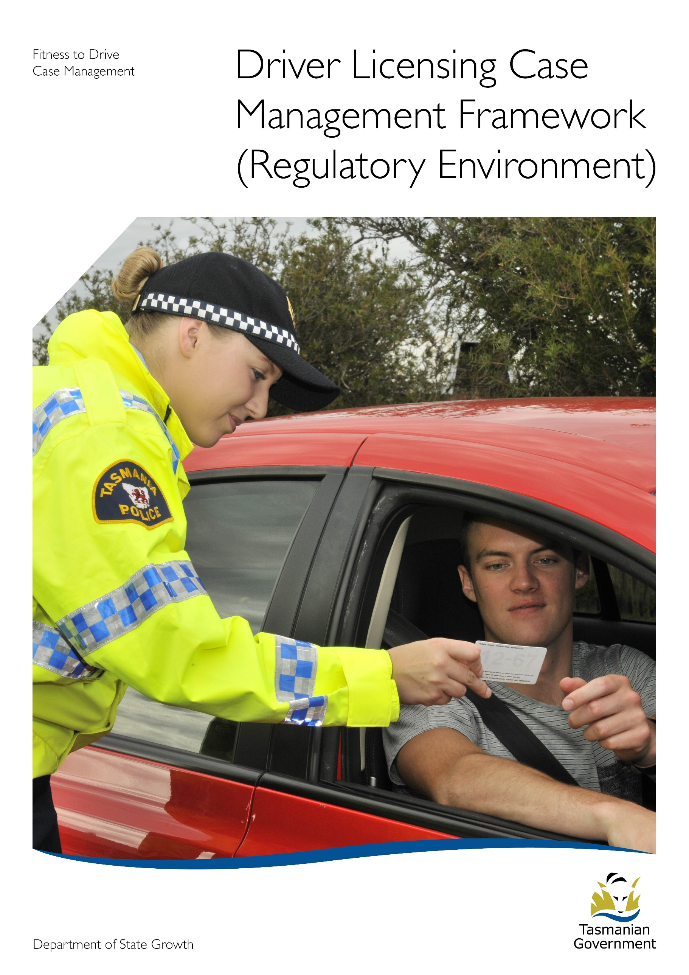
Driver Licensing Case Management Framework (Regulatory Environment)

Fitness to Drive Case Management including:

- Medical Fitness to Drive
- Returning Drivers
- Ancillary Certificates
- Mandatory Alcohol Interlock
- Fitness to driver (knowledge, skill and/or fit and proper person)

Intention of Case Management in Fitness to Drive:

Our intent is to assist the holders of Tasmanian driver licenses to be or remain complaint with the law around driving and driver licensing and in doing so support their safe and appropriate driving, which in turn will have a positive impact on overall road safety outcomes.

To do this we need to make it as easy as possible for drivers to conform and comply with their legal requirements around driving and licensing.
To achieve this a case management framework for fitness to drive has been introduced. This framework aims to support drivers to be compliant and where appropriate enable them to remain within the licensing system.

Purpose:

The purpose of case management in fitness to drive is to identify and monitor current and prospective Tasmanian Driver Licence Holders to ensure they meet the requirements to hold a driver licence.

Principles:

The following principles underpin the case management framework for fitness to drive therefore it is essential that all of our actions and decisions should be consistent with these principles.

- Our driver licensing system should support, where appropriate, people to stay within the system, ensuring they have mobility to access educational, social and employment opportunities and remain a connected member of the community.

- Safe driving is about more than just controlling the vehicle and includes, skills, experience, behaviour and attitude.

- Targeted licensing programs should be implemented which are aimed at meeting individual needs and which assist them remain compliant, reduce poor driving choices and behaviours and positively impact on driving recidivism rates.

- Provision of fair, equitable, transparent and consistent driver licensing decisions for all drivers and appropriate responses and consequences for those drivers who identify themselves as repeat offenders by their own driving behaviours.

Characteristics of Fitness to Drive Case Management:

The following characteristics support how we undertake case management and achieve the underpinning principles.

- Holistic management of the individual, taking into consideration all aspects of the client, including their past and current driving behaviours, physical needs, social and cultural requirements, to make the most appropriate decision in relation to their driving and licensing needs.

- Taking the time to understand all aspects of the client’s licensing needs, the legislative requirements surrounding the client’s needs and the evidence provided. Then utilising the information and evidence in a balanced and measured manner to achieve the best outcomes for the client and overall road safety.

- Decisions are made using all of the available evidence, are unbiased and based in fact.

- All decisions will be fair, equitable, consistent, and transparent and made in-line with the legislative requirements and the appropriate ‘Fitness to Drive Decision Making Guidelines’ (‘Fit and Proper’ – Ancillary Certificates, Returning Drivers, Medical Fitness to Drive).

- Our decisions should be easily understood by the client, including why the decision has been made, what the decision is and when and how the decision will impact them. Clients will be informed they have the right to question a decision and/or provide more evidence to allow a more informed decision to be made.

- Communicating effectively with clients, both in writing and verbally, ensuring that these communications are timely, professional and appropriately targeted to the client and their particular needs, even when the outcome of the decision is not one the client may want.

Fitness to Drive Case Management Framework:

The case management framework for fitness to drive aims to place the client at the centre of the response and to support them remain compliant with their legal requirements around driving and driver licensing.

The following model outlines the five key stages of service delivery in the case management model. The process of case management is dynamic and clients may move through or exit at different stages of the framework depending upon the client’s needs.

The sections following the model give an overview of each of the key stages and highlights the components of each of the models’ five stages.

Fitness to Drive Case Management Model

- Assessment of client need and information gathering

Key outcome of this stage is to understand the client as an individual and their particular driver licensing needs.

This will be achieved through the gathering of information about the client, including but not limited to:
- Current needs and past needs
- Past and current driver licensing history
- Clients driving history and behaviours

This information will be gathered using a range of sources, including but not limited to:

- CID File on RM
- Licensing history on MRS
- Conviction summary from MRS
- Talking to the client
- Requesting additional information from other stakeholders in relation to the client (e.g. medical practitioner/Tasmanian Police/Courts etc.)

- Analysis of current drive Licensing issue

The key outcome of this stage is to understand the particular driver licensing issue currently under consideration and to use the information gathered through stage 1, to make a reasoned and fair decision that is in-line with the legislative requirements.

This will be achieved by using the Fitness to Drive Decision Making Guidelines, these are:
- Medical Fitness to Drive
- Fit and Proper – Ancillary Certificate
- Returning Drivers
- Fitness to Drive (call-ins)

It is important to remember, that this stage can still be about gathering evidence, however the evidence gathered at this stage will be specific to and support the issue currently under consideration. It may be necessary to discuss and work with the client and/or relevant stakeholders (e.g. Occupational Therapists, Driving Assessors, Medical Practitioners, family members, Tasmania Police etc.) to achieve this.

- Action current driver licensing issue

The key outcome of this stage is to action the decision and inform the client of the outcome, using a clear, targeted and appropriate communication approach.

This may be achieved through a number of means, including but not limited to:
- Written communication (letter, statement of reasons or email)
- Telephone conversation (file note on CID file)
- In person (file note on CID file)

This stage may also be where the client raises additional information or provides additional evidence which would enable you to make a new administrative decision. This is also the stage where the client may wish to exercise their right of review.

*It is important to remember that for all administrative decisions, the client has a right of review. Therefore anytime you have new evidence and need to make a ‘choice’ about the decision, even if that choice is to continue with the current action, this is still an administrative decision, and as such the client has the right of review.

- Monitoring of client outcomes

The key outcome of this stage is to monitor the client outcomes resulting from the decision and to undertake any follow-up compliance checks or remedial action resulting from non-compliance with the licensing decision.

This may be achieved through monitoring data, including but not limited to:
- Conviction reports
- MAIP participant data
- Feedback from stakeholders (Medical Practitioners, Tasmania Police)
- Information from the client (show cause letter)

This stage is key to the case management approach and will most likely require conversations and discussion with the client to understand what has contributed to the non-compliance and what will be the most effective method of assisting the client to return to compliance.

- Evaluation or transition to mainstream licensing

The key outcome of this stage is to evaluate the client to determine if further assistance and case management is required to ensure compliance or if the client is ready to transition back into the mainstream licensing system.

This may be achieved by evaluating:
- The clients current driving record and behaviours
- Police record/Conviction summary
- Compliance with any requirements or conditions placed upon the driver licence
- Information provided by the client
- Information/evidence provided by a relevant stakeholder (e.g. driving assessor, OTDA, Medical Practitioner).

*It is important to note that clients may exit case management at different stages, or they may exit and re-enter, this may be as a result of their driving behaviours or other circumstances, however it is important that when a client re-enters case management, that they are treated in line with the principles underpinning case management and the case manager is aware of and manages any bias (conscious or unconscious).

Case Manager Responsibilities:

It is the aim of the case manager to ensure that the most appropriate driver licensing decisions are made to assist individual clients to be or remain complaint with their legal obligations around driving and licensing.

Therefore case managers are responsible for:

- Understanding the legislative framework within which they are making decisions
- Understanding and using the decision making frameworks
- Acting and making decisions in-line with their delegations (as delegated by the Registrar of Motor Vehicles)
- Listening to and understanding the needs of the client
- Gathering all of the relevant information and evidence
- Considering all of the information and evidence gathered, even if that consideration deems the evidence no longer relevant
- Making decisions that are based in fact, are in-line with the relevant legislation and which are unbiased
- Providing balanced and unbiased advice, information and decisions.
- Providing clients with clear, transparent and easy to understand decisions.
- Providing communications to clients which are targeted to the client
- Provide correct and relevant information to the client to assist them make decisions about their compliance in-line with the legislative obligations.

