Looking forward
Transporter
October 2020

It was always going to be an incredibly busy start to 2020 with the new contracts commencing and the planned roll out of new general access bus network in the Northern region. However, no one could have predicted what a trying year it has turned out to be with the significant impact of COVID-19. We trust everyone is staying safe.

A final hurrah from the Bus Services Review team (Project 2018)
The Bus Services Review project officially ended on 30 June. Project team members have moved on to other work, however, for several members of the team this means moving back to their roles within the Passenger Transport Branch.

While the review has ended, there are a number of project activities that were not completed by the project team due to COVID-19. These will now be undertaken by the Passenger Transport Branch over the next six months. This includes the roll out of the new general access bus network for the North West (see below) and finalising school bus network service redesigns. If you have any queries about these, please forward them to ptscontracts@stategrowth.tas.gov.au.

Northern general access network
The new general access bus network for the Northern region, including Launceston and surrounding towns and regions, commenced on 19 January 2020.

The changes that were implemented followed an extensive community consultation period which occurred from April to June 2019 - the consultation report is still available online at www.transport.tas.gov.au.

Overall, the introduction of the new network has been a success and has been well received by the community.

Since the new network commenced we have been monitoring it and have received feedback from bus operators and the community. As a result of this we have implemented several changes which commenced in early July 2020. These changes are listed below:

- The Prospect Vale to Launceston City via Summerhill (Route 165) now travels via the Launceston General Hospital.
- The South Launceston to Launceston City (Route 147) weekday frequency has increased on a trial basis.
Page 1 of 6

- The Waverley to Mowbray (Route 122) and North Riverside to Launceston City (Route 151) trial services has been be extended until January 2022 so that usage levels can be better evaluated post-COVID-19.
- There is a new weekday trial service between Launceston City and Reatta Rd in Trevallyn (Route 152). The service will travel via Dandenong Rd, Delungra Rd and New World Ave with one service operating in the morning from Trevallyn to the city and a return service in the afternoon.
- An additional weekday afternoon service has commenced from Launceston to Evandale.
- The East Coast has an additional three new Saturday services - two between St Marys and Bicheno, one in the morning and one in the evening, and one between Coles Bay and Bicheno in the late evening. The Bicheno to St Marys (route 742) weekday school holiday service also departed later at 5:00pm to align with the school term service.
With the changes introduced, we will continue to monitor along with any further community feedback to see how we can continue to improve the services.

Timetables for the updated network are available at www.transport.tas.gov.au/public_transport/bus_timetables/north.

North West general access network
The new general access bus network for the North West was scheduled to launch in April 2020. However, in light of COVID-19 and in order to minimise disruption to communities, the decision was made to delay implementation. Planned changes to intercity services between Hobart and Launceston, and Launceston and Devonport were also delayed.

Some service changes did go ahead in April. These changes saw Merseylink adopt a new TransportMe ticketing system and start operating the seven-day-a-week Hospital Link service. This service will become known as the North West Express once the North West network is implemented.

The April changes also saw the extension of the Tassielink West Coast to Burnie service route to include the North West Regional Hospital on weekdays. Minor changes to bus stops also occurred in Burnie, with West Coast services no longer stopping in Cattley Street; instead passengers are now getting on and off in Mount Street.

All other changes to the North West network are now planned to commence on 17 January 2021, to allow any changes to school bus services to occur at the start of the school year. The final network, including timetables and maps, will be released in November 2020 so that the community is well informed of the new network before services commence in January 2021.

For the latest information please visit www.transport.tas.gov.au.

Passenger Transport Branch restructure
The Passenger Transport Branch has undergone a restructure. A newly formed Public Transport Team has been created which includes the Contracts and Performance Team, with a newly created Customer Experience Team and Strategic Networks Team. The Passenger Transport Policy, Business Systems, and Regulation and Concession Teams also remain in the Branch.

This restructure is the result of increased pressure on Tasmania’s road network, and the resulting need to enhance the supply and patronage of public passenger transport as one of the most cost-effective and sustainable solutions to the State’s congestion problems.

The current public transport system needs to become more attractive to customers, with greater integration of services, transport modes, timetables, ticketing, marketing and passenger information. To achieve this, the Public Transport Team

will be working closely with operators to continue the good work undertaken by the Bus Services Review Project and undertake future distinct projects including infrastructure upgrades and network reviews.

For any contract or payment related queries, as well as network issues on School Bus Services please continue to contact the Contracts and Performance Team via email at ptscontracts@stategrowth.tas.gov.au or by telephone (03) 6166 3343.

For network issues on General Access services, please contact the Passenger Transport Branch using the contact details above.

New Hobart City Interchange
The new and improved Hobart City Interchange is set to reopen on Sunday, 11 October 2020. An upgrade has seen the progressive installation of new shelters and seating, new bus stop signage and improved timetable information, making waiting more comfortable and finding the right bus easier.

The reopening means departure points for some Metro services will change. The key change for passengers of all operators is the change to stop names across the interchange. The new stop names are shown on the map below.

New timetables and interchange maps are available from transport.tas.gov.au and www.metrotas.com.au.

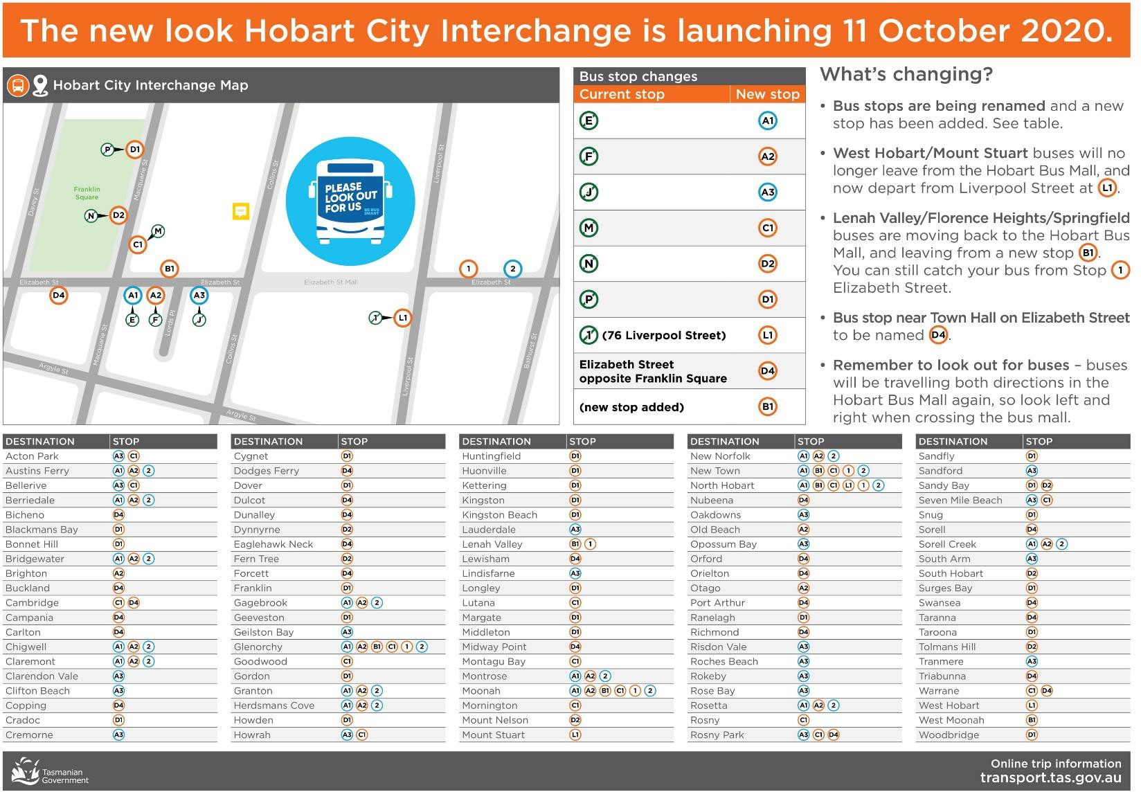

New Bus Stop Infrastructure
State Growth is currently working closely with local councils to upgrade or install new general access bus stops to support network changes as a result of the bus services review.

In the past two years State Growth has funded over 160 new bus stops to be compliant with the Disability Discrimination Act. The majority of these have been in the North West of the state around Devonport and Burnie. We have also upgraded and installed new bus stop infrastructure in regional areas such as Westbury, Perth, Bridport and Nubeena and smaller towns such as Penguin, Ulverstone, Cambridge and Midway Point. Overall during the last financial year State Growth has spent $1.9 million upgrading and improving bus stop infrastructure.

These new stops will improve passenger amenity, ensure that stops are accessible to those with a disability or passengers travelling with prams and also help to improve the visibility of passenger transport to the general public.

A photo of the new bus stop infrastructure and bus turning circle in Emu Heights, Burnie is included below.
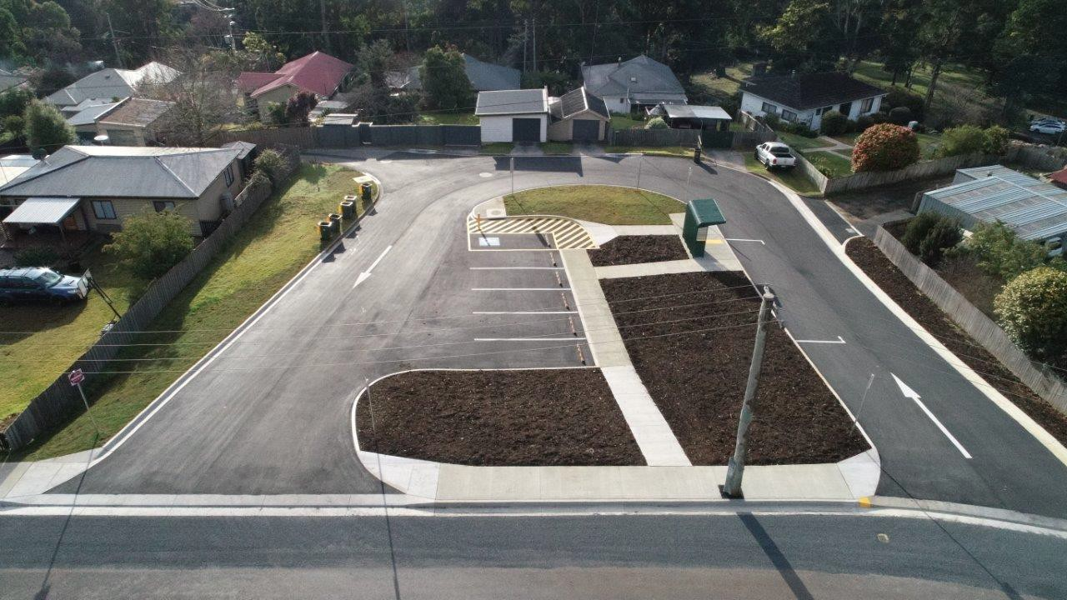

Student Travel

Student Fare
A reminder that the student cash fare is $1.80. A further discount of 20% is available if travelling on a service which uses electronic ticketing or, otherwise, by purchasing a 10-ride ticket ($14.40 for 10 tickets). This fare must be charged unless a student is able to produce a valid bus pass for free travel or transfer pass (discussed further below).

We are aware that under the former contracting arrangements, operators had more flexibility in deciding whether to charge the fare and some operators chose to charge a lesser fare. This is no longer the case.

The new contracting model shifts the revenue risk to the Department of State Growth, so it is no longer an operator’s decision whether to charge a fare or not, because the fare revenue belongs to the Department.

Operators must charge the rates noted above and must not discount the multi-trip ticket to $14.00. It is important that fares are charged consistently to students across the State.

For any operator that has been charging a lesser fare, you will need to advise passengers that the fares are increasing and give a reasonable notice for the change plus a period of time to adjust. You should also advise any passengers that may be eligible for free travel or a transfer pass to check the eligibility criteria on the Transport website.

Where a student refuses to pay, please remember to keep records of unpaid fares (including your efforts to collect unpaid fares) and report fare evasion for any of your fare-charging contracts in your monthly questionnaire.

Please note also that the Minister for Infrastructure and Transport, Hon Michael Ferguson MP has determined that the student fare will remain the same in 2021 and will be reviewed ahead of January 2022.

Transfer Passes
A transfer pass is a pass issued by the Department where a student must travel on more than one fare charging bus service (operated by different bus service providers), between home and school. This is to ensure students do not pay more than the $1.80 student fare to get from home to school, or from school to home.

A student will pay a fare on the first journey of the morning, then show a transfer pass to allow free travel on the second and any subsequent service required to complete their journey. In the afternoon, the process is reversed; the first trip is free and the second trip is where the fare must be paid. Students will always pay the fare on the same service and receive the free travel with the same operator.

The type of transfer pass received depends upon the combination of operators. It will either be a Greencard, Merseylink Smartcard, TransportMe card or a PVC printed transfer pass.

Please direct the public to our website to apply for a transfer pass, //www.transport.tas.gov.au/student. This link also provides a chart of Acceptable Bus Passes for Student Travel, which assists drivers to identify valid free and fare-paying cards.

For further information, parents can contact Bus Passes at bus.passes@stategrowth.tas.gov.au or by calling 1300 135 513 or (03) 6166 3333.

Additionally, we still have some leftover stock of card holders on a key chain that operators may be interested in distributing to students to assist in preventing loss or damage to their bus passes. These holders are clear and will not obstruct the view of the expiry year displayed on a bus pass. Any operators interested in having card holders sent to them, please contact Bus Passes through the details above before stock runs out (please note we will not be ordering any further supplies, so get in quick!).

Transport Website Updates
If you log on to www.transport.tas.gov.au/public_transport you will notice a new ‘Service Updates’ tab. This tab will be used to keep members of the public up-to-date with planned or unplanned changes to general access and school bus services throughout Tasmania.

National Police Certificate
It is a condition of accreditation that you supply a correct National Police Certificate for the purposes of a schedule 1 record
when required by a condition of your accreditation. The due date is printed on your accreditation certificate.

To help you remember to supply your NPC on time, the Transport Commission will start sending SMS reminders. The SMS will be sent at least 8 weeks before the NPC is to be supplied. Email reminders are already provided where we have an email address.

Apply for your NPC when you receive the SMS or email reminder. It can take up to six weeks between making an application and receiving an NPC through Service Tasmania or Tasmania Police.

The Transport Commission has updated the NPC Fact Sheet. You are encouraged to read through the information provided to remind yourself of the condition placed upon accreditation. To view the fact sheet, please see the attached document.

Emergency Management
As we head into the bushfire season, it’s timely to remind all operators of the need to be alert to any issues that may arise in your region.

In the event of an emergency, please remember to contact the Passenger Transport Branch and check the Bureau of Meteorology (BoM), Tasmania Fire Service (TFS), Tasmania Policy and TasAlerts websites for updates and road closures.

Please refer to clause 3.6 of the Standard Conditions which sets out your requirement to have an Emergency Response Plan. This plan should deal with the unavailability of personnel (including drivers), as well as actual and threatened emergencies likely to be encountered in relation to the operation of your service. You should consider generic risks, such as vehicle crashes as well as more likely risks due to the location of your services, such as bushfires, flooding, snow etc.

Under clause 3.5(c) of the Standard Conditions, please remember your drivers must be contactable before, during and after a trip. This is especially important in the event of an emergency.

We will soon begin contacting operators to request a copy of your Emergency Response Plan.

Operator Enquiries
For all enquiries or notifications relating to your contract(s) or the Supplier Portal, please contact our team via email at ptscontracts@stategrowth.tas.gov.au or by telephone (03) 6166 3343. While we are happy to assist in interpreting the contract, please note we are not able to give legal advice.

In relation to payment enquiries, a reminder that your monthly Recipient Created Tax Invoice (RCTI) is sent to you from the Department’s Finance branch. Please do not reply to this email as the Finance team member who sends through your RCTI may be unable to answer your Contract payment-related queries. For the fastest response, please continue to direct all payment related queries to the Passenger Transport Contracts team via email ptscontracts@stategrowth.tas.gov.au or by telephone (03) 6166 3343.

Eligibility Requirements for Adult Concession Fares

Adult concessions

The following adult concessions apply to all general access services from 19 January 2020

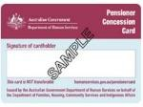
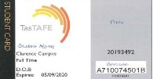
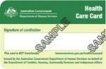
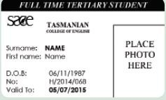

Older Tasmanians 70+
Pensioner concession card Issued by the Department of Human Services and the Department of  Veteran Affairs. Concession applies to the primary card holder. | Adult students  Adult concession fares apply to full- time students from the start of the year in which they turn 19 while they attend a senior secondary college, university, TasTAFE or Tasmanian College of English.
Health care card  Issued by the Department of Human Services. Concession applies to the primary card holder.  Seniors card  Issued by state  or territory governments | Students should carry appropriate student identification to validate their entitlement to adult concession fares.  Full time adult students may be issued a special circumstances student Greencard or equivalent card by the Department of State Growth which entitles the cardholder to either a student concession fare or free travel. The Greencard has adult student/child fare written on the back of it.
Passengers aged 70 years or over should carry appropriate proof of age to validate their entitlement to adult concession such as a seniors card | EIS or RDI Immicard  Evidence of Immigration Status (EIS) or Residence Determination ImmiCard (RDI) issued by the  Department of Home Affairs.

Free travel

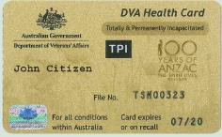
The following free travel arrangements will apply to all general access services from 19 January 2020

Tasmania Police officers  Free travel applies upon showing a Tasmanian Police badge. | Vision impairment travel pass Free travel applies to the cardholder, guide dog and attendant. Passes are issued by the Commissioner of Transport (Department of State Growth)
Ambulance officers  Free travel applies to Ambulance Tasmania and St John Ambulance Officers in uniform.  Companion card  Issued by state and territory governments. Free travel applies to the cardholder’s companion while the cardholder pays the fare for which  they are entitled. | TPI and EDA pensioners Totally and Permanently Incapacitated (TPI) and Extreme Disablement Adjustment (EDA) pensioners need to present a current Goldcard issued by the  Department of Veterans’ Affairs in the name of the passenger, and embossed with TPI or EDA. Passengers travelling on Metro services need to apply for a Greencard for free travel.

Note concessions and free travel also apply to some child students. Please visit www.transport.tas.gov.au for more information

Fact Sheet
PT827 03/20

National Police Certificate (NPC) for Accreditation

Why do I need to provide a current NPC?
You as an accredited operator or nominated responsible person must be a fit and proper person.
Any convictions for offences or crimes, in particular, offences which are considered serious offences under the Passenger Transport Services Act 2011, are considered when making a determination about whether you are a fit and proper person.
A NPC provides a record of all disclosable prior convictions and findings of guilt. The information is used to help make a determination about whether you are a fit and proper person.

What type of NPC is required for accreditation?
The only type of NPC that is acceptable for accreditation is a NPC Schedule 1 record obtained through Tasmania Police (or interstate equivalent).
There are different types of NPCs available. Be wary of commercial online crime certification or checks. It is important that you supply the correct type of NPC obtained through Tasmania Police or it will not be accepted and you will need to acquire the correct one.
A NPC obtained through Tasmania Police that is issued for the purposes of a schedule 1 record will contain the official insignia reserved for Tasmania Police, as well as your own personal reference code and will note that it has been issued by Criminal History Services, Tasmania Police.
I need a NPC because…
… I am applying for accreditation
The applicant (if not a corporation) or the nominated responsible person must submit a current NPC as part of the application for accreditation.
… I am complying with the conditions of an accreditation
A standard condition of accreditation requires
the holder of the accreditation or nominated responsible person to supply a current NPC to the Transport Commission.
These documents are required at regular intervals (normally three years). The schedule which you are due to supply the NPC to the Commission is printed on your accreditation certificate. By law you must supply your NPC before the due date.

Department of State Growth

How do I get a NPC?
You can get an application form for a NPC:
- from a Service Tasmania shop, police station or
- go to http://www.police.tas.gov.au/services- online/police-history-record-checks/ to download it from the Tasmania Police website.
The form is called ‘Consent to Check and Release a National Police Certificate - Application Form’.
For accreditation, the purpose of the record
check is Driver / Public Passenger Licence under Option 1 – Employment / Privilege under Schedule 1.

Does it cost to get a NPC?
You will need to pay a fee for the NPC and these fees can be found on the Tasmania Police link as the end of this page.

Where do I send the NPC?
You can submit the NPC to the Commission by:
- posting a certified copy to: Regulations and Concessions Unit GPO Box 1232
Hobart TAS 7001
- scanning and emailing the NPC to: operator.accreditation@stategrowth.tas.gov.au

What certificates won’t be
accepted?
We can only accept current NPCs issued by Tasmania Police (or interstate equivalent) for the purposes of a schedule 1 record.
Certificates older than 90 days, good character checks, personal references, other national police checks or certificates obtained from an internet- based facility or website (other than downloaded from the Tasmania Police website above) will not be accepted.

Relevant links
Tasmania Police: Police History Record Checks
(link)
Department of State Growth: Operator
Information (link)
Relevant Legislation: The Law (link)

Department of State Growth 2

