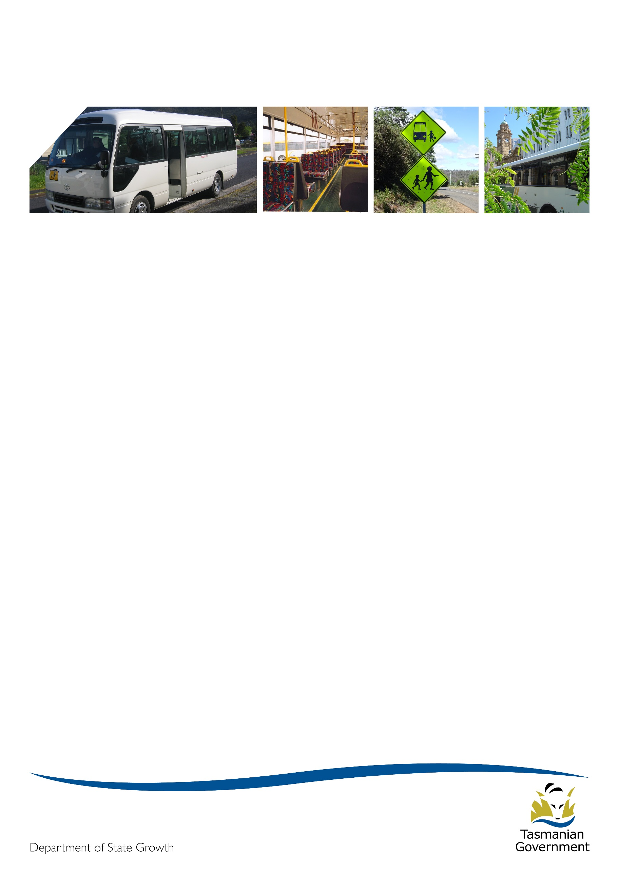
Transporter

October 2018

Summer is just around the corner
The summer holidays are fast approaching, with the final term of school now underway. Recent weather has given us a taste of what to expect and I am sure you can’t wait!

Project 2018 update
School Bus Services Update
Sixty operators have now had all of their contracts matched, and these operators have been sent an email requesting the return of information which will be used by the Project 2018 team to complete the new contracts so that offers can be made as soon as the contract and funding models are finalised.
If you have had all of your services ‘matched’ and have not received an email from State Growth asking you to provide business, route and timetable information then please get in contact. You should first check your email junk folder to make sure it hasn’t been marked as junk.
In total, Project 2018 has now published over 200 school bus matching decisions representing about 60% of services to be re-contracted. The remaining matching decisions will be published shortly. Please remember to check the Transport website periodically, as new matching decisions are published on a Tuesday.
A large number of the remaining services which have not had matching decisions published have been reviewed, and are either being considered for approval by exemption or are part of a service redesign. Project 2018 is currently focussing on those services where more significant changes will be made, and which may result in the rationalisation of services in the area. There are 27 services which are subject to significant redesign, and each is an intensive effort.
Operators who are affected by service redesign have been made aware that the Minister for Infrastructure has recently approved a transition assistance program to provide financial assistance to operators who are not matched to a contract, or who chose not to compete for a service in a closed tender process.
Eligible operators whose service is not being continued, or eligible operators who are required to compete for a contract via a closed tender process but elect not to tender, will be offered an assistance payment that will be the equivalent of the non-capital contract payment for the period April to September 2018 (i.e. six months payment, excluding capital).

To be eligible for this program, operators must currently hold a contract for a rural school bus, urban fringe school bus, long distance school bus, rural fare paying, urban school bus or town bus service and:
- that contract must be identified by State Growth as not being needed (i.e. not directly matched) or be matched to a closed tender process; and
- one or more of the following situations will need to apply:
  - the operator was not approached in 2017 for an early exit for this contract, or
  - the operator was approached for an early exit in 2017, and either:
    - State Growth (not the operator) made the decision not to proceed with the early exit; or
    - the operator did not accept the exit offer, but in State Growth’s view, there are significant mitigating reasons to justify why the operator did not take the early exit offer; and
- if the contract is matched to a closed tender process, then the operator must accept the Transition Assistance offer within seven days of the matching decision being published on State Growth’s website, or prior to the closed tender process being commenced, whichever is the latter; and
- the operator must cooperate with, and facilitate, the change to the new bus service in 2019; and
- there must be a net financial benefit with a payback period of less than one year for the government over the ‘do nothing’ case of recontracting the service, including the payment made to the operator; and
- where a closed tender is involved, at least one operator must remain to provide the required services.
Please note that this is not an opt-in program. Operators will be notified through the service redesign process if they are eligible for the assistance.
General Access Services Update
The state-wide general access network has now been finalised, and all matching decisions have been published on the Department’s website, noting that the maps published on the website represent the general route/corridor that services will operate on.
The Project 2018 general access team has now shifted its focus to working with bus operators to finalise changes to timetables and routes in preparation for a staged rollout of the network in 2019.
The first stage of service rollout will occur in the south in early 2019. The north and west coast services will be rolled out in the first half of 2019, and north-west services will be mid-way through 2019.
The increased service integration that underpins the new network brings with it opportunities to explore initiatives that enhance and promote integration at other levels, such as an integrated set of public timetables, a single online source of timetable information, and an overarching brand that ties all operators and their brands together under a central integrated theme. If implemented, these initiatives will create consistency for passengers and will ultimately set the groundwork for introduction of a common ticketing system. The Project 2018 team will keep general access operators informed as they progress these opportunities.
Contract and Funding Model Update
State Growth and the Tasmanian Bus Association (Tasbus) are in the final stages of negotiating the new contract and working through some final funding issues. State Growth intends to commence contract offers in November.
For school bus operators who are keen to calculate an estimate of their future contract payments, (as a guide only), State Growth has developed a spreadsheet calculator which allows you to enter your contract and vehicle information and derive an estimate of what you will be paid under the new contract.
This model is a slightly simplified version of the school bus payment model. It doesn’t deal with more complex contracting situations, but it will allow most operators to get a reasonable estimate of contract payments.
Copies of this model will be sent to operators soon.
Closed Tender Process
Project 2018 has received several enquiries about how closed tenders will be evaluated. While not yet in a position to publish the full criteria until the tender documentation is officially released and open for submissions, Project 2018 can tell you that the broad criteria, and their weightings, are expected to be:
- Demonstrated Performance (30%)
- Service Offering (25%)
- Capability (25%)
- Price (20%)

Any operator going into a closed tender should however closely review the tender documents provided and comply with those documents.

Accreditation
The Transport Commission, the Department of State Growth and operators all want a safe passenger transport service so that the travelling public can have confidence in Tasmania’s public passenger transport network.
The purpose of passenger transport service operator accreditation is to ensure safety. The Commission must be satisfied that the operator of a passenger transport service:
- is a fit and proper person to operate the service;
- implements appropriate safety, security and related systems (Systems) for the service;
- has the requisite competence and capacity to manage the safety, security and related risks associated with operating the service; and
- is held accountable for any deficiencies in the safety, security or related performance of the service.
When the Systems are not in place or the operator does not have the competence to manage the service, there is a risk that passengers, drivers and road users are exposed to danger by way of unsafe service, vehicle and/or driver.
When there is information supporting that the Systems are not appropriate for the service, the Commission will take appropriate action, including steps to require that the Systems are improved. If the Systems are not improved and the Commission is satisfied that there is a risk to the travelling public, then the Commission will respond with significant action. This action can include the cancellation of an accreditation. When an accreditation is cancelled, the passenger transport service is no longer able to operate.

Accreditation certificate
Accreditation certificates issued by the Transport Commission are very important. They identify to passengers and enforcement officers that a vehicle and its driver are part of an accredited passenger transport service and they can expect that the safety, security and related systems are in place to ensure the service is safe. Accreditation certificates don’t expire.
The accreditation certificate is being redesigned. The new certificate will be issued when:
- a new accreditation is approved; or
- an audit report or National Police Certificate (NPC) is submitted for an existing accreditation (in accordance with the conditions of accreditation) over the next three years.
The conditions that apply to the accreditation certificate will continue to be described on the certificate.
Once issued, the redesigned certificates will not need to be replaced unless there is a change to the conditions of the accreditation.
The original of the accreditation certificate must be kept with the accreditation records in accordance with the Accreditation Standards. A copy of the certificate must be displayed prominently in each vehicle that is used for the Service,

Annual fuel card fees
In October of each year, the Passenger Transport Branch usually undertakes an audit of operator fuel cards ahead of charging the annual administration fee to users of the scheme in November. This year, Passenger Transport has decided to hold off charging the annual administration fee until January 2019, after the signing of new contracts and the vehicle fleet is known. Operators should consider their card requirements and make requests for new cards or card cancellations as soon as possible following the signing of new contracts.
The Bulk Fuel Purchase Scheme is a whole of government common use contract available for use by eligible organisations. Bus operators were provided access to the Scheme around 1992. Access to the Scheme is limited to vehicles that are directly engaged in regular passenger transport services restricted to the carriage of students. The Scheme allows bus operators to access a discounted fuel price.
Additionally, bus operators can access discounted fuel prices without using the Bulk Fuel Purchase Scheme. The Tasmanian Bus Association has advised that bus operators can get a similar price through a chain of fuel stations for its members, and larger operators can get similar prices through direct negotiation.

Changes to the way you receive your monthly payment documents
Most operators currently receive their monthly payment documents via a single email with multiple attachments of different types. The Passenger Transport Branch is enhancing the internal processes for production and distribution of the documentation associated with payments over the next few months. This means that you will now receive your payment information in a couple of emails instead of a single email.
Commencing in November, the RCTI payment statement will be sent in an RCTI payment statement email. Following this will be a change so that Top-up statements and fuel use statements will be sent in separate, appropriately titled emails. There will be no changes to the nature and content of the documents, just the delivery method.
The Passenger Transport Branch acknowledges that this will be less convenient for operators than receiving a single email. The decision to move to this model has not been made lightly. By way of an explanation, payment documents are derived from different business systems, and then manually collated into a single email. This takes considerable time and comes with the risk that information is accidentally omitted or sent incorrectly. The new process will mean that each business system will automatically email the correct information to operators, which will free up valuable time to allow staff to respond to other operator queries.

Bus cost model index (BCMI)
The BCMI has been calculated for October 2018 and is 128.2.

Capital rates
The capital rates have been calculated for the quarter commencing October 2018. Please consider these rates before requesting bus changes on your contract.

Contract Type | July 2018 | October 2018
Urban Fringe Student Only | $1.01 | $1.01
Rural Fare Paying | $1.01 | $1.01
Long Distance Student Only | $1.01 | $1.01
Long Distance General Access | $2.91 | $2.91
Urban Fringe General Access | $2.91 | $2.91
Urban | $0.86 | $0.86
Town | $0.86 | $0.86

For all fare-paying operators, the rates applicable to your monthly contract payment can be found on your Statement of Payment.

Contacting Passenger Transport
For all enquiries or notifications relating to your current contract (i.e. a service you currently provide) please contact the Passenger Transport Contracts unit via email ptscontracts@stategrowth.tas.gov.au or phone (03) 6166 3343.

