This bulletin provides key regulatory information for window film applied to glazing of all light vehicles. A light vehicle is a vehicle with a gross vehicle mass not exceeding 4.5t. Applied film includes tint, perforated artwork, advertising material and any other form such as paint etc.

Privacy glass
This information bulletin does not apply to glazing that is tinted in the initial manufacturing process. This style of glazing is also known as privacy glass and includes markings etched into each piece of glazing to indicate whether a windscreen or window has been manufactured with a tint in the glass.
However if film is applied to this glazing the Luminous Transmittance (LT) values applicable to the specific window and vehicle apply.

Luminous transmittance
There are regulatory requirements for the minimum LT of windows including windscreens of light motor vehicles.
Luminous transmittance is the amount of light that can pass through a window, measured with a tint testing device, as a percentage in relation to the amount that would pass if there was no window in place. A measuring adjustment of 5% is applied to cater for any inaccuracy in the measuring device or technique.
The reflectance value means the amount of light that is reflected by the window.

Requirements
The Vehicle and Traffic (Vehicle Standards) Regulations 2014 Regulation 47, prescribes the minimum LT requirements for light motor vehicles and is specific to certain windows and vehicle types. This is adopted from national model law.

Windscreens
A windscreen must have a LT of at least 70% and must not be coated in a way that reduces its LT or affects compliance with Australian Design Rules. However, a windscreen may have a tinted band applied to the upper part of the windscreen providing this band is no deeper than the greater of:
- the area above the swept path of the windscreen wipers, or
- the upper 10% of the windscreen.

Front side windows
Front windows, other than the windscreen, that are adjacent to the driver’s normal driving position may have film applied to the glazing to achieve a LT of at least 35%.

Rear Glazing
Glazing used in a window or interior partition of the motor vehicle located behind the driver in the normal driving position may have film applied to achieve a LT of 20% subject to the vehicle having at least one external rear vision mirror fitted to each side of the vehicle. Both mirrors must be operational.
Minimum 20% Minimum 35%

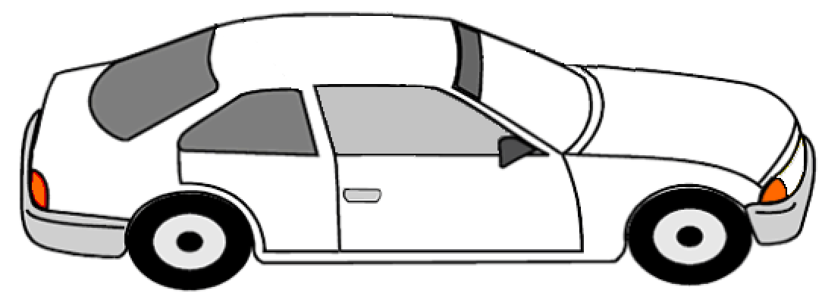
External rear vision mirrors fitted to each side

Rear Glazing - Goods carrying vehicles
A vehicle that is primarily designed for the carriage of goods (for example a van, panel van, ute, truck or a vehicle with an Australian Design Rule category NA or NB) may have, for glazing rear of the drivers normal seating position, a film applied to achieve a LT of 0%. This is subject to the vehicle having at least one external rear vision mirror fitted to each side of the vehicle. Both mirrors must be operational.
Minimum 0% Minimum 35%

External rear vision mirrors fitted to each side

Further Information
Further information relating to this bulletin is available from;
Department of State Growth
Vehicle Standards Unit
Phone: (03) 03 6166 3263
Email: vehicle.standards@stategrowth.tas.gov.au
Web: www.transport.tas.gov.au

Disclaimer
The information contained in this bulletin is for guidance only.
All effort has been taken to ensure the information contained in this bulletin is true and accurate at the time. Any changes in legislative requirements will take precedence over the information that is contained within this bulletin.
All diagrams are representations only and are not drawn to scale, they are for visual assistance only.

