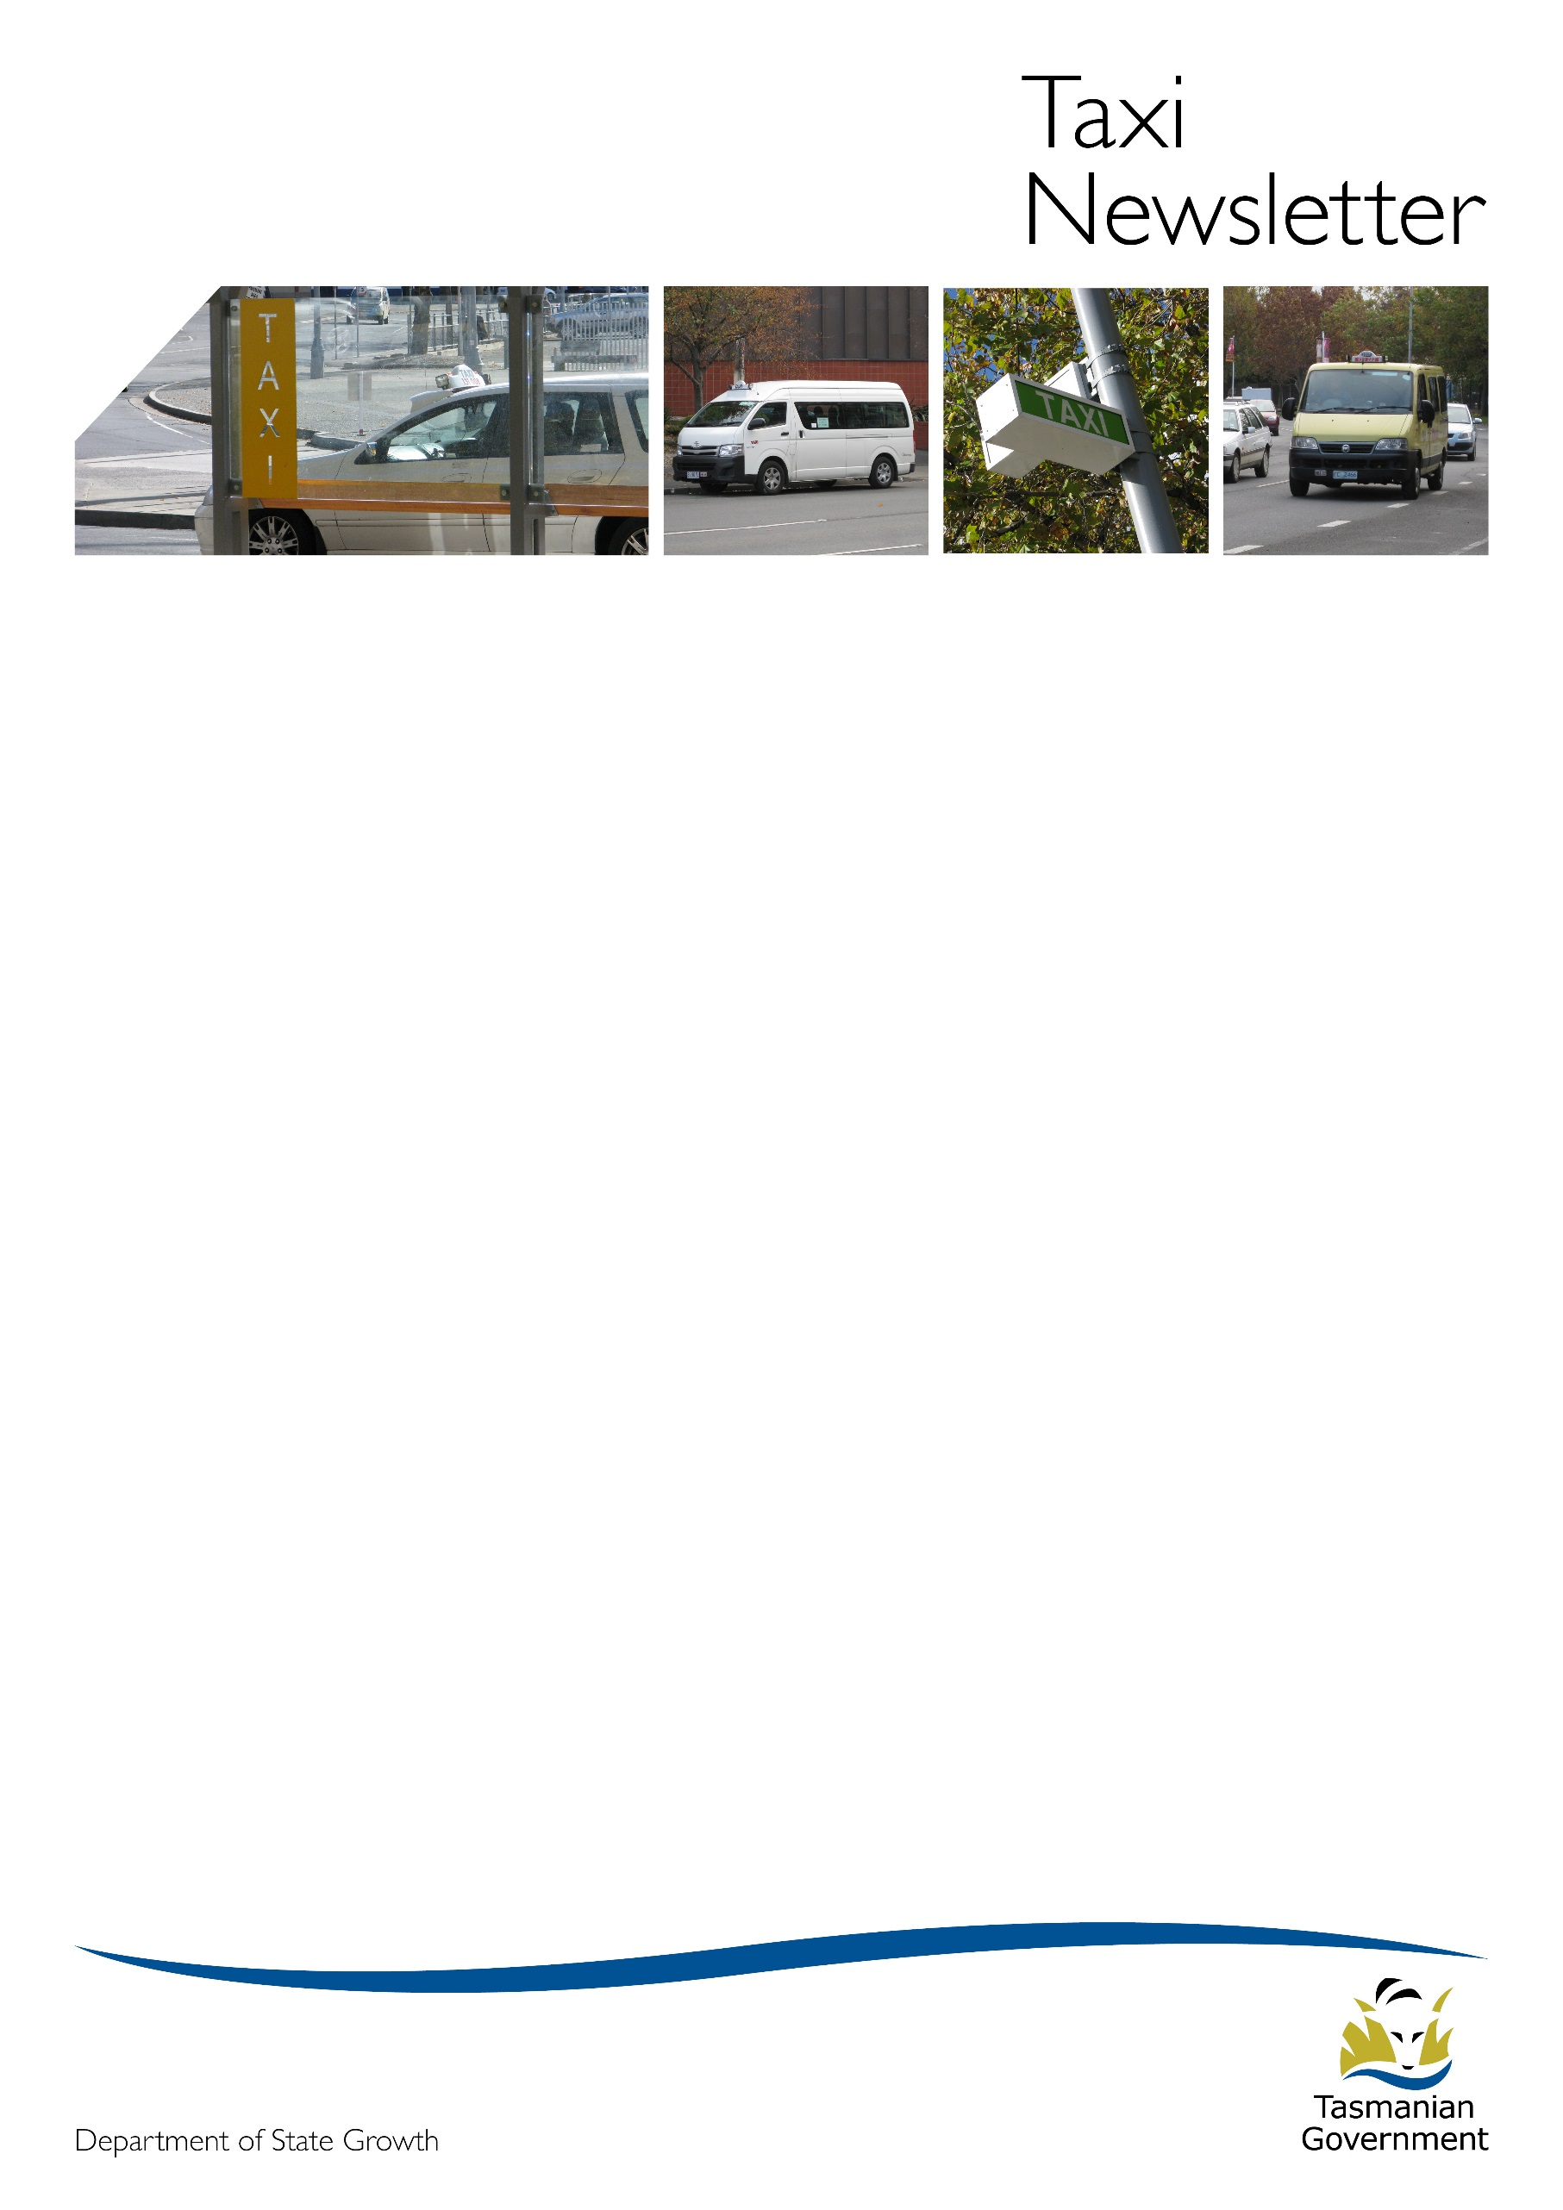Welcome to the June 2017 edition of the Taxi Newsletter.

External signage on ride-sourcing vehicles

State Growth has received reports in recent weeks of Uber vehicles carrying external door signs/branding. Uber has advised that the use and display of external signage is in contravention of the terms that its driver-partners have agreed to operate under in Tasmania.  Uber has commenced an in-app campaign to remind its driver-partners not to use external branding.

Some industry participants have questioned the legality of ride-sourcing vehicles affixing branding to the outside of their vehicles. State Growth can advise that that the display of such signs is not in and of itself unlawful under the current regulatory framework.  However, it is unlawful for a person to do any of the following to a motor vehicle that is not a taxi:

1) install a taximeter

2) describe the vehicle as a ‘taxi’, ‘taxi-cab’ or ‘cab’ or

3) describe the service as a ‘taxi’, ‘taxi-cab’ or ‘cab’ service.

It is also unlawful:

* for a vehicle that is not a taxi to stand at a taxi rank
* for a person to hire out a small passenger vehicle to a person hailing it on a public street if the small passenger vehicle is not a taxi and
* for a person, on a public street, to solicit passenger trade for a motor vehicle on that public street.

Further, any trip provided by a person for ‘financial consideration’ where that trip is not booked and paid for via a ride-sourcing platform with the prescribed features is acting outside of the requirements of the Transport Commission Exemption (issued 7 November 2016) and is potentially committing an offence.

If you have any evidence of ride-sourcing vehicles engaging in rank and hail work, or soliciting for trade on a public street, you should provide this to the Regulations and Concessions Unit so that it can be further investigated. The issue of livery and signage for ride-sourcing vehicles is also being considered as part of the broader Regulatory Review State Growth is currently undertaking.

# Taxi Subsidy Safety Net Scheme extended

A person on the Taxi Subsidy Safety Net or a National Disability Insurance Scheme participant who has a Taxi Smartcard can continue to use their Taxi Smartcard to pay for part of their taxi fare until 30 June 2018. The Taxi Subsidy Safety Net which was to finish on 30 June 2017 has been extended to 30 June 2018.

The WAT Trip Subsidy Interim Payment will continue.

# Hiring period

The hiring period is from the time the taxi is set in motion (starts moving) at the beginning of the hiring until the taxi stops at the end of the hiring. You are only allowed to charge for the hiring period.

This means you can’t start your taximeter unless you are actually starting the trip. For example, if you are transporting a wheelchair-reliant passenger, even if it takes some time to load your passenger, you can’t start your taximeter until the passenger is secured in the taxi and you are seated, and the taxi starts moving.

You must stop your taximeter immediately the trip is finished. You can’t let it keep running while you are unloading a wheelchair-reliant passenger.

It is against the law to charge a fare outside of the hiring period. If you have any questions about what a hiring period is, you can call the Regulations and Concessions team.

# Important information for wheelchair-accessible taxi (WAT) licence holders

The law that relates to WAT licences is the *Taxi and Hire Vehicle Industries Act 2008* and the *Taxi Industry Regulations 2008* which is available online at [www.thelaw.tas.gov.au](http://www.thelaw.tas.gov.au)

If you don’t comply with the law you may receive a fine and/or the Commission may take action against your WAT licence which may include suspending or cancelling it. The Regulations and Concessions Unit can provide you with general advice about licences but if you need advice about the law, you should seek your own independent, professional advice.

**A WAT licence**

When you hold a WAT licence you:

* must be the responsible operator of the licence
* cannot lease your licence and
* should keep a copy of the licence with your records.

**A WAT vehicle**

The Commission makes the decision to approve a vehicle for use as WAT. Information about the necessary modifications and Vehicle Standards that apply to WATs can be found at: <http://www.transport.tas.gov.au/__data/assets/pdf_file/0006/111948/PT802_-_Application_for_Wheelchair_Accessible_Taxi_Licence.PDF>

* you can only use a vehicle as a WAT that:
* has been approved by the Commission and
* is specified in the WAT licence
* the maximum operating age for any WAT vehicle is ten (10 years)
* the licence holder must be the registered operator of the vehicle.

**Contact details**

You must keep your contact details up to date as the Commission may need to write to you about your WAT licence. If your contact details aren’t correct you may not receive important correspondence. You can update details at any Service Tasmania shop or online at: <https://www.service.tas.gov.au/change_of_address_form/>

**Transfer of WAT licence to another person**

The Commission makes the decision to approve the transfer of a WAT licence to another person. You must:

* use the application form on the website at <http://www.transport.tas.gov.au/fees_forms/operator_forms>,
* email the completed form to [operator.accreditation@stategrowth.tas.gov.au](mailto:operator.accreditation@stategrowth.tas.gov.au)
* pay the fee at any Service Tasmania shop

You cannot use a WAT licence, even if you bought it, until you have been notified that the Commission has approved the transfer.

**Transfer of WAT licence to another vehicle**

The Commission makes the decision to approve the transfer for a WAT licence to another vehicle. You must:

* use the application form on the website at <http://www.transport.tas.gov.au/fees_forms/operator_forms>,
* email the completed form to [operator.accreditation@stategrowth.tas.gov.au](mailto:operator.accreditation@stategrowth.tas.gov.au)
* pay the fee at any Service Tasmania shop.

You cannot use the vehicle on the licence until you have been notified that the Commission has approved the transfer.

**Surrendering a WAT licence**

If you do not want to operate a WAT licence you may surrender it. To surrender you must return the licence certificate and licence number plate to:

* any Service Tasmania shop
* reception at 10 Murray Street, Hobart or
* by post to ‘Passenger Transport’ GPO Box 536, Hobart TAS 7001

**Annual administration fee**

An annual administration fee is payable for each licence:

* the Commission sends a notice around each February to remind you when the fee is due
* if you don’t pay the fee by the due date the licence will lapse
* if the licence is lapsed for 28 days the licence number plate will be void and the Commission will cancel the licence number plate
* it is an offence to operate a taxi service under a lapsed WAT licence.

**Suspension and cancellation of a licence**

The Commission can **suspend** a WAT licence in certain circumstances. The following are some examples:

* you don’t comply with a condition of the licence
* you don’t provide the Commission with information that it requires by the date specified
* the taxi becomes unregistered
* the taxi no longer meets the specifications required by law for a WAT
* your accreditation is suspended

The Commission can **cancel** a WAT licence in certain circumstances. The following are some examples:

* you don’t comply with a condition of the licence
* the taxi becomes unregistered and is likely to be unregistered for a prolonged period
* the taxi no longer meets the specifications required by law for a WAT
* the taxi is more than 10 years of age;
* there has been more than 28 consecutive days where you haven’t transported a passenger in a wheelchair
* you are no longer the registered operator of the taxi – e.g. you sell the vehicle

Unless the Commission believes there is an immediate risk to public safety, you will be given written notice and given a reasonable opportunity to respond and address the circumstance, which will be taken into account, before a decision is made to suspend or cancel a WAT licence.

When a WAT licence is suspended or cancelled, it cannot be legally used.

If you have questions about your WAT licence you can find information on the Transport website at <http://www.transport.tas.gov.au/passenger/operators> or you can contact the Regulations and Concessions Unit.



If you wish to discuss the industry or the Council further please contact:

President Mr. Roger Burdon (South) 0418 125 768 or via email [roger.burdon@13cabs.com.au](mailto:roger.burdon@13cabs.com.au)

Secretary Mr. Tony Dilger (North) 0417 036 090 or via email [manager@taxicombined.com.au](mailto:manager@taxicombined.com.au)

# From the Regulations and Concessions team

For operator accreditation or taxi licence enquiries:

Email: [operator.accreditation@stategrowth.tas.gov.au](mailto:operator.accreditation@stategrowth.tas.gov.au)

Phone: 6166 3269