Transporter

July 2021

Public transport in the First 100 Days
Following the state election, Minister Ferguson has been returned to the role of Minister for Infrastructure and Transport.
State Growth will be kept busy delivering the government’s election commitments, picking up around 65 of the government’s 174 First 100 Day commitments. Of these, the most relevant for public transport include commitments to:
- Allow vehicle registrations bills to be paid quarterly and providing advice on more frequent payments.
- Begin the planning with Metro Tasmania to deliver a modern common ticketing solution.
- Commence planning on the introduction of additional school and commuter buses on high demand routes.
- Provide advice on potential locations for three new park and ride facilities, and commence the development of a program to upgrade bus stops at priority locations.

Road Safety Week
In late May we joined with the Road Safety Advisory Council to raise awareness of National Road Safety Week.
You may have seen or participated in some of the initiatives to support this campaign, including, lighting up prominent buildings and structures across the state in yellow and wearing yellow ribbons.
The theme – ‘Drive So Others Survive!’ – asked everyone on the road to monitor their own behaviours and ensure the safety of all people on the road ahead, especially vulnerable road users.
In addition to sharing the road, public transport involves operating large, heavy vehicles filled with lots of people, so it’s a particularly relevant message for us all year round.

Sign up to the Roadworks Report
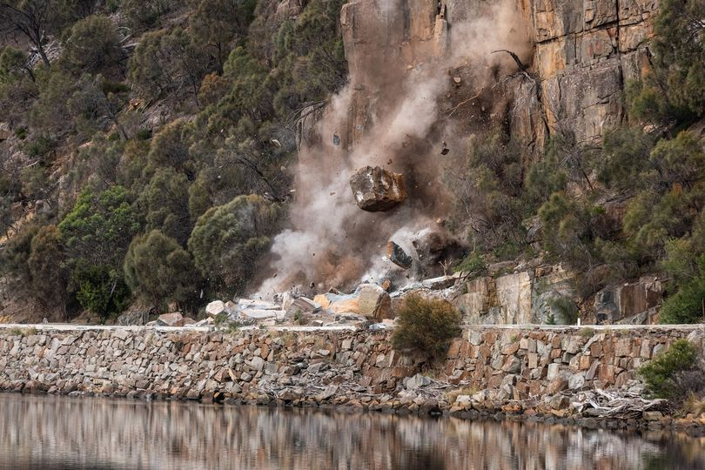
As the short notice closure of the Tasman Highway to remove a rock-fall risk recently demonstrated, disruptions to the road network can develop quickly.
Moving into winter, it’s possible we’ll see more road closures due to weather or environmental factors, in addition to a wide range of planned works around the state.
Keep up to date with the Roadworks Report, an email newsletter distributed by State Roads every Monday.
To sign up to the mailing list, or learn more about planned works and closures, visit https://www.transport.tas.gov.au/projectsplanning/road_closures_and_delays

Requests to Novate
Operators often request information on the process of novating a passenger service contract. We’ve put together a brief overview of the practical requirements below, but the contractual requirements are set out in detail at clauses 25.1 and 25.2 of the Standard Conditions.
To novate, you must notify us, in writing, of your intention to novate, and nominate a party to whom you wish to transfer your rights and obligations under the contract. To do this, email ptscontracts@stategrowth.tas.gov.au and provide the following information
- Your own entity name.
- The contract(s) you are requesting to novate (you may wish to novate some or all of your contracts).
- Details of the party to whom you are novating (including entity name, address, and contact details).
- The date you request the novation to take effect.

When selecting a requested effective day, remember
- It must be the first day of the relevant month.
- Allow at least one month from the date you send this email for the relevant information to be collected and reviewed, documents to be prepared for the Delegate’s consideration and, if approved, for the novation deed to be executed.
- If you are novating to a party who does not currently hold a passenger service contract with the Department, they will be required to become an accredited operator before the novation can take place. This process may cause delays, and should be factored into your proposed date when the novation will take effect.

After you have advised us of your intention to novate, you and the party to whom you are novating will receive a letter outlining all additional information necessary to guide you through the novation process.

If you have any questions about the novation process, contact the Contracts and Performance Team.

Permanent Vehicle Change Request form
We have developed the Permanent Vehicle Change Request Form to streamline requests for the addition, removal, or replacement of an Approved Vehicle. The form is available to all operators at www.transport.tas.gov.au/fees_forms/operator_forms
When completing the form, read it carefully to complete all applicable sections. Some sections are only applicable for certain types of requests (e.g. if you are seeking pre-approval for a vehicle you have not yet purchased or registered, you will initially only be required to complete Part A).
To submit a request, email your completed form to ptscontracts@stategrowth.tas.gov.au
We hope that it will help you provide necessary vehicle information quickly and easily, reducing the time required to process requests. If in doubt, contact the Contracts and Performance Team on (03) 6166 3343 for more information.

Acknowledgements
On Saturday 29 May the Minister for Infrastructure and Transport, the Hon Michael Ferguson MP opened the annual conference of TasBus, the peak industry body for bus operators in Tasmania. The conference proceedings were followed by a gala dinner where the Minister was represented by Madeline Ogilvie MP.
Each year TasBus conducts industry awards which are announced at the conference dinner. We congratulate the winners of three award categories for 2021:
- Achiever of the Year - Grant Hickey
- Outstanding Contributor to the Industry - Shane Dewsbery
- Environmental Award - Metro Tasmania.
We also acknowledge Mr Shane Dewsbery as outgoing President after almost a decade in the role, and welcome Mr Peter Seabourne to the role of President.

Emergency Plans – from your head to paper
There are lots of variables in life, and public transport services are no different. When things change, it can often be without notice, so it’s helpful to have a plan in order to manage in an emergency and keep services running.
A good place to start in developing yours is considering what could go wrong between the start and the end of your day. For example
- What roads do you take? What alternative routes could you take if one or more closed?
- Who drives the bus? What would you do if they couldn’t get to work for a day/week/month?
- What would you do if the bus broke down in a remote area with children on board?
While of course we hope disruptive events don’t happen, it can take the pressure away if you have a plan of action if they do. Once you’ve thought it through, get it down on paper and share copies with your team. In the event of an emergency, you may not be able to communicate effectively with everyone so being on the same page early can save precious time.
For more guidance see clause 3.6 of the Passenger Transport Contract Standard Conditions.

Clarification - Student Bus Pass for Free Transfer
Eligible students can access a Student Bus Pass for Free Transfer when their trip from home to school and/or school to home involves more than one fare-paying service delivered by different operators.
Students pay a fare to the same operator in the morning and afternoon. This ensures the customer only needs to use one smartcard/10-pass ticket. For example, in a four trip journey, the student pays a fare on trips 1 and 4.
- AM: pays a fare on the first trip then shows transfer pass to travel free on the other/s.
- PM: shows transfer pass to travel free on the first trip/s and pays a fare on the last trip.

If in doubt, the operator/s providing the free travel will be printed on the card.
We have updated our paper application form to ensure this advice is consistent across customer-facing documents.

Contacting Passenger Transport
- email ptscontracts@stategrowth.tas.gov.au
- phone 03 6166 3343

