Hobart Congestion
Traffic Analysis - 2016

Introduction

Background
This report was prepared for the Department of State Growth to provide a technical analysis of traffic flow in the Hobart CBD and the main State Highways connecting to the city, during the recent periods of citywide heavy traffic congestion.
Hobart’s traffic system is complex and dynamic. The CBD and surrounds attracts a large volume of traffic throughout the day and rely upon three major arterials for access: Tasman Highway; Brooker Highway; and Southern Outlet. These arterials are connected via the Davey Street/ Macquarie Street Couplet, connected by various major collector roads along its length providing access to and through the City (such as Sandy Bay Road, Barrack Street, Campbell Street and Murray Street).
Traffic volumes on Hobart’s network have grown dramatically, particularly on the Davey Street/ Macquarie Street Couplet over the last decade. In parallel with traffic growth there have been multiple changes to land use and transport systems, which have increased congestion levels along the Couplet as well as the various roads connecting to the Couplet.
During the month of February 2016, higher levels of congestion were experienced. The frequency of the congestion was deemed to be above what is typically experienced. Congestion appeared to peak during the first week of semester for University.
Some heavy congestion events were readily explained by unusual events. One such example included a bus breaking down on the Tasman Bridge which caused widespread congestion along the Brooker Highway, and the main arterial roads connecting to Hobart (including Southern Outlet, Davey and Macquarie Streets, Campbell Street, Sandy Bay Road). Other heavy congestion events did not appear to have an obvious explanation and were therefore the focus of media and broader public attention.

Traffic Congestion
Traffic congestion is a state of the network when traffic demands exceed the available capacity. The state when traffic demand equals capacity is known as ‘saturation’. This state results in lengthy delays and queue formation until demands reduce to levels below capacity. The capacity of a network is not static, but variable and depends on many factors, including traffic volumes and flow conditions on each component of the network, road link conditions, traffic signal phasing and cycle times, parking activity, and other various factors. During periods of traffic congestion small disruptions to traffic flow can result in dramatic reductions in vehicle speeds with stop/ start conditions propagating back into the traffic flow.
Traffic congestion within an element of the network is simplistically described in the speed flow diagram in Figure 1. As the network demand flow increases, vehicle speeds reduce until they reach a maximum volume (shown as q_{max} in Figure 1). As traffic demands then increase beyond this point, vehicle speeds reduces further, thus causing reduced flow. This results in unstable queue formation and lengthy delays within the network. If demands continue to increase, flow can reduce to zero flow and zero speed, which is commonly referred to as ‘gridlock’ conditions.

Figure 1 Speed-Flow Diagram
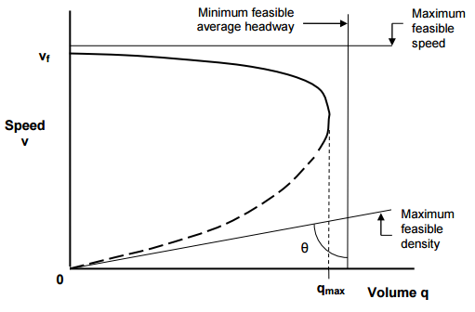
Capacity
Zone of unstable flow – heavy congestion
Zone of stable flow
Source: Austroads, Guide to Traffic Management, Part 2: Traffic Theory

The capacity of each component of the network varies from day to day, as well as throughout a typical peak hour. It is therefore difficult to forecast capacity as much as it is difficult to forecast traffic demands on any given day.
Hobart’s road network is consistently near capacity during peak periods. Relatively small changes in traffic conditions therefore tend to have a large impact on traffic flow.

Analysis of Heavy Congestion

Heavy Congestion Periods in Hobart
During the month of February 2016 there were periods of heavy congestion noted in the Hobart road network. In general terms, the congestion appeared to be more pronounced during the evening peak period and resulted in the following impacts:

Slow moving traffic on the Tasman Bridge, with regular stop/ start flow.

Lengthy queues on most roads connecting to the Macquarie Street/ Davey Street Couplet. This included lengthy queues on Southern Outlet, Barrack Street, Murray Street, Campbell Street, Sandy Bay Road Molle Street/ Byron Street and Antill Street/ Regent Street.

Lengthy delays on all roads through the city, particularly along Macquarie Street and roads connecting to the Couplet. On two occasions, traffic was reported to be gridlocked on Sandy Bay Road and Regent Street near the University in Sandy Bay. Traffic was also effectively gridlocked in the city at this time.

Traffic Flow Observations
Observations of traffic flow were made during heavy congestion periods, both within the network and from the State Growth Transport Control Centre. During the afternoon peak period, the following pattern of congestion appeared consistently:

Slow moving eastbound traffic on the Tasman Bridge resulted in stop/ start traffic conditions. This caused backward forming shockwaves along Tasman Highway approaches to the Bridge.

Slow moving traffic and queue formation along Macquarie Street originating on the Tasman Highway approach to the Bridge. This migrated upstream back into Macquarie Street resulting in successive road segments becoming blocked, with few vehicles progressing through each green phase.

Once congestion reached the top end of Macquarie Street, large queues and lengthy delays resulted at the Southern Outlet approach to the Couplet.

Side roads connecting to the Couplet experienced lengthy delays as only small volumes of traffic could access Macquarie Street during their green phases.

Typically Davey Street experiences heavy congestion during the evening peak period, however during these periods of heavy network congestion it did not experience similar levels of heavy congestion as Macquarie Street.

Causing Factors
The heavy traffic congestion experienced in the Hobart network was caused by multiple factors. These factors were identified through a combination of observations of traffic flow and analysis of traffic data. They include:

Increased traffic demands on the network as a result of the return of schools and University.

Increased parking availability in Hobart, increasing traffic demands on the network within the city.

Road works in various locations reducing capacity and/or reducing vehicle speeds in critical locations.

Changed travel patterns in the network.

Changed land use patterns.

Each of these causing effects are examined in the following sections.

Increased Traffic Demands
Traffic demands on the network increase cyclically as well as progressively over time. Cyclic changes to traffic demands include school and school holiday traffic, as well as peak trading activity (Christmas, Easter, etc).
There is a measurable increase in traffic flow on school days compared to school holiday periods. This can range between a 10% to 20% increase in traffic flows, depending on the nature of the road. Generally, school related ‘spikes’ in traffic occur during the beginning of the school year and also during periods of inclement weather.
Similarly, the start of the University year results in higher levels of traffic on the main arterial roads near the Sandy Bay Campus. University traffic tends to be maximised at the beginning of the first semester and typically settles down throughout the year.
Whilst not assessed in this report, there is anecdotal evidence that tourism may also have contributed to increased traffic demands on the network. Tourism Tasmania have reported record visitations to Tasmania in the past 12 months.

Background Traffic Growth
Background traffic growth occurs on all the major roads connecting to Hobart. Each of the highways connecting to Hobart have experienced relatively steady traffic growth over an extended period of time. Current compound growth rates are:

Tasman Bridge 1.1%

Brooker Highway 1.5%

Southern Outlet 3.6%

It is noted that these values are for daily traffic increases, and that peak hour traffic historically grows at a much lesser rate than daily traffic.
Annual average daily traffic volumes (AADT) for the Tasman Bridge between 1982 and 2015 are shown in Figure 1. It can be seen that traffic growth has been relatively consistent between 1982 and 1995, however growth appears to have slowed in recent years. It is likely that current traffic volumes on the Bridge are approaching capacity, which may be in the order of 70,000 to 75,000 vehicles per day. During peak periods, traffic flow is at capacity in the peak direction (westbound in morning peak and eastbound during evening peak).
Figure 1 Tasman Bridge Traffic Data
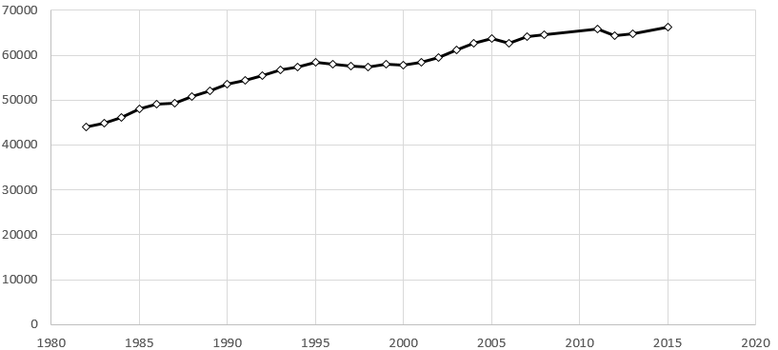

Road Works
The presence of road works reduces traffic capacity on the network. This is through a combination of physical reduction of a road or lane(s), increased side friction, modified traffic conditions, and reduced vehicle speeds.
The greatest single causal impact of recent traffic congestion was the presence of road works in key locations of the network. The most critical road works impact was the Rosny Interchange, as well as various inner city works (including the closure of Liverpool Street over one full week).
The Rosny Interchange works impacted Tasman Bridge traffic flow during the afternoon peak in the following key ways:

Lane widths were reduced and a concrete barrier was placed on a curve as vehicles exited the Bridge. This had an impact of suddenly reducing vehicle speeds on the approach to the barrier, thus causing backwards propagating shock waves along the Bridge.

Lane merging behaviour was modified within the works area, with drivers changing from the left lane to the right lane (to access the Tasman Highway) over a relatively short area. Prior to the road works, a larger merging area was available which reduced the incidence of backward propagating shockwaves on the Bridge.

Modelling analysis was undertaken to understand the impact of reduced vehicle speeds through the road works during the afternoon peak period. This analysis indicated that maintaining higher travel speeds through the road works is critical. The average queues for speeds between 30-km/h and 60-km/h is shown in Figure 2. Whilst the posted speed limit through the works increases to 60-km/h each weekday afternoon, the actual travel speeds through the sweeping bend, with reduced lane width, reduced to between 30km/h to 40-km/h.
This reduced speed caused unstable flow on the bridge, with slow moving queues extending well into Macquarie Street. This in turn reduced capacity in Macquarie Street and all connecting roads along its length, eventually extending into the Southern Outlet.
Figure 2 Rosny Interchange Speed/ Queue Formation
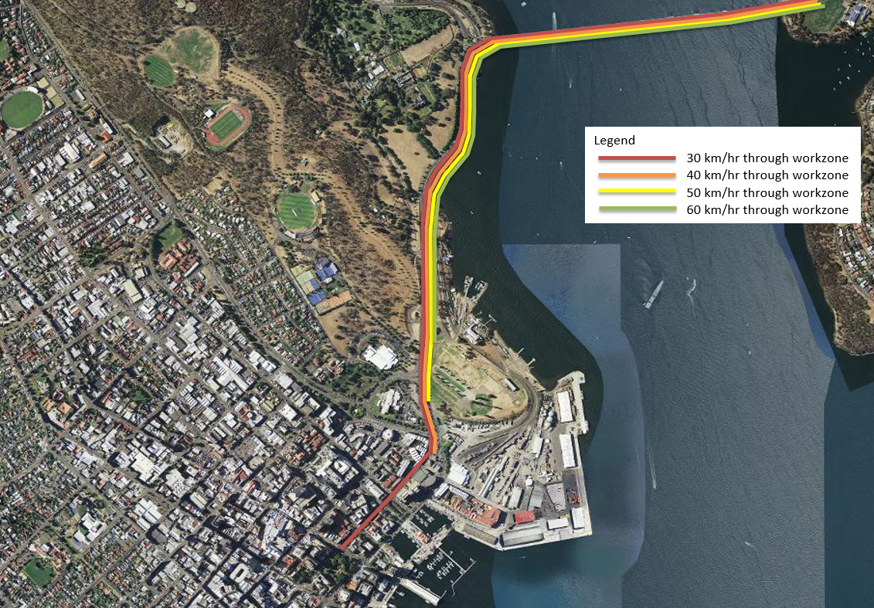

Further traffic modelling was also undertaken of lane changing within the work site. The modelling indicated that the provision of an early merge area (as existed prior to the works) enabled more stable traffic flow, resulting in lower queues extending over the Bridge. This is shown in Figure 3.
Figure 3 Work Site Merging and Vehicle Speeds
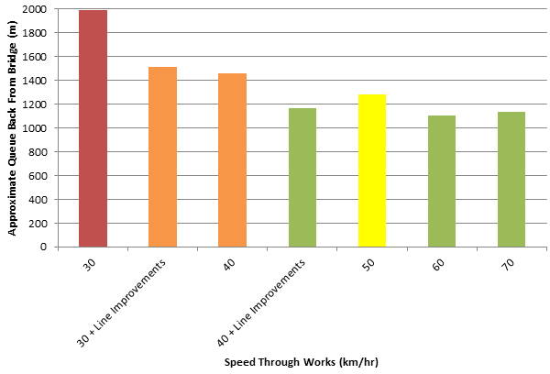
Once improvements were made at the road works site (increased available lane width and additional merge area), traffic flow was measurably improved. Traffic signal SCATS data indicated that congestion decreased by up to 20%.
The closure of Liverpool Street road between Campbell Street and Argyle Street also played a role in increasing traffic congestion through the reduction of network capacity. This impact was more obvious during morning peak, and less so during the evening peak. The road closure redistributed traffic to other sections of the network, thus increasing demands on Davey Street and various roads accessing the city.

Changed Traffic Patterns
There have been various changes to the transport network that has impacted on traffic flow in Hobart and its approaches. These changes include:

Liverpool Street between Elizabeth Street and Murray Street. Through lanes reduced from two to one. Whilst construction of the Icon Complex building had resulted in a temporary lane closure for 18 months, the road was reconstructed.

Morrison Street/ Franklin Wharf. Various changes have reduced capacity through the Sullivans Cove area.

Changed Land Use Patterns
The Myer store reopened in Liverpool Street in November 2015. Whilst this involved the relocation of the temporary Myer sites to the new facility, there is anecdotal evidence that customer visitation has increased.
The completion of the Vodafone building on the corner of Bathurst Street and Argyle Street has increased staff and parking within the CBD.
In recent years, there has been a decentralisation of the University campuses which has resulted in new campuses within Hobart. These University centres include the Menzies Centre, IMAS, and Domain. This has increased staff and student numbers within the CBD and surrounds.

SCATS Traffic Signal Operations
Hobart’s traffic signals operate using SCATS software. Whilst it has had various upgrades over the years, much of the physical infrastructure associated with the SCATS is aging. This results in incompatibility issues with newer versions of the software as well as loop detector failures.

Traffic Data Analysis

SCATS Traffic Signal Data
Comparisons were made of three years of same week in February for 2014, 2015 and 2016. This was done to analyse the changes in traffic volumes on key roads into and through Hobart across the three years. It should be noted that 2014 and 2015 comparison years did not experience heavy congestion, whereas 3 days of the 2016 data were heavily congested.
The results are summarised in the following sections.

Macquarie Street
Macquarie Street SCATS data was analysed at the following intersections:

Southern Outlet

Barrack Street

Harrington Street

Evans Street

Macquarie Street recorded the most significant impacts associated with heavy congestion. The following key issues were noted:

The average weekday traffic volume using Macquarie Street reduced significantly compared to 2015 volumes. The difference was in the order of 1,000 to 3,500 vehicles per day, depending on the location along Macquarie Street. This is shown in Figure 4.

The 2016 hourly weekday flow followed a very similar pattern to 2014 and 2015, except for the evening peak hour. The heavy congestion associated with the evening peak resulted in a large reduction of capacity within Macquarie Street. The congestion created a reduction of approximately 1,000 vehicles per hour in some locations. This peak traffic flow reduction tended to increase the further north along Macquarie Street. This can be seen in Figure 5.
Figure 4 Macquarie Street Average Weekday Daily Traffic Flow
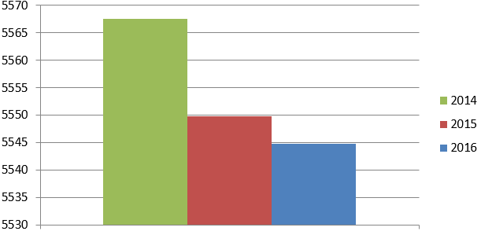 | Macquarie Street (South Hobart approach) Average Daily Weekday Traffic at Southern Outlet intersection.  Note the actual difference in flow is relatively insignificant, with a difference of only 22 vehicles per hour between 2014 and 2016.
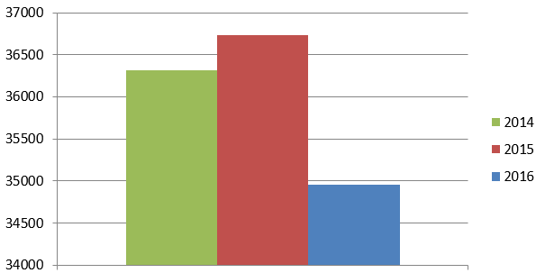 | Macquarie Street Average Daily Weekday Traffic at Barrack Street intersection.  A relatively large reduction of ADT between 2015 and 2016.
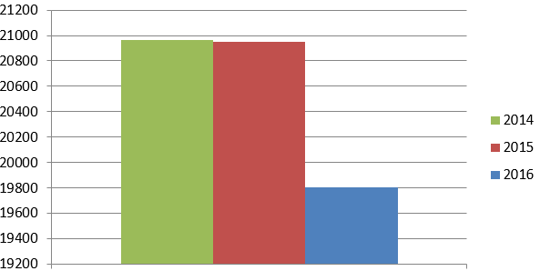 | Macquarie Street Average Daily Weekday Traffic at Harrington Street intersection.  A relatively large reduction of ADT between 2015 and 2016.
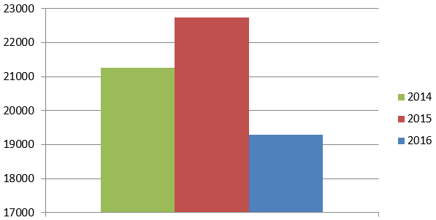 | Macquarie Street Average Daily Weekday Traffic at Evans Street intersection.  A relatively large reduction of ADT between 2015 and 2016.

Figure 5 Macquarie Street Average Weekday Hourly Traffic Flow
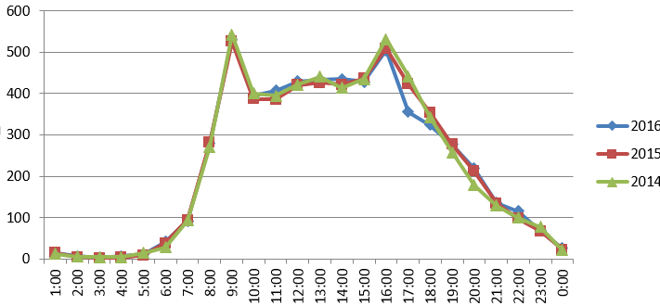 | Macquarie Street (South Hobart approach) Average Daily Weekday Traffic at Southern Outlet intersection.
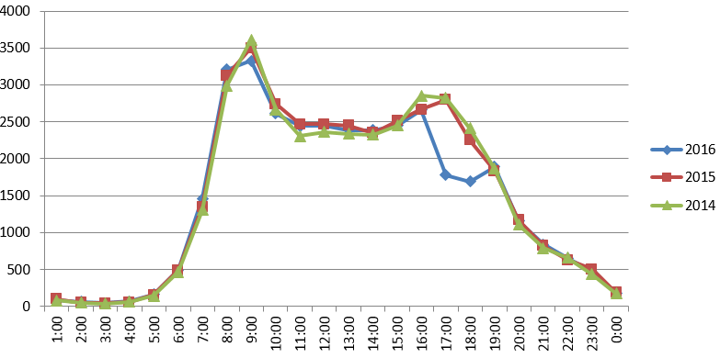 | Macquarie Street Average Daily Weekday Traffic at Barrack Street intersection.
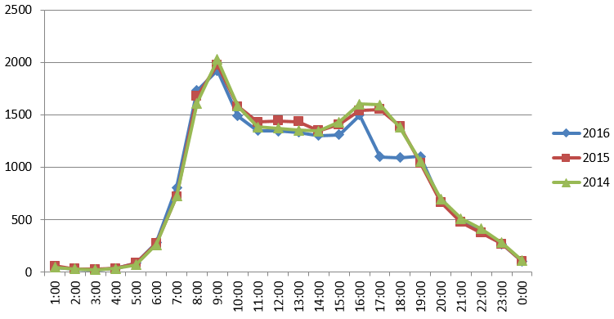 | Macquarie Street Average Daily Weekday Traffic at Harrington Street intersection.
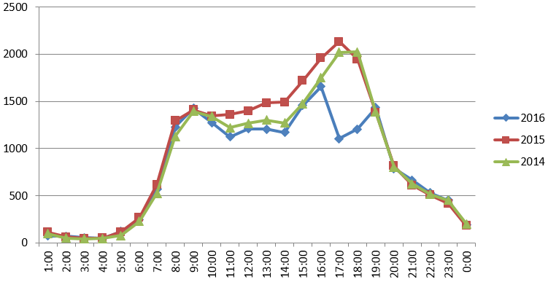 | Macquarie Street Average Daily Weekday Traffic at Evans Street intersection.  Loss of capacity due to heavy congestion

Davey Street
Davey Street SCATS data was analysed at the following intersections:

Southern Outlet

Barrack Street

Harrington Street

Evans Street

Davey Street was less impacted by the congestion. General observations include:

2016 Average weekday traffic volumes generally increased compared to 2014 and 2015 comparison years. The exceptions were Southern Outlet and Evans Street, where a reduction was noted compared to 2015 (Evans Street junction increased in 2016 compared to 2014). This is shown in Figure 6.

The 2016 hourly weekday flow of Davey Street followed a very similar pattern to 2014 and 2015, except for the evening peak hour. The heavy congestion associated with the evening peak resulted in a small reduction of capacity within Davey Street. The reduction was less than Macquarie Street. This can be seen in Figure 7.

There appeared to be a large reduction in traffic flow across the entire day in 2016 at the Southern Outlet. The cause of this is not immediately clear. It is possible that it is a loop detector issue. More investigation is required to determine whether this is an indicator of traffic flow change. Note that the junction does not record movements to the Southern Outlet exit.

Figure 6 Davey Street Average Weekday Daily Traffic Flow
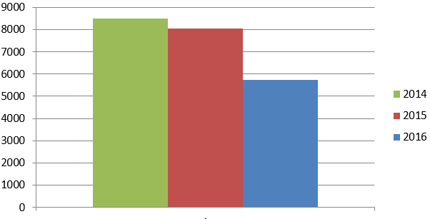 | Davey Street Average Daily Weekday Traffic at Southern Outlet intersection.  Note only vehicles accessing Davey Street (South Hobart approach) or Macquarie Street are recorded. Vehicles entering the Southern Outlet are not recorded.
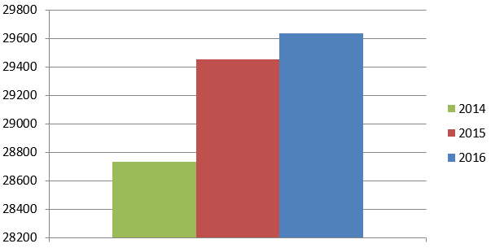 | Davey Street Average Daily Weekday Traffic at Barrack Street intersection.
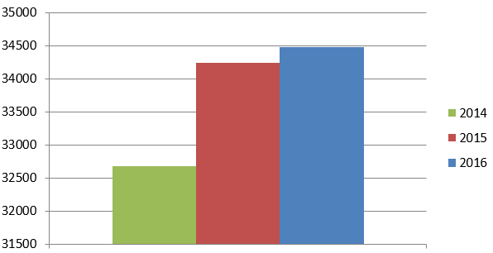 | Davey Street Average Daily Weekday Traffic at Harrington Street intersection.
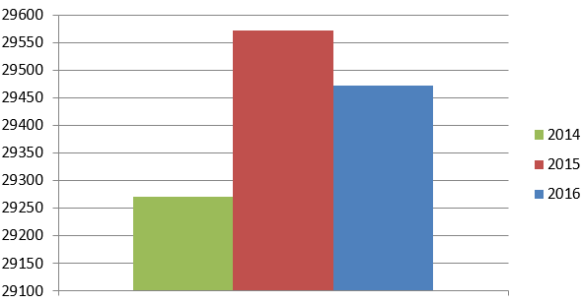 | Davey Street Average Daily Weekday Traffic at Evans Street intersection.

Figure 7 Davey Street Average Weekday Hourly Traffic Flow
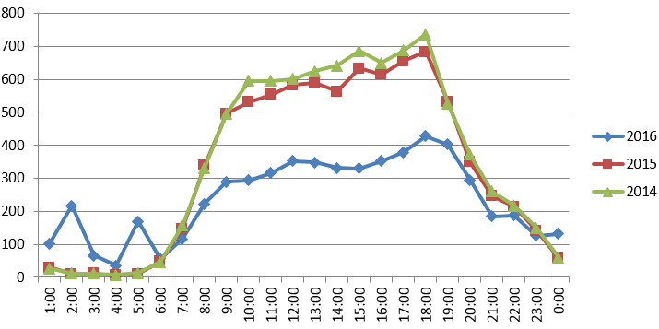 | Davey Street Average Daily Weekday Traffic at Southern Outlet intersection.  Note only vehicles accessing Davey Street (South Hobart approach) or Macquarie Street are recorded. Vehicles entering the Southern Outlet are not recorded.
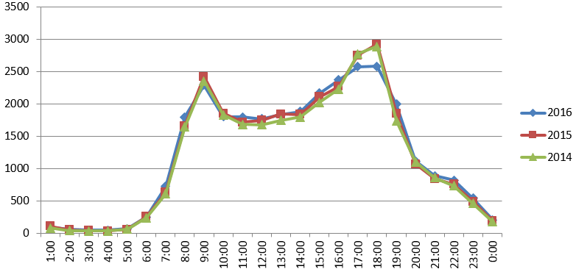 | Davey Street Average Daily Weekday Traffic at Barrack Street intersection.
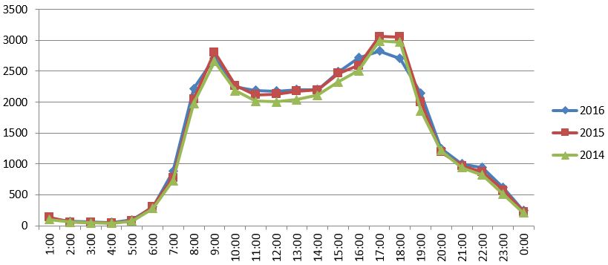 | Davey Street Average Daily Weekday Traffic at Harrington Street intersection.
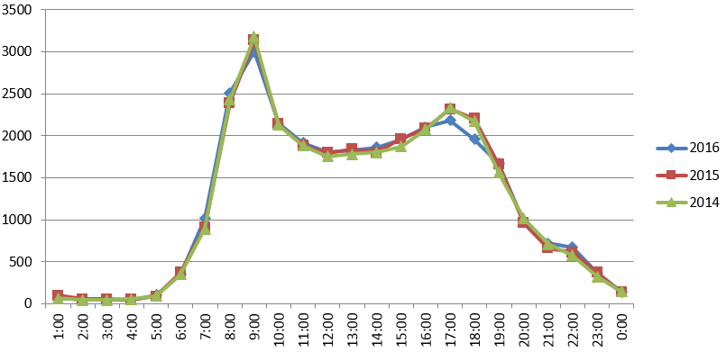 | Davey Street Average Daily Weekday Traffic at Evans Street intersection.

Barrack Street
Barrack Street follows a similar pattern to Macquarie Street, with a decrease of average weekday daily traffic volume in 2016, and a significant reduction of flow during the evening peak. The evening peak reduction was in the order of 260 vehicles per hour in 2016 compared to 2014 and 2015.
This is shown in Figure 8.
Figure 8 Barrack Street Weekday Traffic Flow
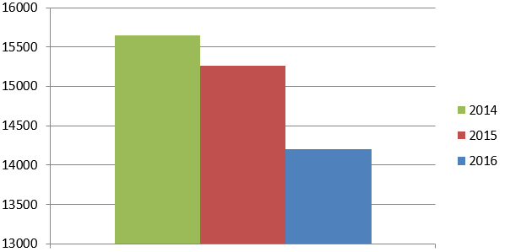 | Barrack Street Average Weekday Daily Traffic Volumes at Macquarie Street Intersection.
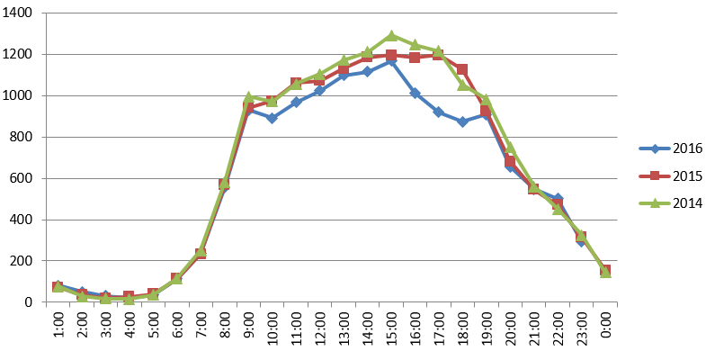 | Barrack Street Average Hourly Daily Traffic Volumes at Macquarie Street Intersection.  Loss of capacity due to heavy congestion

Harrington Street/ Sandy Bay Road
The average weekday traffic volume in 2016 for Harrington Street (Sandy Bay Road approach) was higher than 2015, but lower than 2014.
As with Barrack Street, the evening peak had significantly reduced flow due to the effects of heavy congestion on the network.
Figure 9 Harrington Street/ Sandy Bay Road Weekday Traffic Flow
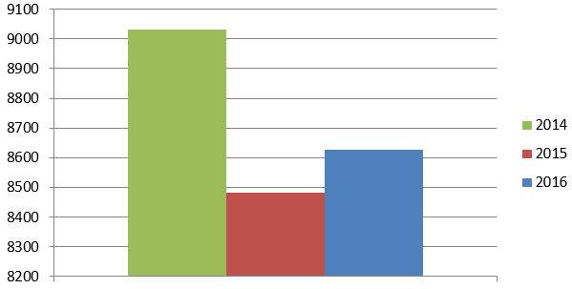 | Harrington Street/ Sandy Bay Road Average Weekday Daily Traffic Volumes at Davey Street Intersection.
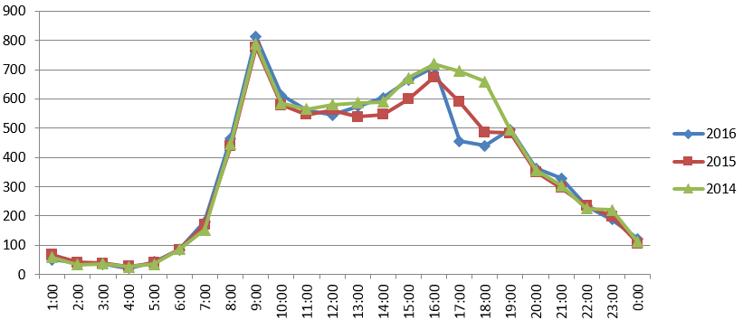 | Harrington Street/ Sandy Bay Road Average Hourly Daily Traffic Volumes at Davey Street Intersection.  Loss of capacity due to heavy congestion

Southern Outlet
The Southern Outlet has experienced average weekday traffic growth across all analysis years. The hourly weekday flows were similar across all years, with the significant reduction during the afternoon peak being consistent with Macquarie Street. This is shown in Figure 10.
Figure 10 Southern Outlet Weekday Traffic Flow
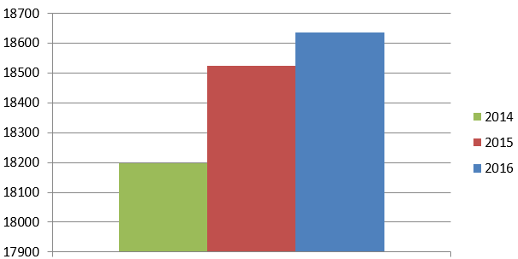 | Southern Outlet Average Weekday Daily Traffic Volumes at Davey Street Intersection.
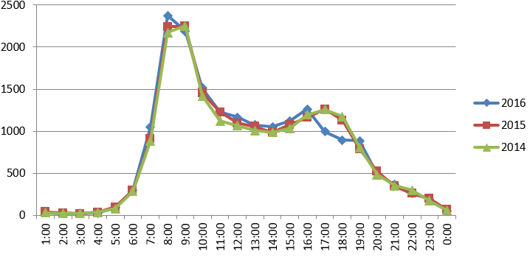 | Southern Outlet Average Hourly Daily Traffic Volumes at Davey Street Intersection.

Car Parking Data
One of the major influences on traffic demand is parking. Parking provides the end-point destination within the City. The availability of parking therefore can have a strong impact on traffic volumes entering the city during the morning, and exiting during the evening. The type of parking also influences traffic demand. Long term parking attracts commuter traffic by storing cars for people working in or near the city, and short term parking attracts trips such as shopping and services. Other factors such as parking price and accessibility play a role in generating vehicle trips throughout the day.
Parking data was obtained from Hobart City Council on the three major Council controlled car parks: Argyle Street Car Park, Hobart Central Car Park, and Centrepoint Car Park for the months of January and February in 2014, 2015 and 2016. These three car parks provide the largest single amount of parking within the city, with a total provision of 2,197 spaces (950 spaces in Argyle Street, 465 spaces in Hobart Central, and 782 spaces in Centrepoint).
The total number of car parking numbers at Council’s major car parking stations is shown in Figure 11 for the months of January and February in 2014, 2015 and 2016. It can be seen that there has been a consistent increase in total car parking demands in January and February between 2014 and 2016. In particular, in February 2016 there has been an increase of 7,129 vehicles compared to 2015, and 12,523 vehicles compared to 2014.
Figure 11 Jan/ Feb Total Monthly Car Parking – Argyle, Centrepoint, Hobart Central
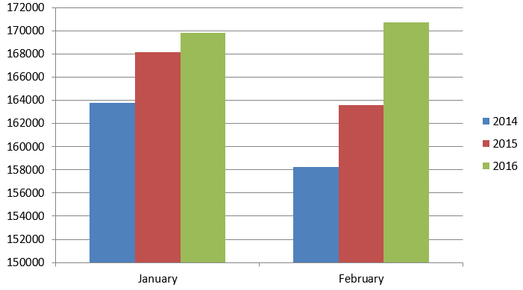
Weekday patronage trends remain consistent however, with a progressive increase in January between 2014 and 2016, and relatively steady during February. This indicates that much of the increase has occurred on weekends. Car parking demands are consistently higher in February compared to January across all three analysis years.

Figure 12 Jan/ Feb Average Weekday Car Parking – Argyle, Centrepoint, Hobart Central
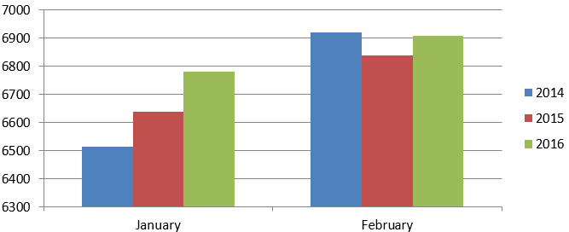

The increase use of the three major Council car parks is only a small proportion of the change in parking within the Hobart CBD. There has been an increase in the quantity of permit and long term parking in Hobart. It is estimated that there has been an additional 500 parking spaces in and around Hobart in the last 12 months. Examples include Evans Street (old Toll site), Vodafone Centre, reuse of land uses for parking (such as small car yards), reopening of Montpelier Street car park.
The majority of these new car parking spaces are long stay/ commuter spaces:
- Evans Street car park (former Toll site) approximately 200 spaces consisting of ~100 permit spaces, ~100 early bird spaces.
- Montpelier Retreat spaces (closed during 2015 for construction activity) approximately 190 spaces consisting of 90 permit spaces and 100 voucher parking spaces.
- Vodafone Centre – approximately 200 spaces
- Various reuse of land for car parking – approximately 100 spaces

It is therefore clear that the increased parking provision has resulted in increased traffic demand into the city. The new car parking spaces also have the impact of redistributing traffic on the network. For example, the use of Evans Street for long term parking spaces differs from the use of the site for a transport depot. When the site was used as a transport depot, many of the trips would have utilised the Brooker Highway and Tasman Highway, however the car park is likely to utilise a wider portion of the network.

Recommendations
Hobart’s traffic network is approaching capacity during peak periods. This results in unstable flow when the transport system is placed under stress. Events such as increased traffic demand (inclement weather, return of school, etc) or reduced capacity (road works, vehicle crash, etc) result in rapid deterioration of traffic flow conditions.
The key locations where the network appears to be at or close to capacity includes:

Tasman Bridge

Brooker Avenue/ Liverpool Street/ Bathurst Street, Railway Roundabout

Southern Outlet/ Davey Street/ Macquarie Street

Sandy Bay Road/ Harrington Street at Davey Street/ Macquarie Street

Barrack Street at Davey Street/ Macquarie Street

These components appear to be the ‘weak links’ of the network and are often the source of citywide congestion when an incident or capacity reducing issue occurs.

Immediate/ Implemented/ Underway
There are currently a number of road network changes that are underway, or pending.

Tasman Bridge Ramps Construction
The single greatest contributor to the current traffic congestion is the road works on the eastern departure of the Tasman Bridge. As stated previously lane widths were reduced, a concrete barrier was placed on a curve as vehicles exited the Bridge and lane merging behaviour was modified within the works area.
Completion of these road works is essential to the improvement of traffic congestion within the CBD. It is recommended that where possible the roadway is widened, line marking is improved and night works be implemented to reduce construction times.
It is noted that the completion of these works will result in greater traffic capacity at the eastern departure of the Bridge and this will improve traffic flow conditions on Tasman Highway and Macquarie Street as a result.

Barrack Street/ Collins Street Junction Upgrades
Hobart City Council are currently implementing changes to the Barrack Street/ Collins Street junction to improve traffic flow at this location. The works will assist in reducing vehicle queues upstream in Barrack Street.

Traffic Data Collection
Work is currently underway to obtain live traffic data that includes travel times on key routes and origin-destination data. This data will be essential to assist with future longer term improvements to the network.

Short Term
Short term recommendations should be considered within a five year timeframe.

Maintenance of Current Clearways
At several locations within the CBD road network the road space is not utilised appropriately due to narrow lanes adjacent to parking. Narrow lanes reduce vehicle speeds and in some instances drivers have been observed encroaching into adjacent lanes, to give space to parked vehicles, impeding a secondary lane of traffic. These include but not limited to:

Davey Street between Barrack and Molle Street. Parking on the right hand side of the road limits road space reducing vehicle speeds in this lane. Several instances observed of drivers encroaching onto adjacent lanes to provide space between themselves and parked vehicles, impeding a secondary lane of traffic.

Davey Street between Antill Street and Southern Outlet. Parking on the left hand side of the road limits road space reducing vehicle speeds in this lane. Several instances observed of drivers encroaching onto adjacent lanes to provide space between themselves and parked vehicles, impeding a secondary lane of traffic.

Davey Street between Antill Street and Southern Outlet. Parking on the right hand side of the road limits road space for vehicles queuing for Huon Road and Macquarie Street.

Barrack Street between Macquarie Street and Davey Street. Parking on the right hand side of the road limits road space reducing vehicle speeds in this lane.

Macquarie Street between Antill Street and Molle Street. Parking on the left hand side of Macquarie Street limits road space, reducing vehicle speeds in this lane. Vehicles parked in the clearway morning peak periods also extends vehicle queues past Antill Street towards the Southern Outlet approach.

Installation of New Clearways and Extension of Existing Clearways
There are several locations on the Davey Street/ Macquarie Street Couplet where new clearways or extensions of clearways would improve traffic flow.
The key locations are:

Macquarie Street between Harrington Street and Murray Street. A clearway on the right hand side of Macquarie Street extending back from Murray Street to the Service Tasmania building would separate right turning traffic from through traffic, thus improving through flow and increasing storage for right turning vehicles.

Davey Street between Salamanca Place and Harrington Street. A clearway on the right hand side of Davey Street, extending back from Harrington Street would separate right turning traffic from through traffic, thus improving through flow and increasing storage for right turning vehicles.

Traffic modelling indicates that these clearways would improve travel times on the Davey Street and Macquarie Street corridors. Macquarie Street shows the greatest improvements to travel times, with 10-km/h to 20-km/h improvements to vehicle speeds during the PM peak (near Murray Street).

Lane Allocation Within Hobart CBD
As stated previously there has been a change in travel patterns within the Hobart CBD. This in turn means that traffic gets redistributed on different roads and will make turns at different locations than they once did. These changes can result in existing lane configurations providing inefficient use of the road space with oversaturated lanes, adjacent to under saturated lanes. There are several examples of this in the Hobart CBD, where travel patterns have changed, but the lane configurations have not changed to match. Two such examples are shown in Figure 13 and Figure 14. Note that these roads are owned and maintained by Hobart City Council.
Figure 13 below shows the current configuration of Murray Street, next to a proposed update to the lane configuration. Of note in the existing configuration is that the three right turn lanes at the intersection of Murray Street and Davey Street, trace back to a single lane upstream of Collins Street. Observations from the State Growth Transport Control Centre show that this single lane that feeds the three right turn lanes at the intersection of Murray Street and Davey Street is over utilised when compared to the adjacent lane. The proposed new lane configuration addresses this issue, distributing traffic flow more uniformly.
Figure 13 Proposed update to Murray Street lane configuration
Existing Lane Configuration | Proposed new Lane Configuration  Davey Street  Macquarie Street  Collins Street

The second example of inefficient use of road space is at the intersection of Molle Street and Macquarie Street.
Between Davey Street and Macquarie Street, the left most lane of Molle Street terminates a short distance past Davey Street, making this lane less attractive. Reviewing SCATS traffic volume data shows that this lane attracts only 50 veh/hr in the peak period, well below the capacity of a single lane. The proposed new lane configuration addresses this issue, distributing traffic flow more uniformly.

Figure 14 Proposed update to Molle Street lane configuration
Existing Lane Configuration  Macquarie Street  Davey Street | Proposed new Lane Configuration

Traffic modelling indicates that these two changes could result in a reduction in Vehicle Hours Travelled in the Hobart CBD by up to 4%. It is recommended that each of the major traffic carrying streets within the CBD be reviewed to ensure that their lane structure is still relevant.

Pedestrian Crossing Locations
There are several locations where pedestrian movements impede high volume traffic movements. Some key locations are:

Murray Street/ Davey Street intersection. The high volume of right turning traffic (three lanes) must give way to pedestrian movements on the southern side of the junction. If all pedestrian movements were confined to the northern crossing location, it would improve traffic capacity significantly. The high volume of pedestrians at this location may require improvements to the northern crossing location (greater crossing width, etc). Alternatively, a revised signal layout that includes a right turn amber signal and a through green arrow (that has no pedestrian conflict) can be considered to improve efficiency of traffic movements at this location.

Harrington Street/ Macquarie Street intersection. The high volume of right turning traffic (two lanes) must give way to pedestrian movements on the northern side of the junction. If all pedestrian movements were confined to the southern crossing location, it would improve traffic capacity significantly.

Note that this treatment is currently in place at the Barrack Street/ Davey Street and Campbell Street/ Davey Street junctions (where a pedestrian crossing is only located on one side of the side road to assist the high volume of turning traffic).

Extension of Hobart Traffic Model
State Growth currently have a series of comprehensive traffic microsimulation models that cover a large portion of Hobart’s traffic network. These include:

Hobart Traffic Model

Brooker Highway Traffic Model

Eastern Shore Traffic Model
These models currently work in isolation and many important components of the network are not included. It is recommended that these models be extended to include:

Sandy Bay approaches to Davey Street. This includes Antill Street, Byron Sreet and Sandy Bay Road approaches and connecting roads within Sandy Bay/ Battery Point.

Western approaches to Hobart. This should include Barrack Street, Murray Street and Campbell Street and a large portion of the North Hobart/ West Hobart network.

Sullivans Cove.
The current ARRB origin-destination data will greatly assist in the development of these models.

Medium Term
Medium term recommendations should be considered within a 5 to 10 year timeframe. Note that some aspects of the medium term recommendations may be achievable within a short term timeframe.

Travel Demand Management
Providing real time driver information may assist in preventing the onset of congestion, or reducing its overall impact. This can be done through the provision of online information (apps/ website providing real time travel time information), or through travel time information on the approaches to the City (such as provided on many mainland freeways).
Measures such as changes to office staff start and finish times may also reduce demands during peak periods. Government agencies and large employers within the City can play a leading role in achieving this.

Communication and Coordination of Greater Hobart Construction Traffic Management
For a city to remain vibrant and relevant it needs to continue to develop. However, if development isn’t coordinated appropriately it can cause situations where multiple construction projects are occurring at once and their combined effects on traffic are greater than the effect of each project individually. To counter this it is recommended that a team or division with members from State Growth and Hobart City Council be established to coordinate construction traffic management.
The impacts of traffic management on the greater Hobart transport network need to be better understood. Mitigation strategies need to be developed to divert traffic onto areas of the network that have spare capacity if possible, or strategies need to be developed to ensure that traffic signal timing can be adapted to cater for the temporary changes to network flow conditions generated by construction activity.

Parking Policy
Having low cost, all-day, large capacity, parking structures in the centre of the CBD promotes commuter traffic within the centre of the city. The further into the centre of the CBD a parking structure is the more time commuters have to travel within the CBD to access it at peak travel times. This is also true of free parking provided at office buildings.
It is recommended to change parking policy to limit inner city parking to short term parking and restricting the use of parking at office buildings.
Consideration should also be given to the cost of congestion imposed on motorists as a result of increasing parking supply. A mechanism for recovering these costs in the form of a parking cost at development stage could assist with infrastructure funding to improve traffic congestion.

Public Transport & Active Transport
The provision of improved public transport and the promotion of active transport modes will assist in reducing private motor vehicle demands.
Measures such as the reuse of the Northern Suburbs railway should be considered, as well as Ferry transport to reduce demands on the Tasman Bridge.
Other measures to improve public transport should also be considered. This may include infrastructure modifications to provide public transport priority (lane allocation, traffic signal priority, etc). There is currently little public transport priority built into Hobart’s transport network. Such improvements would trigger demand shifts towards public transport. Due to Hobart’s constrained network, it is important to ensure that on-road public transport measures do not deteriorate network efficiency to the extent that any travel time benefits are negated.

Incident Management
Hobart’s traffic network is constrained. There are few alternative routes available in the event of an incident (such as a major vehicle crash, large vehicle breakdown, etc). Comprehensive incident management procedures should be developed to cater for perceivable incidents on key components of the network (such as the Tasman Bridge, Davey Street, Macquarie Street, Railway Roundabout, etc). Whilst it is noted that various agencies already have incident management procedures (such as Tasmania Police), however they should be integrated to ensure rapid and effective response.
The recent incident involving a bus breakdown on the Tasman Bridge highlights this need. Whilst tow trucks are rapidly deployed for vehicle breakdowns on the bridge, this did not occur when the bus blocked a lane prior to the PM peak period. This incident caused serious congestion in a wide portion of Hobart’s network that could have been avoided. The availability of appropriate response vehicles to safely remove the bus rapidly may have averted this issue.
Improvements to State Growth’s control centre is also critical to improving incident response management. Improved live monitoring of key routes through the city should be considered, including the installation of more surveillance cameras with recording capability.

Long Term

CBD Access and Commuter Car Parking Locations
Currently there are limited options for people wishing to access the CBD, travelling from the Tasman Highway vehicles are funnelled into Davey Street or Liverpool Street, from Southern Outlet they are funnelled into Macquarie Street. Providing additional access points to the city would assist in dispersing this traffic onto multiple roads.
Additionally commuter parking structures could be provided on the outskirts of the city, but within a reasonable walking distance for an average abled-bodied person. Such locations could be Macquarie Point, Warwick Street or Huon Road. These strategies could be supplemented with shuttle bus (or similar) services.

Railway Roundabout
The railway roundabout is a major cause of congestion and impediment to entering the CBD. The presence of multiple closely spaced signalised intersections, with multiple signal phases reducing capacity at the entrance to the city. The more signal phases within a traffic signal cycle the more intergreen time where no traffic is moving. A possible solution is the grade separation of the roundabout. This would allow for the removal of several sets of signals and the simplification of the signal phasing.

City Planning
Reducing the need for people to enter the city for work purposes, would reduce the congestion on the roads. Consideration should be given to the further development of areas such as Sorell, Kingston and Clarence, for office type employment to negate the need to enter the city.
Consideration should also be given to the cost of congestion imposed on motorists as a result of development. A mechanism for recovering these costs in the form of a headworks charge can assist with infrastructure funding to improve traffic congestion.

Improvements for Cross City Traffic Flow
One of the key issues associated with traffic congestion is the movement of traffic across the Macquarie Street/ Davey Street Couplet.
Measures to improve capacity for through movements on key roads such Sandy Bay Road/ Harrington Street, Barrack Street, Molle Street and Murray Street would play a key role in reducing congestion within the City. Techniques such as grade separation from the Couplet (tunnel, overpass, etc) and/or increased approach lanes should be considered in the long term.
It is also noted that the separation of pedestrian movements at key intersections on the Couplet may also have a positive impact on road capacity. At some locations such as Elizabeth Street and Murray Street, high volumes of pedestrians reduces the available green time for vehicles. Measures such as pedestrian tunnels or overpasses should also be considered in the longer term. Such measures would provide improved pedestrian connectivity between Sullivans Cove and the CBD, but would need to be carefully designed to maintain appropriate levels of mobility.

