JUNE 2020 EDITION

Accreditation audits
Passenger transport operator accreditation is intended to protect the community. This is achieved by ensuring taxi services are safe and operated responsibly and competently. Services must be operated in a manner consistent with maintaining the safety of passengers and the public. This leads to public confidence in the taxi industry.
The systems you use to manage your taxi operation, such as to manage drivers and maintain your vehicles, must meet the Accreditation Standards.
When you became accredited, your systems were assessed by an approved auditor and found to be able to meet the Accreditation Standards.
To ensure your systems are continuing to meet the Accreditation Standards, your taxi service must undergo an audit by an approved auditor (found at this link) at regular times. The auditor puts their findings into an audit report sent to Passenger Transport. Auditors make findings about:
- your systems

- how well your systems function

- how well your systems meet the Accreditation Standards and

- how well your systems work when your taxi service changes (such as when you use new drivers, or use other taxis).

Your audit must be undertaken in time for the audit report to be provided to Passenger Transport by the due date. The due date can be found on your accreditation certificate. If the audit is not provided to the Department it means:
- that you have breached a condition of your accreditation and may be fined and

- questions may be raised as to whether your systems are working.

If you are unable to have an audit done on time, you need to apply for a variation of condition of accreditation by completing a form (found at this link) and paying a fee of $81.00 at Service Tasmania.

Audits due between 1 April 2020 and 30 September 2020 have been deferred for six months. If your audit has been deferred you will have received a new accreditation certificate showing the deferred due date.

Health Information COVID-19
The COVID-19 health directives are changing rapidly. Keep up to date with the most recent information relating to the situation in Tasmania (found at this link).
Encourage your drivers to download the COVIDSafe app (found at this link). If they and/or your passengers who ride in your taxi are exposed to COVID-19 they can be contacted quickly.

Response to COVID-19
The taxi industry has an important role within Tasmania during the global pandemic.
As a taxi operator you provide a transport option for Tasmanians to access essential services such as supermarkets and medical appointments. As restrictions ease, you play a significant part in revitalizing the Tasmanian community by providing transport to and from venues previously closed due to public health orders.
The Tasmanian Government has responded to industry concerns about the impact on taxi businesses with a range of supporting measures so that the taxi industry can continue to provide these services. The range of measures implemented are:
Owner Operator Taxi Licence Tender 2020 | No tender in 2020
Annual Administration Fee | No fee to be paid in 2020
Compliance Audit Deferrals | Audits due between 1 April 2020 and 30 September 2020 deferred for six months
Extending Maximum Operating Age | Taxis which reach the maximum operating age between 1 March 2020 until end of emergency order can still be used
Registration Relief | When registration expires between 1 March 2020 and 30 September 2020 no registration fee applies (on application can be frozen or extended for 12 months)

COVID-19 Safe Workplace Guidelines
The Department of State Growth, in collaboration with industry, has produced the Small Passenger Transport COVID Safe Workplace Guidelines (found at this link). The Guidelines have been developed to ensure consistency across industry and to ensure workers, drivers and others are safe. Operators can use the Guidelines to help prepare their own safety plan.

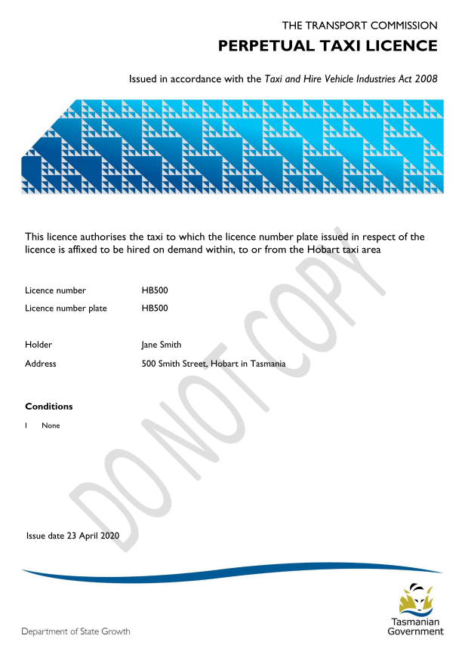
New Taxi Licences
Holders and owners of taxi licences received a revised licence document in May 2020. Your licence will now look like the sample.
Keep your licence document safe, just as you keep any important document safe.
A replacement licence document will only be issued when:
- some information on it changes

- it has been lost, stolen, damaged or destroyed or

- some other reason determined by the Transport Commission.
Before a replacement licence document is issued, the holder or the owner must provide information showing that they no longer have it and pay a fee.

Regulations and Concessions Unit
If you require assistance please e-mail: Operator.Accreditation@stategrowth.tas.gov.au.

