It is the owner’s responsibility to ensure all accessories and equipment attached to a motor vehicle are designed and fitted in a manner which reduces the risk of injury to pedestrians and other road users that may make contact with the vehicle when either parked or in motion.
This information bulletin provides some information on what is acceptable without seeking modification certification.
A vehicle must remain compliant with all applicable Australian Design Rules.
At all times the regulatory requirements take precedence over the information provided here.

Field of view;
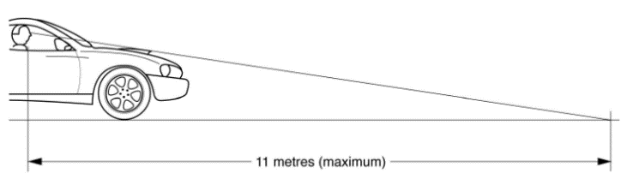
Any accessories or attachments that are fitted, must not reduce the driver’s ability to safely drive the vehicle to which they are attached.
When seated in the driver’s seat in the rearmost set position it shall be possible to see the surface of the road 11 metres or less in front of the driver’s eye or the front edge of the original body when looking across the top of any accessories or attachments.

Bull bars;

Information on Nudge bars, Bull Bars and other Frontal Protection Systems can be found at the Departments website (link below):
http://www.transport.tas.gov.au/vehicles/specifications/vehicle_specification

Rod Holders
Fishing rod holders can only be fitted providing they comply with the following conditions:
- Rod holders must be either removed or retracted behind the profile of the FPS when they are not in use.
- The fitting allows the driver a view of the road and of traffic to the front and sides of the vehicle.
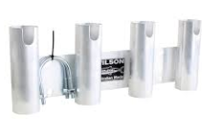
- They must only be attached to the left side of the vehicle.
- They must be designed to carry no more than four fishing rods.
- Rods, hooks and sinkers must be properly secured.
- Vehicle lighting must not be obstructed by rods or holders.

Roof racks;
Loaded roof racks increase the vehicles centre of gravity and may lead to excess body roll, reduced vehicle stability and handling.
Care must be taken to not overload the roof racks or the vehicle manufacturer’s recommendations for roof rack mass. Manufacturers of roof racks generally stipulate the maximum mass for their racks.

Tradesman or ladder racks;
These are generally fitted to utilities or vans and have front supports to carry longer loads.
Conditions that apply to Tradesman/Ladder racks;
- The vertical uprights are behind any bull bar frame work,
- The uprights do not block the regulatory lights,
- There are no sharp corners or edges on the uprights or rack.
- The uprights are kept to a minimum diameter and do not block the drivers view,
- The uprights must be structurally sound and adequate to support the mass of the rack and load,
- The rack must not extend forward of the vehicle front bumper,
- Any load on the rack must not extend forward of the front bumper by more than 1.2 metres.
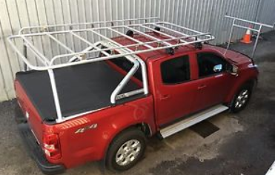
The following picture shows the preferred method of carrying longer items on a roof rack as the front support and uprights can and must be removed when not in use.
For rear overhang or side projections refer to the
information bulletin on the Departmental Website for
Carrying Loads link under heading Web Links below.

Bonnet scoops;
Modifications to the bonnet of a vehicle must take into account the possibility that a pedestrian or cyclist might strike the scoop or bonnet projection in a collision. The top surface of a scoop must not be more rigid than the original bonnet.
Rigid engine-mounted components that are likely to increase injuries to a pedestrian in a collision must not project through and above the vehicle’s original bonnet profile, unless protected with a cover mounted to the bonnet.
Bonnet-mounted scoops must meet the following requirements:
- When a 165mm diameter sphere is placed on the bonnet in front of the scoop (or bonnet projection) and rolled rearwards until it touches the scoop, no point of contact between the sphere and the scoop must lie above a horizontal plane passing through the centre of the sphere.
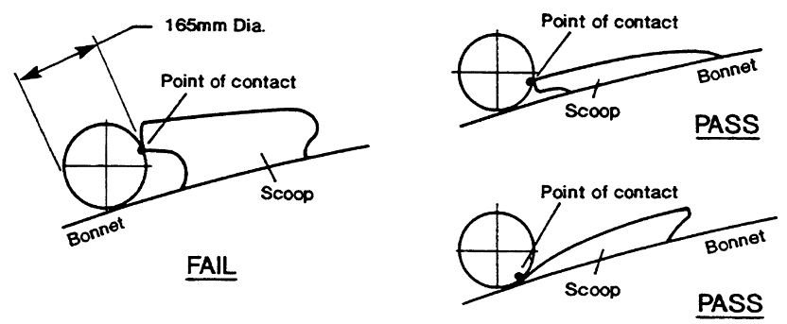
- When sitting in the driver’s seat with the seat located at its rearmost position, it must be possible to see either the surface of the road, 11 metres or less in front of the driver’s eye or the front edge of the original body when looking across the top of the bonnet scoop and
- The edges at the front of a scoop likely to contact a pedestrian in a collision must be well rounded with a minimum of 10mm radius;

- All edges and corners must have a radius of not less than 5mm and be of a general design and construction that reduces the risk of bodily injury to any person;
- The scoop must not have reflective surfaces that will cause glare towards the driver or other road users;
- A bonnet scoop manufactured from a plastic or fibreglass material may be fitted, providing that the hole in the original bonnet does not substantially reduce the strength or impact resistance of the bonnet and no rigid component, such as an air cleaner or carburettor, protrudes beyond the original bonnet profile;
- Holes may be cut in the bonnet to allow the protrusion of an air cleaner or carburettor above the bonnet line providing the protrusions remain underneath the bonnet scoop. In these circumstances, the bonnet scoop or raised bonnet section must be manufactured from mild steel of equivalent gauge to that of the original bonnet; and
- If any bonnet reinforcing braces are cut or modified, the design of the modified bonnet must be of equal strength to the original bonnet and any sharp edges created must be suitably treated.

Accessory gauges;
Additional gauges may be fitted in a position visible to the driver provided they meet the following;
- The gauges, brackets and covers must be of smooth construction with rounded edges so they are not likely to increase the risk of injury to a person.
- Any instrument lighting must not be greater in intensity than the vehicle dash lighting.
- Be positioned in a way that does not adversely affect the driver’s field of view.
- Encroach upon the deployment area of any of the vehicle’s Supplementary Restraint Systems (Air bags, seatbelts, head restraints, etc.).
It is recommended that pressure gauges are of a type that are electronically controlled. If the gauges require pressure lines the lines must be appropriate for the pressures and temperatures involved, protected from damage and that in the event of a leak no fluid is able to spray onto the windscreen or any person.

Side skirts, flares and spoilers;
Cosmetic body modifications such as wheel guards, side skirts and front or rear spoilers are permitted without approval, they must not be fitted so they are likely to increase the risk of bodily injury to a pedestrian or other road user coming into contact with the vehicle. All material is to be of a suitable thickness and be free from sharp edges or corners.
Spoilers, air dams and side skirts must exceed the minimum ground clearance requirements of 100mm. It is recommended that the air flow for the brake cooling is not adversely affected.
Rear spoilers must be within the body shape/outline of the mounting surface (for example, the boot outline). The minimum thickness of end plates is 4mm and they must be free of sharp edges or corners.

Visual display units;
Visual display units such as DVD screens, reversing cameras, and so on may be installed in a motor vehicle without specific approval. However, no part of the image on the screen may be visible to the driver in the normal driving position unless the screen is disabled when the vehicle is being operated or it is considered a driver’s aid.
It is an offence to use a mobile phone (incorporating driver aids) while the vehicle is moving or is stationary but not parked and requires the driver to touch the devise.
The following visual display units are considered driver aids:
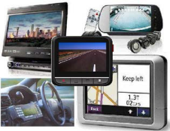
- Dispatch systems
- Navigational or intelligent highway and vehicle system equipment e.g. GPS
- Rear view screens
- Ticket-issuing machines
- Vehicle monitoring devices
Other visual display units not considered driver aids include:
- DVD players
- Television receivers
- Gaming systems
- In-vehicle traffic cameras (which do not increase the vehicle operators field of view)
When fitted, the unit must not:
- Be positioned in a way which adversely affects the driver’s field of view.
- Encroach upon the deployment area of any of the vehicle’s Supplementary Restraint Systems (Air bags, seatbelts, head restraints, etc.)
- Impede the movement of occupants in the vehicle
- Be fitted in a location which could contact occupants in the event of a crash
- Be fitted in a location where any image on the screen is likely to distract other drivers
- Be fitted in a way such that it can easily dislodge in a crash or under heavy braking/acceleration
- Obstruct occupant access into the vehicle.

Web Links;
The Australian Standards can be purchased from; infostore.saiglobal.com/
The ADRs can be accessed at the following; www.infrastructure.gov.au/roads/motor/design/adr_online.aspx
Vehicle and Traffic (Vehicle Standards) Regulations 2014
https://www.legislation.tas.gov.au/view/html/inforce/current/sr-2014-070
Vehicle Standards Bulletin 14 (National Code of Practice Light Vehicle Modifications)
https://infrastructure.gov.au/roads/vehicle_regulation/bulletin/vsb_ncop.aspx
Vehicle Standards Information Bulletins
http://www.transport.tas.gov.au/vehicles/specifications/vehicle_specification
Carrying Loads Information Sheet
http://www.transport.tas.gov.au/vehicles/specifications/vehicle_specification
For more information contact:
Department of State Growth
Vehicle Registration and Standards
GPO Box 536
Hobart TAS 7001
Phone: (03) 03 6166 3263
Email: vehicle.standards@stategrowth.tas.gov.au
Web: www.transport.tas.gov.au

