Public consultation summary report
Tasman Highway - Great Eastern Drive
Tasman Highway Dianas Basin to St Helens overtaking facilities
October 2020

Contents
Public Consultation Summary Report i
Project overview 1
Consultation objectives 2
Consultation process 2
Individual meetings 2
Face to face consultation 2
Other forms of engagement 2
Consultation Feedback & Outcomes 3
What did we hear? 3
Our response 3
What happens next? 6
Further information 6

Project overview
The Tasman Highway is part of the Great Eastern Drive, one of Tasmania’s five self-drive touring journeys developed to drive visitation to regional areas.
This project will improve the experience of the growing number of travellers visiting our state as they travel to experience fast emerging icons such as the Great Eastern Drive.
A section of the Tasman Highway between Diana’s Basin and St Helens Point Road has been identified for an upgrade to improve safety and provide greater overtaking opportunity.
The Tasmanian Government has committed $8.3 million to construct overtaking lanes in each direction and other general road improvements.
The project aligns with the State Roads Infrastructure Service Policy to provide road infrastructure and services meeting the following objectives:
- Are as safe as reasonably possible.
- Support economic growth through responsible investment.
- Enhance the travelling experience for road users.
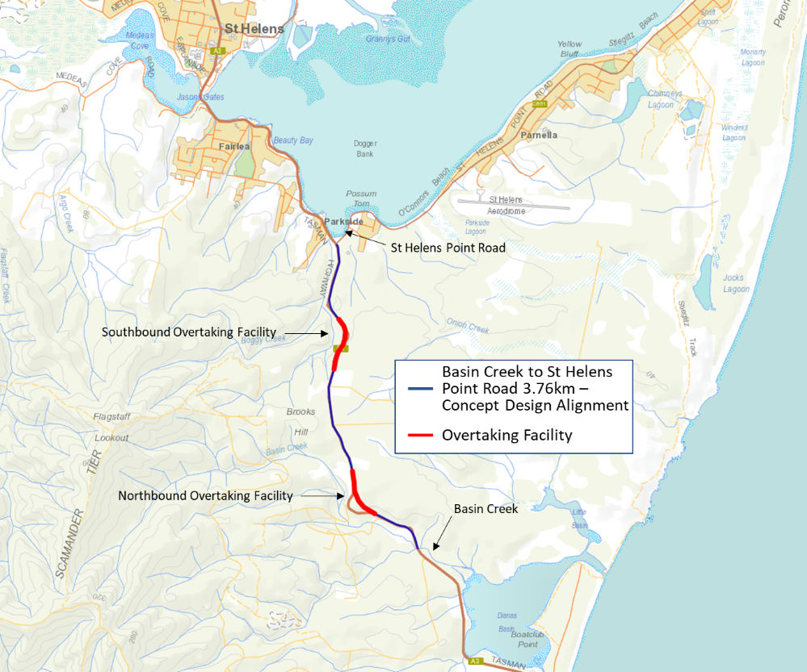
Below is a map of the local area showing the project location.
Figure 1: Basin Creek to St Helens Point Road

Consultation objectives
The level of engagement for the development phase of the project was ‘consult’ for adjacent landowners impacted by land acquisition, and ‘inform’ for the broader public.
The objectives were to:
- Provide a two-way channel between the project team and stakeholders, to allow communication about project progress, benefits, issues and impacts
- Work with stakeholders to reduce construction impacts and realise project benefits
- Let stakeholders know how any issues or feedback during delivery will inform future project decisions
- Minimise impacts on project timeframes due to stakeholder concerns and complaints
- Inform users of the road network that changed traffic conditions can be expected during construction.

Consultation process
In 2018 the Department asked the community to identify areas of the Great Eastern Drive for improvement, highlight any safety concerns and make suggestions about how and where changes could be made. This information informed a planning study that provided the basis for future projects.
Consultation on the design for the Tasman Highway, Basin Creek to St Helens Point Road upgrade began in February 2020 and included landowners adjacent to the proposed upgrade, East Coast Tourism, Break O’Day Council and the St Helens community.
Stakeholder engagement was carried out through direct consultation with adjacent landowners, Break O’Day Council and East Coast Tourism prior to further public consultation taking place through the provision of a public display placed in St Helens between 10 August and 24 August 2020.
Community consultation included a public display which was provided to help the community understand the project before the Development Application (DA) was advertised.
Community issues raised during the public display period and the response to those issues was included in the advertised planning report. This was in addition to input received from stakeholders throughout the wider engagement process.

Individual meetings
10 meetings were held with key stakeholders, including adjacent landowners

Face to face consultation
8 attendees at public display

Other forms of engagement
36 phone calls
132 emails received
1 public display at Break O’Day Council
156 letters were sent to property owners in St Helens to let them know about the public display
9 feedback forms received

Consultation Feedback
What did we hear? | Our response
Why upgrade this section of the Tasman Highway?
Why is this upgrade being done? | The section of the Tasman Highway between Basin Creek and St Helens Point Road has been identified for an upgrade to improve safety and provide greater opportunity for overtaking.  This upgrade forms part of the Roads Package to Support Tasmania’s Visitor Economy program, and will improve safety for all road users, improve travel time reliability and enhance the driver and visitor experience.
Speed limit
Why can’t the speed limit be dropped to 80km/h once the upgrade is complete? | The speed limit on this section of the Tasman Highway is 100 km/h.  Changes to the speed limit are outside of the project scope, this means the speed limit will be reinstated at 100 km/h once works are complete.  Although the speed limit will not be changed as part of this upgrade, the Department may review and assess the speed limit once the proposed road upgrades are completed.
Design queries
Concerns were raised about the appropriateness of the location of the overtaking lanes. | The location of the overtaking lanes has been determined in accordance with the Australian Standards for road design, safety requirements and after careful consideration of the road environment.  This includes ensuring that overtaking lanes aren’t installed where there are accesses onto the road, such as property entrances and other side roads. It also ensures that overtaking lanes don’t end before the steepest section of the road, to allow slower vehicles to be passed.  The addition of overtaking lanes will improve visibility and reduce the potential for head on collisions associated with overtaking manoeuvres into oncoming traffic.
Is the northbound overtaking lane required? | The Tasmanian Government has committed to delivering overtaking lanes in both directions of travel to improve safety, travel time reliability and enhance the driving experience on the Tasman Highway between St. Helens and Dianas Basin. The overtaking lanes will provide drivers a safer opportunity to pass vehicles when there may be significant speed differences due to vehicle type and topography.
Are acoustic barriers required for any adjacent landowners? | A noise assessment was completed in accordance with the Tasmanian State Road Traffic Noise Management Guidelines, October 2015 for the project and has been included in the Development Application.  The noise assessment demonstrated noise mitigation is not required.
Will you be acquiring property? | Landowners with property adjacent to the upgrade will be affected by differing levels of strip land acquisition required to facilitate the alignment of the upgrade.  Affected landowners have been consulted and any required acquisition will be undertaken in accordance with the Land Acquisition Act 1993. This Act specifies the process for land acquisition in Tasmania, how compensation for the land is determined and the time frame in which the process occurs.
Can you include a southbound turning lane into the Archery Club? | This intersection was reviewed by the design consultants and it was found that turning movements do not require any upgraded access facilities at this intersection.
Environmental impacts
How have the environmental impacts of construction been considered? | The Department is committed to carefully managing any environmental impact of delivering infrastructure improvements. Environmental and heritage assessments have been undertaken as part of the project with impacts to be managed in line with an approved environmental and heritage management plan during construction.  Field surveys and ground investigations were conducted between February and April 2020. During the field surveys, no threatened fauna listed under State or Commonwealth legislation were identified.  Preliminary works to identify natural values present along the potential construction corridor were undertaken in June and captured in a Flora and Fauna Report used to inform the Concept Preliminary and Detailed Design phases of the project.  In August, an Environmental Impact Assessment was undertaken to further quantify a number of potential impacts on identified natural values within the works footprint and immediately adjacent areas.  Extensive environmental assessments have been undertaken by suitably qualified professionals. These environmental assessments have been used to inform the project design and specifications.  Tree removal has been minimised.
Has the project considered the impacts to the White-bellied Sea-eagle? | Construction planning includes conditions to manage the sea eagle nest located just south of St Helens.  As recommended in the Environmental Impact Assessment, the nest will be monitored prior to construction and if found to be occupied, construction within a one kilometre line of sight radius of the nest will be delayed and performed outside the breeding season.  If this occurs, construction may take up to two years to complete.
Has the project considered the impacts to the Spotted Quoll and Tasmanian Devil? | No Tasmanian devil dens, or either species of quoll, were identified during the fauna survey and no evidence of these species were observed.  If a den is found during construction, works will stop while the den is managed in line with Department’s protocols, including an approved environmental management plan.
Has the project considered the impacts to the Swift parrot habitat? | Initial ecological assessment of the site identified the presence of potential breeding habitat for the swift parrot within the project area. To minimise the risk of possible breeding disturbance, tree hollows have been covered in six trees, based on specialist advice from ecological consultants.  To reduce impacts on the foraging habitat, and potential impacts to the nesting habitat of the swift parrot the Department will undertake a specific revegetation project to plant key foraging and nesting species, Eucalyptus globulus and E. ovata, in the sections of decommissioned road reserve.  This is in addition to the regeneration that is planned as part of the proposed upgrade.
Why were tree hollows blocked? | Initial ecological assessments identified the presence of potential breeding habitat for the swift parrot within the project area.  To minimise the risk of possible breeding disturbance, tree hollows have been covered in six trees, based on specialist advice from ecological consultants.  Covering tree hollows is a common pre-construction practice that presents considerable conservation benefits, as it reduces the risk of breeding disturbance during later stages of a project.  The trees and hollows were inspected and assessed by an ecologist before the hollows were covered. No fauna was present in any of the hollows, and many of the hollows were considered potentially unsuitable for nesting based on size.
Has roadkill been considered? | There is nothing to indicate that this section of the Tasman Highway is a roadkill hot spot.  Wildlife signs may be considered to raise drive awareness of wildlife in the area.
Will TasNetworks need to relocate power poles in the area? | There are five power poles which need to be relocated and four stay poles which require relocation or installation under the proposed design.  Power pole relocation will require vegetation removal. The area required for vegetation removal was considered along with the entire construction footprint in the Environmental Impact Assessment conducted in August.  Work to relocate the power poles and supporting poles will not start until the outcome of the Development Application is known.
How have natural water courses and road runoff during and post construction been considered? | A Stormwater Report was prepared for the project and has been included in the development application to Council, which addresses post construction stormwater and surface water impacts.  During construction, the contractor will be required to undertake works in accordance with the Department of State Growth’s Construction Specifications including erosion and runoff management measures.
Cyclists
How will this upgrade cater for cyclists? | The project will provide an improved environment for cyclists by:  - accommodating cyclists by improved shoulder width.  - removing 'edge drop' - where there is a difference between the height of the road surface and the height of the shoulder.  In addition, west of the road corridor, an off road path for cyclists has been provided for cyclists between Stacked Loops and St Helens Point Road as part of the Stacked Loops project, which provides the opportunity for cyclists to travel off road for part of this stretch.

Consultation outcomes
Design changes
Landowners with property adjacent to the upgrade will be affected by differing levels of strip land acquisition to facilitate the alignment of the upgrade. Following early consultation with adjacent landowners, changes to the alignment have been made to lessen the impact on landowners where possible.
Input from stakeholders also influenced changes incorporated into the design to reduce environmental impacts.
For example, in one section we have amended the design to allow the retention of a power pole as opposed to relocation which would have had resulted in tree and vegetation removal, and to reduce the overall vegetation removal and maintain visual amenity.
Environmental management
To mitigate impacts on the foraging habitat, and potential impacts to the nesting habitat of the swift parrot the Department will undertake a specific revegetation project to plant key foraging and nesting species, Eucalyptus globulus and E. ovata, in addition to the regeneration that is planned as part of the proposed upgrade.
Feedback from consultation was considered and incorporated into the environmental project plans and technical specifications of the tender documentation.
Feedback received from the public display
Feedback from the public display was included in the advertised planning report of the Development Application to Break O’Day Council. This was in addition to input received from stakeholders throughout the wider engagement process.

What happens next?

The Department of State Growth will continue to engage with affected and interested stakeholders as the project progresses. Once the outcome of the Development Application is known, the Department of State Growth, working with their consultants, will commence further engagement on the next phase.

Further information
Web: www.transport.tas.gov.au/road/projects/
Email: info@stategrowth.tas.gov.au

Department of State Growth
4 Salamanca Place
Hobart TAS 7000 Australia
 | Phone: | 1800 030 688
 | Email: | info@stategrowth.tas.gov.au
 | Web: | www.transport.tas.gov.au

