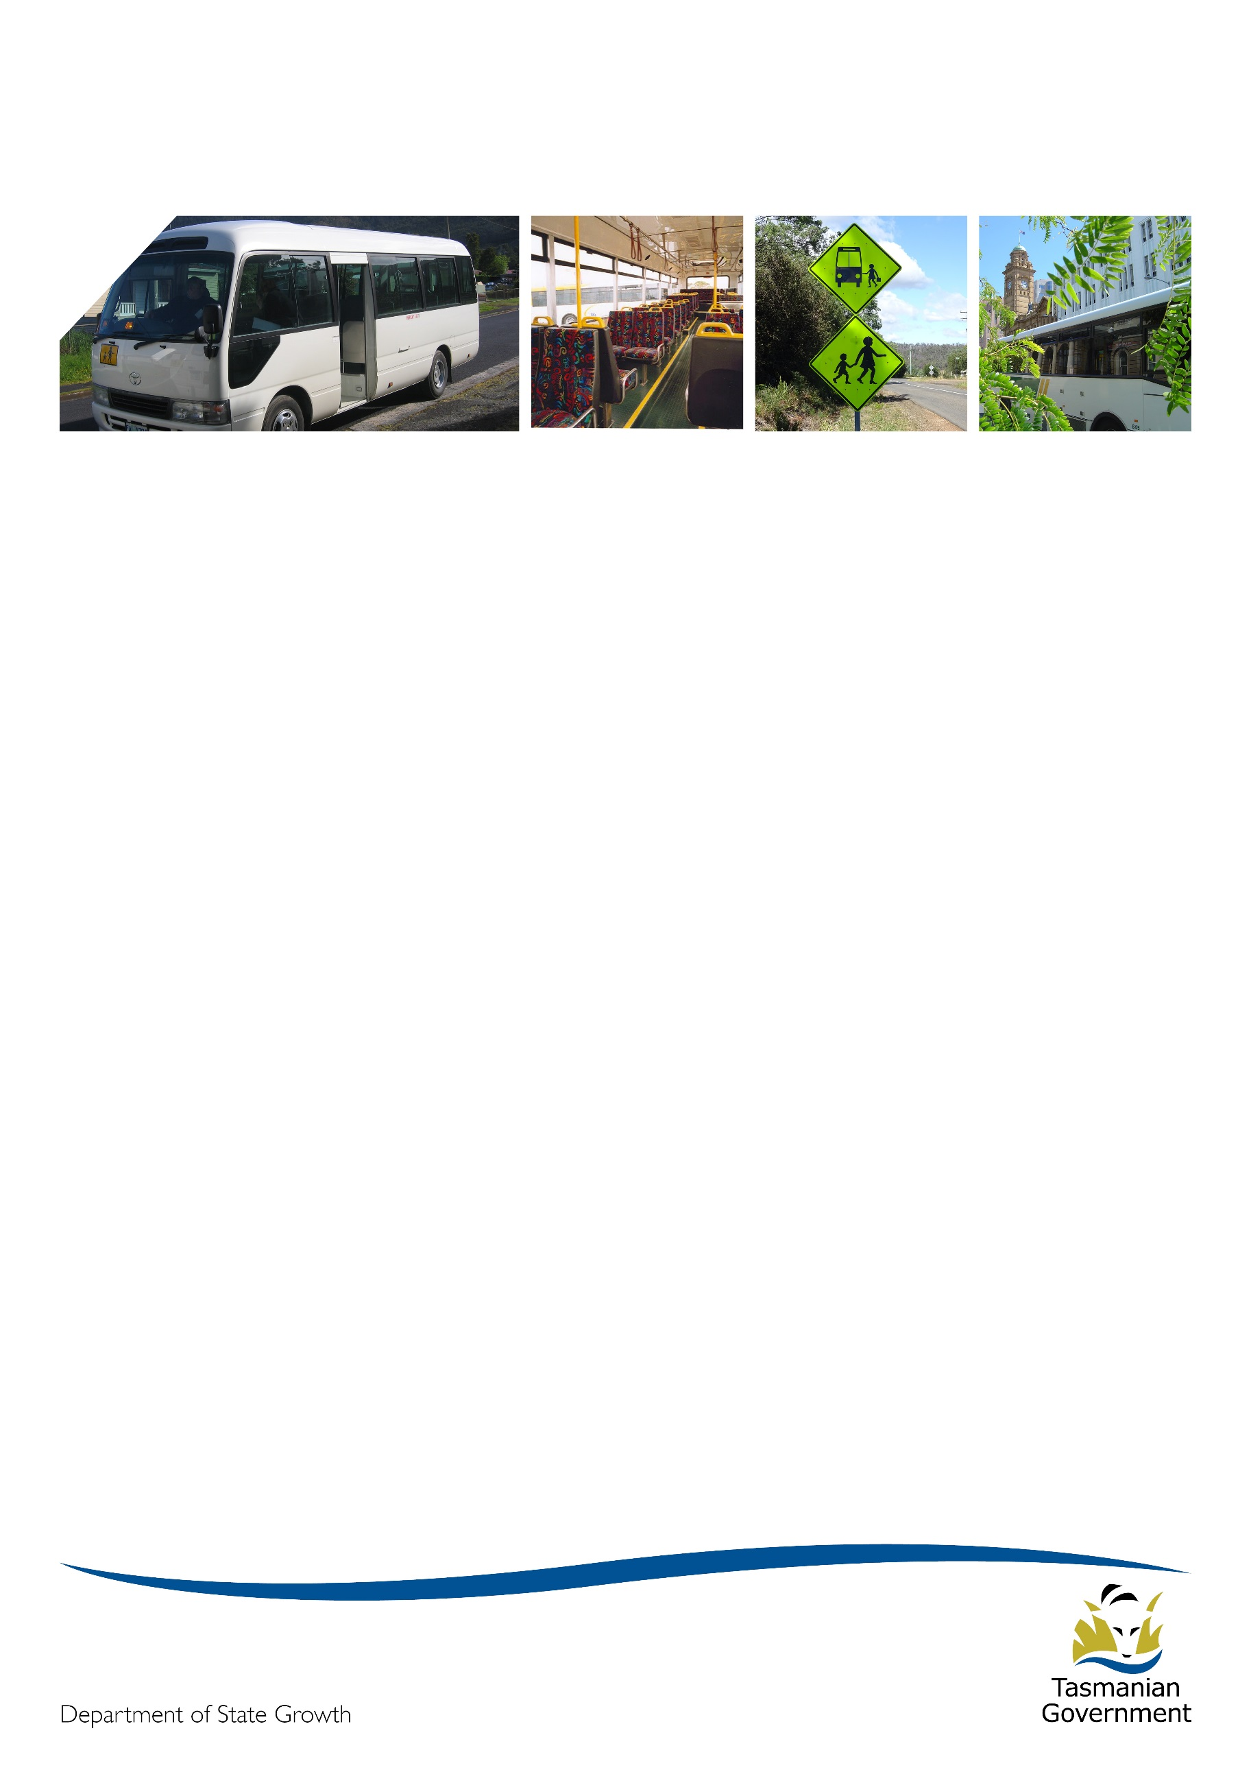
Transporter
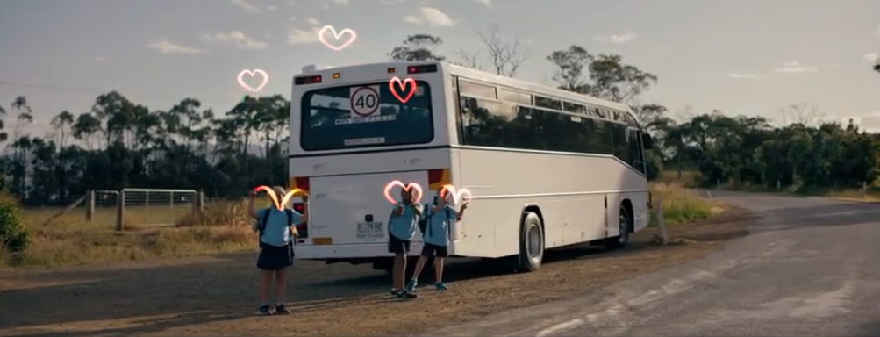

March 2021

And so another year has begun …
It’s fair to say that the commencement of 2021 has been anything but smooth. The Passenger Transport Branch would like to extend a big thank you to all operators who have managed through the back to school period and the rollout of the new North West general access network.

Back to school
School bus service changes
Did you know that the Department of State Growth has school bus contracts with 102 bus operators for the provision of more than 30 school bus services, and 17 specialist school bus services which provide transport support for students with disability?
As you would be aware, State Growth has reviewed school bus services state-wide, with the aim of achieving the right balance of smart route design and faster travel time, while also ensuring the services remain accessible and meet a broad range of transport needs. Following the official closure of the Bus Services Review Project in July 2020, the Passenger Transport Branch has implemented a number of final school bus service redesigns that were not able to be completed during the life of the project.
Consultation regarding changes to the school bus network was undertaken with schools in September and October 2020 with follow-up consultation occurring in December 2020 and January 2021.
Final changes to the school bus network were rolled out at the beginning of Term 1, on 3 February 2021. Some further reviews and changes are still underway in the areas of Dunalley, Copping, South Arm, Lauderdale and Rokeby.
School bus capacity issues
At the start of every school year, Tasmania’s road and bus networks experience an increase in demand. The resultant traffic and congestion remains high for up to two months, while commuters establish their travel patterns, before demand settles down.
The Passenger Transport Branch has received some feedback from operators regarding services which are at, or close to capacity on school and general access school-orientated bus services. Note that capacity includes standing passengers, where standing is permitted.
The Passenger Transport Branch is continuing to monitor demand for school bus services and is working with operators to resolve a number of ongoing issues.
If you operate a School Bus Service, and you are unable to allow a student to travel due to the vehicle being at capacity, you are required to inform the student of any alternative means of transportation that may be available. Alternatively, as soon as practicable, you must operate another trip, or make other arrangements to carry the student. It is very important that you do not carry additional students that would cause the capacity of the vehicle to be exceeded.
Operators are required to inform the Passenger Transport Branch as soon as practicable (by telephone), with details, including the school attended by the student. Subject to contractual requirements being met, the expense of operating another trip will be met by State Growth.
For more information, see clause 3.5(e) of the Passenger Service Contract Standard Conditions.

North West roll out
Changes to North West general access bus services took effect on 17 January 2021, providing the region with a more consistent, frequent and convenient network. The Passenger Transport team hosted information days in Burnie, Penguin, Ulverstone and Devonport in the week leading up to the changes, assisted by customer service staff from Metro and MerseyLink. These sessions were well attended and we got to talk to lots of residents about their new travel opportunities.
Timetables and maps have been distributed to operators, and also available from www.transport.tas.gov.au/public_transport

Bus stop infrastructure upgrades
The updated Hobart City Interchange reopened on 11 October 2020, featuring a new stop on the western side of Elizabeth Street, renamed and redistributed departure points and improved amenity and signage.
State Growth invested in many new bus stops to support the North West service redesign, which are helping passenger transport be more accessible and visible in the community. Each new bus stop is compliant with disability discrimination legislation and poles are coloured bright orange.

Devonport interchange improvements
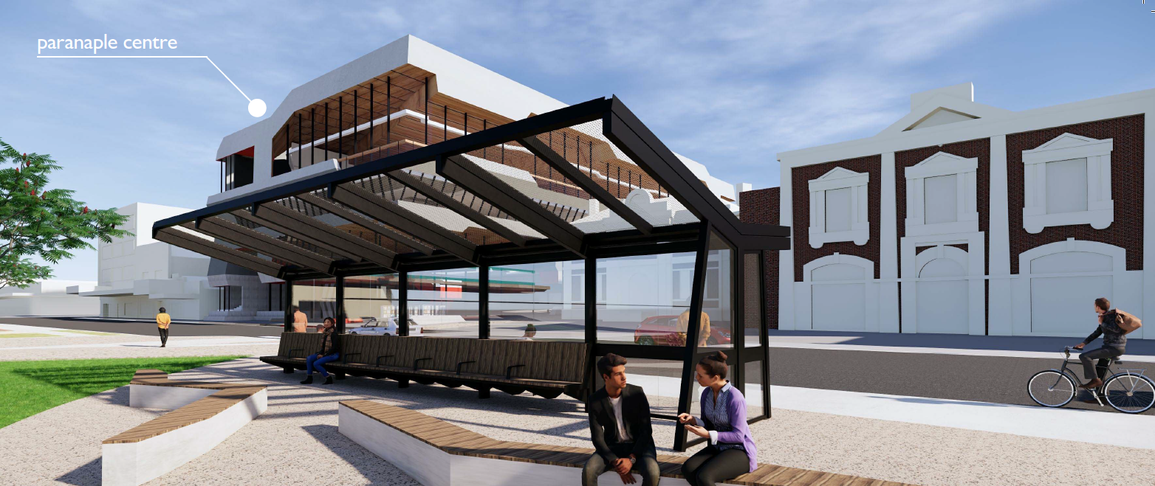
Urban, regional and intercity bus services are now integrated in one convenient location, ideally located opposite the paranaple centre and Providore Place. This change is to provide an accessible common boarding point for both intercity services and the new North West express service, which provides connections to Burnie.
Travellers can now:
- wait for, catch, and transfer buses in one place, instead of walking around the city to connect to different services
- use new modern shelters or the air-conditioned all-access library, online services, and the visitor information centre, art gallery, shops, toilets, parenting room, cafes and restaurants at the paranaple centre
- store luggage and buy intercity tickets at the Visitor Information Centre opposite
The paranaple centre is open across a greater span of hours than the previous arrangements, which is convenient for early morning and weekend passengers, and the Visitor Information Centre is open from 9 am to 5 pm weekdays and 9 am to 2 pm on Saturdays. Future LIVING CITY Retail and Waterfront precincts will all link to Rooke Street, offering easy access to the new hotel, playground, promenades, amphitheatre, and events common.
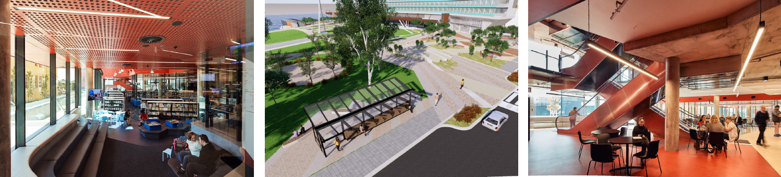
State Growth has been working with the Devonport City Council on the redesign of the interchange to cater for intercity services for a two year period, including $180,000 funding for a new regional shelter with 32 seats and four wheelchair spaces. Devonport Council has advised the new shelter will be installed around mid-2021, because the location is within the new hotel development construction zone. In the interim, a temporary shelter has been installed and passengers, including wheelchair passengers can also use the new shelter for urban services, a few metres from the intercity stop.

Emergency Response Plan
The Passenger Transport Branch will soon be contacting you to request a copy of your Emergency Response Plan which should set out how you’ll deal with a range of risks and threats. Refer to clause 3.6 of the Passenger Transport Contract Standard Conditions for more detail around this requirement.

Your reporting obligations
What to report
School bus operators must use the Operator Portal Payment Claim function to submit your patronage data. General access operators should continue to provide patronage reporting as per previous advice.
Your Monthly Service Report Questionnaire is due no more than five business days after the end of each month and must include detail including non-compliance, performance, complaint and fare data, registration numbers, and detail of vehicles out of service for a variety of reasons.
You also need to report any of the following scenarios in writing by 12:00 pm the following business day:
- you fail to operate or complete a timetabled trip
- any of your vehicles is involved in an incident causing someone serious injury
- any substantial litigation commences against you
- you become aware of any legal breach in connection with your service operation
- your accreditation or authorisation is substantially threatened
On school buses, tell us when you reasonably expect capacity will be exceeded, or when capacity is reaching 90% of operational or 100% of seated capacity on three or more consecutive trips.
For more detail see clauses 19.1 and 19.2 of the Passenger Service contract Standard Conditions.

Contacting Passenger Transport
- email ptscontracts@stategrowth.tas.gov.au
- phone 03 6166 3343

