Passenger Service Contract Standard Conditions
  - Operational guidelines for general access services operating on public holidays

  - Operational guidelines for general access services operating on public holidays

Contents

Authority 1
Scope 1
Period 1
Purpose 1
Passenger service contract requirements 1
Public holidays 2
Christmas Day and Good Friday 2
Statewide public holidays for all of Tasmania 2
Regional holidays 4
Local Government Area maps 10
Calendar 10
Communication to passengers 10

Authority
This guideline is issued under clause 3.5 of the Passenger Service Contract Standard Conditions, this is supported by clause 3.5(a) and 3.5(d). Nothing in this guideline supersedes an operator’s requirements under legislation or the Passenger Service Contract Standard Conditions.

Scope
This operational guideline applies to general access bus services only.

Period
This guideline applies to the new contracts commencing in or after 2020, until further notice.

Purpose
To identify statewide and regional public holidays and outline which timetables operate on these days.
It is standard practice that if a service operates on Sundays then the Sunday timetable operates as the public holiday timetable. If an area has no Sunday services then there will be no public holiday services operating.
For regional public holidays, guidance is needed in regard to which timetable should operate, particularly where a service is operating in an area where only part of the route falls within an area observing the regional public holiday.

Passenger service contract requirements
Under the bus contract payment model – general access services under clause 5.11(a), a year is taken to comprise of 11 public holidays. However, where a passenger service does not operate on a public holiday the number of public holidays will be reduced by each such public holiday.
Under the Passenger Service Contract Standard Conditions a public holiday means a day that is statutory holiday under the Statutory Holidays Act 2000.
The Approved Timetable outlines which days the service should operate, including Sunday/Public Holidays.

Public holidays
The Statutory Holidays Act 2000 (Tas) specifies public holidays in Tasmania as follows:
- Statewide public holidays apply to all of Tasmania (as outlined on Table 1).
- Substitute holidays when some statewide public holidays fall on a weekend, the public holidays are observed on the substitute days (outlined in Table 1).
- Regional holidays apply only to certain areas of Tasmania (as outlined on Table 2).
- Government holidays generally apply to the Public Service sector only, which includes Devonport Cup, Launceston Cup and Easter Tuesday.
In the event that public holidays change - State Growth will provide advice of this to operators and amend the operational guideline accordingly.

Christmas Day and Good Friday
For a period of three years (2021 to 2023), all services will operate the applicable public holiday timetables on Christmas Day and Good Friday.
For regional services (West Coast, Swansea/Bicheno and St Helens), passenger numbers will be reviewed in 2024 to determine if there is a demand for services to operate on these days in 2025 and beyond.

Statewide public holidays for all of Tasmania
Table 1 outlines the statewide public holidays and which timetable is to be performed by a bus operator, particularly where there is a substitute public holiday.
Table 1 Statewide public holidays and which timetables operate on which day
Holiday | Date | Timetable | Substitute holidays | Substitute timetable
January
New Year’s Day | 1 January | Sunday/Public Holiday | if 1 January is on a Saturday, as it was in 2022, the following Monday 3 January is a public holiday | - Saturday 1 Jan: Saturday timetable  - Monday 3 Jan: Sunday/Public Holiday timetable
 |  |  | if 1 January is on a Sunday, as it will be in 2023, the following Monday, 2 January is a public holiday | - Sunday 1 Jan and Monday 2 Jan: Sunday/Public Holiday timetable
Australia Day | 26 January | Sunday/Public Holiday | if 26 January is on a Saturday the following Monday 28 January is a public holiday | - Saturday 26 Jan: Saturday timetable  - Monday 28 Jan: Sunday/Public Holiday timetable
 |  |  | if 26 January is on a Sunday, as it will be in 2025, the following Monday, 27 January is a public holiday | - Sunday 26 Jan and Monday 27 Jan: Sunday/Public Holiday timetable
March
Eight Hours Day / Labour Day | the second Monday in March | Sunday/Public Holiday
March/April
Easter | Good Friday | Sunday/Public Holiday
 | Easter Saturday* | Saturday timetable
 | Easter Sunday* | Sunday/Public Holiday
 | Easter Monday | Sunday/Public Holiday
 | Easter Tuesday** | Weekday timetable (or vacation weekday timetable if Easter Tuesday falls within school holidays)
ANZAC Day | 25 April | Sunday/Public Holiday | When 25 April falls on Saturday, as it will in 2026, or Sunday, as it will in 2027, no substitute or additional holiday is observed.
June
King’s Birthday*** | the second Monday in June | Sunday/Public Holiday
December
Christmas Day | 25 December | Sunday/Public Holiday | if 25 December is a on a Saturday, as it was in 2021, both the Saturday and the following Monday are public holidays | - Saturday 25 Dec and Monday 27 Dec: Sunday/Public Holiday timetable
 |  |  | if 25 December is on a Sunday, as it was in 2022, both the Sunday and the following Tuesday are public holidays | - Sunday 25 Dec and Tuesday 27 Dec: Sunday/Public Holiday timetable
Boxing Day | 26 December | Sunday/Public Holiday | if 26 December falls on a Saturday, as it will in 2026, the following Monday is the public holiday | - Saturday 26 Dec: Saturday timetable  - Monday 28 Dec: Sunday/Public Holiday timetable
 |  |  | if 26 December falls on a Sunday, as it will in 2021, the following Tuesday is the public holiday | - Sunday 26 Dec and Tuesday 28 Dec: Sunday/Public Holiday timetable
*Easter Saturday and Easter Sunday are not listed as public holidays on the WorkSafe Tasmania website (https://worksafe.tas.gov.au/topics/laws-and-compliance/public-holidays) or mentioned in the Statutory Holidays Act 2000, but are shown in the table above for completeness.
**Easter Tuesday is not a public holiday and is only generally a holiday for the Public Service only but is shown in the table above for completeness.
*** Kings Birthday: outlined as the second Monday in June, for the anniversary of the Sovereign

Regional holidays
The following principles apply for regional holidays to guide when a service should operate, particularly if the route operates across different regions.
- Part day regional holidays: For part day regional holidays, such as the Launceston Cup and Devonport Cup, operators should operate their regular weekday timetable for the whole day.
- Services operating wholly within the area observing the regional holiday: If a service operates wholly within the area observing the regional holiday then the Sunday/Public Holiday timetable applies. The exception to this is services which have an interchange with another service which is outlined in their Approved Timetable. Examples of services which should operate a regular weekday timetable on a regional holiday such as Recreation Day, (as they have interchanges with other services that do not observe the regional holiday), include the North West Express and the St Helens to Launceston services as they both connect to the Intercity service.
- Services operating across different areas which do not observe the regional holiday: For services operating across different areas, within the region, where one area observes the regional holiday and the other area does not, the following should apply:
  - Routes which travel from a smaller town to a larger town, where the larger town observes the regional holiday, should operate the Sunday/Public Holiday timetable. This is because generally workplaces and schools will be closed in the larger town, where the direction of travel is orientated. Examples of services which should operate a Sunday/Public Holiday timetable on regional holidays such as the Burnie Show is the Ulverstone to Burnie service, and the Ulverstone to Devonport service on Devonport Show day.
  - Services which travel to and from a similar sized town, such as Burnie to Devonport, should operate their regular weekday timetable. For example, the North West Express should operate a regular weekday timetable on both Burnie and Devonport Show days.
- Intercity timetables: Intercity timetables which connect to a different region that may not observe the regional holiday should operate the regular weekday timetable. For example, the Devonport to Launceston service should operate a regular weekday timetable on Recreation Day as it has connections to the Launceston to Hobart service. Similarly, the Launceston to Hobart service should operate a regular weekday timetable on Royal Hobart Show day and Royal Hobart Regatta day. Services connecting to the intercity such as the north west express and the Launceston to St Helens service should operate a regular timetable on regional holidays (as outlined above).

Table 2 Regional holidays and which timetables operate on which day
Holiday | Day |  | Area observing holiday | Timetable
January
Devonport Cup (generally Public Service only) | Wednesday not earlier than 5 January and not later than 11 January |  | Municipal area of Devonport | Services operating wholly within municipal area of Devonport, including all Devonport urban services:  Regular weekday school holiday  Services operating to and from the municipal area of Devonport, including Latrobe to Devonport, Port Sorell to Devonport, Sheffield to Devonport, and Ulverstone to Devonport:  Regular weekday school holiday  Rationale: As Devonport Cup day is generally only a holiday for public services, all general access services are expected to run to their regular weekday school holiday timetable.
February
Royal Hobart Regatta | Second Monday in February |  | All that part of Tasmania south of and including Oatlands and Swansea, excluding Bronte Park, Catagunya, Strathgordon, Tarraleah, Wayatinah and the West Coast* | Services operating wholly within southern Tasmania, including all Hobart Metro services, Channel to Hobart, Huon Valley to Hobart, New Norfolk to Hobart, Campania/Richmond to Hobart, Dodges Ferry/Carlton and Sorell to Hobart, Tasman Peninsula to Hobart and Swansea to Hobart: Sunday/Public Holiday  Bicheno to Hobart services: Sunday/Public Holiday  Rationale: The Bicheno to Hobart service is expected to operate a Sunday/Public Holiday timetable as Hobart is a larger population centre than Bicheno.  Coles Bay/Bicheno services to St Marys/St Helens: Regular weekday  Rationale: As St Marys/St Helens and Coles Bay/Bicheno does not observe the regional holiday, services need to operate a regular weekday timetable.  Intercity services operating to and from Launceston, including Devonport to Launceston and Hobart to Launceston:  Regular weekday
Launceston Cup (generally Public Service only) | Last Wednesday in February | Part day (from 11am) | Launceston City centre and the following suburbs and townships:  - Alanvale  - Blackstone Heights  - East Launceston  - Elphin  - Franklin Village  - Glen Dhu  - Inveresk  - Invermay  - Killafaddy  - Kings Meadows  - Mayfield  - Mowbray  - Mowbray Heights  - Newnham  - Newstead  - North Riverside  - Norwood | Services operating wholly within urban area of Launceston, including Metro urban and Riverside to Launceston services:  Regular weekday school day  Rationale: As Launceston Cup day is generally only a holiday for public services, all general access operators are expected to run to their regular weekday timetable. Although Government schools may be closed, Catholic and Independent schools may be open.
 |  | All day | Municipal areas of:  - Break O'Day  - Dorset  - George Town  - Glamorgan-Spring Bay (north of and including Cranbrook)  - Launceston excluding Launceston City centre and suburbs specified in the Part Day section above  - Meander Valley excluding suburbs specified in the Part Day section above  - Northern Midlands  - Southern Midlands north of but not including Oatlands  - West Tamar excluding townships specified in the Part Day section above | Services operating to and from the urban area of Launceston, including Metro urban, West Tamar to Launceston, north east (Derby, Scottsdale and Bridport) to Launceston, St Helens to Launceston, Mole Creek to Launceston, George Town to Launceston and Longford/Cressy and Perth and Evandale to Launceston:  Regular weekday school day  Rationale: As Launceston Cup day is generally only a holiday for public services, all general access operators are expected to run to their regular weekday timetable. Although Government schools may be closed, Catholic and Independent schools may be open.
May
Agfest | Friday following the first Thursday in May |  | Municipal Area of Circular Head | Services operating to and from the municipal are of Circular Head, including Smithton to Burnie:  Regular weekday  Rationale: There are no general access services operating wholly within the municipal area of Circular Head. The existing Smithton to Burnie service travels through Wynyard and Burnie which do not observe the regional holiday.
October
Burnie Show | Friday before the first Saturday in October |  | Municipal areas of:  - Burnie  - Waratah-Wynyard  - West Coast | Services operating wholly within municipal area of Burnie, including Metro urban Burnie services:  Sunday/Public Holiday  Services operating to and from Waratah-Wynyard and the West Coast municipal areas to and from Burnie, including Wynyard/Somerset to Burnie and West Coast to Burnie:  Sunday/Public Holiday  Services operating to and from the municipal area of Burnie from the Central Coast, including the Ulverstone/Penguin service to Burnie:  Sunday/Public Holiday  Rationale: The Ulverstone/Penguin to Burnie service is expected to operate a Sunday/Public Holiday timetable as Burnie is a larger population centre than Ulverstone and Penguin. It should be noted that currently Ulverstone/Penguin does not operate a Sunday timetable, therefore no services will operate on a public holiday.  Services operating to and from Burnie and Devonport, including the north west express: Regular weekday  Rationale: The Burnie to Devonport (North West Express) service  is expected to operate a regular weekday timetable as Central Coast and Devonport municipal areas do not observe the regional holiday and the north west express needs to retain connections to the intercity service.
Royal Launceston Show | Thursday before the second Saturday in October |  | Municipal areas of  - Break O'Day  - Dorset  - George Town  - Launceston  - Meander Valley  - Northern Midlands  - West Tamar  Note that although Bicheno and Coles Bay are in Glamorgan Spring Bay they observe the Royal Launceston Show | Services operating wholly within municipal areas of Dorset, George Town, Launceston, Meander Valley, Northern Midlands and West Tamar and to and from Launceston including Metro urban, West Tamar to Launceston, north east (Derby, Scottsdale and Bridport) to Launceston, St Helens to Launceston, Mole Creek to Launceston, George Town to Launceston and Longford/Cressy and Perth and Evandale:  Sunday/Public Holiday  St Helens to Launceston services: Regular weekday school holiday  Rationale: As St Helens to Launceston services connect to intercity services at Epping Forest, these services need to operate a school holiday weekday timetable. The services operate as a school holiday timetable rather than a regular weekday timetable as schools are closed.  Coles Bay/Bicheno services to St Marys/St Helens: Sunday/Public Holiday  Rationale: As St Marys/St Helens and Coles Bay/Bicheno does observe the regional holiday, services need to operate a Sunday/Public Holiday timetable.  Bicheno to Hobart services: Regular weekday  Rationale: The Bicheno to Hobart service is expected to operate a regular weekday timetable as the service travels through Swansea and Hobart which do not observe the regional holiday.  Intercity services operating to and from Launceston, including Devonport to Launceston and Hobart to Launceston:  Regular weekday
Royal Hobart Show | Thursday before the fourth Saturday in October |  | All that part of Tasmania south of and including Oatlands and Swansea, also Bronte Park, Strathgordon, Tarraleah, Wayatinah excluding the West Coast* | Services operating wholly within southern Tasmania, including all Hobart Metro services, Channel to Hobart, Huon Valley to Hobart, New Norfolk to Hobart, Campania/Richmond to Hobart, Dodges Ferry/Carlton and Sorell to Hobart, Tasman Peninsula to Hobart and Swansea to Hobart: Sunday/Public Holiday  Bicheno to Hobart services: Sunday/Public Holiday  Rationale: The Bicheno to Hobart service is expected to operate a Sunday/Public Holiday timetable as Hobart is a larger population centre than Bicheno.  Coles Bay/Bicheno services to St Marys/St Helens: Regular weekday  Rationale: As St Marys/St Helens and Coles Bay/Bicheno does not observe the regional holiday, services need to operate a regular weekday timetable.  Intercity services operating to and from Launceston, including Devonport to Launceston and Hobart to Launceston:  Regular weekday
November
Recreation Day | First Monday in November |  | All parts of Tasmania in which a regional holiday is not observed for the Royal Hobart Regatta (see definition above for the Royal Hobart Regatta)*. | Services operating within municipal areas of West Coast, Circular Head, Waratah-Wynyard, Burnie, Central Coast, Devonport, Latrobe, Kentish, Break O'Day, Dorset, George Town, Launceston, Meander Valley, Northern Midlands and West Tamar excluding intercity Devonport to Launceston services, the North West Express and St Helens to Launceston:  Sunday/Public Holiday  Services operating to and from Burnie and Devonport, including the North West Express: Regular weekday  Rationale: The Burnie to Devonport (North West Express) service  is expected to operate a regular weekday timetable as it needs to retain connections to the intercity service.  St Helens to Launceston services: Regular weekday school holiday  Rationale: As St Helens to Launceston services connect to intercity services at Epping Forest, these services need to operate a school holiday weekday timetable. The services operate as a school holiday timetable rather than a regular weekday timetable as schools in Launceston are closed.  Coles Bay/Bicheno services to St Marys/St Helens: Sunday/Public Holiday  Rationale: As St Marys/St Helens and Coles Bay/Bicheno does observe the regional holiday, services need to operate a Sunday/Public Holiday timetable.  Bicheno to Hobart services: Regular weekday  Rationale: The Bicheno to Hobart service is expected to operate a regular weekday timetable as the service travels through Swansea and Hobart which do not observe the regional holiday.  Intercity services operating to and from Launceston, including Devonport to Launceston and Hobart to Launceston:  Regular weekday
December
Devonport Show | Friday nearest to the last day in November, but not later than first day in December |  | Municipal areas of:  - Devonport  - Kentish  - Latrobe | Services operating wholly within municipal areas of Devonport, Latrobe and Kentish, including Devonport urban, Latrobe to Devonport, Port Sorell to Devonport and Sheffield to Devonport services:  Sunday/Public Holiday  Services operating to and from the municipal area of Central Coast to Devonport:  Sunday/Public Holiday  Rationale: The existing Ulverstone to Devonport service is expected to operate a Sunday/Public Holiday timetable as Devonport is a larger population centre than Ulverstone. It should be noted that currently Ulverstone to Devonport services do not operate a Sunday timetable, therefore no services will operate on a public holiday.  Services operating to and from Burnie and Devonport, including the North West Express: Regular weekday  The Burnie to Devonport (North West Express) service is expected to operate a regular weekday timetable as Central Coast municipal area and Burnie municipal area do not observe the public holiday.
*Swansea and towns south of Swansea including Triabunna, Orford and Buckland observe the Royal Hobart Regatta and the Hobart Royal Show day. Towns north of Swansea such as Bicheno and Coles Bay observe Recreation Day and Royal Launceston Show.

Local Government Area maps
Figure 1 below shows the municipal boundaries for regional holidays which are observed by the whole municipal area.
Please refer to the descriptions in Table 2 above for the following regional holidays:
- Regional holidays that are observed by only certain parts of a municipal area (Royal Hobart Regatta, Royal Launceston Show, Royal Hobart Show and Recreation Day).
- Regional holidays that are generally only a holiday for public services (Devonport Cup and Launceston Cup).Figure 1 Regional day holidays by municipal area for northern Tasmania
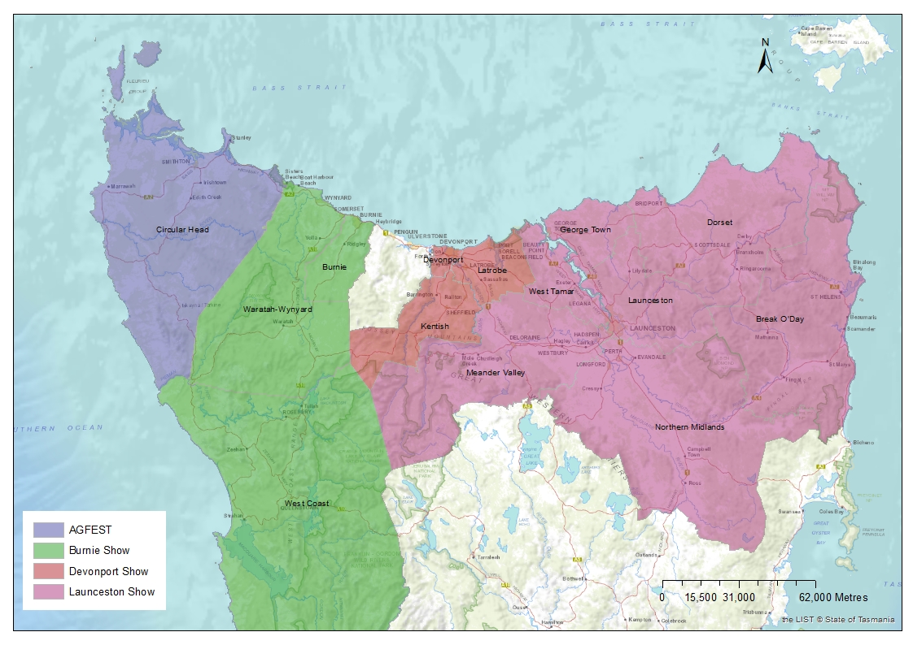

Calendar
State Growth will publish a forward calendar on www.transport.tas.gov.au to guide operators on which services should operate on which public holidays.

Communication to passengers
Operators will need to communicate to passengers via their website which services run on which public holiday, especially where there are regional variations. It is also operators’ responsibilities to check if any schools that they regularly service are open on regional holidays and provide adequate notice to State Growth and the relevant schools if their service is not operating a regular weekday timetable.

Department of State Growth
GPO Box 536
Hobart TAS 7001 Australia
 | Phone: | 1800 030 688
 | Email: | info@stategrowth.tas.gov.au
 | Web: | www.transport.tas.gov.au

