Handbook and Application Form
Registration scheme for
Special Interest Vehicles

Special-Interest Vehicles

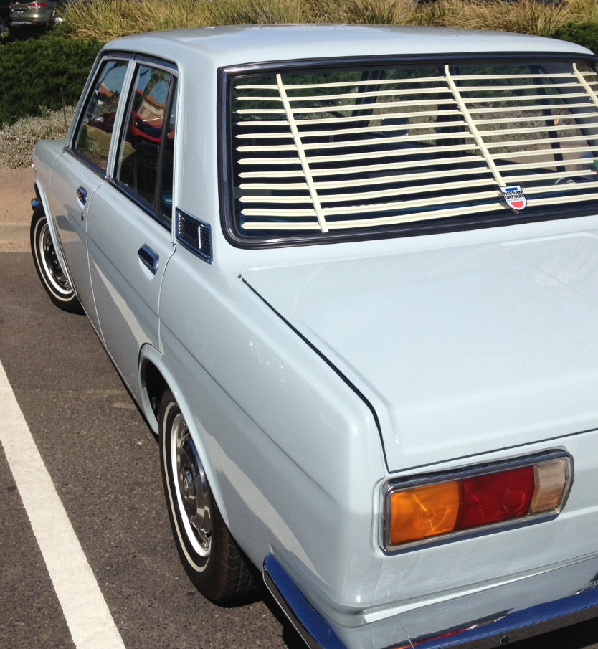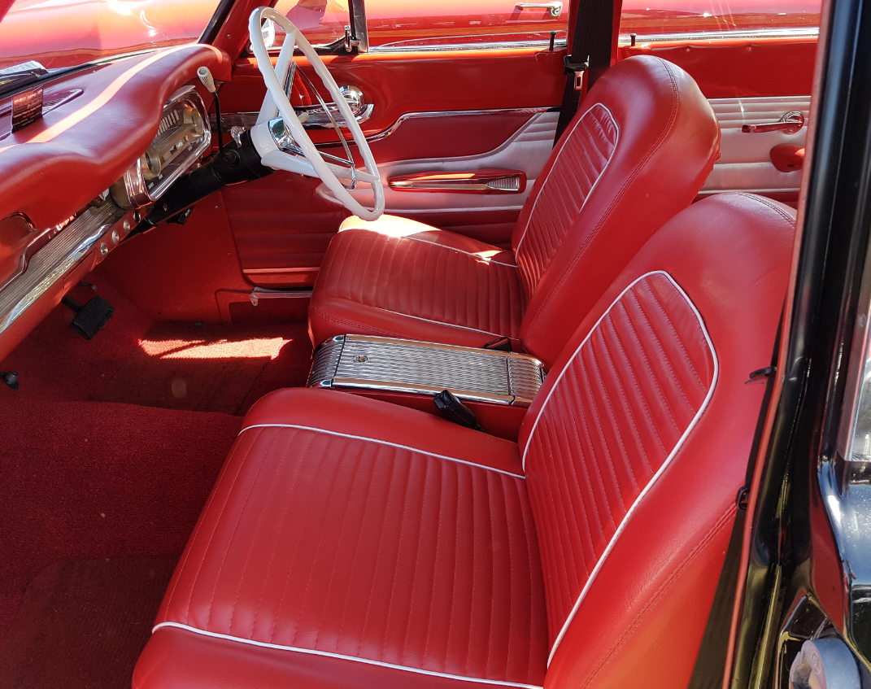
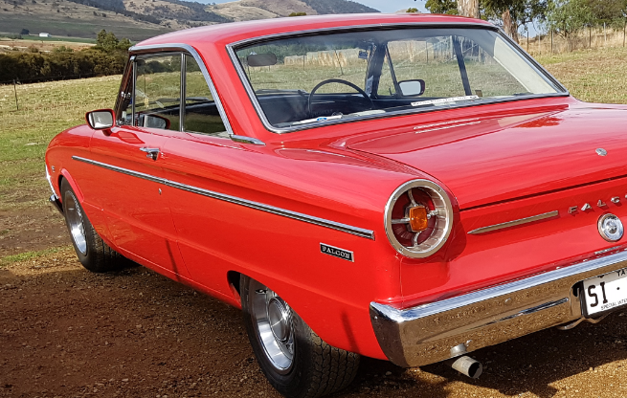

Department of State Growth
Contents

1. Purpose 3
2. Introduction 3
3. Classes of Special Interest Vehicle Registration 3
Class A 3
Class B 4
Class C 4
4. Approval Procedure 4
5. Class ‘A’ Approval 4
6. Class ‘B’ & ‘C’ Approvals 5
7. Guidelines for eligibility and conditions of use as a Special Interest vehicle 5
Class A 5
Class A conditions of use include: 6
Class B 6
Class B conditions of use include: 6
Class C 7
Class C conditions of use include: 7
8. Fees and Charges 7
9. Recording Journeys in Log Book 7
10. Renewal of SI Registration 8
11. Transfer of SI Registration 8
12. Cancellation SI Registration 8
Application for Special Interest Vehicle Registration 9
Application checklist – Class B Rally Vehicle 10

1. Purpose
This Handbook sets out the guidelines for granting vehicles Special Interest (SI) vehicle registration in Tasmania and the conditions of use applicable to each vehicle class. It also contains an application form for SI vehicle registration.

2. Introduction
SI vehicle registration is a conditional registration scheme designed to allow motor vehicles (other than campervans or motor homes) that are compliant with three specific vehicle classes (See Section 3) limited use on the road network, an exemption in motor tax and reduced Motor Accident Insurance Board (MAIB) fees.

The registered operator must have and maintain Tasmanian registration on at least one non-conditionally registered motor vehicle registered in their name throughout the registration period of the SI registered vehicle.

SI registration requires the vehicles use to be recorded in a log book (Special Interest and Club Event Vehicles Log Book) issued by the Registrar of Motor Vehicles. You can use a Special Interest Registered vehicle for 104 days if renewed for a 12-month period, or in the event the registration is renewed for 3- or 6-months, 104 days of use in total over a 12-month period.

SI registration is not transferable to another operator. An application and inspection process is required at change of ownership.

Vehicles granted SI registration are conditionally registered and must display white number plates with black characters beginning with an “SI” prefix as issued by the Registrar. Personalised number plates cannot be displayed on SI registered vehicles. Previous registration plates (if applicable) are to be handed in at the time of obtaining SI registration.

3. Classes of Special Interest Vehicle Registration
There are three classes of vehicles, which may be granted SI vehicle registration. All require the registered operator to have at least one non-conditionally registered motor vehicle in their name throughout the registration period of the SI registered vehicle. The classes include the following with varying eligibility criteria and conditions of use:

Note: Other than the specific vehicle features required for rally events, the SI vehicle registration scheme is not a mechanism for vehicles to be exempt from relevant vehicle standards.

Class A
A motor vehicle (other than campervans or motorhomes), being in exceptional condition inside and out either in original, restored or modified condition and has been manufactured 30 years ago or are replicas of a body and frame manufactured at least 30 years ago prior to the date of application.

Class A vehicles must be compliant with the relevant vehicle standards applicable to it and undergo an inspection at an Approved Inspection Station (AIS). A list of AIS and their contact information is available from;
https://www.transport.tas.gov.au/vehicles/vehicle_inspections/ais/ais_locations/ais_lightvehicles

The vehicle’s condition will be assessed as meeting the standards required of a Class A - SI vehicle specified in the Light Vehicle Inspection Manual available at;
https://www.transport.tas.gov.au/vehicles/vehicle_inspections/ais/ais_inspection_manuals

Class B
A motor vehicle designed or adapted to be used exclusively in rallies conducted by an approved motorsport organisation sanctioned National or International rally, promotion of a rally event, travelling to and from such events or travelling to and from a place for repairs.

Approved Motorsport Organisations are: Confederation of Australian Motor Sports (CAMS) & Australian Auto - Sport Alliance (AASA).

The registered operator must hold and maintain a current CAMS National Rally Licence or a Clubman Rally Licence or an AASA National Tarmac Rally or National Gravel Rally Licence.

Other than for the purpose of diagnosis or assessment of a repair the vehicle must be driven by a license holder of a CAMS National Rally Licence or a Clubman Rally Licence or an AASA National Tarmac Rally or National Gravel Rally Licence.

A copy of the vehicle’s Approved Motorsport Organisation Log Book appropriately endorsed as a rally vehicle must be produced, on request, indicating the vehicle has been passed by a recognised scrutineer, and inspected at required intervals.

The vehicle may be fitted out with equipment that meets the required standards for competing in these events.

Class C
Vehicles adapted or modified exclusively for charitable events (e.g. Variety’s TasBash, etc.). As per Class A and B, campervans and motorhomes are excluded from SI registration.

4. Approval Procedure
An SI applicant must determine the class of SI registration that suits their vehicle and taking into account the intended use of the vehicle to establish if the vehicle is Class A; In excess of 30 years or Class B; Rally vehicle, or Class C; charitable event vehicle and complete the appropriate section of the application form and declaration.

5. Class ‘A’ Approval
Class ‘A’ motor vehicles must be 30 years of age or greater or are replicas of a body and frame manufactured at least 30 years ago prior to the date of application, and not a campervan or motor home.

Having completed the application form and signed the declaration, the motor vehicle is required to be inspected at an Authorised Inspection Station where a "pre-registration" inspection is to be undertaken by a Vehicle Examiner. The vehicle will be assessed against the SI eligibility criteria of being in exceptional condition inside and out, compliant with the 30 year requirement.

The fee for this inspection is a commercial arrangement between the AIS and the SI applicant.

When a vehicle successfully meets the eligibility criteria and complies with relevant vehicle standards the applicant will be issued an AIS inspection report indicating a “pass”. This document and the completed SI application form, containing the signed declaration, can then be presented to a Service Tasmania outlet with evidence of entitlement (e.g. receipt of purchase) and personal identification to complete the registration process.

If the vehicle has been previously registered, the registration plates (other than SI plates) must also be returned and a refund of any existing Tasmanian registration fee will be issued to the previous registered operator.

Note: Legislation requires a vehicle registered under this class to be at least 30 years of age. It is not possible to register a vehicle that does not meet this age requirement. In determining age eligibility the month of manufacture will also be used.

6. Class ‘B’ & ‘C’ Approvals

Unlike those eligible for class ‘A’, due to the nature class ‘B’ and ‘C’ vehicles, authorisation from Registration and Licensing Services is required in the form of an ‘Approval in Principle’ prior to the vehicle being inspected at an AIS.

To initiate this the completed SI application and supporting information must be forwarded to Registration and Licensing Services prior to the vehicle being inspected.

In reviewing the application it may be necessary for officers of Registration and Licensing Services to seek further information from an Approved Vehicle Certifier or recognised scrutineer verifying that the vehicle meets the required eligibility or safety standards for this class.

Following the issue of an Approval in Principle document, the vehicle can undergo an inspection at an AIS where a pre-registration inspection is to be undertaken applicable to the relevant SI application. The fee for this inspection is a commercial arrangement between the Approved Inspection Station (AIS) and the SI applicant.

A vehicle that successfully meets the eligibility criteria of the relevant class will be issued an AIS inspection report that together with the application form, containing the signed declaration and the ‘Approval in Principle’ can then be presented to a Service Tasmania outlet with evidence of entitlement and identification.

If the vehicle has been previously registered the registration plates must also be returned and, if applicable a refund of any existing Tasmanian registration fee will be issued to the last registered operator.

7. Guidelines for eligibility and conditions of use as a Special Interest vehicle

Class A
At the time of inspection and throughout the SI registration period a Class A vehicle must be well restored or a combination of superior restoration and excellent original condition, or an extremely well maintained original vehicle showing very minimal wear in superior condition.

The vehicle must have been manufactured 30 years ago or is a replica of a body and frame manufactured at least 30 years prior to the date of application.

Note: The Registrar of Motor Vehicles has no discretion to approve registration for vehicles less than 30 years of age.

Vehicle modifications are acceptable subject to being certified where relevant and not affecting compliance with relevant vehicle standards (including Australian Design Rules) and the vehicle remains visually identifiable as the make /model variant.

Certified modifications such as altering the configuration of the vehicle such as conversion to a convertible or cabriolet conversions, or from a van to a utility of the model are acceptable subject to being of superior finish and standard.

Modifications must be compliant with Vehicle Standard Bulletin 14 or if a Street Rod Vehicle the National Guidelines for the Construction and Modification of Street Rods in Australia, or as otherwise acceptable to the Registrar of Motor Vehicles.

Further information relating to VSB14 and the National Guidelines for the Construction and Modification of Street Rods in Australia is available from the link below.
https://infrastructure.gov.au/vehicles/vehicle_regulation/bulletin/index.aspx

Appropriate modification certification is required with this task performed by Approved Vehicle Certifiers (AVC) in Tasmania. A list of AVC’s are available from the following address. https://www.transport.tas.gov.au/vehicles/vehicle_inspections/avcais

Class A conditions of use include:
- Restricted to 104 days of use within a 12 month period.
- The registered operator must maintain the Tasmanian registration of at least one non-conditionally registered motor vehicle in their name throughout the registration period of the SI registered vehicle
- The registered operator must maintain the Special Interest and Club Event Vehicles Log Book allocated to the particular vehicle.
- The vehicle cannot carry a load or tow a trailer and must not be used for hire or reward

Note: For the purposes of this section a load does not include passengers or general items that are associated with the recreational use activity (i.e. done for enjoyment i.e. not for work) of the vehicle. The carrying of commercial loads or industrial use (e.g. heavy or large loads) is not permitted.

Class B
Vehicles modified for competition in rally events conducted on either gravel or tarmac roads as sanctioned by an Approved Motorsport Organisation. These vehicles must be scrutineered and deemed acceptable by the appropriate club or event scrutineer at intervals as required by the motorsport organisation and be appropriately endorsed as a rally vehicle.
The SI applicant must hold and maintain throughout the SI registration, a current National Rally Licence or a Clubman Rally Licence or an AASA National Tarmac Rally or National Gravel Rally Licence

Note: If an imported vehicle not previously registered in Australia, a copy of import approval from the Department of Infrastructure, Regional Development and Cities must be provided. Conditions of import approval may also be included as conditions of SI registration.

Class B conditions of use include:
- Restricted to 104 days of use within a 12 month period.
- For use on public roads in Approved Motorsport Organisation sanctioned rally event,
- For use in organised promotional of a sanctioned rally event,
- To drive to and from such events,
- To drive to and from a place for the purpose of repairs or maintenance,
- The registered operator and driver must hold a current CAMS National Rally Licence or a Clubman Rally Licence, or an AASA National Tarmac Rally or National Gravel Rally Licence (other than when the vehicle is road tested by a person conducting repairs for the purpose of the repair). The registered operator must maintain the licence while the vehicle is SI registered.

- Restricted to 104 days of use within a 12 month period.
- The registered operator must maintain the Tasmanian registration of at least one non-conditionally registered motor vehicle in their name throughout the registration period of the SI registered vehicle.
- The registered operator must maintain the Special Interest and Club Event Vehicles Log Book allocated to the particular vehicle.

Class C
Vehicles that have been adapted or modified exclusively for use in charitable events such as Variety Tasmanian TasBash and other similar recognised charitable events.

Class C conditions of use include:
- Restricted to 104 days of use within a 12 month period. For use on public roads in a recognised charitable event.
- To drive to or from a place for the purpose of repairs or maintenance for participation in the charitable event.
- The registered operator must maintain the Tasmanian registration of at least one non-conditionally registered motor vehicle in their name throughout the registration period of the SI registered vehicle.
- The registered operator must maintain the Special Interest and Club Event Vehicles Log Book allocated to the particular vehicle.

Vehicle modifications must be compliant with Vehicle Standard Bulletin 14, if a Street Rod vehicle the National Guidelines for the Construction and Modification of Street Rods in Australia, or as otherwise acceptable to the Registrar of Motor Vehicles. Appropriate modification certification is required.

8. Fees and Charges
SI vehicle registration, when granted, receives a full exemption of motor tax and a reduced MAIB premium.

The SI number plates incur a fee payable at the time of issue at Service Tasmania. Personalised or plates other than plates issued by the Registrar of Motor Vehicles are not available within the SI registration scheme.

9. Recording Journeys in Log Book
Each daily journey undertaken in a SI registered vehicle must be recorded prior to travel, in non-erasable ink, in the specific Special Interest and Club Event Vehicles Log Book issued by the Registrar of Motor Vehicles for that vehicle. This includes any travel undertaken in other states or territories and travel for the purpose of repair, refuelling or relocation.

The date of the journey, odometer reading and a brief description of the journey must be recorded before each journey commences.

Note: A journey constitutes a round trip from the registered garage address to be completed on a particular day. If the journey continues into the next day or beyond, it is deemed to constitute two or more trips.

Upon renewal (see below) the existing Special Interest and Club Event Vehicles Log Book can continue to be used by simply ruling a line under the last entry for the previous 12 month period and start recording trips for the next year.

10. Renewal of SI Registration

An invitation to renew the registration of an SI registered vehicle will be forwarded to the registered operator prior to the expiry date. It is the registered operator’s responsibility to maintain SI registration or undertake other forms of registration prior to use on a road or road related area.

The vehicle will not require another inspection prior to SI renewal, however the condition of the vehicle and registered operator conditions of SI must remain compliant with the eligibility requirements of the particular SI registration vehicle class.

11. Transfer of SI Registration
SI vehicle registration cannot be transferred to a new registered operator, even if the new operator could also be eligible for SI registration.
Where a change of operator occurs, the SI registration must be cancelled and the plates returned. The Log Book issued to the vehicle must be returned at the time of cancellation. The vehicle can then be re-inspected and new registration obtained following the application process relevant to each class.

12. Cancellation SI Registration
The Registrar of Motor Vehicles reserves the right to review the continued applicability of SI vehicle registration. If a breach of conditions of SI registration occurs or the vehicle is allowed to deteriorate or does not meet the vehicle eligibility or registered operator conditions of SI registration, suspension or cancelation of registration may be initiated.

Department of State Growth
Road User Services Division
Form Number: MR161 09/2022
Application for Special Interest Vehicle Registration
Details Entered on MRS
Proof of identity | Sighted
Proof of address | Sighted
Proof of garage address | Sighted
Approved Motorsport Organisation details | Sighted

 | Approval in Principle is not required  Class A – Vehicle manufactured 30 years or more prior to date of application (campervans/motorhomes excluded from SI registration).  Obtain a pre-registration inspection report marked as “passed” from an Approved Inspection Station, attach this application and then present to Service Tasmania. |  |  | Approval is required from Registration and Licensing Services before pre-registration inspection.  Class B – Rally Vehicle (refer application check list)  Class C – Charitable event vehicle  Once completed, forward this application along with all required documentation to vehicle.management@stategrowth.tas.gov.au
Name:
Address:
Contact Phone Number:
Email Address:
Drivers Licence No:
Rally Licence No:
Import Approval Number:
Make/Model of Vehicle:
Comments on Vehicle:
Registration No:
(if previously registered)
VIN/Chassis Number:
Engine Number:
Month and Year of Manufacture
Registration number of another currently registered vehicle in your name (must be unconditionally registered in Tasmania):

Conditions of Special Interest Vehicle Scheme
Special Interest vehicles are subject to conditions of use depending on which class the vehicle has been conditionally registered under, the SI handbook identifies conditions that will continue to relate to your vehicle.
Statutory Declaration
I hereby declare that the information I have provided in this application is current and correct to the best of my knowledge and that I will abide by all appropriate conditions of the Special Interest Vehicle Scheme for my class of vehicle.
Signed:
Date:

Application check list
Class B – Rally Vehicle
 | YES
I have completed and signed my application form for SI registration. | ☐
I have a motor vehicle registered with Tasmanian non-conditional registration.  Registration of this motor vehicle must be in applicant’s name. Vehicles registered in associated company names are not considered. | ☐
I have provided a copy of my current Approved Motorsport Organisation National Rally, Clubman Rally, National Tarmac Rally or National Gravel Rally Licence or AASA equivalent licence.  Motorsport licence outside of the above are not accepted. | ☐
I have provided a copy of the vehicle’s Approved Motorsport Organisation Log book with the:
- Page which depicts vehicle details  - Page which specifies vehicle body and safety features  - Page of details of vehicle modifications  - Page of Scrutiny history endorsed by a recognised motor sport scrutineer within the last 12 months.  - Page of the record of vehicle ownership with the applicant’s name being recorded and endorsed. | ☐
 | ☐
 | ☐
 | ☐
 | ☐
I have provided current colour images of the vehicle:  - One from each angle of the vehicle, and  - One which includes the vehicles seating position.  Photos from the log book are not accepted. | ☐
Import approval documentation  Only required if the vehicle has been imported | ☐

