Positive Provision Policy for Cycling Infrastructure

Mainstreaming the Provision of Cycling Facilities as Part of Transport Projects and Maintenance of Cycling Space

Passenger Transport Policy Branch
October 2013

Date: 8 October 2013
Version: Final

Disclaimer: This document is an internal DIER policy guide. Its use is applicable to DIER projects on State roads, as well as non-transport related DIER projects.

Contents
1 Policy Context and Aim 1
2 Scope 2
3 Benefits 2
4 Principal Urban Cycling Network Routes 3
4.1 New Roads Projects and Major Upgrades 3
4.2 Road Upgrades and Improvements 3
4.3 Non-Road Transport Projects 4
4.4 Maintenance 4
4.5 Local Roads 4
5 Regional Arterial Cycling Network Routes 5
5.1 New Roads Projects and Major Upgrades 5
5.2 Road Upgrades and Improvements 5
5.3 Non-Road Transport Projects 5
5.4 Maintenance 6
5.5 Local Roads 6
6 Definitions 7

Appendix 1 – Project Assessment Criteria 8

Appendix 2 – Recommended Maintenance Assessment Criteria 9

Appendix 3 - Principal Urban Cycling Networks 10

Mainstreaming the Provision of Cycling Facilities as Part of Transport Projects; and Maintenance of Cycling Space

Policy Context and Aim

The vision of the Tasmanian Walking and Cycling for Active Transport Strategy 2010 is to create a safe, accessible and well connected transport system that encourages more people to walk and cycle as part of their everyday journeys.

The vision supports the priorities of the Tasmanian Urban Passenger Transport Framework which include increasing travel choice and reliability; encouraging healthy, active, liveable and accessible communities; and reducing greenhouse gas emissions.

Priorities of the Tasmanian Walking and Cycling for Active Transport Strategy 2010 include improving infrastructure and facilities that support walking and cycling for transport, specifically:
- Identifying the Principal Urban Cycling Networks (PUCNs) in each urban centre and developing plans for delivering cycling infrastructure on the networks, including provision of end of trip facilities and wayfinding signage.
- Developing guidelines to ensure that cycling needs are considered in the planning and design of new roads and road upgrades for routes identified on the PUCNs of the integrated cycling network plans.
- Maximising useability of cycling infrastructure on State roads by developing it to an appropriate standard and maintaining it in an acceptable condition.
- Working with Councils to improve walking and cycling connections to major destinations and public transport routes on local roads.

The purpose of this policy is to help achieve those Priorities by establishing a set of criteria for mainstreaming the provision of transport oriented cycle facilities as part of transport projects and maintaining these facilities at an acceptable standard through maintenance contracts on State-owned roads.

The policy provides a tool for ensuring that making provision for cycling is considered and objectively evaluated at the commencement of the scoping of State Government transport projects, and in the development of maintenance contracts.

The policy may also be used in consideration of maintenance and other works on State-owned roads undertaken by the relevant local council and/or others under the Roads and Jetties Act 1935 and on approvals for traffic control devices on local roads provided by the Transport Commission under the Traffic Act 1925.

Some changes to DIER’s standard specifications to reflect the mainstreaming approach to maintenance activities around infrastructure on cycling routes may be necessary.

Scope

This document sets out the criteria to be applied in relation to providing transport-oriented cycling facilities:
- as part of new State Government road projects, upgrades and improvements; and
- as an element in transport infrastructure projects that are not road focused; and
- within road maintenance regimes and long-term road maintenance contracts.

The document establishes criteria for providing cycling facilities on State-owned roads that incorporate:
- the Principal Urban Cycling Networks (PUCNs); and
- the broader Arterial Bike Networks.

The application of the criteria set out in the document will help to facilitate a consistent approach to mainstreaming the provision and maintenance of cycle facilities on State assets.

The document does not provide guidance as to the type of cycle facilities to be provided, as this will be determined as part of project briefs based on Austroads Guides, established Tasmanian Standards and specific considerations such as the road environment, user needs and an analysis of benefit and cost.

Benefits

The benefits of including cycle facilities as part of road projects include:
- Supporting a balanced equity of access for all road users. Cycling is a low cost transport mode, and supporting cycling as a transport mode can contribute to increased social equity and inclusion, environmental benefits, and improved health and wellbeing for the community.
- Delivering cycle facilities at a lower cost than would be possible if they were provided otherwise than as part of a wider road project. Delivering cycling facilities as part of a broader project may reduce design and delivery costs.
- Delivering cycling facilities on Principal Urban Cycling Networks more quickly than would be the case if a subsequent process were undertaken to build the facilities.
- Increased opportunities for integration of transport modes, and opportunities for supporting better integration of land use and transport planning to facilitate active transport.
- Better integration of on-road and off-road cycling facilities, which is likely to provide a better experience for cyclists.
- Improved safety for cyclists through the provision of infrastructure that reduces the potential for conflict with vehicles.

Principal Urban Cycling Network Routes

The Principal Urban Cycling Networks (PUCNs) are high priority transport-oriented cycling routes identified in Launceston, Hobart and Burnie/Devonport through extensive stakeholder consultation in 2011. Appendix 3 contains maps of the PUCNs.

New Roads Projects and Major Upgrades
Where the State Government undertakes major projects on the Principal Urban Cycling Networks, provision will be made for cycling. This may include acquiring sufficient reservation width to retrofit enhanced on-road or off-road facilities at a later date.

In all cases it is critical that early negotiation with the relevant local council takes place so that any formal transfer of the on-going maintenance responsibility for cycling infrastructure can be resolved prior to completion of the project.

Where new bridges are proposed, these must include provision for cyclists. If this is not proposed as part of the initial construction, new bridges must be designed and constructed in such a fashion so as to allow for cycling facilities to be added later.

If a decision is made not to provide for cycling initially or later, the decision must be endorsed by DIER’s Executive Group. Appendix 1 sets out the key queries for assessment.

Road Upgrades and Improvements
Where the State Government undertakes road upgrades or improvements on routes identified on the Principal Urban Cycling Networks, provision will be made for cycling if the upgrade involves road widening, lane duplication and lane widening. Appendix 1 sets out the key queries for assessment.

Where the improvement or upgrade provides traffic engineering improvements such as the installation of roundabouts, traffic islands, traffic signals, new intersections and changes to line markings and lane widths for other road users, these improvements will also cater for cyclists.

If a decision is made not to make provision for cycling as part of road upgrades or improvements identified on the Principal Urban Cycling Networks, the reasons for the decision will be recorded and submitted to the General Manager Transport Infrastructure Services for approval and reporting to DIER’s Executive Group. Good road design practices to minimise hazards for cyclists as an alternative will be implemented.

Where safety barriers are installed as components of road upgrading and improvement projects, care will be taken to ensure that these do not reduce available space or create a hazard for cyclists.

Non-Road Transport Projects
Opportunities for incorporating initiatives to support cycling for transport must be considered by the DIER when it leads non road projects including:

- Passenger and freight rail projects involving the building of new infrastructure; or

- Other passenger transport projects, including Transit Corridor Projects; or

- Development of transit centres and interchanges; or

- Ferry projects.

Where a project is on or links to routes identified as part of the Principal Urban Cycling Networks, features that enable cycling should be included as part of the design. Decisions to include or exclude cycling infrastructure will be explained and recorded in the business case/assessment documents.

Maintenance
Where State-owned roads are located on the Principal Urban Cycling Networks, maintenance contracts will need to be managed to recognise that road surfaces need to be maintained in a safe and acceptable condition for cyclists, such as ensuring that sweeping at regular intervals occurs. The key principles contained in Appendix 2 should be considered for adoption as actions in maintenance contracts.

Where these State-owned roads are located in urban areas and the relevant local council has an agreed role in maintenance under the Roads and Jetties Act 1935, the key principles contained in Appendix 2 need to be considered.

Local Roads
There are many segments of the Principal Urban Cycling Networks located on local roads. Where changes to these local roads are planned requiring approval of traffic control devices under the Traffic Act 1925, such as the installation of roundabouts, traffic islands, traffic signals, new intersections and changes to line markings and lane widths for other road users, these improvements should also take account of the Principal Urban Cycling Network routes and cater for cyclists.

Regional Arterial Cycling Network Routes

The Regional Arterial Cycling Network routes comprise those networks linking to and radiating out from the PUCNs, such as those defined under the North West Coastal Pathway Plan, the Greater Launceston Bicycle Network, and the Hobart Regional Arterial Bicycle Network.

New Roads Projects and Major Upgrades
Where major road projects are undertaken on routes identified on the three Regional Arterial Cycling Networks, consideration will be given to making provision for cycling as part of the project, particularly where:

- the road project is within 5km of a major retail, commercial or employment centre; or
- the road would need to be significantly rebuilt if a decision was made to make provision for cycling/provide cycling infrastructure at a later date.
Consideration can include acquiring sufficient reservation width to retrofit off-road facilities at a later date. Appendix 1 sets out the key criteria for assessment.

Where an active decision is made not to make provision for cycling as part of new road projects on Regional Arterial Cycling Networks that meet the above criteria, the reasons for the decision will be recorded and reported to the General Manager Transport Infrastructure Services, and good road design practices to minimise hazards for cyclists will be implemented.

Road Upgrades and Improvements
Where road upgrades and improvements are undertaken on routes identified on Regional Arterial Cycling Networks that meet the criteria set out in Appendix 1, consideration will be given to making provision for cycling.

If a decision is made not to make provision for cycling in road upgrades and improvements on regional arterial cycling networks, the reasons for the decision will recorded and good road design practices to minimise hazards for cyclists will be implemented.

Non-Road Transport Projects
Where a project led by DIER is on or links to routes identified on one of the three Regional Arterial Cycling Networks that meet the criteria set out at Appendix 1, consideration will be given to making provision for cycling as part of the project.

Maintenance
For State-owned roads that are located on Regional Arterial Cycling Networks sealing regimes and maintenance contracts will reflect consideration for the needs of cyclists. The key principles contained in Appendix 2 should also be considered for adoption as actions in maintenance contracts along the Regional Arterial Cycling Networks (refer to definitions for identification of these networks).

If these State-owned roads are located in urban areas and the relevant local council has an agreed role in maintenance under the Roads and Jetties Act 1935, the key principles contained in Appendix 2 should also be considered.

Local Roads
The majority of the segments of the Regional Arterial Cycling Networks are located on local roads. Where changes to these local roads are planned requiring approval of traffic control devices under the Traffic Act 1925, such as the installation of roundabouts, traffic islands, traffic signals, new intersections and changes to line markings and lane widths for other road users, these improvements should also take into consideration the provision of space for cyclists as part of the Regional Arterial Cycling Network routes.

Definitions

Cycle facilities
When assessing the type of bicycle facility appropriate to the particular project, consideration of the location in the strategic cycle route network is required. The Cycling Aspects of Austroads Guides is also a useful guide document for this assessment. While not an exhaustive list, the types of facilities to be considered include: cycle lanes, separated paths, contra-flow lanes, Copenhagen-style separated lanes.

Major Projects
Projects such as town bypasses, as well as changing an at-grade intersection to grade separation. The addition of an additional carriageway or a multi-lane roundabout would also fall under this definition.

Major Retail, Commercial and Employment Centres
These Centres serve a broad urban catchment area meeting employment, civic and retail shopping needs. Examples include Devonport, Burnie, Kings Meadows, Mowbray.

Principal Urban Cycling Networks
In terms of supporting people to cycle for transport, these routes are of highest priority to the State Government. Maps of the Principal Urban Cycling Networks are included at Appendix 3 and also available for download at: http://www.dier.tas.gov.au/ passenger_transport/ cycling_and_walking. Some parts of these networks already have cycling infrastructure in place, whilst other parts of the network currently have no specific provision for cycling.

Regional Arterial Bicycle Networks
In the context of this document, the highest priority parts of these networks are those within a 5km radius of major retail, commercial and employment centres. Some parts of these networks have cycle facilities in place, whilst in other parts there is no specific provision for cycling as yet. Cradle Coast Authority (http://www.cradlecoast.com/ _literature_105476/ North_West_Coastal_Pathway_Plan), Launceston City Council and Cycling South (http://www.cyclingsouth.org/images/stories/Documents/final-cyclingsouth2010.pdf) are the respective owners of the information relating to these networks.

Road Upgrades and Improvements
This includes:
- minor widening or narrowing of existing carriageways; or
- making, placing or upgrading kerbs, gutters, footpaths, roadsides, traffic control devices and markings, street lighting and landscaping

Wayfinding signage
DIER’s Cycle Route Directional Signage Resource Manual (May 2013 Version 2.1) provides guidance in relation to directional signage principles, as well as providing a suite of directional signage templates.

Appendix 1 – Project Assessment Criteria

New Road Projects, Upgrades and Improvements
And Non-Road Projects
A decision not to make provision for cycling must be approved by the Executive
Is the route/project on a Principal Urban Cycling Network

Make provision for cycling
yes

no

Within 5km of Activity Centre
Is the route on a regional arterial bike plan

yes

yes
no
no

Good design practices to minimise hazards for cyclists
Would road rebuilding be required to install facilities later
Consider making provision for cycling

yes
no

A decision not to make provision for cycling will be recorded and reported to GM TIS

Appendix 2 – Recommended Maintenance Assessment Criteria

Resurfacing
- When assessing resealing projects, consideration should be given to providing a surface that is suitable for cyclists. If aggregate above 10mm in size is used, efforts must be made to compact the surface after the sealing. Diverting traffic on to the shoulder or other areas commonly used by cyclists is to be adopted during daylight hours when a site is under active traffic management. After initial aggregate placement and compaction, surfaces should be swept again within 48 hours/
2 working days of resealing to remove loose stones.
- Care needs to be taken to ensure that resealing does not result in cracks, dips, or edges running parallel to the direction of travel, or otherwise uneven surfaces that may create a hazard for cyclists.
- Traffic management plans that highlight the presence of loose aggregates and/or slippery surfaces are to be implemented, with repeater signage at appropriate instances and/or locations, such as on downhill approaches to corners.

Allocation of road space
- An assessment is to be made of the road to determine whether it is desirable and possible to reallocate road space to better provide for cycling. This is particularly relevant for the uphill direction of travel, especially around corners, where the speed differential of bicycles and other vehicles using the road is greatest and visibility can be restricted.

Linemarking
- When resealing is programmed, the opportunity to review the provision of space for cycling should be undertaken. Wider travel lanes can be made narrower to provide a sealed shoulder for cyclists to use.
- On routes where Raised Retro-Reflective Pavement Markers are installed, placement in accordance with the applicable standard should also take into account the hazard that poor placement can create for cyclists.

Service installations
- Approval for service authorities to install assets in pavement along Principal Urban Cycling Routes should specifically be subject to consideration of the impact on cycling safety. This may result in greater attention to pavement joins between existing and reinstated seals, as well as locating any proposed utility covers/lids outside the cycling space, being a requirement on service authorities.
- Traffic management plans that highlight the presence of loose aggregates and/or slippery surfaces are to be implemented, with repeater signage at appropriate instances and/or locations, such as on downhill approaches to corners.
- Grates and utility covers installed on Principal Urban Cycling Routes, whether in cycle lanes or otherwise, must be appropriate for cyclists and maintained/replaced so as to minimise the hazard for cyclists.

Appendix 3 - Principal Urban Cycling Networks

Note that higher resolution versions of these maps can be found at: http://www.dier.tas.gov.au/passenger_transport/cycling_and_walking

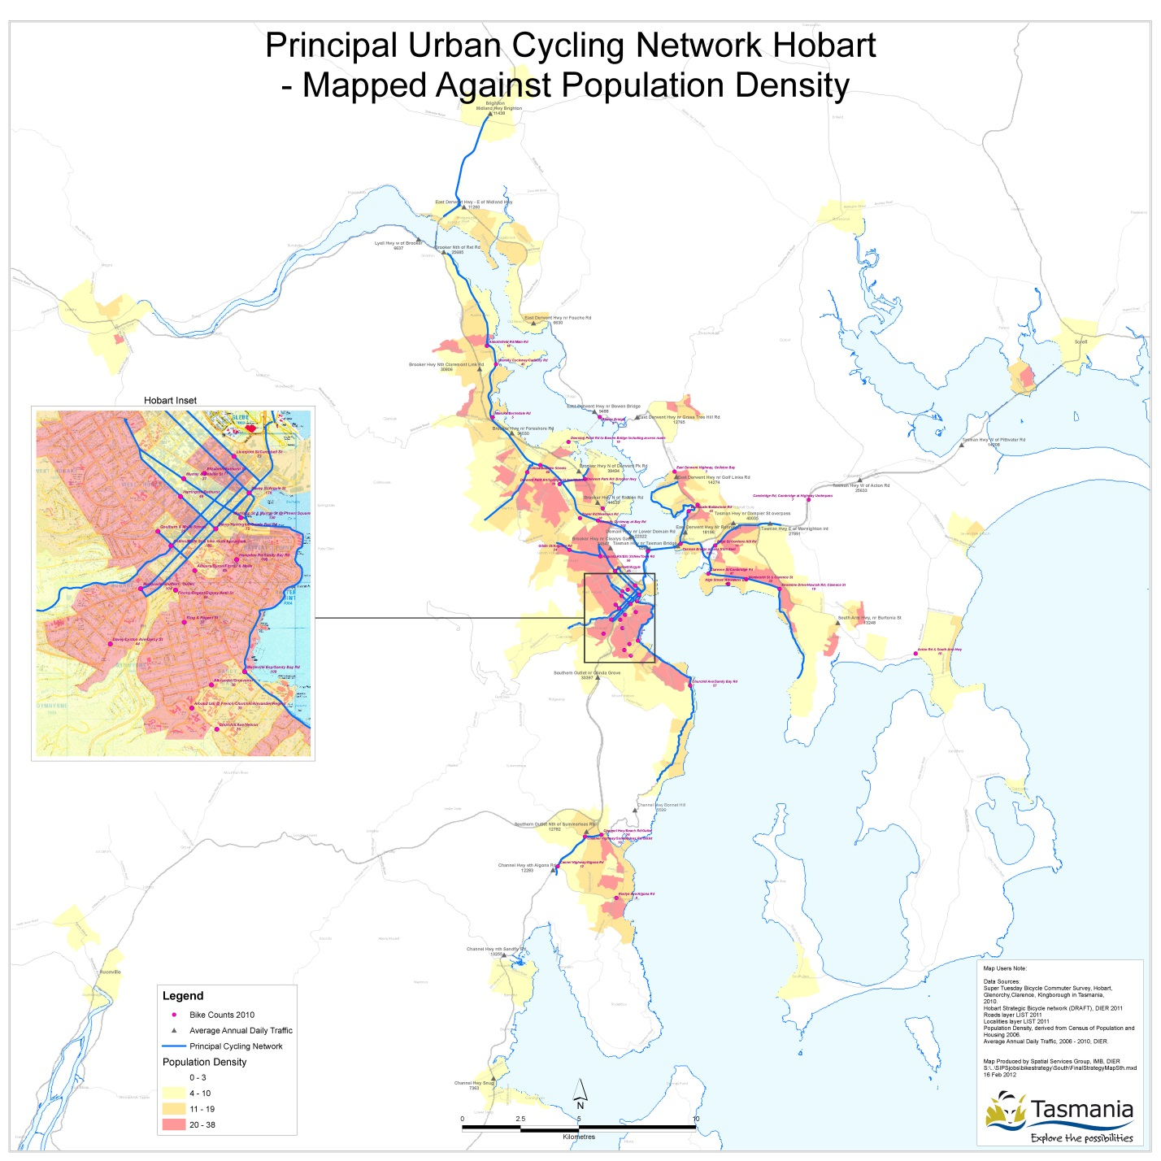

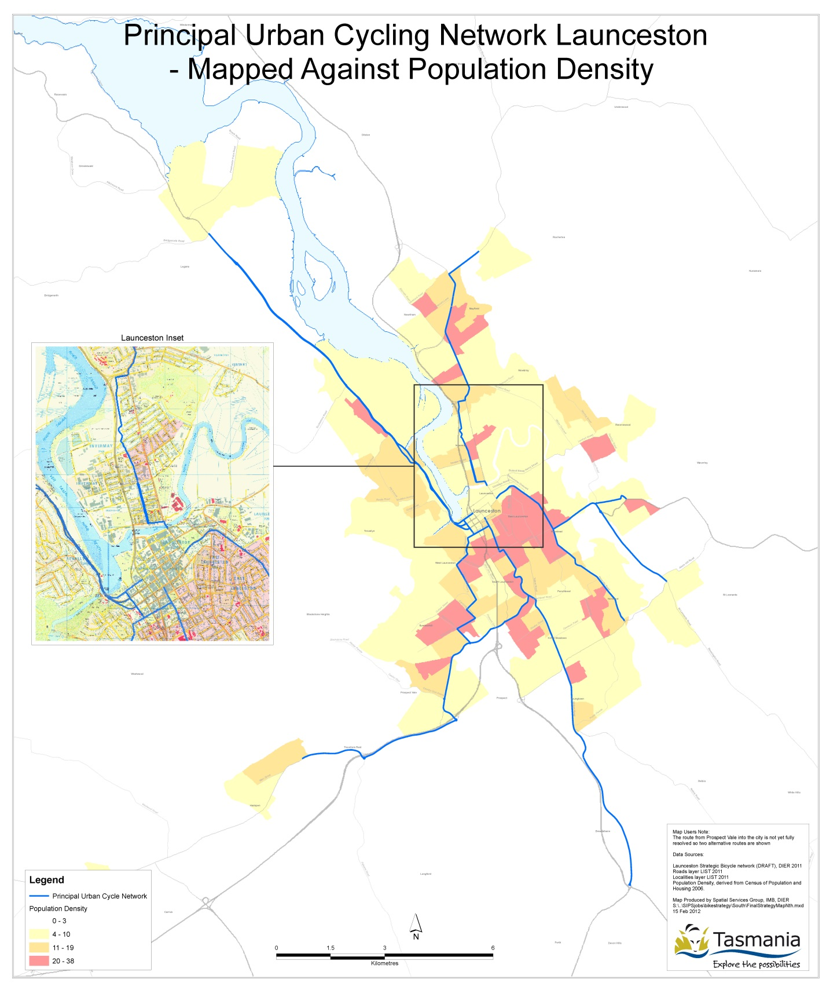

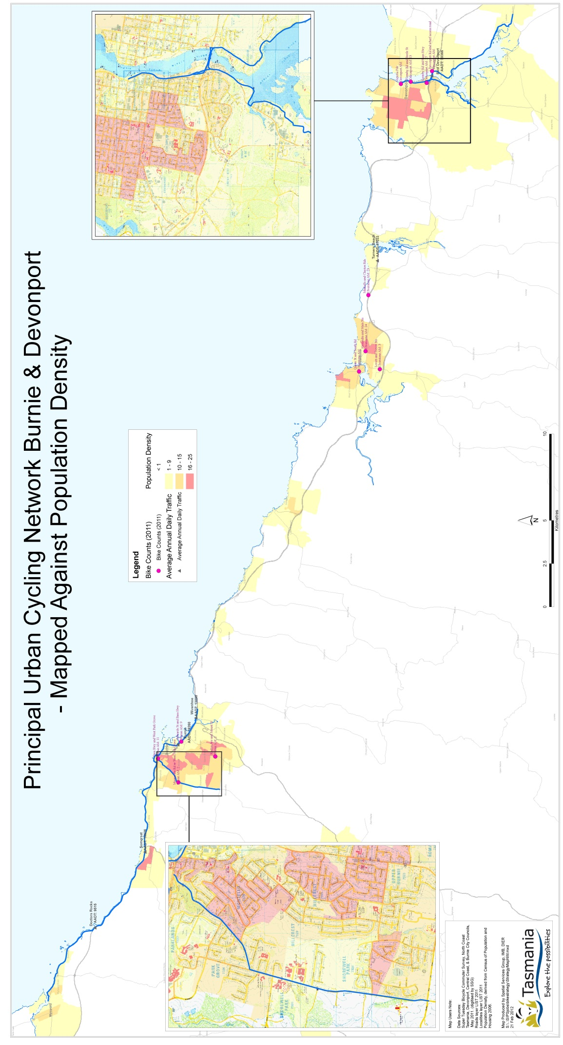

Passenger Transport Policy Branch
Passenger Transport Division
Department of Infrastructure, Energy and Resources

GPO Box 936, Hobart 7001
Ph: 1300 135 513
Email: dier@dier.tas.gov.au
Visit: www.dier.tas.gov.au

