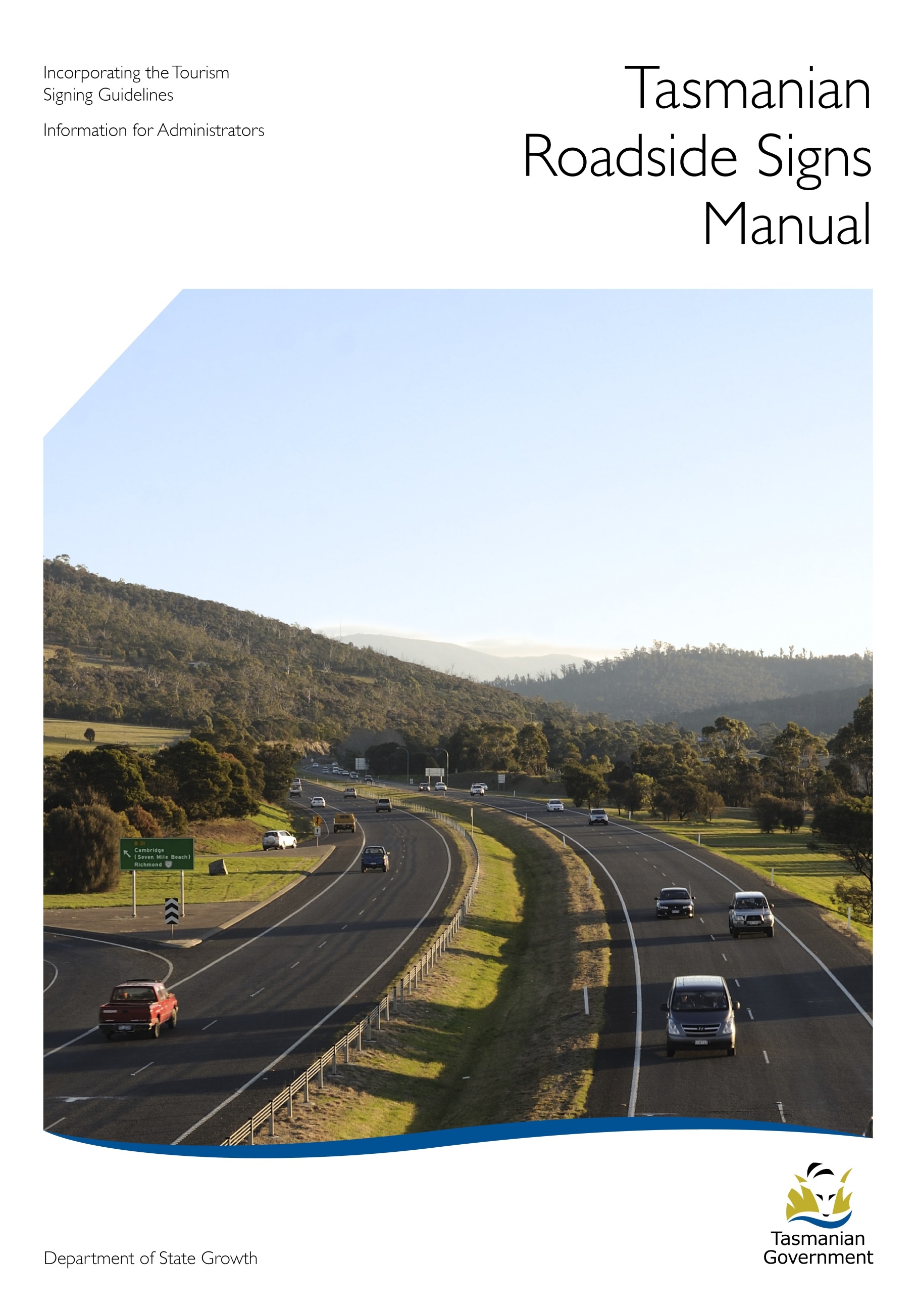

This page has been left blank intentionally for printing purposes.

Contents
Tasmanian Signs Manual 1
(i) Introduction 1
(ii) Definitions 2
Part A - Traffic Control Signs 4
1. Regulatory Signs 4
2. Warning Signs 5
Part B - Guide Signs 7
1. Advance Direction Signs 9
2. Intersection Direction Signs 9
3. Fingerboard Direction Signs 9
4. Reassurance Signs 10
5. Street Name Signs 10
6. Route Markers 10
Part C - Service Information Signs 11
1. Service Information Symbols and Tourism Shields 11
2. Community Facilities 13
2.1. General Facilities Signs 13
2.2. Fuel Outlet Signs 15
Part D - Tourism Signing Guidelines and Principles 18
1. Tourism Information Signs in Rural Areas 20
2. Tourism Information Signs in Urban Areas 26
Part E - Tourism Information Signs – Types 28
1. Features - Natural, Cultural and Historic 28
2. Facilities - Commercial Tourism 29
3. Promotional Signs 30
(i) ‘Welcome to Tasmania’ 30
(ii) Tourism Precinct 31
(iii) Municipal and City/Town Boundary Greetings 33
(iv) Tasmanian Visitor Information Network (TVIN) Centre 34
(v) Information Bay, Lay-by and Non TVIN Information Centre 36
(vi) Visitor Radio 37
(vii) Historic Town / Historic Village/Historic Precinct 38
(viii) Themed Routes 39
(ix) Wildlife Parks 42
4. Application Process For Tourism Information Signs 44
Part F - Tourism Signs Specifications 49
1. Application of Rural and Urban Tourism Information Sign Specifications 49
2. Road Category Details 65
3. Palette – Service Information Symbols and Tourism Shields 66
4. Tasmanian Visitor Information Network (TVIN) Signs 77
Part G - Advertising / Commercial Signage 78
1. Advertising and Commercial Signs 78
2. Temporary Advertising Signs 78
3. Other Advertising Signs 80

Tasmanian Signs Manual
Including the Tourism Signing Guidelines

Introduction
Road signs should never be used as the principal or only means of promoting the location of a business or activity to customers. The development of appropriate promotional material, involvement with multiple distribution networks including visitor information centres, and involvement with themed routes and the like will always be more successful in attracting customers.
Revised Tourism Signing Guidelines were introduced in January 2000 as part of an integrated approach to the dissemination of visitor information, including signage. For the first time, there is an opportunity to develop tourism signage across Tasmania in a consistent manner through the principal integrating mechanism of colour, utilising a set of principles and standards that minimise confusion and maximise effectiveness without compromise to the safety of road users.
The development of the signage under this approach focussed on three elements – guide signs, operator signs and administrative/legislative reform. The guide signs improvement program is progressively addressing key needs around the state; the operator signage program is likewise gradually being implemented; and, improvements to the management of signage issues are being provided through the on-going development of this manual along with recent and future legislative reform.
This Manual is designed to be an information resource for administrators in State and Local Government, whose role is to approve or administer signage issues, and will be updated from time to time as policies are reviewed.
Questions concerning the content of this Manual should in the first instance be addressed to the Tourism Signs Consultant, Department of State Growth (ph 03 6166 3328).

Definitions
For the purposes of this Manual the following definitions are made:
Access:
Any place where vehicles enter and/or leave a road, at a common level, from an adjoining property. This definition includes but is not limited to private entrances, driveways and farm gates.
Department of State Growth:
Department of State Growth
Junction or Intersection:
A place where two or more roads cross or meet at a common level and does not include the ramps leading to or from a grade separated interchange.
Local Government Road:
Means those roads maintained by Municipal Council as defined in the Local Government (Highways) Act, 1982.
Local Area Tourism Sign Plan:
A Local Area Tourism Sign Plan is a method for local government to develop guidelines for the design and location of tourism information signs based on the distinct local character of the place and the expectations and aspirations of the local community.
Public Road:
Land over which the general public has permanent right of passage including the whole width between abutting property boundaries, all footpaths and the like, and all bridges over which such a road passes being a road which is the responsibility of the Minister administering the Roads and Jetties Act 1935, or a road for which a council has accepted responsibility by resolution or a road shown on the municipal map.
Road Authority:
For State Roads, the Minister administering the Roads and Jetties Act, 1935 and, for roads other than State Roads, the relevant state or local government authority.
State Road:
Means a State highway or subsidiary road within the meaning of the Roads and Jetties Act, 1935.
Tourism Information Signs:
The generic name for signs directing to commercial tourism facilities or natural, cultural or historic features.
Urban and Rural Areas:
Those areas as defined in Part F 1 of this Manual as below.
 | Posted Speed Limit in km/h ⁽⁵⁾
Road Category ⁽³⁾⁽⁴⁾ | 60 or less | 70 to 80 | > 80
I | Urban ⁽²⁾ | Urban ⁽²⁾ | Rural ⁽¹⁾
II | Urban ⁽²⁾ | Urban ⁽²⁾ | Rural ⁽¹⁾
III | Urban ⁽²⁾ | Urban ⁽²⁾ | Rural ⁽¹⁾
IV | Urban ⁽²⁾ | Rural ⁽¹⁾ | Rural ⁽¹⁾
V | Urban ⁽²⁾ | Rural ⁽¹⁾ | Rural ⁽¹⁾
Other non-State Roads (e.g. Council, Forestry) | Urban ⁽²⁾ | Rural ⁽¹⁾ | Rural ⁽¹⁾

Notes:
- Refer to Part D Tourism Signs – Principles, Rural Areas.
- Refer to Part D Tourism Signs – Principles, Urban Areas.
- For details of Road Categories see Part F, 2.
- State and Local Government Roads, see definitions on pages 2 and 3 above.
- Where there are differing speed limits in opposing directions of the same section of road the lower speed limit shall be used for the purposes of this Table.

Part A - Traffic Control Signs

Regulatory Signs
  - Introduction
A traffic control device is any sign, signal, pavement marking or other installation placed or erected by any public authority or official body having the necessary jurisdiction, for the purposes of regulating, warning or guiding road users.
Regulatory Signs are the means of putting into practical effect orders (which include Acts of Parliament and Regulations) for the regulation of road users. For example, such orders may impose restriction on speed or on the turning of traffic in a particular direction at an intersection.
Regulatory Signs are either mandatory or prohibitory. The mandatory signs give instructions to road users about what they must do, the Stop and Give Way Signs being examples. The prohibitory signs give instructions about what must not be done, for example No U Turn and Speed Limit Signs.

  - Legislative Authority
Regulatory Signs have specific legal significance and the powers of administrative authorities and road user traffic rules that apply are covered in various Traffic Acts and Regulations. They include:
Traffic Act 1925
Transport Act 1981
Local Government (Highways) Act 1982
Traffic (Road Rules) Regulations 1999
Vehicle and Traffic Act 1999

  - Design Principles
The design and application of Regulatory Signs is beyond the scope of this signs manual and advice should be sought from the following Australian Standards,
1742.1, 1742.2, 1742.3, 1742.4, 1742.7, 1742.8, 1742.9, 1742.10, 1742.11, 1742.12, 1742.13 and 1743.

Warning Signs
  - Definition
Warning Signs are used to alert road users to hazardous or potentially hazardous conditions that may not be apparent or discernible owing to road geometry or environmental conditions. The signs may advise motorists to stop, slow down or prepare for some other possible manoeuvre that may not be apparent from other signs or devices, or from road or traffic conditions.

  - Legislative Authority
Warning Signs have no legal significance apart from advising road users of the need to exercise greater caution.

  - Design Principles
The design and application of Warning Signs is not given in this signs manual and advice should be sought from the following Australian Standards,
1742.1, 1742.2, 1742.3, 1742.7, 1742.8, 1742.9, 1742.10, 1742.13 and 1743.
In Australian Standard 1742.1 the signs are listed into sub-classifications according to the sign function namely:
Alignment Series, eg Curve Warning,
Intersection and Junction Series, eg Cross Road Warning Sign
Advance Warning of Traffic Control Series, eg Give Way Sign Ahead
Road Width, Low and Narrow Clearance Series, eg Narrow Bridge
Road Obstacle series, eg Floodway,
Pedestrian, Bicycle Series and School Series, eg Pedestrian
Rail Level Crossing Series, eg Rail Crossing
Auxiliary Series, eg Next 500m
For the purposes of this signs manual Temporary Roadworks signs are included under the heading of Warning Signs as these signs are used on the roadside to advise road users of temporary hazardous conditions which could endanger them or the personnel and plant engaged in work on the road.
Likewise, Hazard Markers are included in this definition as they are used to emphasise to approaching traffic a marked change in the direction of travel or the presence and width of an obstruction.

Part B - Guide Signs

Guide Signs are used to inform road users of the direction and/or distance to destinations on the route to be followed, or along other roads that intersect the route. They also identify points of geographical or cultural interest and give directions to roadside services such as rest, camping or parking areas.
There are well-established principles confirmed by research into road signing which are accepted in Australia and other western countries. One of the main findings is that a driver is capable of comprehending only a certain amount of information in any given time, therefore vehicle speed, the amount of legend to be read and the distance from which the driver can read the sign, are all contributing factors in sign design.
The variety of legends used on guide signs precludes the adoption of standard sized signs. The size will depend on the letter size selected, the number of words in the legend, symbols used and the general arrangement. In addition, other considerations must be made which include visual impact of the sign, available space, its position relative to the traffic lane, its prominence or visibility from other roadside features, and minimising the number of signs to enable driver comprehension.
A full and comprehensive guide to the design of guide signs is outside the scope of this signs manual and further information can be obtained in Australian Standards 1742, 1742.1, 1742.2 together with Department of State Growth – Roadworks Specifications.
The Alpha-Numeric Route Code System was implemented in 1979 with specific aims:
- The rationalisation of place names appearing on guide signs to ensure that destinations were not selected on an ad hoc basis - the system ensures that once a destination is shown it appears at all decision points until it is reached;
- To give all significant roads a number so that, with the assistance of road maps, visitors to an area could navigate by following distinct route numbers in addition to destination information.
The System is based largely on the United Kingdom system whereby eight zones have been created and routes chosen according to their importance to visitors. There are eight zones with their boundaries being the major highways.

Routes are designated as follows:
- The National Highway, which is identified by the National Highway Shield.
- ‘A’ Routes, which are those roads considered to be of greatest importance as major arterials and in the main comprise State Roads.
- ‘B’ Routes, which are the sub-arterials or roads strategically located so as to form a connecting link between A Routes or towns or key centres.
- ‘C’ Routes, being those other minor roads within the State considered to be of sufficient importance to be included in the route-code network. In the main, these ‘C’ routes are roads under the control of local government or government instrumentalities such as Forestry Tasmania.
Research indicates there is a limit to the amount of information a driver can absorb without distracting from the task of driving. Consequently, a hierarchy of focal destinations has been chosen. This policy has resulted in one, two and in some instances three destinations being displayed on any one sign installation at an intersection.
The category of a route does not reflect the road condition or pavement standard to be expected. It is emphasised that the signing scheme is basically a route numbering system as distinct to a road numbering system. Consequently, it is possible that a route with a particular number may include several different roads and be a combination of both State, local and other roads through more than one municipality. A route may also be a combination of both sealed and unsealed sections of road or roads.
The Department of State Growth is responsible for the maintenance and renewal of the alphanumeric signs on State Roads and on all other roads the road authority is responsible for maintaining the signs. In this regard the cooperation of all road authorities is sought to maintain the integrity of the route code system by funding the installation of replacement signs as required.

Advance Direction Signs
Are erected prior to an intersection and allow a driver time to select a route before reaching the intersection. These signs have generally a white legend on a green background. There are three types of Advance Direction Signs; Minor Route/Road, Stack and Diagrammatic. Normally the signs are erected on the roadside, but in some instances can be positioned on overhead gantries where conditions dictate and early selection of the correct traffic lane is essential.
Advance Direction Signs at key points throughout the State may be embellished with the addition of photographs of key tourism icons as a means of highlighting features and destinations for travellers. Typical application on State Roads may include;
Advance Direction Signs for bypassed towns with significant tourism importance;
- significant intersections which involve major direction change, eg. Granton, Sorell, Conara Junction, Campbell Town/ Lake Leake Rd, Bass Hwy/ Murchison Hwy, etc.
- key features, eg. National Parks.
The value of ‘photo signs’ will be enhanced through minimal use statewide.
Enquiries on the use of photo signs should be directed to the Tourism Signs Consultant, Department of State Growth (ph 03 6166 3328).

Intersection Direction Signs
These signs are positioned at the intersection and are generally provided at major intersections on the State Road Network and on some local government roads in major urban areas. They are coloured white on a green background and they repeat the destinations shown on the Advance Direction Signs.

Fingerboard Direction Signs
These signs are erected at intersections and have a black legend on a white background. They are erected at minor rural road junctions and are provided on both State and Local Government Roads that form the Alpha-Numeric Route Code Network. They are the most common direction sign used along the roadside.

Reassurance Signs
May be used on urban arterials or on the departure legs of intersections to reassure motorists that they are travelling towards their intended destination. These signs have a white legend on a green background. Generally, only those intersections which carry significant volumes of traffic warrant the provision of these signs.

Street Name Signs
Are used to indicate the names of roads and streets to road users. In most instances the Street Name Sign is located at the intersection; however, in major urban areas it may be necessary to provide additional street name information on Advance or Intersection Direction Signs. In accordance with Australian Standard 1742.5 Street Name Signs are to have a black legend on a white background.

Route Markers
As an additional navigation aid route markers may be installed on significant through routes to supplement other forms of direction signs. In the most part signs are displayed as freestanding markers on separate posts.

Part C - Service Information Signs

Service Information Symbols and Tourism Shields
  - Introduction
This section sets out the Service Information Symbols and Tourism Shields that may be used to identify services and tourism features available to road users adjacent to the road or along a side road.
Part F 3 describes the various types of Service Information Symbols and Tourism Shields and guidance is given on their use.

  - Use
In general, Service Information Symbols are designed for use in rural areas and ‘small town’ situations where the presence of facilities as hotels, eating places, petrol, etc., are either not normally expected by the traveller or are difficult to locate. In these areas Service Information Symbols and Tourism Shields may be displayed provided the service or tourist feature is not generally more than ten kilometres away and only at the most direct access to the facility. In very remote areas, signing over a greater distance may be provided on a case by case basis, taking into account motorists’ needs.
In ‘major urban areas’, to prevent a proliferation of signs particularly on major arterial roads and to ensure commercial equity between businesses competing for passing trade, the use of Service Information Symbols or Tourism Shields should not be permitted. The only exceptions are the provision of signs to Caravan Parks where the difficulty of manoeuvring caravans in a traffic stream could create a traffic hazard or for certain attractions (see Part D, Intent of Guidelines, p18).

  - Design Principles
- Service Information Symbols and Tourism Shields can be provided as a separate sign panel or be integrated into the design of a wide variety of guide and tourism information sign formats.
- Because of the wide variety of sign types that may benefit from the inclusion of symbols and/or shields, it is not practical to adopt a standard sized symbol/shield.
- Generally, the majority of symbols used in Tasmania are common with those used in other States and the Territories. In the most part, they form part of the Australian Standards. There are, however, some symbols and Tourism Shields that are peculiar to Tasmania.
- A maximum of six symbols and/or shields may be placed on any one sign panel. Careful selection of symbols/shields appearing on signs will provide maximum information and avoid unnecessary duplication.
- Where a town is bypassed, services and features of the town may be signed either as a separate sign panel or be included in the format of Guide Signs.
- Symbols and Tourism Shields are to be designed in accordance with the drawings available from the Department of State Growth and shown in this manual at Part F 3.

Community Facilities

2.1. General Facilities Signs
(i) Introduction
A community facility is a feature not necessarily related to travel, but which may be sought by significant numbers of strangers to a district and may include:
Recreational facilities, eg. swimming pool, sports ground, aerodromes (excluding airports) and golf course.
Public facilities eg, hospital, police/fire station, public library, municipal offices, waste disposal sites and tertiary education institutions. Note: primary and secondary schools would only be signed if they have some special feature sought by significant numbers of visitors to the district.
Private facilities e.g. churches, religious institutions and a major shopping centre precincts.
(ii) Use
Community facility signs may be permitted by the Road Authority on the roadside where the facility is not readily visible from the road or where the facility is visible but the route to it is not obvious.
Signs will only be approved on a State Road at a single location via the most direct/convenient side road. Signing via two or more routes will only be approved where the facility is sought by significant numbers of visitors to a district or where alternative routes are required to handle significant traffic volumes.
In an urban area, signs may be approved provided the facility is generally not more than two kilometres away and in rural areas the facility should not be situated more than 10km from the sign position. In very remote areas, signing over a greater distance may be approved on a case by case basis, taking into account motorists’ needs.
Signs will not be approved where they promote one facility to the disadvantage of others. As an example, many shopping centres are really only a collection of small shops and if signs are permitted for the shopping centre, smaller corner retailers may rightfully feel aggrieved. Obviously to attempt to sign all would result in an unnecessary mass of signs on the roadside. In fact, all road users could be placed in an invidious situation as a large increase in the number of signs could result in the driver overlooking or misreading important regulatory or directional signs essential to the driving task.

(iii) Design Principles
Community facility signs shall be coloured as follows:
- Recreational facilities: these signs shall be coloured white legend on a blue background and may include Service Information Symbols.
- Signposting to major facilities such as the Derwent Entertainment Centres and large regional shopping centres which generate large amounts of traffic, may require conventional guide signs as described in Part B of this manual to ensure proper traffic management.
- Public and private community facilities: with the exception of signs to Hospitals and Emergency Medical Services (which are white legend on a blue background) public, private community facilities are to be signed with a black legend on a white background.
Except as indicated above community facility signs should comprise rectangular signs similar to street name signs (see Australian Standard 1742.2). However, where such signs are not appropriate other sign layouts may be chosen which are in keeping with the general design. The final decision would rest with the road authority.
Primary considerations in sign design are:
- the size of lettering required according to the prevailing traffic speed,
- the amount of information to be included, and
- road conditions and location constraints.
Signs should contain the minimum amount of information to avoid sensory overload and wherever possible are to bear the shortest name by which the facility is commonly known. For example, the name of the shopping centre would only be shown on the sign if there could be confusion as to which shopping centre the sign refers.

(iv) Financial Arrangements and Responsibilities
On State and Local Government Roads the cost of design, manufacture, installation and maintenance of these Community Signs is as follows:
- Recreational Facility: responsibility of the municipal council and/or the applicant.
- Public Community Facilities: responsibility of the municipal council and/or the applicant.
- Private Community Facilities: responsibility of the applicant.

2.2. Fuel Outlet Signs
(i) Intent
Fuel Outlet signs are designed for use in rural and/or remote areas where the presence of a petrol services station(s) is not readily expected by the traveller or is difficult to locate. Their principal purpose is to inform road users of available fuel locations and not as advertising signs for specific companies.

(ii) Criteria
- The signs permissible under this standard may be displayed on the highways of bypassed towns having no more than three (3) service stations. (Towns with more than this number of stations will be of a size where it is reasonably expected by travellers that this service is readily available).
- Erection of these signs will not preclude display of the white on blue bowser service symbol as part of a service symbols panel, on road direction signs as part of the direction signs system.
- To be eligible, an outlet should be open at least six (6) days a week including weekends and public holidays; trading a minimum of ten (10) hours each day is preferred (eg. 8.00am - 6.00pm). Should it not be practical to open during these hours, then “CLOSED” plates (Fig.13) are to be attached to the sign to avoid unnecessary travel by customers.
- Fuel Outlet signs will not be approved on the roadside in advance of a petrol station as on-site signage is considered adequate for the purposes of attracting custom, and motorists would drive by the premises where on-site signing is normally erected.
- Fuel Outlet signs may be permitted on one or both approaches to a junction deemed by the Road Authority to be the primary point of access from the through road.
- The service station should not be located more than 5km from the sign position. In a very remote area, signing over a greater distance may be approved on a case-by-case basis taking into account motorists needs.
- Fuel Outlet signs will not be approved where they would promote one outlet to the disadvantage of another. These signs will not be approved for an outlet 5km down a side road when another outlet is located on the through road, within 5km of the side road junction.
- Fuel Outlet signs will not be approved in urban areas where the presence of multiple outlets is to be expected.
- The service station must have all relevant State and Local Government licences and approval to operate as a commercial fuel outlet.

(iii) Conditions
Approval to display these signs on the roadside will be conditional on the removal of any unauthorised signs erected or displayed on the roadside promoting that business.
The owner of the sign must ensure the prices displayed are those shown on the fuel bowser at that time and they remain current and accurate.

(iv) Specifications of Sign
An example of the design of a Fuel Outlet Sign is shown below. The design depicts a sign 1800 wide x 400mm deep, which is generally the minimum size sign used. There may be occasions where there are site limitations and in these instances a sign of decreased length may be permitted.
In consultation with the original applicant the Road Authority shall determine where on the roadside the signs are to be positioned. Signs may be displayed beneath an existing Advance Direction sign – if so, the sign width must match that of the direction sign unless otherwise instructed. Where a width greater than 1800mm is required the sign owner will be responsible for the full cost of such a sign. Should another application be received from a second service station for signs then the additional sign shall be placed on the same supports as the original signs.
If the road authority determines that these signs be freestanding, a maximum of three (3) signs may be allowed on one set of uprights, each sign for a different outlet. Any costs incurred by the initial applicant to erect the signs may be shared between the various parties by negotiation between themselves.

(v) Ownership and Maintenance
The owner of the sign is responsible for the design, manufacture, installation and on-going maintenance of these signs. Similarly, the owner shall be responsible for their removal on permanent closure of the business.
The road authority reserves the right to remove signs which no longer comply with the original approval, have fallen into a state of disrepair or the service station closes.

(vi) Application
Applications for these signs should be addressed to the road owner.

(vii) Style of Sign

Part D - Tourism Signing Guidelines and Principles

Tourism signs fall into three categories, namely features, facilities and promotional. Their purpose is to direct visitors to tourism features and facilities and inform them of key aspects of the State’s tourism industry.
The Tourism Signing Guidelines have been developed in recognition that road signs alone cannot inform visitors of the wide variety and distribution of Tasmania’s tourist attractions and services. There are a number of other sources of information accessible to visitors before and after their arrival in Tasmania. Together with the Guidelines, these information sources provide an integrated solution to the needs of visitors. These other sources include:-
Tourism Tasmania Consumer Web site www.discovertasmania.com
Themed Trails
Tasmanian Visitor Information Network Centres
Guide Signs
The Guidelines and their underlying principles develop the notion that all travellers on Tasmanian roads will benefit from an integrated approach. While it is important that road signs work in their own right, the development of these Guidelines has taken account of trends in road sign delivery worldwide with a strong emphasis on safety and the needs of visitors.
The specifications contained in this Manual, which were effective from 1 January 2000, cover the design, manufacture and installation of Tourism Information Signs in Tasmania. The specifications are for use by all Road Authorities to manage Tourism Information Signs to ensure consistency of style, content and placement on all roads.
A ‘Guide for Operators’ has also been developed to assist tourism operators understand their entitlements. The Guide is available on the Department of State Growth website at www.stategrowth.tas.gov.au.
Parts D, E and F of this Manual are designed to give State and Local Government administrators a broad understanding of the Guidelines, the underlying principles, the specific detail of available options for tourism signs and advice on how applications for signs are presently processed.
The application process outlined in Part E 4 is available to tourism operators wishing to erect new tourism signs.
Underlying Principles
The Guidelines provide tourism operators with a legitimate opportunity to display tourism information signs on roadsides for the primary purpose of directing travellers.
This opportunity is intended to negate the need for any other forms of signing on or alongside roads remote from the facility or feature identified. The primary function of these signs is to guide travellers to their chosen destination, not to advertise.
The signs permitted must therefore comply strictly with the specifications detailed in this Manual, to ensure a consistent and equitable opportunity is afforded to all operators. Importantly, the design criteria enable the motorist to easily comprehend the message whilst driving.
Research undertaken in the development of these Guidelines clearly demonstrated that both Tasmanians and visitors to Tasmania assign a high value to the protection of our roadsides from a plethora of advertising signs.
Intent of the Guidelines
The Guidelines seek to achieve an equitable framework for the approval of all tourism information signs, recognizing that there are a multitude of circumstances in which signs are sought that sometimes challenge the capacity of any one set of rules to meet the needs of visitors and satisfy the expectations of operators.
From time to time, there may be requests for additional signage from attractions on the basis that large numbers of visitors and locals are seeking the facilities and, consequently, potential confusion over journey direction or other problems of access from the surrounding road network exist. In such cases, it is considered that the guidelines provide sufficient flexibility for a case by case assessment.
Such attractions would be expected to be able to demonstrate annual visitation in excess of 100,000 people per year with the nature and presentation of the attraction reflecting the highest standards of quality and providing a unique and exceptional visitor experience.
The case for additional signage however will relate more to the movement of large numbers of visitors and locals seeking the facility. Matters for consideration here will include public safety and relative location of the attraction in terms of the surrounding road network, rather than the nature of the attraction.
Consideration of such requests will only be given if the applicant has documented support from their city/municipal council and from the relevant Regional Tourism Association.

Tourism Information Signs in Rural Areas
- Introduction
It is the intent of this section of the Manual to set out the design, manufacture, erection and siting criteria for the provision of Tourism Information Signs within State and Local Government roads in rural areas of Tasmania. Rural areas are defined in Part F 1 of this manual.

- Types of Tourism Information Signs
The three categories of Tourism Information Signs are:
- Natural, Cultural and Historic Feature Signs
Signs coloured with a white legend on a brown background, erected to indicate the location of natural, cultural or historic features. These signs may include the Service Information Symbols and Tourism Shields as described in Part F 3 of this Manual.
- Commercial Tourism Facility Signs
Signs coloured with a yellow legend on a blue background, erected to indicate the location of a commercial tourism facility. These signs may include the Service Information Symbols and Tourism Shields as described in Part F 3 of this Manual.
- Promotional Signs
Signs erected to highlight elements of our state.

- Sign Formats
Natural, Cultural and Historic Feature Signs and Commercial Tourism Facility Signs may appear on the roadside in the following formats:
- Access Tourism Information Signs - signs erected at the access to a tourism facility or feature.
- Advance Access Tourism Information Signs - signs erected on one or both approaches to the access of a tourism facility or feature.
- Advance Junction Tourism Information Signs - signs erected on one or both approaches to an intersection where the facilities or features are down a side road.
- Lay-by Tourism Information Signs - one or more panels of tourism information signs erected on the roadside in a designated pull-off area to allow vehicles to stop clear of the through traffic lane.
- Use of Sign Formats
The location of a tourism business should be a primary consideration at the time of initial business planning. Road signs should not be expected to compensate for poorly located businesses. Therefore, to ensure that signs do not proliferate on the roadside and that Tourism Information Signs do not detract from other legitimate signs necessary for the control and guidance of road users the following requirements for the use of sign formats should be met:-
- If the access to a tourism property cannot be made obvious from signing within the property, one single or double sided Access Tourism Information Sign may be approved at the access to the facility, either within the property boundary or in the road reserve;
- One Advance Access Tourism Information Sign may be approved on each approach to a tourism facility. Where the facility abuts a primary road but access is from the side road (less than 100m from the junction) - the property may be deemed as being accessed from the primary road and Advance Access Signs may be permitted in lieu of Advance Junction Signs.
- Advance Access Tourism Information Signs should only be approved where access to the facility is complex or it is impractical for the operator to provide signs on the property that are visible from the road.
- A maximum of eight (8) Lay-by Tourism Information Signs may be installed on any one sign structure. Where more than eight (8) signs are required, an additional sign structure may be permitted subject to there being a safe and suitable location.
- A maximum of three (3) Advance Junction Tourism Information Signs may be installed on any one sign structure. Where more than three (3) Advance Junction Tourism Signs are requested in advance of an intersection then up to two other separate sign structures may be approved to house a maximum of nine (9) tourism signs subject to there being a safe and suitable location.
- Where more than 9 operators are seeking tourist signs in advance of a particular junction, the preferred approach would be to develop a tourist information lay-by and consolidate tourist information at that point. Where such concentrations of tourism product exist, a case may exist to seek tourism precinct signage – see Part E (3)(ii).
- Advance Junction Tourism Information Signs should only be approved at the road junction that provides direct access to the property. Such signs may be approved to a maximum of two (2) junctions from the facility where:-
- the presence of the tourism business is in an area where visitors would not normally expect to find such a business;
- the business is in a remote location and is difficult to find;
- the absence of the additional signs may cause unnecessary and indirect travel to find the business;
- the business is some distance from a major tourism route normally travelled by visitors.

- Siting of Signs
To ensure that Tourism Information Signs are placed so that they can be easily and safely read and in a position that does not obscure other legitimate signs necessary for the control and guidance of road users the following requirements must be met.
- Access Tourism Information Sign are to be sited in accordance with Part F 1 Figure 9.
- Advance Access Tourism Information Sign are to be sited in accordance with Part F 1 Figure 10.
- Lay-by Tourism Information Signs are to be sited in accordance with Part F 1 Figure 11.
- Advance Junction Tourism Information Signs are to be sited in accordance with Part F 1 Figure 12.
Where standard specification advance junction signs cannot be approved due to site limitations on the left hand side of the road, the signs may be permitted on the right hand side of the road. In circumstances where the standard specification Advance Junction signs cannot be accommodated at the recommended distance from the junction on either the left or right hand sides of the road, the following treatments may be permitted:
- reduce the length of the single line sign from 3m to no less than 1.5m and abbreviate names and symbols to suit; or
- allow the 3m standard specification sign to be erected within the junction area, ensuring that such signs do not impede vision of any existing signs nor impede sight lines for road users in the junction.
Other than in circumstances provided for at D4, advance access style signs should not be used to signpost operators located in side roads.

- Design Manufacture and Erection Details
All Tourism Information Signs should be designed, manufactured and erected in accordance with the following Australian Standards and Specification:
AS 1074 Steel Tubes and Tubulars for Ordinary Service.
AS 1170 SAA Loading Code Part 2 Wind Forces.
AS 1743 Aluminium and Aluminium Alloys – Flat Sheet, Coiled Sheet and Plate.
AS 1742 Manual Uniform Traffic Control Devices
AS 1743 Road Signs – Specifications
AS 1744 Forms of Letters and Numerals for Road Signs
AS 1906 Retro Reflective Materials and Devices for Road Traffic Control Purposes – Part 1 Retro Reflective Materials.
AS 2700 Colour Standards for General Purposes.
Department of State Growth, Tasmania Roadworks Specifications.

- Identification Marks
The manufacturer’s symbol or name, appropriate design identification and the month and year of manufacture shall be clearly and permanently stamped or engraved on the rear of each sign panel. The ciphers used shall be between 5 and 15mm high and located on the bottom left corner of the panel when viewed from the rear of the sign. On State Roads the signs must also display the Department of State Growth’s Permit Number. The attachment of a tag on which the identification marks are stamped or engraved may be used providing the tag is of aluminium or similar material and is securely fastened to the sign.

- Sign Design Specifications
To ensure that Tourism Information Signs are consistent in their design and easily read by the travelling public the following requirements must be met:
- Sign Materials - All materials used in the manufacture and erection of the sign(s) shall be in accordance with the Standards and Specifications detailed in Clause 6 above.
- Sign Colour - All colours, reflectivity and adhesives shall be in accordance with those specified in Clause 6 above.
- Commercial Tourism Facility Signs
Background - blue retro reflective Class 2 pressure sensitive adhesive.
Lettering Border and Arrow - yellow retro reflective Class 2 pressure sensitive adhesive.
Service Information Symbols and Tourism Shields in accordance with Part F 3 of this Manual.
- Natural, Cultural and Historic Feature Signs
Background - brown retro reflective Class 2 pressure sensitive adhesive.
Lettering Border and Arrow - white retro reflective Class 2 pressure sensitive adhesive.
Service Information Symbols and Tourism Shields in accordance with Part F 3 of this Manual.
- Lettering and Symbols/Tourist Shields
Letter Size - 140mm uppercase / 105mm lower case.
Typeface – Series E Modified.
A maximum of three (3) Service Information Symbols and/or Tourism Shield as detailed in Part F 3 of this Manual may be used in conjunction with the name of the facility or feature to indicate the service(s) offered.
- Design Specifications - Size and Layout
Access Tourism Information Signs shall be manufactured in accordance with Part F 1 Figure 1.
Advance Junction and Lay-by Tourism Information Signs shall be manufactured in accordance with Part F 1 Figure 2.
Advance Access Tourism Information Signs are to be manufactured in accordance with Part F 1 Figures 3 or 4.
- Content
Tourism Information Signs will generally contain only the registered or trading name of the business, approved Service Information Symbols or Tourism Shields (where space permits), the distance to the facility/ feature from the Sign, and the appropriate left or right direction arrow. See Part F 1 Figure 1, Figure 2, Figure 3, Figure 4.
- Installation
Access Tourism Information Signs shall be installed in accordance with Part F 1 Figure 5.
Advance Junction and Lay-by Tourism Information Signs shall be manufactured in accordance with Part F 1 Figure 7 or Figure 8.
Advance Access Tourism Information Signs are to be manufactured in accordance with Part F 1 Figures 6A or 6B.

- Additional Information on Signs
To allow Tourism Information Signs to convey information of relevance to the travelling public, the following information may be placed on the sign:-
- Tourism Information Signs may incorporate additional information advising ‘No Vacancy’ or ‘Closed’ by means of a detachable sign plate in accordance with Part F 1 Figure 13.
- Tourism Information Signs may incorporate additional information advising days/hours of opening/closing provided that the additional information is in accordance with the Design Specifications detailed above.

Tourism Information Signs in Urban Areas
2.1. Guiding Principles for Urban TVIS Signs
In Urban Areas (see definition in Part F 1 of this Manual) where the municipal council has established a Local Area Tourism Sign Plan (which includes the design and display of tourism signs) the approving authority for Tourism Information Signs will be that council. In the absence of such a Plan or where a Plan does not include State roads, the approving authority for tourism information signs on state roads in urban areas shall be Department of State Growth to the following standard:-
- TVIS colours - yellow on blue for commercial tourism facilities, white on brown for natural/cultural/historic features, using the same eligibility criteria as for 'rural' areas.
- signs to be street blade size with no more than two lines of lettering, preferably displayed beneath the street name sign at the junction/intersection with the street in which the property is located, subject to Council approval.
- Service Information Symbols and Tourism Shields may be used in conjunction with or as an alternative to the proposed street blade signs having regard to principles outlined in Part C.

Local Area Tourism Signs Plan (LATSP)
A LATSP is a method for councils to develop guidelines for the management, design and siting of Tourism Information Signs based on the local character of the town together with the visions and aspirations of the local community for that town.
One of the aims of a LATSP is to ensure that Tourism Information Signs in urban areas are compatible with the desired amenity and visual character of such environments.
The design and placement of signs affect the character of the environment in which they are sited. Signs that are well designed, appropriate in scale and suitably located can add interest, character and vitality to the built environment. Poorly designed, constructed or located signs can degrade streetscapes, detract from heritage buildings, cause visual clutter and, most importantly, distract motorists’ attention from legitimate traffic signs designed and installed to protect public safety.
- Where councils wish to develop Local Tourism Sign Plans they should consult with Tourism Tasmania who can provide assistance in aligning signage plans with broader strategies designed to emphasise local features / attractions and feature visitor centres as a focal point. The plan must not compromise the statewide focus for signposting tourism features and facilities.
- The use of signs to the standard used in rural areas is not recommended as general practice having regard to streetscape and urban design issues.
- Unless delegated authority exists, councils must consult with the Department of State Growth prior to making decisions in respect of any sign proposed for State Roads in urban areas.
- Tourism signs for commercial tourism facilities and natural, cultural and historic features should not be permitted at signalised junctions, roundabouts or other complex intersections / junctions with high demands on drivers.
- In developing Local Area Tourism Sign Plans, councils shall determine limits on the number of signs at street junctions having regard to road safety and the capacity of motorists to see, read and interpret information displayed, based on AS 1742.5.
- Consideration of Advance Access Tourism Information Signs in urban areas should only be given if there are unusual circumstances that justify their use on road safety grounds.

Part E - Tourism Information Signs – Types

Features - Natural, Cultural and Historic
  - Intent of Signs
Directs visitors to natural, cultural and historic features and attractions which may charge admission or provide free entry, such as waterfalls, walking tracks, historic buildings or sites, and National Parks, etc.

  - Key Criteria
The feature must have all relevant State and Local Government licences and approvals to operate as a tourist attraction and should:-
- provide a substantive tourism experience. Other than admission fees, any commercial/retail aspects of the attraction must be of lesser significance in comparison to the feature itself.
- be open on weekends and at least four other days of the week, as well as public and school holidays.
- be open at least 9 months of the year, with periods of closure evident from signage.
- be listed on The national tourism product database ATDW-Online (Australian Tourism Data Warehouse) managed through Tourism Tasmania.
- be registered for accreditation with Tourism Industry Council Tasmania.

  - Ownership and Maintenance
The owners/ operators of the feature shall be responsible for the production, installation, maintenance and removal of the relevant signs if the Feature is closed to the public.
The road authority reserves the right to remove signs that no longer comply with the original approval, have fallen into a state of disrepair or the Feature is no longer open to the public.

  - Style of Sign

Facilities - Commercial Tourism
2.1. Intent of Signs
Directs visitors to tourism related commercial facilities and services such as accommodation, tearooms, restaurants, wineries, craft shops, etc.
2.2. Key Criteria
The business must have all relevant licences and approvals to operate as a tourism business and generally should:
- provide a substantive visitor experience or service, eg. accommodation, gift shop, antique store, gallery or restaurant.
- be open on weekends and at least four other days of the week, as well as public and school holidays.
- be open at least 9 months of the year, with periods of closure evident on signage.
- be listed on The national tourism product database ATDW-Online (Australian Tourism Data Warehouse) managed through Tourism Tasmania.
- be registered for tourism accreditation with Tourism Industry Council Tasmania.
2.3. Ownership and Maintenance
The Commercial tourism facility shall be responsible for the production, erection and maintenance of the relevant sign including removal if the business ceases operating.
The road authority reserves the right to remove signs which no longer comply with the original approval, have fallen into a state of disrepair or the facility is no longer operational.
2.4. Style of Sign
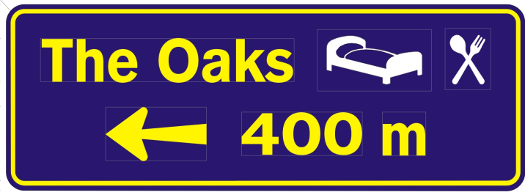
Advance Access

Advance Junction

Promotional Signs

‘Welcome to Tasmania’
- Introduction
At the major air and sea ports of arrival into Tasmania, ‘Welcome’ signs can be erected to greet visitors to Tasmania. Generally these signs will be funded by State Government. The designated ports are as follows:-
- Hobart Airport
- Launceston Airport
- Devonport Airport
- Burnie Airport
- Devonport Ferry Terminal

- Design
The design shall parallel the promotional strategies of Tourism Tasmania and as negotiated with the landowners and / or partners.
- Ownership and Maintenance
The State Government will be responsible for the design, installation and maintenance of the relevant signs unless other arrangements are entered into with the landowner.
The State Government will remove signs which no longer comply with the promotional strategies of Tourism Tasmania or have fallen into a state of disrepair.
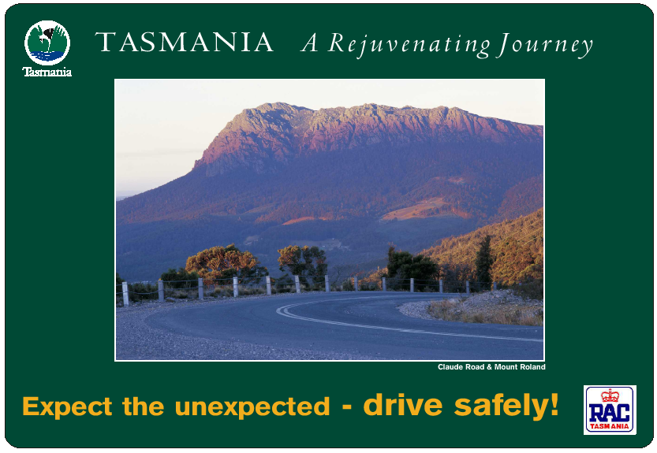
- Style of Sign

Tourism Precinct
- Introduction
Signs may be erected to indicate a defined tourism precinct where evidence exists of an integrated approach to tourism in a particular area / region.
- Criteria
- Evidence of a critical mass of attractions in the precinct / bypassed town providing a substantive tourism experience;
- The development of an integrated tourism development and promotional strategy by the local tourism association or local council focusing on the precinct experience.
- On going commitment by the local operators to the strategy.
The determining authority as to the classification of an area as a tourism precinct, for signing purposes, will be Tourism Tasmania.
- Design
Signing of tourism precincts will generally be on separate dedicated structures and not on existing guide signs.
The letter size and the total sign should be sufficiently large, so as to be readily appreciated having regard to its location and vehicle operating speeds.
Signs are not permitted which, because of colour, animation, siting or aspect, detract from the value of traffic signals or road marking.
Design specifications and location of the signs shall, in the final event, be determined by the Road Authority.
As provided for in Part B (1) of this Manual, bypassed town tourism precincts can be highlighted through the use of photographs on the Advance Direction Signs
- Installation of Signs
Signs are to be installed in accordance with Australian Standard 1742.2 and Department of State Growth Tasmania Roadworks Specifications. Where these two differ, on State Roads Department of State Growth Tasmania Roadworks Specifications shall take precedence. In the final event, the installation of the sign(s) shall be determined by the Road Authority.

- Ownership and Maintenance
Precinct signs will generally be provided at the cost of the relevant Municipal Council which shall be responsible for sign erection, maintenance and removal of the signs.
The approving authority / road authority will remove signs which no longer comply with the original approval, have fallen into a state of disrepair or the precinct no longer exists.

Municipal and City/Town Boundary Greetings
- Introduction
With the approval of the Road Authority, Local Government may erect greeting signs at municipal or town/ city boundaries at their discretion.
- Installation of Signs
Signs are to be installed in accordance with Australian Standard 1742.2 and, on State roads, the Department of State Growth Tasmania Roadworks Specifications shall take precedence where these two differ.
- Design
The letter size and the total sign area should be sufficiently large, so as to be readily appreciated having regard to its location and vehicle operating speeds. The total sign should have a surface area no greater than 3 square metres.
In those cities/towns that have a TVIN Centre, the city/town boundary signs should be designed to accommodate the italicized ‘i’ symbol – see Part E 3 (iv).
Signs are not permitted, which, because of colour, animation, siting or aspect, detract from the value of traffic signals or road marking.
Design specifications of the signs shall, in the final event, be determined by the Road Authority.
- Ownership and Maintenance
The signs shall be funded by the city/municipal council which shall also be responsible for sign installation, maintenance and removal.
The road authority reserves the right to remove signs which no longer comply with the original approval or have fallen into a state of disrepair.
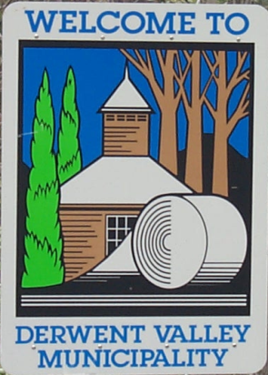
- Style of Sign

Tasmanian Visitor Information Network (TVIN) Centre
- Introduction
Tasmanian Visitor Information Network (TVIN) Centres authorized by Tourism Tasmania to use the italicised ‘i’ symbol may, with the approval of the Road Authority, erect signs directing to the Centre at the city / town boundary and at additional locations within the city / town.
The italicized yellow on blue ‘i’ is a registered trademark symbol and, as such, its use is limited to parties licensed to do so.
- Type and Location
As a general principle, the focus of signs leading into cities and towns will be to guide visitors to the TVIN centre servicing the community or region. The State Government (through Tourism Tasmania) will provide TVIN signs on primary access roads leading to cities / towns where TVIN’s are located.
A tiered approach to TVIN signs is recommended as below:-
- Advance signs 10 – 30 km from the city / town boundary;
- A combined town 'Welcome' and TVIN sign on major access roads at the city / town boundary;
- Direction signs at junctions leading to the Centre;
- Appropriate signs at or on the TVIN Centre;
An after-hours information board at or near the Centre outlining the location of key features and commercial tourism facilities is a desirable asset for visitors arriving after regular opening hours.
Location, design and number of signs will be determined by Tourism Tasmania in consultation with the Road Authority in conformity with signs shown in Part F (4).
Signs are to be installed in accordance with Australian Standard 1742.2 and, on State roads, Department of State Growth Tasmania Roadworks Specifications. Where these two differ, on State Roads Department of State Growth Tasmania Roadworks Specifications shall take precedence. In the final event, the installation of the sign(s) shall be determined by the Road Authority.
- Eligibility
Will be determined by Tourism Tasmania. Details of current Centres can be obtained from Tourism Tasmania.

- Maintenance and Ownership
Tourism Tasmania shall generally fund manufacture and erection of standalone TVIN signs including costs incurred in their maintenance and removal if required.
The road authority reserves the right to remove signs that no longer comply with the original approval, have fallen into a state of disrepair or the TVIN Centre is closed.
- Style of Sign

Information Bay, Lay-by and Non TVIN Information Centre
- Introduction
The following guidelines relate to erection of the white on blue ‘i’ used for non-TVIN information centres, information bays and lay bys. An application to erect such signs would generally be made, or supported by the city/municipal council.
- Eligibility Criteria
- Non TVIN Information Centre
A premise with a dedicated area set aside for the provision of free and saleable tourism literature to visitors and accessible by the public during reasonable hours most days of the week. Where the information area is within the premises of another business activity, provision of information / literature will not be conditional upon purchases from that other business activity.
- Information Bay
A permanent roadside structure providing a range of visitor information.
- Lay-by
A panel of tourism and/or service information signs providing visitor information.
- Ownership and Maintenance
The signs will generally be provided at the cost of the relevant city/municipal council which shall also be responsible for sign design, installation, maintenance and removal.
The road authority reserves the right to remove signs which no longer comply with the original approval, have fallen into a state of disrepair or the facility is closed.
- Style of Sign

Visitor Radio
- Introduction
Prior to submitting an application for signs, the Broadcaster must obtain all necessary approvals permitting the broadcasting of a Visitor Radio Information Service.
- Broadcast Content
- The broadcast content must provide visitor information (which may include advertising) relating to visitor attractions and facilities in the broadcast area, to the satisfaction of Tourism Tasmania.
- Installation
Signs are to be installed in accordance with AS 1742.2 and Department of State Growth Tasmania Roadworks Specifications. Where these two differ, on State roads the Department of State Growth Tasmania Roadworks Specifications shall take precedence.
In the final event, installation of these signs shall be determined by the Road Authority.
- Ownership and Maintenance
The broadcaster will be responsible for the manufacture, installation and maintenance of the relevant signs and for their removal upon cessation of the broadcast service.
The road authority reserves the right to remove signs which no longer comply with the original approval, have fallen into a state of disrepair or the service ceases to operate.
- Style of Sign
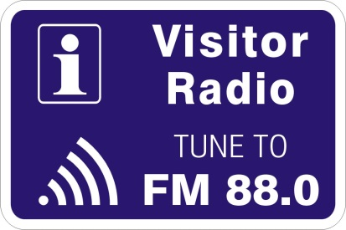

Historic Town / Historic Village/Historic Precinct
- Introduction
For a town, village or precinct to qualify for the ‘historic’ classification and receive relevant signs the following criteria apply.
- There should be a reasonable number of well-grouped structures dating from before 1901 (pre-federation), each of which has not been dramatically altered since that time.
- At least one building of historic interest is to be open for inspection by the public during normal trading hours.
- The town, village or precinct is to have in place the means to provide information, interpretation, guidance and advice on its historic buildings and structures.
- The determining authority for these classifications will be Tourism Tasmania in consultation with the Heritage Council of Tasmania.
- Approved historic towns, villages or precincts may qualify for white on brown Advance Direction Signs and the appropriate Tourism Shield, on the boundaries of the town, village or precinct.
- The following are classified as Historic Towns as at 14 July June 2006;
Bothwell, Campbell Town, Carrick, Deloraine, Derby, Evandale, Franklin, Hamilton, Kempton, Latrobe, Longford, New Norfolk, Oatlands, Pontville, Queenstown, Richmond, Ross, Stanley, Swansea, Westbury, Zeehan.
- Ownership and Maintenance
The Road Authority is responsible for the costs of design, manufacture, installation and maintenance of the signs.

Themed Routes
- Introduction
In partnership with the three regional council bodies (Cradle Coast Authority, Northern Tasmania Regional Development Board, Southern Councils Tourism Task Force) Tourism Tasmania has implemented a ‘touring route’ strategy designed to improve the Tasmanian touring holiday experience.
The Strategy is underpinned by the Tourism Tasmania’s Tourism Development Framework which defines a touring route as:
- a primary themed route connecting clusters.
The intent of the Touring Route Strategy is to feature the key attractions of Tasmania and facilitate the delivery of the ‘Tasmanian Experience’ to visitors. Tourism Tasmania is encouraging the development of themed touring routes through the regional partnerships whereby each route will have its own development strategy embracing product development, standardised literature, web sites, integrated tourist signage, public infrastructure, etc.
A touring route is intended not to encourage a rush from one cluster to another, but rather to highlight all the opportunities along the way to experience Tasmania – there will be many products / experiences that are accessible off the major ‘A’ classified road network as visitors journey from one region to another.
Generally touring route signs will not appear on existing guide signs – the preferred solution is for standalone signs, which do not detract from Traffic Control, and Guide Signs. A minimalist approach is deemed more desirable than saturating routes with vast numbers of touring route signs
- Criteria
A primary themed route between clusters will portray and link some of the State’s unique natural, cultural or heritage features and in a manner which make it a ‘must see and do’ for tourists.
It is essential that the quality of the experience of a themed route is maintained at a very high level to ensure it creates a perception of ‘something special’ and is held in high regard by tourists.
The distinguishing issue for determining whether a collection of natural, cultural or historic features joined by a roadway constitutes a ‘touring route’ will be the presentation of such features and how they can be experienced by tourists; and, the manner in which the route between such features is part of the experience.
A route that simply links together the general features and facilities of an area would not constitute by itself a touring route.
To be classified as a touring route and be eligible for signage as part of the guide system, the route must satisfy the following criteria:
- The route should have significant tourism and or/ scenic appeal, including a high frequency of quality tourist attractions;
- The route must not be based on attractions which are strictly seasonal or are not a permanent feature of the route;
- The route must use only suitably maintained roads, preferably sealed, which are also capable of handling the higher volumes of traffic attracted to the area;
- Tourist literature covering the route must be developed and made available through TVIN Centres and local information outlets along the way;
- The theme of the route should reflect its unique characteristics and be aligned with Brand Tasmania values.
- The route must be endorsed and supported by the relevant Regional Tourism Authority as part of its Regional Touring Strategy;
- There should be no overlap with other Journeys but it will be an advantage for connections to other Journeys to be well co-ordinated.
- The determining Authority for the approval of Journeys will be Tourism Tasmania in association with the respective Regional Tourism Authority.
- Maintenance and Ownership
The proponents of touring routes will be responsible for the production, erection and maintenance of the relevant signs unless other arrangements are entered into with the Road Authority.
Signing of routes will generally be on separate dedicated structures and not on existing guide signs.
The road authority reserves the right to remove signs that no longer comply with the original approval, have fallen into a state of disrepair or the Journey or Trail ceases to function as intended.
- Style of Signs
Signs may include:-
- route markers – shields or smaller signs erected along the route;
- advance signs – to indicate a change of direction, particularly on rural roads;
- junctions signs;
- position or interpretative signs; and
- end marker / signs – to signify the end of a themed route.
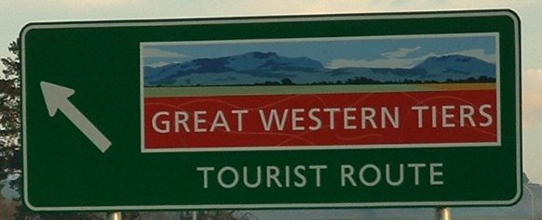

Wildlife Parks
- Introduction
Wildlife Parks are nature-based attractions that are considered to be of substantial importance to the State’s tourism industry as a core element of Tasmania’s natural heritage and are key contributors to the Tasmanian tourism brand core appeals, primarily through the display of native Tasmanian fauna.
- Key Criteria
Wildlife Parks must have all relevant State and Local Government licences to operate as a tourist attraction, including a Wildlife Exhibition Licence, and must:-
- comply with all criteria for being a Natural, Cultural or Historic Feature.
- Display a varied range of native fauna, which may be complemented with domestic animals, reptiles, fish or birdlife. Species not native to Tasmania / Australia may also be displayed but must not be the dominant exhibit.
- offer a quality visitor experience, including identification and interpretation of species / exhibits.
- be open on weekends and at least four other days of the week, as well as public and school holidays for at least 9 months of the year and preferably all year round.
- Signage Entitlement
Wildlife Parks may be eligible for tourism signs in either rural and / or urban environments. The determining authority for entitlement shall be Tourism Tasmania, in consultation with the Nature Conservation Branch, Department of Primary Industries Water and Environment (DPIWE).
Generally, signage will be limited to those locations providing direct access to the attraction. The road authority, in conjunction with Tourism Tasmania, may also give consideration to more distant locations.
All signage is subject to availability of safe and suitable sites on the roadside.
- Ownership and Maintenance
The attraction shall be responsible for all costs associated with the design manufacture, erection and maintenance of the signs. The attraction shall also be responsible for all costs associated with their removal if the business has closed or no longer meets the criteria for recognition as a Wildlife Park.
The road authority reserves the right to remove those signs that no longer comply with the original approval, have fallen into a state of disrepair or that the attraction has failed to remove following closure.

- Sign Style
The design of the signs shall be determined on a case by case basis. Wildlife Parks may be accorded signage of a design standard as shown in Fig XX (see Part F). SHOW IMAGES HERE OF AD AND ID SIGNS

Application Process For Tourism Information Signs
Applications for natural, cultural, historic features signs, commercial tourism facility signs and promotional signs should be forwarded to the Tourism Signs Consultant, Department of State Growth, using the application forms which follow.
There are certain conditions that need to be satisfied prior to formal approval being given to erect a tourism sign. The approval stages involve seeking permission from the landowner (either State Government or Local Government) and in some cases gaining planning approval from the city/municipal council.
- The Process for State Roads
- All enquiries should be directed to the Tourism Signs Consultant, Department of State Growth (ph 03 6166 3328).
- An Application Form will be forwarded, if appropriate, to the enquirer.
- Applicant completes and returns.
- If eligible, permits and permissions are provided, other than those required by Local Government, to allow the signs to be erected.
- Guidelines on placement, lettering and style along with authorized manufacturers are also provided.
- Some councils require planning permission be given for signs. Contact must be made with the local council once Department of State Growth approval is provided.
- Once the signs are installed, the applicant must advise the Tourism Signs Consultant of completion.
- The Process for Local Government Roads
- Contact the Tourism Signs Consultant, Department of State Growth (ph 03 6166 3328).
- An Application Form will be forwarded, if appropriate, to the enquirer.
- Applicant completes and returns Form.
- Eligibility letter copied to council, applicant also receives guidelines on placement, lettering and style along with authorized manufacturers.
- Applicant contacts the council to complete approval process.
- If approved, the applicant must advise the Tourism Signs Consultant when the signs are installed, to confirm completion.

TOURISM INFORMATION SIGNS APPLICATION - FORM A
(Commercial Tourism Facility/Natural, Cultural, Historic Feature)

Works in the State Road Reservation require approval under the provisions of the Roads and Jetties Act 1935.

Receipt of a completed application does not necessarily mean that permission will be granted.

Please complete all sections
Attach additional pages if there is insufficient space

APPLICANT NAME:
POSTAL ADDRESS:
CONTACT NO:
E-MAIL ADDRESS:
(if issued, the permit will be sent to this address)

Permits will only be issued in the name of the business operator. Are you the business operator?
Yes - Declaration not required | No - Business operator must sign the declaration below
Declaration of title holder consent
I, the undersigned, am the registered business operator subject of this application. I hereby indicate my consent to the making of this application for approval of tourism signs, as described in this application.

……………………………….. ………………………………. ……………………
Name Signature Date

Email:………………………………..………………………………..……………………………
(a copy of the permit will be provided to the business operator.)
DETAILS OF TOURISM FACILITY / FEATURE
Registered Business Name:

Location of Business:

Local Government Area:

Brief Description of Business (i.e. nature and operation):

Is your business currently trading? Yes No

Hours / days of operation
Is your business closed seasonally? Yes No If Yes, when? .......................................
Is your business listed on the national tourism product database ATDW-Online (managed through Tourism Tasmania)?
Yes No
Are you registered for Tourism Accreditation with the Tourism Industry Council Tasmania? Yes No
DETAILS OF PROPOSED SIGNS
Proposed location of signs: (Attach a map or sketch drawing of proposed location(s), showing business premises and surrounding roads)

Are there tourist information signs currently erected at or near the proposed location? Yes No
If Yes, please give details? .......................................

Proposed sign information: (Signs are considered directional and the business name and trading identity only to be shown)

DETAILS OF OTHER SIGNS
Do you have other signs erected remote from your business location? Yes No
If Yes, do the signs have Local Government planning approval? Date of approval ……………... Permit No. ……………….
- Show location of these signs on the above map or sketch drawing.
Do you have written consent of the landowner to display the sign(s)? Yes No

Supporting Information/applicant checklist:
Business Operator’s signature (if required)
Copy of Certificate of Business Name Registration
Copy of Certificate of Occupancy (if accommodating travellers)
Other information that may assist in considering the application (e.g. business brochure, liquor licence details)

Signature of Applicant

I / we certify that the above information is true and accurate; that the business has and meets all statutory and Local Government licences and approvals to operate as a tourism business / feature.

I / we hereby submit the application accordingly:

…………………………………………….. ………………………………………… …………………….
Applicant’s Name Applicant’s Signature Date

Submit your application:

By email: vin.gerasimenok@stategrowth.tas.gov.au By mail: Vin Gerasimenok,
Tourism Signs Consultant
Department of State Growth
GPO Box 536
HOBART TAS 7001

If you require any assistance in completing this application please contact Vin as below:
Telephone: (03) 6166 3328
Fax: (03) 6233 3581
Email: vin.gerasimenok@stategrowth.tas.gov.au

Personal Information Protection Statement
You are providing personal information to the Department of State Growth, which will manage that information in accordance with the Personal Information Protection Act 2004. The personal information collected here will be used by the Department for the purpose of dealing with your application, pursuant to the Roads and Jetties Act 1935 and associated legislation. Failure to provide this information may result in your application not being processed or records not being properly maintained. The Department may also use the information for related purposes, or disclose it to third parties in circumstances allowed for by law. You have the right to access your personal information by request to the Department and you may be charged a fee for this service.

TOURISM PROMOTION SIGNS APPLICATION - FORM B
(Tourism Precinct, Themed Tail and Visitor Radio)

Works in the State Road Reservation require approval under the provisions of the Roads and Jetties Act 1935.

Receipt of a completed application does not necessarily mean that permission will be granted.

Please complete all sections
Attach additional pages if there is insufficient space

Applicant Name:
Postal Address:
Contact No.
Email address:
(if issued, the permit will be sent to this address)
Primary Contact Person:
Person responsible for implementation and
on-going management of proposal:

Has there been any consultation? Yes No
If Yes, who has participated?

DETAILS OF PRECINCT / TRAIL / VISITOR RADIO AREA
Proposed location:

Brief Description of concept and any related features and facilities:

Local Government area:
Tourist attractions, facilities and features in proposed location:

Are the tourism attractions, facilities and features listed on the national tourism product database ATDW-Online (managed through Tourism Tasmania)? Yes No
Are the tourism attractions, facilities and features registered for Tourism Accreditation with the Tourism Industry Council Tasmania? Yes No
DETAILS OF PROPOSED SIGNS
Proposed location of signs: (Attach a map or sketch drawing of proposed location(s), showing their relationship to the precinct/proposed trail/visitor radio broadcast area and surrounding roads)

Proposed artwork or words for the signs:

Do you have written consent of the landowner to display the sign(s)? Yes No
If Yes, has Local Government planning approval been given to display of the proposed signs?
Date of approval ……………... Permit No. ……………….

How is the project to be funded?

DETAILS OF OTHER SIGNS
Are there any other precinct / trail / visitor radio signs located in the proposed area? Yes No
If Yes, show location of these signs on the above map or sketch drawing.
Are there tourist information signs currently erected at or near the proposed locations. Yes No
If Yes, give details:

Supporting Information/applicant checklist:
Letters of support
Approvals from relevant authorities
Program content (Visitor Radio)
Other information that may assist in considering the application; e.g. promotional brochure (Trails) or business plan (Visitor Radio)

Signature of Applicant

I / we certify that the above information is true and accurate and submit the application accordingly:

…………………………………………….. ………………………………………… …………………….
Applicant’s Name Applicant’s Signature Date

Submit your application:

By email: vin.gerasimenok@stategrowth.tas.gov.au By mail: Vin Gerasimenok,
Tourism Signs Consultant
Department of State Growth
GPO Box 536
HOBART TAS 7001

If you require any assistance in completing this application please contact Vin as below:
Telephone: (03) 6166 3328
Fax: (03) 6233 3581
Email: vin.gerasimenok@stategrowth.tas.gov.au

Personal Information Protection Statement
You are providing personal information to the Department of State Growth, which will manage that information in accordance with the Personal Information Protection Act 2004. The personal information collected here will be used by the Department for the purpose of dealing with your application, pursuant to the Roads and Jetties Act 1935 and associated legislation. Failure to provide this information may result in your application not being processed or records not being properly maintained. The Department may also use the information for related purposes, or disclose it to third parties in circumstances allowed for by law. You have the right to access your personal information by request to the Department and you may be charged a fee for this service.

Part F - Tourism Signs Specifications

Application of Rural and Urban Tourism Information Sign Specifications
This table indicates the application of both Rural and Urban Tourist Information Sign Specifications in accordance with the Department of State Growth, Draft Tasmanian Road Hierarchy and Targets and the associated speed environments.
 | Posted Speed Limit in km/h ⁽⁵⁾
Road Category ^{(3/4)} | 60 or less | 70 to 80 | > 80
I | Urban ⁽²⁾ | Urban ⁽²⁾ | Rural ⁽¹⁾
II | Urban ⁽²⁾ | Urban ⁽²⁾ | Rural ⁽¹⁾
III | Urban ⁽²⁾ | Urban ⁽²⁾ | Rural ⁽¹⁾
IV | Urban ⁽²⁾ | Rural ⁽¹⁾ | Rural ⁽¹⁾
V | Urban ⁽²⁾ | Rural ⁽¹⁾ | Rural ⁽¹⁾
Other non State Roads (eg Local Govt, Forestry) | Urban ⁽²⁾ | Rural ⁽¹⁾ | Rural ⁽¹⁾

Notes:
- Refer to Part D Tourism Signs – Principles, Rural Areas.
- Refer to Part D Tourism Signs – Principles, Urban Areas.
- For details of Road Categories see Part F, 2.
- State and Local Government Roads, see definitions on pages 2 and 3 of this Manual.
- Where there are differing speed limits in opposing directions of the same section of road the lower speed limit shall be used for the purposes of this Table.

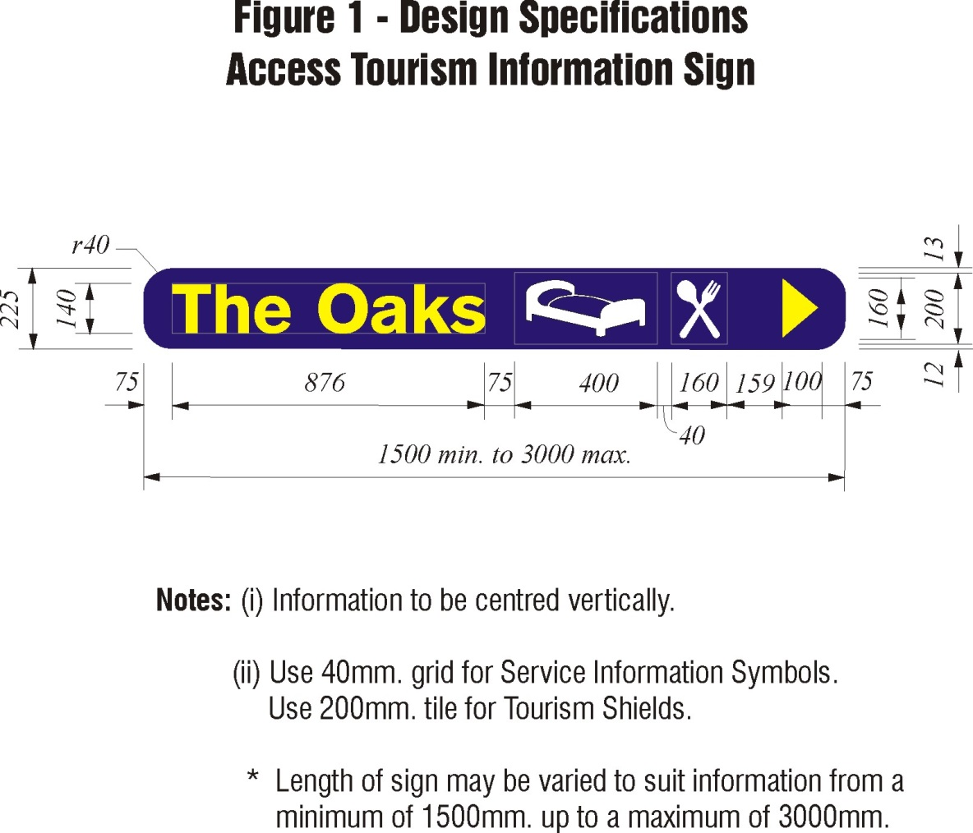
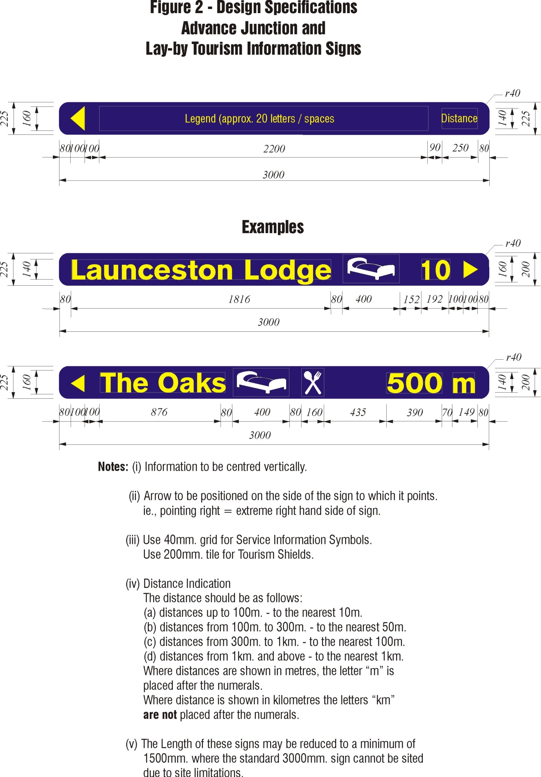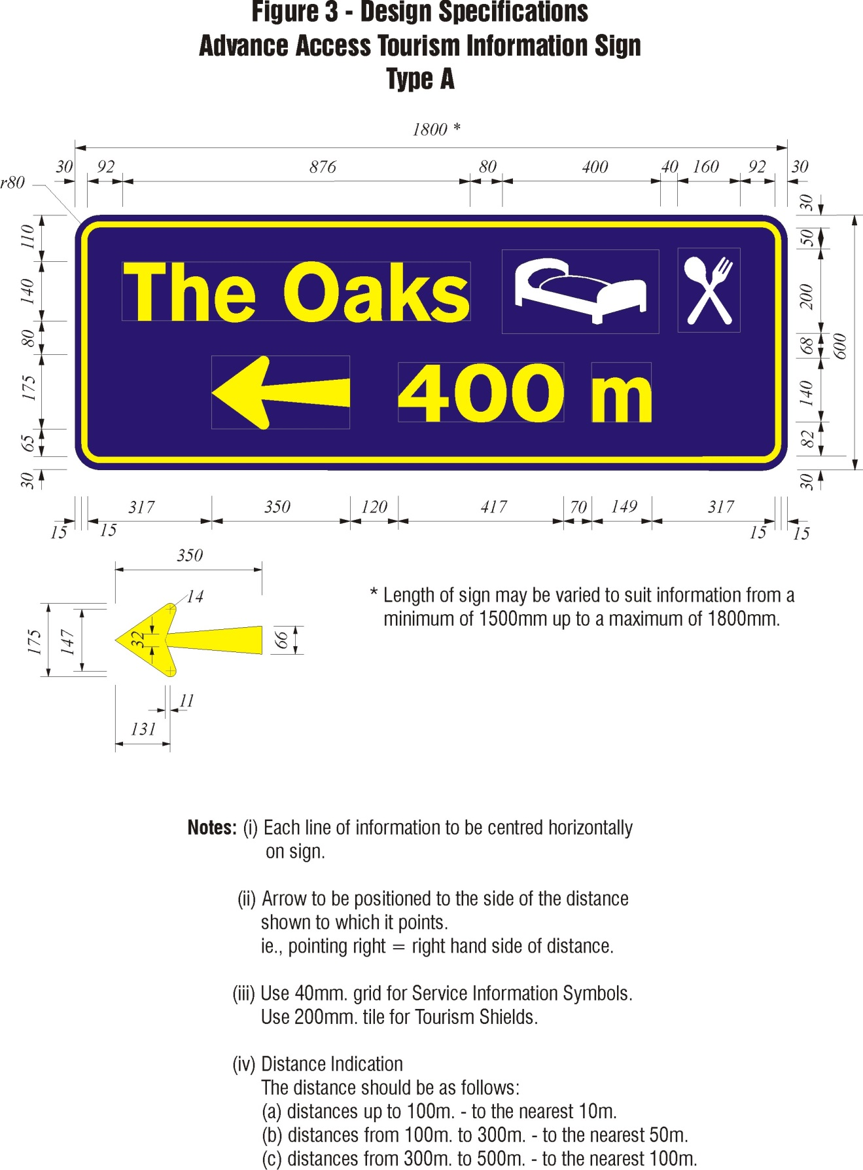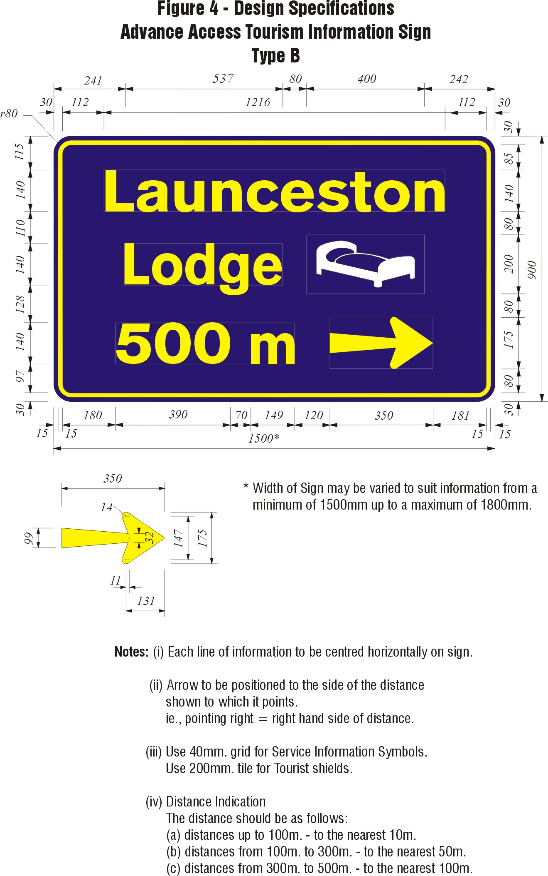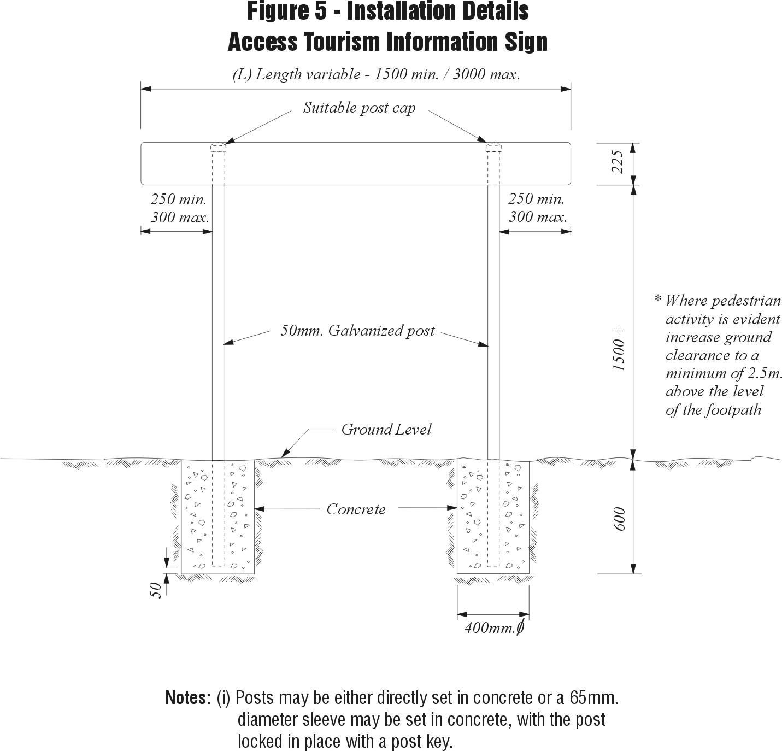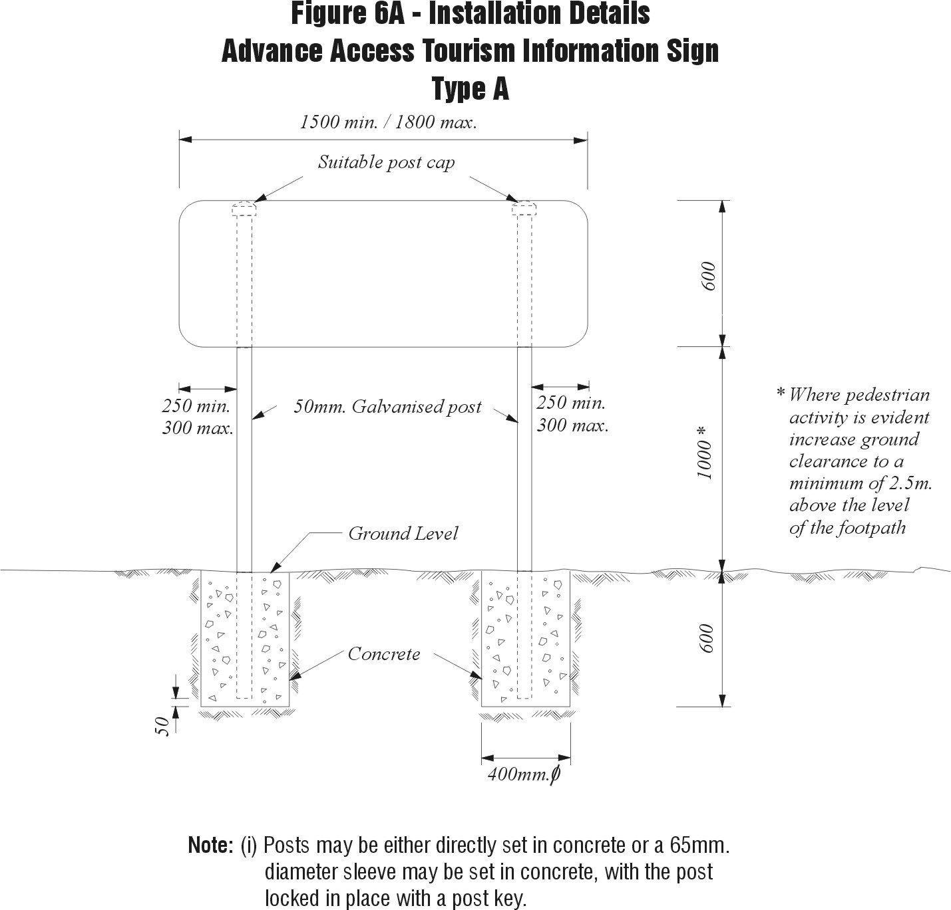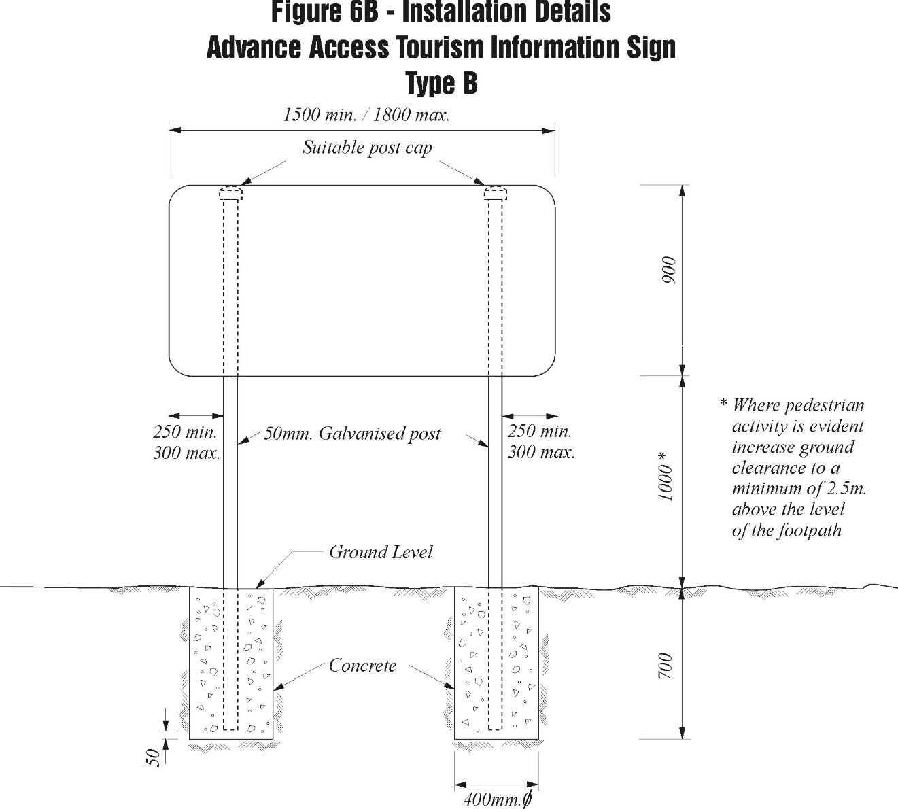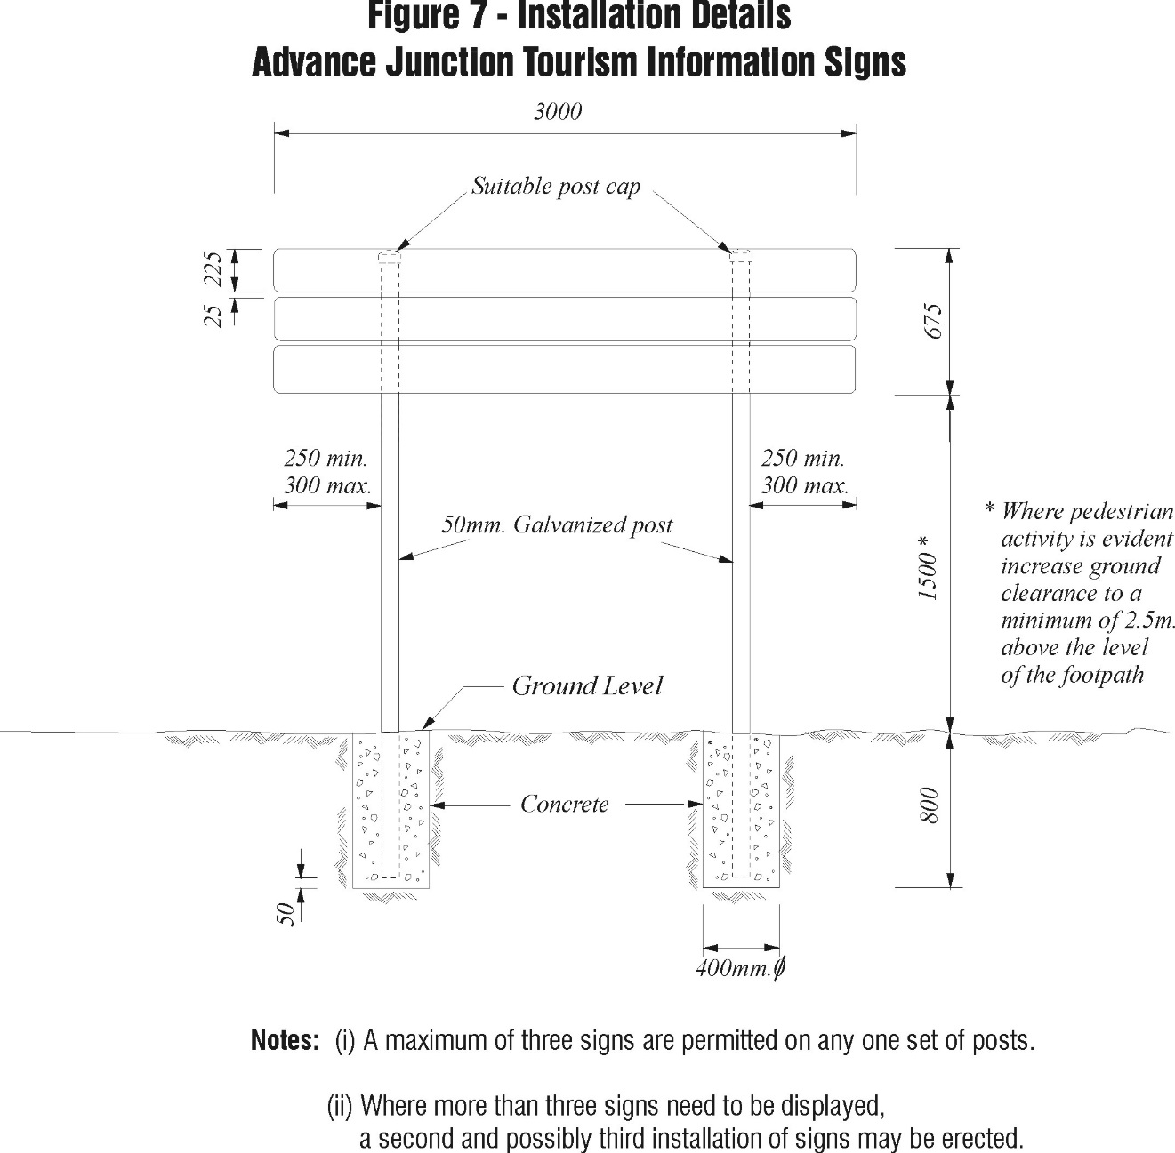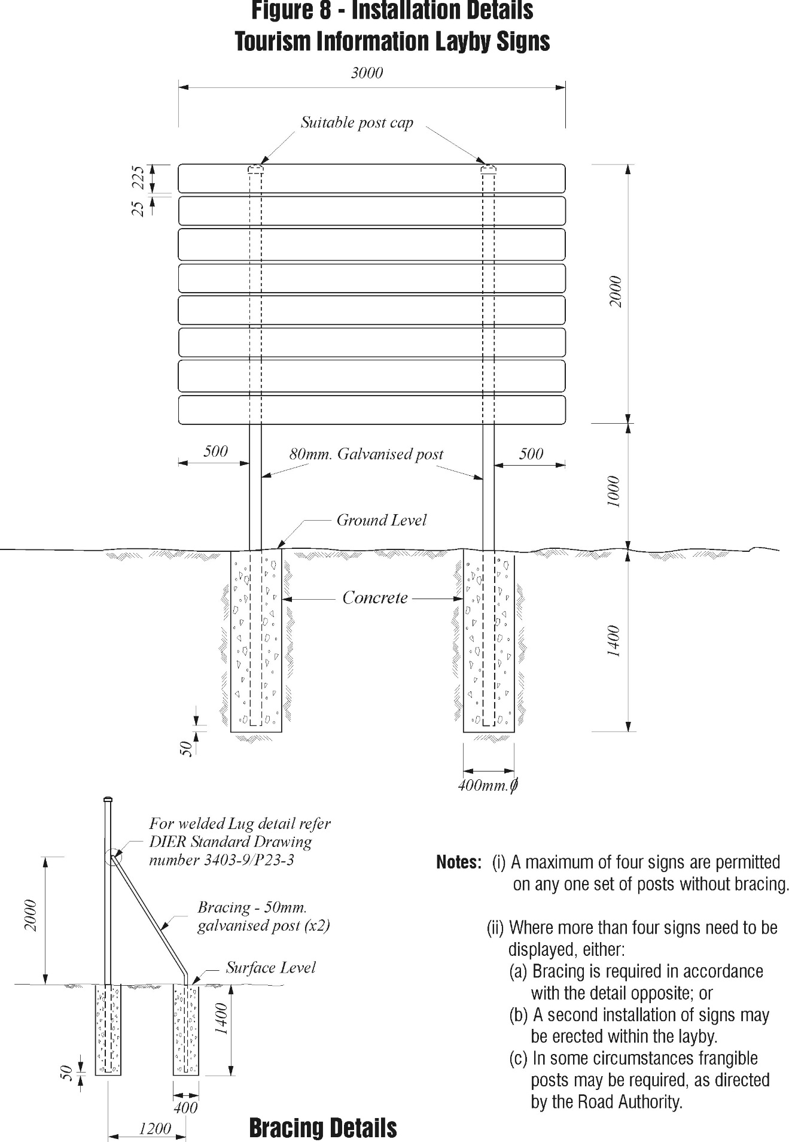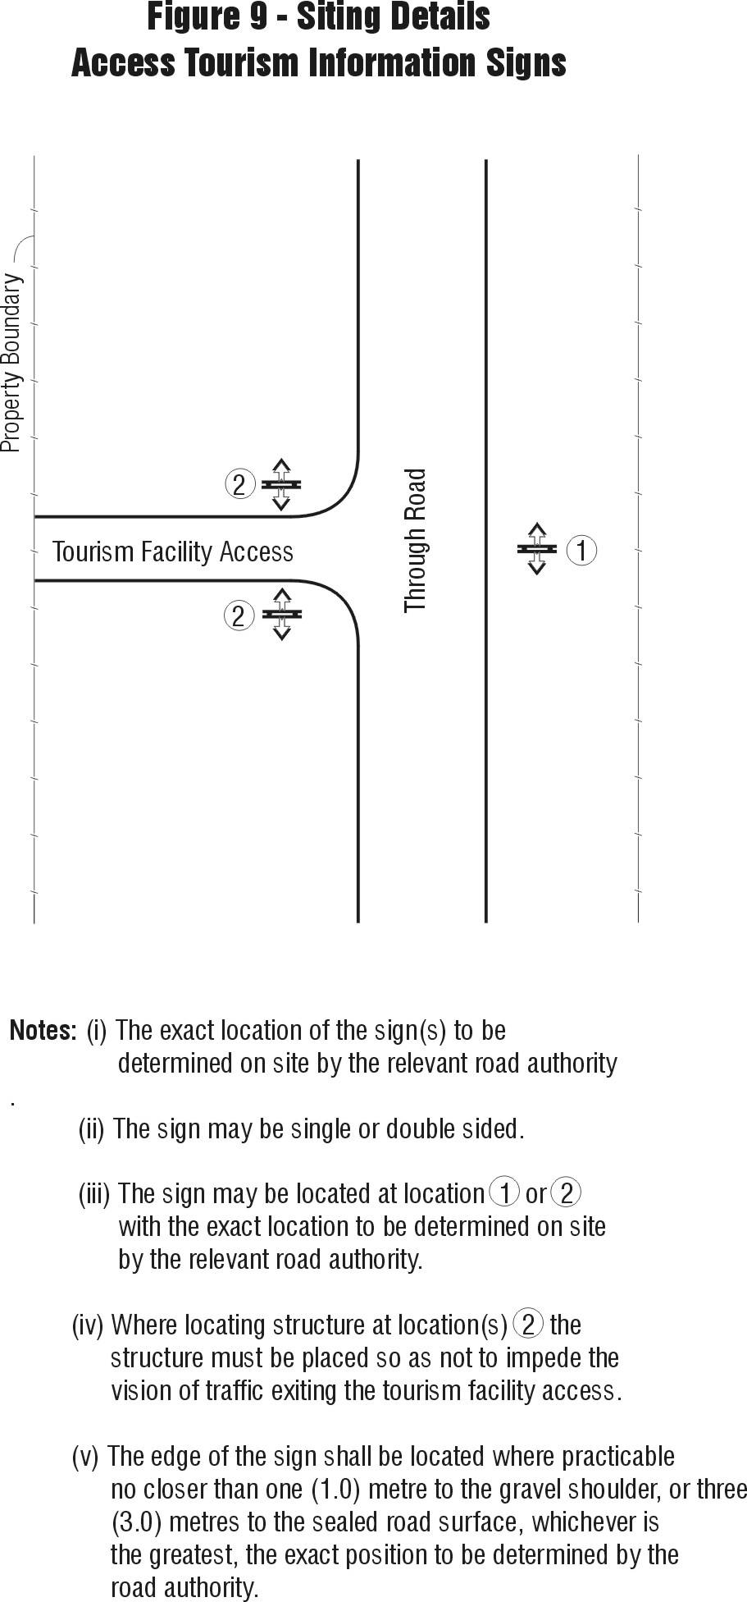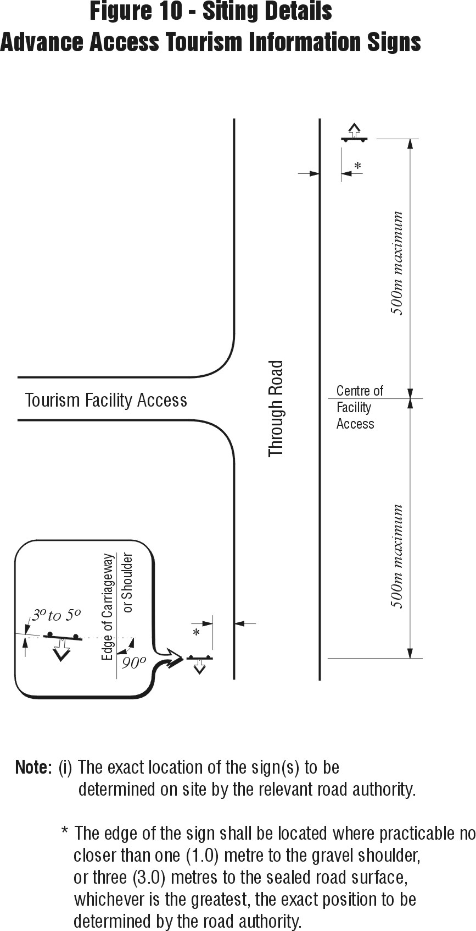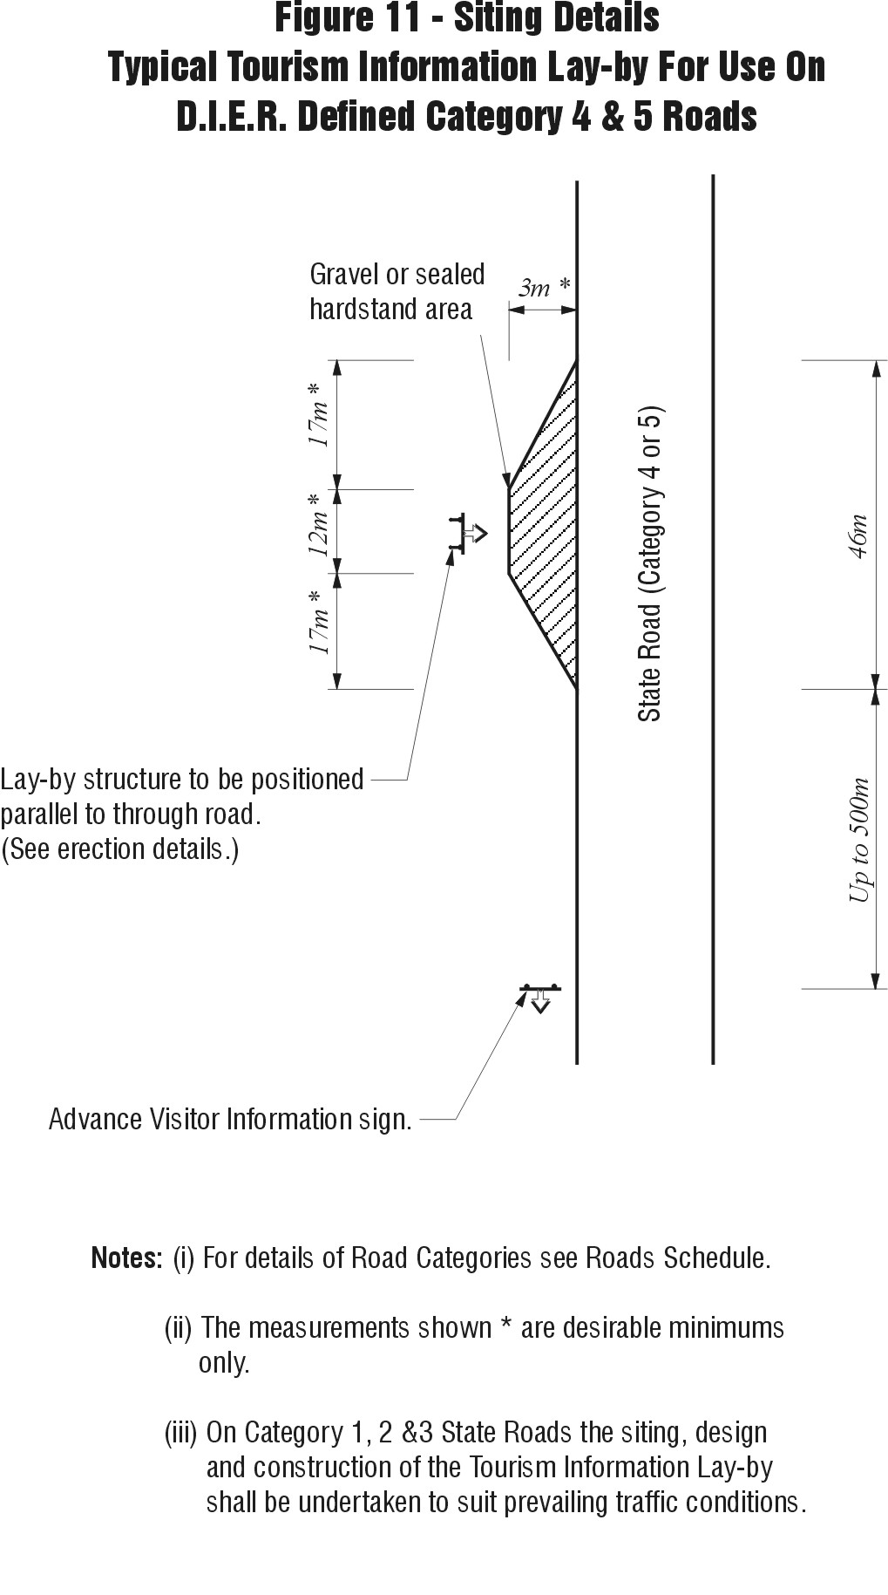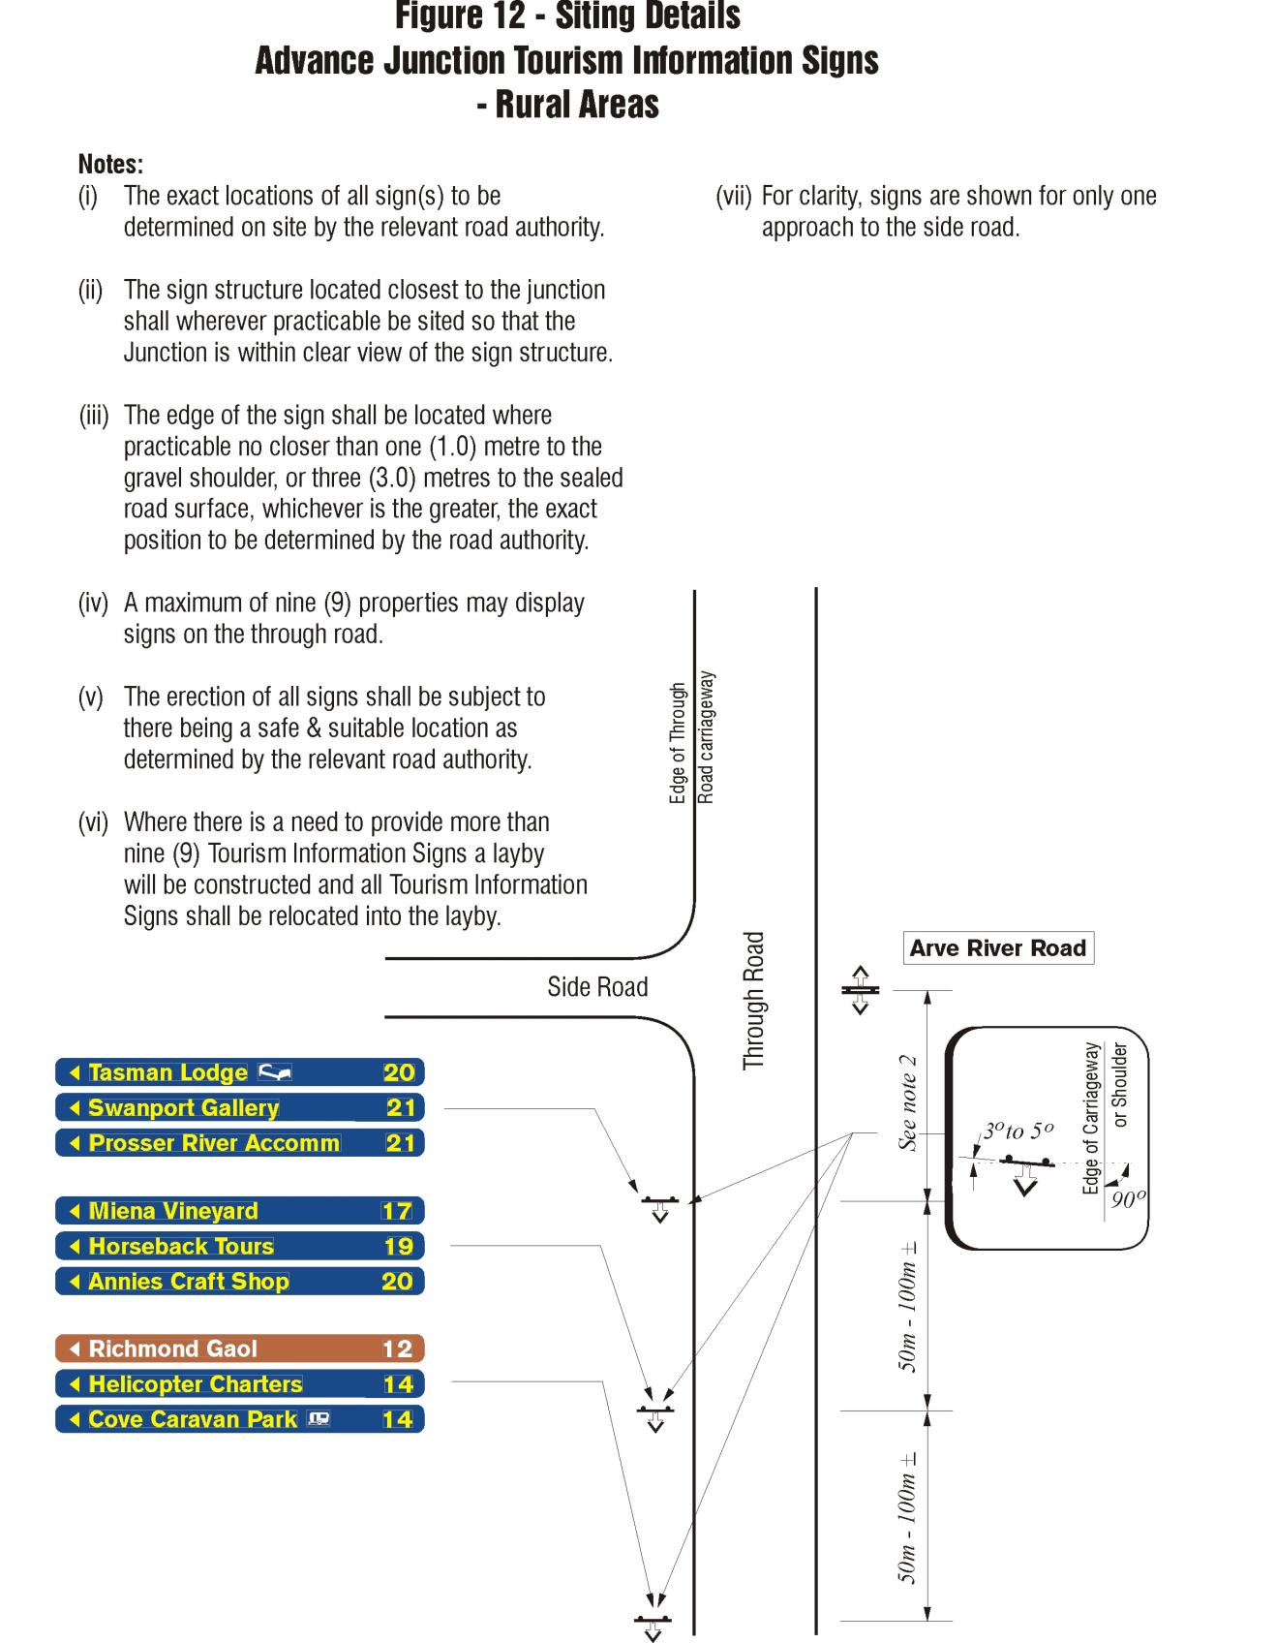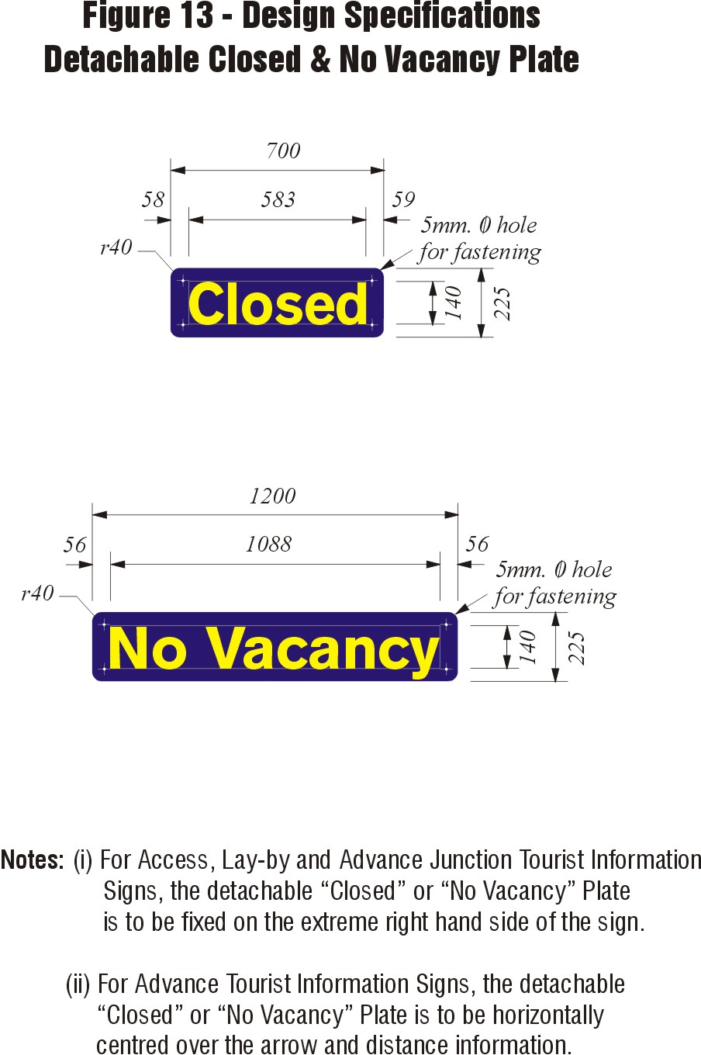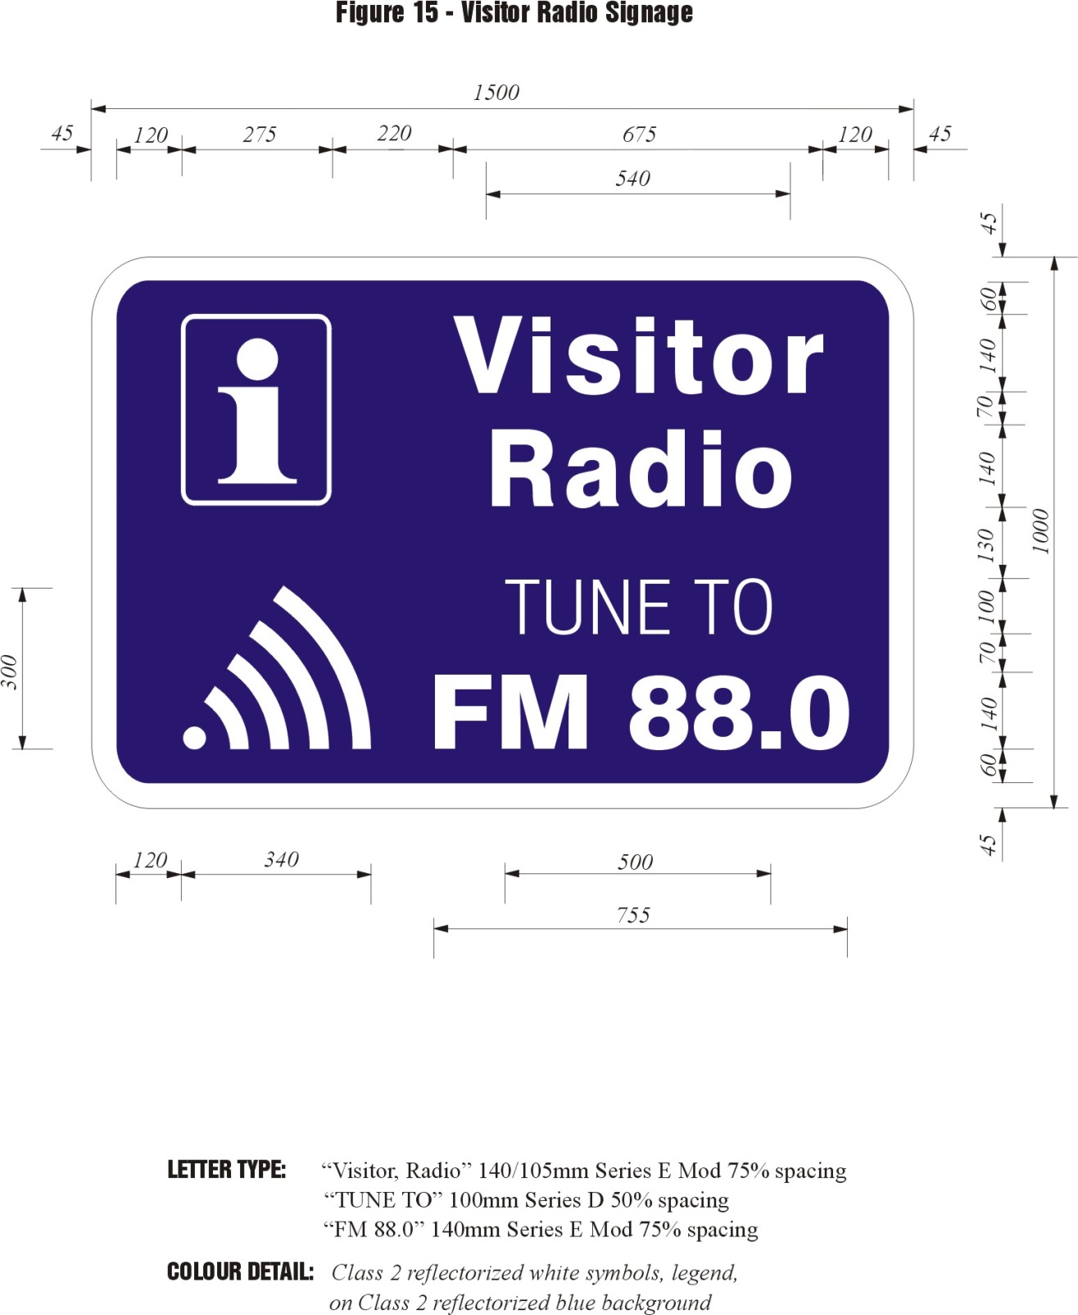

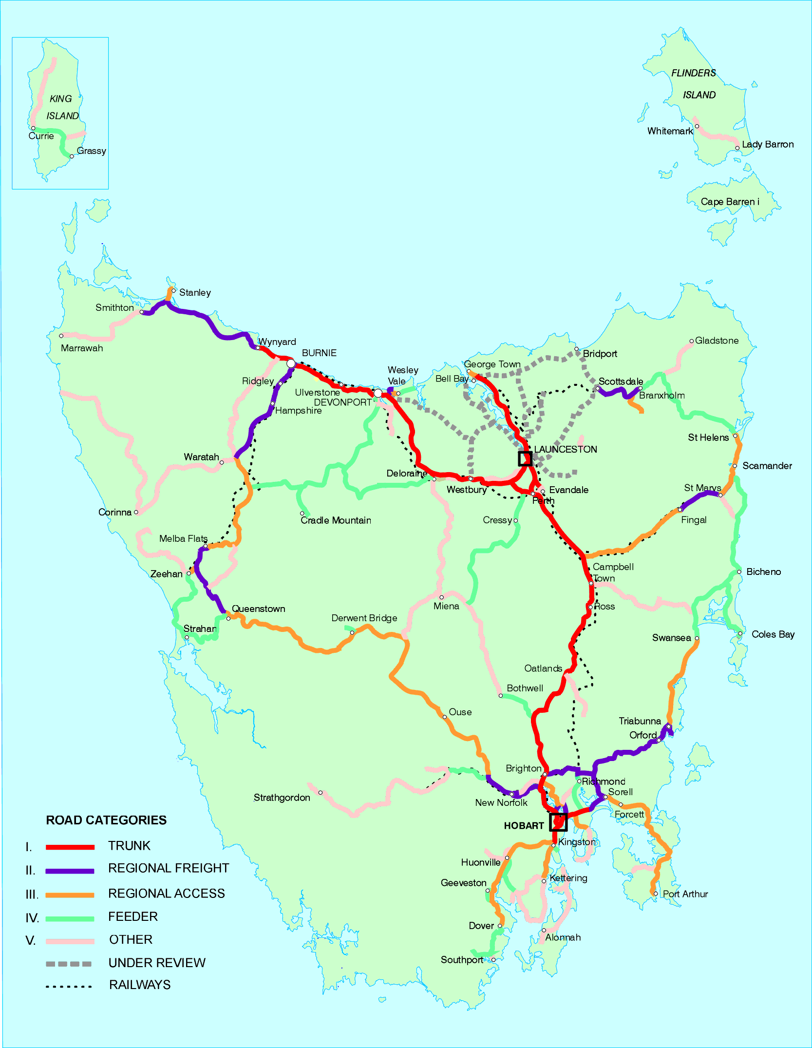
Road Category Details
Source - Draft Tasmanian Road Hierarchy and Targets – Department of Infrastructure, Energy and Resources (DIER), 1999.

Palette – Service Information Symbols and Tourism Shields
Service Information Symbols:

Hospital/First Aid/Emergency Services.
Indicates hospitals, ambulance stations or first aid stations where casualty service is available from personnel qualified in the medical profession.
With the symbol there must be a legend denoting the type of centre eg., Hospital, Ambulance, First Aid, etc.,
Police.
Indicates a police station.
Public Telephone.
Coin operated type available to the public 24 hours a day. Generally this symbol will only be displayed where the telephone is either not readily visible from the road, or is located not more than 10km along the side road in rural areas, or not more than 500m in urban areas and provided that a similar facility is not located within a similar distance on the through route.
Emergency Telephone.
Used to highlight the existence of an emergency telephone to summon assistance 24 hours per day in emergencies such as vehicle breakdown or accidents. These phones are funded by the Road Authority and are normally not connected to the general telephone network.
Help Telephone.
Used to highlight the existence of roadside help telephones on major arterial type roads.
Tasmanian Visitor Information Network (TVIN) Centre.
A trade marked symbol indicating a manned visitor information centre meeting criteria to be registered for accreditation under the National Visitor Accreditation Scheme.
Information.
Used to advise the location of non-Tasmanian Visitor Information Network (TVIN) Centres and unmanned sources of information such as lay-bys.
Fuel Outlet.
Indicates the location of a Fuel Outlet selling petrol that may or may not provide mechanical repairs. Opening times may vary however the service must be available at reasonably expected times
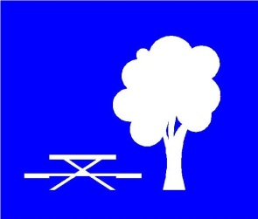 | Rest Area.  An area clear of the road where, at a minimum, parking, fire-places, picnic tables, drinking water, toilets and shelter sheds are provided free of charge to the public.
Wayside Stop (picnic area).
An area clear of the road where parking, fireplaces and litter bins are provided.
Accommodation.
A motel, hotel or guest-house which has all necessary licenses and approvals to operate.
Youth Hostel.
An officially recognised hostel affiliated with Youth Hostels Association of Tasmania Inc.
Caravan Park.
A caravan park which has all necessary licenses and approvals to operate and has sites available for casual users.
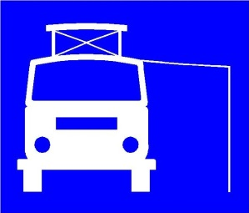 | Motorhome Site.  Indicates a motorhome site that may not have amenities or power.
Camping Site.
A camping site must have all necessary licenses and approvals to operate and have sites available for casual users.
Restaurant or Licensed Restaurant.
An establishment where a sit down, substantial meal of more than one course is available, during normal meal hours, at least five days a week.
Refreshments.
An establishment where light refreshments are available during normal trading hours, at least five days a week. It is not necessary for the facility to provide seating for customers.
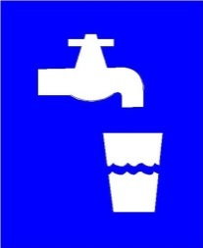 | Drinking Water.  Indicates that clean safe drinking water is available to the travelling public, free of charge.
Winery.
Used to indicate a winery which has a cellar door arrangement where wines may be sampled and purchased. Also used to indicate direction of travel on a wine route.
Public Toilets.
Provided and managed by a public authority and accessible to the public free of charge and open seven days a week. In rural areas the toilets should be located within 10km from the road on which the sign is displayed and in urban areas within 2km from the sign.
Public Toilets with Facilities for Disabled Persons.
Provided and managed by a public authority accessible to the public free of charge and open seven days a week with special facilities for those with disabilities. In rural areas the toilets should be located within 10km from the road on which the sign is displayed and in urban areas within 2km from the sign.
Dump Station for Motorhome Wastes.
Indicates a site for the emptying of black and grey water tanks from self contained motorhomes and the like
Litter Bin.
Indicates the provision of a litter bin adjacent to the roadside.
Airport.
A principal airport or airstrip of a region where regular scheduled flights, charter or emergency medical flights are available.
Bass Strait Ferry.
Bass Straight passenger and vehicular ferry operating between Devonport and Melbourne.
Bruny Island Ferry.
Passenger and vehicular ferry operating between Kettering and Bruny Island.
Parking.
Indicates parking facilities.
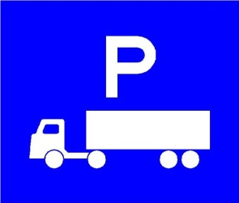 | Truck Parking Area.  Indicates an area clear of the road where large haulage vehicles can stop to check their loads and where the driver can rest.
Australia Post Office.
Indicates Australia Post Offices.
Internet Access.
Indicates the availability of internet access via dedicated facilities to the travelling public
Disabled Access.
Indicates that access is available to disabled persons.
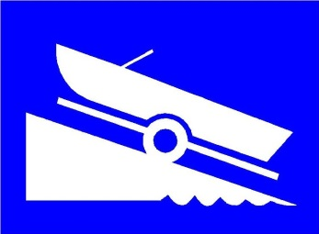 | Boat Ramp.  Launching facility for small boats which must meet the following criteria:  - the ramp must extend to the low water mark and provide some slipping facilities for all normal trailer craft,  - there must be ample parking for cars and trailers, and  the area must be safe for manoeuvering.
Sporting Facilities and/ or Activities:
The following symbols indicate sporting facilities or activities available to the general public. They may also indicate the availability of such equipment for hire where relevant and where indicated by appropriate wording on the signs.
 | Swimming Pool
 | Tennis Court
 | Athletic Centre
 | Cycling
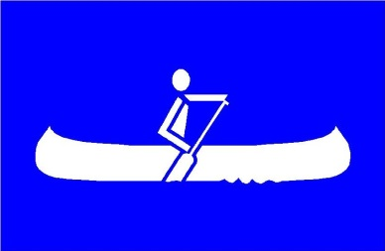 | Canoeing or Kayaking
 | Golf Course
 | Playground
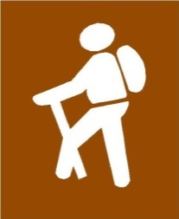 | Hiking or Walking Trail
 | Fishing

Tourism Shields:
The determining authority for the use of the following Tourism Shields shall be the Chief Executive of Tourism Tasmania.

Scenic Feature.
A panorama or vista which may be viewed from a prepared roadside vantage point or lookout or a feature of significant appeal to visitors.
Historic Town or Village.
A town with a reasonable number of well-grouped, pre-federation structures with at least one building of historic interest open for public inspection.
Historic Bridge.
A bridge classified ‘Historic’ by the National Trust which may be open to use by vehicular Traffic.
Historic Railway
A historic railway open to the public for excursions.
Historic Building.
A building that has been classified ‘Historic’ by the National Trust and is available for public viewing.
Historic Site.
A class of land as classified under the Nature Conservation Act 2002.
National Park.
A class of land as classified under the Nature Conservation Act 2002.
State Reserve.
A class of land as classified under the Nature Conservation Act 2002.
Forest Reserve.
A class of land as classified under the Forestry Act 1920.
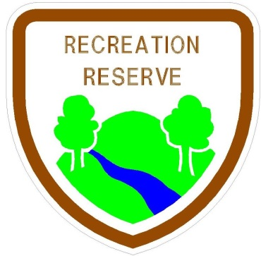 | Recreation Reserve.  A class of land as classified under the Nature Conservation Act 2002.
Nature Reserve.
A class of land as classified under the Nature Conservation Act 2002.
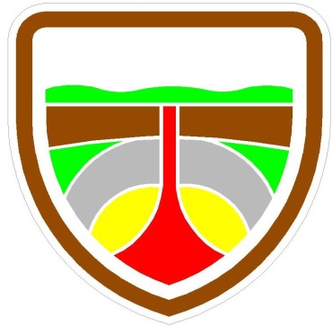 | Geological Feature.  A geological phenomenon recognised by the University of Tasmania.
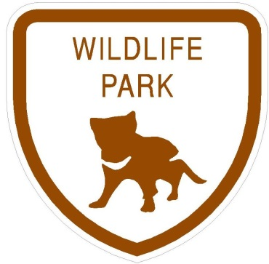 | Wildlife Park.  A Wildlife Park open to the public holding a wildlife exhibition licence issued by the Director of National Parks and Wildlife. The image chosen shall be representative of the dominant species in the park.
Crafts.
Locally made or at least Tasmanian manufactured craft works on display and/or offered for sale.
Antiques.
A building housing a collection of old wares on display and/or offered for sale, open to the public at least five days a week, including weekends, during normal tourist / trading hours.
Museum.
A building open to the public at least five days a week, including weekends, during normal tourist / trading hours in which objects illustrating art, culture or science are kept for viewing.

Tasmanian Visitor Information Network (TVIN) Signs
Are only to be used for visitor centres authorized to display the registered trade mark of the Tasmanian Visitor Information Network
For details of Centres authorized to display the symbol and all other inquiries relating to TVIN signs, contact the TVIN Executive Officer, Tourism Tasmania (6230 8154).

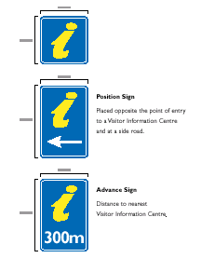

Part G - Advertising / Commercial Signage

Advertising and Commercial Signs
- Within Road Reserve
Other than approved Traffic Control, Guide, Service or approved Tourism Information Signs, neither permanent nor temporary advertising and commercial signs (including sandwich boards) are permitted to be erected, put up or placed in a State or Local Government Road reserve subject to a speed limit in excess of 60kph.
- Within Road Reserve (60kph or lesser zones)
Other than approved Traffic Control, Guide, Service or approved Tourism Information Signs, neither permanent nor temporary advertising and commercial signs (including sandwich boards) are permitted to be erected, put up or placed in a State or Local Government Road reserve without the permission of the road authority and Local Government.
- Private Property (‘over the fence advertising’)
Advertising and commercial signs on private property both on and off the premise is not covered by this Manual and is controlled by Local Government under various controls such as the Land Use Planning and Approvals Act 1993, By-laws and the Local Government (Building & Miscellaneous Provisions) Act 1993.

Temporary Advertising Signs
- Event Advertising
- Definition of Event Signs
For the purposes of this Manual, a temporary event sign is a sign that is displayed no earlier than two weeks before an activity or event of a civic or community nature and is removed by the proponent within two days after the event and is defined as:-
Any poster or notice, placard or board, picture or banner that is temporarily placed, erected or put up within a road reservation for the purposes of attracting the attention of road users.
Generally these signs advertise events that have either a sporting, cultural, religious, educational or recreational interest to the community at large.
- Approval Process
Section 16(1) of the Roads and Jetties Act 1935 states that any structure including an advertising sign, billboard or poster erected within any state road reservation requires the prior approval of the Minister administering the Act. Likewise, the Local Government Highways Act 1982 and Local Government (Building and Miscellaneous Provisions) Act 1993 empower Local Government Authorities to control signs proposed for erection on local roads.
- Policy
In determining whether to permit or refuse an application to erect a Temporary Event Sign a number of factors relevant to the safe use and operation of the road network need to be considered by the road authority. Aspects that should be considered are:
- the sign should not detract from the message of legitimate signs needed for the purposes of road safety, statutory control and guidance of road users;
- the sign should not obstruct or form a confusing background to traffic signs or signals;
- the sign should not obstruct a driver’s or pedestrian’s view of the road or of other road users;
- the method of construction, selection of materials and site installation must be such that the sign cannot cause danger to road users;
- the number of competing signs in the area - too many signs in one location can be hazardous to road safety because drivers may be overloaded with information;
- the design, location and colouring of the sign must be simple and clear;
- the sign should only be permitted within the region / town of the event.
Acceptable Event Signs
Subject to the necessary consent of the Local Council and the road authority, organisers of the following types of events may be permitted to place temporary signs within the road reservation boundaries of State or Local Government Roads.
Charitable Fundraising Events and Doorknock Campaigns
Tasmania (VFL) / Tassie Mariners Games
Garden Week Exhibition
Major Craft and Antique Fairs
Power Boat Titles
Agricultural Shows
Tulip Festival
State / National Athletic Competitions
School/Church Fairs
Rural Exhibitions
Interdominion Racing
Town Festivals
State / International Cricket Matches
Regattas
State / International Rowing Events
NOTE:
This list is not exhaustive but serves to illustrate that the only signs that may be approved are those temporary event signs intended to advertise events such as community social occasions, major sporting, cultural, religious, educational or recreational events or charity fundraising doorknocks. Undoubtedly this is an area where it is not possible to provide specific and rigid criteria and, as such, it will ultimately depend on the professional judgement of both local government authorities and the Department of State Growth (on State Roads) to determine whether or not a sign application is approved or rejected.
- Sign Specifications for Events
- the total area of the sign shall be no greater than 3.0m² in size,
- sites for the location of temporary event signs should be chosen so that the sign is no closer than one (1) metre from the outside edge of the gravel shoulder or three (3) metres from the sealed road surface, whichever is greater;
- the sign shall not be illuminated, nor should retro-reflective materials be used;
- the location, selection of materials and methods of construction of the sign are to be such that no danger is caused to road users. The sign should be able to withstand the effects of wind or rain;
- the sign should inspire confidence in the event being advertised. As a result, the quality of the sign design and the materials used in its construction must achieve a professional standard;
- the message appearing on the signs must be clear and concise to ensure a road users can interpret the message;
- the sign shall be erected at right angles to the roadway but angled off the direction of the traffic by approximately 5 degrees to reduce headlight glare reflecting back into the motorists vision;
- the sign shall not conflict with the colour combinations or shape of traffic signs, so as to cause confusion to road users; and
- flashing or animated signs, including those employing flashing lights are prohibited.

Other Advertising Signs
- Portable Signs (A-Frame ‘Sandwich Boards’)
This Manual does not attempt to control any freestanding portable sign such as an A-frame (sandwich board) positioned on a footpath or nature strip within an urban area. Contact should be made with the local council whether planning permission is required to place such signs.
These signs should not be positioned where they impair public safety or impede the passage of road users in particular pedestrians.
- Mobile Advertising Signs
For the purposes of this Manual, mobile advertising signs are defined as:
Those signs on vehicles, trailers, trucks or other transportable objects which are intended be driven, parked or placed within or adjacent to a road reserve with the sole purpose of advertising/ selling a product, event or to display a particular message.
Approval of such signs on private property may be required under the Local Government Planning Scheme or By-laws and requires the prior consent of the landowner.

- Property Sale & Land Development Signs
Property sale and land development signs must be located on or within the boundaries of the property for sale and must meet the requirements of the Local Authority Planning Scheme and/or by-law.
A Portable sign (sandwich board) to indicate an “Open Home” may be permitted within a State or Local Government Road outside the property in question during the inspection period, provided that due regard is given to the safety of pedestrians and other road users.

- Roadside Vendors
This Manual does not attempt to control, prohibit or influence roadside stalls or vending. Provisions dealing with roadside stalls and vending on all public roads are contained in Section 56(c) of the Vehicle and Traffic Act 1999. The operative date was 1 January 2002.
- Government Promotion
Situations may arise where services or initiatives of Government (Commonwealth, State or Local) result in the need to display promotional signage.
Examples include: Road Safety Campaigns, Water Restriction and Fire Permit Periods.
Such signage is not to be erected nor displayed in a State or Local Government Road without the permission of the road authority. Erection of such signage on private property is subject to landowner permission and Local Authority Planning Schemes, By-laws and the Local Government (Building & Miscellaneous Provisions) Act 1993.
- Electoral
The erection or display of electoral advertising signs within State and Local Government Roads is prohibited. The provisions of Local Authority Planning Schemes and Bylaws make adequate provision for such advertising. The Tasmanian Electoral Commission also provides candidates with advice in the Handbooks it produces for candidates.

Department of State Growth
GPO Box 536
Hobart TAS 7001 Australia
Phone: 1300 851 225
Email: info@stategrowth.tas.gov.au
Web: www.transport.tas.gov.au
© State of Tasmania June 2015

